Learning in digital Era - ACCA4025
Assignment I
Gheorghe Luca Atanasiu - 2224316

Task 1a.
Essential skills for study and employment (250 words)

Essential skills are a set of fundamental skills that individuals require to succeed in their studies, work, and daily life. These skills are considered essential because they form the foundation for acquiring, applying, and communicating knowledge across a wide range of contexts.
The key essential skills for study and employment include:

1. Communication: The ability to express thoughts and ideas effectively, both orally and in writing, and to listen actively to others [1].
2. Digital literacy: The proficiency in using digital tools and technologies for a variety of tasks, including data analysis [2].
3. Problem-solving: The capacity to identify and analyze problems, generate and evaluate potential solutions, and make informed decisions.
4. Teamwork: The ability to work collaboratively with others, share responsibilities, and contribute to achieving shared goals.
5. Time management: The capacity to plan and prioritize tasks, manage time effectively, and meet deadlines [3].
6. Adaptability: The flexibility to adjust to new situations and challenges, learn from experiences, and continuously improve.
7. Numeracy: The competence to understand and use numbers, data, and statistical information to solve problems and make informed decisions.
8. Critical thinking: The capacity to analyze information, evaluate arguments, and make logical conclusions [4].

Acquiring and mastering these essential skills is crucial for academic success, career advancement, and personal growth. These skills are not only essential for employment and academic achievement, but they also support an individual’s ability to adapt to the changing demands of the modern world. By developing these skills, individuals can increase their employability, contribute positively to their workplace, and thrive in personal and professional lives.

References,
[1] Skills You Need (2011). What is communication? Verbal, non-verbal & written | SkillsYouNeed. [online] Skillsyouneed.com.
Available at:
https://www.skillsyouneed.com/ips/what-is-communication.html
[Accessed 21 Feb. 2023].

[2] Staff, L. (n.d.). LibGuides: Digital Literacy: Computer Skills, Netiquette & Internet Safety: Library Guide for Digital Literacy. [online] bowvalleycollege.libguides.com.
Available at:
https://bowvalleycollege.libguides.com/digital-literacy
[Accessed 21 Feb. 2023].

[3] Mind Tools (2022). MindTools | Home. [online] www.mindtools.com.
Available at:
https://www.mindtools.com/arb6j5a/what-is-time-management.
[Accessed 21 Feb. 2023]

[4] Skills You Need (2011). Critical Thinking | SkillsYouNeed. [online] Skillsyouneed.com.
Available at:
https://www.skillsyouneed.com/learn/critical-thinking.html
[Accessed 21 Feb. 2023]

Task 1b.
Similarity: 50
Comment: To improve the originality of my writing, I aim to reduce my similarity score from 50% to the recommended threshold of 30%. My strategies will include using paragraphing tools, incorporating a range of adjectives, consulting multiple sources for a comprehensive understanding of essential skills required for academic and occupational success. I will compare my current skillset with the required competencies in organizational contexts, and thoroughly review and revise my work to minimize the risk of unintentional plagiarism.
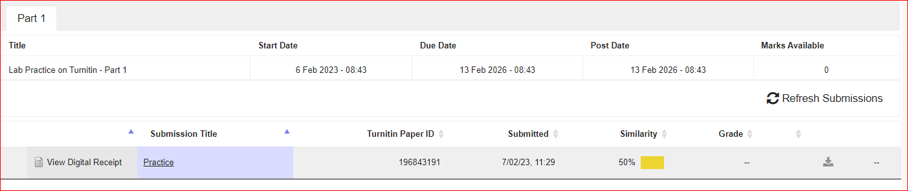

Task 2:
Link: https://sway.office.com/deYGqZDb7uOtodAq
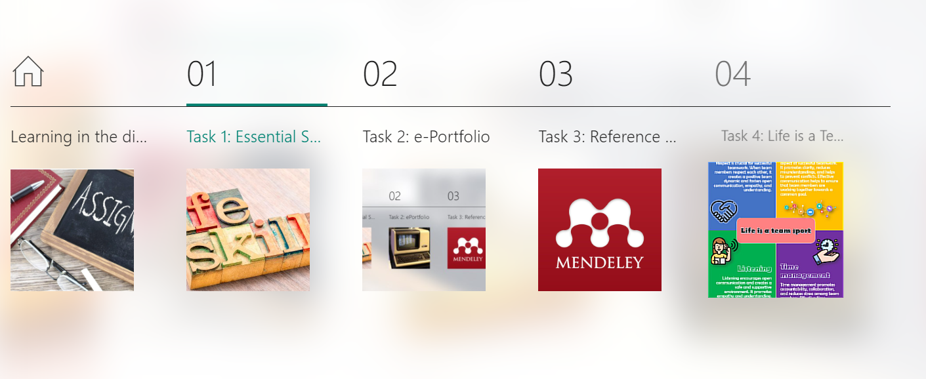
Task 1 is on the 1st page.
Task 2 is the e-Portfolio itself.
Task 3 Mendeley referencing tool documentation.
Task 4 Life is a Team Sport Poster

Task 3:
Document the use of automatic referencing (Mendely)

Step 1
I downloaded and installed Mendeley using the Google search engine.
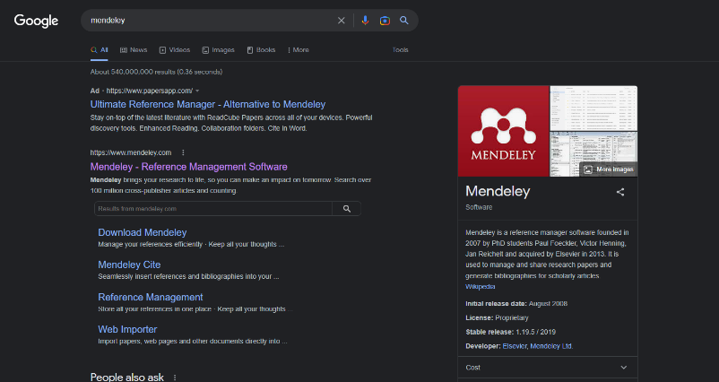

I clicked the website link. Sent me to their Home Page and from there I clicked the Download button.
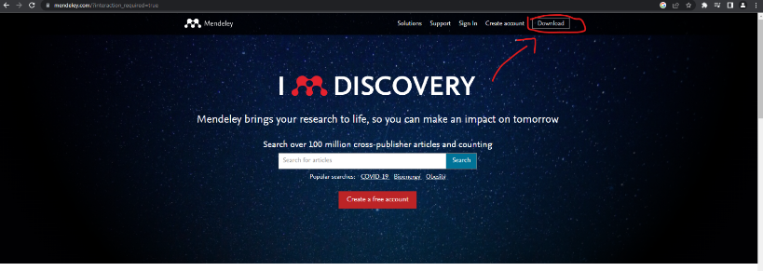

I selected the correct operating system (Windows in my case) then I clicked “Download for Windows” and the Download started.
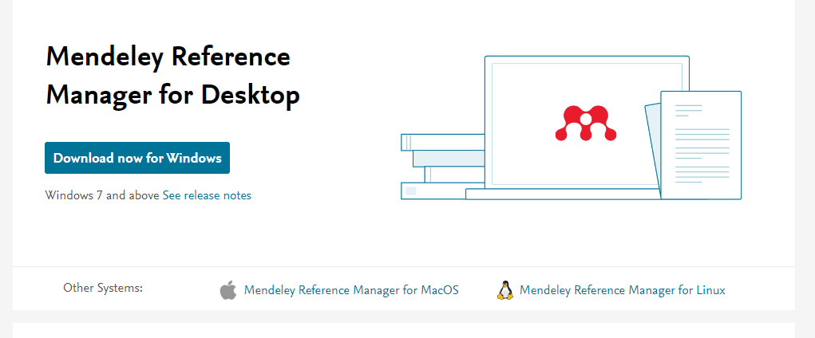

Step 2
After the download was finished, I went back on the website and clicked the “Create account” option.
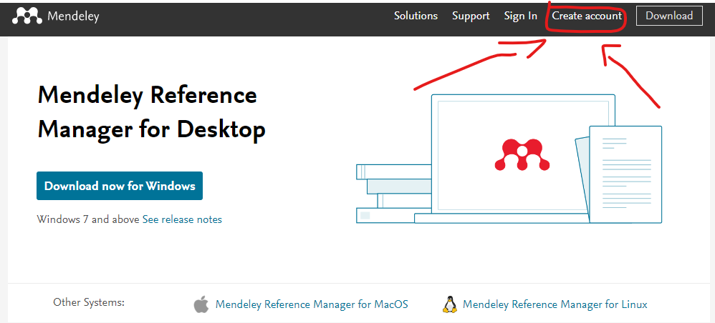

After the account was created, I opened the Mendeley app and logged in.

Step 3
Using Google Scholar, I searched for the reference used on Task 1.

I typed in the search box the name of the study I picked.
After that I looked for the best results and downloaded the pdf version by clicking on it.
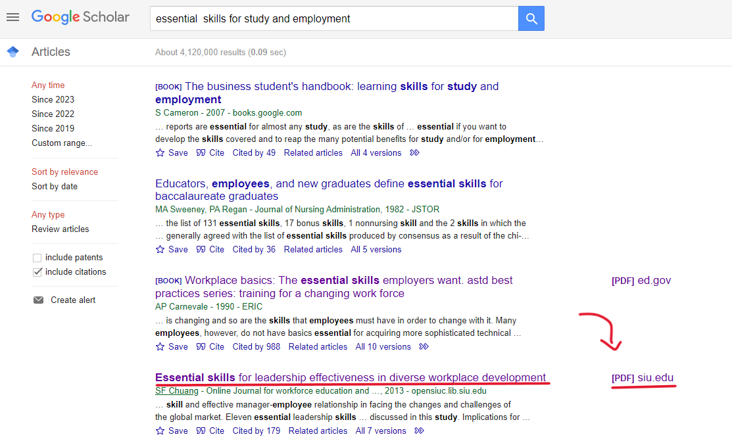

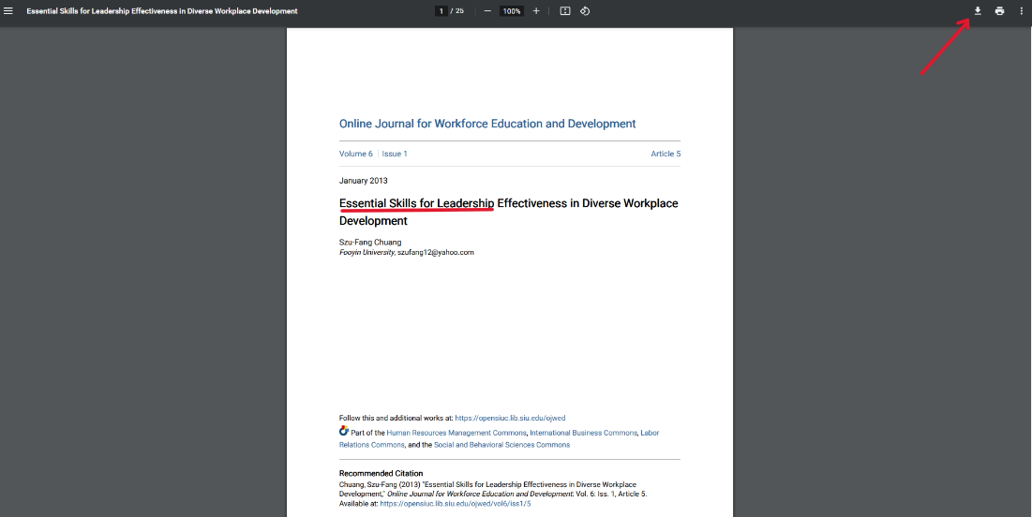

Step 4
After the document was downloaded, I opened Mendeley, logged in and went to Library to add a new document.
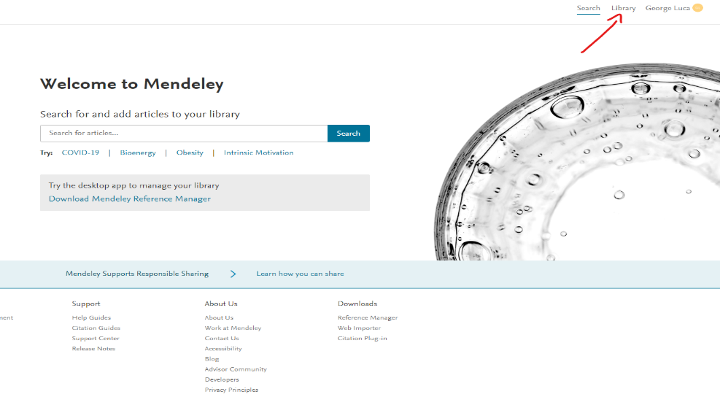

From there I clicked the +Add New button and selected File(s) from computer
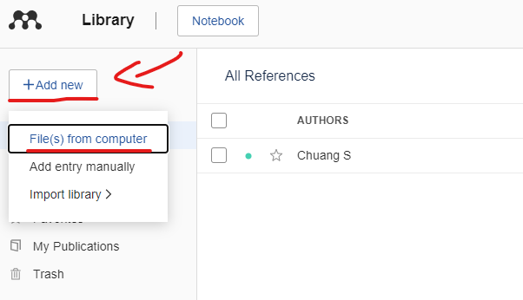

After I located the document, I selected it and added it to Mendeley.
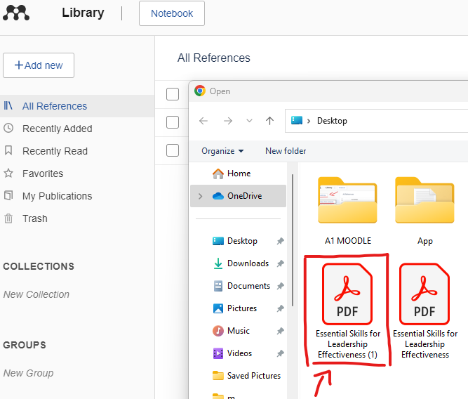

The PDF now appeared on the ‘’All References’’ tab along with the name of the Author(s), Year, Source, the Date when the document was added and the File type.
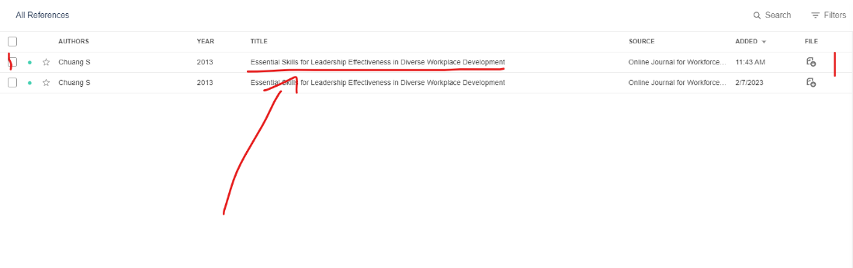

Step 5
By clicking on the freshly added document it opens a page where you can find all the details needed for reference along with the opportunity to go through the document itself.
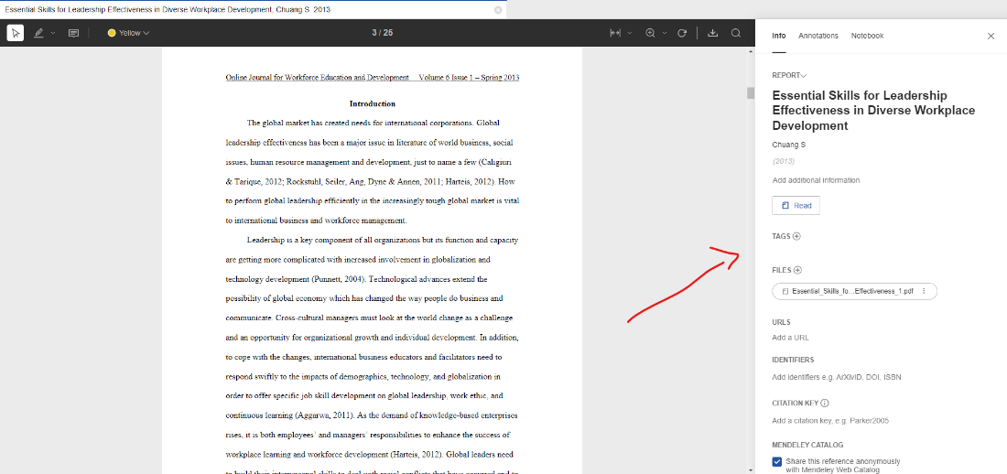

Task 4.

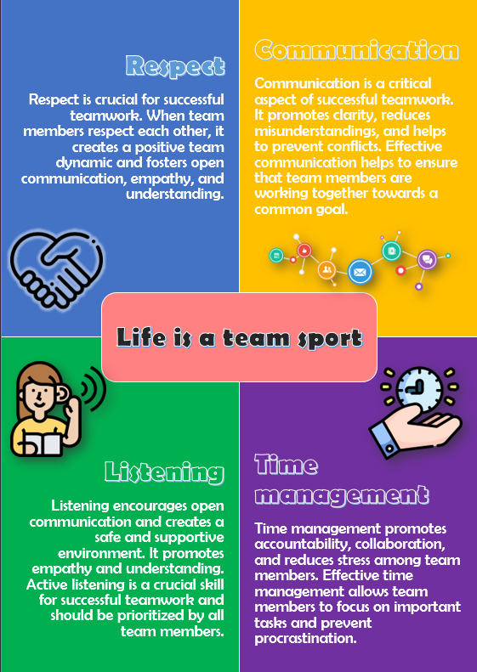

Time Management:
Time management is an essential aspect of teamwork that can significantly impact the success of a project. Effective time management ensures that team members can complete tasks within set deadlines, leading to a more efficient and productive team. It allows team members to focus on important tasks and prevents procrastination, ensuring that time is used effectively [1].
One of the benefits of good time management in teamwork is that it promotes accountability among team members. When tasks are assigned with specific deadlines, team members are more likely to take ownership of their roles and ensure that their work is completed on time. This creates a sense of responsibility and helps to prevent the accumulation of work that could lead to delays or a substandard project outcome.
In addition, time management can foster a sense of collaboration among team members. When each member is responsible for completing their assigned tasks on time, it creates a sense of shared responsibility for the success of the project. This can lead to more open communication, a better understanding of each other's roles, and ultimately, a more cohesive and effective team.
Furthermore, good time management can help to prevent burnout and stress among team members. When tasks are planned and completed in a timely manner, team members are less likely to feel overwhelmed or pressured to rush their work. This can help to maintain the morale of the team and create a more positive work environment.
In conclusion, time management is a critical component of successful teamwork. It promotes accountability, collaboration, and reduces stress among team members. Teams that prioritize time management are more likely to achieve their goals, deliver projects on time, and create a positive working environment.

Respect:
Respect is crucial for successful teamwork. When team members respect each other, it creates a positive team dynamic and fosters open communication, empathy, and understanding. This can lead to a more balanced distribution of tasks and improved outcomes. Additionally, respect helps to prevent conflicts within the team, creating a more harmonious work environment. In conclusion, respect is an essential component of effective teamwork and should be prioritized by all team members to achieve the best possible results [2].

Listening:
Listening is a vital component of effective teamwork. When team members actively listen to each other, they gain a better understanding of each other's perspectives, ideas, and concerns. This can lead to more productive discussions, better decision-making, and ultimately, improved outcomes. Moreover, listening encourages open communication and creates a safe and supportive environment where team members feel heard and valued. It also promotes empathy and understanding, which can help prevent conflicts and foster collaboration within the team. In conclusion, active listening is a crucial skill for successful teamwork and should be prioritized by all team members to achieve the best possible results [3].

Communication:
Communication is a critical aspect of successful teamwork. Effective communication helps to ensure that team members are working together towards a common goal, with a shared understanding of their roles and responsibilities. It promotes clarity, reduces misunderstandings, and helps to prevent conflicts. Moreover, communication encourages active listening, which fosters empathy and understanding among team members. This can lead to a more positive team dynamic, increased collaboration, and improved outcomes. Additionally, communication helps to ensure that everyone is on the same page and that important information is shared in a timely and effective manner. In conclusion, effective communication is essential for successful teamwork and should be prioritized by all team members [4].

Link (OneDrive) : Life is a teamsport

References,
[1] Kashyap, S. (2019). Importance of time management in the workplace. [online] ProofHub.
Available at:
https://www.proofhub.com/articles/importance-of-time-management-in-the-workplace.
[Accessed 20th Mar. 2023]

[2] Deer, M. (2020). The Importance of Respect in the Workplace. [online] CPD Online College.
Available at:
https://cpdonline.co.uk/knowledge-base/business/importance-respect-workplace/.
[Accessed 21st Mar. 2023]

[3] Deakinco. (2016). The five elements of successful teamwork. [online] DeakinCo. | Powering workplace performance.
Available at: https://deakinco.com/resource/the-five-elements-of-successful-teamwork/.
[Accessed 21st Mar. 2023]

[4] Stowell, C. (2018). Team Leadership: Why Effective Team Communication Is So Important. [online] CMOE.
Available at:
https://cmoe.com/blog/team-leadership-why-effective-team-communication-is-so-important/.
[Accessed 21st Mar. 2023]

