University of Wales Trinity Saint David



Student name: Hywel Cleaves
Student ID Number: 2520281
Programme: PT Engineering Portfolio
Module: Engineering Design
Module code:ACMA4008
Assignment Title: Engineering Problem

Contents

- Introduction and Objectives
- Interpretation of the client brief
- Key Legislation Considerations
- Specification
- Timeline
- Design Concepts
- Final Design and production
- Conclusion and further work
- References

- Introduction and objectives.

The objective of this Technical report is to identify the best solution to an engineering problem through research and product development. The problem is, a tank cover used to cover an anodising tank for health and safety reasons, has been highlighted as a safety concern itself. This triggering a problem, leading to a product re-design. The solution needs to rectify the current safety concern whilst also being reproducible as the business has numerous tanks currently in use with the same design.

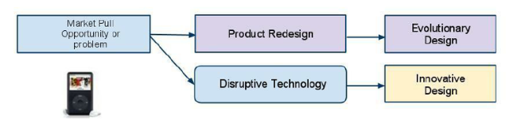
Figure 1 Product redesign trigger.

Objectives
Multiple objectives need to be achieved to design and create an effective solution.
- Identify and consider key legislation in terms of safety to ensure the business complies with government guideline.
- Consider materials to be used whilst also keeping in mind cost, production, and the harsh environment the product will be used in.
- Multiple different designs to be brainstormed
- CAD model alongside fully dimensioned technical drawing to the BS8888 standard of the final design
- Consideration and reasons for design final design choice with production methods.
- Gant chart to guide reasonable timeline

- Interpretation of the client brief.

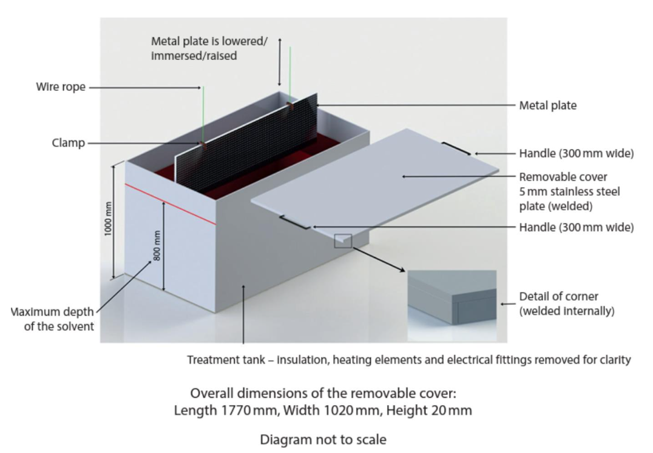
Figure 2 - Anodising Tank Illustration (University of Wales Trinity Saint David, 2024)

Time | Unspecified in the brief, however due to being raised by the health and safety officer as a major risk to staff, swift resolution is needed 2-3 months for design, build and installation.
Target Market | In house project for dozens of tanks within the plant, if successful volume will be in the low 100s once rolled out to the companies other sites.
Function | To cover anodising tank containing 30% sulphuric acid that’s heated to 25 degrees C for health and safety purposes. Must be safety operated by one person, and clearance from above must be achievable due to tanks function.
Design Constraints | No changes can be made to the tank itself, including dimensionally. There must be clearance from above to allow access for parts. Must be a single person operation. However tank lid can be altered.
Size | Tank lid must fit tank, current dimensions are 1770mm x 1020mm x20mm
Aesthetics | Product will be designed for use in manufacturing industry, so cost and effectiveness should be prioritised over aesthetics however product should look professional.
Durability | Tank lid should last 5+ years with correct servicing and regular planned maintenance. Tank Lid is only in use when tanks are not being used.
Materials | Strong, long lasting materials need to be considered. Corrosion resistance should be high priority as the tank lid is covering 30% Sulphuric acid, should also be easy to clean. Lightweight as possible due to operation.
Safety | Must correctly fit tank to fulfil purpose, whilst also being a safe one person operation. Sharp edges need to be considered and avoided. Should conform to the Health and Safety at work act 1974. Alongside correct risk assessments upon installation.
Cost | Nothing specified within the brief, however for initial design, manufacture and installation. <£10,000 and £400 per unit thereafter.
Environmental Consideration | Made from recyclable materials where reasonable.  Material locally sourced.  Waste should be disposed of correctly and responsibly.  No use of hazardous materials.
Testing | A prototype of the initial design will undergo testing to ensure correct fit on the tank and ensure lid is operational via a single person. Dynamic testing should be carried out to ensure suitability within the production environment.  Maintenance and removal testing ensure that the tank lid can be removed and re-fitted with ease and within specified time limit to minimise production disruption.  Fatigue testing in an acidic environment

- Key Legislation Considerations.
When considering design options for the Tank lid, which is a manual lift currently performed by two personal, on a piece of equipment that contains 30% Sulphuric acid. Numerous legal considerations should be made, key one include, the health and safety at work act 1974 which covers not only the employer but also the employee. It details the responsibility both parties have within the workplace.
“The Health and Safety at Work etc. Act 1974 (HSWA) is the primary legislation for workplace health, safety, and welfare in the UK. It mandates that employers, as far as reasonably practicable, ensure the safety of employees, visitors, and the public, while requiring employees to take reasonable care of themselves and others.”
Manual handling - Manual Handling Operations Regulations 1992 must also be taken into consideration, this guidance is aimed at preventing injury, specifically musculoskeletal.
“The guidance explains how to avoid, assess and reduce the risk of injury from manual handling”
HSE Risk assessment for manual handling
Whilst there is no specific legal limit in the workplace the HSE guidelines state 25KG at waist height for a male and 16KG for a female. Average fist grip (knuckle) height for UK male is 770mm and female being 740mm, so with tank height being 1000mm this brings the lift needed to place the lid onto the tank into the shoulder height category.
A rough calculation using the dimensions in the design total 71.55KG for the current tank lid.
Length m X Width m X Thickness mm X Density (8.0g/cm3 for stainless)
1.77m x 1.02m x 5mm x 8 = 71.55kg
This puts the current design firmly in the high risk categories, risking both injury and claims against the business.

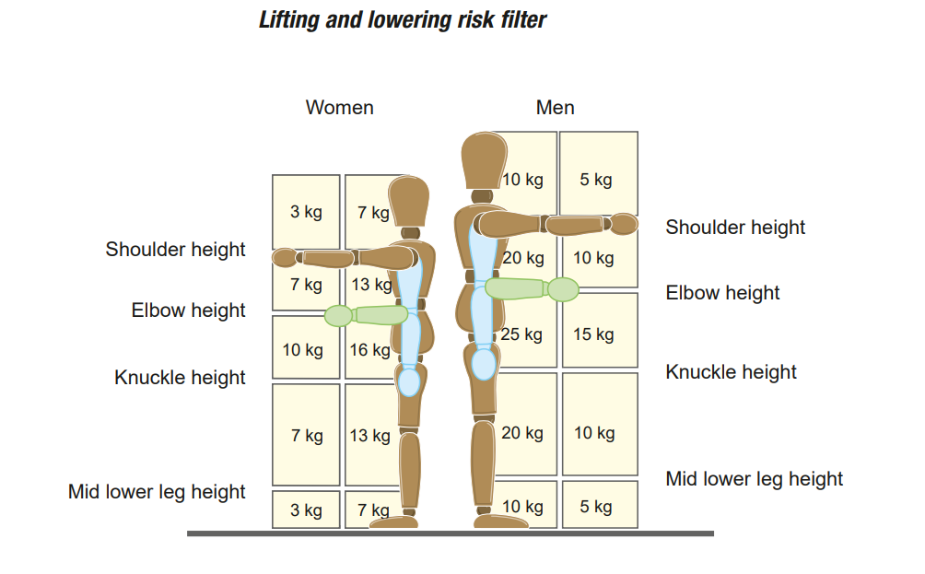
‌C.O.S.H.H – Control of Substances hazardous to health regulations 1992, this is aimed at assessing risks associated with the use of Hazardous substances, then using that risk assessment prevent and control whilst also providing information instruction and training.
PUWER – Provision and use of work equipment regulations 1998,
“These Regulations, often abbreviated to PUWER, place duties on people and companies who own, operate or have control over work equipment. PUWER also places responsibilities on businesses and organisations whose employees use work equipment, whether owned by them or not.”

- Specification

When researching and developing designs the primary requirements must be considered, from the design brief we understand that
- Must be safe to operate
- Operated by a single person
- Tank dimensions and material must remain the same.
- Tank lid can be altered
- Must be clearance from above, to allow aluminium parts to be lowered.
Another consideration is the environment in which the lid is used, over a 30% sulphuric acid tank, heated to 25 degrees.
The new cover design should be, acid resistant, heat resistant, durable and lightweight. Research into alternative material can be summarised in the below table showing resistance to acid, Density, cost, uses in manufacturing.

🧪 Sulphuric Acid Tank Lid comparison

Material | Acid Resistance (Sulphuric) | Density (kg/m³) | Approx Cost (USD/kg) | Durability / Notes | Lid manufacturing process | Cost
PTFE | Excellent (very strong acids) | 2,100–2,200 | ~$5–$11+ | Outstanding resistance; good for lids & gaskets, higher cost than basic plastics | Compression moulding | moderate for high volume
PVDF | Very good up to ~98% H₂SO₄ | 1,760–1,800 | ~$1.50–$1.80 (raw resin) ≈ $1.5–$3/kg market adj. | Good balance chemical resistance, weight, price | Injection moulding | Low for high volume
FRP (Fiberglass Reinforced Plastic) | Very good (93–98%) | ~1,500–2,000 (composite) | ~$3–$7/kg (material basis) supply resin + fibres | Lightweight structural option; overall lid cost also fabrication dependent | Hand lay up | High
PP (Polypropylene) | Good (up to ~98%) | ~850–940 | ~$1–$3/kg | Lowest cost & lightest; good moderate resistance | Injection moulding | Low for high volume
HDPE | Good (up to ~80%) | ~950–970 | ~$1–$3/kg | Very light and low cost; less suitable at higher concentrations | Injection moulding | Low for high volume

Looking at the common industry standard the below chart outlines plastics which are acid resistant specifically Sulphuric.

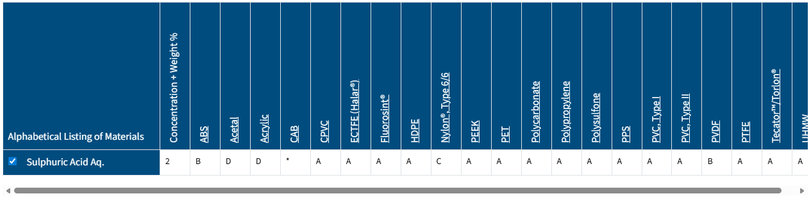
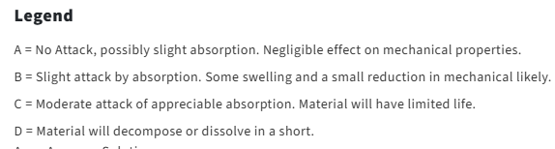

Figure 3 Material suitability table.

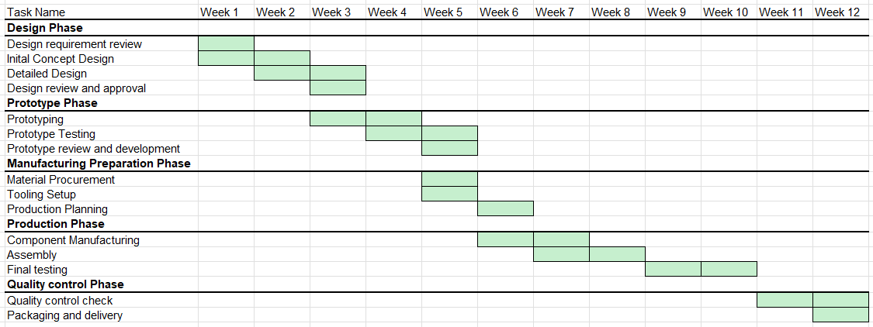
- Timeline

Figure 4 Gant chart for time management during the project

6.Design Concepts

The first design is based upon the premise of modifying the existing tank lid by welding four lifting eyes at equal distances in all four corners. Then purchasing a 4 chain lifting arrangement. This would allow the lifting equipment currently used to hoist sheets into the process to also lift the lid when needed. The benefits to this design is installation of the eyes could be done in house and the chains are readily available to purchase at varying dimensions, both at low cost. The disadvantages are the lifting equipment would be subject to LOLER inspections, potentially creating another layer of complexity to the process, and the use of the crane/hoist could potentially impact production depending on how the process is laid out. It will also still be difficult to get the lid into the correct position involving operator skill and awareness.

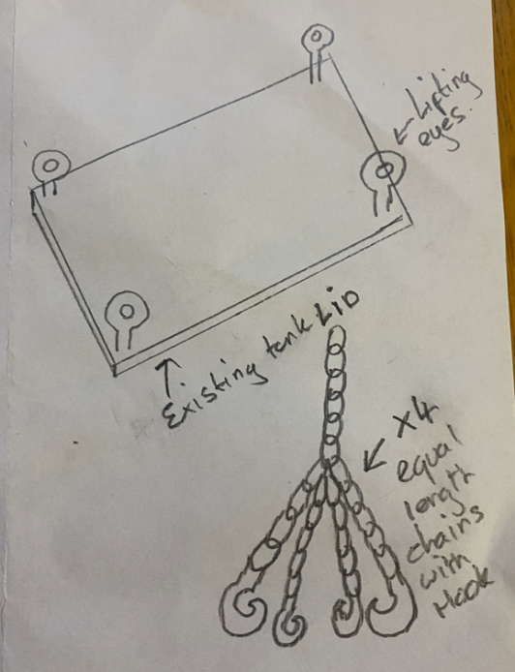
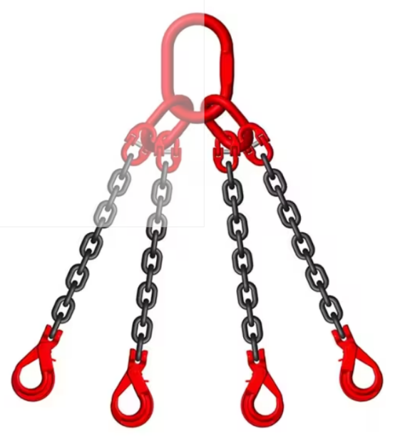

‌

The second design concept involves modifying the tank and lid in order to create a “Hot Tub” type opening system, a stainless steel block could be welded onto the outside of the tank with a slot cut out of the centre and a groove machined on top. The lid could then be modified to have a l shaped bar welded to it. The bar would the sit inside the slot cut out of the block and act as a guide. Operators would then lever the lid into position. This design would make the lift easier but involves a lot of clumsy moving parts liable to break. The cost to manufacture the parts would be high as it would have to be outsourced and the testing would have to be vigorous. It also doesn’t eliminate the full weight of the lift for the operator which was the main concern. The design could be modified by incorporating bearings into the slot allowing a smoother motion and the tank lid material could be changed to a lighter weight product however this design is still liable to failure and difficulties.
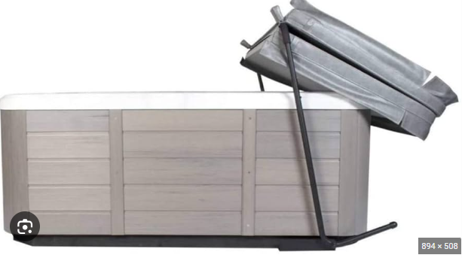
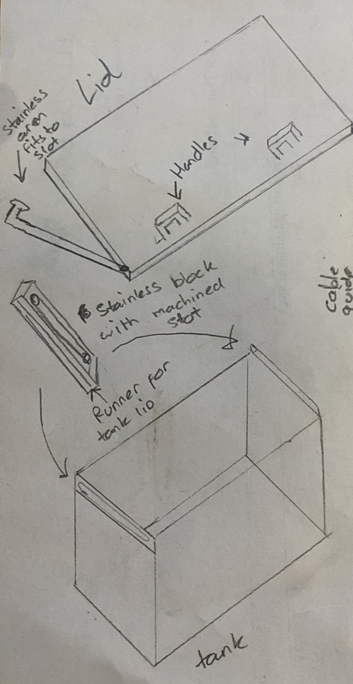

The third design, again involves modifying both the tank and the existing lid, by installing hinges on one side of the tank this will allow the lid to open/close from a pivot point. Then by installing a motor at the base of the tank, this coils be done by either fixing to the tank itself or the floor. This would power a spool of stainless steel wire either forward or reverse which would open or close the tank lid. The wire would need to run through a guide which sole purpose is to keep the wire off the tank and allow clearance. The benefits of this design is the operator is taken completely out of the lift, all the weight will be taken by the motor and wire system. Fully operational via remote or button depending on configuration. The disadvantage are that this could become costly as parts would have to be outsource and maintenance would have to be done regular on motors.
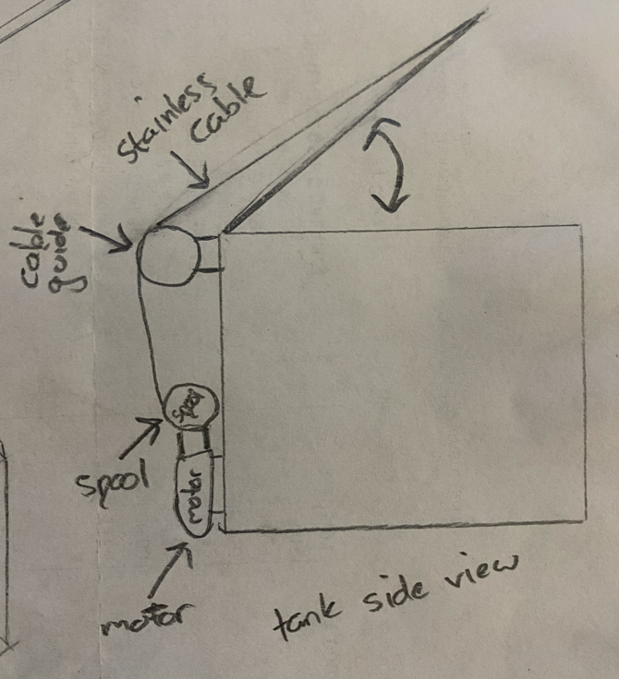

- Final Design

When deciding which design is optimal, the design brief objective must be considered.
- Must be safe to operate
- Operated by a single person
Additional parameter taken into consideration are cost of production as the lid will be used in multiple tanks across the company’s additional sites and the environment the lid is going to be used.
The final design tackles the safety concern by splitting the lid into two pieces, this will immediately reduce weight. The edges have been chamfered to avoid any sharp edges and two handles applied to each section ensuring the operator has adequate purchase on the lid. One half of the lid also has a 20mm overlap which should act as a seal to ensure any fumes are contained.

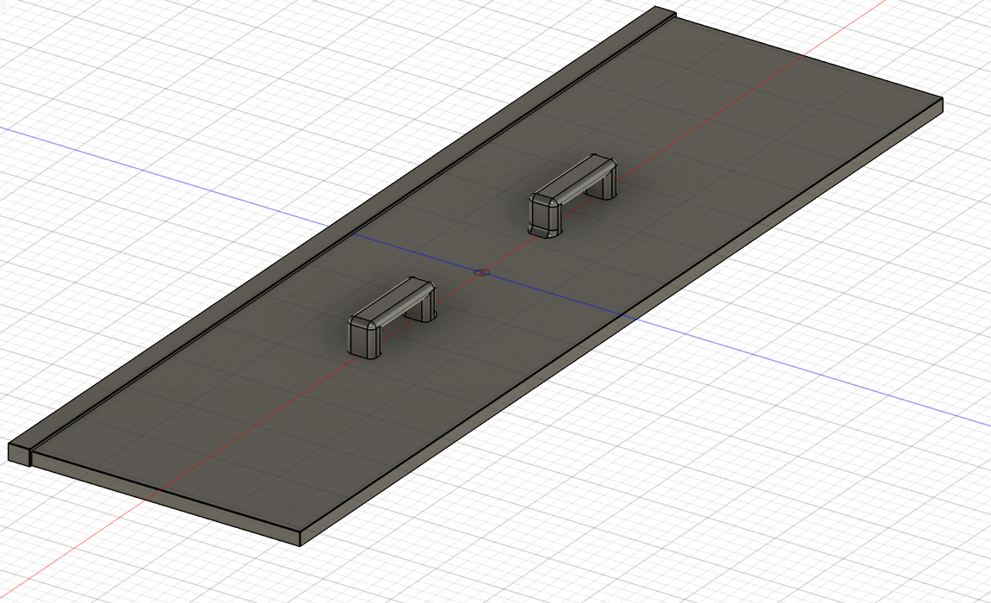

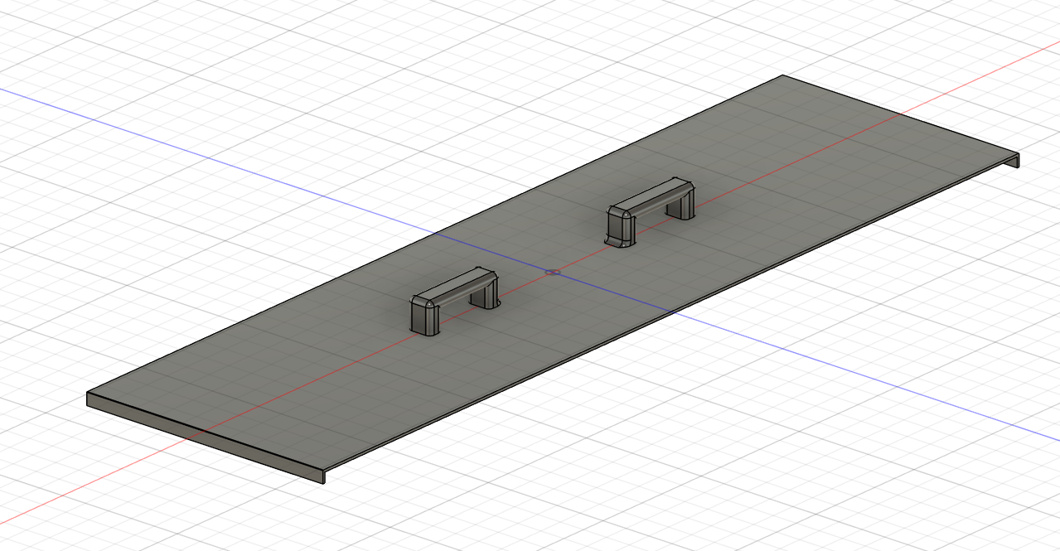

The main change will be replacing material used, currently the tank lid is made from 5mm Stainless steel, which is extremely heavy for a manual lift. Instead the new lift design should be made of Polypropylene which has a high resistance to acid, is lightweight and injection moulding can be used for production which will be low cost for the volume needed. Each section of the lid will be less than 5kg which ensures a simple, safe, single person operation. With minimal supporting documentation, the current procedure will need to be slightly modified. Some disadvantages are the production of the lids will have to be outsourced and the task is still manual.

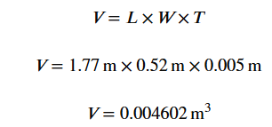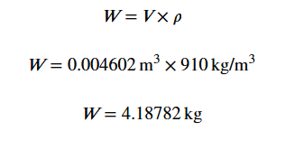

Figure 5 Calculation of new design weight
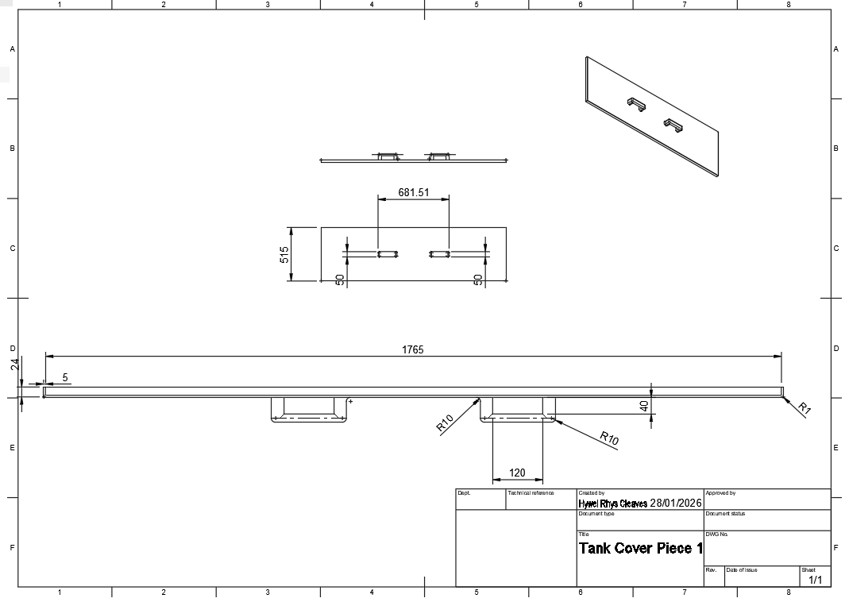
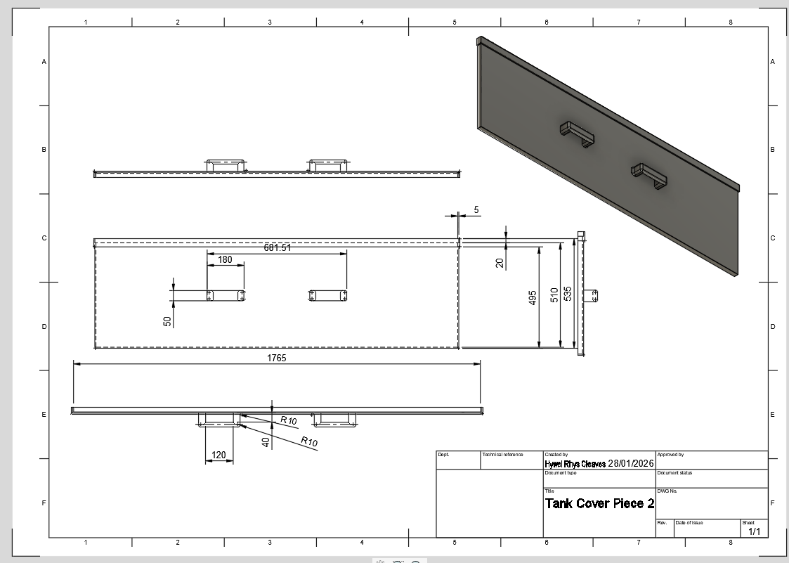

Production of tank Lid
Injection moulding has been chosen to produce the tank lids as it has excellent accuracy to ensure tank lid fits correctly and will require minimal design changes during testing. Low part cost in high volume production and the handles will be integrated with the lid itself ensuring strength and safe operation. Other production routes considered were CNC machining however there is a higher volume of waste and a long production time, Blow moulding which is limited to hollow parts, Compression moulding is cheaper but injection moulding offers better accuracy and complex geometries, and for the thin walls and handles accuracy is needed. However compression moulding could be considered.

- Conclusion and further work
In conclusion the key objective have been met ensuring the major safety concern has been alleviated whilst offering a simple and cost effective solution. The new design meets all of the core functions needed to keep the tank sealed. There will be an initial cost to changing the material however this has been considered and most effective production route chosen, maintenance will also be low with expectancy to replace lids upon failure, the lifespan of the lid should be 5+ years. Further work could be done automate the tank lid taking the operator away from the task and ensuring safety however this would need to be balanced against reasonable cost.

References

Devon, R. and Jablokow, K. (2015). Teaching Front End Engineering Design (FEED). [online] Available at: https://www.researchgate.net/publication/267216572_Teaching_Front_End_Engineering_Design_FEED.
‌
First in Architecture (2013). Average Male and Female Dimensions / Heights. [online] First In Architecture. Available at: https://www.firstinarchitecture.co.uk/average-male-and-female-dimensions/.

Health and Safety Executive (n.d.). Manual handling at work: Simple manual handling risk filters - HSE. [online] www.hse.gov.uk. Available at: https://www.hse.gov.uk/msd/manual-handling-risk-filters.htm.
‌Hand Lay-Up (Composite Open Molding)
ScienceDirect. (2016) Hand Lay-up – an overview. Available at: https://www.sciencedirect.com/topics/engineering/hand-lay-up (Accessed: 27 January 2026).
• Describes hand lay-up as the simplest, lowest-equipment cost composite processing method, emphasizing manual labour and its dependence on operator skill, with long cycle times.
ExploreComposites.com. (2021) Composite Manufacturing Methods. Available at: https://explorecomposites.com/articles/design-for-composites/basics-manufacturing-methods/ (Accessed: 27 January 2026).
• Notes hand lay-up (open moulding) as among the least expensive composite methods, suitable for low-volume production.
ScottBader.com. (n.d.) Hand Lay-up Guide. Available at: https://www.scottbader.com/knowledge-hub/composites/hand-lay-up-guide/ (Accessed: 27 January 2026).
• Outlines hand lay-up process steps and highlights low tooling cost and manual labour dependence.
Compression Molding
SEAWIN Industrial Ltd. (2025) Compression vs Injection Molding: Key Differences. Available at: https://www.seawinindustrial.com/processes-technology/compression-vs-injection-molding/ (Accessed: 27 January 2026).
• Compares compression and injection molding, noting that compression has lower tooling cost than injection, moderate production cost, and slower cycle times.
MFG Shop. (2025) Compression Molding vs Injection Molding: A Detailed Comparison. Available at: https://shop.machinemfg.com/compression-molding-vs-injection-molding-a-detailed-comparison-of-cost-efficiency-and-applications/ (Accessed: 27 January 2026).
• Describes compression molding as having simpler tooling, making it less expensive to set up compared with injection molding, though slower per part.
Wikipedia. (n.d.) Compression molding. Available at: https://en.wikipedia.org/wiki/Compression_molding (Accessed: 27 January 2026).
• States compression molding is one of the lowest cost molding methods compared with injection molding and wastes relatively little material.
Injection Molding
SEAWIN Industrial Ltd. (2025) Injection vs Compression Molding Comparison. Available at: https://www.seawinindustrial.com/processes-technology/injection-vs-compression-molding-comparison/ (Accessed: 27 January 2026).
• Notes that injection molding has a higher initial investment but lower unit cost at volume due to automation.
Shinzoft.com. (2025) Injection Molding vs Compression Molding: Choosing the Right Technique. Available at: https://www.shinzoft.com/injection-molding-vs-compression-molding-choosing-the-right-technique-for-your-production-needs/ (Accessed: 27 January 2026).
• Highlights high tooling costs for injection molding and its cost effectiveness in high-volume production despite that high initial setup.
Web, T. and PPD (2024). Plastic injection moulding and its key benefits vs other processes - Plastic Injection Moulding. [online] Plastic Parts Direct. Available at: https://www.plasticpartsdirect.co.uk/2024/08/20/plastic-injection-moulding-and-its-key-benefits-vs-other-processes/.
Chain (2024). Chain Lifting Slings - 2360kg Load - Rapid Racking. [online] Rapidracking.com. Available at: https://www.rapidracking.com/en/rra/chain-lifting-slings-with-safety-hooks-2360kg-load-4-leg-manutan-a140517?utm_source=google&utm_medium=cpc&utm_campaign=GG-GS-R-UK-EN-Catch_All&shopping=true&gad_source=1&gad_campaignid=22902540901&gclid=EAIaIQobChMIs7fyibWxkgMVPphQBh3oOQaNEAQYAiABEgLiD_D_BwE [Accessed 29 Jan. 2026].

