

AFFORDABLE PETS SERVICES

BUSINESS PLAN

Module code: BMSW 4006
Module name: Managing Enterprise in the 21st Century
Module Leader: Zahida Khan
Students:
- Berfin Sahin
- Rashida Morton 2112665
- Stefania Enoaica 2124107
- Raya Salah 2026066

Contents

Executive Summary

The objective of this presentation is to present a business plan for a company that offers pet sitting, dog walking, and other similar services​
It was required to start by reviewing the ideas that already exist on relevant topics like entrepreneurship, innovation, strategy, marketing, and the trends and advantages of having pets to complete this assignment.
Following this investigation, a sector-wide examination of the enterprises' immediate area was conducted. This study considered technological and social aspects in addition to factors related to the economy and political-legal issues.
For the same goal, the following were investigated: the relationships between current and potential customers, suppliers, partners, and other services. In this analysis, the most crucial factors are the clients and other services used for enabled business.
Then, a tool known as systemic SWOT was used, which helps identify difficulties, restrictions, hazards, and surveillance scenarios in addition to opportunities and threats to the organisation, its strengths, and weaknesses.
The following phase involved analysing rival companies that are currently offering services and determining their unique advantages and disadvantages.
The PESTLE analysis and a market analysis were then used by we to analyse the environment in which the company will operate.
Affordable Pets Services it is a partnership agreement. Four partners with equal roles each contribute equally to its formation. The corporation is owned by BERFIN SAHIN , RASHIDA MORTON, STEFANIA ENOAICA and RAYA SALAH.
The last step was to conduct a financial study of the business to ascertain its value.

Business Overview
- Name: AFFORDABLE PET SERVICES
- Legal structure: PARTNERSHIP
- MISSION-
- Our mission is to create fantastic personal care for your beloved pets in the best viable way.
- When you are unable to walk your pet, we are here to provide you with the confidence to use our services.
- To enrich the lives of pets and their families by providing excellent pet care.
- Also, to become one of the leading pet services that can be relied on to give customer satisfaction, leaving customer and their pets confident and satisfied that they will be given the absolute best care our service offered
- If /when a customer must be hospitalised at any point, we are we are here to take care of their pets and leave them feeling relaxed and assured that their beloved pets had been well l taken care of by our professional and qualified staff members
- Assured that pets were properly vetted and given treatment accordingly, such as worming tablets, grooming flea drops etc
- When you are on holiday, to give you complete confidence to enjoy your holiday know,

TARGET MARKET

Before starting our pet-sitting/walking services business, we are confident that there is a wide range of both elderly and individual clients who would need our services. We will ensure that we develop strategies that will help, especially the more vulnerable clients. This will give us several options to generate revenue for our company.
Because of that, we have created strategies that will enable us to reach out to various individuals (pet owners) whom we know cannot afford to do without our services. We have conducted our market research and survey and will ensure that our pet sitting/walking services are well accepted in the marketplace. Below is a list of the people to whom we have specifically marketed our products and services;
- Elderly
- disabled
- Households who own pets
- Students who own pets
- Busy people who own pets

PRODUCT AND SERVICES

Affordable pet services are going to offer varieties of pet-related services. Our intention of starting our pet sitting, walking business is to provide a safe facility for owners of pets to keep their pets whenever they are not able to or if they are vulnerable when they are busy at work and also to help in developing our client's pets in any skills and knowledge of their choice as it relates to specific useful competencies they want their pet to possess.
We want to go beyond pet-sitting services to help our clients develop their pets' capability, capacity, productivity, and performance
Our products and service offerings are listed below;
- Pet sitting/walking
- pet grooming
- Overnight stays
- Obedience training
- Pet training
General merchandise of pet-related products (pet foods, shampoos, dog ties, dog chains, and pet clothes
We offer 3 Packages Bronze, Silver, and Gold. Our Packages aim to please all
Bronze package-30 minutes' walk, basic grooming (wash and dry) and a toy £29.99
Silver package-60 minutes' walk/run special grooming (wash and dry cutting nails combing fur) food and a toy £39.99
Gold packages-75 minutes' walk /run luxury grooming (wash and dry, deep conditioning, cutting nails combing fur), food and a toy £49.99
We offer a wide range of additional products and services, such as administering medication, taking the animals to the vet, grooming your pet, and bringing the animal’s food to the customer’s home. We have toys, bedding, shampoo, bowls
whether you just cannot get out to being busy at work or going on holiday no matter what the reason, we have it covered to help put your mind at ease and your beloved pet feel safe
we want all our animal friends to have the best quality on the market.
We, as pet sitters, will stop by to take care of their requirements. We go beyond for their physical needs, cleanliness, and affection.

Market Audit _Competitors Analysis

A marketing audit is a valuable system examination of the way a business is being marketed. Marketing audits show business owners where marketing efforts are successful, show the failures so the essential changes can be made for a business to succeed and develop (Denise & Jaroslav,2013)
Before starting a business, plan there are tools to use that measure value, risk and effectiveness of marketing. Marketing audit will systematically analyse as well as evaluate and explain both the internal and external marketing environment.
Competitors analysis is an assesses the position of potential competitors. We are based in Birmingham city with 50 loving friendly and insured dog carers. In our sitters we offer a different service such as home dog, dog boarding, dog walking, dog night and days care. Our big competitor is Dog walker and Pet sitters, they are based in Birmingham, and they are on the market for long times which means they have a good reputation and more clients.
We compare:
- Brand awareness,
- Cost
- Product
- Customer experience
- Relationship

Marketing Audit _PESTEL ANALYSIS:

Political factors | Economic Factors | Technological factors | Social Factors | Environmental factors | Legal factors
Long term profitability | Inflation rates | Everchanging, never stops changing | Culture | Climate change | Understanding the industry inside out
Political stability | Economy rules and regulations | Slow and fast speed of texting | Religious believes | Summer, winter, rainy day's
 |  | Technology's impact on product offering | Attitudes

For a business plan its necessary to have Pestel analyse external aspects surrounding the company, a useful tool to do that is PESTEL analysis which focus on areas; economic, political, economic, social, environmental, and legal factors.
The tables above show all the areas we need to look at before starting up our business-like economic factors e.g. the financial crisis caused by the Ukraine war and the inflation that reaches a staggering 11.5% we consider decreasing our service price so everyone can afford it, also the table showing the Legal factors, we have the right to work in UK, our services for everyone in our area. We have good team who deal with technology and product.
We are using SWOT ANALYSIS in our business plan, which is showing our weaknesses, strengths, opportunities and threats.
Weakness: as we are new in the market, we have about 15% customers in our place and people does not know about our services, so we need to build a good network in the area and hand out cards to further advertise our business. Our services are not available around all the United Kingdom
Facing constant competition from individuals that simply walk dog for small fee on the daily basis.
Strength: we have in our dog walking business also pet services which means we can also look after your beloved pets, and we have insurance which covers doctor visits and transport pick and return services. Also, we provide toys, kits, food and dog cloth in our shop and our customers trust us. Most importantly our services are available 24 /7.
Opportunity: We are looking forward in the future to extend our services to cover all UK and EU as we can hire and train more staff dog walkers and carers so we can serve more clients.
Threats: facing ongoing competitors can be our threat but once we have established relationship between our dog walker and the dog's owner there are small risk, they can switch services providers.
The tables down shown our SWOT analysis:
Strengths:  Training of workers  Available 24/7 days a week | Weaknesses:  Only dogs  Service is not available around the UK
Opportunities:  Extending  Hiring more staff | Threats:  Trust  Competitions

Marketing Plan

Your marketing strategy should include digital PR as a key component. It is a terrific method to boost your pet brand's credibility and authority. What is online PR? Writing helpful, educational, and interesting articles is how you get them accepted for publication on reputable pet business blogs and websites.

Since the articles link back to your website, readers and search engines will view your brand as trustworthy and authoritative. For our clients, we apply this method widely, and they have gotten fantastic results.

The secret is to provide educational content that is useful to pet owners, pertinent to your industry, and appropriate for the publisher's website. Avoid links that are highly promotional or sales oriented.

There are numerous promotional strategies you may use to spread You may use numerous promotional strategies the word about your company. Start by including a listing for your service in the Yellow Pages, which is where most people check when they suddenly need your service. You can get a massive advertisement for not much money by using telephone books as your advertising medium. Get more than a normal listing; otherwise, you risk being lost in the crowd. Consider what others have and try to mirror it as closely as possible in terms of size and colour use. Make sure to include both your website address and phone number and one or two of your greatest or most distinguishing features. Promotional items include discounts, freebies, and unique events that serve as incentives or to say, "thank you." Promotions are a wonderful opportunity for creativity and amusement. Every new customer of one dog walker received a free dog tag for the pet's collar that was inscribed with the dog's name, address, and phone number on one side and the words ‘’Pet Sitting"

Promotional items include discounts, freebies, and extraordinary events that serve as incentives or to say "thank you.

Promotions are a wonderful opportunity for creativity and amusement. Every new customer of one dog walker received a free dog tag for the pet's collar that was inscribed with the dog's name, address, and phone number on one side and the word.

Management team

Financial Plan

Starting with $25,000, which is a modest but doable amount, we can see from the cash flow prediction that we are on track. All the equipment, insurance, marketing, promotion, and checks are covered for the first month, and many are covered for the first year, as can be seen in the cash flow. By the conclusion of year three, our financial objective is to at least double our initial budget.
Cash flow forecast

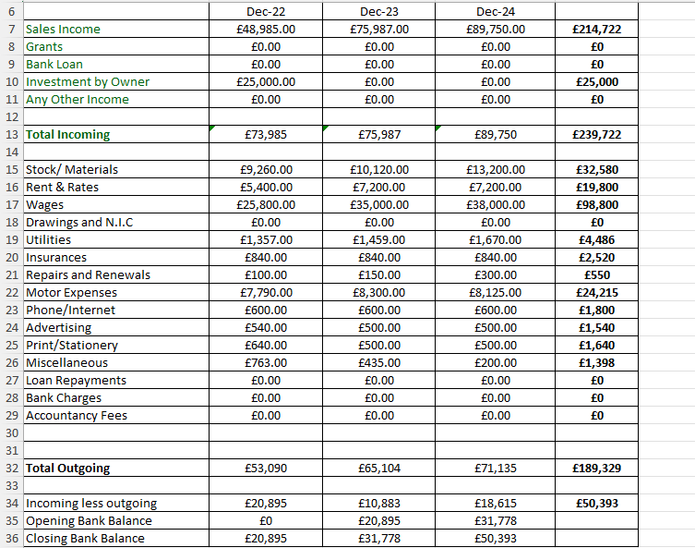

Source: Personal Cash flow forecast produced by author

Cash flow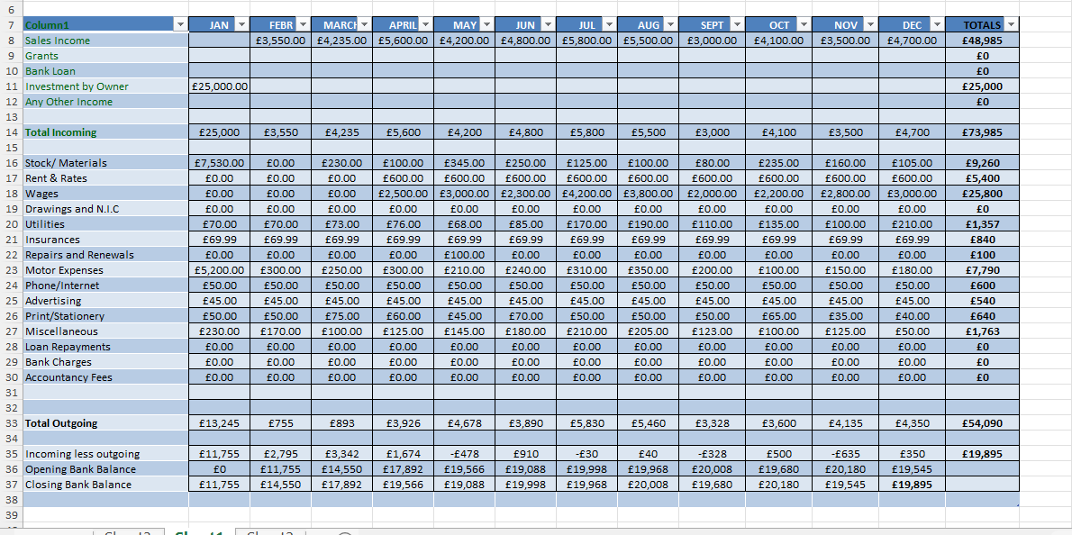
Source: Personal Cash flow forecast produced by author
We projected the monthly revenues based on the busiest holiday seasons, as seen in the image above. Giles (2020) asserts that vacations are the primary reason Brits go abroad, followed by business trips and visits to family and friends. As a result, we would earn more money over the summer, Christmas, Easter, and midterm breaks.
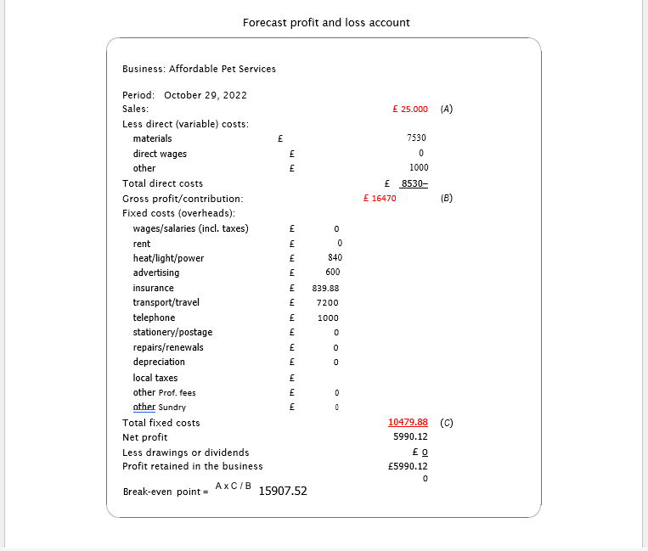
Source: Personal Cash flow produced by author

CONCLUSION:

- Total sales: 25 000
- Fixed cost: materials 7530+wages o +insurance 839.98 +transport 7200 +advertising 600 =16169.98
- Our Break-even point = 25000 (sales) *10479.88 (total fixed cost) / 16470 (sales minus materials) =15907.52
- In the first year our company expect to have a net profit 0f 5990.12

REFERENCES
- Amstrong, G., Adam,S.,Denize ,S.,and Kotler, P. (2014). Principles of marketing .Peearson Australia.
- Bosma, N., Wennekers, S., Guerrero, M., Amoros, J. E., Martiarena, A., & Singer, S. (2013). Global Entrepreneurship Monitor Special Report on Entrepreneurial Employee Activity, Boston: Babson College.
- Drucker, P. F., 1974. Management: Tasks, responsibilities, practices. New York: Harper & Row.
- Drucker, P. F., 1997. Innovation and entrepreneurship: Practice and principles. Oxford: Butterworth-Heinemann
- Mariotti, S., & Glackin, C., (2017). Entrepreneurship: Starting and Operating a Small Business, 4th Edition, Pearson.
- Shane, S. & Venkataraman, S. (2000). The promise of entrepreneurship as a field of research. Academy of Management Review, 25(1), 217-226.
- Tuten, T.L. (2019).Principales of Marketing for a Digital Age.SAGE.
- Ommani, A.R., 2011. Strengths, weaknesses, opportunities and threats (SWOT) analysis for farming system businesses management: Case of wheat farmers of Shadervan District, Shoushtar Township, Iran. African journal of business management, 5(22), pp.9448-9454
- Perera, R., 2017. The PESTLE analysis. Nerdynaut.
- Porter, 1998. Competitive strategy - Techniques for analysing industry and competitors. New York: Free Press.

