Section 2

Introduction
The concepts of OOP in Java are key ideas behind Object-Oriented Programming. There are various types of factors such as abstraction, encapsulation, inheritance, and polymorphism. Generally, the concepts of OOP in Java are used for creating variables and methods and it needs to reuse all the parts which are used without compromising the security as well. The abstraction is used for simple things such as variables, objects, and classes. It also represents the complex data and underlying code. There are various types of practices that are used for keeping the fields more private and it provides the access through the methods of a public class.

Part A - Understanding
1. Definition of Array and its importance in programming
An array is one type of data structure that is used for storing a collection of elements in a fixed size of the same type of data. An array is also used for storing a collection of data but it is more often important as an array which is used as collection of variables of similar type.
Instead of declaring the variables individually, such as number 1, number 2 it needs to declare one variable for array from integer and use it such as number 1[0], number 1[1] for representing the variables individually (Assal and Chiasson, 2018, p. 281). Here, 0, 1, 2 are index values with variable, and those are used to represent the elements individually which are available in the array.
Importance of arrays in programming
- Arrays represent multiple items of data that are similar in type using a single name.
- In arrays, all the elements can be accessed by using the number of indexes randomly.
- Arrays are placed in memory in contiguous memory locations of the memory which is extra and it is being allocated in case of arrays. It avoids of the overflow of memory or memory shortage in arrays.
- Using the arrays, various data structures are implemented as well such as stack, tree, linked list, graphs, queue, and so on.
- An array that has two-dimension is used for representing the matrices.
2. Define inheritance in OOP
Inheritance is one type of mechanism where one class acquires the property of another class. As an example, an inherits of child class traits of a parent. With the application of Inheritance, it can re-use the methods and fields of the existing class. Hence, the inheritance mainly facilitates the reusability of parent class and the major concept of OOPs.
There are mainly five types of Inheritance in Java such as
Single Inheritance
In the single inheritances, one class generally inherits the methods of the basic properties which enable or derived the class (Calefato et al. 2018, p. 1352). It is also used for inherits the behaviors or properties from the parent class which is single. It enables the reusability of code along with new features from the code which exists.

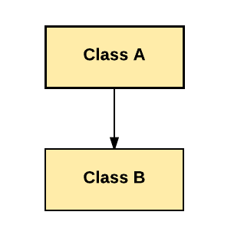
Figure 7: Single Inheritance

As shown from the above diagram, Class B extends only Class A. Class A is parent class or super class and Class B is Child Class or Sub Class.
Multiple Inheritances
In Multiple Inheritance, one class extends to more than one class.
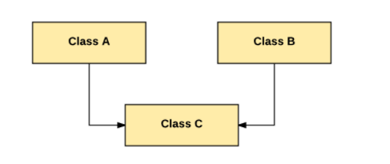
Figure 8: Multiple Inheritances

As shown from the above diagram, Class C extends from both Class A and Class B.
Multilevel Inheritance
When one class is derived from a class, it is also a child class of another super class. Those types are called the Inheritance of Multilevel. As shown in the figure, class B is derived from class A and class C is derived from Class B. In that case, the C class is used for inheritance and implicitly uses the methods and properties of the class.
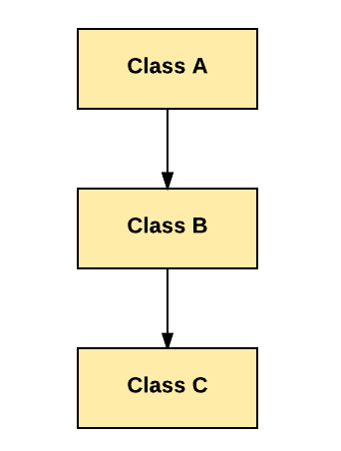
Figure 9: Multilevel Inheritance

As shown from the above figure, Class is derived from Class B, and Class B is derived from Class A.
Hierarchical Inheritance
In the hierarchical Inheritance, many subclasses inherit from one class.
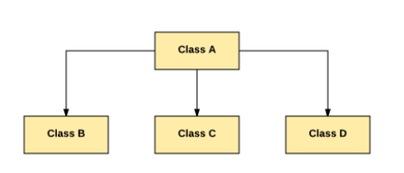
Figure 10: Hierarchical Inheritance

As shown from the above figure, Class A is inherited by Class B, Class C, and Class D.

Hybrid Inheritance
Inheritance of Hybrid is the sum of multilevel inheritance and multiple inheritances. Since the inheritance which is multiple is not supported by java, it goes towards ambiguity (Hoda et al. 2017, p. 60). Therefore, the inheritance is only achieved through the usage of interfaces.
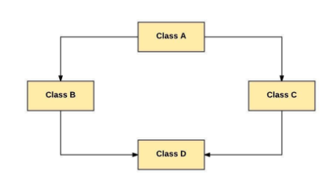
Figure 11: Hybrid Inheritance

As shown from the above figure, protected and public members of Class A are derived into Class D. First, it goes to class B and then D and on the other hand, it goes to class c and then class D.
Inheritance in Java
Java Inheritance is one type of mechanism which mainly used for one class and uses it one another class based on its property. In Java, it establishes the relationship “Is-A” which exists between the classes and needs to use inheritance. The class of parents is used as parent class or super class and the class which is inherited from it, called the child class or subclass. The extends keyword is used for inheriting the values based on its features of the super class.
Inheritance Syntax of Java
class subClass extends superClass
{
//methods and fields
}
Example of Inheritance with Coding
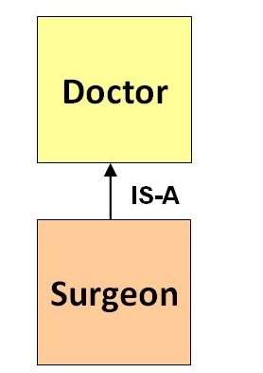
Figure 12: Example of Inheritance

class Doctor {
void Doctor_Details() {
System.out.println("Doctor Details...");
}
}

class Surgeon extends Doctor {
void Surgeon_Details() {
System.out.println("Surgen Detail...");
}
}

public class Hospital {
public static void main(String args[]) {
Surgeon s = new Surgeon();
s.Doctor_Details();
s.Surgeon_Details();
}
}

Part B - Testing
There are three types of popular testing such as Alpha Testing, Beta Testing, and Acceptance Testing.
Alpha Testing
It is the most popular and common testing which is used in the industry of software. The objective for the testing is required for identifying the defects or possible issues before releasing it in the market or for the user (Baltes and Diehl, 2018, p. 187). The alpha testing is mainly carried out at the end of the process of software development but it is implemented before the testing of Beta. Still, there are many minor designs that are made for making a result in testing. The testing of alpha is conducted from the end of the developer and it can use the virtual environment for creating different types of testing as well.
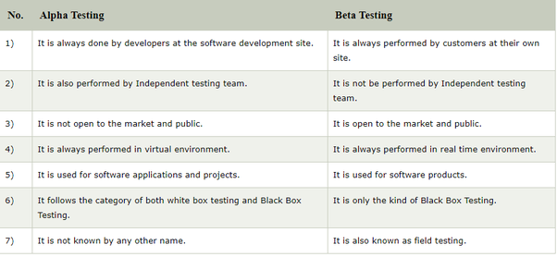
Figure 13: Comparison of Alpha Testing and Beta Testing

Beta Testing
Testing of Beta is generally formal testing of software that is carried out by the customer. It mainly performs on Real Environment before product releasing to market for end-users which are in actual (Alahyari et al. 2017, p. 71). The testing of Beta mainly carried out for ensuring that there are not any vital failures in the product or software. After that, it also checks whether it is achieving the requirements of business from the perspective of end-user or not.
Acceptance Testing
An Acceptance Testing is mainly performed by the client and it also verifies whether it is giving end to end flow of system or not (Lindsjørn et al. 2016, p. 274). The client also accepts the testing of software when there are various functionalities and features are used as expected. It is the final phase of testing and after that, software or product goes into production. It is called acceptance testing.

Part C - Implementation
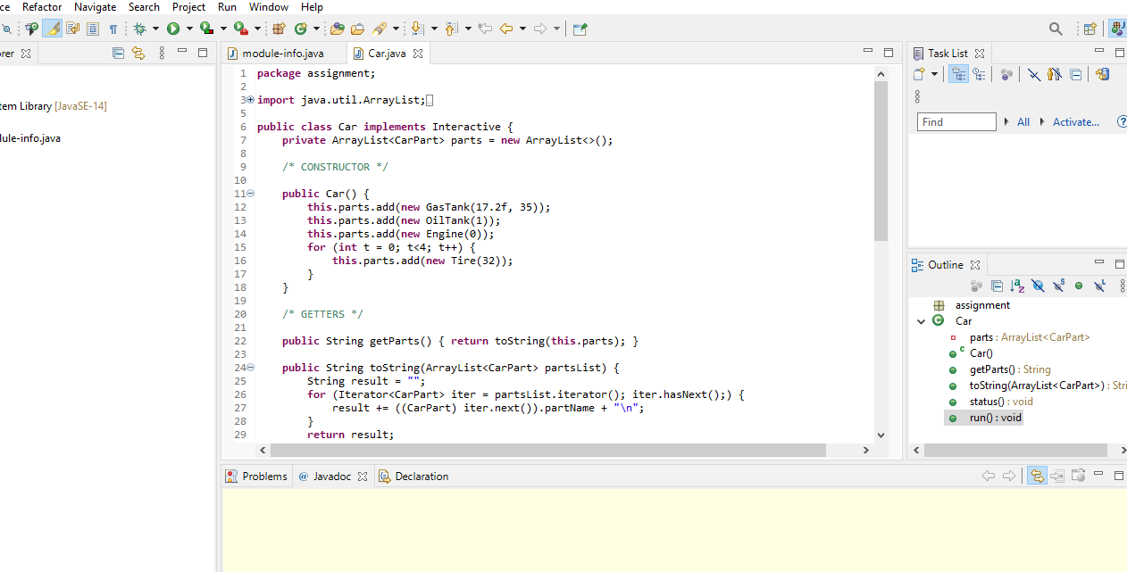
Figure 14: Execution of Car Classes and Methods

As shown from the above figure, the classes are built using the concept of OOPs and it allows the care which needs to be constructed and represent the computer. Various methods are used and it also contains the data such as VRN which is Vehicle Registration Number, model, Manufacturer, No. of Sets, Power, Type, and so on (Sedano et al. 2017, p. 130). Those are also contained by creating class functions and it meets all the criteria such as forwards, backward, speed of the vehicle, and so on.
Source Code
package Car;

import java.util.ArrayList;
import java.util.Iterator;

public class Car implements Interactive {
private ArrayList<CarPart> parts = new ArrayList<>();

/* CONSTRUCTOR */

public Car() {
this.parts.add(new Manufacturer Ford(17.2f, 35));
this.parts.add(new Model -Kuga(1));
this.parts.add(new Engine 1500cc(0));
for (int t = 0; t<4; t++) {
this.parts.add(new Tire(32));
}
}

/* GETTERS */

public String getParts() { return toString(this.parts); }

public String toString(ArrayList<CarPart> partsList) {
String result = "";
for (Iterator<CarPart> iter = partsList.iterator(); iter.hasNext();) {
result += ((CarPart) iter.next()).partName + "\n";
}
return result;
}

As shown from the above code, first it needs to make a package of Car. After that, it needs to type the command: import java.utill.ArrayList; and create a public class for implementing the functions as per requirements. The array list is declared which is in the next line and using the values which are provided such as add the manufacturer which is Ford, add name of model which is Kuga, add new engine which is of 1500 cc. Coming to the next part of the program, the public strings are used for getting the parts and it also returns to the string for measuring the result. It mainly uses the values from which those can make them part of array list and the result of string is also generated (Abrahamsson et al. 2017, p. 10). The generated results are used for declaring the value of the parts which are mainly the part of item and use the iterate for using the status as well. It needs to use the run command as well which generates the floating value and uses the size which is also required in it.
Public void run() {
try {
do {
float miles = getFloat("How many miles are you driving?");
OilTank oTank = null;
Engine engine = null;
for (int p = 0; p<parts.size(); p++) {
parts.get(p).function(miles);
if (parts.get(p).partName == "oil tank") { oTank = (OilTank) parts.get(p); }
if (parts.get(p).partName == "engine") { engine = (Engine) parts.get(p); }
}
oTank.setEngineAgeModifier(1 + (engine.getLifeInMinutes() / engine.getBestCondition()));
} while (getBoolean("Keep driving?"));
this.status();
} catch (CarCrashException e) {
System.out.println(e.getMessage());
System.out.println("Your car crashed! You'll have to buy a new one and start over.");
} finally {
System.out.println("Thank you for driving responsibly.");
}
}
}

As shown from the next part of the code, it declares the void run function and it is used for generating the float and declares about the miles which are achieved. It needs to make declare the function and variable as per the required size. After that, it gives the boolean function which can be used as the modifier and needs to give the Boolean function as well.

Conclusion
In section 2 of the report, the definition of the array, as well as its explanation, is given based on the importance. For defining the inheritance of OOP, suitable coding is provided which demonstrates the answer of researcher. In part B, the short essay is delivered for explaining 3 popular testing models. The comparison and contrast between them are also discussed briefly. In the final part, a java program is constructed which represents a car. The required methods and classes are used for representing and constructing the values which are outline. Additionally, sample code is provided along with its detailed discussion, Furthermore, all the required methods are developed using Java Eclipse such as Backwards, Forwards, Speed of Vehicle, and so on. All the commands are executed successfully without any issues.

References
Abrahamsson, P., Salo, O., Ronkainen, J. and Warsta, J., 2017. Agile software development methods: Review and analysis. arXiv preprint arXiv:1709.08439.
Alahyari, H., Svensson, R.B. and Gorschek, T., 2017. A study of value in agile software development organizations. Journal of Systems and Software, 125, pp.271-288.
Assal, H. and Chiasson, S., 2018. Security in the software development lifecycle. In Fourteenth Symposium on Usable Privacy and Security ({SOUPS} 2018) (pp. 281-296).
Assal, H. and Chiasson, S., 2018. Security in the software development lifecycle. In Fourteenth Symposium on Usable Privacy and Security ({SOUPS} 2018) (pp. 281-296).
Baltes, S. and Diehl, S., 2018, October. Towards a theory of software development expertise. In Proceedings of the 2018 26th acm joint meeting on european software engineering conference and symposium on the foundations of software engineering (pp. 187-200).
Baltes, S. and Diehl, S., 2018, October. Towards a theory of software development expertise. In Proceedings of the 2018 26th acm joint meeting on european software engineering conference and symposium on the foundations of software engineering (pp. 187-200).
Calefato, F., Lanubile, F., Maiorano, F. and Novielli, N., 2018. Sentiment polarity detection for software development. Empirical Software Engineering, 23(3), pp.1352-1382.
Calefato, F., Lanubile, F., Maiorano, F. and Novielli, N., 2018. Sentiment polarity detection for software development. Empirical Software Engineering, 23(3), pp.1352-1382.
Cosentino, V., Izquierdo, J.L.C. and Cabot, J., 2017. A systematic mapping study of software development with GitHub. IEEE Access, 5, pp.7173-7192.
Hoda, R., Salleh, N. and Grundy, J., 2018. The rise and evolution of agile software development. IEEE software, 35(5), pp.58-63.
Hoda, R., Salleh, N., Grundy, J. and Tee, H.M., 2017. Systematic literature reviews in agile software development: A tertiary study. Information and Software Technology, 85, pp.60-70.
Kuhrmann, M., Diebold, P., Münch, J., Tell, P., Garousi, V., Felderer, M., Trektere, K., McCaffery, F., Linssen, O., Hanser, E. and Prause, C.R., 2017, July. Hybrid software and system development in practice: waterfall, scrum, and beyond. In Proceedings of the 2017 International Conference on Software and System Process (pp. 30-39).
Lei, H., Ganjeizadeh, F., Jayachandran, P.K. and Ozcan, P., 2017. A statistical analysis of the effects of Scrum and Kanban on software development projects. Robotics and Computer-Integrated Manufacturing, 43, pp.59-67.
Lindsjørn, Y., Sjøberg, D.I., Dingsøyr, T., Bergersen, G.R. and Dybå, T., 2016. Teamwork quality and project success in software development: A survey of agile development teams. Journal of Systems and Software, 122, pp.274-286.
Sedano, T., Ralph, P. and Péraire, C., 2017, May. Software development waste. In 2017 IEEE/ACM 39th International Conference on Software Engineering (ICSE) (pp. 130-140). IEEE.
Sedano, T., Ralph, P. and Péraire, C., 2017, May. Software development waste. In 2017 IEEE/ACM 39th International Conference on Software Engineering (ICSE) (pp. 130-140). IEEE.

