BMIH6007
International Meetings Management for the
Hotel Industry

Student id: 2127382
Student name: Adrian Grigore
Lecturer: Kathryn Flynn

Slide 1

Slide 2

Ours is an age of modern technology. We don’t think of a single day without science or technology. The impact of science is visible in the fields of tourism, travel and hospitality industry. So, there arises a need to be adjusted with updated technology to offer premium service and ensure the satisfaction of the customers. The hospitality industry arranges many conferences from time to time to discuss and implement modern technical issues in their respective places. So, the feasibility analysis of these meetings is needed to understand whether the upgrade with recent technology will be fruitful or not. The feasibility test will conduct the cost-benefit analysis to predict the probable profit or loss and then take enough measures to bring adjustments in the planning (Das, 2023). Here, the “Customizable Comforts Conference” feasibility plan is analyzed. This plan will especially give importance to guest personalization with the help of innovation and technology. The conference will display and propose a cutting-edge mobile app that will allow guests to customize their room’s facilities like temperature, lighting, entertainment, etc. before arriving in the hotels. Besides, the plan will analyze market factors, operational factors and financial factors with revenue and sponsors sources with the meeting’s profit possibility.

Slide 3

Situational Analysis and Research
Market Factors: Here the target audiences, possible demands and supply of the services and competition among rivals will be analysed.
Target Market: The meeting will target hotel owners, CEOs, CFOs, CMOs, COOs, Board of Directors, hotel chains, different hotels, motels, resorts, etc. (Morritt & Weinstein, 2022). Moreover, it will provide h-tech companies which have developed specialized mobile apps. In this regard, persons with special knowledge about engineering, technology, designing, and developing technology should be invited. Probable investors and funders must be invited to attract them and seek seed funds. Besides, consultants, advisors, and representatives of different customer groups can be targeted to attend the conference.
Demand: Public demand is changing very rapidly in recent days. With the increment in livelihood, lifestyle and circumstances, demand is being enhanced (Ezeh, 2017). The hospitality sector is facing a very growing guest demand. People want more services and facilities with customization. The customization demand is visible in the computer industry. For example, Dell is dedicated to offering different types of computers based on customers’ needs or provides customization. So, it is proven that people are very much prone to customization. Recent technological upgrades in smartphones, smart homes and wearables specify that people like customization (Lei et al., 2019). They choose phones based on their preferred colours, design, accessibility etc. So, it is assumed that people will like an app that will provide personalization. People nowadays prefer tolerable temperatures, entertainment and adjustable lighting when spending their vacation in any resort or hotel (Lock, 2019). So, the mobile app providing customization facilities will be highly demandable and therefore, the meeting will be a success.

Slide 4

Supply: Conferences or meetings are being arranged from time to time focusing on technology in the hospitality sector. However, there are hardly any conferences that give importance to adjusting or implementing the effect of technology on customer personalization before their arrival. So, the proposed meeting will mitigate the potential gap between customer preferences and hotels’ services (Bilgihan, 2016). As a result, the supply or outcome of the conference will be a unique and relevant idea.
Competition: There are many hospitality concerning companies in the UK. However, few are focusing on customer customization during vacation. That means that few companies don’t like technology-oriented services and they have a gut feeling about traditional hotel services. So, the proposed conference will appear as a niche topic. It has to compete with traditional hospitality companies. The proposed service will differentiate itself from traditional hotel services and will showcase its services as trending and customer-oriented services (Bharwani & Mathews, 2021). It will also open up an opportunity to make partnerships with existing hospitality companies and will reach a broader audience.

Slide 5
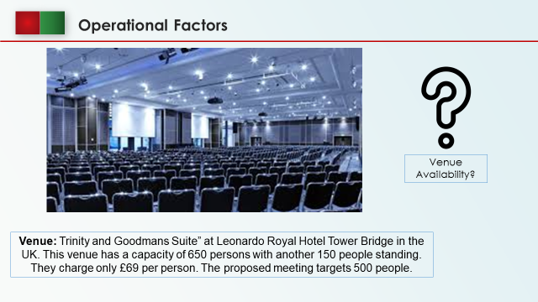
Operational Factors
Here, the probable date of the conference, audience number, venue capacity and availability on the date, necessary skills, resources, staff and other facilities will be analysed to ensure the smooth arrangement of the conference (MacCarthy & Atthirawong, 2023).
Venue: A well-equipped, modern and resourceful conference centre should be booked to arrange the meeting (Van Maasakkers & Oh, 2020). Considering all these issues, Dubai, Las Vegas or Singapore can be considered to organize the conference as these cities are equipped with innovation and much hospitality. However, the customers are the main targets of the meeting. So, their comfort, transportation, timing etc. should be considered when selecting the venue as some of the representatives will attend the meeting (Iwamoto et al., 2010). The English people are dedicated to taking advantage of these hospitality services. They spend a lot of time in spending their vacation in various cities. So, a venue can be selected in the UK to reduce their hassle. So, the feasibility plan of the meeting suggests the “Trinity and Goodmans Suite” at Leonardo Royal Hotel Tower Bridge. This venue has a capacity of 650 persons with another 150 people standing. They charge only £69 per person. So, this venue will be feasible for this meeting as the meeting targets 500 people. This venue is near the railway station and also the airport. From any place, anybody can get there by car easily.
Venue Availability: The meeting is proposed to be held in June-July, 2025. So, the venue should be booked 13-14 months in advance to ensure the availability and smoothness of the meeting. To do this, the online calendars of the hotel should be followed and the convenors should contact the reception or sales department regularly to secure venue availability. The requirements of seats, necessary facilities, resources, staff, lighting, technical equipment, and necessary machinery for presentations, catering and other services should be confirmed (Gibbs et al., 2016).

Slide 6
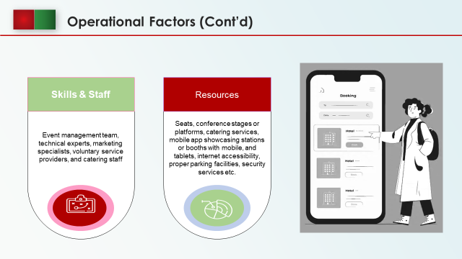
Skills & Staff: For the proper functioning of the conference, multiple skills are needed. For example, technical expertise is a must to showcase the mobile app, its accessibility, facilities and advantages to the guests. In addition, presentation equipment like microphones, projectors, screens, speakers etc. must be available. To inform them about the meeting to the targeted audience, vast advertising and marketing are necessary. Beautiful presentation of the booths, information providing booths, and voluntary services should be provided. Catering and hospitality should be the top-most attraction with the main target showcasing a cutting-edge mobile app to the invitees (Tomislav et al., 2020). For these services, well-qualified staff must be available. Best hi-tech companies with popularity in technical expertise and companies with the best customisation facilities for customers through their technologies should be invited. The event management team, technical experts, marketing specialists, voluntary service providers, and catering staff can ensure the mentioned services in the proposed meeting (Haase & Davis, 2017).
Resources: Common resources are seat availability, furniture, conference stages or platforms, catering services, audio-visual equipment, mobile app showcasing stations or booths with mobile, and tablets, internet accessibility, proper parking facilities, security services etc. (Schütter, 2021). The demonstration of the mobile app should be easier and if possible invitees should be allowed to use the app in hand to understand the advantages of this app for pre-booking of the hotels.
By analysing all these sub-points under operational factors, “Trinity and Goodmans Suite” is a good choice where these services and resources can be properly ensured.

Slide 7
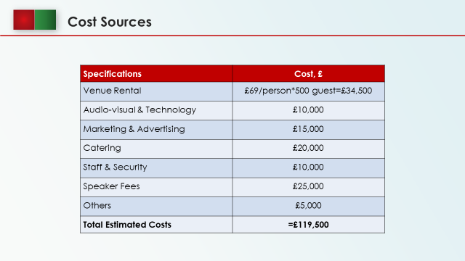
Financial Factors: Among all the factors, the financial factor is the most important as it identifies the quantitative advantage or disadvantage of an event (Darroch et al., 2016). It indicates whether a conference to launch a unique system in the favour of customers will be a profit or loss. It considers the revenue sources, costs and funding sources as well as the profit margin.
Venue Rental: This is based on the average conference pricing and per-head cost of the venue. It is seen that the per-head seat cost is £69. So, the total venue rental is £34,500.
Audio-visual & Technology: This includes presentation materials and mobile app display stations (Bovenberg et al., 2017). The estimated cost is £10,000.
Marketing & Advertising: Advertising, press release, promotion and social media marketing on the conference to inform all will cost £15,000.
Catering: Meals, lunch, snacks, and welcome drinks will cost £20,000 for all the invitees.
Staff & Security: To provide all the services, security, management and coordination, the salaries and commissions to be offered to the staff are estimated to be £10,000.
Speaker Fees: To facilitate the keynote speakers and VVIP guests with some remuneration and travel allowance £2500 will be expensed.
Others: Last of all, some miscellaneous cost is estimated to be occurred. For this, £5,000 will be kept aside as a buffer for unforeseen costs.
So, the total estimated cost by the summation of these costs is £119,500.

Slide 8
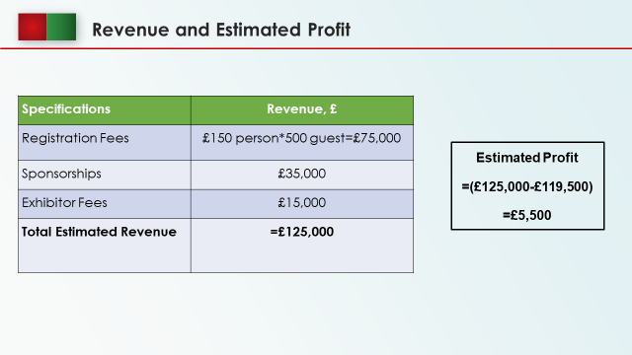

Revenue and Estimated Profit
Registration Fees=£150 person*500 guest= £75,000
Sponsorships=£35,000
Exhibitor Fees=£15,000
Total Estimated Revenue= (£75000+£35,000+£15,000) = £125,000
Estimated Profit=£125,000-£119,500=£5,500

Slide 9
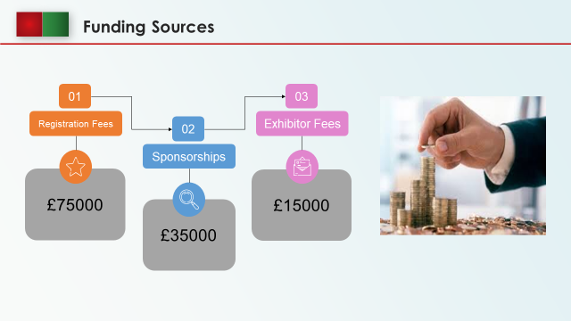
Funding Sources
As it is a combined program of hotel owners, the hospitality industry, technological integration companies as well as customers, so, funds should be jointly collected from all of them to get the full advantages from the success of the meeting. These sources are-
Registration Fees: Initially, the number of invitees (representatives, investors, speakers, academicians, journalists etc.) is estimated to be 500. The overhead registration fee will be charged £150 per person to offer them premium services, facilities and hospitality. So, it will generate £75,000.
Sponsorships: Hotel owners, boards of directors, h-tech companies, resort owners, and hotel chains will likely contribute as sponsors (Currie et al., 2019). They will sponsor the sessions, network events, marketing, booths etc. For this, the initial amount is predicated as £35,000.
Exhibitor Fees: The hi-tech companies and technical expert companies will showcase their unique mobile app, display the features and inform the guest about the available personalization of the room ambience like lighting, entertainment and temperature (Sen & Durfee, 2018). If the guests are convinced of the characteristics, they will likely invest in the proposed technology. Besides, the customers will want to take the facilities of these industries more than traditional hospitality companies. So to get future benefits, the exhibitor should donate initially and the amount is predicted to be £15,000.

Slide 10
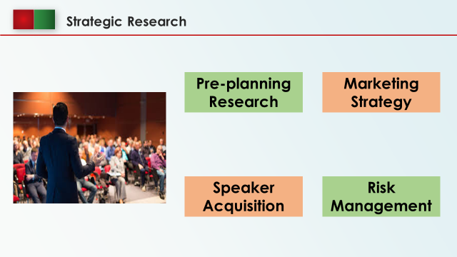
Pre-planning Research: Before the execution of the conference, guest preferences, trends, competitors’ strengths and weaknesses, interests of the target market etc. must be researched and analysed (Schlentrich, 2018).
Marketing Strategy: A brand identity for international meetings, industry publications, magazines, travel blogs, a user user-friendly website, collaboration with travel agencies etc. can be taken as a promotional strategy and activity (Rogers & Davidson, 2015).
Speaker Acquisition: Renowned speakers like CEOs from hotel chains, h-tech companies, successful hotel owners, technology developers, industry etc. can be invited and for this, a thorough analysis is needed to identify the best speakers.
Risk Management: Strategic research is also necessary to develop a contingency plan for low registrations, technical glitches, and other random issues (Montgomery & Strick, 2010).

Slide 11
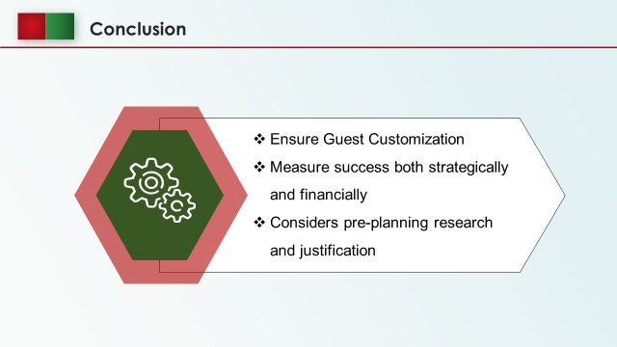
Conclusion
Customizable Comforts Conference will provide an opportunity to integrate technology and hospitality in guest customization in pre-booking conditions. The feasibility plan analyses the quantitative and qualitative aspects and measures the success of the conference. Moreover, the feasibility plan considers other pre-planning factors like marketing, risk managing, competitiveness etc. to indicate the fruitfulness of an event.

Slide 12
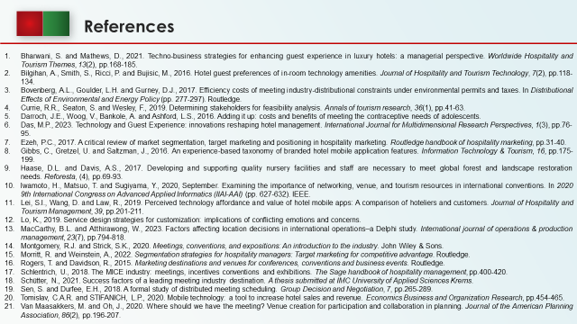
- Bharwani, S. and Mathews, D., 2021. Techno-business strategies for enhancing guest experience in luxury hotels: a managerial perspective. Worldwide Hospitality and Tourism Themes, 13(2), pp.168-185.
- Bilgihan, A., Smith, S., Ricci, P. and Bujisic, M., 2016. Hotel guest preferences of in-room technology amenities. Journal of Hospitality and Tourism Technology, 7(2), pp.118-134.
- Bovenberg, A.L., Goulder, L.H. and Gurney, D.J., 2017. Efficiency costs of meeting industry-distributional constraints under environmental permits and taxes. In Distributional Effects of Environmental and Energy Policy (pp. 277-297). Routledge.
- Currie, R.R., Seaton, S. and Wesley, F., 2019. Determining stakeholders for feasibility analysis. Annals of tourism research, 36(1), pp.41-63.
- Darroch, J.E., Woog, V., Bankole, A. and Ashford, L.S., 2016. Adding it up: costs and benefits of meeting the contraceptive needs of adolescents.
- Das, M.P., 2023. Technology and Guest Experience: innovations reshaping hotel management. International Journal for Multidimensional Research Perspectives, 1(3), pp.76-95.
- Ezeh, P.C., 2017. A critical review of market segmentation, target marketing and positioning in hospitality marketing. Routledge handbook of hospitality marketing, pp.31-40.
- Gibbs, C., Gretzel, U. and Saltzman, J., 2016. An experience-based taxonomy of branded hotel mobile application features. Information Technology & Tourism, 16, pp.175-199.
- Haase, D.L. and Davis, A.S., 2017. Developing and supporting quality nursery facilities and staff are necessary to meet global forest and landscape restoration needs. Reforesta, (4), pp.69-93.
- Iwamoto, H., Matsuo, T. and Sugiyama, Y., 2020, September. Examining the importance of networking, venue, and tourism resources in international conventions. In 2020 9th International Congress on Advanced Applied Informatics (IIAI-AAI) (pp. 627-632). IEEE.
- Lei, S.I., Wang, D. and Law, R., 2019. Perceived technology affordance and value of hotel mobile apps: A comparison of hoteliers and customers. Journal of Hospitality and Tourism Management, 39, pp.201-211.
- Lo, K., 2019. Service design strategies for customization: implications of conflicting emotions and concerns.
- MacCarthy, B.L. and Atthirawong, W., 2023. Factors affecting location decisions in international operations–a Delphi study. International journal of operations & production management, 23(7), pp.794-818.
- Montgomery, R.J. and Strick, S.K., 2020. Meetings, conventions, and expositions: An introduction to the industry. John Wiley & Sons.
- Morritt, R. and Weinstein, A., 2022. Segmentation strategies for hospitality managers: Target marketing for competitive advantage. Routledge.
- Rogers, T. and Davidson, R., 2015. Marketing destinations and venues for conferences, conventions and business events. Routledge.
- Schlentrich, U., 2018. The MICE industry: meetings, incentives conventions and exhibitions. The Sage handbook of hospitality management, pp.400-420.
- Schütter, N., 2021. Success factors of a leading meeting industry destination. A thesis submitted at IMC University of Applied Sciences Krems.
- Sen, S. and Durfee, E.H., 2018. A formal study of distributed meeting scheduling. Group Decision and Negotiation, 7, pp.265-289.
- Tomislav, C.A.R. and STIFANICH, L.P., 2020. Mobile technology: a tool to increase hotel sales and revenue. Economics Business and Organization Research, pp.454-465.
- Van Maasakkers, M. and Oh, J., 2020. Where should we have the meeting? Venue creation for participation and collaboration in planning. Journal of the American Planning Association, 86(2), pp.196-207.

