Assignment 1: Site Production and Project Management (M5X01875) – Submission 2: SA1 Swansea Project
Contents
Introduction 1
Techniques 1
Discussion (550 words) 2
Conclusion 2
Bibliography 2
Gantt Chart - Estimation Cost of Weeks 1 - 18 4
Gantt Chart - Week 1 - 3 5
Gantt Chart - Week 4 - 10 6
Gantt Chart - Week 11 - 17 7
Gantt Chart of Week 18 including Labourers and Estimated Budget also a compressed Gantt Chart of the entire Project 8

Introduction
Programming is an important aspect and system that is used widely in the construction industry. And a Gantt chart is one of the most popular and useful ways of showing activities/tasks displayed against time. First established in the mid-1890’s after the interest in new management ideas and techniques to help time work correctly. At a glance from a simple Gantt chart it is possible to see all activities to be carried out, when they will start and should finish including the duration of every task, also if any activities may be overlapping each other to ensure a smooth completion and finally the start and end date of the entire project which is essential and important. (Gantt.com, 2018)
To ensure any construction project is successful there are many programmes that must be in place before building can commence on site such as a time programme of the project. There are many factors and techniques that must be considered, all will be covered in the following document including a small residential project Gantt chart.

Techniques
With a wide range of techniques and software available to choose from to create Gantt charts, it is important that the right application is chosen, the following are available to use:
- Microsoft Project - Known as a project manager software product, developed and designed to assist project managers in creating a plan, assigning resources to activities/tasks, tracking the process of work and the ability to manage the budget and analyse workloads.
- Microsoft Excel – A well known software used for many aspects to place data and create a template or area for work to be organised and presentable.
- Oracle Primavera Project Plan – like Microsoft project this software includes project management, product management, collaboration and control capabilities tools to enable a project manager to combine all documents and aspects together into one database.
- Mindview Business Edition – a professional min mapping software that allows project managers and other member of a construction team to visually brainstorm, organise and present ideas.
- Asta Powerproject – well known software enables the user to create Gantt charts for project management especially in the construction field. One main feature it contains is the risk identification, a quantitative and qualitative risk analysis can be set up, to identify any risks and anticipate them before they can occur.
Throughout this assignment a wide range of skills were required to ensure that all aspects were covered to ensure that the Gantt chart was complete and up to date with everything. The knowledge to add certain tasks and link in with how many days were required to ensure the work was completed on time and significantly can the work be done. The ability to identify areas in which needed to be adapted to ensure that all activities are able to be completed in the timescale given.

Discussion
The assignment required a Gantt chart to be created, containing all the different activities and tasks needed to be made for the construction of the semi detached dwelling drawings issued. Using the SPON’s Architects’ and Builders’ Price Book of 2015 as a reference to indicate all the tasks that were needed to complete the project. From there on an estimated price of these tasks were made on scrap paper, and then calculated with the total number of labourers required to complete and this task estimated cost was established.
Originally the Gantt chart was to be created on the Asta Powerproject software which was available at university, unfortunately due to the cost of the software and unable to use frequently in the university the use of Microsoft Excel was needed, although it wasn’t to the same standard as the Asta Powerproject software, it created a draft of the proposed work and tasks to be completed and the time scale required.
After several attempts a final draft of the Gantt chart was made, with a total of 18 weeks of proposed work at an estimated cost of nearly over £220,000, all established from the SPON’s book and the knowledge on how long and how big the build will be. Pages 4 to 6 of the report show the Gantt chart created of the day to day activities and a similar chart in page 3 containing the proposed week by week work and the estimated cost of every week and month from the beginning of the project. Excel was a great software to use and allowed links to be made with the ability to change date and automatically update in the chart using simple formulas and equal too solutions.
From the results obtained, a project of this scale and magnitude will take a long time and will require a lot of focus to ensure that all aspects are completed on time and to the required legislative standards currently in place. With a clear view of the critical path from the final draft a possibility to adapt the chart can be made to ensure that certain things are done simultaneously.

Conclusion
Throughout the assignment it has become clearer that time management, organisation and determination is essential to a projects success. With the ability to create Gantt chart and analyse the progress of work and work on key areas is vital to the survival of a project and everyday is a new and different day that will bring something to solve with the possibility of consequences to time lost or shortage of materials.
Without these software’s giving the ability to monitor and control a projects time programme a high percentage of projects would take months if not years to be completed without, which shows that the organisation at the beginning of a project is the key to the survival and completion of a build. In the future the use of Asta Powerproject will be much greater or even Microsoft Project as they have many tools that allow relationships to be made and combine information for the project together all in one place. Considerations to be made in the future, the possibility of overlapping more tasks to reduce the overall duration of the project and assign appropriate lead times.

Bibliography
AECOM, 2015. Spon’s Architects' and Builders' Price Book 2015. 114th ed. s.l.:AECOM.
Gantt.com, 2018. Gantt.com. [Online]
Available at: http://www.gantt.com/
Manning, F., 2015. My Top 5 new Microsoft Project 2016 Client Features from the Microsoft Ignite Conference. [Online]
Available at: https://www.brightwork.com/blog/my-top-5-new-microsoft-project-2016-client-features-from-the-microsoft-ignite-conference#.Wpgr9ujFLIU
Microsoft, 2018. What's new in Project 2013. [Online]
Available at: https://support.office.com/en-us/article/what-s-new-in-project-2013-1d223a6e-9e54-4c42-a79b-6df1fa59f5f0?ocmsassetID=HA102749523&CorrelationId=81174b4b-addc-4863-a294-e7ce1276a538&ui=en-US&rs=en-US&ad=US
Rodriguez, J., 2017. Learn How to Prepare a Gantt Chart for a Project. [Online]
Available at: https://www.thebalance.com/what-is-a-gantt-chart-844535

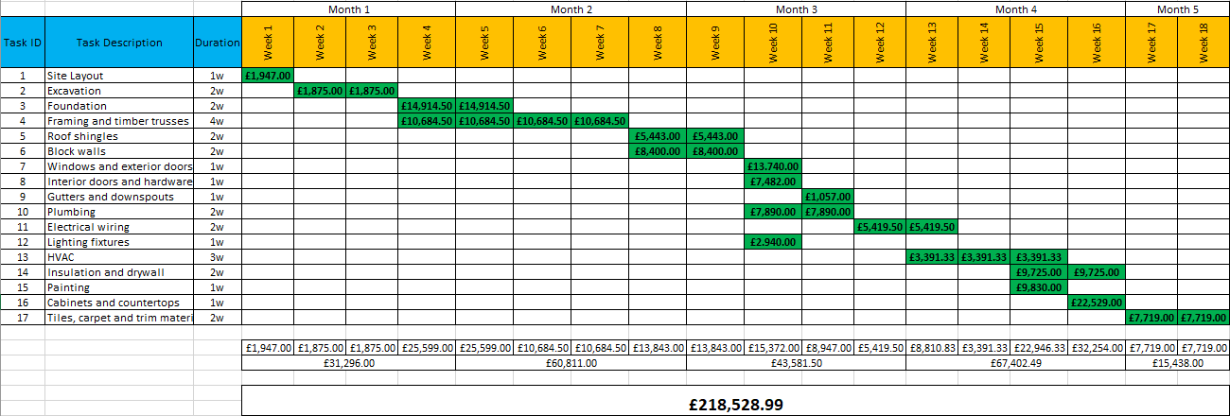
Gantt Chart - Estimation Cost of Weeks 1 - 18

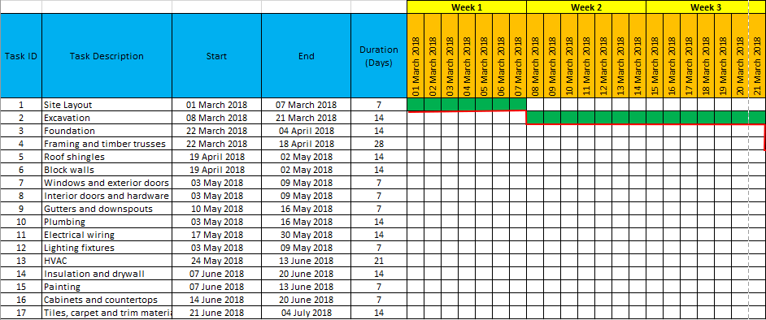
Gantt Chart - Week 1 - 3

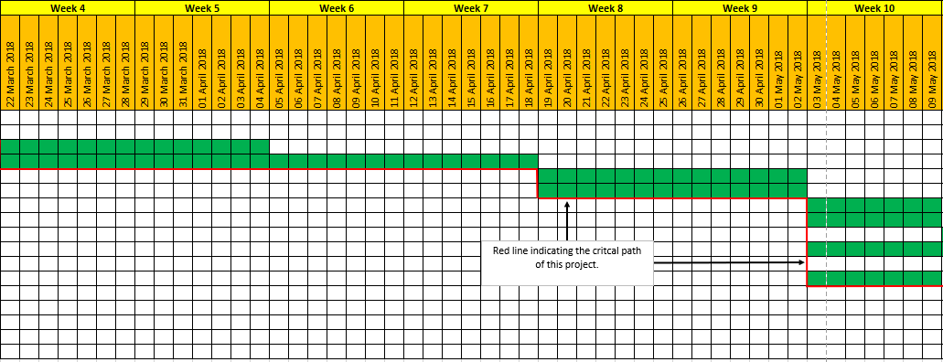
Gantt Chart - Week 4 - 10

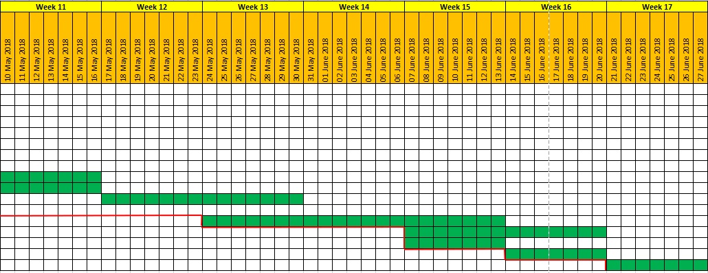
Gantt Chart - Week 11 - 17

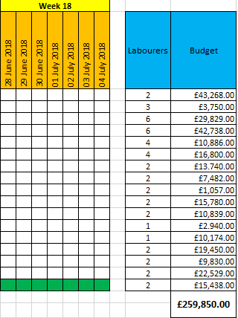
Gantt Chart of Week 18 including Labourers and Estimated Budget also a compressed Gantt Chart of the entire Project

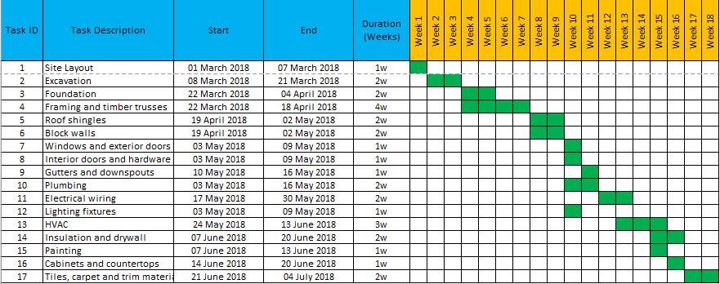
Gantt chart introducing the week by week activities including their proposed start and finish dates.

