Configure and manage Virtualised Network
Nicholas Gelstharp (2211042)
Network Operating Systems and Services

Contents

Task One: 2

Swansea Network
1.1: Installation of Routing and Remote Access Service:
Screenshot showing the installation of the servers on the server
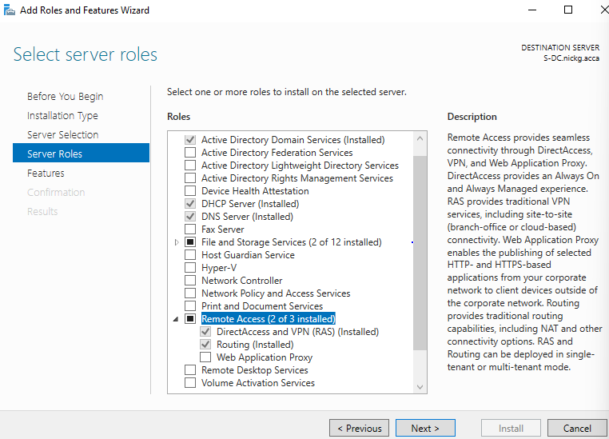
1.1: Modification of Firewall rules to allow ICMP Traffic:
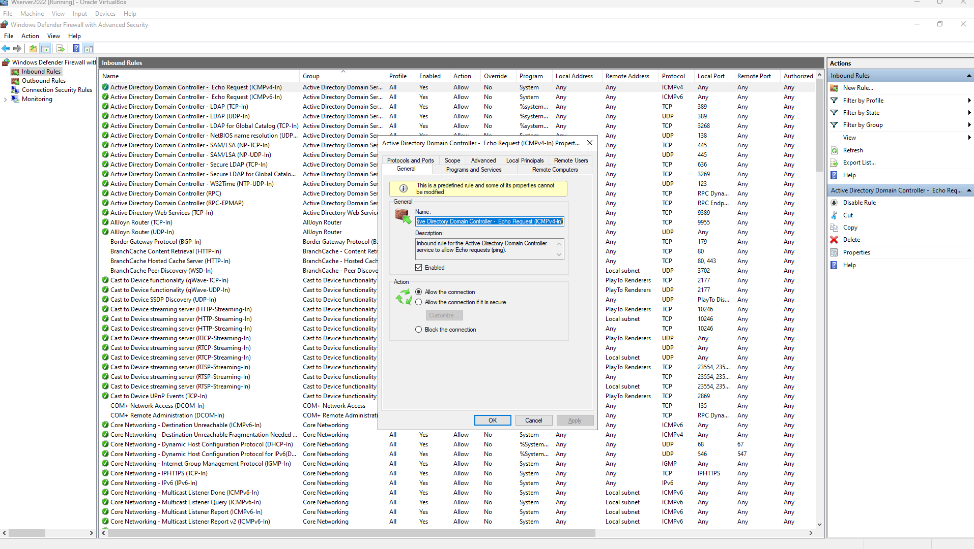
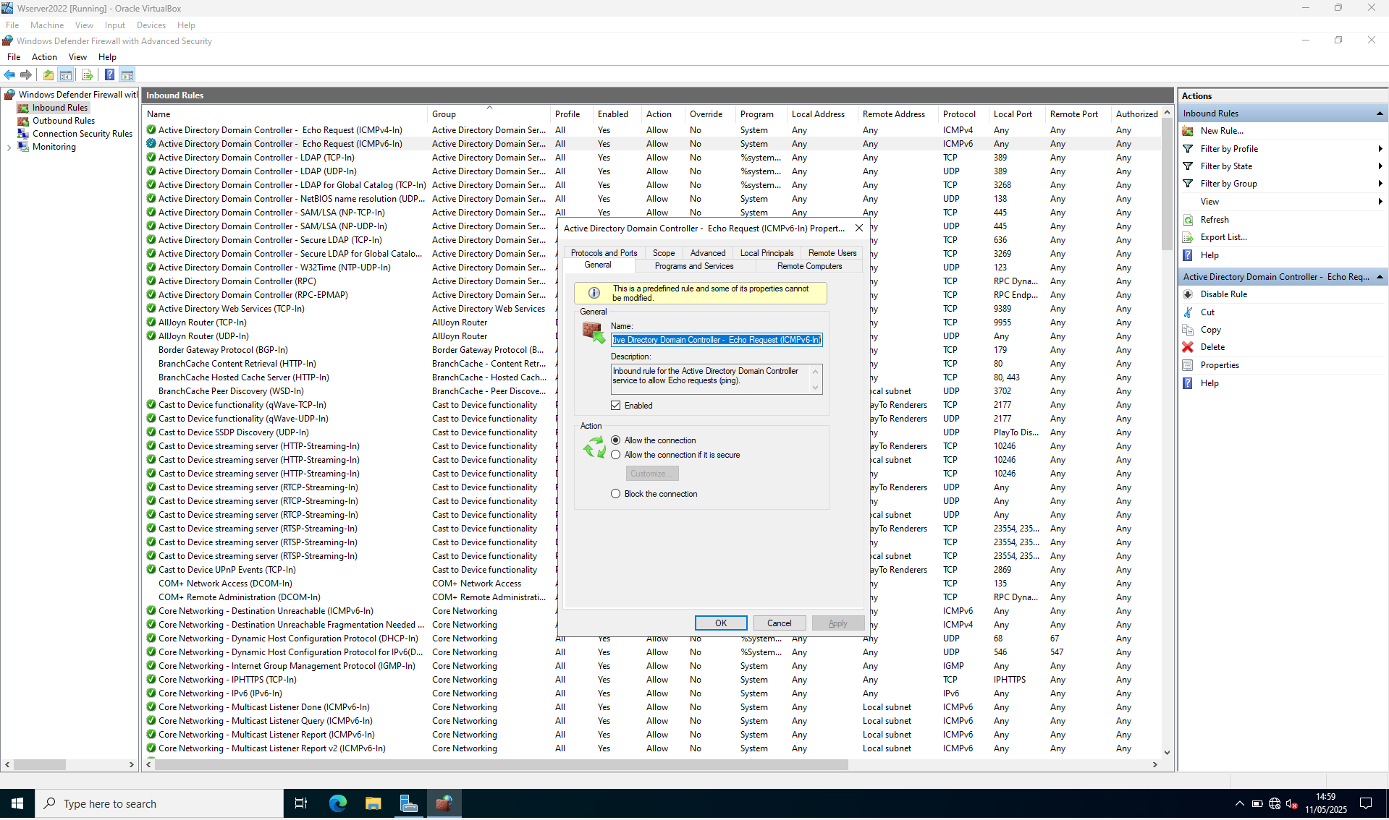
1.2: Site to site VPN
I was unable to complete this
1.3: Creation of forest
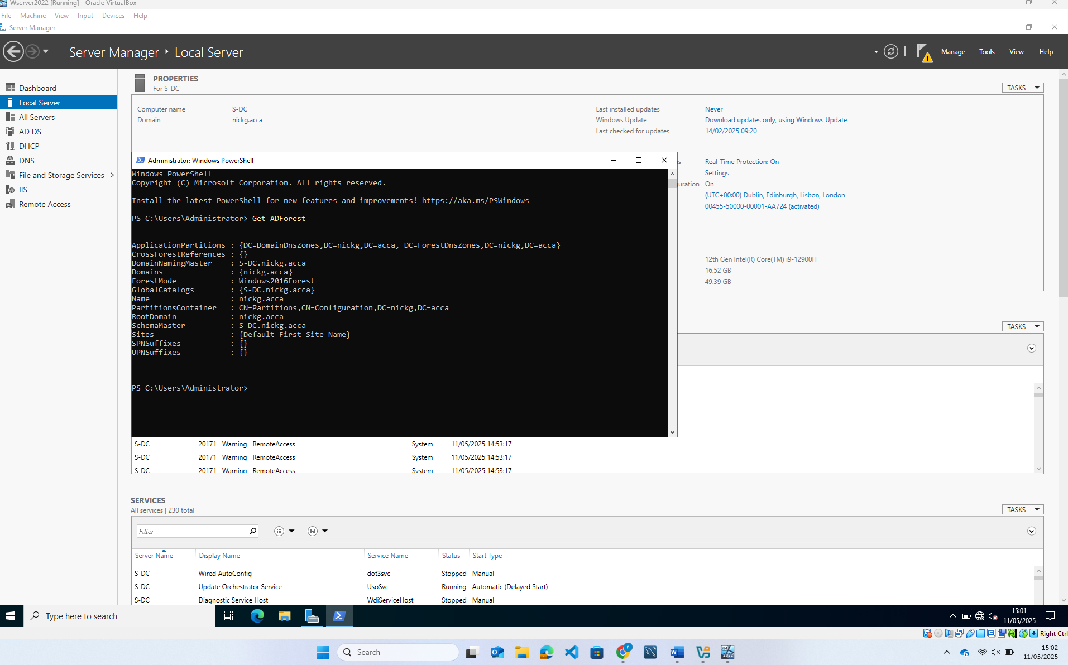
1.4: Creation of A Records for all servers
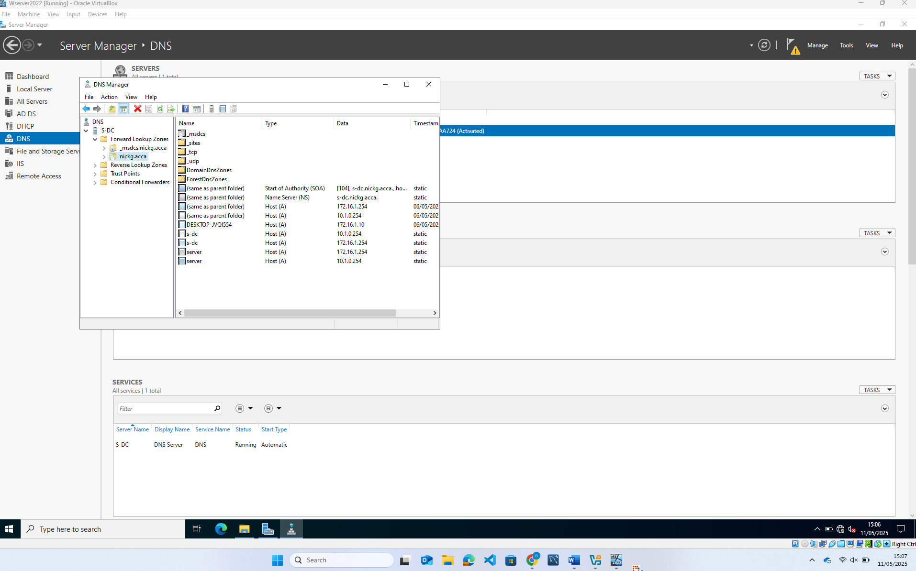
1.5: PTR records
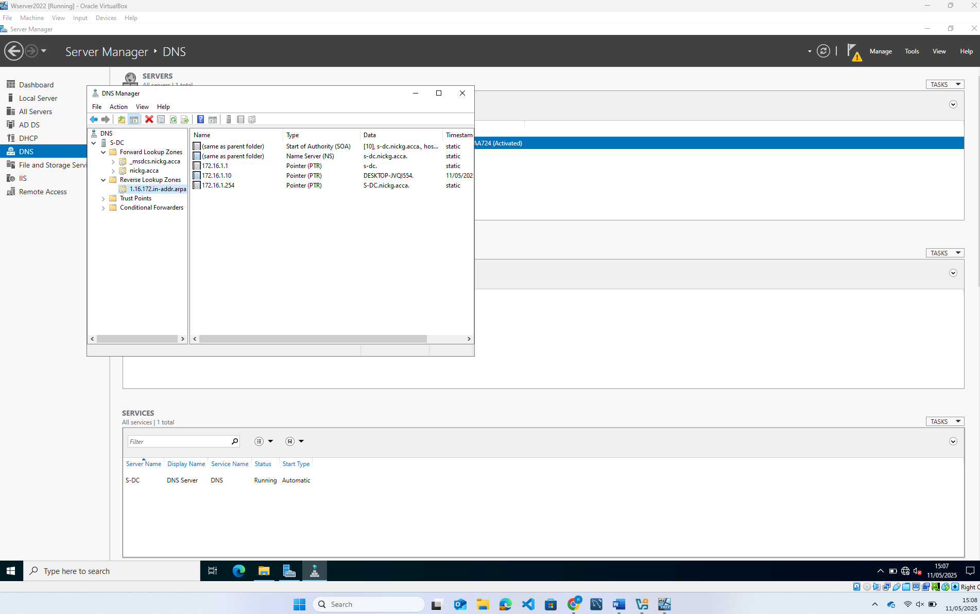
1.6: Creation of User Accounts
Here is the script I used to import the users from the .csv file
# Import the Active Directory module
Import-Module ActiveDirectory

# Path to your CSV file
$csvPath = "Z:\userList.csv" #

# Define the OU path (Users container in nickg.acca domain)
$ou = "CN=Users,DC=nickg,DC=acca"

# Import CSV and create users
Import-Csv -Path $csvPath | ForEach-Object {
$firstName = $_.first_name.Trim()
$lastName = $_.last_name.Trim()
$displayName = "$firstName $lastName"

# Create sAMAccountName as first.last (max 20 characters, lowercase)
$username = ("$firstName.$lastName").ToLower() -replace '\s',''
$username = $username.Substring(0, [Math]::Min(20, $username.Length)) # Truncate if needed

# Create UPN
$userPrincipalName = "$username@$($_.domain)"

# Read other fields
$email = $_.email
$jobTitle = $_.job
$department = $_.department
$city = $_.city
$company = $_.company

# Create AD user
New-ADUser `
-Name $displayName `
-GivenName $firstName `
-Surname $lastName `
-DisplayName $displayName `
-UserPrincipalName $userPrincipalName `
-SamAccountName $username `
-EmailAddress $email `
-Title $jobTitle `
-Department $department `
-City $city `
-Company $company `
-Path $ou `
-AccountPassword (ConvertTo-SecureString "P@ssw0rd123" -AsPlainText -Force) `
-ChangePasswordAtLogon $true `
-Enabled $true
}

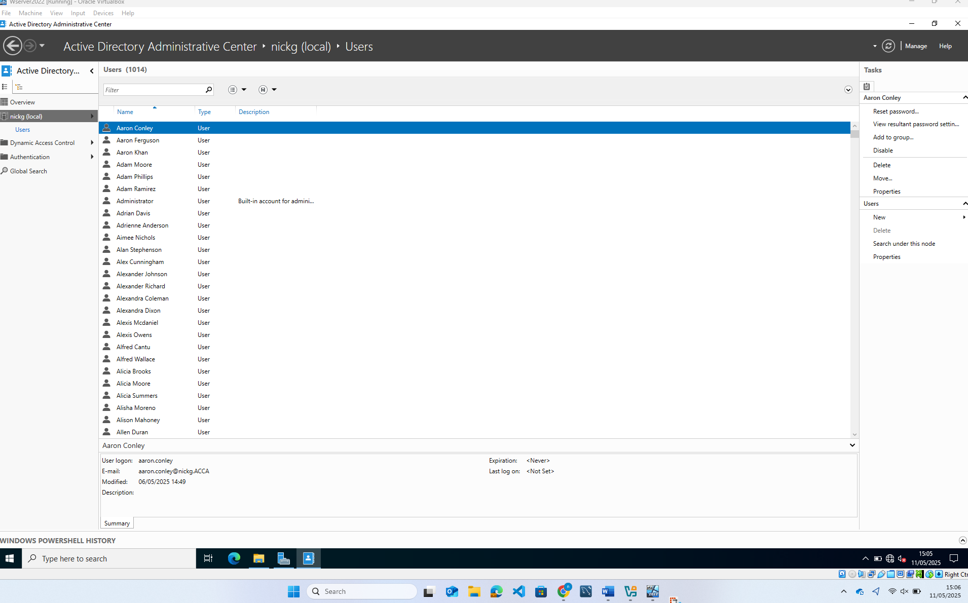

1.7: Assigning drive d:\
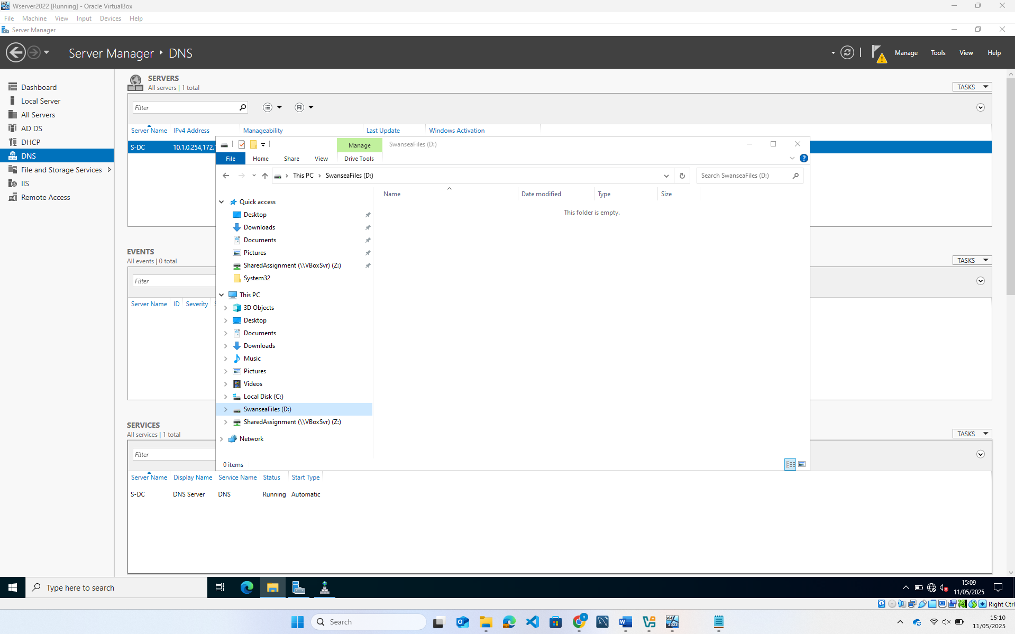
1.8: DHCP server setup
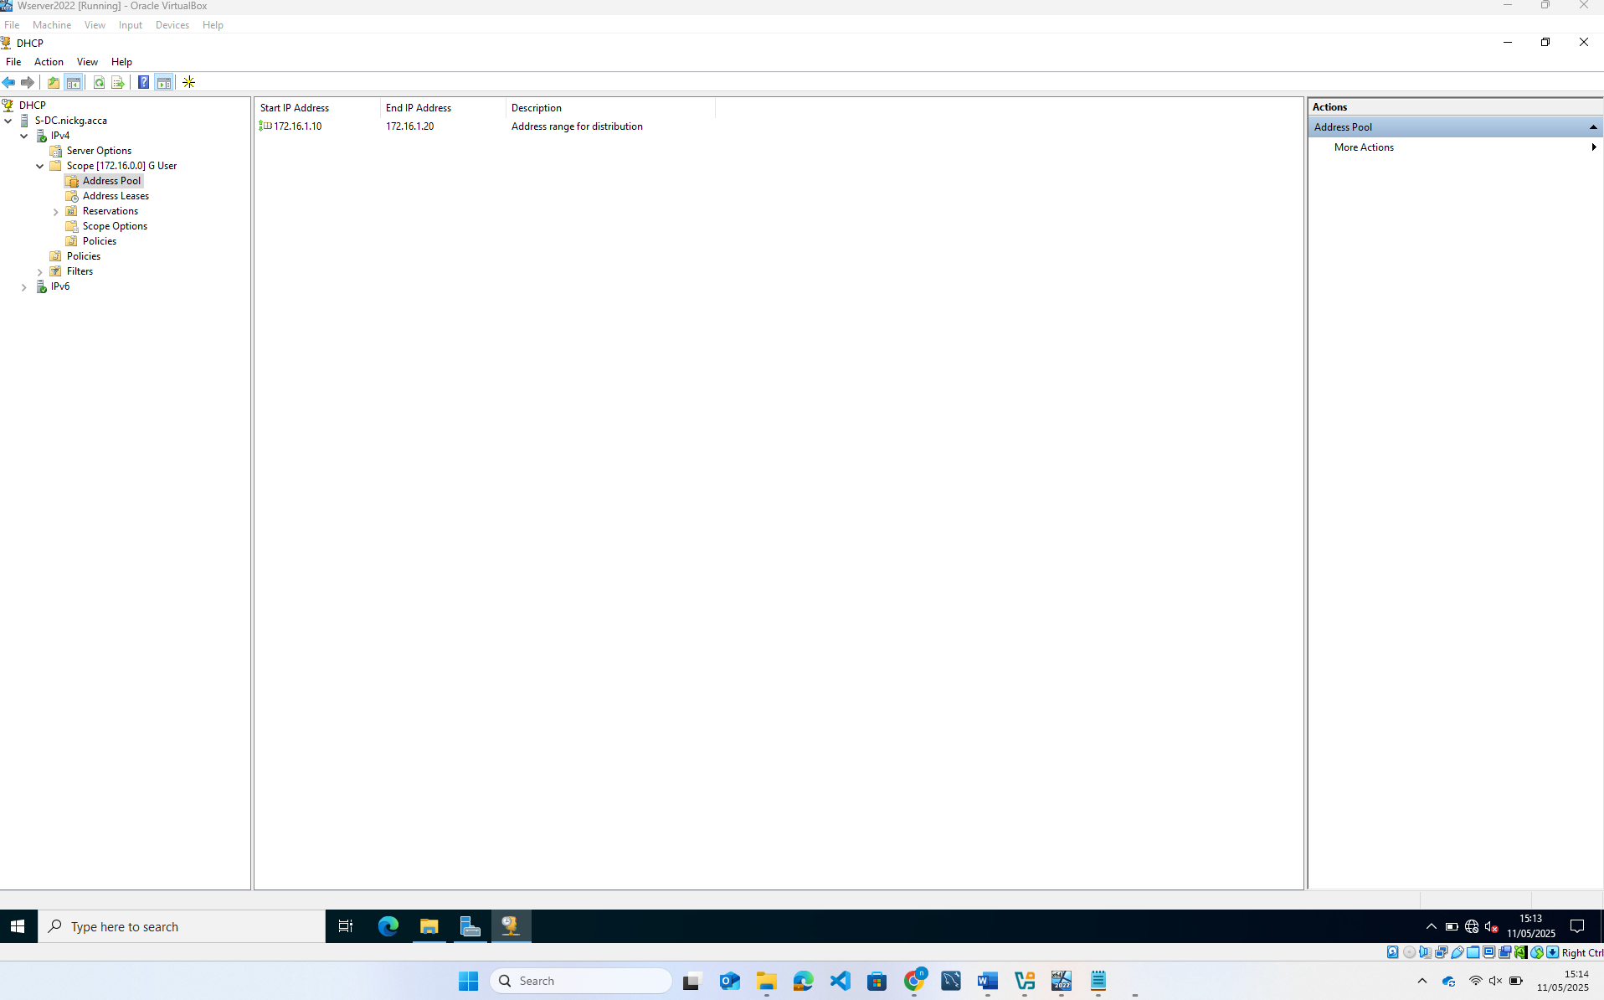
1.9: Joining client to domain
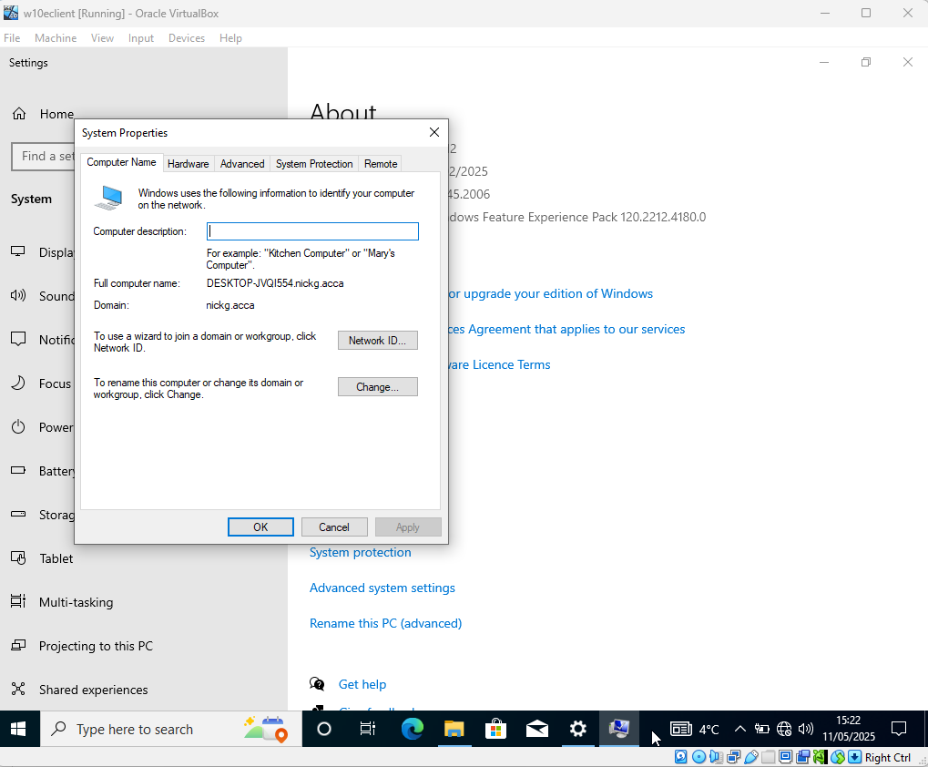
1.10: Client getting IP using dhcp
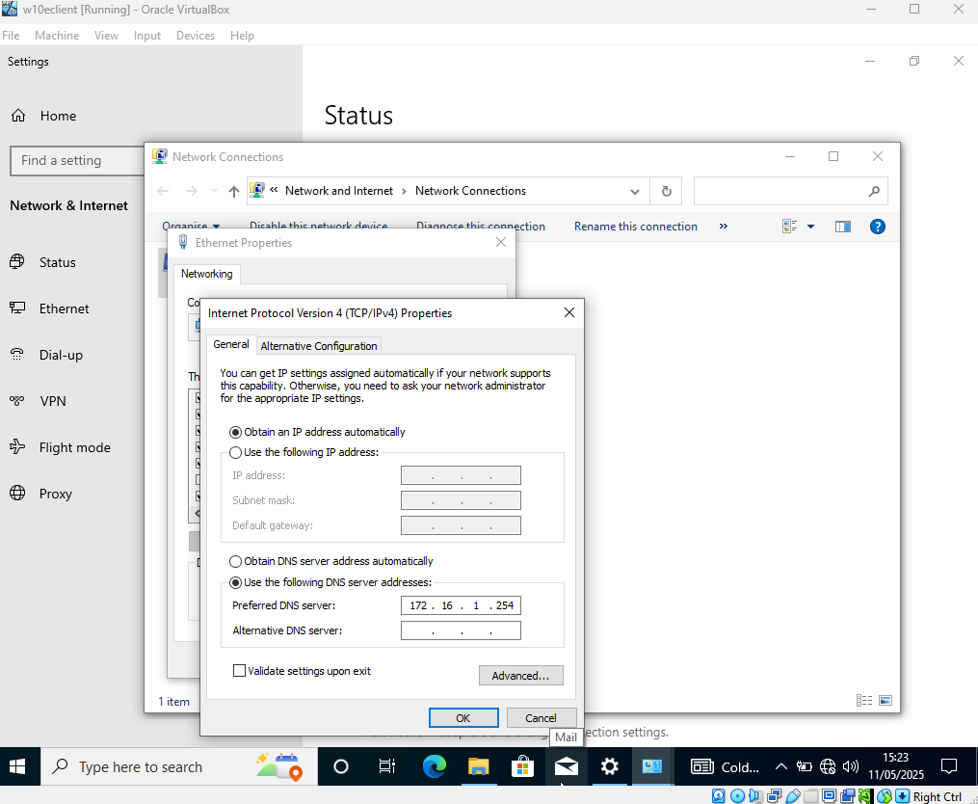
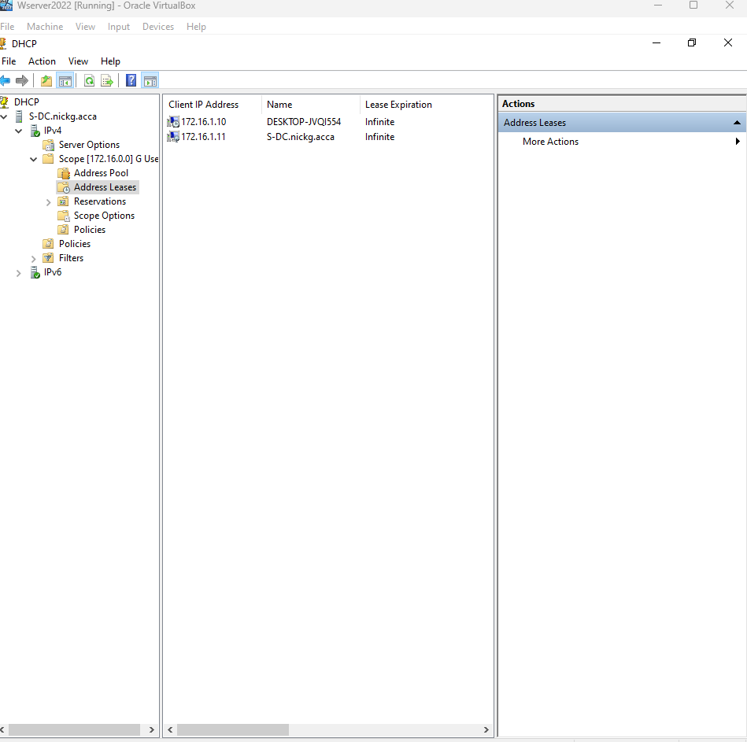

Cardiff Network

2.4: Configure DHCP Services. The range is 10.1.1.10 – 10.1.1.20. Determine other DHCP options as per the infrastructure.
Image showing the network configuration on the linux server
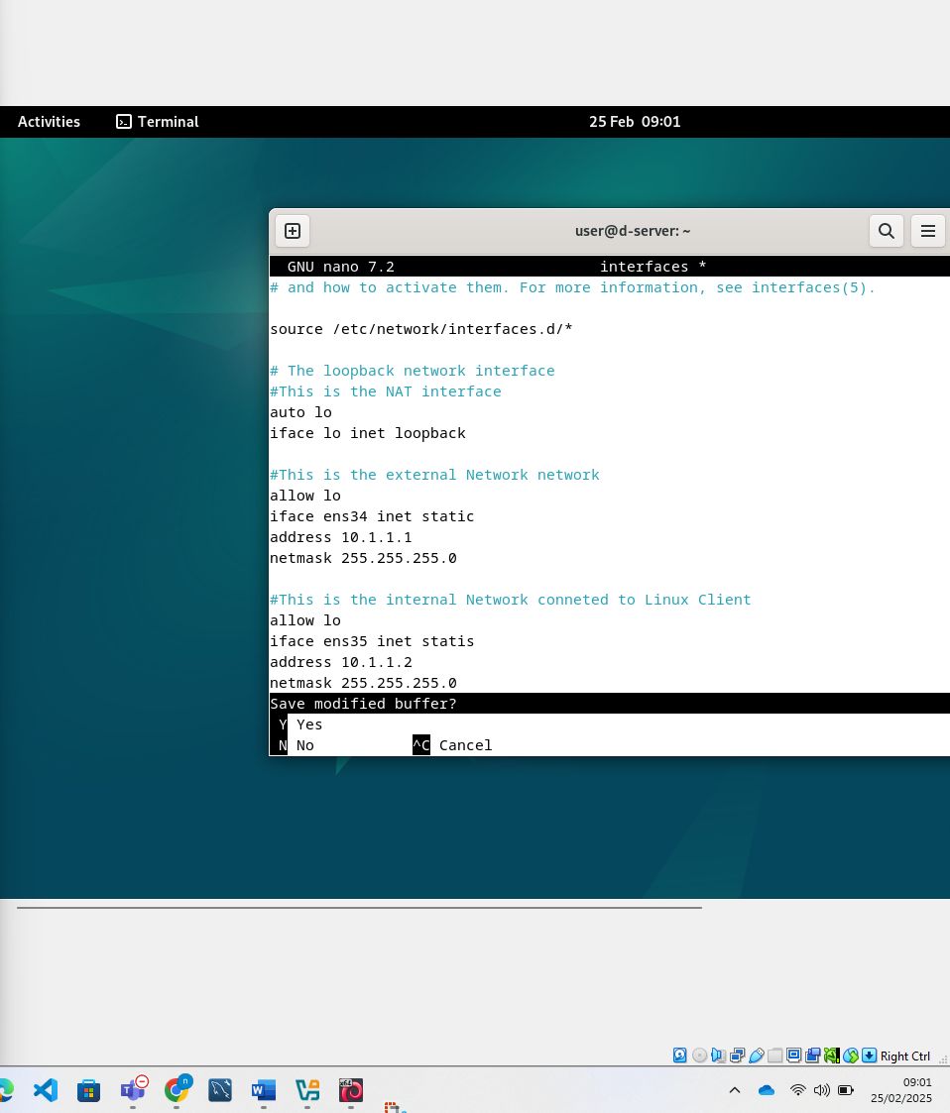
Image showing the DHCPO setup on the linus server
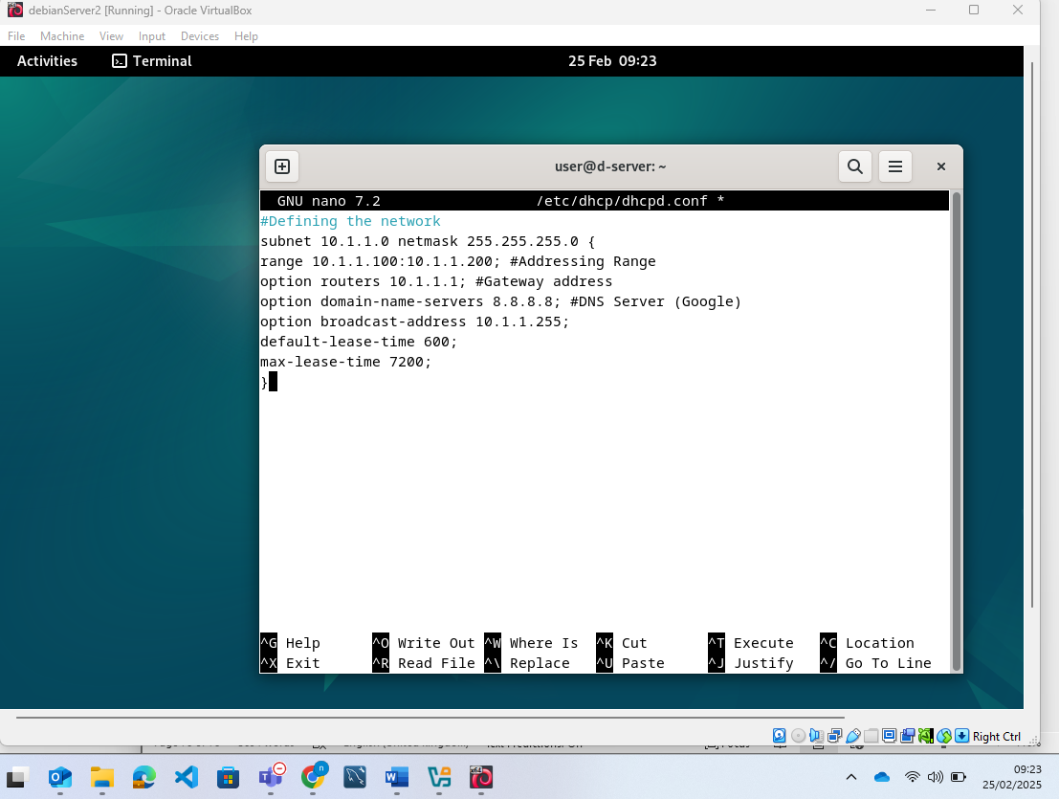
I then restored the network settings as required and restarted the DHCP service. I then checked it was running and it was as shown below
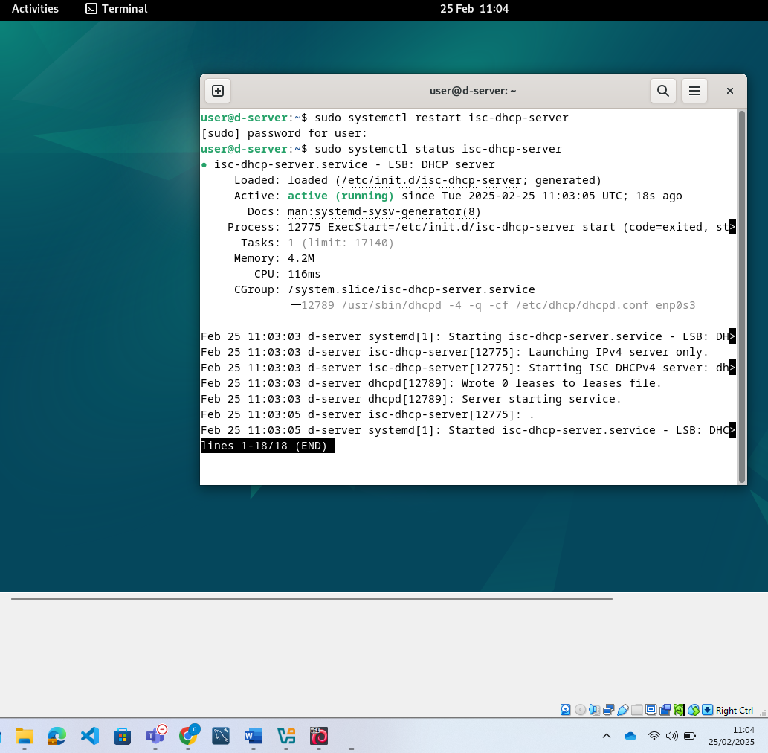

2.5: Join the ClientC1 to appropriate domain and assign DHCP IP address.
Image showing a request for an IP address using DHCP from the linux server
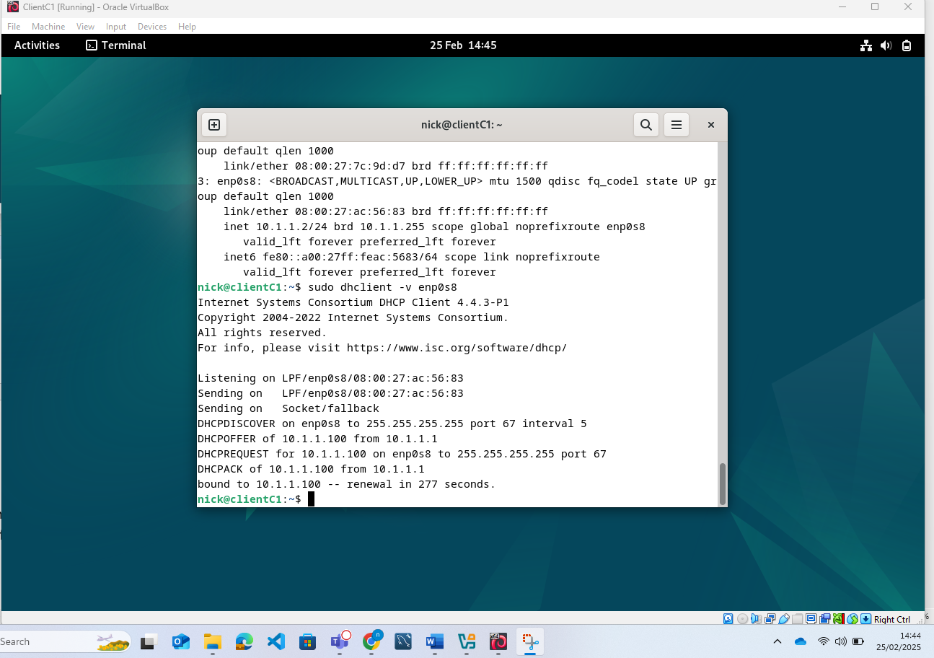
The range shows the same as what I designated which meant this was successfully done. Just to be sure though I ran a ping from the client machine again
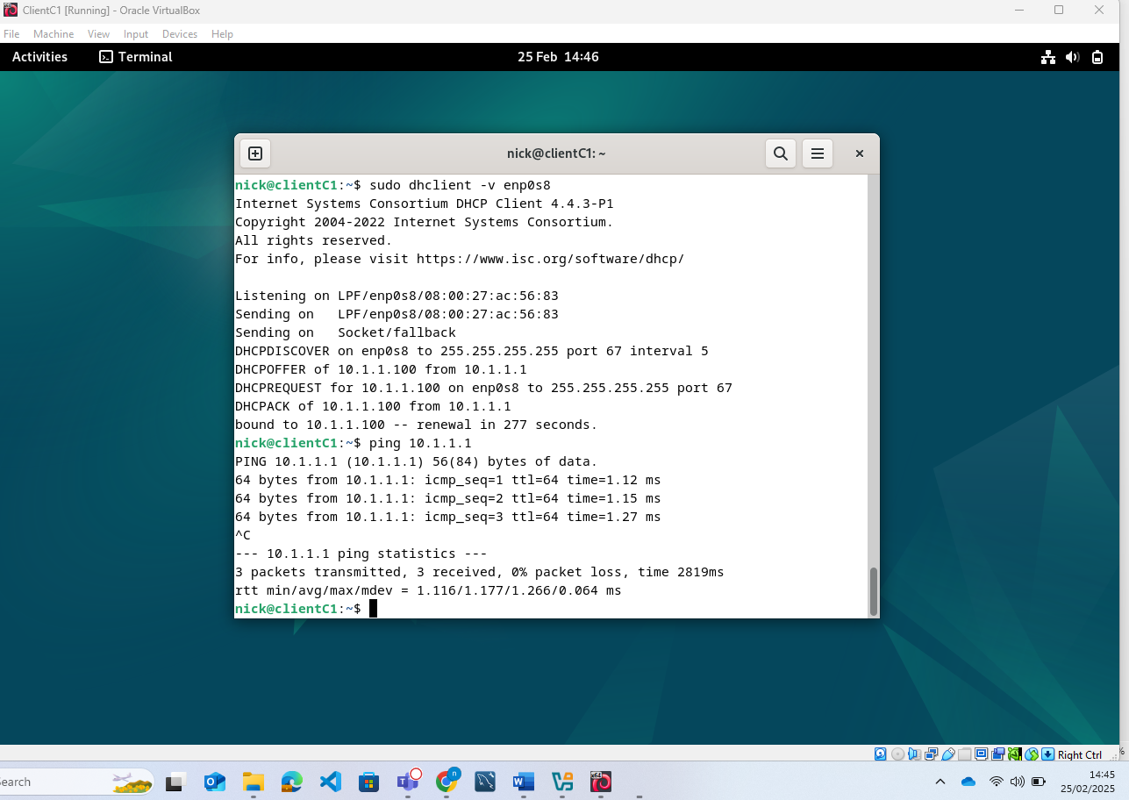
I then went on to the server and checked which Ip addresses it had assigned to make sure that it has assigned the IP address and there was no coincidence
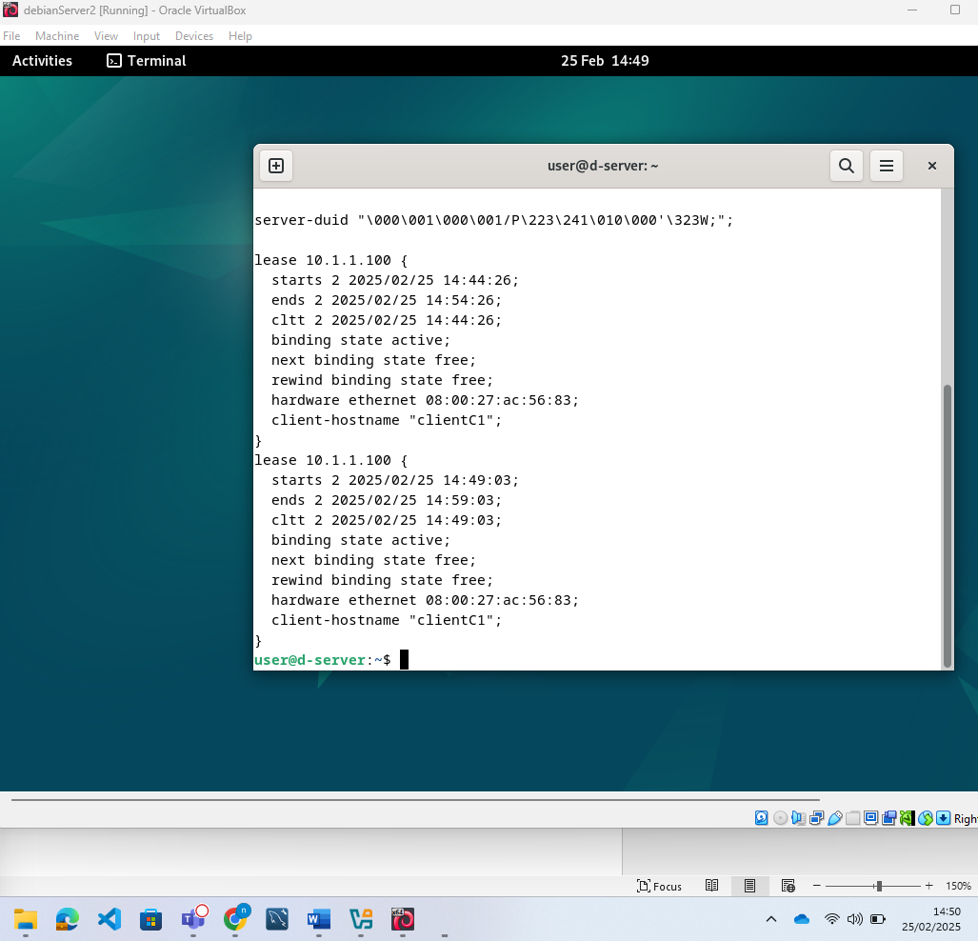
3. Testing Network Connectivity:
Here is the Windows Server pining the Debian server
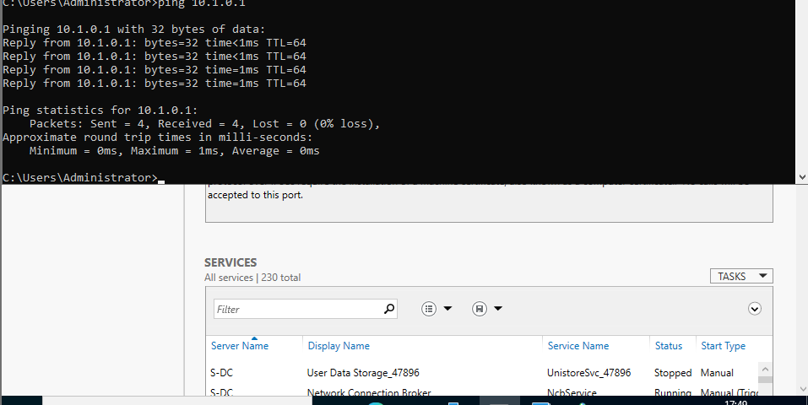
Here is the Debian server pining the Windows Server
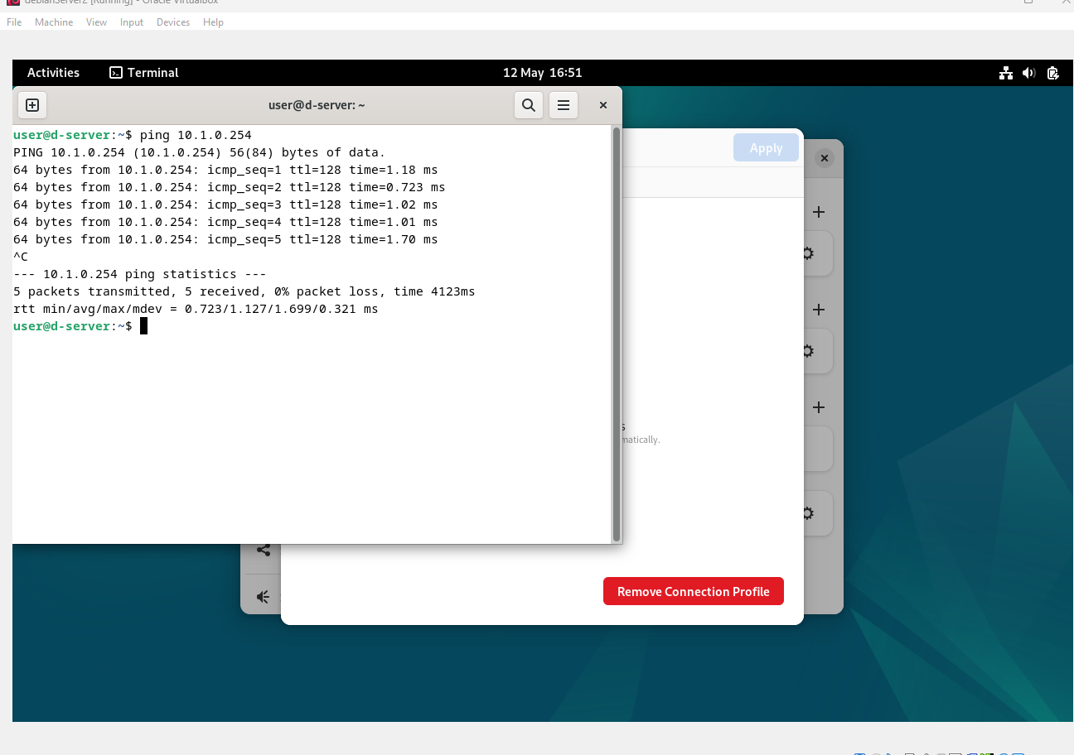
Here is the Windows Server pining the windows client
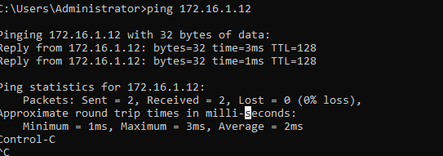
The windows machine, despite being connected was unable to ping the server. I manually put in the IP, I checked the firewall was off on both the client and the server, and they were obviously connected because I could see that the server could ping the host machine without any issue. What was also strange was that if the server was restarting I was able to ping from the host. I tried a tracert from the host and that times out before even a single hop. I can only think that the issue is either with the A records or PTR settings, or it is with the two NIC’s which on the server. As I checked the virtual box settings and made sure that everything was set up as needed, which the ping from the server confirmed anything. I was however unable to resolve this problem.
This is a screenshot of the linux client connecting to the server
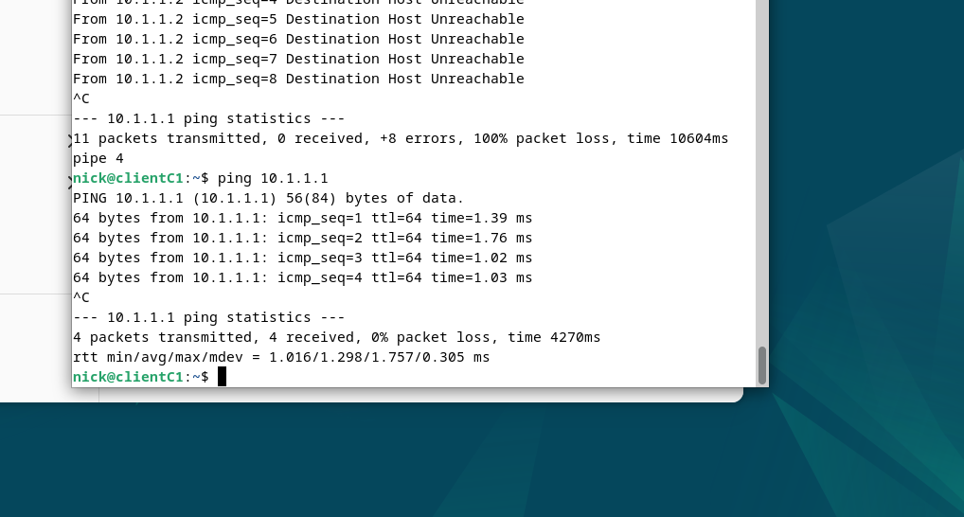
4. Sharing Disk Space, here are the permissions to allow users to edit drive D as shared earlier
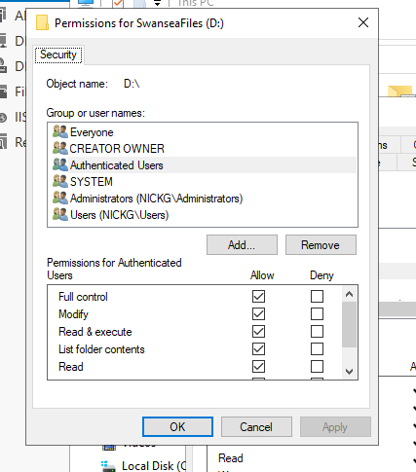
I did not complete tasks 5 or 6.

