

Benefits of Flexible working arrangement concerning diversity and inclusion in work and analyse
the role of Human Resources

Assignment 1
Individual presentation

Module name: Managing people
Module code: LCBB5004

Student name: Maria Ivanova Etova
Student number: 2030546

Lecturer: Terry Walcott
Submission date: 15.08.2022
Slide 1: Title page
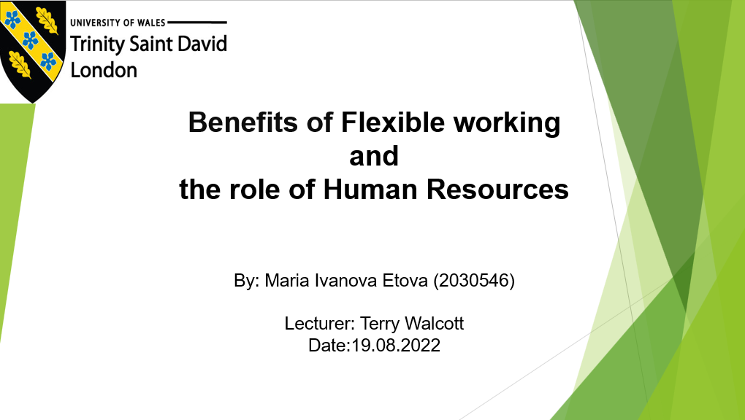

Slide 2: Table of Contents

Table of Contents
Title page……………………………………………………………………………………1
Slide 2 - Table of contents………………………….……………………………………..2
Slide 3 - Company introduction…………………………………………….....................4
Slide 4 - Human Resource Management (HRM)…………….……………………....…5
Slide 5 - Business ethics and morality……………………………………..…………….6
Slide 6 - Flexible work arrangement……………………..……………………………....7
Slide 7 - Flexible work arrangement in ASDA……………………………….................8
Slide 8 - Benefits of Flexible work arrangement ……………………….……………..10
Slide 9 - Diversity and equality……………………………………………..…..............12
Slide 10 - Diversity in ASDA……………………………………………………………..13
Slide 11 - Benefits of Diversity……………………………………………………….....14
Slide 12 - Conclusion...………………………………………………………….……….16
Slide 13 - References…………………………………………………………………….17
Slide 14 - Final page……………………………………………………………………..19

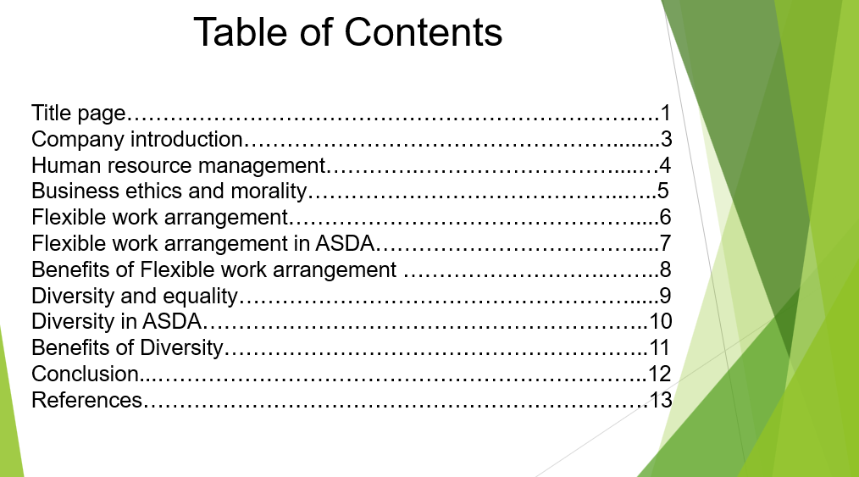

Slide 3: Introducing ASDA
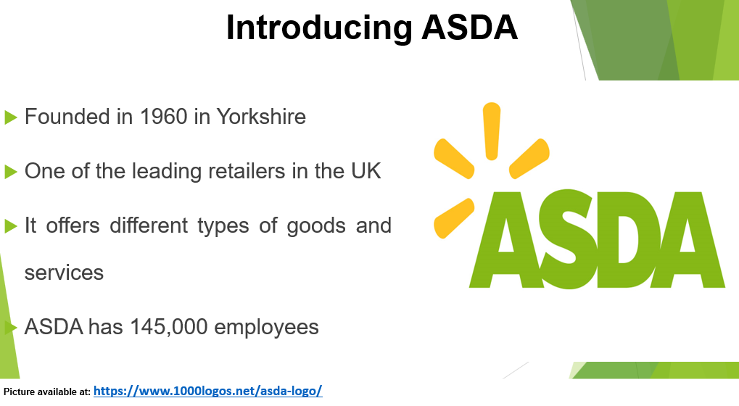
ASDA was founded in 1960 in Yorkshire (ASDA, 2018). It is one of the largest retailers in the United Kingdom. It offers different types of goods and services such as petrol stations, pharmacies, financial services, food, clothing, and home appliances. ASDA has 145,000 employees, who serve more than 18 million customers per week (ASDA, 2018). Given the large number of its employees, human resource managers are a very important part of the company.

Slide 4: Human Resource Management (HRM)
Human Resources Management (HRM) encompasses the employment and development of employees (Armstrong, 2014). It is one of the most important departments in each organisation and is responsible for all aspects related to employees, including hiring, training, paying, firing, etc (CIPD, 2021). The main human resources strategy is to solve the problems with a people-centric solution.

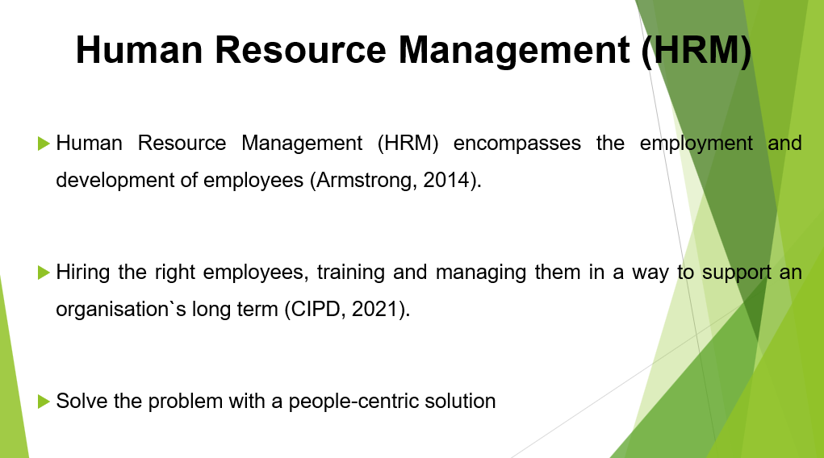

Slide 5: Business ethics and morality
Another very important duty for human resource managers is to monitor business ethics and morality in the company. Business ethics is the policies and principles in organisations which aims to protect the interests of all people who are part of the organisation. It includes topics such as company governance, all forms of discrimination, bribery, and misconduct by employees or employers (Twin, 2021). While morality is largely related to the relationships between the participants in the organisation such as the integration of employees in the work environment, respect for all of them, and how each one communicates with the other participants in the organisation.

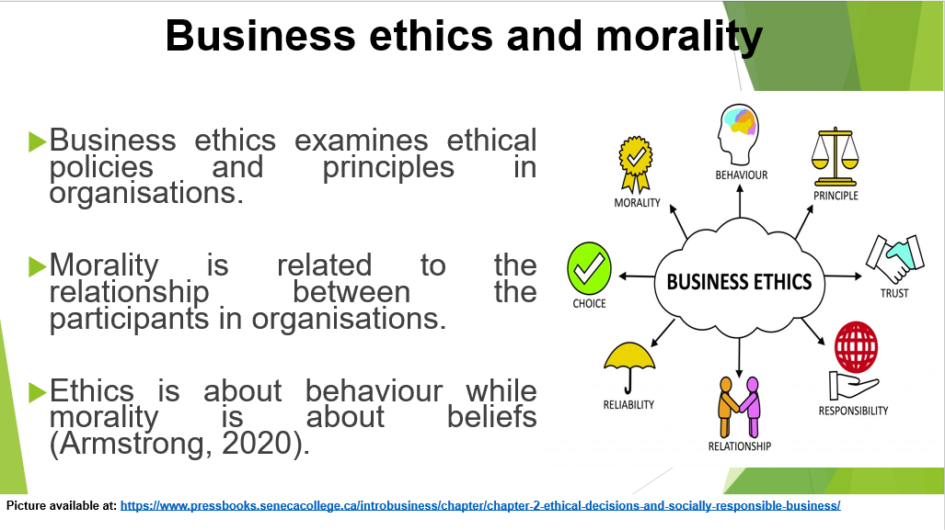

Slide 6: Flexible working arrangements
A flexible working arrangement is becoming more and more popular which is why human resource managers have to find a way to offer it to their employees, complying with all the ethical and moral principles of the company. A flexible working arrangement is a way to meet the needs of employees such as how many hours they work, from where and when they work (Gov. UK, 2012).

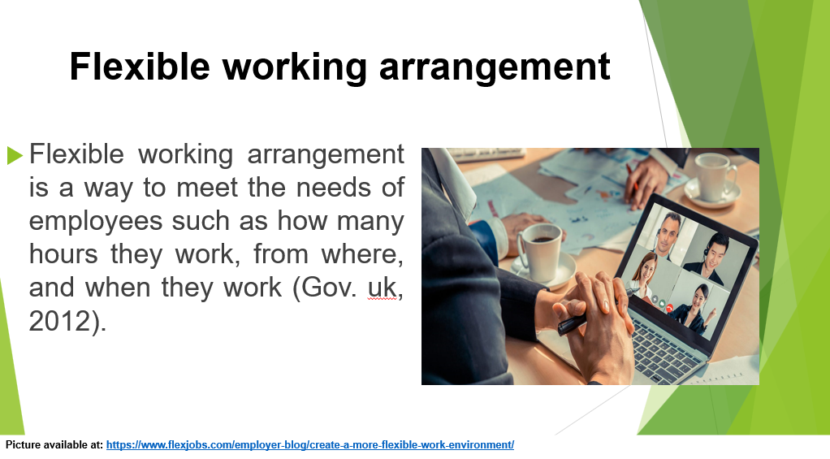

Slide 7: Flexible working arrangements in ASDA
ASDA offers several flexible working options such as full-time or part-time working arrangements, which allows each member of staff to choose if they want to work 4,6 or 8 hours, this is attractive for people who work in more than one job or for those who are the student, and it is suitable for the position as cashiers, shop assistance, store managers, security etc.
Another option is working from home, it is attractive for people who have kids, or for those who have to care for a family member with disabilities. The suitable job positions are Sales, IT, Marketing and PR managers, etc.
ASDA also offers its employees shift working time, especially in their 24 hours open stores, employees can choose whether they want to work a day or night shift.
The last one is job sharing it gives a possibility for two or more employees to work in the same job position, which allows for taking sick leave, they also can take advantage of shift work and take holidays.

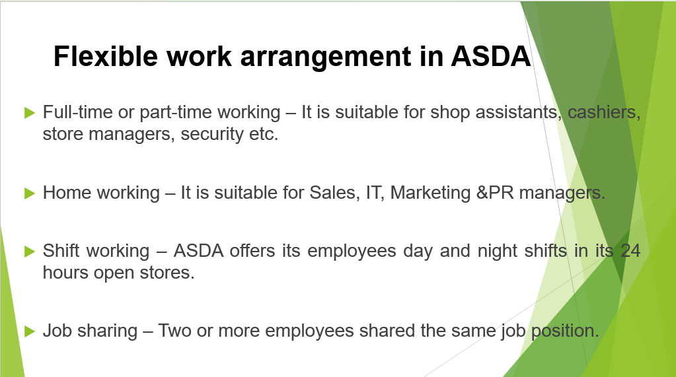

Slide 8: Benefits of flexible working arrangements
. Flexible working brings a lot of benefits for employees and employers. Nowadays, flexible working hours are much more attractive to employees, than fixed ones, therefore by offering flexible working hours companies have a greater chance of retaining their employees which leads to increased employees’ loyalty, as well as reduced the company`s expenses for hiring and training new staff (Beattie, 2019). It also helps to reduce employees` stress, have been proved that commuting, such as morning traffic jams, and overcrowded trains and buses, has a huge impact on increased stress levels. Stressed and overworked employees are much more likely to switch their work as well as take sick leave more often. By offering to work from home employers help to reduce stress on them, which leads to less absenteeism (Beattie, 2019). Also, with shift working, employers can increase companies` working hours, which leads to more satisfied customers, therefore increasing the profit. Also, many of the employees have to care about their kids or family member with disabilities, with flexible working arrangements employees, have the opportunity to balance their personal life and professional commitments (Beattie, 2019)
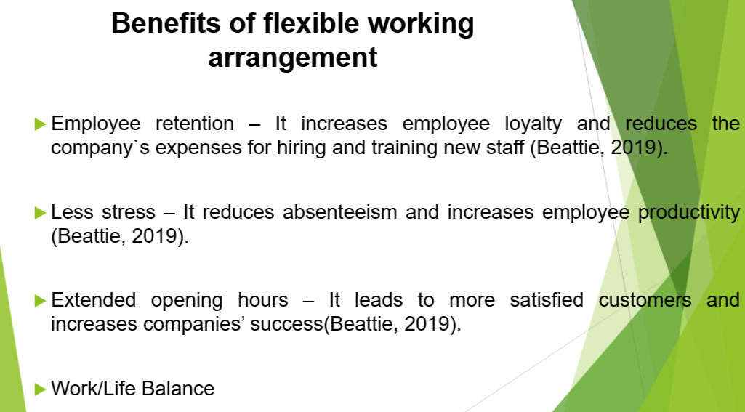

Slide 9: Diversity and equality
Deciding about flexible working arrangements should be made based on all the company's ethical principles, but also consider diversity and equality.
Diversity is the inclusion in the work process of people with different social and ethnic statuses, gender, and sexual orientation. All these differences make us unique and shape our personalities, skills, and views of our surroundings.
Equality is a very important part not only of the work environment but also of our lives. Everyone is entitled to equal treatment and benefits regardless of race, gender, or social differences.

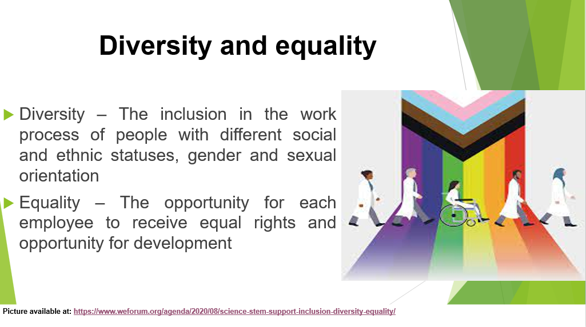

Slide 10: Diversity in ASDA
ASDA has great diversity among its staff and successfully integrates each employee into the working process. The company wants to provide a non-judgement environment for its staff, in which discrimination is not allowed and everyone should be proud of who they are, where they come from and what is their gender and sexual orientation. ASDA is recognized as an LGBT-friendly employer. Also, it invests in a program ‘Women in leadership’ through this program women are allowed to occupy leadership positions (Office, 2014).
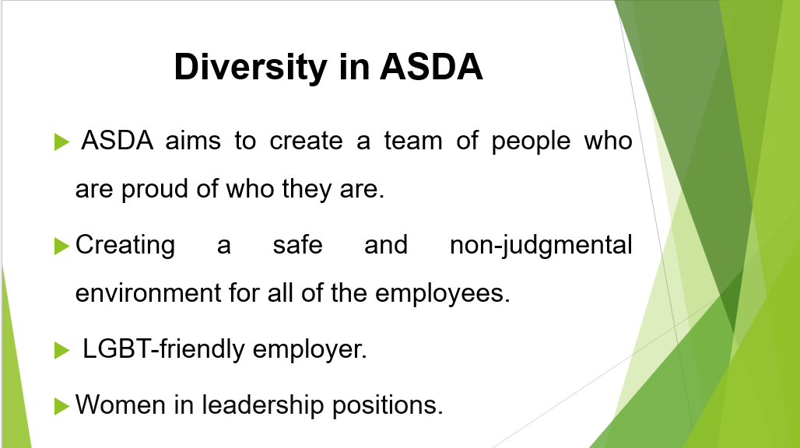

Slide 11: Benefits of Diversity
Diversity is an important step for the development and success of the business not only in the local but also in the international market. Employees with different backgrounds have different talents, experiences, and skills, therefore it leads to an increase in their creativity, and the ability to take faster and more accurate decisions which increases companies` success (Carson, 2020). Also, a multicultural workforce helps develop the companies by opening new markets in different counties, learning their legal norms, and serving different groups of customers. It also helps in growing the business by making it more competitive and profitable (Reynolds, 2019). Also, the diversity of the team allows for exchanging experience and skills with different people, which leads to an increase in the competence of employees and their productivity (Reynolds, 2019).
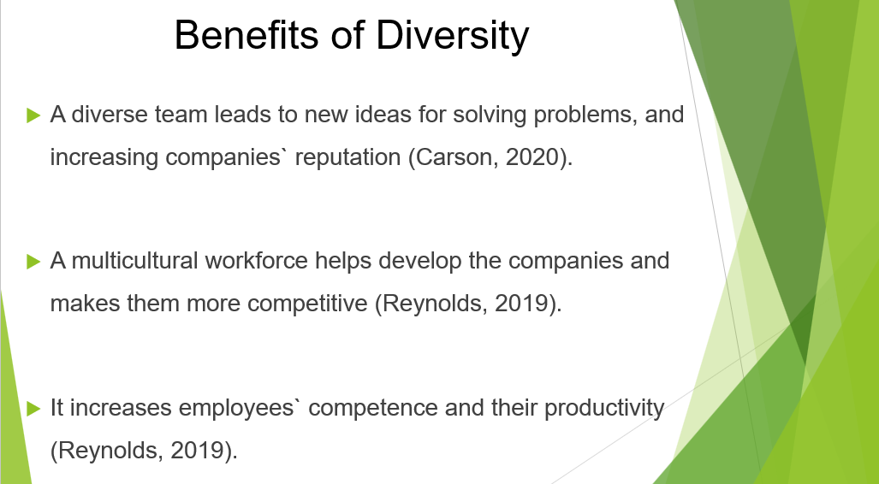

Slide 12: Conclusion
During the pandemic, HR managers had to find a way to keep their staff and ensure their safety. With flexible work arrangements and diversity, companies have found a way to attract their staff, and increase diversity in the company, thus not only successfully going through the pandemic but also increasing employee productivity.

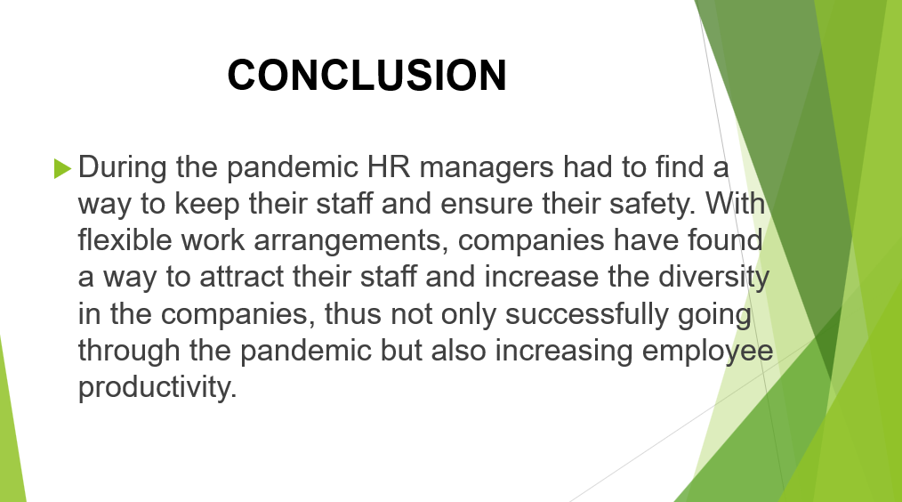

Slide 13: Reference list

Armstrong, M, 2014. Armstrong’s handbook of human resource management practice. 13th edition ed. London, England: Kogan Page.
Armstrong, M, 2020. Armstrong’s handbook of human resource management practice. Fifteen edition ed. London, England; New York: Kogan Page.
ASDA,2018 Asda.com [Online]
Available at: https://corporate.asda.com/our-story
[Accessed 31 July 2022]

Beattie, A., 2019 Benefits of Flexible Working for Employers [Online]
Available at: https://croner.co.uk/resources/business-advice/benefits-of-flexible-working/#:~:text=Benefits%20of%20flexible%20working%20for%20employees%201%20Less,with%20children%20are%20currently%20in%20the%20workforce.%20
[Accessed 1 August 2022]
Carson college of business, 2020. 10 Benefits of Diversity in the Workplace [Online]
Available at: https://onlinemba.wsu.edu/blog/10-benefits-of-diversity-in-the-workplace/
[Accessed 20 July 2022].
CIPD, 2021. Strategic Human Resource Management. [Online]
Available at: https://www.cipd.co.uk/knowledge/strategy/hr/strategic-hrm-factsheet#gref
[Accessed 20 July 2022].
Office, G. E., 2014. Gov. UK. [Online]
Available at: https://www.gov.uk/government/case-studies/think-act-report-asda
[Accessed 01 August 2022].
Reynolds, K., 2019. 13 benefits and challenges of cultural diversity in the workplace Hult Blog. [Online]
Available at: https://www.hult.edu/blog/benefits-challenges-cultural-diversity-workplace/#:~:text=Diverse%20cultural%20perspectives%20can
[Accessed 20 July 2022].
Twin, A., 2021. Investopedia. [ Online]
Available at: https://www.investopedia.com/terms/b/business-ethics.asp
[Accessed 29 July 2022]

Gov. UK, 2012. Flexible working [Online]
Available at: https://www.gov.uk/flexible-working
[Accessed 01 August 2022]


All pictures are available at:

https://www.1000logos.net/asda-logo/
https://www.pressbooks.senecacollege.ca/introbusiness/chapter/chapter-2-ethical-decisions-and-socially-responsible-business/

https://www.layamgroup.com/ethical-work-culture-nurture-it-for-the-growth-and-success-of-your-organization/

https://www.flexjobs.com/employer-blog/create-a-more-flexible-work-environment/

https://www.weforum.org/agenda/2020/08/science-stem-support-inclusion-diversity-equality/


https://www.astrixinc.com/importance-sending-thank-job-interview/

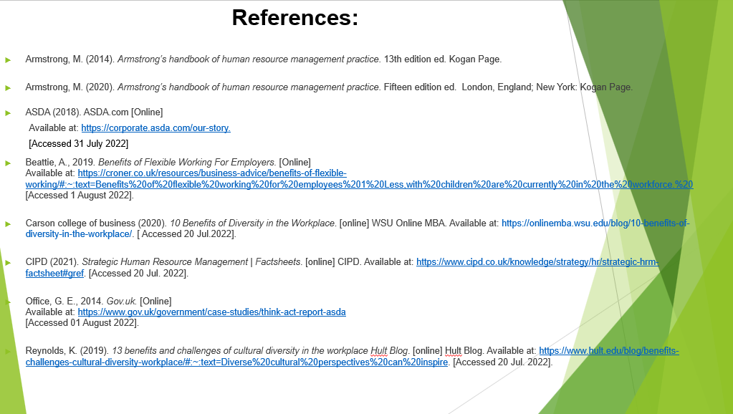

Slide 14: Thank you!



