Report Title: The Evolving Role of HR in the Contemporary Business World

Name: Lisa Davies

CIPD Membership
Number: 48699101

Date: 11th January 2018

Word count (max 3900 words)

I declare that this assignment is my own work and that any information obtained from books and other sources have been appropriately referenced.

Signed: Lisa Davies

Date: 11th January 2018

The Evolving Role of HR
in the Contemporary
Business World

______________________________________________________________

TABLE OF CONTENTS
______________________________________________________________

1.0 | INTRODUCTION……………………………………………………………. | 4
2.0 | FORCES SHAPING THE HR AGENDA……………………….………... | 4
 | 2.1 Models of the HR Function……………………………………….  2.2 HR Strategies……...………………………………………………..  2.3 Insights and Solutions……...…………………………………….  2.4 Business Ethics and Accountability…………………………… | 5  7  7  8
3.0 | TOOLS FOR ANALYSING THE BUSINESS ENVIRONMENT……………………………………………………..……... | 8
 | 3.1 SWOT………………………………………………………...………  3.2 PESTLE……………………………………………………………...  3.3 Porter’s 5 Forces…………………………………………………..  3.4 Comparison of Tools……………………………………………... | 8  10  11  12
4.0 | FACTORSTHAT IMPACT ORGANISATION’S BUSINESS AND HR FUNCTION………………………………………………………………….. | 13
5.0 | KEY STAGES IN STRATEGY FORMULATION………………………...  5.1 HR’s Contribution to Business Ethics  and Accountability.................................................................... | 15  17
6.0 | BUSINESS PERFORMANCE AND THE ROLE OF HR IN BUSINESS PLANNING AND THE CHANGE MANAGEMENT AGENDA…………………………………………………………………….. | 18
7.0 | DIFFERENT SOURCES OF BUSINESS AND CONTEXTUAL DATA FOR PLANNING PURPOSES……………………………………………. | 20
8.0 | CONCLUSION……………………………………………………………… | 21
9.0 | REFERENCES……………………………………………………………… | 22
___________________________________________________________________

1.0 INTRODUCTION
___________________________________________________________________

Human Resources (HR) practices have undergone numerous changes over the last few decades. These changes have been driven by continuous development within the workplace, accompanied by advancements in technological breakthroughs and competitive pressures, practices have helped improve organisations productivity and value. To ensure that changes are implemented, it is imperative that engagement and involvement at all levels within an organisation is met.

It is the role of the HR function to ensure that all staff are encouraged to collaborate, to believe and work within the mission and vision of the organisation, to ensure that a strategy is followed and to ensure that the needs of the organisation are met (Araimi, 2011).

This delegate paper will help demonstrate the ‘The Evolving Role of HR in the Contemporary Business World’, by identifying business issues, including internal and external factors and the impact of HR on business operations.
___________________________________________________________________

2.0 FORCES SHAPING THE HR AGENDA
___________________________________________________________________
HR strategies are built around business strategies; it is suggested that the business strategy should include employees, who are often the driving force behind organisational goals.
The major functions of Human Resources consist of constant planning, job analysis, recruitment and selection, training and development, performance appraisal, compensation and career planning (Salvendy, 2012).
The size of an organisation will also have an impact on the HR function (CIPD, 2015).

According to Ward & Rhodes (2014) there are four organisational sizes:
- Micro – less than 10 employees
- Small – less than 50 employees
- Medium – less than 250 employees
- Large – more than 250 employees
In small or micro-sized organisations, HR departments are likely to consist of HR generalists.
Taylor & Woodhams suggests that HR generalists ‘have knowledge of and are involved in, all areas of the HR function. Sole practitioners will always tend to be generalists as they need to be able to deal with every part of the HR remit on their own’ (2016, p25).
HR departments within larger companies will have HR specialists who would be experts in a specific area of HR.

2.1 Models of the HR Function

The HR Model is the complex description of key Human Resources objectives, capabilities, processes and standards. The HR Model is a bridge between HR Strategy and other key areas of HR Management, i.e. processes and organisational structure and also provides an analytical framework.
Business academic, David Ulrich (2016), developed a pioneering, new model which has the ability to influence the dynamics of human resources and is still used in the workforce today (Taylor & Woodhams, 2016).

The model shown in Figure 1 illustrates the Ulrich model, also known as the 3-legged stool model.
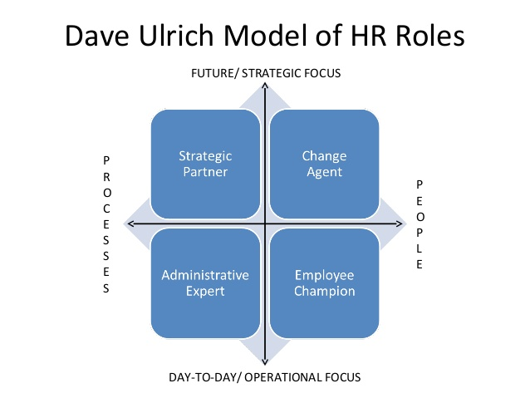

Figure 1: Ulrich Model
Source: Shingal (2016)

There are other HR models used within organisations, which all serve a different purpose:

- The Harvard Model - The Harvard model claims to be comprehensive in as much as it seeks to comprise six critical components of HRM. The dimensions included in the model are: stakeholders, interests, situational factors, HRM policy choices, HR outcomes, long-term consequences and a feedback loop through. The outputs flow directly into the organization and the stakeholders (Management Study HQ 2013).

See Figure 2: The Harvard Model

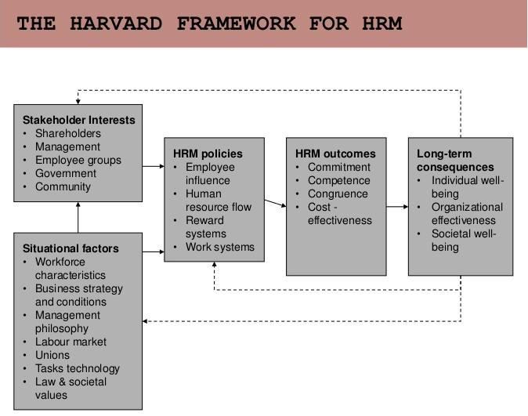
Figure 2: The Harvard Model
Source: Management Study HQ (2013)

- The Guest Model - This model was designed by David Guest (1997) and as such, claims to be a much superior model compared to others. This model claims that HR managers have specific strategies which demand certain practices and when executed, will result in outcomes. These outcomes include behavioral, performance related and financial rewards (HRM Guide 2017).
2.2 HR Strategies

According to Momin and Mishra (2015), HR strategies are a set of actions that are aimed at the organisation’s culture and people, as well as processes and systems to enable organisations’ to achieve their long term business goals. The HR strategy has four main key dimensions such as people, culture, organisation and HR systems (Lakshmi, 2016).

The cultures of organisations’ consist of their beliefs, norms, values and management styles. HR systems include the selection of employees, communication, career development and learning and development (Salvendy, 2012). All these factors contribute to the formulation of HR strategies (Bamberger, Biron & Meshoulam, 2014).

A successful HR strategy requires the participation of the entire workforce.
2.3 Insights and Solutions
Human Resources involves the business leaders of the organisation in the planning processes and the governance (Jeston and Nelis, 2014).
This involvement would enable the business alignment, which results in greater support for the business. The development of advanced workplace planning and greater implementation of workforce analytics should be agreed (Jiang et al, 2012).

This enables organisations to transform their business data, talents and external workforce data into suitable insights (Jeston and Nelis, 2014).
The Human Resource Management function leads the transformation process of many organisations, towards a high performing, engaged, appropriately aligned and highly capable workforce.

2.4 Business Ethics and Accountability

Human Resources are responsible for implementing key policies and procedures which underpin effective delivery of messages to the organisation about ethics. Due to HR’s expertise in internal communication and change management, it is the responsibility of HR to integrate ethics into processes; i.e. employer brand, recruitment process, induction and others. HR also needs to ensure that ethical values are embedded and monitored via surveys and exit interviews (Ghillyer, 2012).

Taylor & Woodhams believe ‘it is absolutely vital that the HR function takes an ethical approach in all its actions. Ethical behaviour is a core element of the required standards of an HR professional’ (2016, p36).
___________________________________________________________________

3.0 TOOLS FOR ANALYSING THE BUSINESS ENVIRONMENT
___________________________________________________________________

3.1 SWOT

Strengths, Weaknesses, Opportunities and Threats is an excellent technique for understanding the weakness and strengths of an organisation as well as identification of open opportunities and the potential threats. The threats can also be eliminated by proper analysis of SWOT (Buller and McEvoy, 2012).

It is highly important to determine the strengths of the organisation and the possible threats which could include competition and downturn in the economy.

As shown in Table 1: example of SWOT Analysis

SWOT Analysis

Source: Family Housing Association (2017)
STRENGTHS | WEAKNESSES | OPPORTUNITIES | THREATS
- A successful track record of providing good quality homes and supporting communities  - High levels of overall tenant satisfaction  - Specialist Services are very well thought of by both tenants and commissioners  - Successful track record for delivering new developments  - Partnerships with local authorities  - Committed staff, excellent team work  - Recognition of and commitment to change by Board and staff – significant progress made to address areas for improvement  - Support of key stakeholders in responding to the challenges  - Strengthened Board – broad range of skills – reflecting needs of the business  - Permanent CEO, Executive director appointments  - Flexibility in the structure of the organisation to respond to changes in the housing sector  - Improving relationship, engagement & collaboration with tenants  - Improving levels of staff engagement and staff morale  - New values established  - Reducing silo working | - Headroom is tight – impacting on resilience to internal and external shocks  - High cost of current loans – 96% of which are fixed. (Higher than the sector average)  - Higher levels of voids / low demand for Extra Care schemes in rural areas of Ceredigion, Pembrokeshire and potentially Carmarthenshire (however, this appears to be linked to poor quality information held by CCC)  - Extra Care Community costs – historic ‘decision’ to carry the losses.  - Board learning to work with each other – forming, storming, norming & performing – more finance skills required  - Need to build trust between the Board and staff.  - Until recently there has been a lack of leadership and this is changing but still recognised as an area for continued work  - Silo working still evident  - Staff morale, communication & engagement  - Housing Team structure  - Risk averse, lack of change and innovation  - Poor profile and reputation  - Tenant engagement & communication  - Under investment in housing stock (as a result of focus on development)  - ICT systems and service poor Staff turnover / absence / retention | - For growth, if and when the Association’s financial position allows  - To explore new funding sources and models  - To support our competitors who may vulnerable to the impact of local, regional and national policy and budgetary decisions  - Explore & exploiting local opportunities where services are reconfigured or re-commissioned by health and local authorities  - Lead & participation in the growing number of regeneration opportunities across the Swansea Bay City region  - Explore opportunities to pilot or develop housing that can generate energy rather than just consume it; modular housing; non-traditional forms of construction  - Explore opportunities for collaboration with health, social care and leisure to exploit the growing recognition of the role of housing in prevention and in sustaining well-being.  - Establish strong relationship with new ICT provider to address underperformance of system and services and use opportunities to innovate and improve the way we work and the service we provide  - Continue to build on improving relationship with tenants and develop and offer new and different ways for engagement and participation with a wider range of groups and individuals  - Develop housing specifically for under 35s  - Explore options for rewarding and recognising staff  - Dispose of poor quality & under performing stock and re-invest in new housing and services | - Rent reform  - Changes to local housing allowance affecting rents and service charges  - Austerity Measures - Welfare reform  - Delays in delivery of the development programme – on budget  - Continued challenges letting Extra Care Schemes in Pembrokeshire, Ceredigion, and Carmarthenshire  - Changes to commissioning - Cuts to Supporting People and Care & support funding streams  - Costs increasing at a rate higher than income – monitor and align both  - Pension costs – decision to be made on what the association can afford to sustain whilst remaining an attractive offer for staff.  - Losing key staff – impact on ability to deliver services / run the association  - Ageing population – increasing demands on services, more complex needs  - Health Board reforms – reducing budgets, recommissioning services  - Local Government reorganisation  - Aging workforce – implications for recruitment and succession planning  - Negative Management  - Poor ICT infrastructure and services  - BREXIT  - As regeneration opportunities materialise will land prices increase and prevent FHA from land acquisition  - Impact of increasing cost of materials for maintenance and development

3.2 PESTLE
By using PESTLE, organisations can analyse their environments within which they operate.
This will provide them with the information required to predict change before it happens and plan how to manage. This enables organisations to be proactive and make plans for the future.
PESTLE stands for:
- Political - Brexit, Government involvement and law change
- Economic - Funding, minimum wage increase and interest rates
- Sociological - Aging population, health and global warming
- Technological - Social media, streaming, buying and selling of goods
- Legal - Legislation, import and export, taxation
- Environment - Waste disposal and recycling
(Kew et al, 2010)

3.3 Porter’s 5 Forces
As illustrated in Figure: 3, ‘Porter’s Five Forces’ is a common model applied by organisations to evaluate the weight of the five forces in the market that influence the quality and feasibility of the industry (Professional Academy, 2017).
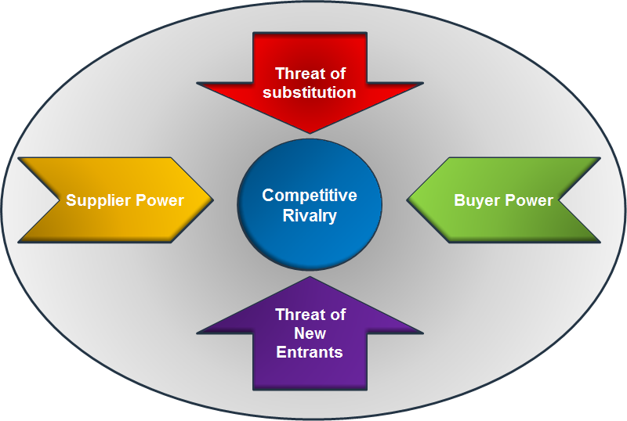
Figure 3: Porter’s Five Forces Model
Source: Professional Academy (2017)

According to Hanlon (2013) ‘Porter’s Five Forces’ evaluates and influences the following:
- Supplier Power - influences the way that suppliers influence prices. This is determined by the number of suppliers, uniqueness of each product, strengths of the products and others.

- Buyer Power - signifies the importance of each buyer to the overall business process and is determined by the number of buyers and the value each buyer brings to the business.

- Competitive Rivalry - signifies the number and the capability of the competitors. This is the most important factor for a business entity because customers would switch on to other brands if they were not satisfied with a particular brand.

- Threat of Substitution - is affected by the ability of the consumers to explore a different way of doing the individual job parameters (Hanlon, 2013). If the substitution product is easily available and the substitution option is viable, then it would weaken the power of the business.

- Threat of New Entrants - signifies the ability of other people to enter the same market or the same industry. In the absence of significant barriers in the market, the company may not be able to maintain their favorable position and the new competitors would take the company’s position soon.

3.4 Comparison of Tools
- SWOT
This technique is useful in analysing the present condition of the organisation and to anticipate the future concerns. The SWOT tool helps to uncover the opportunities and understand the possible weakness of the business. The tool also provides insights about the organisation’s good characteristics and their weaknesses. It is important to determine the advantages of the organisation, unique selling proposition, lowest cost resources, quality of manpower and quality of products to remain ahead of the competition. The strengths should be considered from the internal perspectives as well as from the customers’ point of view (Gentry et al, 2013).
There could be various weaknesses to a business such as missed deadlines, lots of pending work, a high rental cost of office space, outdated data on market research, insufficient record keeping, and infrequent cash flow systems.
The opportunities of the business comprise of the interesting trends, loyal customer base, seasonal high demands of products, high demand for similar merchandise and others (Buller and McEvoy, 2012).

- PESTLE
The macro environment of an organisation is analysed through PESTLE analysis. This analysis gives an idea to the leaders regarding the present situation and future position of the organisation. This analysis comprises of the components that influence the business framework and each factor denoted by the letters, representing the influencing factors of the industry. The results from PESTLE help the company to plan for its future (Sadgrove 2015).
The SWOT model is less robust than PESTLE analysis. This is because PESTLE provides the overall analysis of the macro environment that affects the smooth functioning of the particular organisation. PESTLE analysis is appropriate for organisations that wish to conduct market research on the industry and the products. PESTLE analysis allows the experts to examine a wide variety of factors, which is helpful in the process of decision making. PESTLE analysis takes account of the various factors like economical, political, social and technological factors that influences the functioning of the organisation.
- Porter’s Five Forces
Porter’s Five Forces is a unique model that helps organistions perform a competitive assessment. It helps organisations to assess the viability of a particular service, product or future expansion. The SWOT analysis, on the other hand, is a general assessment of the organisation. The Porter’s Five Forces is suitable for assessing competition within the market and examining its correlation with profitability.
___________________________________________________________________

4.0 FACTORS THAT IMPACT ORGANISATION’S BUSINESS AND HR FUNCTION
___________________________________________________________________

A clear understanding of which sector your organisation sits, has an impact on how HR functions work. According to Taylor & Woodhams (2016), most belong to one of the three major economic sectors:
- Private Sector – owned by private individuals or other organisations
- Public Sector - Central Government, local authorities, public service providers
- Third Sector - Co-operatives, charities and campaigning organisations
As shown in Table 2, there are different internal as well as external factors that affect the functioning of a business and particularly the HR function.

Table 2: Internal/External factors affecting functioning of Businesses

Source: Armstrong and Taylor (2014)
Internal/External Factors Affecting Functioning of Businesses
Government Regulations | There are new legislations formed at regular intervals, which affect the functioning of HR departments, such as recruitment, training, termination, compensation, HR policies and others. For example, an organisation must comply with the rules for terminating an employee; otherwise they could be imposed heavy fines and it would be detrimental to the organisation’s reputation. This is one of the external factors faced by companies
Technological Advancements | Technology is an external factor that is rapidly changing and it is imposing a high degree of influence on organisations. Organisations are facing constant pressure to adopt the latest technology. On the other hand, the introduction of new technology implies that there would be redundancies of human manpower e.g. HR departments re-structures resulting in reducing workforce as their share of work is carried out by new technology.
Economic Conditions | The biggest external factors that influence an organisation are the economic conditions of the country and the world at large. It affects the talent pool and the recruitment decisions of the organisation. Organisations should prepare themselves with suitable strategies in times of economic downturn. Companies should face the bad economy with appropriate strategies e.g. in times of economic downturn, organisations should engage in lower recruitment drives, in order to cut down the costs.
Workforce Demographics | This is one of the most important internal factors that affect the function of organisations. This factor deals with the retiring workplace population and hiring methods opted by organisations. Organisations must look for different ways of recruitment that are best suited.

___________________________________________________________________

5.0 KEY STAGES IN STRATEGY FORMULATION
___________________________________________________________________

Human resource strategies include several steps that should be followed. The steps describe the translation of the selected strategy into organisational action to fulfill the desired goals and objectives. Human Resources are involved in each of these stages.

The steps are described below:
- Determining organisation’s objectives
- Evaluation of organisational environment
- Setting up of quantitative targets
- Co-ordination with divisional plans
- Analysis of performance and performing gap analysis
- The selection of a suitable strategy
- Development of an organisational framework for implementing a successful strategy.
- Disbursement of sufficient resources to the vital activities.
- Creation of policies that are in line with the strategies
(Lakshmi, 2016)
Strategic HR involves two types of integration process known as the vertical and horizontal process;
Vertical integration deals with the alignment of HR practices along with the strategic management process. This is based on the contingency approach and creates a framework for the overall fitment of the management strategies (CIPD, 2016).
The horizontal integration consists of coordination of the various types of HR practices. It deals with the efficient allocation of resources. The primary idea of the organisation is to create a “fit” as well as a “flexible” organisation, which can efficiently manage the dynamic environment of the organisation.
Strategy formulation and the implementation of the strategy are the two most important functions of the HR team. The stage of strategy formulation deals with the evaluation of the interaction between strategic choices and strategic factors by senior managers. The strategy implementation deals with the various tools as well as techniques that are utilised by managers to implement their formulated strategies (CIPD, 2016).
The key stages in the formulation of strategy are:
- Strategic Choice – The strategic choice deals with the selection of a particular alternative for the betterment of the organisation. The basic role of HR is to choose between several options, which are beneficial for both the organisation and the employees.

- Corporate – The corporate level strategy comprises of the overall direction and the philosophy of the organisation towards the growth as a whole. HR takes various strategies towards this stage such as proper utilisation of corporate resources, improving performance of employees and managing the diverse workforce.

- Business - The business level strategy deals with the actions and decisions in relation with the business units. HR plays a key role by implementation of a suitable HR strategy after the selection of a suitable competitive strategy.

- Functional - The functional level strategy concerns with the major functional operations within the business unit. HR again, plays a key part by maximising the productivity of the resources within the organisation.

There are two types of models that underline the formulation and implementation of HR strategies. They are:
- Control based models deal with the fact that organisation’s constantly monitors and evaluates the performance of the employees. It is based on the degree of workplace control as well as the behavior of the managers.

- Resource based models is based on the employee-employer exchange and is based on the employee behaviors. These two models form the basis for the HR strategy.

5.1 HR’s Contribution to Business Ethics and Accountability
Human Resources is accountable for workforce management practices. HR should ensure that employees meet the ultimate organisational outcomes. HRM practices should formulate data-driven HRM strategies and solutions (Marsden Caffrey & McCaffery, 2013).
HR practices also need to be accountable so that existing processes can be improved to enable the success of the department to be measured.
Accountability practices of workplace management should consist of steps i.e. planning and aligning, reinforcing, developing, deploying and hiring of suitable candidates (Sikora and Ferris, 2014).
The HR process should include the analysis of key workforce success, strategies and challenges. Analysis of workforce measures and performance of all the employees should be measured on a regular basis (HR.wa.gov, 2017).
As illustrated in Figure 3, employees should fulfill their individual accountabilities so that there are effective HRM practices within the organisation.

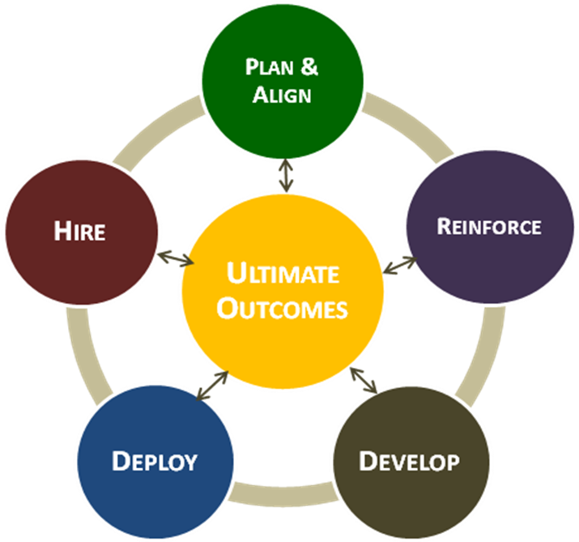

Figure 3 – Accountability of Workforce Management
Source: HR.wa.gov (2017).

___________________________________________________________________

- BUSINESS PERFORMANCE AND THE ROLE OF HR IN BUSINESS PLANNING AND THE CHANGE MANAGEMENT AGENDA
___________________________________________________________________
According to Kew & Stredwick ‘performance depends on both efficiency and effectiveness. Efficiency is a measure of economy in the use of resources. Broadly, it is measured as outputs divided by inputs. It involves avoiding waste, avoiding over-manning, increasing labour productivity, generally doing the right thing. Effectiveness is a measure of how far an organisation achieves its goals. It is about doing the right thing. Both are important but ultimately effectiveness is more important’ (2010, p 477)
There are various types of data, which are used by HR, including qualitative data i.e. using visual comparison and databases as well as survey results and quantitative data sources such as spreadsheets and bespoke software. HR is responsible for the optimum utilisation of internal and external data.
HR also has a pivotal role to play in change management which are controllable and uncontrollable change.
Controllable Change is:
- Involvement at the initial stage of project planning
- Advising project leaders of skills available within the organisation and identifying any skills gaps, training requirements, new vacancies and new working practices.
- Balancing out the narrow/short term goals with broader strategic needs
- Assessing the impact of change in one area/department/site on another part of the organisation
(Taylor and Woodhams, 2016)
Uncontrollable change is:
- The reaction from employees to change.
- Their reaction will be about their personality and the ability to change. Some will feel less comfortable about change.
- HR’s contribution would be to be prepared for different reactions and deal with appropriately.
(Taylor and Woodhams, 2016)
Business performance should be evaluated by traditional and modern indicators. The traditional indicators measure the performance of the employees with reference to the goals of the organisation.
Business performance can be evaluated by using the following:

- Balanced Scorecard - as shown in Appendix 1, the balanced scorecard is used by HR to align the business activities to the strategic goals of the organisation, improve levels of communication and evaluate the organisational performance. This scorecard was proposed by Norton and Kaplan and is one of the most popular performance management methods used.

- AMO-Black box model is used for assessing the performance of employees. AMO signifies the Ability, Motivation and Opportunity. The black box signifies the relation of HRM and the performance management within an organisation. It describes the mediating mechanism by the virtue of which HRM impacts the performance of the employees.

- Kotter’s 8-Step Change - as illustrated in Figure 4, HR also use Kotter's 8-Step Change. The various stages are create urgency, formation of powerful coalition, creation of a compelling vision, communicating the vision, removal of obstacles, creation of short term success, building on the change and true implementation of the modifications in the corporate culture.

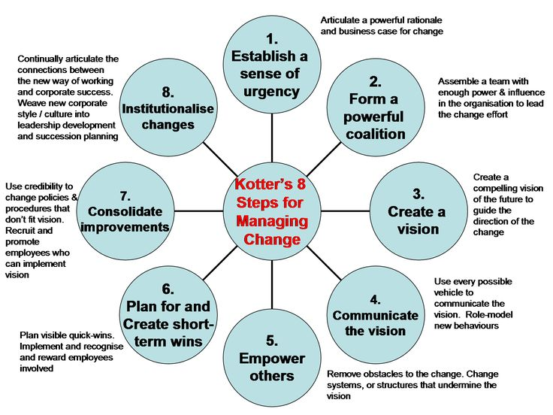

Figure 4: Kotter’s 8 Step Challenge
Source: Mindtools (2017)

- Key Performance Indicators - (KPIs) are a vital means by which organisations can judge how well they are performing. KPIs allow organisations to identify some of their most important metrics and provide a standardised way of determining whether or not they are meeting their goals, targets and objectives. KPIs can be used to measure virtually anything.
___________________________________________________________________

7.0 different sources of business and contextual data for planning purposes
___________________________________________________________________
HR uses a wide source of information for the purpose of planning and uses various sources of internal data and external data for the formulation of strategies and decision making. Internal data for planning purposes would be quantitative data such as salaries. This information would help organisations with workforce planning and help with the retention of staff. Qualitative information would be information gathered by satisfaction surveys from staff and customers. Results from customer surveys could provide information about how organisations compare to its competitors.
External data is utilised by HR for:
- Competitive information
- Government data
- Trends in HR
- Environmental analysis
- Technological advancements.
HR utilises vital information sources from both internal sources as well as the trusted external sources, for the purpose of smooth functioning.
___________________________________________________________________

8.0 CONCLUSION
___________________________________________________________________
The Human Resource function has a very promising future providing it is managed correctly and designed and led in a strategic manner. The main objectives of Human Resource Management essentially revolve around the effective utilisation of human resources, an optimum level of working relationships amongst employees and the maximum individual development of human resources.
The business environment is an extremely dynamic place where there is co-existence of both internal and external factors. HR plays a crucial role in balancing the effect of external factors. Therefore, HR is required to co-ordinate with the business processes and implements suitable policies and procedures that are beneficial to the organisation as a whole.

______________________________________________________________

REFERENCES
______________________________________________________________

Books:

Araimi, F. (2011). Power of Human Resources. Bloomington, IN: Authorhouse
Armstrong, M. and Taylor, S. (2014). Armstrong's Handbook of Human Resource Management Practice. Kogan Page Publishers
Bamberger, P.A., Biron, M. and Meshoulam, I, (2014). Human Resource Strategy: Formulation, Implementation and Impact. Routledge
Buller, P.F. and McEvoy, G.M, (2012). Strategy, Human Resource Management and Performance: Sharpening Line of Sight. Human Resource Management Review
Ghillyer, A, (2012). Business Ethics now. McGraw-Hill
Hanlon, A, (2013). How to Use Porter’s 5 Forces. Smart Insights
Jeston, J and Nelis, J, (2014). Business Process Management. Routledge.
Kew,.J and Stredwick,.J,(2010) Human Resource Management in a Business Context 1st edition, London
Lakshmi, T (2016). Linkage of HR Strategy with Business Strategy for Organisational Effectiveness an Analytical Study.
Marchington.N, et al. (2016) Human Resource Management at Work, 6th edition, CIPD: London
Marsden, P., Caffrey, M. and McCaffery, J. (2013). Human Resources Management Assessment Approach. Capacity Plus.
Momin, W.Y.M. and Mishra, K, (2015). HR Analytics as a Strategic Workforce Planning. IJAR.
Sadgrove, M.K, (2015). The Complete Guide to Business Risk Management. Ashgate Publishing, Ltd.
Salvendy, G, (2012). Handbook of Human Factors and Ergonomics. John Wiley & Sons.
Sikora, D.M. and Ferris, G.R, (2014). Strategic Human Resource Practice Implementation: The Critical Role of Line Management. Human Resource Management Review.
Stone, R.J, (2013). Managing Human Resources. John Wiley and Sons.
Taylor,.S,and Woodhams,.C,,(2016) Studying Human Resource Management 2nd addition

Website:
Benjamin.T, (2013) Internal and External environmental factors influencing HR activities. (Online) Available at www.smallbusiness.chron.com/external-internal-evironment-factors-influencing-hr-activities-34745.html [Accessed: 18/12/2017].
CIPD, (2015) changing HR operating models. (online) Available at https://www.cipd.co.uk/knowledge/strategy/hr/operating-models CIPD, (2015) HR and business ethics. (online) Available at https://www.cipd.co.uk/podcasts/hr-business-ethics [Accessed: 06/01/2018].
CIPD, (2015) PESTLE analysis. (online) Available at https://www.cipd.co.uk/knowledge/strategt/organisational-development/pestle-analysis-factsheet [Accessed: 06/01/2018].
CIPD, (2016) Strategy of Human Resource Management (online) Available at https://www.cipd.co.uk/knowledge/strategy/hr/strategic-hrm-factsheet [Accessed: 06/01/2018].
CIPD, (2016) Understanding the economy and labour market. (Online) Available at https://www.cipd.co.uk/knowledge/work/trends/economy-labour-market-factsheet [Accessed: 02/01/2018].
HR.wa.gov. (2016). Washington State HR https://hr.wa.gov/ [Accessed: 20/12/2017].
Management Study HQ (2013) Human Resource Management Models. Available from: https://www.managementstudyhq.com/hrm-models.html [Accessed: 20/12/2017].

http://www.professionalacademy.com/media/images-news/Porters-Five-Forces.png [Accessed: 06/01/2018].
Price. A (2017) The Harvard Map of HRM. (Online) Available at https://www.hrmguide.co.uk/introduction_to_hrm/harvard-map-.htm [Accessed: 06/01/2018].
Shingal, T (2016) Managing HR Roles: David Ulrich’s Model. Available from: https://blog.mettl.com/managing-hr-roles-david-ulrich-model [Accessed: 08/01/2018].
Ward, M & Rhodes, C, (2014) Small business and the UK economy. (online) available at http://researchbriefings.files.parliament.uk/documents/SN06078/SN06078.p [Accessed: 03/01/2018].

