
Student Name: Thomas Clarke
Student ID: 2437137
Module Code: LCLM4005_LON
Lecturer: Sukhpreet Grewal
Module: Employability and Career Development
Date: 23/03/2026

CV
Thomas Clarke
2437127@student.uwtsd.ac.uk
Age: 30
Work Experience
Delivery trade plate driver: Beadles Volkswagen-London June 2023 to December 2025 Picking up and delivering vehicles, conducting digital appraisals of the car's condition (dents, scratches, cleanliness) before and after transportation, and performing short test drives.
Skilled Labourer Ht: Helped tradesmen with various tasks on site, cleaning, prepping site for work, maintained tools. December 2019 to May 2023
Valeter/Driver NCCC: Assisted with moving cars to multiple sites and valeted new and used cars ready for sale. London February 2019 to November 2019
Skilled labourer Agency-London: Van driver, delivered materials to work sites and helped tradesmen. October 2015 to September 2018
Warehouse Operative Wolseley: Assisted with taking in deliveries, put stock in to locations and served customers at the front desk. London September 2014 to June 2015
Education Certificate of Higher Education Business Skills for the Workplace (Certificate of higher education) UWTSD-London, Level 4 Greater London June 2025 to Present
(GCSE) Crownwoods School, London Mathematics
(GCSE) Crownwoods School, London, English (GCSE) Crownwoods school-London
Skills • Labouring,
General hard worker within a team or on my own.
Office experience
Microsoft Word
Communication skills
Phone etiquette
Microsoft Excel
Organisational skills Microsoft Office, driving licence

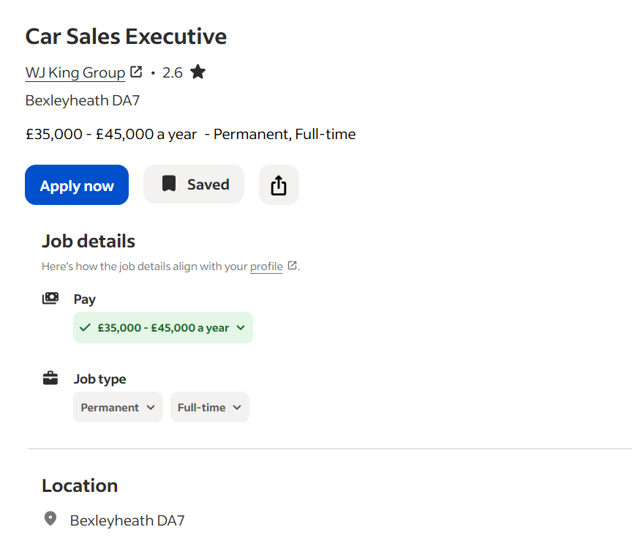

Full job description
WJ King is a trusted, family run business for over 65 years. We are one of the fastest growing car dealer groups covering South East London and Kent, across seven leading automotive manufactures, incorporating Vauxhall, Peugeot, Seat, Suzuki, Cupra, KIA and BYD franchises.
An exciting opportunity has now arisen for an experienced Car Sales Executive to join our team in WJ King, Bexleyheath, Kent.
This is a rare opportunity to join a winning team and bring your years of experience to the table.
Experience of brands is preferred but not essential.
We represent 7 Brands across 12 Locations selling new and used vehicles.
We are looking for a team player who can work within a strong team. Ideally, you will be capable of delivering a significant volume of units with a strong focus on customer satisfaction.
Rewards:
- £35,000.00 – £45,000.00 per year
- Pension
Apply today for immediate consideration...
Job Types: Full-time, Permanent
Pay: £35,000.00-£45,000.00 per year
Application question(s):
- Are you able to travel to our location within 30 minute journey time?
- Do you have a Driving Licence with less than 6 points
Experience:
- automotive: 2 years (required)
- sales: 2 years (required)
Work Location: In person

Thomas Clarke _

Alix Budgen
WJ King Group
Bexleyheath DA7
23/03/2026

Dear Mr Budgin
I wish to apply for the role of car sales executive, currently being advertised on indeed. Please find enclosed my CV for your consideration.
As you can see from my attached CV, I have over 4 year’s experience in the sales and dealership industry, and I believe in my ability to meet and exceed sales targets, that combined with my strong customer service skills and in depth product knowledge, during this time make me the right/perfect candidate for the role.
In my previous role as a trade plate driver I was responsible for vehicle inspection and appraisal, at Beadles, Volkswagen, I have been responsible for engaging with customers and was very consistent and dependable with meeting targets and business objectives.
During this time I have developed a lot of confidence and excellent communication skills for the industry, built lasting relationships with customers and gained knowledge of after sales support.
All of this, coupled with my enthusiasm and dedication, strong negotiation skills, customer-focused approach and passion for the automotive industry has helped me to believe In my confidence and ability to contribute to your team.
I am confident that I can bring this level of success with me to your organisation and help your company build upon their reputation in the automotive industry. With my previous experience and expertise, I believe my contribution will have a positive impact to your team.

Thank you for the opportunity to apply for this role. I look forward to hearing from.

Yours sincerely
Thomas Clarke

