Live Events Project (BMTP5018) Joshua Wilson

Mad Hatter’s Afternoon G&Tea

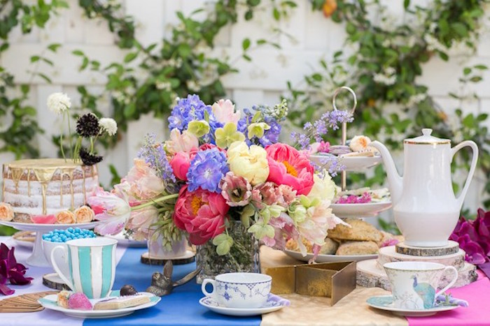

(Kara’s Party Ideas, 2016)
Table of Contents
Description and concept of the event 3
Event marketing plan 4
Market Research 4
Timing, location, and event programme 5
Project planning techniques 6
Aim and objectives 6
Contingency Plans 6
Financial Considerations 7
Risk Assessment 7
Evaluations 7
Conclusion 9
Reference List 10
Appendices 11

Description and concept of the event

This event will be an Alice in Wonderland-themed afternoon gin and tea party. There has been clear and effective negotiation the weeks and months prior to the event to ensure success.

To start developing and implementing the event, there are key components that need to be included and taken into consideration before the event begins. This is known as the characteristics of events.
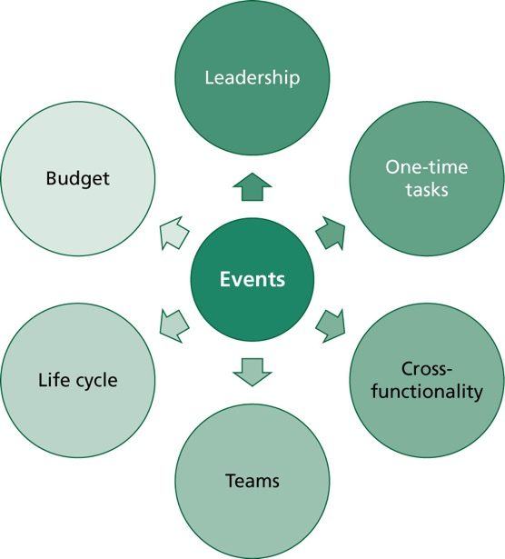
Six components lead to a successful event. Leadership being one. Being able to take control confidently and professionally ensures that each area is covered effectively, and more work can be achieved. An example of this was having everyone’s input to the choice of venue for the afternoon tea. Many people had different suggestions to a venue, but we showed leadership in casting a vote. All of those that had chosen the most popular venue got to take it. This was us stepping up as leaders in our team.

(Bladen, 2012, p.24)

Furthermore, all our team were delegated into certain roles. For example, the hospitality department, the social media, and design department etc. Having these areas compiled and designated to each member, meant that one-time tasks were able to be achieved, professionally and promptly.

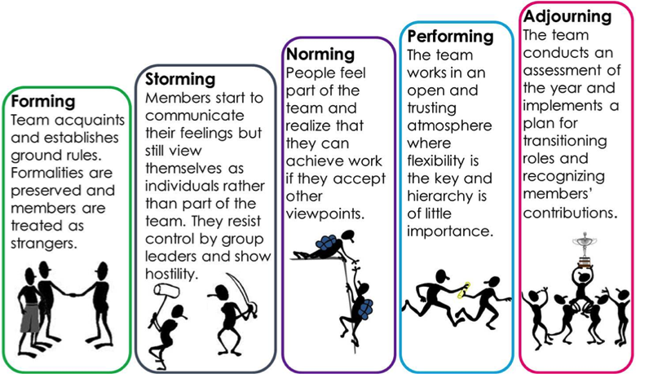
“Tuckman's theory focuses on the way in which a team tackles a task from the initial formation of the team through to the completion of the project. Tuckman later added a fifth phase; Adjourning and Transforming to cover the finishing of a task.” Using the expertise learned from this theorist and through personal initiative, this made the implementation stage easier to execute.

(The Team Building Company, 2022).
The team has ensured that security has been established for the venue, so that members of the public can be made to feel safer, as well as alcohol being served. Sam Goodfield will be taking part of this operation, as per negotiation with the team.
(NS4B, 2018)

Jessie, a member of our team is the Director of Harbour Lights Spirits. She will be bringing miniature bottles of her gin for a welcome drink for guests. This is a great business proposition and a great gesture for guests.

Event marketing plan

The team worked on a marketing plan to help publicise and promote the afternoon tea event as much as possible. One factor being the colour of the venue. “People have colour preferences, and colours affect mood. Colour can be manipulated through lighting or other design features. ‘Colour symbolism’ is culturally defined, as in whether red suggests heat, anger or danger.”
(Getz, 2012, p.230)

The factor of colour is one of many that Getz describes. Will the public enjoy it, and do they like the look of it? The colour pink in GNSQ adds to the unique aesthetic and to the colours used in Alice in Wonderland. It blends in and provides sharpness to the venue.

Together, the team were able to push this event out on social media across Swansea, so that the event was publicised to the highest standard. For example, Facebook and Instagram were used, as these are the two platforms that most people view.

Working alongside Ty Hafan charity to raise awareness. Through a live auction that will be taking place during the event, all proceeds raised will be going to this charity.

This event will be marketed to predominately adults, as there is going to be alcohol served. The team will be expecting this demographic on the day. As well as this venue being licensed, children will not be able to attend.

Market Research

As part of the theme the team were going by for the event, one of the team members conducted some research into how many people drunk gin. It was an interesting research plan, which can be seen in Appendix 3.

Food by Sean was found. A local catering firm in Swansea, the team were impressed. Their menu gave the team a real clarity into the style of food served. Before confirming the menu, the team had to ensure that the food served was going to generically appeal to everyone. Any food that was too extravagant perhaps would not have been as successful.

Ideas that this company gave to the group was of a great standard. They shared photographs of what their ideal afternoon tea would include.

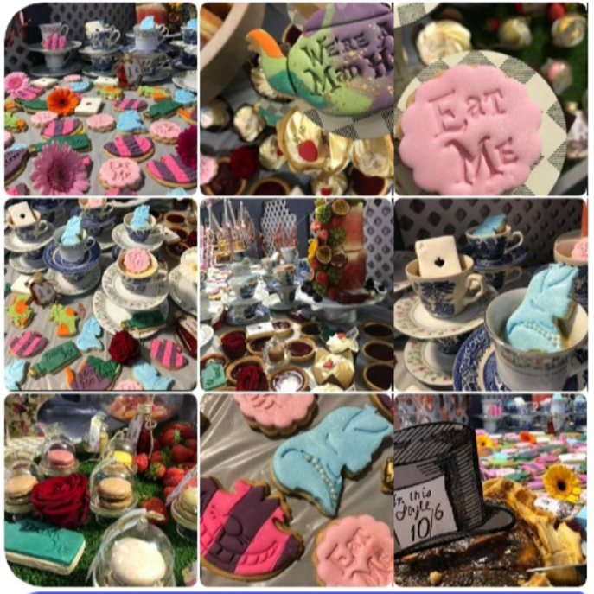
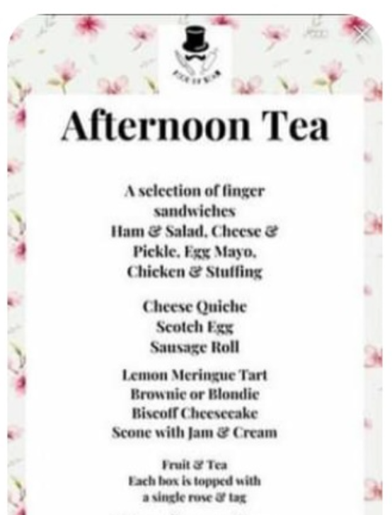
(Food by Sean, 2022) (Food by Sean, 2022)
What makes the afternoon tea event stand out to all the others is what the team wants. This event will bring the WOW factor, as the venue, theme and items used will stand out amongst the public. For example, the venue has different authentic items that the public will love. These being, different sculptures, fancy mirrors, velvet ornaments etc. All these quirky ideas draw the public in more and heightens the WOW factor even more.

Additionally, Gin Ne Sais Quoi staff will be dressing up in Alice in Wonderland costumes to stand out with the aesthetic of the theme.

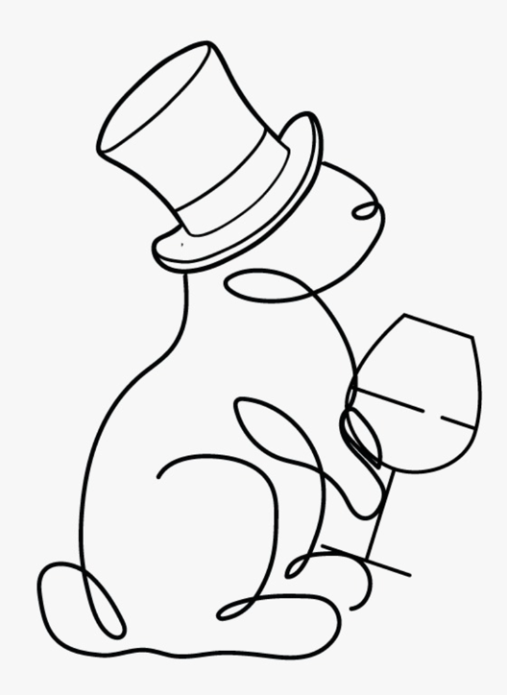
Furthermore, decorations were needed. For example, the White Rabbit with his clock, playing cards, eat and drink me bottles for the tables etc. It is vital that expectations are excelled, so that the public go away from the event ready to spread the great news to the wider community. One of the logos that the team came up with shown below was discussed and linked in greatly to the event. It was thought that it would be eye-catching and pleasing to the public.

Timing, location, and event programme

The Alice in Wonderland Afternoon Tea will be held on 30th April 2022 from 4:00-7:00pm, as members of the public would be free and willing to come and support after work etc. Looking at this from a COVID perspective, the public are eager and ready to get back to events again. The team chose an afternoon tea party, as there isn’t a lot of people close together like a concert, but they still have the same atmosphere from getting out again.
Created by the team

Gin Ne Sais Quoi will be the venue. The aesthetic of pink flowers displayed across the venue, different unique sculptures, purple and red velvet furniture etc fits in nicely. The team liaised with the General Manager to discuss logistics etc. Geographically, GNSQ was the most convenient, as it is situated in the heart of Swansea Marina. This makes it easier for the public to get to, as well as the availability of public transport close by.
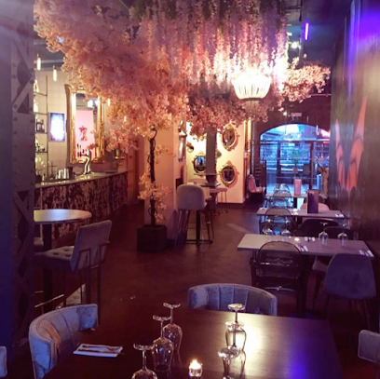

Project planning techniques

Regarding the events programme, members of the team will be abiding by a planned itinerary that will be used for the duration of the event. An outline of this plan can be found in Appendix 1 of this assignment.

Aim and objectives

(Pubs With, 2022).

To run a successful, professional event that the public will love and remember. To ensure that the fundamentals of the event stick by the team, so that future events can be excelled and developed further. The proceeds gained from this event will be going towards a worthwhile and important charity (Ty Hafan), who provide holistic palliative care for children living with life-limiting illnesses. Everyone is using their events management expertise to broaden their knowledge in preparation for their future career.

There needs to be a mentality of success within the group. The event should give all students the skills and qualities needed to be a successful events planner and liaise with other industry professionals in their working lives.

Furthermore, the team has incorporated SMART objectives into the event, so that there is a clear and concise portrayal into what is going to be accomplished. Having the ability to sell pre-sale tickets for the public is key, as the team wants the venue to be filled. The manager of GNSQ will also facilitate with the selling and distribution of the tickets.

Contingency Plans

A venue. It was extremely difficult to get a venue confirmed, as it conflicted with other events, time of day etc. Even though this proved to be a minor inconvenience for the team, effective communication was carried throughout, so that a venue was able to be confirmed eventually. Another contingency was the day of the week. In the planning stages of the event, there was discussions of having the event throughout the week. This just was not going to work, as too many people would have had to rush home from work and go straight to the event. This was not feasible.

However, there were two incidents where the decided date clashed with another event in Swansea that perhaps would have drawn bigger crowds. However, the team was able to review all these dates and collectively decide the best day that would suit everyone and for the event to successfully go ahead.

“The staging of any event has to make allowances for what might go wrong. ‘What if’ sessions need to be implemented with the staff. A stage at a festival may face an electricity blackout, performers may not arrive, or trouble may arrive instead. Therefore, micro-contingency plans need to be in place. All these must fit in with the overall event risk management and emergency plans. At corporate events in well-known venues, the venue will have its own emergency plan that needs to be given to everyone involved.”
Bowdin et al (2011, p.516)

Financial Considerations

All financial matters are imperative for the event, as ultimately, the team wants to make a profit overall. An outline of the cost associated with the areas of this event can be found in Appendix 2.

Harbour Lights will be providing miniature bottles of Harbour Lights Sunset Gin for a discounted price of £5 per bottle. Giving a discount will benefit all parties, as it is cheaper for the public, but it also promotes and benefits marketing, as the logo on the bottle will make the public remember them.

Risk Assessment

Detailed risk assessment can be found at Appendix 5. Regarding licensing and documents, the venue will have those ready and prepared for us hosting the event, as they are licensed bar. Research into this was planned in the initial phase.

Evaluations

Evaluations are a huge part of the events process. According to Bowdin, “…An evaluation of the event concept in order to determine the extent to which the event concept matches the needs of the event and the resources available to the Event Manager to implement it.”
Bowdin et al (2006, p.108)

The execution of the event was professional. According to Shone and Parry 2019, “There are several elements to closing down an event. Besides clearing out the venue and closing the doors, there will be a range of administrative tasks to tie up. These will include the completion of the accounts, payment of final bills to contractors, and final marketing activities such as closure press releases and providing information about future plans or next year’s event, if there is to be one.”
Shone and Parry (2019, p.285)

The event close-down links to three other areas of the ‘final phase’. During the initial phasing of the event, the team drew up a work break-down schedule that was able to be suited to each department when the event had concluded. This ensured continuity and promptness was maximised.

Summary sheets detailing how to break down the event were all given to each member of the team. This made it easier for everyone to understand what to do and how to do it.

Additionally, administrative duties including financial turnover, raffle money etc will be analysed and completed post evaluation. The physical close-down areas like putting chairs and tables away, as well as the decorations etc will be done after guests leave and the premises is empty.

Overall, the main evaluation will be carried out by the team whenever every box is ticked and completed.
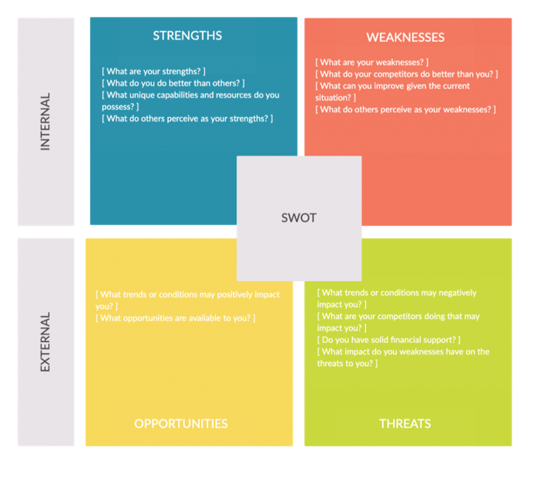
According to The Guardian, “A SWOT analysis is an internal review of an organisation's strengths, weaknesses, opportunities, and strengths. These steps provide an organisation with a rounded view of the current position of the business internally and externally and helps you define achievable goals or objectives.”

(Jervis, J. 2012)
Strengths of the team are communication, professionalism, and hard-working mentality. These areas are what made the team stand out from others and ensured a successful event was guaranteed.
(Creately, 2021)

Weaknesses lack of communication from various organisations. With emails, there wasn’t as good of communication that was once thought. This led to more contingency planning. This could be an area that could be improved. Physically visiting these businesses with appointments to get areas covered. Lack of initiative may have been an issue here.

There is always room for opportunities. The team believe that a small afternoon tea party like this can expand, grow, and prosper into bigger venues across Swansea and South Wales. Getting the social media presence around Wales can help even more, which will benefit the team.

Threats could be major competition. Companies in Wales could take over an event easier than the team at GNSQ. This could have a financial impact on the team and lead to hardships when trying to make profits elsewhere etc.

Conclusion

This event was created by a team of gracious and professional people. This assignment highlights all the areas that the team covered to ensure event success. Overall, the team is proud of what has been achieved and the planning techniques that have been achieved.

Reference List

- Bladen, C. (2012) ‘Events Management: An Introduction’. 1st edn. New York: Routledge

- Bowdin, G, et al (2011) ‘Events Management’ Oxford: Butterworth Heinemann. 3rd edn. Great Britain: Routledge

- Bowdin, G. A. J. et al (2006) ‘Events Management’. 2nd edn. Great Britain: Routledge

- Creately, (2021) The Complete Guide to Strategy Evaluation. [Image] Available: https://creately.com/blog/business/strategy-evaluation-process/ [Accessed: 18 March 2022].

- Food by Sean, (2022) Photos. [Image] Available: https://www.facebook.com/Food-by-sean-1180888145303151/photos/?ref=page_internal [Accessed: 15 March 2022].

- Food by Sean, (2022) Photos. [Image] Available: https://www.facebook.com/Food-by-sean-1180888145303151/photos/?ref=page_internal [Accessed: 15 March 2022].

- Getz, D. (2012) ‘Event Studies: Theory, Research and Policy for Planned Events’. 2nd edn. Great Britain: Routledge

- Goldblatt, J (2006) ‘Special Events: Event Leadership for a New World’ Wiley: New Jersey

- Jervis, J. (2012) ‘Best bits: How to create the perfect business plan’, The Guardian, 20th March. Available at: https://www.theguardian.com/social-enterprise-network/2012/mar/20/best-bits-business-plan-starting-up (Accessed: 18 March 2022).

- Kara’s Party Ideas, (2016) Alice in Wonderland Tea Party. [Image] Available: https://karaspartyideas.com/2016/07/alice-in-wonderland-tea-party-3.html [Accessed: 25 February 2022].

- NS4B, (2018) TUCKMAN’S STAGES OF GROUP DEVELOPMENT. [Image] Available: https://ns4business.com.br/tuckmans-stages-of-group-development/ [Accessed: 03 March 2022].

- Pubs With, (2022) Gin Ne Sais Quoi. [Image] Available: https://pubswith.com/pub/606ea191615f662e3467a953 [Accessed: 03 March 2022].

- Shone, A. and Parry, B. (2019) ‘Successful Event Management’. 5th edn. Great Britain: Ainscow, A.

- The Team Building Company (2022) Forming - Storming - Norming – Performing. Available at: https://www.teambuilding.co.uk/theory/Forming-Storming-Norming-Performing.html (Accessed: 03 March 2022).

Appendices

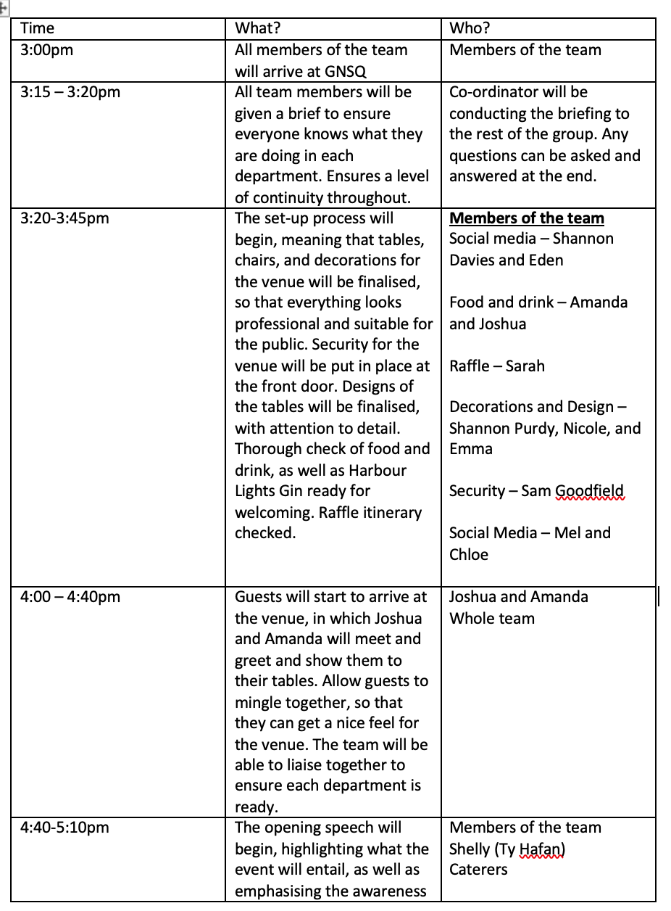
(1)

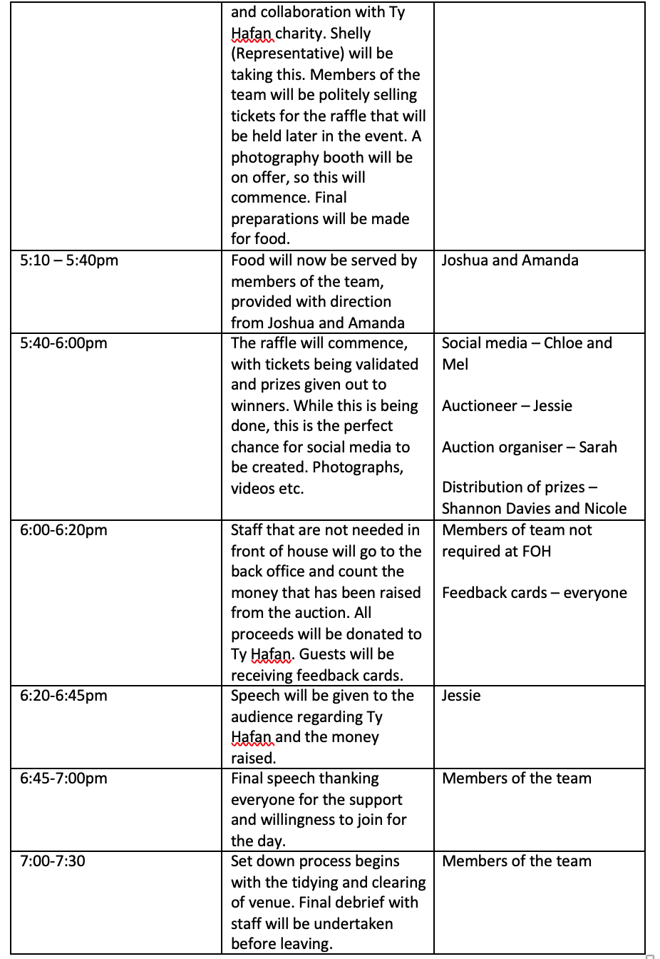

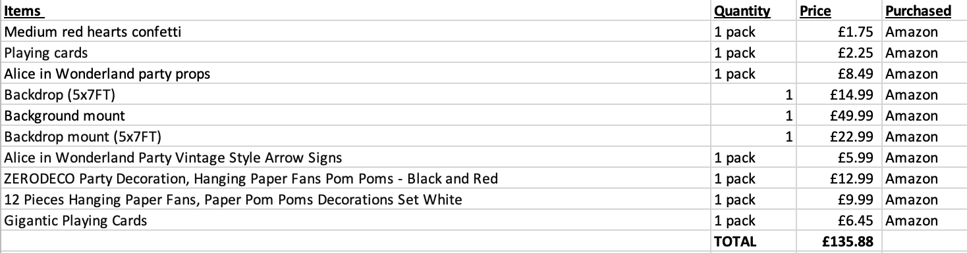
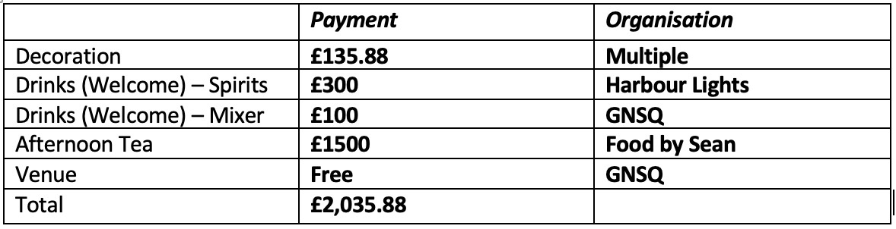
(2)

Gin Survey
(3)
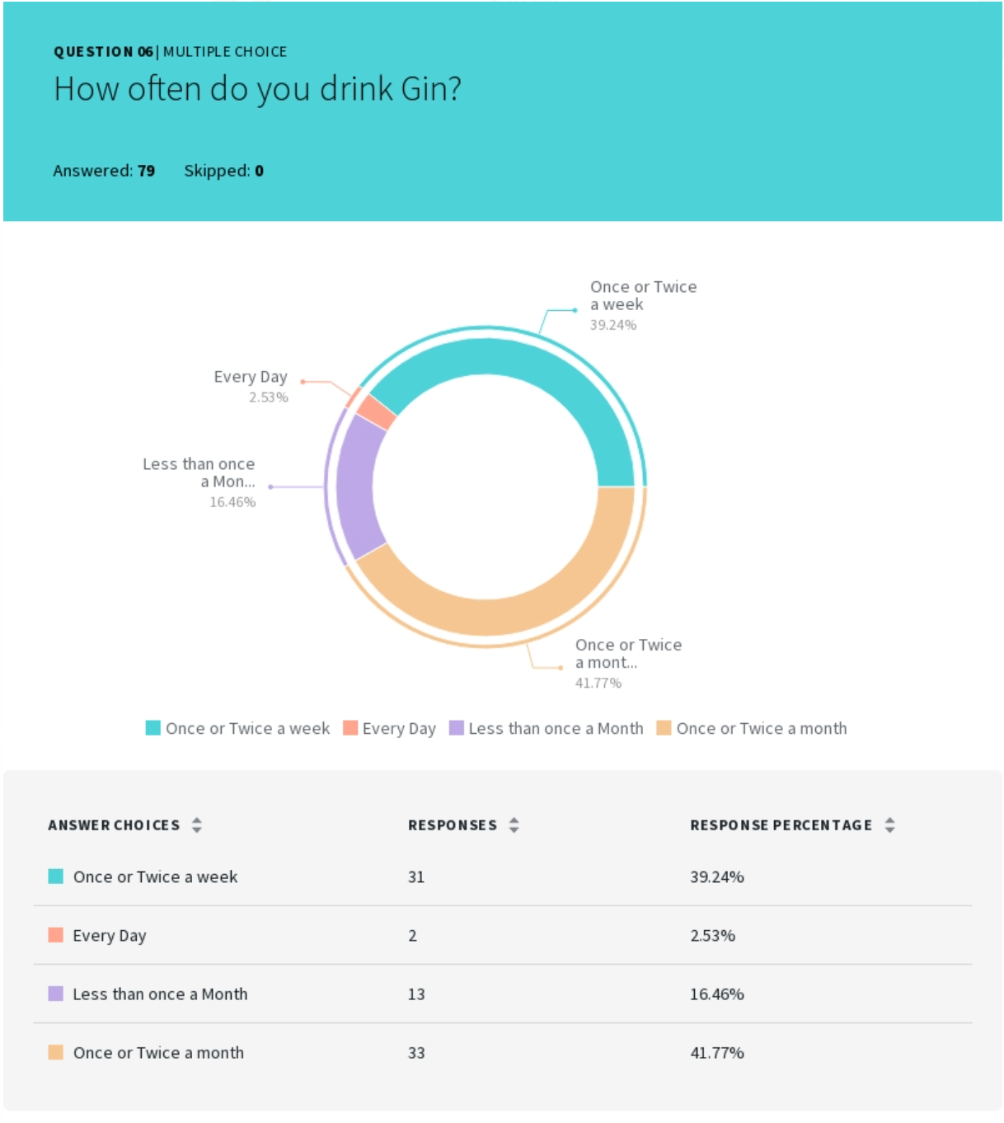
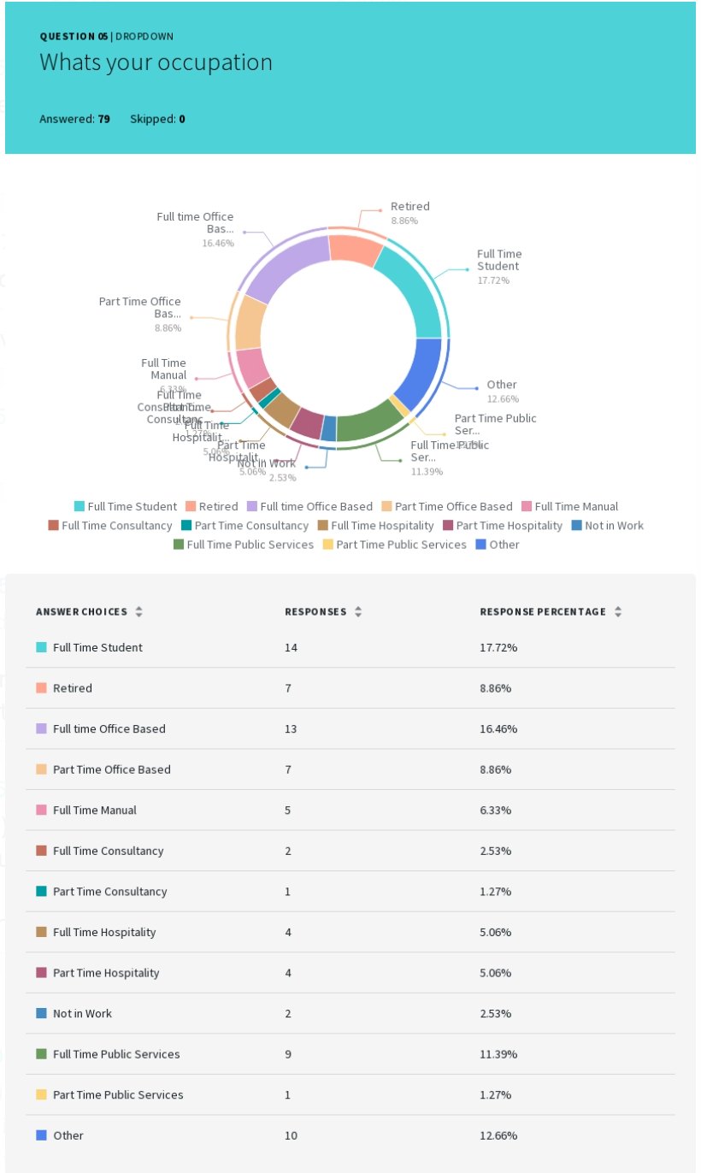
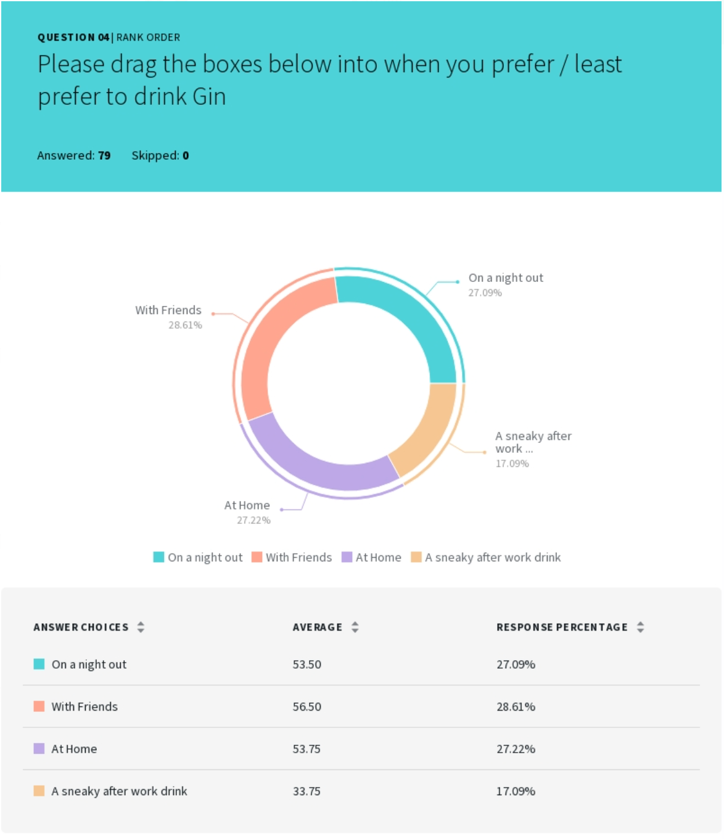

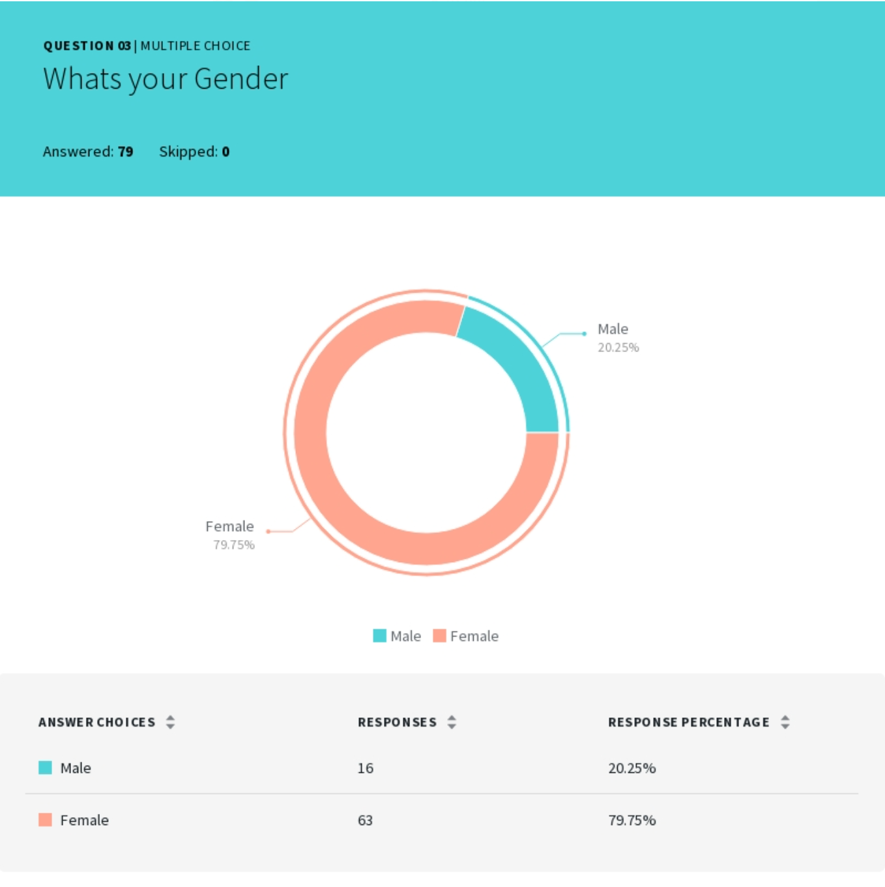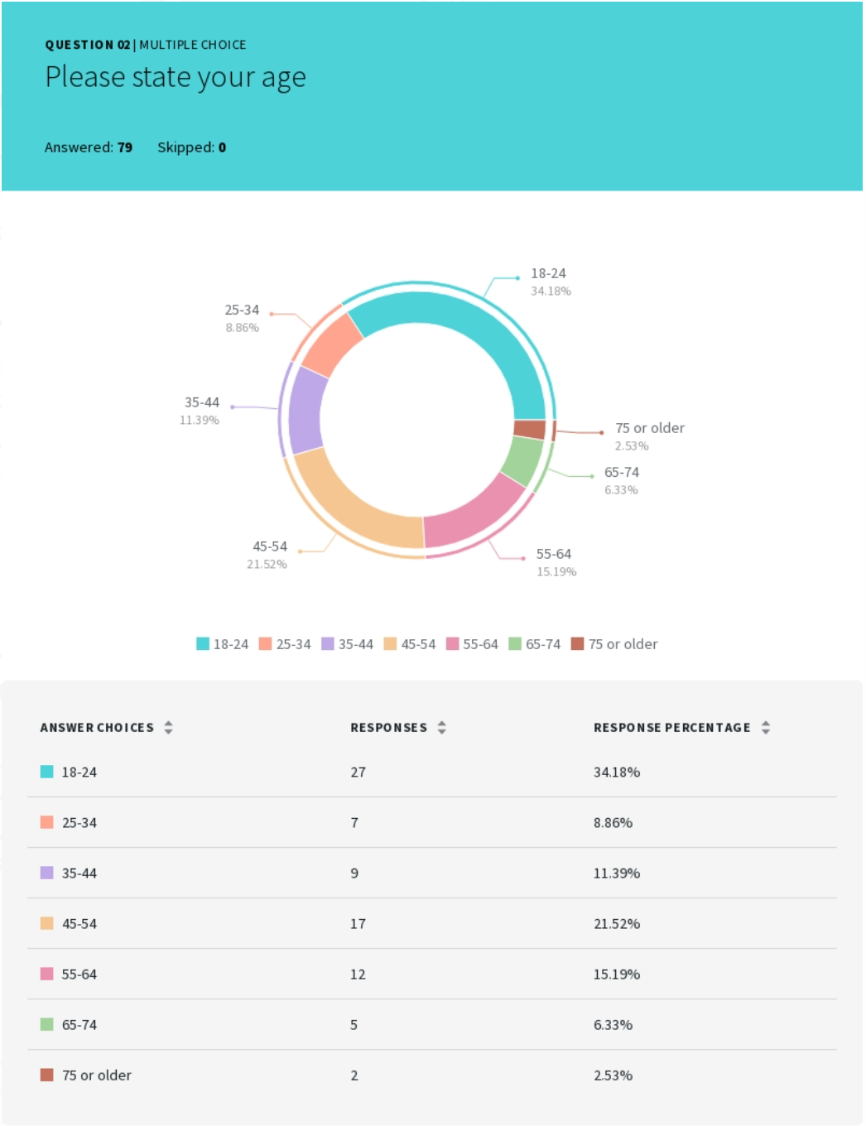

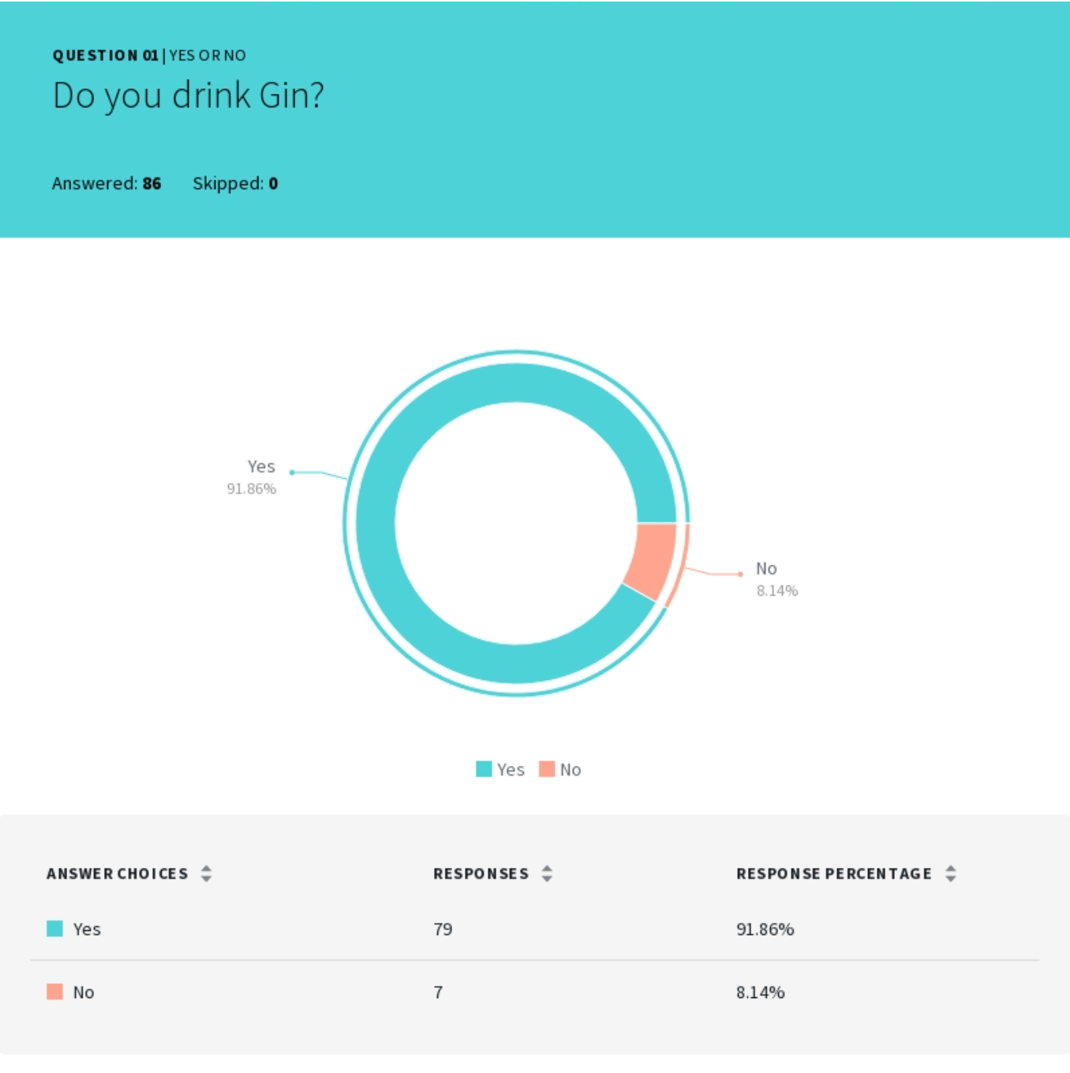

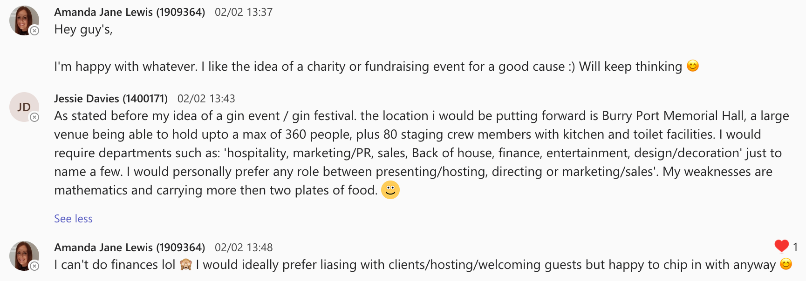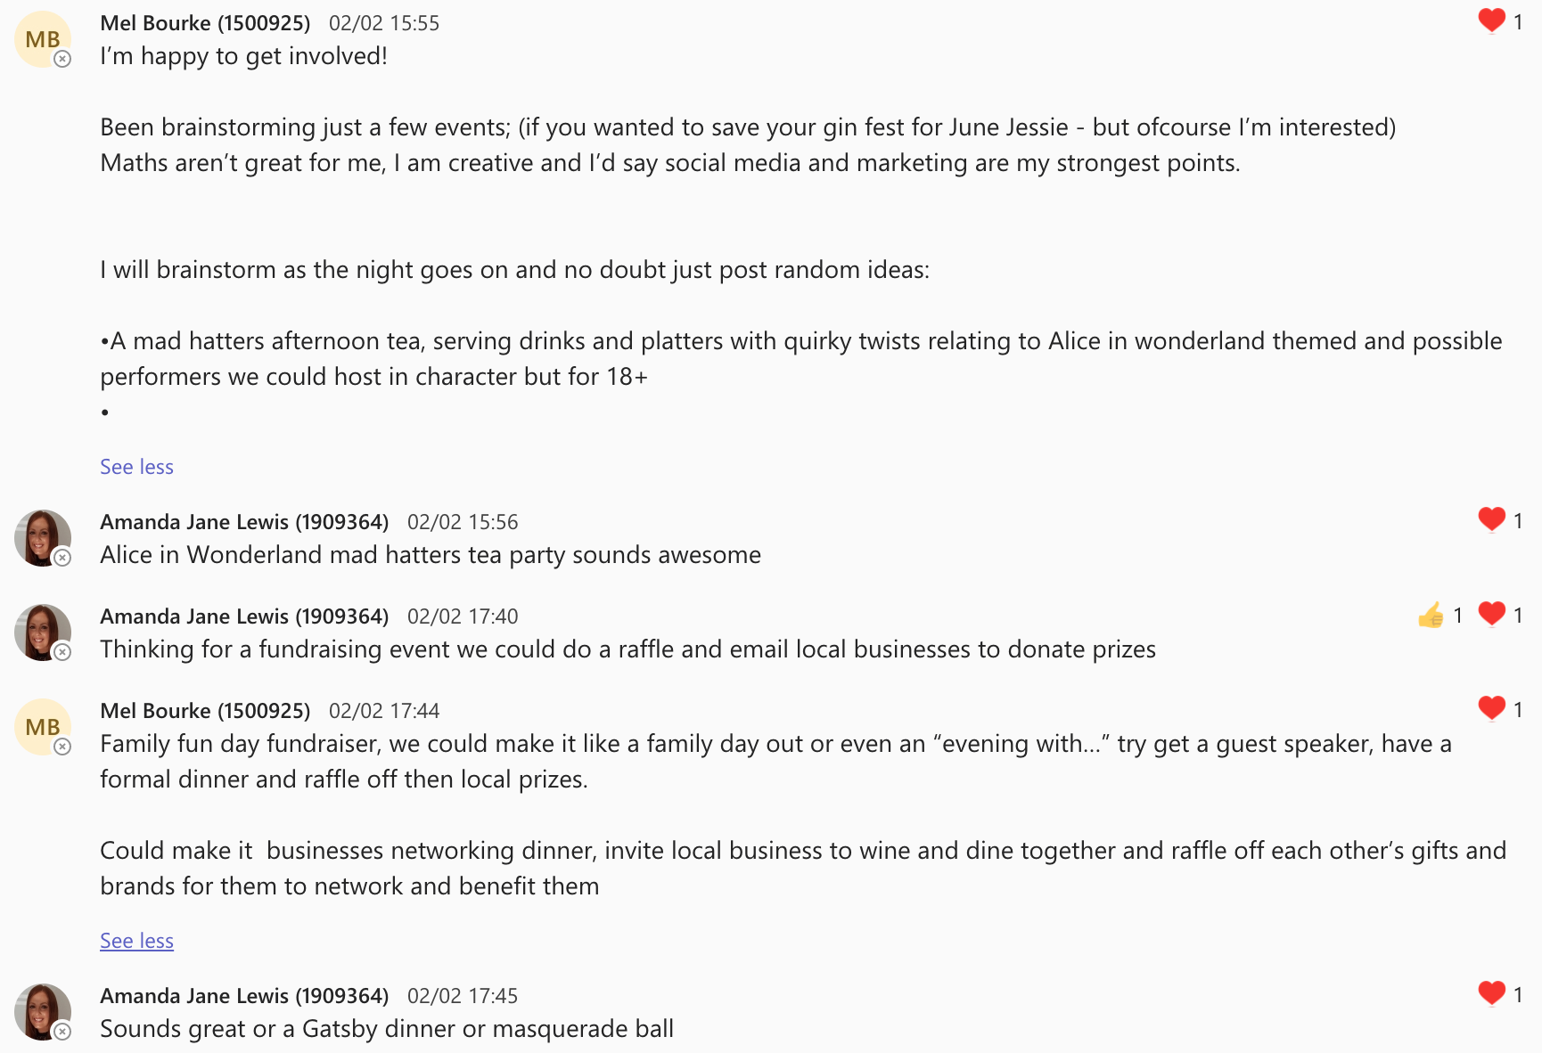
(4)
Screenshots of Meetings etc

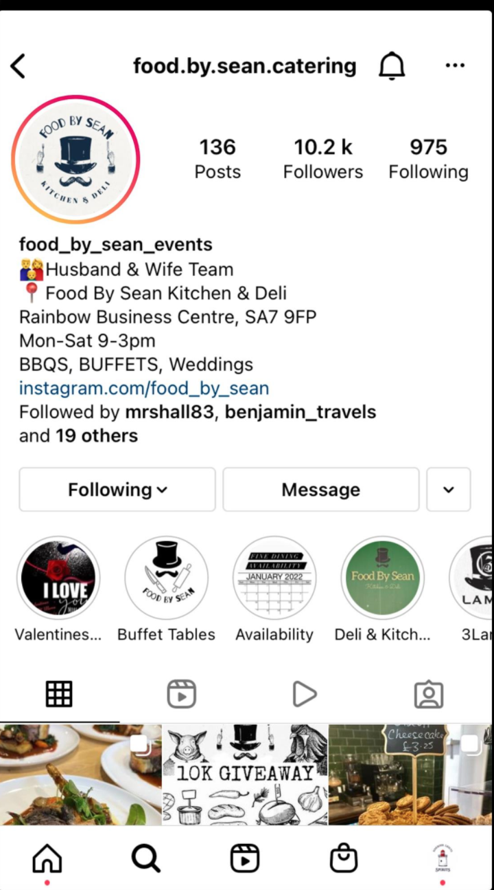
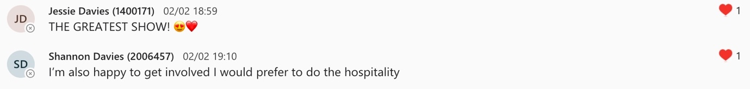

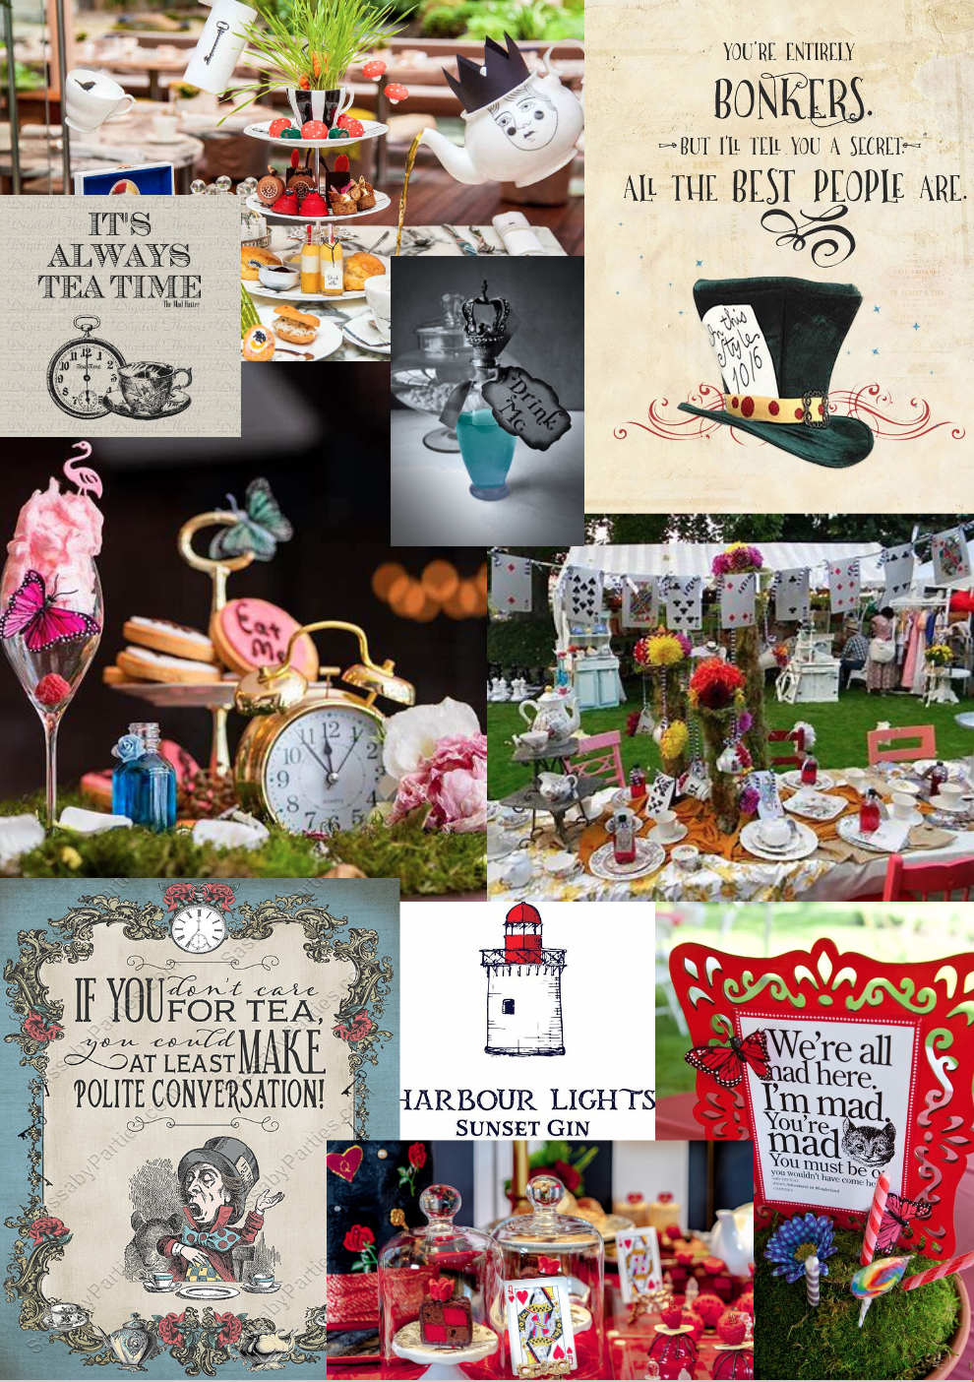

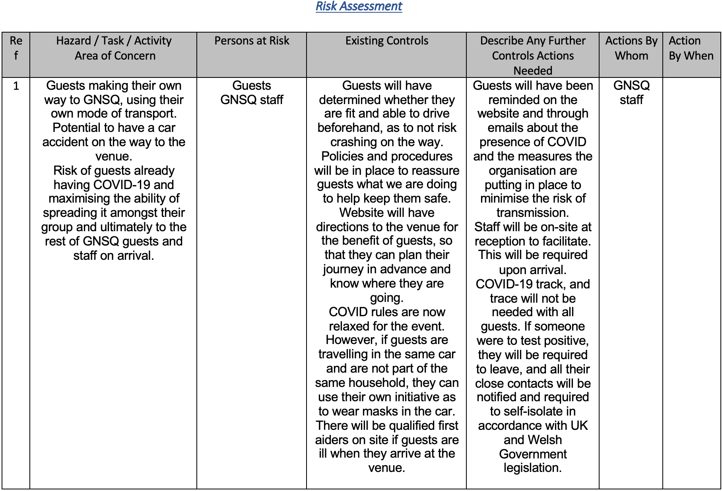
(5)



