Pericles Funeral Oration
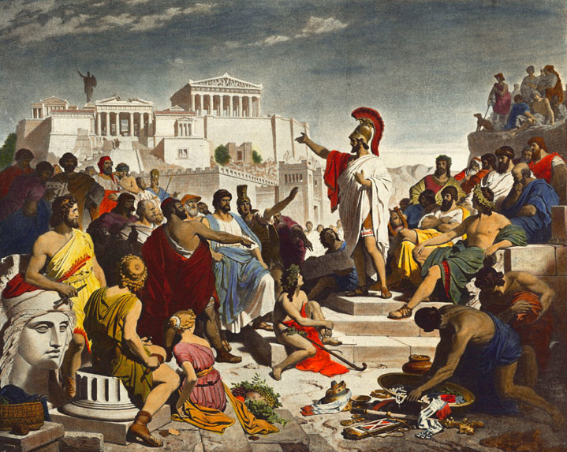
Thucydides account of Pericles Funeral Oration (Book 2, Chapter 2, Section 34-46) in his ‘History of the Peloponnesian War’ is considered to be one of the most important speeches in Western Democracy. Many modern scholars agree, that the speech is the foundation of great speeches such as the ‘Gettysburg Address’ and the ‘Finniest Hour’. The speech was delivered by the Strategoi Pericles around the year 431BC (Thucydides, 1954, 2.2.34) during the First year of The Peloponnesian War. Athens had been laid siege to by Sparta and her allies. Athens knew that it would be unable to win a land campaign against the Spartans due to its small army (Thucydides, 1954, 2.1.13). However, if the Athenians could gather every Attican citizen into the walls of Athens, use her Navy to resupply the city and draw Sparta into Navel combat, Then the Athenians might stand a chance (Thucydides, 1954, 2.2.14). This became known as the Periklean strategy and in 431 BC, the strategy was put into place as war with Sparta was declared with a Peloponnesian army on its way (Thucydides, 1954, 2.2.14+17). As custom when Athens went to war, a public funeral was held to those who were the first to die in war (Thucydides, 1954, 2.2.34). At this sacred of events, Pericles a Strategos who had been one of the main advisors to the Athenian assembly, made a speech to the people of Athens to try and boost their moral and glorify Athens’ form of democracy (Book 2, Chapter 2, Section 34).
Figure 1:Phillip Von Foltz’s 1852 oil on Canvas painting of , ‘Pericles Gives the Funeral Speech/ Perikles hält die Leichenrede’, https://commons.wikimedia.org/wiki/File:Discurso_funebre_pericles.PNG

When reading the oration, we have to take note of a number of factors. The main factor being Thucydides’ methodology. When Thucydides began writing his History, he wrote many of the speeches as if he was writing them and what he thought should have been said during them (G. Cawkwell, 1997). Scholars such as Paul Cartledge have been able to recognise Thucydides’ style of writing and rhetoric showing that in some sections, he is elaborating on what was said (P. Cartledge 2016). Also, he wrote the speeches sometime after the events that he talks about and scholars’ debate whether he was present or not (G. Cawkwell, 1997). Therefore, Pericles Oration has been affected by the methodology used by Thucydides because Periclase’s’ speech is being used as a mouthpiece for Thucydides (G. Cawkwell, 1997, p2) and isn’t entirely a word for word transcription.

One of the main things that we get from this oration is the idea that Athenian democracy is a political system that should be considered a model to other Polies and that it has many benefits to the polis society (G. Cawkwell, 1997) . These benefits include a law system that provides it people with justice and “Favours the majority instead of the few” (Thucydides, 1954, 2.2.37). The speech also criticises the Spartans and how their way of life, limits their prosperity. “We live freely, not only in our government but in our everyday lives” (Thucydides, 1954, 2.2.37), “We leave our city open to all” and “our enemies seek bravery with painful training” (Thucydides, 1954, 2.2.39). These remarks are designed to make the Athenians support the war effort and is again a way for the people to support Pericles even though his strategy to keep everyone in Athens was unpopular (P. Cartledge 2016). In all, The Funeral Oration is a cornerstone of modern democratic rhetoric. Even though most of the speech is embellished by Thucydides and may be written to how he would have presented the speech, it tackles with challenges modern democracy faces and is a powerful piece of literature that defends our democratic process.,

Reference List:
P. Cartledge (2016), ‘Democracy: a life’, Oxford, Oxford University Press

G. Cawkwell (1997), ‘Thucydides and the Peloponnesian War’, New York, Routledge

Thucydides (1954), ‘History of the Peloponnesian War’, London, Penguin Group

P. Von Foltz (1852), ‘Pericles Gives the Funeral Speech/ Perikles hält die Leichenrede’, [oil on Canvas], https://commons.wikimedia.org/wiki/File:Discurso_funebre_pericles.PNG

