Module: Problem Solving and Decision Making
Module Code: LCLM4004

Student Name: Emma Louise

Table of Contents
Introduction 3
Identifying the Problem (5W2H Analysis) 4
External Environment (PESTEL Analysis) 4
Cause-and-Effect Analysis 5
Potential Resolutions and Decision-Making 6
Conclusion 7

Introduction
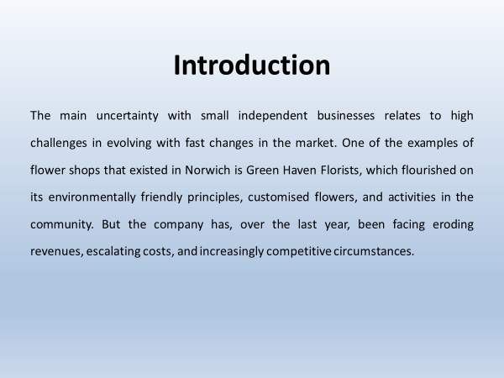
The main uncertainty with small independent businesses relates to high challenges in evolving with fast changes in the market. One of the examples of flower shops that existed in Norwich is Green Haven Florists, which flourished on its environmentally friendly principles, customised flowers, and activities in the community. But the company has, over the last year, been facing eroding revenues, escalating costs, and increasingly competitive circumstances. It is in the current presentation that structured problem-solving tools are applied to seek the nature of the challenges facing the business, what surrounds the business, and even the roots of the decline, before proposing avenues for making informed decisions.

Identifying the Problem (5W2H Analysis)
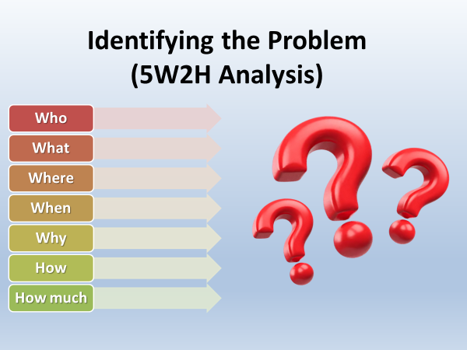
The first one is to demystify the nature and the range of the problem. Using the 5W2H method:
- Who? Headed by Liam and Priya Patel, Green Haven Florists and their customers.
- What? This represents a 30 percentage point decrease in sales in-store in the last year.
- Where? The real-world store on a high street in Norwich is becoming more and more unproductive due to decreased pedestrian traffic (Ahmad et al., 2018).
- When? Especially apparent during the past 12 months.
- Why? Increase in operational expenses, intense online competition by the online florists, and the online presence is outdated.
- How? The consumers have moved to the online shopping process, and the retailers that deliver the products to the customers on the same day and give incentives.
- How much? The loss of revenue is so harsh that it jeopardises the sustainability in the long run.

External Environment (PESTEL Analysis)
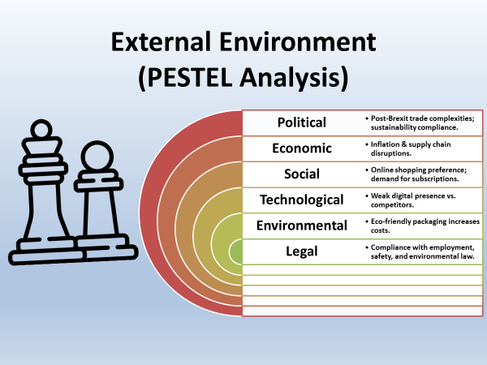
The PESTEL framework is used to familiarise oneself with external forces.
- Political:
The post-Brexit trade complexities and importation regulations also make it more expensive to source some of the flowers (Shin and Moon, 2021). Business sustainability policies also compel companies to package products in a way that is practical to the environment, and potentially, though in line with the philosophy of Green Haven, this increases the cost.
- Economic:
Supply chain issues and inflation have increased the prices of flowers, particularly foreign types of flowers such as tulips and orchids. Economic uncertainty also requires businesses to further cater to price sensitivity among customers who look online to find cheaper alternatives.

- Social:
People have moved towards the habit of shopping online. Younger customers are sensitive to online interactions and subscription services, whereas long-term clientele requires promotional plans more and more commonly, as well as almost free delivery.
- Technological:
Their competitors have a greater online presence via Instagram marketing and an easy-to-use website. The old-fashioned website of Green Haven does not accommodate online orders and reaches the digital audiences efficiently.
- Environmental:
The fact that Green Haven has a strong eco-friendly approach can also be considered an advantage; however, biodegradable wrapping and using locally sourced flowers are more expensive than options with a conventional approach. Those competitors not focused on sustainability can cut prices (Grewal et al., 2017).
- Legal:
Companies are required to adhere to employment law, health and safety laws, and environmental standards that contribute to the cost of compliance (Bocquet et al., 2019).

Cause-and-Effect Analysis
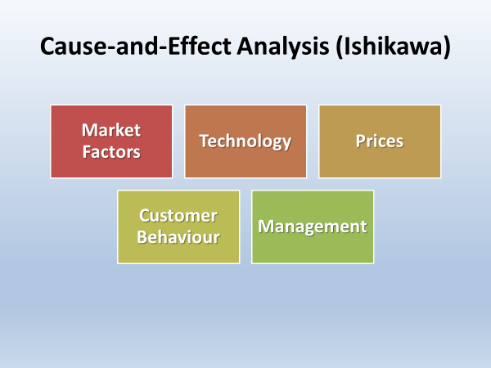
An FDI (Ishikawa) display shows the reasons why Green Haven has difficulties:
- Market Factors: The threat of more competition by national chains and boutique florists.
- Technology: Software, Old-fashioned website, poor digital marketing.
- Prices: Increase in the expenses of importing flowers, and the high prices of green packaging (Khan et al., 2021).
- Customer Behaviour: Choosing online shopping and less expensive variants (Tien et al., 2021).
- Management: Low experience with digital trends, and uses word-of-mouth advertising.
This is a result of the interplay of these reasons, which explain the fall in sales and profitability. Whereas certain ones may partially be out of control (such as inflation), others (including digital presence and service models) can be handled on a strategic level.

Potential Resolutions and Decision-Making
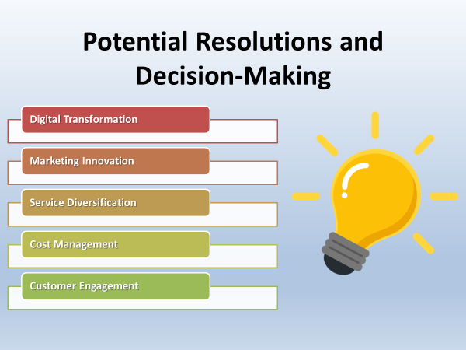
There are a number of strategic choices Green Haven can use:
- Digital Transformation:
Expand the site with some of the current e-commerce functionalities, mobile optimisation, and better navigation. Launch any type of subscription services (e.g., weekly or monthly delivery of the flowers, etc.) in order to generate recurrent revenues (Lamberton and Stephen, 2016).
- Marketing Innovation:
Instead, increase social media activity, and Instagram, in particular, by displaying tailor-made arrangements and interaction with local influencers.
- Service Diversification:
Hire more drivers, such as drivers who deliver to Norwich within four hours, in order to compete with other nationwide chain stores. Make Wedding, event, and corporate packages.
- Cost Management:
Discuss with the local suppliers to get a lower price and consider buying the hybrid type of packaging that is environmentally-friendly, yet cheaper.
- Customer Engagement:
Introduce loyalty programs as a method to keep long-term customers, as well as make sustainability the selling point (Kumar and Reinartz, 2018) .

Conclusion
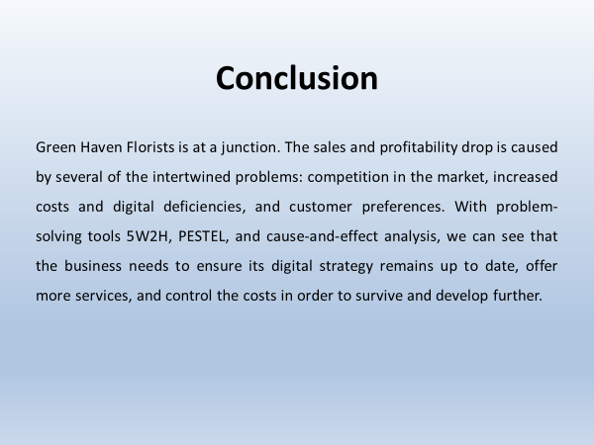
Green Haven Florists is at a junction. The sales and profitability drop is caused by several of the intertwined problems: competition in the market, increased costs and digital deficiencies, and customer preferences. With problem-solving tools 5W2H, PESTEL, and cause-and-effect analysis, we can see that the business needs to ensure its digital strategy remains up to date, offer more services, and control the costs in order to survive and develop further. The case shows how small businesses cannot only bank on previous strengths, but they also have to evolve time and again in relation to the constantly changing market conditions.

References
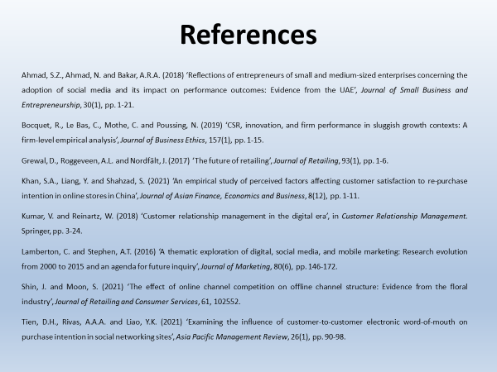
Ahmad, S.Z., Ahmad, N. and Bakar, A.R.A. (2018) ‘Reflections of entrepreneurs of small and medium-sized enterprises concerning the adoption of social media and its impact on performance outcomes: Evidence from the UAE’, Journal of Small Business and Entrepreneurship, 30(1), pp. 1-21.
Bocquet, R., Le Bas, C., Mothe, C. and Poussing, N. (2019) ‘CSR, innovation, and firm performance in sluggish growth contexts: A firm-level empirical analysis’, Journal of Business Ethics, 157(1), pp. 1-15.
Grewal, D., Roggeveen, A.L. and Nordfält, J. (2017) ‘The future of retailing’, Journal of Retailing, 93(1), pp. 1-6.
Khan, S.A., Liang, Y. and Shahzad, S. (2021) ‘An empirical study of perceived factors affecting customer satisfaction to re-purchase intention in online stores in China’, Journal of Asian Finance, Economics and Business, 8(12), pp. 1-11.
Kumar, V. and Reinartz, W. (2018) ‘Customer relationship management in the digital era’, in Customer Relationship Management. Springer, pp. 3-24.
Lamberton, C. and Stephen, A.T. (2016) ‘A thematic exploration of digital, social media, and mobile marketing: Research evolution from 2000 to 2015 and an agenda for future inquiry’, Journal of Marketing, 80(6), pp. 146-172.
Shin, J. and Moon, S. (2021) ‘The effect of online channel competition on offline channel structure: Evidence from the floral industry’, Journal of Retailing and Consumer Services, 61, 102552.
Tien, D.H., Rivas, A.A.A. and Liao, Y.K. (2021) ‘Examining the influence of customer-to-customer electronic word-of-mouth on purchase intention in social networking sites’, Asia Pacific Management Review, 26(1), pp. 90-98.

