

LCLM 5005 – Organisational Culture: Individual Report Organisational Culture: Individual Report – Toyota
Component 2- Individual report
Name: Rebecca Bolton
Student ID: 232331
Date: 11 November 2025
Lecturer Name: David Oyebisi

Contents
Introduction 3
Trompenaars’ Seven Dimensions of Culture model………………………………………………4
Organisational Culture and Its Influence on Structure and Decision Making…………………..4
Identifying and Analysing Toyota’s Organisational Culture………………………………………5
Adaptation to the External Environment Through Culture……………………………………….5
Organisational Health………………………………………………………………………………..6
Toyota’s Organisational Culture: Linking Theory to Practice……………………………………7
Key Highlights from the 2024 Financial Report…………………………………………………10
How This Aligns with Toyota’s Organisational Culture…………………………………………11
Impact of Organisational Culture on Performance and Recommendations…………………11
Comparative Insight: Toyota vs Tesla……………………………………………………………11
Recommendations for Improvement……………………………………………………………..11
Conclusion………………………………………………………………………………………….11
References…………………………………………………………………………………………12

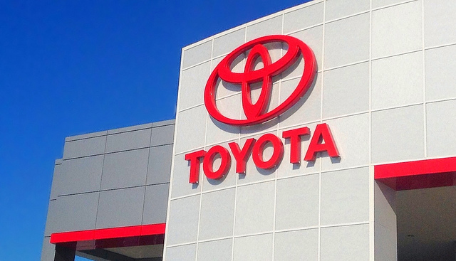
This Photo by Unknown Author is licensed under CC BY-SA-NC

Introduction
I chose to do my report on Toyota Motor Corporation (Toyota) because I am aware that many organisations including the government organisation I work for, have copied Toyota’s culture for streamlining processes and focus of lean principles. Their organisational culture represents the shared values, beliefs and practices that shape how work is conducted within an organisation Culture significantly influences organisational processes such as decision making, structural design, motivation, and performance. In an era of globalisation, companies must manage a diverse workforce, often span multiple countries and cultural backgrounds, while maintaining coherent organisational principles (Mullins & Christy, 2016).
Toyota provides a compelling case study of how strong organisational culture can shape strategy, decision making, and global competitiveness.
Toyota is widely recognised for its distinctive Toyota Way, which emphasises continuous improvement (Kaizen), respect for people, and long term thinking. Its culture underpins its operational processes, management philosophy, and global expansion strategy. This report critically assesses how organisational culture influences Toyota’s structure and decision-making, applies cultural frameworks to analyse Toyota’s internal environment, evaluates its adaptation to external pressures, examines potential cultural barriers, and assesses the impact on organisational performance. Recommendations for enhancing Toyota’s culture and effectiveness are also provided.

Trompenaars’ Seven Dimensions of Culture model
Figure 1 - I have used Trompenaars’ Seven Dimensions of Culture model that is useful for cross cultural analysis, especially in global operations. This model helps explain Toyota’s adaptability across cultures
Factor | Toyota’s Cultural Orientation
Universalism vs Particularism: | Toyota leans toward universalism standardised processes and global principles.
Individualism vs Communitarianism: | Strongly communitarian team goals over individual ones.
Specific vs Diffuse: | Relationships often extend beyond work roles, especially in Japan.
Achievement vs Ascription: | Promotion based on seniority and contribution, blending both
Sequential vs Synchronic Time: | Toyota’s planning is sequential, with clear timelines and milestones.
Internal vs External Control: | Internal control dominates employees are expected to master processes and improve them.

Trompenaars and Hampden-Turner (2012) argue that understanding cultural dimensions such as universalism vs particularism and communitarianism vs individualism is essential for global business success.
Toyota’s success in global markets stems from its ability to adapt its core culture to local norms: In Japan: Communitarian, hierarchical, and long term focused and In Europe/US: More achievement oriented, with greater individual autonomy.
This flexibility is crucial for a multinational company like Toyota. Trompenaars helps to explain how Toyota maintains its identity while respecting local cultures.

Organisational Culture and Its Influence on Structure and Decision Making
Organisational culture has a profound effect on both formal structure and decision making. At Toyota, the culture of continuous improvement and collective responsibility has shaped a lean, flexible, and team oriented structure. Lean manufacturing principles, including the Just-in-Time (JIT) system, reflect a culture that values efficiency, elimination of waste, and quality control (Liker, 2004).
Decision making is influenced by consensus driven practices, where input is solicited from various levels of the organisation, reflecting Toyota’s cultural emphasis on respect for people and collaborative problems solving (Fujimoto, 1999).
The influence of culture is also evident in Toyota’s hierarchical yet participative structure. While strategic decisions are typically made by senior management, operational decisions often involve team input through mechanisms such as the quality circles and daily problem-solving routines. Schein (2010) argues that such structures are manifestations of underlying cultural assumptions; in Toyota’s case, assumptions of continuous improvement and respect for employees are embedded in the operational hierarchy. Furthermore, decision making at Toyota is often slow but deliberate, as consensus and risk mitigation are cultural imperatives, ensuring high quality outcomes (Nonaka & Takeuchi, 1995).
However, there are potential drawbacks and cultural barriers. The strong adherence to cultural norms can slow innovation in situations where rapid change is needed. For instance, Toyota’s initial response to the global recalls in 2009–2010 was criticised for being overly cautious, reflecting a culture prioritising thorough review over immediate action (Stevenson, 2011). Nonetheless, the long term benefits of culture driven decision making are evident in Toyota’s reputation for reliability and operational excellence.

Identifying and Analysing Toyota’s Organisational Culture
Several frameworks can be applied to analyse Toyota’s culture, including Schein’s levels of culture, Hofstede’s cultural dimensions, and Handy’s typology.
Schein’s Model
Schein (2010) identifies three levels of culture: artifacts, espoused values, and underlying assumptions. At Toyota Artifacts include visible practices such as Kaizen boards, standardised work instructions, and team problem solving meetings. Espoused values emphasise continuous improvement, respect for people, teamwork, and customer focus. Underlying assumptions include beliefs in collective responsibility, long term planning, and personal accountability for quality (Liker, 2004).
This model highlights how Toyota’s operational behaviours are deeply rooted in cultural assumptions, influencing both employee behaviour and managerial decision making.
Hofstede’s Cultural Dimensions. Hofstede’s (2011) model offers insight into national culture influences, which are reflected in Toyota’s corporate culture. Key dimensions include Collectivism vs. Individualism, Japan scores highly on collectivism, mirrored in Toyota’s emphasis on teamwork, consensus, and group responsibility. Uncertainty Avoidance, High uncertainty avoidance is evident in Toyota’s focus on standardisation, rigorous quality control, and risk mitigation. Long term orientation reflects Toyota’s strategic planning, investment in continuous improvement, and prioritisation of sustainable growth.
These dimensions explain why Toyota’s culture prioritises consistency, meticulous planning, and employee involvement in decision making.
Handy’s Cultural Types, Handy (1993) identifies four cultural types: power, role, task, and person. Toyota primarily exhibits a role culture and task culture. Role culture is evident in the structured responsibilities and standardised procedures at manufacturing plants, whereas task culture emerges in problem solving teams and Kaizen initiatives, where expertise and collaboration are critical (Liker, 2004). The coexistence of these cultural types allows Toyota to maintain operational stability while fostering innovation at the team level.

Adaptation to the External Environment Through Culture
Toyota’s culture is central to its ability to respond to external pressures such as global competition, technological change, and sustainability challenges. The Toyota Production System (TPS), underpinned by cultural values, allows the company to respond flexibly to shifts in demand and supply chain disruptions (Ohno, 1988).
Cultural emphasis on continuous improvement enables rapid identification of process inefficiencies and adaptation of best practices across global plants.
Moreover, Toyota’s culture facilitates cross cultural management in international markets. By integrating local practices while maintaining core cultural principles, Toyota achieves consistency and adaptability. For example, Toyota plants in the U.S. and Europe adopt lean practices while incorporating local labour norms and regulatory requirements (Fujimoto, 1999). The cultural commitment to learning and knowledge sharing enhances global competitiveness, innovation, and customer satisfaction.
Additionally, Toyota’s sustainability initiatives, such as the development of hybrid vehicles, reflect long term cultural values. Decision making guided by cultural principles ensures investments in environmental sustainability, even when short term profits may be lower (Toyota Motor Corporation, 2022).

Organisational Health
Organisational health is best measured through structured diagnostics that assess leadership, culture, strategy execution, and adaptability key predictors of prolonged performance and resilience.
Organisational health refers to how effectively an organisation operates, makes decisions, and adapts to change while maintaining a strong culture and strategic clarity. According to McKinsey & Company, it encompasses three core elements, alignment around vision and strategy, execution capability, and capacity for renewal. Their Organisational Health Index (OHI) is a widely used diagnostic tool that evaluates nine dimensions of high-performing cultures, drawing insights from over 8 million respondents across 2,500 organisations globally.
Healthy organisations consistently outperform their peers. McKinsey’s research shows that companies with strong organisational health deliver three times the total shareholder returns of unhealthy ones. These organisations also demonstrate greater resilience, fewer safety incidents, and stronger financial performance even during periods of disruption such as the COVID-19 pandemic.
To measure organisational health effectively, leaders must, establish a baseline using tools like the OHI to understand current strengths and weaknesses. Track progress over time, adapting interventions to suit the organisation’s goals and context. Focus on key behaviours such as strategic clarity, role clarity, personal ownership, and competitive insight known as “power practices” that drive performance. Empower frontline teams and use data-driven decision-making to foster innovation and agility.
Ultimately, organisational health is not a one off assessment but a continuous leadership priority. It should be managed as rigorously as financial performance to ensure sustainable success. (Camp et al., 2024).
Corporate Philosophy Summary presented on Behalf of Toyota Motor Corporation
A representative of Toyota Motor Corporation shares an overview of corporate philosophy, which continues to be guided by the foundational Toyota Principles. These values have shaped their mission to contribute to a prosperous society through responsible business practices. In 2020 they formalised this commitment under the "Toyota Philosophy," setting our mission as Producing Happiness for All. Our goal is to be the most trusted and respected company in every community we serve.
Toyota is deeply committed to sustainability and the enduring wellbeing of both society and the planet. Their approach is grounded in Sustainability Fundamental Policy and a range of supporting frameworks that guide the environmental and social responsibilities.
Toyota operate with a "Customer First" mindset, delivering innovative, safe, and high quality products and services that meet diverse global needs. They uphold strict standards for data protection, ensuring compliance with privacy laws across all regions.
Employees believe their people are the key to their success. Toyota fosters creativity, teamwork, and personal growth, while promoting equal opportunities and a culture of inclusion. They maintain fair working conditions, prioritise health and safety, and uphold human rights including a zero tolerance policy on forced or child labour. They encourage open dialogue and respect employees’ rights to associate freely, in line with local laws. Ethical leadership and a strong corporate culture are central to their management approach.
They value relationships longevity with suppliers and dealers, built on mutual trust and shared growth. The selection process is inclusive, and merit based, and they adhere to fair competition laws in every market.
Toyota is committed to stable, sustained growth and enhancing corporate value. They provide transparent, timely updates on financial and operational performance to shareholders and investors.
They strive for environmentally responsible growth, reducing their impact on climate and biodiversity. Their technologies aim to balance economic progress with ecological preservation. They respect the cultural and legal frameworks of every region they operate in and pursue cleaner, safer mobility solutions. Maintaining integrity in all public sector relationships and reject any form of bribery. Across all locations, they actively engage in social contribution initiatives that strengthen communities and enrich lives.
This philosophy reflects Toyota’s dedication to ethical business, inclusive growth, and global responsibility.

Toyota’s Organisational Culture: Linking Theory to Practice
Toyota’s lean structure isn’t just about cutting waste; it’s built on deep cultural beliefs. Schein’s model helps explain this. At the “underlying assumptions” level, Toyota assumes that every employee can contribute to improvement and that waste is the enemy. These beliefs shape everything from Kaizen boards to how teams work together.
Toyota’s decision making is consensus driven. That’s very different from Western models, which often prioritise speed and individual authority. Toyota’s approach builds trust and quality, but it can slow things down when quick action is needed. This contrast shows how culture shapes strategy and risk.
Consensus brings inclusivity and thoroughness, but it can be a bottleneck in a crisis. Toyota’s strengths rigour, focus, and reliability can become a weakness if the market shifts fast. One solution is to build agile decision making units that still respect the wider culture.
Applying Cultural Frameworks, Kaizen boards aren’t just tools they’re cultural symbols. They show Toyota’s belief in shared responsibility and steady progress.Toyota’s collectivism reflects Japanese norms, but it’s not rigid. In global plants, Toyota blends local autonomy with central values showing that national culture influences, but doesn’t define, corporate culture.
Toyota mixes role culture (structured operations) with task culture (problem solving teams). This balance creates tension but it’s productive. It allows Toyota to stay stable while still innovating.
Toyota’s culture of learning and standardisation helped it bounce back quickly from supply chain shocks. Culture isn’t just internal it’s a strategic buffer. Toyota adapts its core values to fit different labour laws and regulatory environments. That flexibility keeps its identity intact while respecting local norms.
Using Key Performance Indicators, Toyota’s culture drives results, fewer defects, better staff retention and strong market position. Kaizen, respect for people, and standardisation aren’t just values they’re performance tools.

Figure 2 - As stated by Akio Toyoda in Toyota’s corporate philosophy statement:
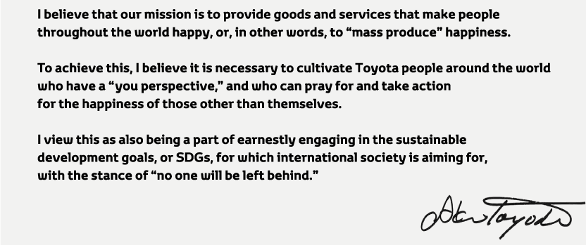
(Toyoda, n.d.)

Figure 3 – is a linking theory to practice flowchart
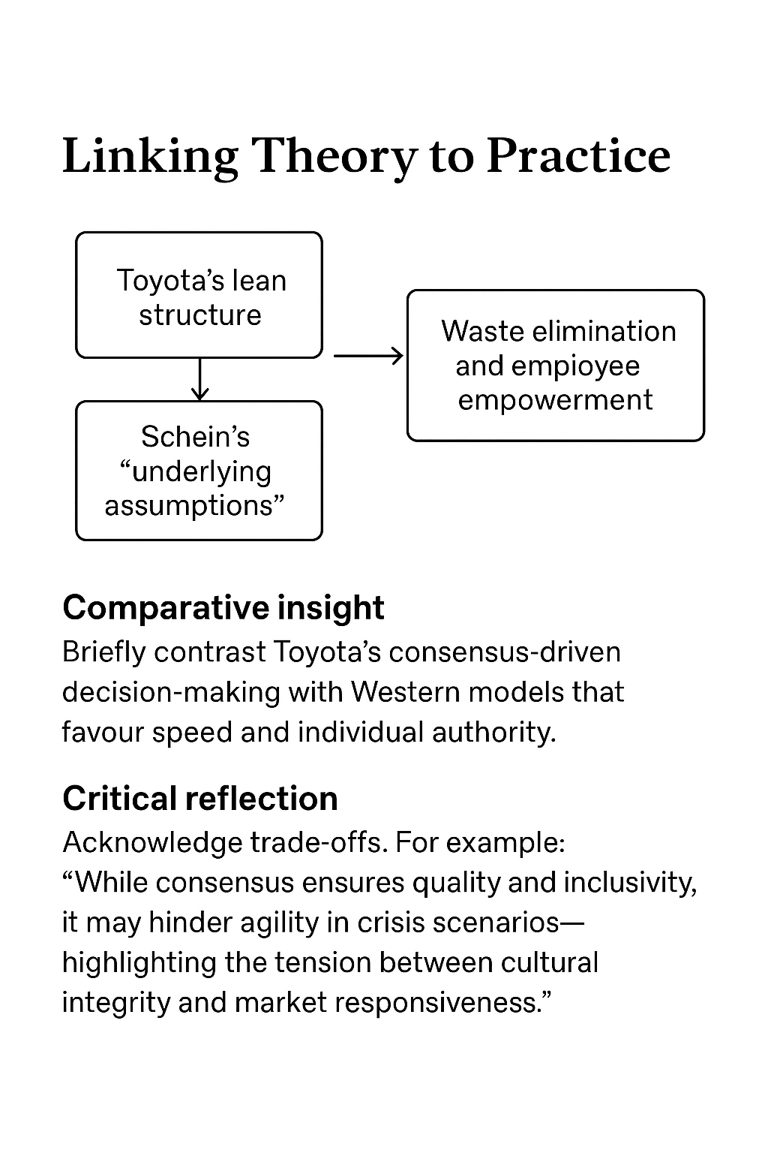
Figure 4 details McKinsey Organisational Health Index (OHI) table to complement my discussion of diagnostics and performance:
Dimension | Toyota’s Cultural Alignment | Impact on Performance
Direction | Clear long term vision rooted in “Toyota Way” and Kaizen principles | Strategic clarity drives consistent innovation and global expansion
Leadership | Hierarchical but participative; leaders’ model continuous improvement and respect | Builds trust, stability, and employee engagement
Culture and Climate | Strong collectivist culture with emphasis on teamwork and quality | Enhances collaboration, reduces defects, and improves customer satisfaction
Accountability | Employees take ownership of quality and process improvement | High reliability and operational excellence
Coordination and Control | Standardised procedures and lean systems ensure tight coordination | Efficient resource use and reduced waste
Capabilities | Deep expertise in lean manufacturing and problem-solving | Sustained competitive advantage in production and innovation
Motivation | Respect for people and career development foster intrinsic motivation | High retention and productivity
External Orientation | Adapts core values to local markets while respecting regional norms | Global responsiveness and cultural agility
McKinsey & Company (n.d.)

Key Highlights from the 2024 Financial Report
Figure 5 – Details Toyota’s 2024 financial report shows strong growth, long term planning, and disciplined operations all of which align closely with its organisational culture of continuous improvement, respect for people, and strategic resilience. Here’s a breakdown of what the report reveals and how it connects to Toyota’s core cultural values.
MEASURE | RESULT | INTERPRETATION
Sales revenue rose by 21.4% to ¥45.1 trillion | showing strong global demand and operational efficiency.
Operating income nearly doubled | up 96.4% to ¥5.35 trillion | reflecting cost control and productivity gains.
Net income more than doubled | reaching ¥5.07 trillion | with earnings per share rising to ¥365.94.
Total assets increased to ¥90.1 trillion | showing long term investment in capacity and innovation.
Cash flow from operations hit ¥4.2 trillion | supporting reinvestment and financial stability.
Employee numbers rose to 77 | 824 | reinforcing Toyota’s commitment to people and sustainable growth.

How This Aligns with Toyota’s Organisational Culture
The sharp rise in operating income and productivity reflects Toyota’s Kaizen mindset of small, ongoing improvements across all levels. High cash flow and reinvestment suggest that Toyota is not just chasing short term profits but building for the future. The increase in employee numbers and stable equity per share show respect for employees. Consensus driven decision making and structured problem solving likely contributed to the cautious but effective financial strategy. Toyota’s growth in total assets and equity reflects its cultural focus on sustainability and strategic planning. Strong earnings and low volatility in returns reflect Toyota’s culture of standardisation and risk avoidance. Toyota (2024).

Impact of Organisational Culture on Performance and Recommendations
Toyota’s culture significantly contributes to its operational excellence, innovation, and global competitiveness. The embedded principles of Kaizen and respect for people drive continuous improvement, employee engagement, and high quality outputs. Cultural practices support knowledge transfer, problem solving, and efficiency, resulting in strong financial performance and market leadership (Nonaka & Takeuchi, 1995).

Comparative Insight: Toyota vs Tesla
A useful benchmark for Toyota’s culture is Tesla, whose organisational approach contrasts sharply. Toyota’s culture is consensus driven, process oriented, and rooted in collective responsibility, reflecting Japanese norms of future planning and risk mitigation (Hofstede, 2011; Schein, 2010). In contrast, Tesla’s culture prioritises speed, individual authority, and rapid innovation, often driven by Elon Musk’s top down leadership style. This results in faster product cycles and bold strategic pivots but also exposes Tesla to higher operational risk and volatility (Stevenson, 2011; Robbins & Judge, 2023). While Toyota’s structured decision-making foster’s reliability and quality, Tesla’s agile culture enables disruptive innovation. This comparison highlights how cultural orientation shape’s organisational structure, responsiveness, and strategic outcomes.

Recommendations for Improvement
Encourage adaptive innovation, establish dedicated innovation teams with greater autonomy to complement consensus driven, decision making, reducing potential delays in crisis response. Enhance cross cultural training. While Toyota adapts to local environments, structured cross cultural programmes could further improve understanding and integration of global teams. Balance cultural rigidity with agility, periodically review processes and decision making frameworks to ensure they remain flexible in rapidly changing markets.
I recommend Toyota fosters a culture that encourages digital innovation while maintaining core principles of quality and continuous improvement. Implementing these recommendations would strengthen Toyota’s ability to leverage culture as a competitive advantage while mitigating potential barriers to effective functioning.
I would also encourage them to increase Transparency and Knowledge Sharing
Toyota’s culture includes a layer of secrecy, which can hinder innovation and collaboration.

Conclusion
Toyota’s 2024 financial results aren’t just numbers, they’re a reflection of its culture in action. The report shows how values like Kaizen, respect, and forward thinking translate into real-world performance. It confirms that Toyota’s organisational culture is not only intact but actively driving its global success.
Toyota Motor Corporation demonstrates the profound impact of organisational culture on structure, decision making, and performance. Through frameworks such as Schein’s levels of culture, Hofstede’s cultural dimensions, and Handy’s typology, it is evident that Toyota’s culture shapes operational processes, facilitates global adaptation, and drives sustained performance. While cultural rigidity can occasionally slow responsiveness, the alignment of values, practices, and strategic goals ensures Toyota remains a resilient and innovative organisation. Recommendations such as fostering adaptive innovation, enhancing cross-cultural understanding, and promoting agile practices will further strengthen Toyota’s competitive advantage and organisational effectiveness.
Ultimately, Toyota exemplifies how a deeply embedded culture when strategically aligned and continuously evolved can serve as a powerful engine for long term success. By integrating cultural insight with operational excellence, Toyota not only sustains its global leadership but also sets a benchmark for how values driven organisations can thrive in a rapidly changing world. Its ability to balance tradition with transformation, and discipline with innovation, confirms that organisational culture is not a backdrop but a strategic asset that drives enduring performance

References
Cameron, K. S., & Quinn, R. E. (2011). Diagnosing and Changing Organizational Culture: Based on the Competing Values Framework (3rd ed.). San Francisco: Jossey-Bass.
Demir, S. and Paksoy, T., 2021. Just-in-Time and Lean Management. In: Reference Module in Engineering. Boca Raton: CRC Press/Taylor & Francis.
Denison, D. R. (1990). Corporate Culture and Organizational Effectiveness. Wiley.
Empirically links culture traits to performance, ideal for revitalisation strategies.
Explores organisational culture through symbolic and interpretive lenses, similar to Alvesson’s critical approach.
Feldman, D. C., & Bolino, M. C. (1996). “Career Patterns of the Mobile Manager: A Review and Research Agenda.” Journal of Management, 22(4), 617–644.
Fujimoto, T. (1999) The Evolution of a Manufacturing System at Toyota. Oxford: Oxford University Press.
Handy, C. (1993) Understanding Organisations. 4th edn. London: Penguin.
Hatch, M. J. (1993). “The Dynamics of Organizational Culture.” Academy of Management Review, 18(4), 657–693.
Hatch, M. J. (2018). Organization Theory: Modern, Symbolic, and Postmodern Perspectives (4th ed.). Oxford University Press.
Hofstede, G. (2011) Dimensionalizing cultures: The Hofstede model in context. Online Readings in Psychology and Culture, 2(1), pp.1–26. Available at: https://doi.org/10.9707/2307-0919.1014 (Accessed: 10 November 2025).
Kotter, J.P. (1996) Leading Change. Boston: Harvard Business School Press.
Liker, J.K. (2004) The Toyota Way: 14 Management Principles from the World’s Greatest Manufacturer. New York: McGraw-Hill.
Martin, J. (2002). Organizational Culture: Mapping the Terrain. Sage.
McKinsey & Company (2023) Organizational health is still the key to long-term performance. Available at: https://www.mckinsey.com/capabilities/people-and-organizational-performance/our-insights/organizational-health-is-still-the-key-to-long-term-performance (Accessed: 27 October 2025).
Mullins, L. & Christy, G. (2016) Management & Organisational Behaviour. 11th edn. Harlow: Pearson.
Nonaka, I. & Takeuchi, H. (1995) The Knowledge-Creating Company: How Japanese Companies Create the Dynamics of Innovation. New York: Oxford University Press.
Ohno, T. (1988) Toyota Production System: Beyond Large-Scale Production. Portland: Productivity Press.
Panigrahi, S., Al Ghafri, K.K., Al Alyani, W.R., Khan, M.W.A., Al Madhagy, T. and Khan, A., 2023. Lean Manufacturing Practices for Operational and Business Performance. International Journal of Engineering Business Management, 15, pp.1–16.
Pinto, J.L.Q., Matias, J.C.O., Pimentel, C., Azevedo, S.G. and Govindan, K., 2018. Introduction to Lean and Just-in-Time Manufacturing. In: Just in Time Factory. Cham: Springer, pp.1–18.
Cameron, K. S., & Quinn, R. E. (2011). Diagnosing and Changing Organizational Culture: Based on the Competing Values Framework (3rd ed.). Jossey-Bass.
Robbins, S. P., & Judge, T. A. (2023). Organizational Behavior (19th ed.). Pearson.
Rees, G., & Mullins, L. (2023). Management and Organisational Behaviour (13th ed.). Pearson.
Schein, E.H. (2010) Organisational Culture and Leadership. 4th edn. San Francisco: Jossey-Bass.
Stevenson, W.B. (2011) ‘Toyota Motor Corporation: Globalization and Performance Challenges’, Journal of Business Strategy, 32(6), pp. 24–32.
Toyoda, A. (n.d.) Toyota’s corporate philosophy statement. [online] Toyota Motor Corporation. Available at: https://global.toyota/en/company/message-from-president/ [Accessed 27 Oct. 2025].
Toyota Industries Corporation. (2024) Annual financial report 2024. Available at: https://www.toyota-industries.com/investors/item/2024_annual_financial_report_E.pdf (Accessed: 10 November 2025).
Toyota Motor Corporation (2022) Sustainability Report 2022. Available at: https://global.toyota/en/sustainability (Accessed: 6 October 2025).
Toyota Motor Corporation (2025) Integrated Report 2024. Available at: https://global.toyota/pages/global_toyota/ir/library/annual/2024_001_integrated_en.pdf (Accessed: 10 November 2025).
Trompenaars, F. and Hampden-Turner, C. (2012) Riding the Waves of Culture: Understanding Diversity in Global Business. 3rd edn. London: Nicholas Brealey Publishing.
Wils, T., Wils, L., & Tremblay, M. (2014). “Revisiting the Career Anchor Model: A Proposition and an Empirical Investigation.” Relations Industrielles, 69(4), 813–838.
Womack, J.P. and Jones, D.T., 2003. Lean Thinking: Banish Waste and Create Wealth in Your Corporation. New York: Free Press.
Zeithaml, V.A., Bitner, M.J. & Gremler, D.D. (2013) Services Marketing: Integrating Customer Focus Across the Firm. 6th edn. New York: McGraw-Hill.

