
Managing Enterprise in 21st Century - BMSW4006
BUSINESS PLAN

March 17, 2021
University of Wales Trinity Saint David
ANGHEL ADRIAN BREZEANU 1918103

Table of Contents
1. Company concept 1
2. Company name 2
3. Mission statement 2
4. Business Aims 2
5. Business Objectives 2
6. Legal Identity 3
7. Marketing and PR Plan 3
8. Pricing Strategy 4
9. 7 P’s 4
10. Marketing samples 5
11. Physical Location 9
12. Human Resource Strategy 9
13. Sources of Finance 9
14. Cash flow forecast 9
15. SWOT Analysis 11
16. References 11

- Company concept
Raw is a company that sells freshly squeezed juice. I came up with this idea after visiting my original country this year, because there are juice bars everywhere. I was impressed by how people are willing to stay on the que to get something fresh, instead of bottled juice. After I returned, I was going, as usual, to different stores to do grocery shopping, when I noticed that I could find everything that I wanted, except for fresh juice. So, this idea came up from a necessity actually. I noticed that people are willingly consume lots of sugar, but they also need to consume natural sugar that can be found on fruits.
I also did a lot of research regarding the fresh juice consumption in the past years, and I found that since 2010, the demand for fresh juice grew with almost 40% (Gov UK, 2015). At the same time, I found out that the tax for sugar in UK is quite big, and people tend to replace the usual soda with more natural juice, which is a lot cheaper (Southey, 2019). Another interesting fact that I found out is that the Brits are beginning to slowly replace the beer with natural juice (Mehmet, 2019).
The information that I found made me realise that I do actually have a chance to build my fresh juice business, because there is a demand for that. I became more optimistic regarding my business and I am confident that I will manage to gain profit and to achieve all my business objectives.
- Company name
The company name is Raw and the meaning behind that is the fact that I wanted a simple name that can make people remember the taste of our products. I was searching for sophisticated, long names, but I felt that this word ‘raw’ represents exactly what I was thinking about my company, because it is short and simple.
One of the definitions of the word ‘raw’ is ‘being in or nearly in the natural state: not processed or purified’ (Merriam-Webster, 2021), and this is the exact representation of my juices.
- Mission statement
The RAW company wants to offer a taste of holiday, summer, freshness, and health, all in one glass of freshly squeezed juice, made 100% from recyclable materials.
- Business Aims
Everybody prefers natural juice instead of the juices that contain chemicals, harmful for organism. And the juice derived from tasty oranges, mandarins, lemons, or grapefruit is 100% natural, full of vitamins and very appreciated in all seasons.
My business aim is to give the customers the daily recommended dose of vitamins, while promoting the use of recyclable materials, to help saving the planet as well.
- Business Objectives
I have many objectives for the next few years for my business, and all of them are revolving around promoting the health that comes in a glass of fresh juice and the benefits or recycling. More specific, my business objectives are:
- I want to have at least 10 sales per day by the end of the first month since opening.
- I want to start having profit in the first 6 months.
- I want to create a recycling station that will be available for free to anyone who is buying from us.
- I want to create a trend on TikTok regarding the benefits of natural juices and recycling.
- I want to expand my business in the next 3 years in every Asda, Tesco, or Morrisons in Cardiff, followed by all around Welsh during the next 10 years.

- Legal Identity
After an in-depth research, I decided to run my company as a sole trader, because I felt that, in the beginning, this is the best option for me, until I will start gaining profit, clients and expand my business. There are a few advantages to the sole trader legal identity that are suitable for me:
- The registration is simple. All I have to do is apply for a sole trader UTR number, without any costs, and I am able to start my business (GOV UK, 2021).
- Flexible payment options. I can spend any amount of money when I want, and I will declare everything at the end of the financial year (Byte Start, 2021).
- Easy to close the business. In case that my business doesn’t work, I can simply close it without lose that much or to have to depend on someone else (West, 2020).

- Marketing and PR Plan
The juice that I made can be modified to contain only fruits or vegetables that the customer wants, and by this reason means that my juice is suitable for all age types. I chose to start my business in a hypermarket because I can target people that are out on a daily basis, there is lots of traffic, and usually few things to grab to drink on the spot. At the same time, people that are out shopping are more keen to spend money on something extra that wasn’t planned before (BBC, 2021).
Based on this premises, the starting point of the marketing campaign is to design a logo, followed by a business card, and to create a pitch that I can use to obtain a contract to sell in supermarkets.
To attract customers, I am looking forward to create a plan of 60 seconds videos that will be uploaded on TikTok. The content will be in regards to the juice, its benefits, types of juice, and I will make the content as interactive as possible. I chose TikTok as a platform because there I can interact the best with people and I can use my creativity to attract customers, and I can also access the creator fund and start gaining additional profit (Patel, 2021).
In the first 2 days from opening, I am planning on giving the customers the juice at half price, meaning £1.5 per glass. At the same time, I will develop a loyalty scheme, and I will give each customer a card, and I will put a stamp each time they present the card. If they will have 4 stamps, they will receive a glass of juice for free.
Moreover, one of my objectives are to expand my business, and to do so, I will need, between others, reviews and demand from customers. For this, I will include an QR code into the thank you card, so that people can scan the code and write their reviews about the service and the product.
- Pricing Strategy
After a lot of research, I decided that the pricing strategy that I want to adopt for my business is the ‘Pricing at a Premium’. I think this is the most suitable pricing strategy because I am a small business, and I don’t have competitors in the area at the moment, and I can easily set up a price that will be fair to the customers, but that it will also help me keeping the business alive by making profit (Martin, 2021).
The standard price will be £3 per each 200ml glass of juice. For the first 2 days I will offer everything at half price, so that the customers can have a sample of my product. At the same time, I have a bundle offer, if someone buy 4 glasses of juice in one or more transactions, the 5th glass will be free.
- 7 P’s
Product
Raw will have a very wide range of products. We produce natural juice without any addition. The main juice that will come will be the orange juice. Also, will be available citrus combinations juices depending on the buyer’s will. Children juices are marketed in special glasses, with various characters from cartoons to attract children. A glass will include 200ml of natural juice, but the glasses will be greater for those who want a greater portion of health. Products are prepared in front of the customer, so they will see the entire process and will enjoy the taste of fresh and tasty juice.
Price
Our price will be affordable for everyone, every 200ml of juice will cost £3. The price will not change, will remain constant, except for the first two days when the customers will have the opportunity to try the delicious juice at half price. I will also introduce a loyalty scheme, and give every customer a stamp card, and when they get 4 stamps, the 5th drink will be free.
Promotion
The main app for online marketing will be TikTok, because it saw a rise in popularity, and the app is helping the small business, especially across UK (Bucciacchio, 2020). I will use this platform to create content about natural juice, its benefits, types, and I will also be creative and create funny challenges.
Apart from TikTok, I will offer everything at half price in the first two days from opening, in order for everyone to taste a sample.
Place
The location will be at ASDA Pentwyn, because I know the location, and there is no competition in the area. Also, I chose a supermarket because people are always spending money on groceries, and perhaps they will get thirsty and they will need something natural to drink.
People
The people involved in my business is myself and the two employees that I will have. I won’t need special suppliers because I will go myself to buy the fruits and vegetables, to carefully pick them and to make sure of their quality.
Process
I will make sure that every order passes the quality check, and that the fruits and vegetables used are always fresh, for the best results. The customers will be able to see the entire process of making the juice, which will bring more satisfaction.
Physical evidence
The best evidence will be the taste of juice, as well as the customer service. Every customer will receive the loyalty card, and every order will be honored.

- Marketing samples
The first marketing sample is the logo, which represents the company and it is bubbly, easy to remember, using only primary colours.
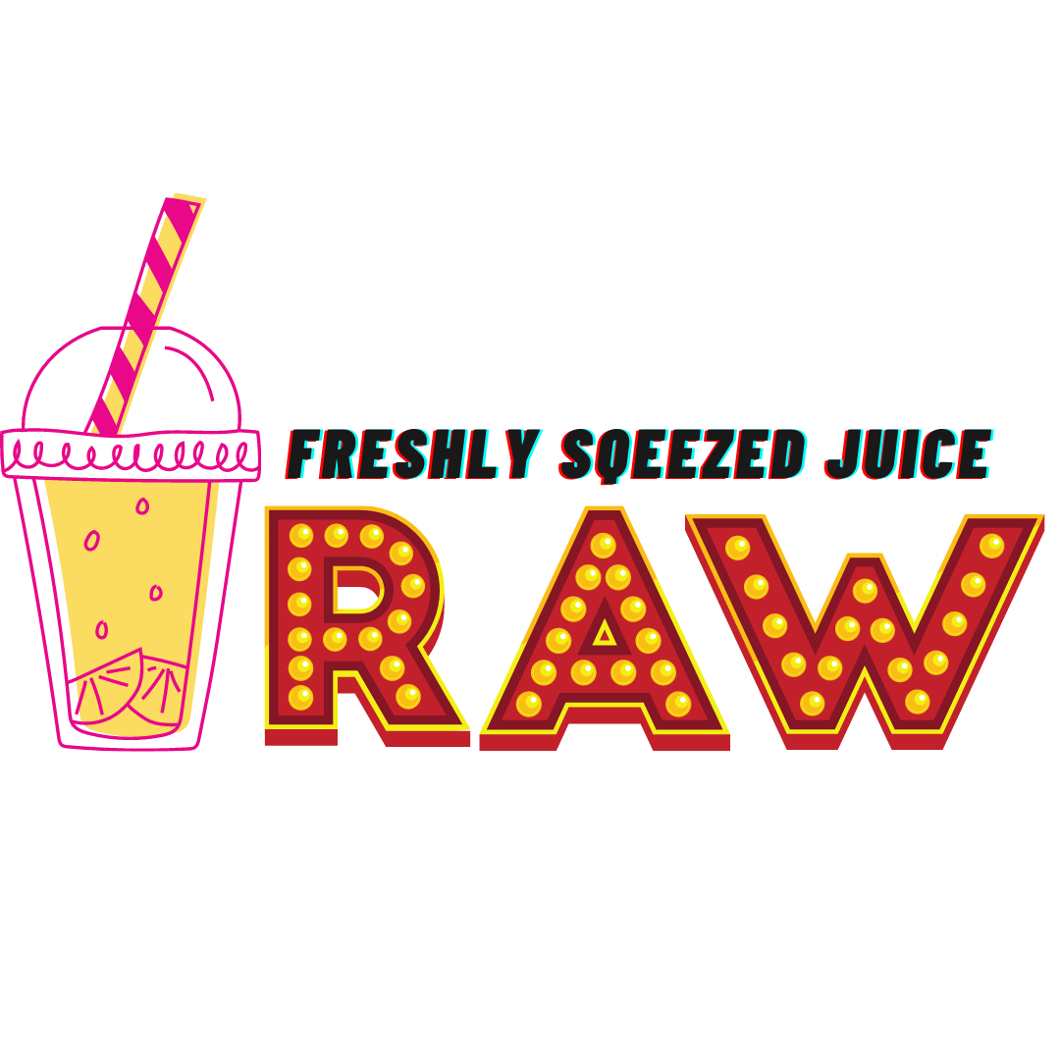
The second sample is the business card
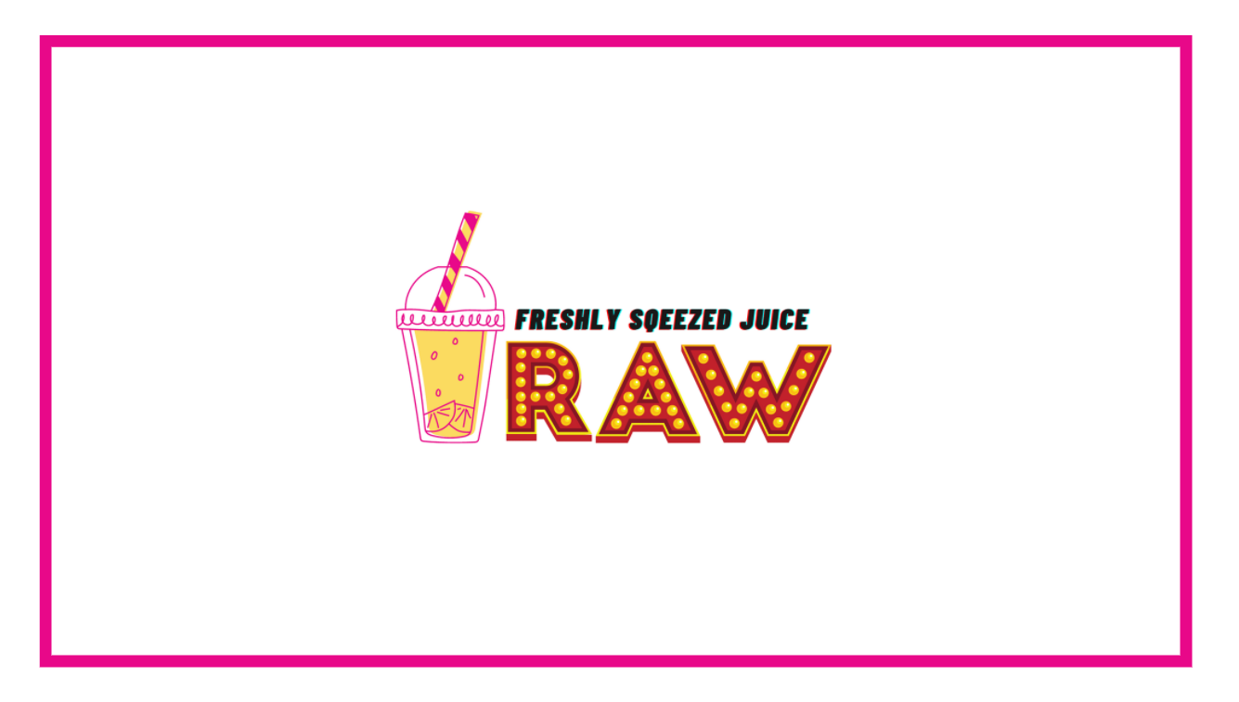
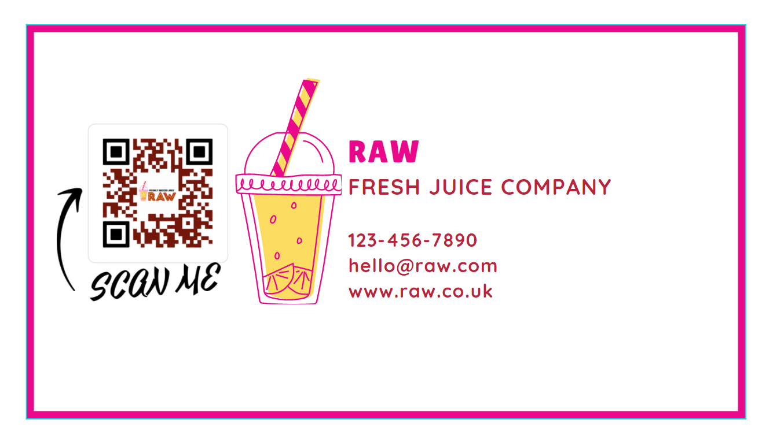

The loyalty cards will look like this:

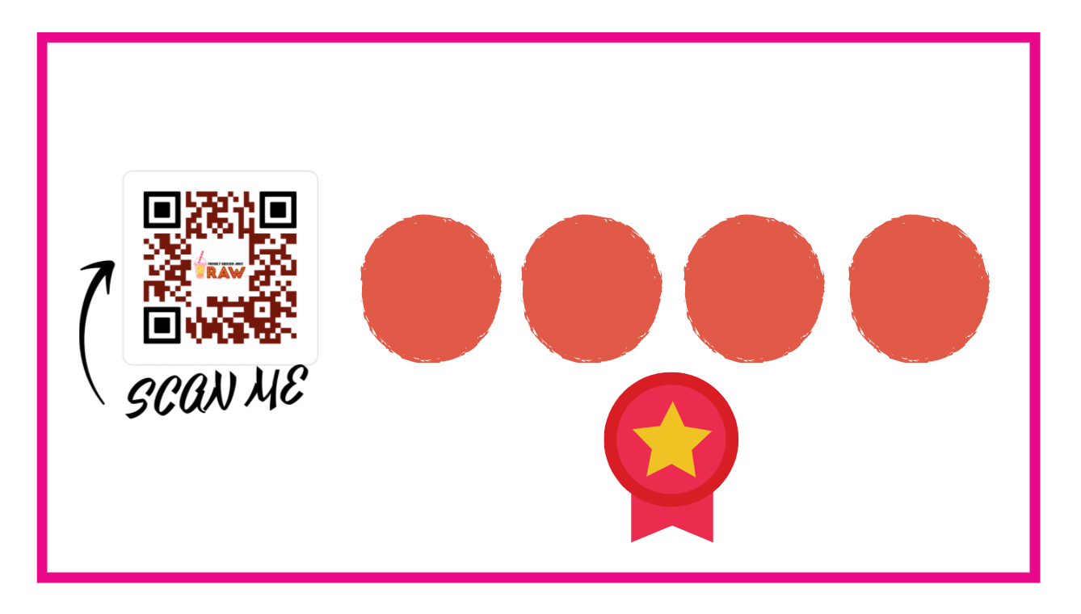
The products will look like below:
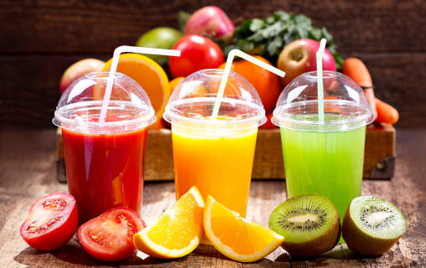
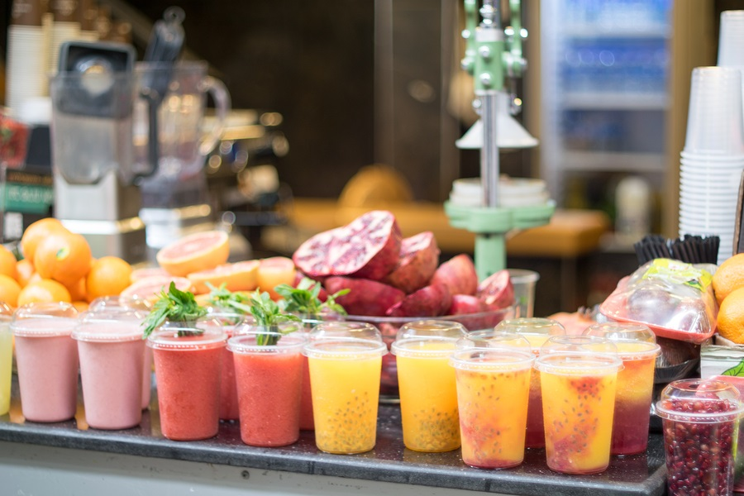
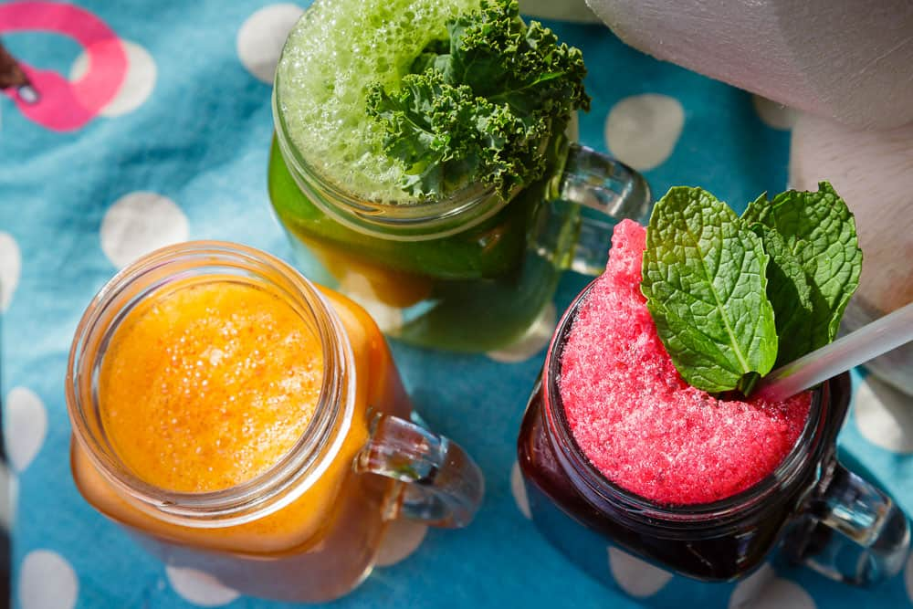

- Physical Location
The location will be, at the beginning, at ASDA Pentwyn, looking to expand to every ASDA, Morrisons and Tesco in Cardiff. This is the most used supermarket in the Pontprennau area, and this is why I chose to start my business here.
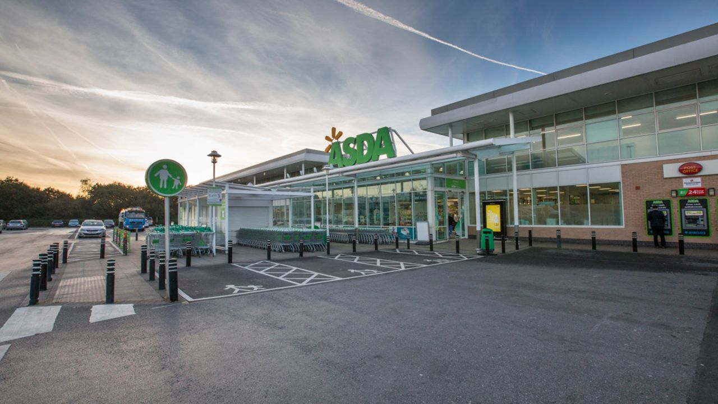
- Human Resource Strategy
I will be the one that does the sales, payroll, and administration, but I will need two employees to work part time to the juice bar. Their salaries will be £500/months, and I will recruit them from Indeed.
- Sources of Finance
I will be my own source of funding because is not an expensive start up, to need a loan or funding from other parts.
The costs will only be the rent, which is £420, the £1530 price of fruit, £105 price glasses of single use, and £500 the juice machines. The total cost will be £2555, money that I already have available to invest in my small business.
- Cash flow forecast
I wanted to make cash flows based on multiple types of sales so I can have a minimum on knowledge regarding the minimum profit that I will have.
100 glasses of juice per day.
£3 / cup of juice.
100 x £3 = £300/day.
£300x 30 days = £9000/month from which you subtract:
£3060(the price of fruit).
£210/month (price glasses).
Rent space: £420.
Salaries £500 x 2 = £1,000 (2 employees). - Allowances
Profit of £4310 per month! - Allowances
70 glasses of juice per day
£3 / cup of juice.
70 x £3 = £210 / day
£210 x 30 days = £6300/month of subtraction:
£2160 (price of fruit)
£147 (price glasses of single use)
Rent space: £420
Salary: £500 x 2 = £1,000 (2 employees) - allowances
Profit of £2573per month! - Allowances
50 glasses of juice per day
£3/cup of juice
50 x £3 = £150 / day
£150 x 30 days = £4500/ month of subtraction:
£1530 (price of fruit)
£105 (price glasses of single use)
Rent space: £420
Salary: £500 x 2 = £1,000 (2 employees) - allowances
Profit of £1445 per month! - Allowances
30 glasses of juice per day
£3 cup of juice
30 x £3 = £90/ day
£90 x 30 days = £2700/ month of subtraction:
£900 (the price of fruit)
£63 (price glasses of single use)
Rent space: £420
Salary: £500 x 2 = £1,000 (2 employees) - allowances
Profit of £317 per month! - Allowances
- SWOT Analysis
STRENGTHS  Location  Natural Juice  Honest price  Fresh products  Loyalty card | WEAKNESSES  New on the market  Lack of experience
OPPORTUNITIES  The increased interest in natural juice  Location with people that are buying groceries  TikTok  Share the passion for a healthy lifestyle | THREATS  No sales  Products that expire fast  Not enough engagement on social media

- References

BBC (2021) How do supermarkets tempt you to spend more money? Available at: https://www.bbc.co.uk/food/articles/how_supermarkets_tempt (Accessed: 8th of March 2021).
Bucciacchio, V. (2020) How Can TikTok Help Your Small Business? Available at: https://www.business2community.com/social-media/how-can-tiktok-help-your-small-business-02301146 (Accessed: 8th of March 2021).
Byte Start (2021) 7 ways being a sole trader is better than working via a limited company. Available at: https://www.bytestart.co.uk/advantages-sole-trader-versus-limited-company.html (Accessed: 8th of March 2021).
Gov UK (2015) Fruit juice boost for UK. Available at: https://www.gov.uk/government/news/fruit-juice-boost-for-uk (Accessed: 8th of March 2021).
GOV UK (2021) Set up as a sole trader. Available at: https://www.gov.uk/set-up-sole-trader (Accessed: 8th of March 2021).
Martin, J. (2021) 6 Different Pricing Strategies: Which Is Right for Your Business? Available at: https://quickbooks.intuit.com/global/resources/finance-funding/6-different-pricing-strategies-which-is-right-for-your-business/ (Accessed: 8th of March 2021).
Mehmet, S. (2019) Brits are swapping beer for fruit juices. Available at: https://www.newfoodmagazine.com/news/92678/brits-are-swapping-beer-for-fruit-juices/ (Accessed: 8th of March 2021).
Merriam-Webster (2021) raw adjective. Available at: https://www.merriam-webster.com/dictionary/raw (Accessed: 8th of March 2021).
Patel, N. (2021) 8 Useful TikTok Marketing Tactics. Available at: https://neilpatel.com/blog/tiktok-marketing/ (Accessed: 8th of March 2021).
Southey, F. (2019) Field-to-bottle: British farmer grows cold pressed juice market in Europe. Available at: https://www.foodnavigator.com/Article/2019/02/11/Field-to-bottle-British-farmer-grows-cold-pressed-juice-market-in-Europe (Accessed: 8th of March 2021).
West, T. (2020) Closing a limited company down – what are your options? Available at: https://www.crunch.co.uk/knowledge/limited-company/how-to-close-limited-company-down-options/ (Accessed: 8th of March 2021).

