ACDA 4004
Micros peripherals and interfaces
Course work
Student number: 2317422
Rhys Jones

Section 1
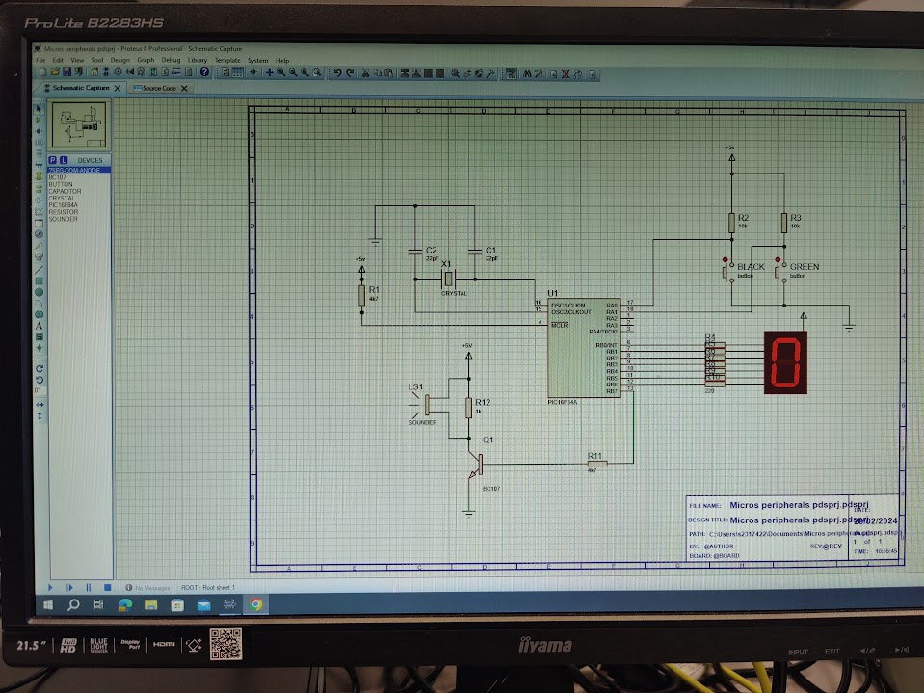
For this project we will be using the PIC16F84A to power the 7 segment LED display. The circuit we will be using is pictured below. This schematic displays hexadecimal digits depending on what the buttons are programmed to do.
Figure 1: The whole schematic
Firstly, I will be talking about the crystal, which is in figure 2 featured below. the crystal oscillator is necessary for this circuit in order to add a specific delay interval whenever needed to the circuit. This will ensure that the circuit will function properly and effectively. The reason for using a crystal oscillator is due to its stable and accurate clock signals which are crucial for time sensitive operations. The use of the 2 capacitors in parallel allows the crystal to operate at a lower frequency. By choosing the right amount of capacitance we can minimize the risk of oscillator refusing to work because of high frequency and avoid damaging it by providing to much power to the crystal oscillator. The crystal also offers very good stability compared to other alternatives, ensuring the microcontroller stays consistent over a long period of time. Crystal oscillators offer a low jitter which keeps the transitions predictable and consistent. The +5V connected to the 4k7 ohm resistor allows the Pic to operate at a reasonable voltage and current.
Figure 2: crystal oscillator and power supply

Next, I will be talking about the buttons and how they operate the circuit. The two buttons in figure 3 can be used to operate the circuit in many ways, such as turning all segments on and off, increasing and decreasing the value of the digit displayed and display a certain digit. In this circuit all the uses mentioned will be used throughout this project to showcase how they can be used affectively. The two buttons will use code in order to operate and can easily be changed.

Figure 3: buttons

Figure 4 shows the 7 segment LED display and its connections to the PIC. The power supply connected directly to the display keeps the LED activated. The 7 connections going from the pic to the LED or used to provide data in binary. This data is however converted into hexadecimal to keep the storage to a minimum. Each connection is responsible for operating 1 segment on the display. In order to correctly display each segment a truth table will be used, which will be discussed later on. The display is connected to the pic with 220-ohm resistors since that is the maximum value current you can safely have running into a LED display without the risk of burning out.

Figure 4: Led display and connection
The last part I want to discuss is the transistor and sounder pictured in figure 5.
Figure 5: Transistor and sounder

The use case for the sounder here is for a high pitch noise to be produced when the value increases and a low pitch noise to be produced when decreasing the value.
The transistor is used in order to ground the connection when the sounder is not needed and opens up briefly for the sounder to produce noise before closing again. This way it is easy to control the sounder as the transistor has many different functions.

Section 2
For the truth table we worked out the hex value by putting the binary values in and then converting them into hex on the next row. In figure 6, shown below, the character displayed on the led is on the left, the next 8 digits is the binary value needed for that character and the last column is the he value converted from binary. Thee hex value is what will be used in the program as it takes up the least amount of storage.
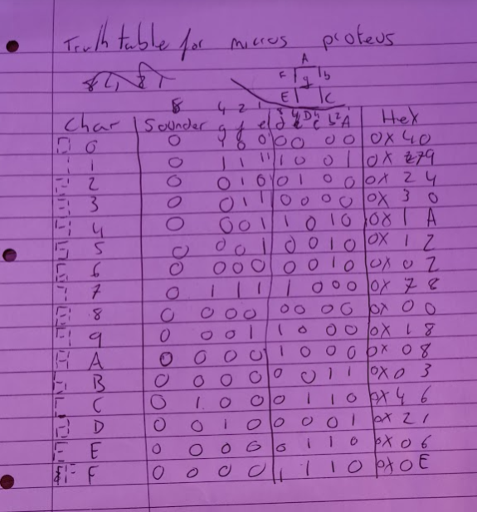
Figure 6: truth table from binary to hex

Section 3
3.1
list p=16F84 ; select processor type

radix hex ; define radix as hexadecimal

; #include "p16f84.inc"

;----------------------------------------------------------------------

; cpu equates (memory map)

portB equ 0x06 ;port B address

trisb equ 0x06 ;trisB address in register bank 1

status equ 0x03 ;status register

RP0 equ 5 ;bit 5 of status register

RP1 equ 6 ;bit 6 of status register

count equ 0x0c ; counter 0 to 255

nCount equ 0x0d ; pause routine inner loop counter

mCount equ 0x0e ; pause routine outer loop counter

;----------------------------------------------------------------------

org 0x000

start

bcf status,RP0 ; clear bank selection bits in the status reg

bcf status,RP1

bsf status,RP0 ; select bank 1

movlw 0x00 ; load w with 0x00

movwf trisb ; load it into trisb to make portb all outputs

bcf status,RP0 ; reselect bank 0

clrf portB ; clear all lines low

clrf count ; initialize counter to 0

get_count

;movf count, w ; move count to W

movlw 0x40 ;char 0 for display

movwf portB ; move W to port B to update the display

addlw 1 ; add +1 to W

movwf count ; save W in count

call pause ; delay 200ms by subroutine

call pause

call pause

call pause

call pause ; five pause executions equals ~ 1 second

movlw 0x79 ;char 1 for display

movwf portB ; move W to port B to update the display

addlw 1 ; add +1 to W

movwf count ; save W in count

call pause ; delay 200ms by subroutine

call pause

call pause

call pause

call pause ; five pause executions equals ~ 1 second

movlw 0x24 ;char 2 for display

movwf portB ; move W to port B to update the display

addlw 1 ; add +1 to W

movwf count ; save W in count

call pause ; delay 200ms by subroutine

call pause

call pause

call pause

call pause ; five pause executions equals ~ 1 second

movlw 0x30 ;char 3 for display

movwf portB ; move W to port B to update the display

addlw 1 ; add +1 to W

movwf count ; save W in count

call pause ; delay 200ms by subroutine

call pause

call pause

call pause

call pause ; five pause executions equals ~ 1 second

movlw 0x19 ;char 4 for display

movwf portB ; move W to port B to update the display

addlw 1 ; add +1 to W

movwf count ; save W in count

call pause ; delay 200ms by subroutine

call pause

call pause

call pause

call pause ; five pause executions equals ~ 1 second

movlw 0x12 ;char 5 for display

movwf portB ; move W to port B to update the display

addlw 1 ; add +1 to W

movwf count ; save W in count

call pause ; delay 200ms by subroutine

call pause

call pause

call pause

call pause ; five pause executions equals ~ 1 second

movlw 0x02 ;char 6 for display

movwf portB ; move W to port B to update the display

addlw 1 ; add +1 to W

movwf count ; save W in count

call pause ; delay 200ms by subroutine

call pause

call pause

call pause

call pause ; five pause executions equals ~ 1 second

movlw 0x78 ;char 7 for display

movwf portB ; move W to port B to update the display

addlw 1 ; add +1 to W

movwf count ; save W in count

call pause ; delay 200ms by subroutine

call pause

call pause

call pause

call pause ; five pause executions equals ~ 1 second

movlw 0x00 ;char 8 for display

movwf portB ; move W to port B to update the display

addlw 1 ; add +1 to W

movwf count ; save W in count

call pause ; delay 200ms by subroutine

call pause

call pause

call pause

call pause ; five pause executions equals ~ 1 second

movlw 0x18 ;char 9 for display

movwf portB ; move W to port B to update the display

addlw 1 ; add +1 to W

movwf count ; save W in count

call pause ; delay 200ms by subroutine

call pause

call pause

call pause

call pause ; five pause executions equals ~ 1 second

movlw 0x08 ;char A for display

movwf portB ; move W to port B to update the display

addlw 1 ; add +1 to W

movwf count ; save W in count

call pause ; delay 200ms by subroutine

call pause

call pause

call pause

call pause ; five pause executions equals ~ 1 second

movlw 0x03 ;char b for display

movwf portB ; move W to port B to update the display

addlw 1 ; add +1 to W

movwf count ; save W in count

call pause ; delay 200ms by subroutine

call pause

call pause

call pause

call pause ; five pause executions equals ~ 1 second

movlw 0x46 ;char C for display

movwf portB ; move W to port B to update the display

addlw 1 ; add +1 to W

movwf count ; save W in count

call pause ; delay 200ms by subroutine

call pause

call pause

call pause

call pause ; five pause executions equals ~ 1 second

movlw 0x21 ;char d for display

movwf portB ; move W to port B to update the display

addlw 1 ; add +1 to W

movwf count ; save W in count

call pause ; delay 200ms by subroutine

call pause

call pause

call pause

call pause ; five pause executions equals ~ 1 second

movlw 0x06 ;char E for display

movwf portB ; move W to port B to update the display

addlw 1 ; add +1 to W

movwf count ; save W in count

call pause ; delay 200ms by subroutine

call pause

call pause

call pause

call pause ; five pause executions equals ~ 1 second

movlw 0x0E ;char F for display

movwf portB ; move W to port B to update the display

addlw 1 ; add +1 to W

movwf count ; save W in count

call pause ; delay 200ms by subroutine

call pause

call pause

call pause

call pause ; five pause executions equals ~ 1 second

goto get_count ; repeat forever

;--------------------------------------------------------------------

;subroutine pause: lets waste some time....

;

;inputs: nothing

;outputs: nothing

;

;does: nothing but waste some time

;corrupts: register W

;

;description: two loops using "mCount" and "nCount" register files

; "mCount" is the outer loop counter (255 down to zero)

; "nCount" is the inner loop counter (255 down to zero)

;

;--------------------------------------------------------------------

pause

movlw 0xff ; set w = 255 decimal

movwf mCount ; mCount = w: outer loop counter

loadN

movlw 0xff ; set w = 255 decimal

movwf nCount ; nCount = w: inner loop counter

decN

decfsz nCount, f ; nCount--

goto decN ; if nCount != 0 then repeat nCount--

decfsz mCount, f ; else decrement Count

goto loadN ; if mCount != 0 then

; reload nCount to 255 and decrement

return ; else exit subroutine

end

Section 3.2
list
p=16F84 ; select processor type
radix
hex ; define radix as hexadecimal
#include p16f84a.inc ; Include register definition file

;-------------------------------------------------------------------

indr equ 0x00
FSR equ 0x04

portA equ 0x05
;port A address
trisa equ 0x05 ;trisA address in register bank 1

portB equ 0x06
;port B address
trisb
equ 0x06 ;trisB address in register bank 1

status
equ 0x03
;status register
RP0 equ 5
;bit 5 of status register
RP1 equ 6
;bit 6 of status register

count equ 0x0c ; counter 0 to 255
nCount equ 0x0d ; pause routine inner loop counter
mCount equ 0x0e ; pause routine outer loop counter
;-------------------------------------------------------------------

org 0x000

start
bcf status,RP0 ; clear bank selection bits in the status reg
bcf status,RP1

bsf status,RP0 ; select bank 1

movlw 0x03
movwf
trisa
;set 2MSBs as==of portA as inputs (switches)

movlw 0x00 ; load w with 0x00
movwf
trisb ; load it into trisb to make portb all outputs

bcf status,RP0 ; reselect bank 0

clrf
portB ; clear all lines low
clrf
count ; initialize counter to 0

movlw 0x79
movwf 0x10

movlw 0x24
movwf 0x11

main_loop
btfss portA,0
call
black_button_pressed

btfss portA,1
call
green_button_pressed

movf
count,w
;count value
addlw 0x10
;add offset to start of lookup table
movwf
FSR
;set address for lookup table
movf
indr,w
;get value from lookup table
movwf
portB
;set LED display

goto main_loop
;repeat forever

black_button_pressed
call pause
btfss portA,0
goto
black_button_pressed
incf
count,f
btfsc count,4
clrf
count

return

green_button_pressed
call
pause
btfss portA,1
goto
green_button_pressed
decf count,f
btfsc count,4
clrf
count

return

preset_count
movlw 0x0F
movwf
count

return

;-------------------------------------------------------------------

pause
movlw 0xff ; set w = 255 decimal
movwf
mCount ; mCount = w: outer loop counter
loadN
movlw 0xff ; set w = 255 decimal
movwf
nCount ; nCount = w: inner loop counter
decN
decfsz
nCount, f ; nCount--
goto
decN ; if nCount != 0 then repeat nCount--

decfsz
mCount, f ; else decrement Count
goto
loadN ; if mCount != 0 then
; reload nCount to 255 and decrement
return ; else exit subroutine

;-------------------------------------------------------------------
END

Seection 3.3
list
p=16F84 ; select processor type
radix
hex ; define radix as hexadecimal
#include p16f84a.inc ; Include register definition file

;-------------------------------------------------------------------

indr equ 0x00
FSR equ 0x04

portA equ 0x05
;port A address
trisa equ 0x05 ;trisA address in register bank 1

portB equ 0x06
;port B address
trisb
equ 0x06 ;trisB address in register bank 1

status
equ 0x03
;status register
RP0 equ 5
;bit 5 of status register
RP1 equ 6
;bit 6 of status register

count equ 0x0c ; counter 0 to 255
nCount equ 0x0d ; pause routine inner loop counter
mCount equ 0x0e ; pause routine outer loop counter
;-------------------------------------------------------------------

org 0x000

start
bcf status,RP0 ; clear bank selection bits in the status reg
bcf status,RP1

bsf status,RP0 ; select bank 1

movlw 0x03
movwf
trisa
;set 2MSBs as==of portA as inputs (switches)

movlw 0x00 ; load w with 0x00
movwf
trisb ; load it into trisb to make portb all outputs

bcf status,RP0 ; reselect bank 0

clrf
portB ; clear all lines low
clrf
count ; initialize counter to 0

movlw 0x00
movwf 0x10

movlw 0xff
movwf 0x11

main_loop
btfss portA,0
call
black_button_pressed

btfss portA,1
call
green_button_pressed

movf
count,w
;count value
addlw 0x10
;add offset to start of lookup table
movwf
FSR
;set address for lookup table
movf
indr,w
;get value from lookup table
movwf
portB
;set LED display

goto main_loop
;repeat forever

black_button_pressed
call pause
btfss portA,0
goto
black_button_pressed
incf
count,f
btfsc count,4
clrf
count

return

green_button_pressed
call
pause
btfss portA,1
goto
green_button_pressed
decf count,f
btfsc count,4
clrf
count

return

preset_count
movlw 0x0F
movwf
count

return

;-------------------------------------------------------------------

pause
movlw 0xff ; set w = 255 decimal
movwf
mCount ; mCount = w: outer loop counter
loadN
movlw 0xff ; set w = 255 decimal
movwf
nCount ; nCount = w: inner loop counter
decN
decfsz
nCount, f ; nCount--
goto
decN ; if nCount != 0 then repeat nCount--

decfsz
mCount, f ; else decrement Count
goto
loadN ; if mCount != 0 then
; reload nCount to 255 and decrement
return ; else exit subroutine

;-------------------------------------------------------------------
END

Section 3.4
; FILE: count.asm
; AUTHOR: JMY
; DATE: 24th March 2005
; DESCRIPTION: Count to 255 at 1 second intervals and display on a seven
; segment display in binary.
; The pause subroutine takes apx. 0.2 sec.
; Pause is called 5 times

list p=16F84 ; select processor type
radix hex ; define radix as hexadecimal
; #include "p16f84.inc"
;----------------------------------------------------------------------
; cpu equates (memory map)

indr equ 0x00
FSR equ 0x04

portA equ 0x05 ;port A address
trisa equ 0x05 ;trisA address in register bank 1

portB equ 0x06 ;port B address
trisb equ 0x06 ;trisB address in register bank 1

status equ 0x03 ;status register
RP0 equ 5 ;bit 5 of status register
RP1 equ 6 ;bit 6 of status register

count equ 0x0c ; counter 0 to 255
nCount equ 0x0d ; pause routine inner loop counter
mCount equ 0x0e ; pause routine outer loop counter

;----------------------------------------------------------------------

org 0x000

start
bcf status,RP0 ; clear bank selection bits in the status reg
bcf status,RP1

bsf status,RP0 ; select bank 1
;set port A as inputs

movlw 0x03 ;load w with 0x03 - 2 LSBs set
movwf trisa ;make two LSBs of part A inputs (switches)

movlw 0x00 ; load w with 0x00
movwf trisb ; load it into trisb to make portb all outputs

bcf status,RP0 ; reselect bank 0

clrf portB ; clear all lines low
clrf count ; initialize counter to 0

movlw 0x40 ;char 0 on 7 seg display
movwf 0x10 ;store in address 0x10 - start of lookup table

movlw 0x79 ;char 1
movwf 0x11
movlw 0x24 ;char 2
movwf 0x12
movlw 0x30 ;char 3
movwf 0x13
movlw 0x19 ;char 4
movwf 0x14
movlw 0x12 ;char 5
movwf 0x15
movlw 0x02 ;char 6
movwf 0x16
movlw 0x78 ;char 7
movwf 0x17
movlw 0x00 ;char 8
movwf 0x18
movlw 0x18 ;char 9
movwf 0x19
movlw 0x08 ;char A
movwf 0x1A
movlw 0x03 ;char B
movwf 0x1B
movlw 0x46 ; char C
movwf 0x1C
movlw 0x21 ; char D
movwf 0x1D
movlw 0x06 ; char E
movwf 0x1E
movlw 0x0E ; char f
movwf 0x1f

main_loop

btfss portA,0 ; test black button
call black_button_pressed

btfss portA,1 ;test green button
call green_button_pressed

movf count,w ; get count value
addlw 0x10 ; add offset for start of look up table
movwf FSR ; set address for lookup table
movf indr,w
movwf portB ; Set LED display

goto main_loop ; repeaat forever

black_button_pressed
call pause ; wait 20ms for switch debounce
btfss portA,0
goto black_button_pressed
incf count ; increment count
btfsc count,4
clrf count
return

green_button_pressed
call pause ; wait 20 ms for switch debounce
btfss portA,1
goto green_button_pressed
decf count,f
btfsc count,4
call preset_count
return

preset_count
movlw 0x0F
movwf count
return
;--------------------------------------------------------------------
;subroutine pause: lets waste some time....
;
;inputs: nothing
;outputs: nothing
;
;does: nothing but waste some time
;corrupts: register W
;
;description: two loops using "mCount" and "nCount" register files
; "mCount" is the outer loop counter (255 down to zero)
; "nCount" is the inner loop counter (255 down to zero)
;
;--------------------------------------------------------------------
pause
movlw 0x19 ; set w = 255 decimal
movwf mCount ; mCount = w: outer loop counter
loadN
movlw 0xff ; set w = 255 decimal
movwf nCount ; nCount = w: inner loop counter
decN
decfsz nCount, f ; nCount--
goto decN ; if nCount != 0 then repeat nCount--

decfsz mCount, f ; else decrement Count
goto loadN ; if mCount != 0 then
; reload nCount to 255 and decrement
return ; else exit subroutine

