The University of Wales Trinity Saint David
School of Applied Computing
Wales Institute of Science and Art

Database Analysis and Design

Introduction to Web and Database Concepts (ACCA4023)
Robert Iwan Jamieson (2004728)
Date of submission: 05.05.2021
Contents
Chapter 1 Introduction 4
Chapter 2 Context Diagram 5
Chapter 3 Level 0 Data Flow Diagram (DFD) 6
Chapter 4 Entity Relationship Diagram (ERD) 7
4.1 ERD designed in Visio 7
4.2 Resulting ERD in final database 8
4.3 Normalization 9
Chapter 5 Forms included within the Celtic Catering database 10
Chapter 6 Reports included within the Celtic Catering database 17
Chapter 7 Database user guide 20
7.1 Forms 20
7.1.1 The difference between forms 21
7.2 Queries and Reports 21
7.3 Database example walkthrough 22
Chapter 8 Conclusion 25

List of figures
Figure 1: Context diagram design for Celtic Caterers system 5
Figure 2: LVL 0 DFD design for Celtic Caterers system 6
Figure 3: ERD design for Celtic Caterers system 7
Figure 4: Relationships implementation within the Celtic Caterers system 8
Figure 5: Main menu form implementation within the Celtic Caterers system 10
Figure 6: Customer form implementation within the Celtic Caterers system 11
Figure 7: Customer ID search form implementation within the Celtic Caterers system 11
Figure 8: Details of booked events form implementation within the Celtic Caterers system 12
Figure 9: Event list form implementation within the Celtic Caterers system 12
Figure 10: Food inventory form implementation within the Celtic Caterers system 13
Figure 11: Invoice form implementation within the Celtic Caterers system 13
Figure 12: Order form implementation within the Celtic Caterers system 14
Figure 13: Product Inventory form implementation within the Celtic Caterers system 15
Figure 14: Sales within date range form implementation within the Celtic Caterers system 15
Figure 15: Staff form implementation within the Celtic Caterers system 16
Figure 16: rprt2021YearSales report implementation within the Celtic Caterers system 17
Figure 17: rprtCustomerIDSearch report implementation within the Celtic Caterers system 17
Figure 18: rprtDetailedOfBookedEvents report implementation within the Celtic Caterers system 18
Figure 19: rprtFirstQuarterSales report implementation within the Celtic Caterers system 18
Figure 20: rprtInvoices report implementation within the Celtic Caterers system 19
Figure 21: rprtSalesWithinDateRange report implementation within the Celtic Caterers system 19
Figure 22: Reveals annotated frmInvoices form 20
Figure 23: Reveals cropped frmMainMenu form 21
Figure 24: Reveals cropped and annotated frmMainMenu form 22
Figure 25: Reveals cropped frmInvoices form and the Order ID “O12347” selected. 22
Figure 26: Reveals cropped and annotated frmInvoices form 22
Figure 27: Reveals annotated rprtInvoices report 23
Figure 28: Reveals cropped and annotated qryInvoices query 23
Figure 29: Reveals cropped and annotated frmInvoices form 23
Figure 30: Reveals cropped and annotated warning message when attempting to print 24
Figure 31: Reveals print options 24
Figure 32: Reveals cropped and annotated rprtInvoices report 24
Figure 33: Reveals cropped and annotated frmInvoices form 24

Chapter 1 Introduction
I have been tasked with not only designing a database but also to build one for the Celtic Caterers business. A few important areas that the database should include is an invoice that can be sent to print or viewed on screen; recordings of transactions made from the supplier and the ability to query information about catering events that have been booked.
This report covers the analysis and design stages of the database and reveals screenshots of the implemented database. This report contains a context diagram, a Level 0 Data Flow Diagram (DFD) as well as an Entity Relationship Diagram (ERD) that have been used to design the database. All data in the ERD conforms to the rules of the Third Normal Form (3NF). Screenshots of appropriate aspects of the database are revealed, including all the reports and forms. Finally, the user guide of the database and the conclusion are shown towards the end of the report.

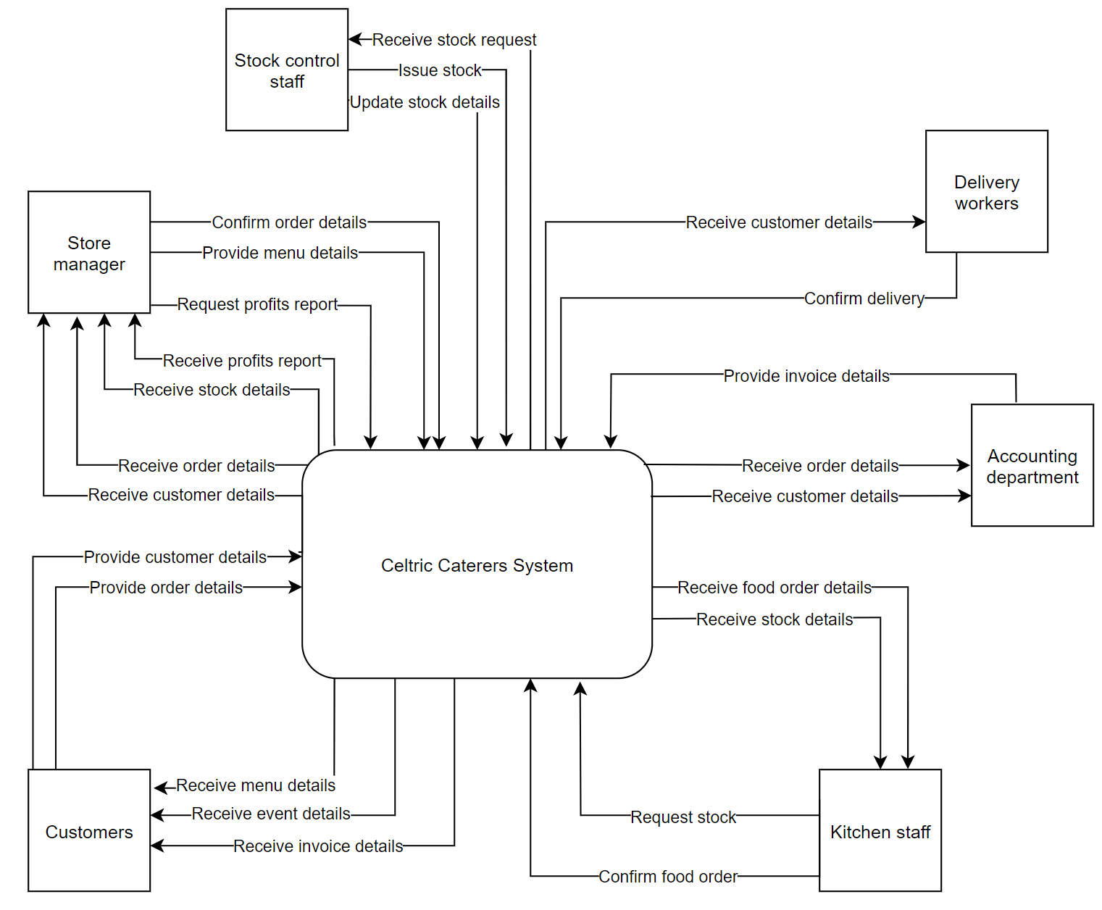
Chapter 2 Context Diagram
Figure 1: Context diagram design for Celtic Caterers system
The context diagram is designed for the operations needed within the Celtic Caterers business. It reveals the key processes flowing through the system and its important entities.

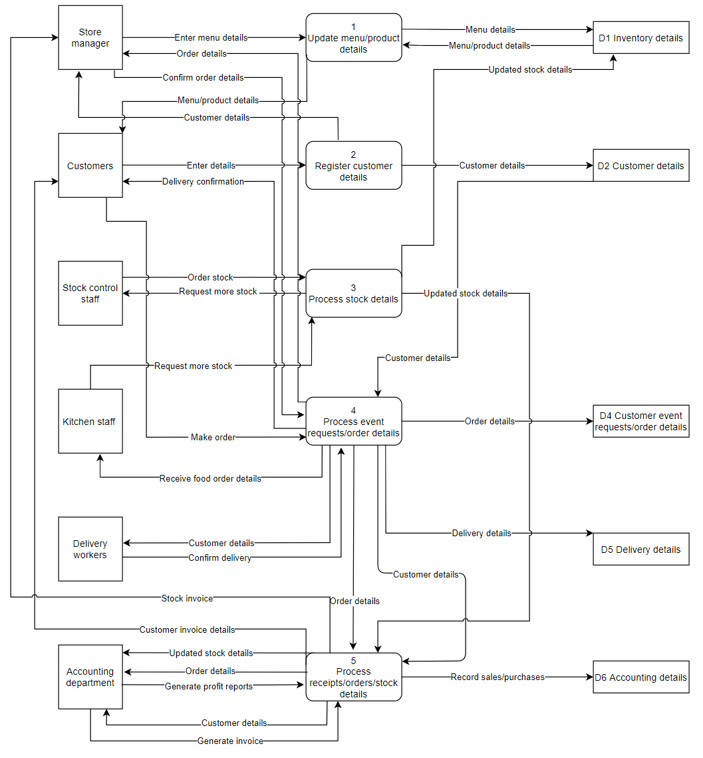
Chapter 3 Level 0 Data Flow Diagram (DFD)
Figure 2: LVL 0 DFD design for Celtic Caterers system
The Level 0 DFD reveals more in-depth information than the context diagram. It goes further by revealing more processes flowing through the system. The diagram reveals data that is stored in the data store symbols and similarly to the context diagram reveals important entities.

Chapter 4 Entity Relationship Diagram (ERD)

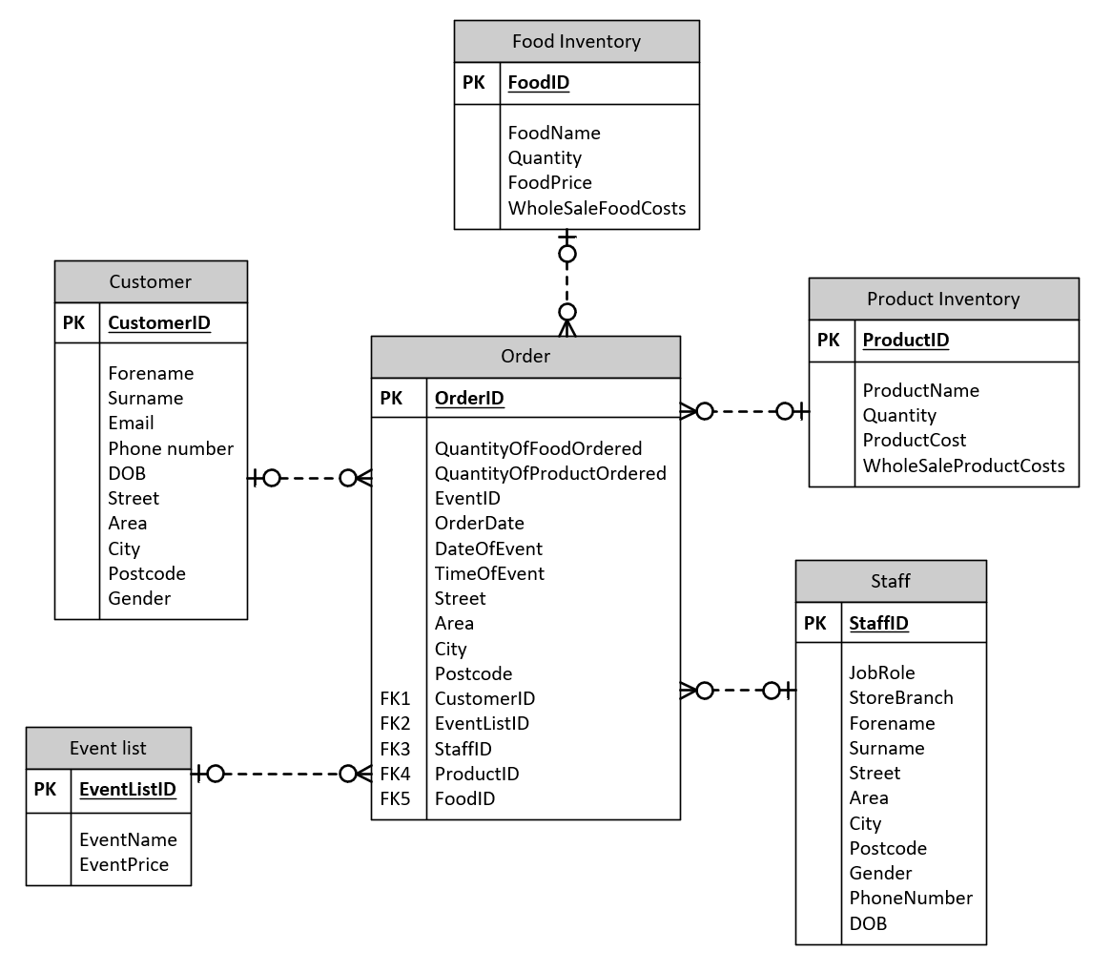
4.1 ERD designed in Visio
Figure 3: ERD design for Celtic Caterers system
This ERD was designed in Visio with the purpose of its elements being replicated in the database relationships. The ERD reveals the:
- Tables that will be implemented
- Fields used within each table
- Primary and foreign keys
- The relationship structures
The ERD design meets the requirements outlined for the system as it enables the specified aspects of the business to function, allows data to flow and allows for data to be stored and accessed whenever necessary.

4.2 Resulting ERD in final database
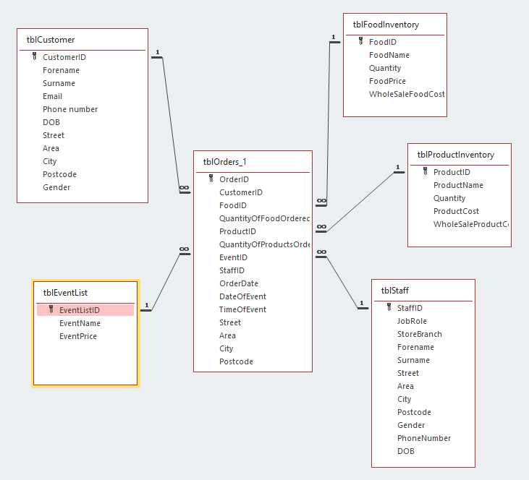

Figure 4: Relationships implementation within the Celtic Caterers system
Above are the resulting relationship structures within the Celtic Caterers database system. It follows the ERD design and therefore implements all the same fields, tables and the same degree of the relationships. The database has a total of six tables, similarly to the ERD in the design stage.

4.3 Normalization
I have made sure all data fields meet the rules of the Third Normal Form (3NF). As much redundant data as possible has been deleted.
3NF
CustomerID, Forename, Surname, Email, Phone number, DOB, Street, Area, City, Postcode, Gender
EventListID, EventName, EventPrice,
FoodID, FoodName, Quantity, FoodPrice, WholesaleFoodCosts
OrderID, CustomerID, FoodID, ProductID, QuantityOfProductsOrdered, QuantityOfFoodOrdered, EventID, StaffID, OrderDate, DateOfEvent, TimeOfEvent, Street, Area, City, Postcode
ProductID, ProductName, Quantity, ProductCost, WholesaleProductCost
StaffID, JobRole, StoreBranch, Forename, Surname, Street, Area, City, Postcode, Gender, PhoneNumber, DOB.

Chapter 5 Forms included within the Celtic Catering database
Below are all the forms within the database. Every form has a button to return to the main menu and to close the form. This allows users to navigate freely across all forms and use them to run queries and reveal and print reports.
I shall briefly mention the purpose of each form below, however the functionality of buttons within forms and more will be explained in the user guide.
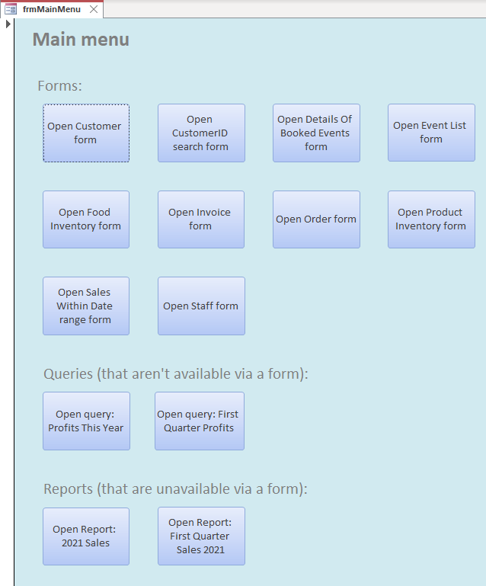
frmMainMenu

Figure 5: Main menu form implementation within the Celtic Caterers system
Above is the main menu form. It is the main form of the database and allows users to navigate to all other forms, queries and reports via button macros. It is always displayed automatically when the database is first opened.

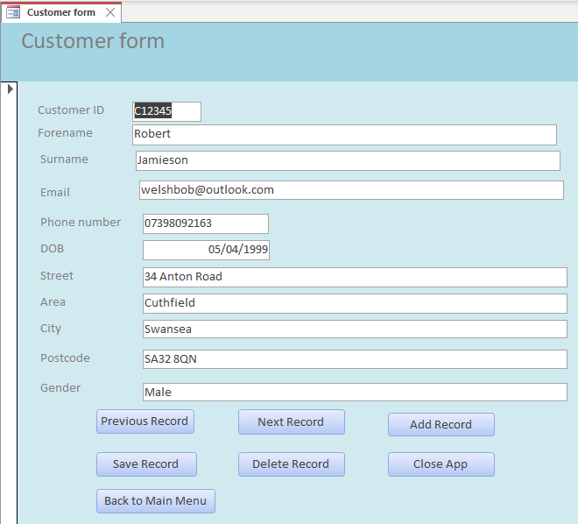
frmCustomer

Figure 6: Customer form implementation within the Celtic Caterers system
This form is linked with the customer details table. It allows staff to find, delete, view, edit, save and add customer details to the database. These include the Customer ID, Forename, Surname, Email, Phone number, DOB, Street, Area, City, Postcode and Gender.
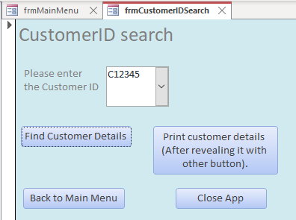
frmCustomerIDSearch

Figure 7: Customer ID search form implementation within the Celtic Caterers system
This form is used to query customer details by entering a customer ID. The resulting report can be printed.

frmDetailsOfBookedEvents
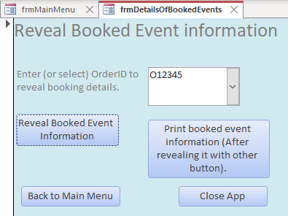

Figure 8: Details of booked events form implementation within the Celtic Caterers system
This form allows users to query information about booked events. The resulting report can be printed.
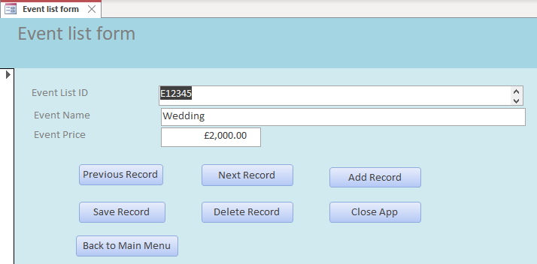
frmEventList
Figure 9: Event list form implementation within the Celtic Caterers system
This form is linked with the event list table. Its purpose is to allow staff to find, view, edit, add, delete and save event details in the database. These include the Event List ID, Event Name and Event Price.

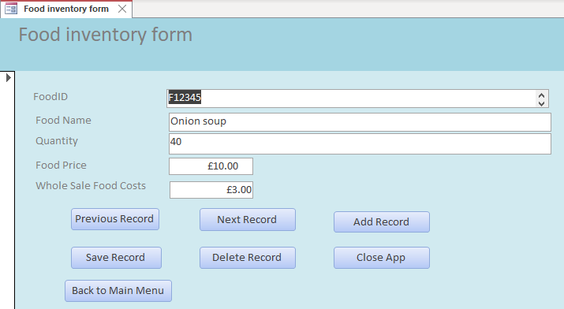
frmFoodInventory
Figure 10: Food inventory form implementation within the Celtic Caterers system
This form is linked with the food inventory table. It allows staff to find, add, edit, view, delete and save food inventory details in the database. These include the Food ID, Food Name, Quantity, Food Price and Wholesale Food Costs.
frmInvoice
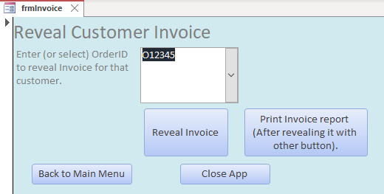

Figure 11: Invoice form implementation within the Celtic Caterers system
This form is used to query customer invoices. The user also has the option of printing the customer invoice.

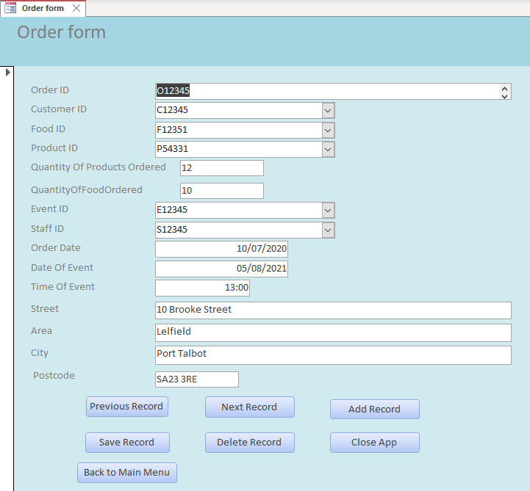
frmOrder

Figure 12: Order form implementation within the Celtic Caterers system
This form is linked with the order table. Its purpose is to allow staff to find, delete, edit, add, view and save order details in the database. These include the Order ID, Customer ID, Food ID, Product ID, Quantity of Products Ordered, Quantity Of Food Ordered, Event ID, Staff ID, Order Date, Date Of Event, Time Of Event, Street, Area, City and Postcode.

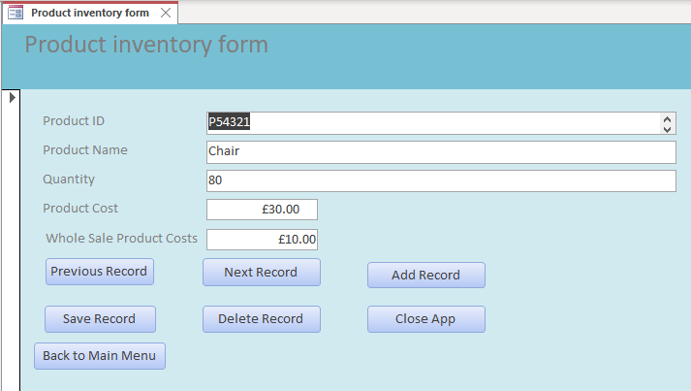
frmProductInventory

Figure 13: Product Inventory form implementation within the Celtic Caterers system
This form is linked with the product inventory table. It enables staff to delete, edit, view, find, add and save product inventory details in the database. These include the Product ID, Product Name, Quantity, Product Cost and Wholesale Product Cost.
frmSalesWithinDateRange
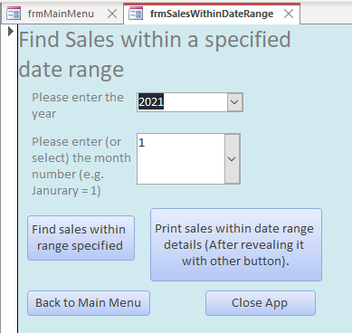

Figure 14: Sales within date range form implementation within the Celtic Caterers system
This form is used to query details about sales within a user defined specified date range. The user must enter the sale year and sale month number.
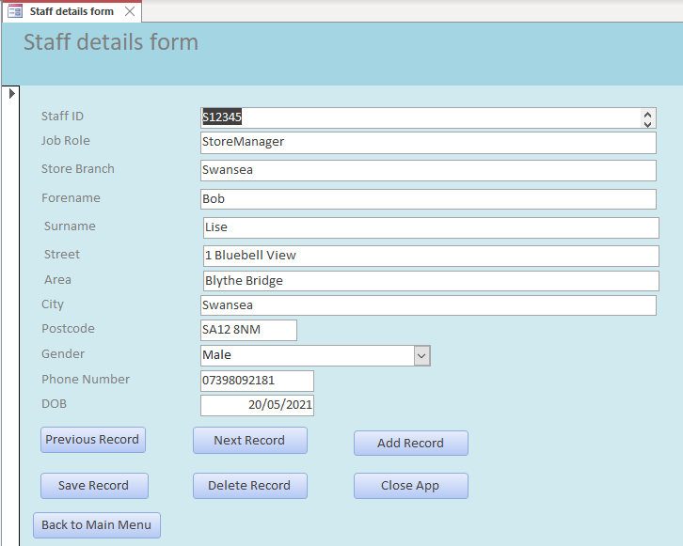
frmStaff

Figure 15: Staff form implementation within the Celtic Caterers system
This form is linked with the staff table. Its purpose is to allow staff to view, find, delete, edit, add and save staff details in the database. These include the Staff ID, Job Role, Store Branch, Forename, Surname, Street, Area, City, Postcode, Gender, Phone Number and DOB.

Chapter 6 Reports included within the Celtic Catering database
Below are all the reports within the database.
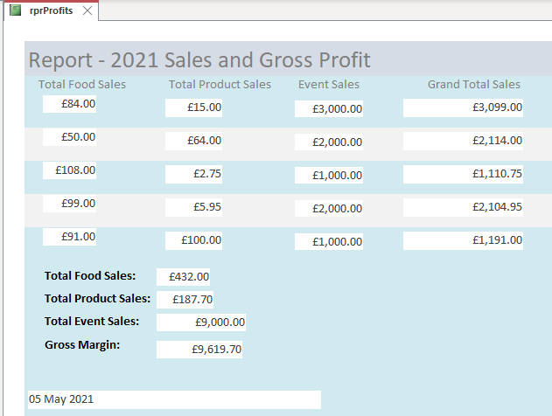
rprt2021YearSales

Figure 16: rprt2021YearSales report implementation within the Celtic Caterers system
The above report is created via the query: “qryProfitsThisYear”. The query is designed to reveal crucial sale details for the year 2021. The query performs calculations, hence adds additional information to the report not seen in any table such as the gross margin.
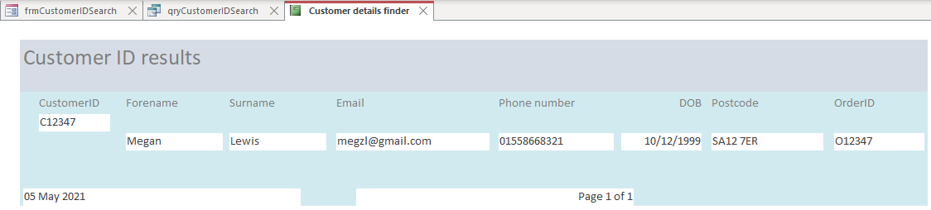
rprtCustomerIDSearch
Figure 17: rprtCustomerIDSearch report implementation within the Celtic Caterers system
This report is created when the user queries for customer details by using the customer’s ID in the “frmCustomerIDSearch” form. It reveals important information about a customer, such as their contact information.

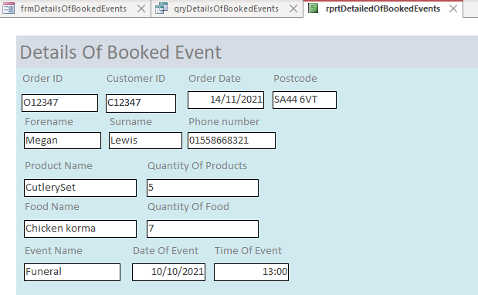
rprtDetailedOfBookedEvents

Figure 18: rprtDetailedOfBookedEvents report implementation within the Celtic Caterers system
The form “frmDetailsOfBookedEvents” creates this report when an Order ID such as “O12347” is queried. It reveals details about a booked event, such as the date of the event.
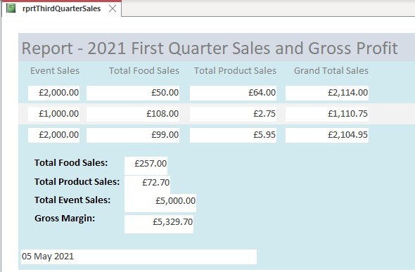
rprtFirstQuarterSales2021
Figure 19: rprtFirstQuarterSales report implementation within the Celtic Caterers system
This report is created via the query: “qryFirstQuarterProfits”. The query reveals sales information for the first quarter of 2021. The query performs calculations, hence adds additional information to the report not seen in any table such as the gross margin.
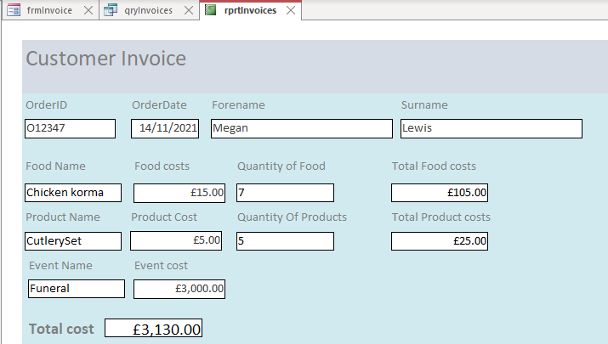
rprtInvoices

Figure 20: rprtInvoices report implementation within the Celtic Caterers system
This report is created when the user queries for order details by typing the Order ID in the “frmInvoice” form. It reveals customer invoices and can be printed out via the form mentioned.
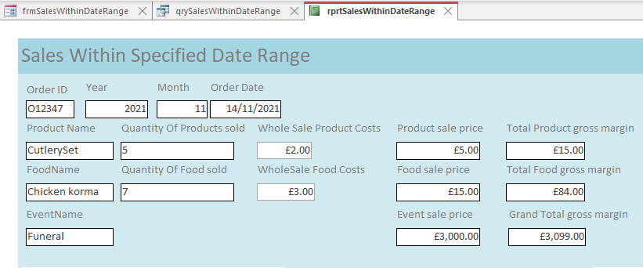
rprtSalesWithinDateRange
Figure 21: rprtSalesWithinDateRange report implementation within the Celtic Caterers system
This report is created when the user queries for sales within a user defined specified date range, by entering the year and month via the “frmSalesWithinDateRange” form. As suggested, it shows sales information for the month and year specified.

Chapter 7 Database user guide
In this guide I will not discuss how to use tables since all data within tables are directly editable by their corresponding form. Instead, this guide will predominantly reveal the functionalities of the forms, how to print, how to navigate the system and how to make use of queries and reports.

7.1 Forms
All forms (except the main menu form) include the following buttons:
- Close App – Allows user to close the form.
- Back to Main Menu – Once clicked the Main Menu form appears.
The majority of forms include the following buttons:
- Previous Record – This is used to navigate to the previous record (if any).
- Next Record - This is used to navigate to the next record (if any).
- Add Record – This allows a new set of data to be inputted.
- Save Record – This allows users to save/update any changes made to the data within the form. For instance, new data or existing data that has been modified can be saved.
- Delete Record – This allows users to delete any record available.
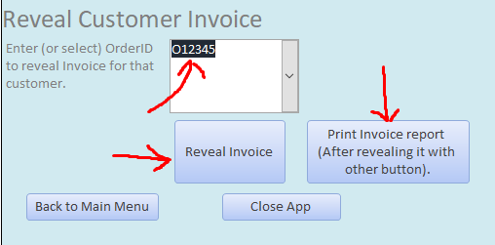
Some forms include additional buttons for specific reasons – either to query for specific details or to print a report. For example, in the “frmInvoice” form users should type in or use the dropdown box to find existing Order ID’s. Once that is done, the user can then click a button to query a customer’s invoice, which opens up a query and a report. It also has an additional button so users can print that report if they wish, as seen below:

Figure 22: Reveals annotated frmInvoices form

7.1.1 The difference between forms
Most forms are used to edit, delete, view, find, add and save data. However, some forms are used to search for, find, print and view specific data via queries and reports. The following forms are used to edit, delete, view, add, find and save data:
- frmCustomer
- frmEventList
- frmFoodInventory
- frmOrder
- frmProductInventory
- frmStaff
Meanwhile, the forms below are used to query for specific sets of data via a macro query and show the results via a report and query.
- frmCustomerIDSearch
- frmDetailsOfBookedEvents
- frmInvoice
- frmSalesWithinDateRange

7.2 Queries and Reports
Many queries are better run via their own respective forms in order to show reports. However, there are two queries that are run via the Main Menu, of which their two corresponding reports are opened via the main menu too. The queries and their corresponding reports can be seen below:
- Query: qryFirstQuarterProfits – Report: rprtFirstQuarterSales2021
- Query: qryProfitsThisYear – Report: rprt2021YearSales
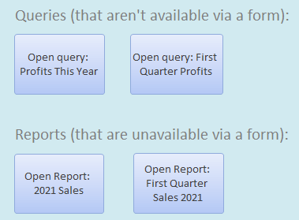

Figure 23: Reveals cropped frmMainMenu form
To reveal the outcome of these queries users can simply click the query buttons on the main menu or the report buttons. The reports offer a more user friendly view in which summary details such as the total sale details are shown. Whereas the queries offer a more technical view and more details are revealed, such as whole sale costs.

7.3 Database example walkthrough
Below is a step by step guide on how to use the database for viewing, searching for and printing out a customer’s invoice.
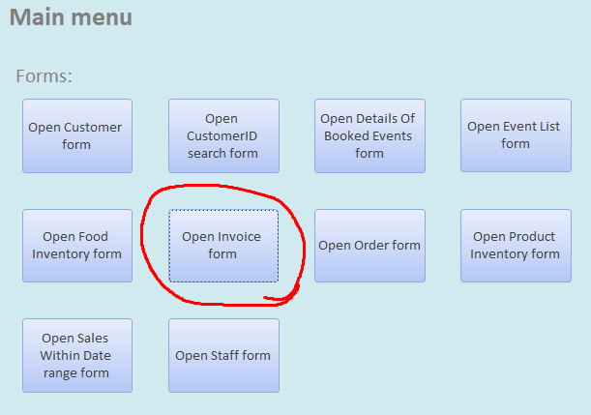
First, via the main menu click on the “Open Invoice form” button:

Figure 24: Reveals cropped and annotated frmMainMenu form
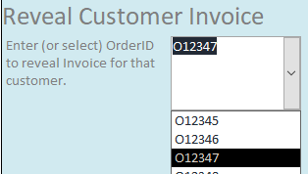
Now that the invoice form has appeared, either type in a customer’s Order ID or choose one from the dropdown box:

Figure 25: Reveals cropped frmInvoices form and the Order ID “O12347” selected.
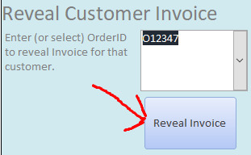
Now, click the “Reveal Invoice” button:

Figure 26: Reveals cropped and annotated frmInvoices form

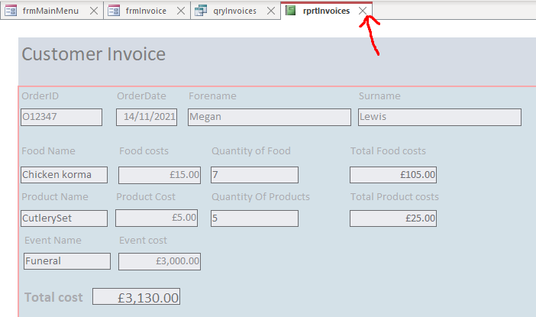
The customers Invoice report is now shown. To exit the report, click the cross sign as seen below:
Figure 27: Reveals annotated rprtInvoices report
The query relating to that report is now shown. To exit, click the cross sign again:
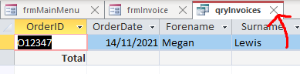

Figure 28: Reveals cropped and annotated qryInvoices query
You should now be back at the invoice form. Now that the invoice report has been generated, it can be printed. If you want to print the invoice report, click the button below:
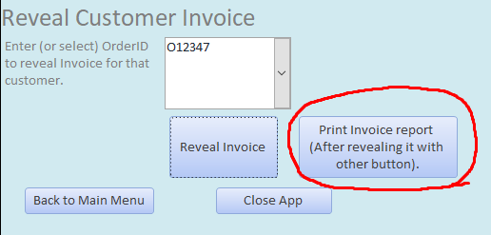

Figure 29: Reveals cropped and annotated frmInvoices form
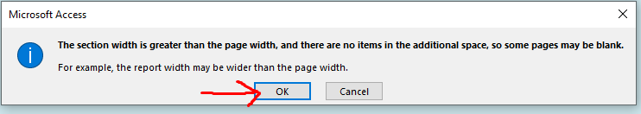
If there is a warning message, proceed and click ok:
Figure 30: Reveals cropped and annotated warning message when attempting to print
Now, the print configuration options will appear. Once configured to how you want it, click OK:
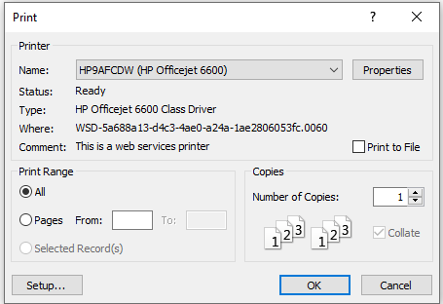

Figure 31: Reveals print options
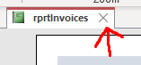
Once printed, to exit, once again click the cross sign:

Figure 32: Reveals cropped and annotated rprtInvoices report
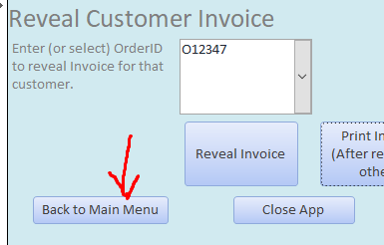
Now, either click the “Close App” button to close the form or go directly back to the main menu by clicking the “Back to Main Menu” button, as seen below:

Figure 33: Reveals cropped and annotated frmInvoices form
You will now be back on the main menu form.

Chapter 8 Conclusion
In conclusion, the database has been designed in-depth with the help of a context diagram, Level 0 DFD and an ERD. The implemented database has especially followed the ERD very closely, having all of the data fields and tables from the diagram included. All data fields in the database conform to the rules of the Third Normal Form (3NF). The database has fulfilled the requirements suggested by Celtic Caterers as it allows invoices to be viewed and printed; it reveals the stock of products and food and users are able to query information about any event that has been booked. Furthermore, the database allows for essential data to be stored, accessed, modified and deleted via user friendly forms.
The user guide provides a good insight into how to use the database – particularly about how users can navigate through the system, query it and view and print reports.

