Effective Team working and Communication
Minhazur Rahman – 1706274

Contents
Introduction 3
Team: 3
Workplace Communication 3
Workplace performance 3
Types of communication 4
Verbal Communication: 4
Non-verbal communication: 4
Different theories related to public communication 4
Models of Communication: 7
How workplace communication and performance of employers can be improved 8
Providing training: 8
Inspiring people: 8
Making content clear: 8
Using technologies: 9
Application of Theories: 9
Teamwork: 9
Co-ordination: 9
Conclusion 10
References 11

Introduction
In our day to day life, communication is one of the most important factors that enhances the performance and productivity of an individual from different aspects. Since people develops their lives through different stages and they are strive to communicate with other people in society (Thomas et al., 2013). Communication is a part of everyday life. It may be overlooked in some areas, but when dealing with a team environment, communication is very important for the individual. The author from his/ her personal experience of working in the health and social care field as a manager knows how the communication has been influencing on different teams on achieving organizational goals and objectives. In this essay, the writer will different aspects of communication and how workplace communication and performance of employers can be improved.

Team:
Team indicates to a group of people working for achieving a specific goal. According to Bent and Tipple (2013), “While some people are gathered to achieve a specific organizational goal or objective that is considered as team.” In this regards (Levi, 2011) goes further and said, When some professionals are get together and works co-operatively for completing a task that is considered as team.”

Workplace Communication
To define the term Workplace communication that is very important for any organization to make the employees productive and operate the company efficiently Crawford et al (2015) noted, “Workplace communication is the process of exchanging information, both verbal and non-verbal, within an organization.” It is also beneficial to make an individual experienced and enhance the productivity and performance.

Workplace performance
In an organizational context the performance of the employees is a critical factor for achieving the organizational goals and objectives. Workplace performance enhances the performance and production of the individuals of an organization to achieve the organizational goals. To define the term workplace performance Whitcomb and Whitcomb (2013) stated “Workplace performance indicates to the mutual performance of employees and the working environment of an organization to achieve the organizational goals and objectives including job duties and responsibilities.”

Types of communication
To develop the communication skills of an individual, s/he should have practical knowledge of different types of different types of communication. Such types of communication have been represented in the following-
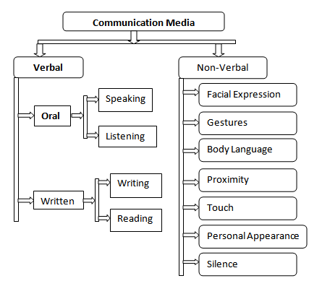
Figure 1: Communication process Source: (Thomas et al., 2013)

Verbal Communication:
According to Hartley (2016), “Verbal communication is the use of sounds and words to express something in a certain context.” It helps an individual to represent him or herself effectively. There are two types of Oral communication and written communication.

Non-verbal communication:
According to Thomas et al. (2013), “Nonverbal communication indicates to a communication process without the use of sounds and words to express something.” In an organizational context, the non-verbal communication indicates to sign language, gesture, using image, etc. It is also effective to make an effective communication with someone.

Different theories related to public communication
To define the term communication Hargie et al (2014) said, “Communication indicates to passing of information, ideas, and attitudes from person to person.” In an organizational context and a team the impact of proper communication can be very clear for anyone to understand. To ensure proper communication among the team members to complete a task, the theories in the following are very effective.
Diffusion Theory:
The Diffusion of innovations theory was proposed by Everett Rogers in 1962 that demonstrates how, why, and at what rate new ideas and technology spread. In this regards, Hartley (2016) said, “Diffusion research examines how ideas are spread among groups of people beyond centering on the conditions of an environment.” According to Molinari and Bushy (2012), “Human behavior, getting new ideas, how to implement them, step-by- step, are the discussion topic of the diffusion theory.” In the diffusion theory, there are five stages that are followed by an individual to make an effective communication and those are-

Figure 2: Stages of Diffusion theory Source: (Hargie et al, 2014)
Agenda Setting Theory:
According to Thomas et al (2013), “the Agenda setting theory evaluates the effectiveness of impact of the media to inform people regarding different important issues in our day to day life.” It is a theory that demonstrates the information and awareness among targeted people of the society. To describe the Agenda theory Molinari and Bushy (2012) noted, “Community discussion, media interaction and public relations are most important impact on a certain community.” In an organizational and business environment, the Agenda setting theory has reputation for creating public relationship with the assistance of the media, the public and policy makers.
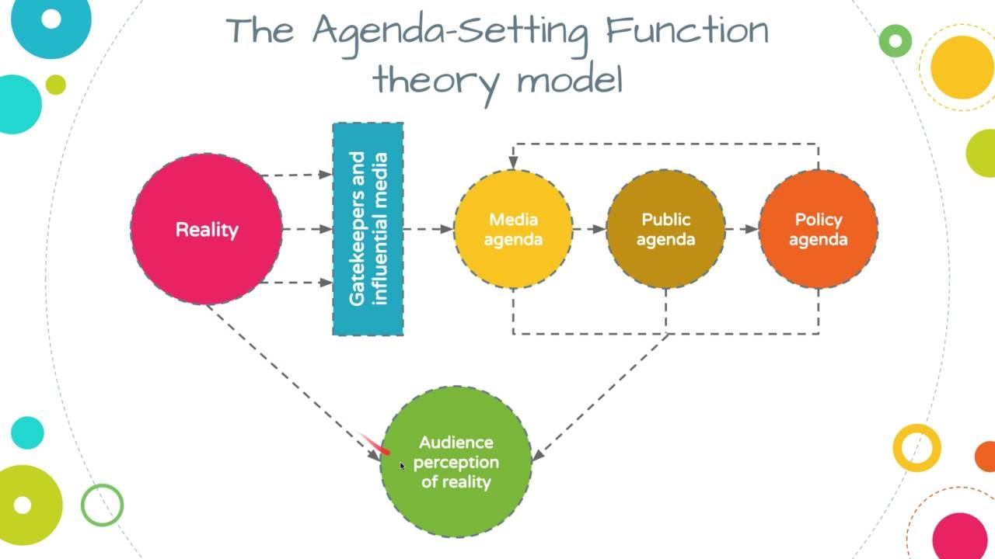
Figure 3: Agenda Setting Theory Source: (Levi, 2011)
Hypodermic/Bullet Theory:
This theory also relies on the powerful principle of media and its consumers. According to Hargie et al (2014), “Hypodermic/Bullet Theory is an effective model that suggest an intended message that directly received the receiver or customers. According to this theory, the information has great impact like bullet on the targeted audiences.

Models of Communication:
Aristotle's Model: Aristotle's communication Model is considered as is the earliest mass communication model that was developed some 2000 years ago in Greece. According to this model, a communication can be completed with five necessary factors including communication: Speaker, Speech/message, Audience, Effect and Occasion. It is considered as person centered model of communication. This model states, a speech should be given based in an occasion that has an effect on the audiences with a specific massage from the speaker.
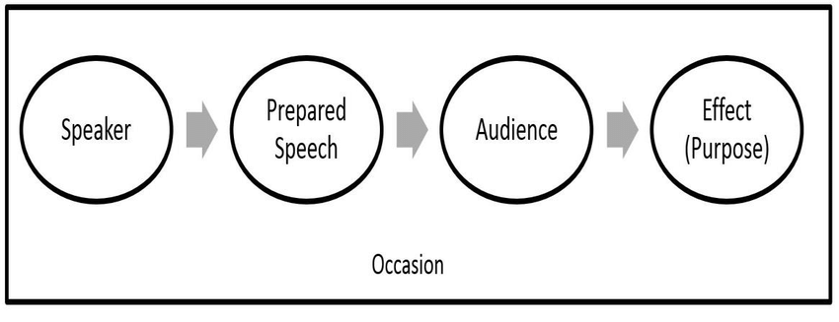
Figure 5: Aristotle's Model of communication Source: (Bent and Tipple, 2013)
Shannon and Weaver's Model (1949): Shannon and Weaver's Model of communication is considered as mathematical theory of communication or transmission model that includes a technique to the problem of how to convey maximum information in a given channel. In this model of communication a Sender sends his or her message using a specific channel to a receiver.
Lasswell's Model: In the organizational context for making mass communication the Lasswell's Model (1948) is used that describes an act of communication by defining who said it, what was said, in what channel it was said, to whom it was said, and with what effect it was said. According to this model, the massage of an individual is considered as very important for the receivers and the speaker is also very important.
All of these theories and models for communications are very important and effective for ensuring public communication in a certain community. The writer has the effectiveness of both of these theories in the health and social care home. The application of these theories have developed the working performance and environment of the health and social care home. The workers have performed very by following both of these theories.

How workplace communication and performance of employers can be improved
In an organizational context, effective communication is fundamental for ensuring better performance and improving the performance of the professionals, patients and the organization providing care (Molinari and Bushy, 2012). To develop the communication process among the workers, patients and officials of an organization by using verbal, non-verbal, written and online communication, and different ways can be followed to develop the communication and performance of the employees or teams. Some of the have been explained in the following by the writer.

Providing training:
In an organizational context, the workers and the employees of the company can be trained with different basic training courses for establishing effective communication among the employee and the customers. In this regards, the employees and the staffs can be taught with effective verbal communication, non-verbal communication like sign language, gestures, etc. written communication and online communication (Thomas et al., 2013). Such training programs will enhance the skills and experiences among the employees from different aspects. As a result, the employees will be more interested develop their performances according to needs.

Inspiring people:
The employees of the organizations can be inspired to communicate with each other. They have to make understand that effective communication skills will help them to build relationship and trust among them. They will be capable to win the trust and satisfaction of the customers with proper communication. As a result, their performance will be developed. According to Bent and Tipple (2013), “the performance of an employee is greatly enhanced, if the communication skill is better.”

Making content clear:
The employees and the staffs of an organization should be cleared regarding the expected contents. They should be given with proper guidelines and specification that will contain the relevant data that will ensure effective communication and performance of the employees. In teamwork of an organization in the health and social work, the team members should be informed regarding their roles and responsibilities. If they will be provided with information and transparent knowledge of something, they will be capable to achieve organizational goals and objectives according to guidelines. It will be also beneficial for developing the performance of the employees or team members.

Using technologies:
To develop the communication and performance of the team members and employees of an organization in health and social care context, use of technology is must. Use of required technology is very much crucial for developing the communication skills of the team members. For instance, use of email, social media and a website can ensure transformation of huge data and information within a shortest span of time. As a result, the employees or team members get huge opportunity to develop their performances with required data. They can share their opinions thoughts and learning things to achieve the goals and objectives of team and organizations.

Application of Theories:
To ensure the development of communication among the team members and the employees of an organization in health and social care proper application of different theories are also very important. In this regards, the application of Diffusion Theory by informing stages and explaining them among the team members can be beneficial. Another important Agenda theory can be applicable by using written communication approach and online communication is also very helpful from different aspects.

Teamwork:
To ensure proper communication among the staffs and employees of an organization or in an organizational context teamwork or multi-professional collaboration is another essential factor that can also develop the performances of the employees to achieve the organizational goals and objectives. It develops an interpersonal relationship among the employees of an organization and develops their skills to achieve the organizational goals and objectives from different aspects. Mutual understanding in a group of people is embedded in organizations and performing according to tasks contributes to achieving the organization's goals and objectives.

Co-ordination:
Ensuring proper co-ordination of communication activities is another most important thing that can enable the team members to communicate with each other. Proper monitoring and controlling of the activities of the employees will ensure the achievements of conveying information, proper understanding and developing trust among people. The management of an organization can easily solve a conflicting situation with proper monitoring and co-ordination among the employees. As a result, the management of an organization will be capable to develop their performances from different aspects.

Conclusion
In conclusion, communication has been proved as one of the most important factors that has crucial roles in our day to day lives. To be success both in our personal and professional lives, an individual should be careful regarding the enhancement and development of performance and productivity. Since people develops their lives through different stages and they are strive to communicate with other people in society. Communication is a part of everyday life. It may be overlooked in some areas, but when dealing with a team environment, communication is very important for the individual. The author from his/ her personal experience of working in the health and social care field as a manager knows how the communication has been influencing on different teams on achieving organizational goals and objectives. In this essay, the writer will different aspects of communication and how workplace communication and performance of employers can be improved.

References
Bent, H. and Tipple, L. (2013). Worship 4 today. London: Church House Pub.
Bent, H. and Tipple, L. (2013). Worship 4 today. London: Church House Pub.
Crawford, M., Kydd, L. and Riches, C. (2015). Leadership and teams in educational management. Buckingham: Open University Press.
Hargie, O., Dickson, D. and Tourish, D. (2014). Communication in management. 4th ed. Aldershot: Gower.
Hartley, P. (2016). Group communication. London: Routledge.
Levi, D. (2011). Group dynamics for teams. Thousand Oaks: Sage Publications.
Molinari, D. and Bushy, A. (2012). The rural nurse. New York: Springer Pub. Co.
Thomas, J., Pollard, K. and Sellman, D. (2013). Interprofessional working in health and social care. 6th ed.
Whitcomb, C. and Whitcomb, L. (2013). Effective interpersonal and team communication skills for engineers. Hoboken, N.J: John Wiley & Sons Inc.

