Project Management
Assignment 1
Module code: LCBB5005

Name: Laurentiu Marcel Gornic
Student number: 1817470
Module lecturer’s name: Dr Molly Jack

Table of Contents
- Introduction 3
- Business aims and objectives 3
- Project scope………………………………………………………………..4
  - Work Breakdown Structure……………………………………………4
- Project scheduling………………………………………………………….7
  - The Gantt Chart………………………………………………………...8
- Cost management and earned value management (EVM)………………8
- Resource management……………………………………………………..9
- Communication management plan………………………………………10
  - Stakeholder analysis…………………………………………………...11
- Risk management…………………………………………………………11
- Conclusion………………………………………………………………...12
- Reference list……………………………………………………………..14

- Introduction
The restaurant company plays a major role in the local economy and meets the needs of people for social relations between the initial food and drink supply. Restaurants have always played a crucial role in the business, financial, intellectual and creative life of a society (Feldman 2015).
The respective project plan concerns the restaurant which reflects the country's traditional specificity, Romania, where the region's historical heritage and legends, also popular for their hospitality, will be portrayed.
In conclusion, this paper describes the execution of the project plan for the restaurant in Romania.
As a project management plan for an organisation allows the manager to provide a comprehensive and succinct report, a standardised form which is accessible to members of the project management team as well as to project stakeholders, this document is one of the main documents in the sector. The project plan will list all phases and integrate critical time, cost and quality criteria and specifications by enhancing the following questions: why, where, how, where and how (Lester 2014).
2. Business aims and objectives
The business in Romania's traditional restaurant aims to establish a place for customers to relax and enjoy their free time with family, friends, holidays and weddings, and business meetings. It designs and builds an area that corresponds to local traditions and customs.
The following SMART structure (see Fig.1) is used to define the objectives for the business restaurant:
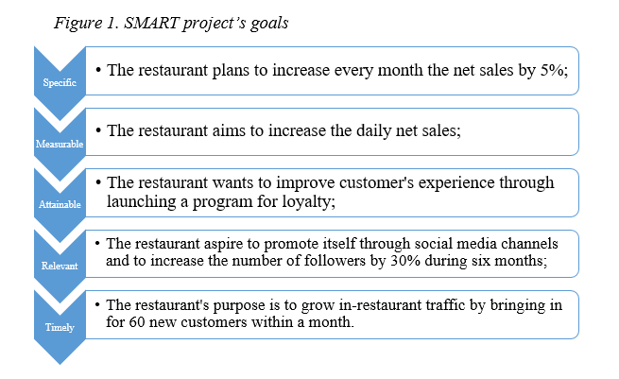
- Project scope
The execution of any project is basically related to its concept and the project scope planning. The complexity of the project management includes processes that define, schedule and track the success of the project work. The scope therefore shows the necessary project work to complete the expected project successfully. The project scope management determines the amount of work required and indispensable in order for the project to be completed successfully (Derenskaya 2018). Mazur et al. (2009) consider the scope of the project to be the content of work on efficient project management to decide the number, sequence, working hours, resources and costs of the work needed.
  - Work Breakdown Structure
In order to evaluate the project lifecycle schema for each step of the task, a Work Breakdown Structure (WBS) is required to assess the size and complexity of the work. To ensure effective project management, each process must be divided into stages and tasks, and subtasks until the systemic control of the plan is appropriate (Lester 2014).
The WBS forms the basis on which the allocation of human, material and financial resources for the projects can be planned and monitored and also for every task. A small group of companies representing the entire restaurant business is easier for the project management team to control than the whole organisation as a single operation.
The tasks given by the WBS (see fig. 2) will be allocated to project management personnel, helping all of them, providing clarified information and a better understanding of their tasks, as well as being a helpful tool for providing stakeholders with a structured report. The WBS deliver the progress of the processes directly to the management and is required to update every task.
Although the WBS represents the plan structure, it is done in early stages, so all the tasks that may occur during the project operation cannot be covered.
The following diagram provides a detailed structure for the future business plan for restaurants:
4 4 4 4 4 4 4 4 4 4 4 5 5 8 8 99 9 5 2 2 454554 4 4 5 5 6 6 6 6 6 5 11 1 4 5 5 5 6 6 6 6 6 6 6 6 6 6 6 6 6 6 6 6 6 6 6 9 9 9 9 9 9 8 8 77 7 4 4 1 1 1 1 4 4 4 4 4 4 5 5 6 6 6 6 6 6 9 9 9 9 9 9 9 9 9 9 9 9 9 9 9 9 9 9 9 9 9 9 9 9 9 9 9 9 9 9 9 9 9 9 9 9 9 9 9 9 99 9 9 9 9 9 9 9 9 9 9 9 9 9 9 9 9 9 9 9 9 9 9 9 99 9 9 9 9 9 9 9 9 9 9 99 9 9 9 9 9 9 9 9 9 9 9 9 9 9 9 9 9 9 9 9 9 9 9 9 9 9 9 9 9 9 9 9 9 9 9 99 9 9 9 9 9 9 9 99 9 9 9 9 9 9 9 9 9 99 9 9 9 9 9 9 9 9 9 9 9 9 9 9 9 9 9 9 6 6 6 6 6 6 6 6 6 6 6 6 6 6 6 6 6 6 6 6 6 6 6 6 6 66 6 6 99 9 9 87 7 77 7 7 7 7 77 7 77 7 7 7 77 7 7 7 7 7 7 7 7 7 7 7 7 77 7
Figure 2. The Work Breakdown Structure
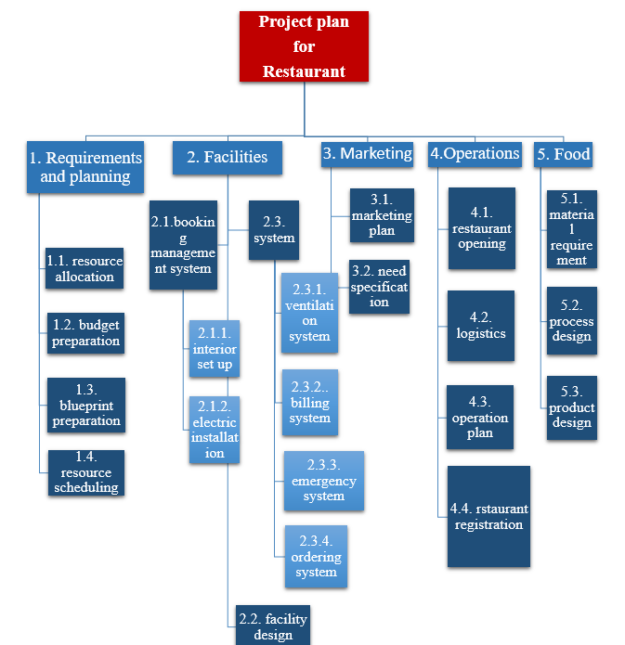
7 7 7 7 7 7 7 7 7 7 7 7 7 7 7 7 7 7 7 7 7 7 7 7 77 7 7 7 7 7 7 7 7 7 7 7 7 7 7 7 7 7 7 7 7 7 7 7 7 7 7 7 7 7 7 7 7 7 7 7 7 7 7 7 7 7 7 7 7 7 7 7 7 7 7 7 7 77 7 7 7 7 77 7 7 7 7 7 7 7 7 7 7 77 7 7 7 7 7 7 77 7 7 77 7 7 7 7 77 7 77 7 7 7 7 7 7 7 7 7 77 7 7 7 7 7 7 7 7 7 7 7 7 7 7 7 7 7 7 7 7 7 7 7 7 7 77 77 7 7 7 7 7 77 7 7 7 7 7 7 7 7 7 7 7 7
4. Project scheduling
The project planning literature usually focuses on resources which maximize project period goals and serve as a guidance when implementing the project plan.
The structure of the schedule plays a significant role. Firstly, to strategically assign the resources to the various performance optimisation tasks and secondly to serve as a basic line of external planning, such as material purchases and preventive maintenance, external deliveries and internal clients, as described by Wu et al . (1993). It also provides a framework for contact across the outbound and inbound supply chain of the organisation.
In addition, during execution the project tasks are under pressure, which may lead to unexpected distress. These scheduling delays can occur due to activities which may take more or less time than originally planned, when resources are required, orders may emerge after the timetable, new activities may emerge or the older ones may be withdrawn as a result of changes in project scope, due dates may be delayed or any other changes can lead to higher costs or do not occur in the original financial plan if the project schedule is regularly reprogrammed or interrupted. Finally, there is a question or concern about the quality of the project plan (Goldratt 1997).
For the study of project preparation, this project will use the Gantt Chart methodology. 7 7 7 7 7 7 7 7 7 7 77 7 7 7 7 7 7 7 7 7 7 7 7 7 7 7 7 7 7 7 7 7 7 7 7 7 7 7 77 7 7 77 7 7 7 7 77 7 7 7 7 7 7 77 7 7 7 7 77 7 77 77 7 7 77 7 77 77 7 7 7 7 77 77 7 77 7 77 7 7 77 7 7 77 7 7 7 77 7 7 7 7 77 7 7 7 7 7 7 7 7 7 7 7 7 7 7 7 7 7 7 7 7 77 7 7 7 7 7 77 77 7 7 7 7 7 7 7 7 7 77 7 7 7 7 7 77 77 7 7 7 77 77 7 7 7 77 7 7 77 7 7 7 7 7 7 7 7 7 7 7 7 7 7 7 7 7 7 7 7 7 7 7 7 7 7 77 77 7 7 7 7 77 7 7 7 7 77 7 7 7 7 7 7 77 7 7 7 7 7 7 7 7 7 7 77 7 7 7 7 7 7 7 77 7 7 7 7 7 7 77
4.1. The Gantt Chart
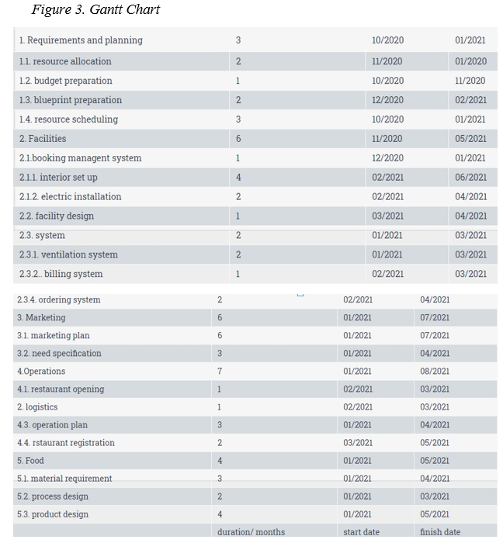
5. Cost management and earned value management (EVM)
Project Cost Management is an essential task for the manager in tracking and assessing costs for particular operation(s), where they have been cost-effective, and in measuring and managing project patterns (Lester 2014).
The earned value management approach is an essential tool to execute the project on schedule. In accordance with what is expected, this method tests the job efficiency of the project plan and estimates the final price (Gasparotti et al. 2017). Eun Hong et al. (2003) also claimed that the project manager can handle every issue until it is crucial and can maximise the projects' opportunities.
For each operation, the EVM calculates three values of the Task Breakdown Structure:
• Projected value (PV) – the cumulative expected costs to be expended during the projected duration of the project;
• Actual cost (AC) expense-the overall costs for work completed directly and indirectly;
• Value obtained (EV) – an average value for budget-completed work.
The PV is projected at approximately £50.000 of investments planned over 6 months for the business plan. The AC is equivalent to £59.000, with the EV estimated at £50.000 so that the work is completed in due course and the initial costs of the project are met.
6. Resource management
For successful project completion, staff are required to monitor a plan, as it is necessary to assess the company's success or failure to directly and indirectly include people involved in various project phases.
The project focuses on WBS people who are responsible for the work success. They examine through RACI chart where R means responsible, A-accountable, C-consulted, and I-informed during the project planning process.
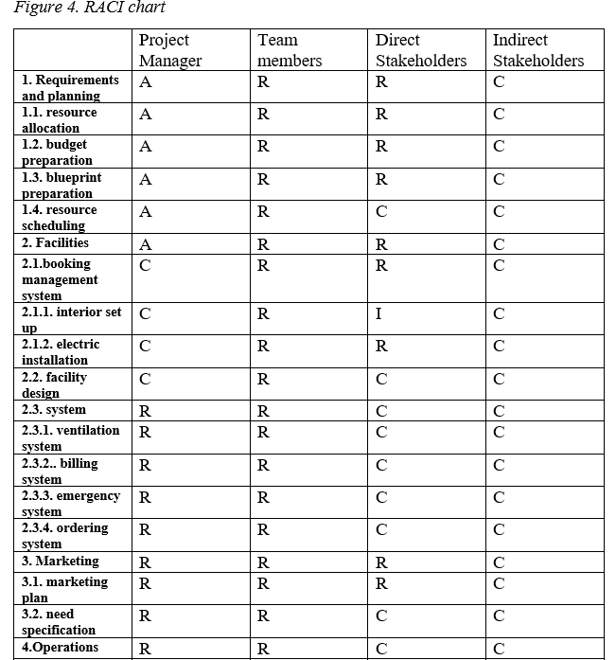
7. Communication management plan
The project manager may consider the stakeholders who may be involved in the current project or business. The following paragraph is intended for the study of stakeholders interested in the project activities of the restaurant.
7.1. Stakeholder analysis
There are two groups of stakeholders: direct and indirect. The first category is linked to those involved in the project preparation, management or execution. It includes stakeholders like the customers, sponsors, the project manager, team members, suppliers with financial and technical services, consultants, and staff (Lester 2014). (Lester 2014). In fact, people and organisations directly involved in various phases of the project are direct stakeholders in the restaurant.
The group of indirect stakeholders includes those who participate indirectly in the projects. This group includes such people as managers and staff, with the exception of those directly related to the project; human resources departments, counterparts, ministers; and, last but not least, representatives, government, public utilities, technical inspectorates and stakeholders (Lester 2014).
8. Risk management
Risks can occur at any time, but they must not be overlooked during the project phases. In assessing the risks, a research method known as risk assessment may take place in the project.
The five main phases of the risk management plan principles that must be followed to better understand project risks and avoid unexpected costs, deadlines, quality or safety criteria:
- Risk awareness
- Risk identification
- Risk assessment
- Risk evaluation
- Risk management
The manager will identify these risks and create a risk register in order to track them. If the risks are detected, they shall be informed and permanently tracked in the register.
The following structure follows the overview of the risk management method:
- Risk awareness
- Risk identification
- Risk owner identification
- Qualitative assessment
- Quantification of probability
- Quantification of impact
- Exposure rating
- Mitigation
- Contingency provision
- Risk register
- Software usage
- Monitoring and reporting
9. Conclusion
In conclusion, the current report analyzed the phases of a chosen project, in this case it was to analyze a restaurant business in Romania, having a budget of £50.000 and the duration of the project was 6 months. For this project was required to develop a project management plan, including the analysis of its stakeholders, risks, time and costs. The report is discussing about the business aims and its objectives, the project scope and uses the WBS method, analyze the project schedule through Gantt Chart methodology, cost management and EVM, the project resources, studies the communication plan and stakeholder analysis and states the risks of the project management plan. 7 7 7 7 7 7 7 7 7 7 7 7 7 7 7 7 7 77 7 7 7 7 7 7 7 7 7 7 7 7 7 7 7 7 7 7 7 7 7 7 7 7 7 7 7 7 7 7 7 7 7 7 7 77 77 7 7 7 7 7 7 7 7 7 7 7 7 7 7 7 7 7 7 7 7 7 7 7 7 7 7 7 7 7 7 7 7 7 7 7 7 7 7 7 7 7 7 7 7 7

Reference list:
- Derenskaya, Y (2018) PROJECT SCOPE MANAGEMENT PROCESS. Baltic Journal of Economic Studies, 4(1), [online] Available at: http://www.baltijapublishing.lv/index.php/issue/article/view/340/pdf [Accessed 17 May 2020].
- Herroelen, W. and Leus, R. (2005) Project scheduling under uncertainty: survey and research potentials. European Journal of Operational Research. 165(2), p.289-306. ScienceDirect [online]. Available at: https://www-sciencedirect-com.ezproxy.uwl.ac.uk/science/article/pii/S0377221704002401?via%3Dihub [Accessed: 13 may 2020].
- Gasparotti, C., Raileanu, A. and Rusu, E. (2017). The Earned Value Management - A Measurement Technique of the Performance of the Costs and Labor in the Project. ACTA UNIVERSITATIS DANUBIUS, 13(2). [online] Available at: http://journals.univ-danubius.ro/index.php/oeconomica/article/view/4029/3971 [accessed: 13 may 2020].
- Goldratt, E. (1997) Critical Chain. The North River Press. [Google Scholar].
- EunHong, K., William, G., Wells, Jr. and Duffey, M. (2003). A Model for Effective Implementation of Earn Value Management Methodology. International Journal Of Project Management, 21, p. 375-382.
- Lester, A. (2014) Project Management, Planning and Control. 6th ed. HB [online]. Available at: https://web-a-ebscohost-com.ezproxy.uwl.ac.uk/ehost/ebookviewer/ebook/ZTAwMHh3d19fNDg2NDk2X19BTg2?sid=742edcc7-cd91-4d2a-bda6-138550ed3368@sdc-v-sessmgr03&vid=0&format=EB&lpid=lp_65&rid=0 [Accessed: 30 April 2020].
- Mazur, I., Shapiro, V., Ol`derogge N. H. and Polkovnikov A. V. (2009) Project management. Moscow: Omega-L. (in Russian)
- The Restaurant Technology Guys (2018) Strategy & Planning: Define Your Goals. [online] Available at: https://restauranttechnologyguys.com/strategy-planning-define-your-goals/ [Accessed: 15 May 2020].
- Wu, S., Storer, R. and Chang, P. (1993) One machine rescheduling heuristics with efficiency and stability as criteria. Computers and operations research, p. 1-14.

