Assessment Task 1 –Individual Report

Programme: BA (Hons) Leadership and Management Skills for the Workplace
Module: Developing Emotional Intelligence Skills for the Workplace BMSW6106
Student: Mihai Arhire (2030027)
Lecturer: Ogochukwu Agunenye

Table of Contents
Introduction ……………………………………………………………………………………….3
The Importance of Emotional Intelligence in the Workplace 4
Emotional Intelligence and Competitive Advantage 6
Key Emotional Intelligence Models 7
Goleman’s Model of Emotional Intelligence 7
Bar-On Model of Emotional-Social Intelligence 9
Mayer-Salovey-Caruso Emotional Intelligence Test (MSCEIT) 10
Application and Critical Evaluation of Emotional Intelligence Models 12
Recommendations for Developing an Emotionally Intelligent Workforce 14
Conclusion 16
References 17
Appendix……………………………………………………………………………………………………………………………………………….19

Introduction
In this increasingly turbulent economic environment, businesses are faced with increasing complexities that require both technical skills and emotional and social competencies. According to Singh et al. (2022), emotional intelligence is the capacity to identify, comprehend, and regulate one's own emotions as well as those of others. It has become a crucial quality in today's industry. This report considers the importance of developing an emotionally intelligent workforce within John Lewis Partnership, a UK-based leading retailer, and provides an overview of how employers can train and develop their existing staff to increase their emotional intelligence.
Since John Lewis Partnership is an employee-owned firm and high-quality customer service makes the retail industry in which the business operates very competitive, the organization's success is deeply related to its employees' emotional and social competencies. Therefore, the development of EI becomes a strategic priority. This report critically reviews three principal models of emotional intelligence: Goleman's model, the Bar-On model, and the MSCEIT (Mayer-Salovey-Caruso Emotional Intelligence Test) and applies these models in the context of the John Lewis Partnership to test their relevance and effectiveness toward developing an emotionally intelligent workforce.

The Importance of Emotional Intelligence in the Workplace

Figure 1: Importance of Emotional Intelligence at Workplace; Source: Author
Within an uncertain business environment characterised by technological transformations, unpredictable changes in the economy, and continuous shifts in consumer preference, emotional intelligence has come to be the most critical ingredient of organisational success. Technical skills or industry knowledge may be learned, but emotional intelligence represents several interpersonal and intrapersonal skills that equip individuals with the ability to manage at work. Research findings all tend to show that high emotional intelligence is a prime characteristic of resilient, adaptable, and communicative staff—very necessary in a volatile economic environment.
In the John Lewis Partnership, however, where employees have ownership stakes and are part of the integral governance of the organisation, the role of emotional intelligence is very sharp. Indeed, this peculiar model places a stronger need for emotionally intelligent people to strengthen the components of collective success and the welfare of employees. Those who exhibit high emotional intelligence will be able to thrive under the pressure of a fast-changing retail environment. They know how to show their resistance to hard tasks, adapt fast to new situations, and communicate with colleagues and customers in the most appropriate form.
An emotionally intelligent workforce in JLP means that it will have better teamwork and hence improve the organisation by building up better relations with the customers. Therefore, employees who understand their emotions better and can empathise with others create a much more harmonious and cooperative work atmosphere. Not only does this improve staff satisfaction, but it also raises customer service and loyalty.
In customer-based retail, where expectations are changing rapidly, the ability to connect with customers at an emotional level is very important. Workers who excel in emotional intelligence are more likely to effectively anticipate and meet customer needs, thereby securing JLP a competitive edge. Therefore, JLP's emotional intelligence development is not only a strategic advantage but a precondition for the survival of its distinctive culture and long-term success in a dynamic market (Goleman, 2021).

Emotional Intelligence and Competitive Advantage
Investing in emotional intelligence within the John Lewis Partnership can derive high competitive benefits, more so in the fast-changing retail environment. Developing and fostering high EI among JLP's employees has the potential to improve many aspects of the operation and the overall business performance.
Improved Customer Service: High-EI employees can easily recognise and understand customers's feelings and needs. This makes them better able to understand the questions and complaints of customers. In JLP, where great customer service is the premise of its brand identity, emotionally intelligent employees would contribute much towards customer satisfaction and brand loyalty. They are better able to create positive interactions, resolve issues quickly, and build long-term relationships with customers, entrenching the company's reputation and repeat business.
Better Employee Engagement: Emotionally intelligent people tend to have more satisfied and engaged employees. They can manage workplace relationships much better and keep their own emotions at bay, hence providing a more agreeable and fulfilling work environment. Increased morale, reduced employee turnover, and improved productivity could be expected for JLP in the event of investments made in emotional intelligence training. Consequently, the engaged employee will be more willing to work towards the organisation's goals, and the positive attitude will act as a push for the organisation's performance.
Improved Teamwork: People with high emotional intelligence possess proper communication and teamwork skills. Emotionally intelligent employees are endowed with perception skills of different opinions, conflict resolution skills, and the ability to solve problems as a team. In a retail environment where teamwork means everything in problem-solving and innovation, JLP benefits from the synergy and cooperation that go with a high-EI workforce. This collaboration can bring about more creative solutions and a more agile response to market changes.
Resilience in the Face of Adversity: It is essential to have the capacity to deal with stress and adapt to change in times of turbulence. Such workers are much better at staying composed and bouncing back in times of adversity. According to Carminati (2021, for JLP dealing in a volatile market, emotionally intelligent workers can make the organisation resilient and sustainable. They will view change more positively, rebound quickly from setbacks, and remain productive to steer the company around economic fluctuations and stability.
With these advantages in mind, it is clear that developing an emotionally intelligent workforce is a strategic priority for JLP. With a focus on EI, JLP will be able to improve its customer service, engage its staff further, foster improved teamwork, and encourage resilience. In subsequent parts, three of the more influential models of emotional intelligence are outlined before being critically assessed concerning their overall relevance and effectiveness within the context of the operational and strategic objectives of JLP.

Key Emotional Intelligence Models

Goleman’s Model of Emotional Intelligence
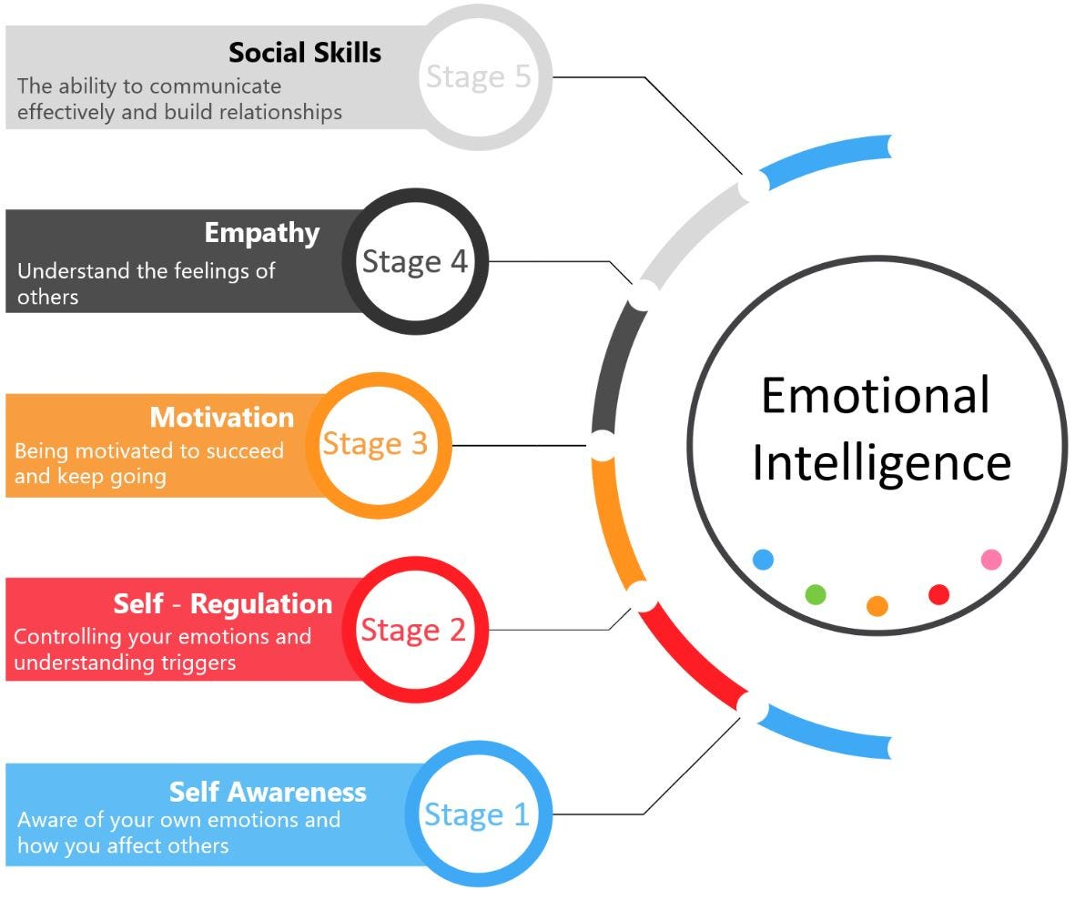
Figure 2: Daniel Goldman's Emotional Intelligence Model; Source: (Clement et al., 2023)
The model of emotional intelligence described by Daniel Goleman in the mid-1990s is a leading framework that illustrates five key constituents of emotional intelligence. Each of these constituents plays a contributory role towards interpersonal effectiveness and personal success at work.
Self-awareness refers to the state or quality of being conscious of one's emotions and their consequences for thought processes and behaviours. High-self-awareness refers to a person who, at all times, is aware of and understands his emotional state and how that state controls how he treats others around him. Individuals with this insight will be able to make conscious decisions and act accordingly in different situations.
Self-regulation means to keep control over one's feelings, more so amid adversity or stressful conditions. It implies keeping calm and clear-headed, thereby avoiding impulsive actions. Highly effective self-regulation enables the management of conflict constructively and staying calm under pressure.
Motivation is what pushes you to reach your goals and helps you maintain a positive outlook amidst encountering any hindrances. Motivated individuals have passion for their goals, and in the process, they develop strength in the event of an obstacle. The drive therefore fuels persistence and a proactive approach towards winning over the challenges.
Empathy is the ability to understand and share the feelings of another. The ability involves perceiving others' feelings and bringing about a reaction that is appropriate to sensitivity. Aamir (2023 says an individual with such abilities in empathy creates strong attachments, helps support others, and eases through social complexities.
Social skills are the component that involves the ability to build and maintain good relations, communicate effectively, and work collaboratively. Individuals with high social skills exert much influence in controlling and avoiding conflicts, thus developing a cooperative work environment.
Goleman's model provides so many illustrations of how these components interact in the realisation of personal and professional success and also points out emotional intelligence as one driven by good leadership and the art of being a good team player (Singh et al., 2022).

Bar-On Model of Emotional-Social Intelligence
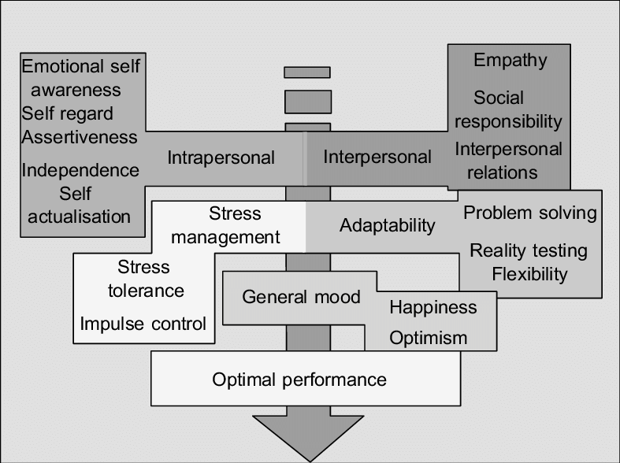
Figure 3: Bar-On-Model of Emotional- Social Intelligence; Source: (Garcia Zea et al., 2023)
By extending an individual's emotional abilities to social intelligence, Reuven Bar-On's emotional intelligence model addresses the need for a balance between social and emotional competencies in both personal and professional spheres. For this paradigm to function, he claims that there are five essential components.
Intrapersonal skills include self-awareness, self-regard, and emotional self-awareness. These skills help a person know and manage his or her emotions properly, as they may affect their growth and regulation of themselves, according to Saha et al. (2023).
Interpersonal skills refer to empathy, social responsibility, and interrelationship skills. Such skills are concentrated on maintaining proper understanding and positive engagement with others at individual levels, creating social bondage, and cooperative working.
The stress management component includes stress tolerance and impulse control. This element focuses on the ability to handle stressors and manage emotional responses in high-pressure environments.
Adaptability includes reality testing, flexibility, and problem-solving. This bundle of skills enables an individual to adjust to change, assess situations precisely, and arrive at an appropriate solution to the problem at hand.
General moods incorporate optimism and happiness. This component looks at how a positive outlook and general well-being should be maintained, as they could affect an individual's motivation and resilience.
Although this model by Bar-On is quite comprehensive, its broad classifications might not address issues specific to retail challenges that JLP, in particular, faces. For example, despite its emphasis on stress management, it does not provide any concrete methods on how to gain such competencies within a retail setting. Another weakness of the model is its high reliance on self-report measures, which sometimes may not show the real emotional and social competencies applied. Thus, the application of the Bar-On model needs to be supported by other diagnostic tools, like performance-based measures, to define the actual degree of emotional intelligence each particular employee possesses.

Mayer-Salovey-Caruso Emotional Intelligence Test (MSCEIT)
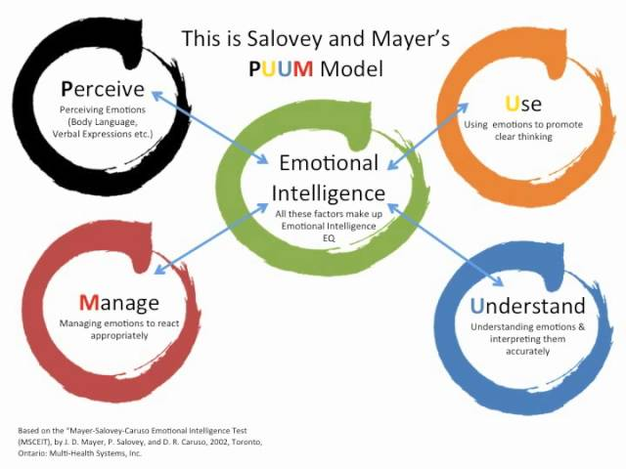
Figure 4: Mayer-Salovey-Caruso Emotional Intelligence Model; Source: (Moon, 2021)
The Mayer-Salovey-Caruso Emotional Intelligence Test is a performance-based test developed by Peter Salovey, John Mayer, and David Caruso that involves the use of objective tasks in measuring emotional intelligence rather than self-reports. This instrument measures people's real potential for emotional ability through their performance on different emotional tasks.
Perceiving Emotions is the capacity to recognise and understand one's own emotions as well as those of others. This ability, which enhances interpersonal relationships and self-awareness, is the ability to recognise emotional cues and react correctly to them.
Using emotion is an ability that the individual uses to assist thinking processes like reasoning and problem-solving through the use of emotions. This factor thus reflects the use of feelings in a manner that improves creative reasoning, decision-making, and problem-solving skills, hence making them essential in building relevant emotional competencies for personal and professional living.
Understanding emotions involves the ability to understand the language of feelings and how emotions act upon one another. The said ability involves the recognition of sources and results of emotions and an appreciation of subtleties in emotional dynamics in situations, which is important for communication and relationship management.
Managing Emotions refers to the ability to control one's emotional state and that of others to attain certain ends. The dimension covers aspects of controlling emotional responses, managing stress, and influencing the climate of a group or organization. Proper management of a person's emotions is very vital for maintaining healthy work environments, conflict resolution, and personal and team goal achievement.
The performance-based approach of the MSCEIT offers a practical and objective measure of emotional intelligence, explicating how individuals apply their emotional skills in real-life situations. Thus, this model is very useful to those organisations desiring to assess and develop emotional competencies among employees.

Application and Critical Evaluation of Emotional Intelligence Models
Goleman’s Model of Emotional Intelligence
The five basic factors that underline Daniel Goleman's model are self-awareness, self-regulation, motivation, empathy, and social skills. For the John Lewis Partnership, all these factors are important not only externally, with the customers, but also internally among co-workers.
Self-awareness allows the employees of John Lewis Partnership to understand that their emotions offer the type of interaction they would have with customers and with other staff members. Self-regulation is managing stress levels because of the pressure; in surmounting difficult situations, one does not allow one's emotions to take over one's professional demeanour. For instance, a holiday season employee under pressure needs to control feelings of frustration and remain composed to offer the best possible service in terms of customer attendance.
This means that they are intrinsically motivated to work towards these goals and are more likely to exhibit high commitment if JPL's values are part of the organisational values. Such intrinsic motivation would be sufficient to push performance levels higher and be part of the success pool for the company in general (Clement et al., 2023). Such motivated employees would be willing to go the extra mile to enhance customer satisfaction and business performance.
By empathising, the employees will be able to discern what the clients need and respond appropriately to such needs. Social skills make them fit to work effectively cooperatively as a team and communicate. For example, a team is given the mandate to come up with a new store layout. The team has to communicate and work effectively as a team to ensure the desirable store layout is realised, given that social skills come into play in making the project successful. (Carminati, 2021).
Goleman's model is far-reaching but at least limited. While it represents a framework for the competencies of individuals, it may not provide for the collective nature of EI in a large, employee-owned organisation like John Lewis. It probably overshadows important components of organisational culture and collective emotional intelligence that are necessary. Moreover, Goleman's model can be criticised for being too generic, and such broad categorisation might not provide explicit suggestions on developing emotional intelligence in the retail setting.
The increased applicability of Goleman's model can only be assured when complemented with strategies that build collective emotional intelligence within teams. This may include team-building exercises or collaborative projects to foster shared perceptions about the principles of emotional intelligence.
Bar-On Model of Emotional-Social Intelligence
Social competences, which highlight intrapersonal and interpersonal abilities as well as stress management, flexibility, and overall mood, are included to the Bar-On model in addition to emotional intelligence (Bru-Luna et al., 2021). The Bar-On model shares certain similarities with the requirements of the John Lewis Partnership, since the latter's emotional and social competences are critical to achieving success within the organisation.
Social skills and social responsibility are two of the major components at John Lewis for maintaining a positive culture both within the workplace and in achieving effectiveness in handling its customers. The results are supportive employees who create an open and collaborative environment that leads to increased organisational performance.
In the current economy and its dynamic demand patterns, stress management and flexibility to the dynamics of change are critical organisational skills in the retail environment. The emphasis on these competencies by the bar-on model takes an employee's hand through the challenges to assure themselves of maximum productivity even in the face of odds.
The over-emphasis of over-generalisation by the Bar-On model can sometimes be a daunting challenge, but it emerges as a strength in projection to a complete or whole understanding of both emotional and social competency. But its general approach may be a bit too broad to tackle some of the specific issues facing John Lewis. Overreliance on self-report measures can also be another limitation of the model in that there may not always be a truthful reflection of the true competencies of the employees. To this extent, the Bar-On model on emotional intelligence may be complemented using other assessment tools and performance-based evaluations to the extent of understanding much more accurately the level of emotional intelligence of the employees (Aamir, 2023).

Mayer-Salovey-Caruso Emotional Intelligence Test (MSCEIT)
Among other skills, the MSCEIT highlights the ability to perceive, use, comprehend, and handle emotions. It is a performance-based assessment of emotional intelligence. Such clinical assessment would provide critical insight on behalf of the John Lewis Partnership.
Similar to many police personnel that come under every business training jurisdiction, the ability to recognise emotion accurately is a crucial component of customer service work (Singh et al., 2022). The MSCEIT may lead the company to make those employees relatively more able to appropriately expand their emotional understanding of others, particularly customers' emotional states, which will lead to better service and greater customer satisfaction.
Ability to regulate his emotions while promoting a beneficial working environment. The focus that would be provided by the MSCEIT of this component would make John Lewis sure that employees are ready to cope with various stressful situations so that they maintain their levels of productivity.
Moreover, the performance-based manner in which the emotional intelligence assessment was carried out makes its results more objective than the self-report techniques (Saha et al., 2023). The task-based methodology of the test may, therefore, be unable to account for the very complex emotional dynamics that occur in a large organization. This being the case, the MSCEIT is applied at an individual level and might hence miss a host of organisation-level elements that may affect emotional intelligence. If used sensitively, the MSCEIT would be valuable; it must be supplemented, however, by qualitative assessments and other team approaches that give fuller insights into employees' emotional and social skills.

Recommendations for Developing an Emotionally Intelligent Workforce
An emotionally intelligent workforce cannot be achieved within the John Lewis Partnership by any single approach that draws only on insights from the application and evaluation of emotional intelligence models. The following recommendations therefore become helpful in providing a strategic framework for the development and leveraging of emotional intelligence within the organisation.
Comprehensive Training Programmes: The emotional intelligence of employees can be fostered through comprehensive training programmes that target key emotional competencies. These programmes should comprise workshops and coaching exercises that allow workers to find out and control their emotions can include mindfulness and emotion regulation techniques. Training that enhances workers' capability to understand and empathise with others by, for instance, role-plays, active listening exercises, and feedback sessions to enhance interpersonal skills (Moon, 2021).
Incorporate Emotional Intelligence into Recruitment and Selection: The John Lewis Partnership can put in place the need for emotional competencies amongst its new members by incorporating criteria of emotional intelligence during the recruitment and selection process. This can be done by integrating instruments, such as the MSCEIT, for assessing candidates' emotional competencies in the recruitment process. This system gives a better, more objective measure of their abilities. It helps to identify those who have the emotional competencies necessary for success in John Lewis.
Create a Culture that Enables Emotional Intelligence: It is expected that for emotional intelligence to be developed and sustained, the organisation should have a culture that enables, encourages, and values emotional intelligence. John Lewis Partnership will develop a culture that enables emotional intelligence by making a change in the company's values and mission statement to include emotional intelligence, highlighting its importance. In addition, it shows the firm's seriousness in developing emotionally intelligent employees. Develop reward and recognition programmes that identify or reward people with high emotional intelligence, as indicated by Alwali and Alwali202022.
Evaluation and Feedback: To check whether such emotional intelligence programmes would work at John Lewis Partnership, tools like the MSCEIT and feedback questionnaires from the employees should be utilised to evaluate the effectiveness of any training or development ram. Assessments periodically can effectively provide valuable insights into the various facets of the programmes and point out areas that require improvement. Review and fine-tune training and development programmes continually for relevance, effectiveness, and emerging needs and challenges, guided by assessment results and employee feedback.
Greater Collaboration and Connectivity: A workforce with high emotional intelligence will help employees collaborate and connect better. The John Lewis Partnership can engage in activities and workshops that are aimed at creating a collaborative culture, enhancing communication, and mutual support. These activities would let better relationships grow within the teams and strengthen collaboration. Effective channels of open and transparent communication strengthen relationships by eliminating possible causes of conflict and dealing with conflicts that arise before they have a bearing on the working relationship. This is ensured through regular team meetings, feedback sessions, and open-door policies as described by Lubbadeh (2020).

Conclusion
In conclusion, with the prevailing economic turbulence, emotional intelligence is a key aspect that can be put to effective use by the John Lewis Partnership. Models such as Goleman's, Bar-On, and MSCEIT will help the organisation realise the development needs of the workforce and consequently develop strategies for enhancing emotional competencies. The advised approach, in this case, would be to provide full-scale training, infuse EI into recruitment, create a culture driven by EI, and finally, conduct a continuous assessment of initiatives. Of course, a focus on emotional intelligence should further develop competitive advantage, improve the level of customer service, and lead to higher employee engagement. As John Lewis has to proceed through market changes, investing in EI will not only develop the skills of people themselves at a very personal level but will also nurture a supportive and cooperative work environment that is vital and at stake in the future while overcoming any challenge or creating long-term success.

References
Aamir, A., 2023. Emotional Intelligence and Organizational Commitment-Application of the Goleman’s Model of Emotional Intelligence. International Journal of Intellectual Human Resource Management (IJIHRM), 4(01), pp.01-06.
Alwali, J. and Alwali, W., 2022. The relationship between emotional intelligence, transformational leadership, and performance: A test of the mediating role of job satisfaction. Leadership & Organization Development Journal, 43(6), pp.928-952.
Ayub, A., Sultana, F., Iqbal, S., Abdullah, M. and Khan, N., 2021. Coping with workplace ostracism through ability-based emotional intelligence. Journal of Organizational Change Management, 34(5), pp.969-989.
Bru-Luna, L.M., Martí-Vilar, M., Merino-Soto, C. and Cervera-Santiago, J.L., 2021, December. Emotional intelligence measures: A systematic review. In Healthcare (Vol. 9, No. 12, p. 1696). MDPI.
Carminati, L., 2021. Emotions, emotion management and emotional intelligence in the workplace: Healthcare professionals' experience in emotionally-charged situations. Frontiers in sociology, 6, p.640384.
Clement, M.K., Mayer, J.D. and McGaughy, J.A., 2023. MSCEIT measure of emotional intelligence. The SAGE Handbook of Clinical Neuropsychology: Clinical Neuropsychological Assessment and Diagnosis, pp.235-246.
Craemer, M., 2020. Emotional intelligence in the workplace: How to use EQ to build strong relationships and thrive in your career. Sourcebooks, Inc.
Garcia Zea, D., Sankar, S. and Isna, N., 2023. The impact of emotional intelligence in the military workplace. Human Resource Development International, 26(1), pp.85-101.
Goleman, D., 2021. Leadership: The power of emotional intelligence. More Than Sound LLC.
Gómez-Leal, R., Holzer, A.A., Bradley, C., Fernández-Berrocal, P. and Patti, J., 2022. The relationship between emotional intelligence and leadership in school leaders: A systematic review. Cambridge Journal of Education, 52(1), pp.1-21.
Lubbadeh, T., 2020. Emotional intelligence and leadership–the dark and bright sides. Modern Management Review, 25(27), pp.39-50.
Moon, J., 2021. Effect of Emotional Intelligence and Leadership Styles on Risk Intelligent Decision Making and Risk Management. Journal of Engineering, Project & Production Management, 11(1).
Rivers, S.E., Handley-Miner, I.J., Mayer, J.D. and Caruso, D.R., 2020. 29. Emotional Intelligence. by RJ Stenberg. 2nd Edition. Cambridge: Cambridge University Press, XXII, 1250, pp.709-735.
Saha, S., Das, R., Lim, W.M., Kumar, S., Malik, A. and Chillakuri, B., 2023. Emotional intelligence and leadership: insights for leading by feeling in the future of work. International Journal of Manpower, 44(4), pp.671-701.
Singh, A., Prabhakar, R. and Kiran, J.S., 2022. Emotional intelligence: A literature review of its Concept, models, and measures. Journal of Positive School Psychology, 6(10), pp.2254-2275.



