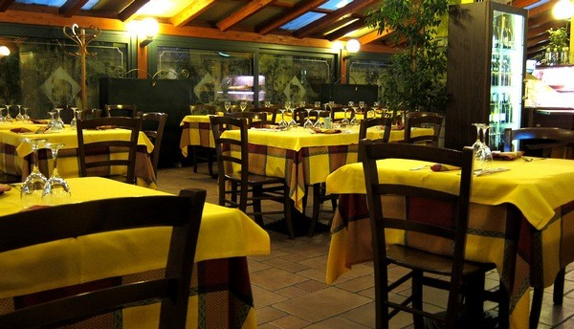
Part 1.

Menu for Bella Italiano
  - Food and Beverage Operations
  - BMIH4002
  - Mohammed Miah. 2118790
Bella Italiano:
A Modern Italian Dining Experience
Bella Italiano is an exciting new Italian restaurant concept that will be introduced to the Hotel Trinity Hotel Chain. The concept aims to provide a modern and vibrant dining experience, showcasing the rich and diverse flavors of authentic Italian cuisine in a contemporary setting.
Target Audience: Our primary target audience includes both hotel guests and local residents seeking an elevated dining experience. Bella Italiano aims to attract individuals who appreciate quality food, exceptional service, and a sophisticated ambiance. The restaurant will cater to a wide range of age groups, from young professionals and couples to families and tourists.
Reasoning behind Menu Choices: The A la Carte menu at Bella Italiano has been carefully curated to showcase a diverse range of Italian culinary traditions while incorporating modern techniques and flavors. Each dish is prepared with the finest ingredients, sourced locally and imported from Italy to ensure an authentic taste.
Sustainability and Seasonality: Bella Italiano is committed to sustainability and seasonality. The menu will feature dishes made with locally sourced and seasonal ingredients whenever possible. By partnering with local farmers and suppliers, the restaurant aims to minimize its environmental impact and support the local community.
We have chosen to offer classic Italian dishes with a contemporary twist, appealing to both traditionalists and those seeking innovative culinary experiences. The menu emphasizes the use of fresh, seasonal produce, ensuring that each dish bursts with flavor. We also strive to accommodate various dietary preferences and offer a selection of vegetarian, gluten-free, and lactose-free options.
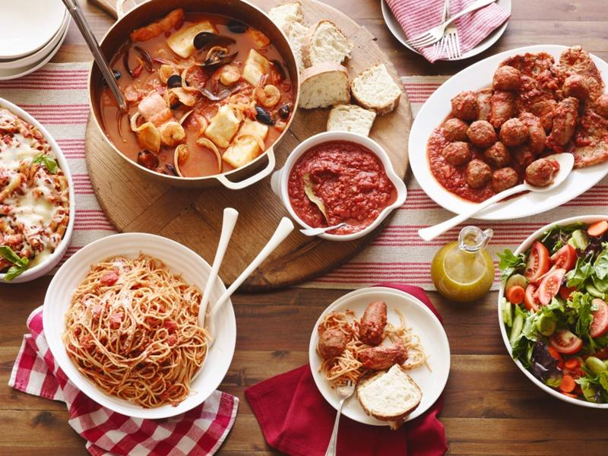

Part 2 MENU
Starters:
Caprese Bruschetta £5. / Approx. 245 calories
Toasted Italian bread topped with fresh tomatoes, mozzarella, basil, and balsamic glaze.

Arancini Balls £7.5 / Approx. 280 calories
Crispy risotto balls stuffed with mozzarella and served with marinara sauce.

Prosciutto. £6 / Approx. 200 calories
Wrapped Asparagus - Grilled asparagus wrapped in prosciutto, drizzled with lemon-infused olive oil.
Mains:
Gnocchi al Gorgonzola £13 / Approx. 450 calories
Homemade potato gnocchi served with a creamy gorgonzola sauce and walnuts.

Osso Buco £19 / Approx. 650 calories
Slow-cooked veal shanks in a rich tomato and vegetable sauce, served with saffron risotto.

Grilled Sea Bass £20 / Approx. 350-400 calories
Fresh sea bass fillet grilled to perfection, accompanied by lemon butter sauce and roasted vegetables.

Desserts:
Tiramisu £6 / Approx. 350 calories
Classic Italian dessert with layers of coffee-soaked ladyfingers, mascarpone cream, and cocoa.
Lemon Ricotta Cake £6 / Approx. 380 calories
Moist and tangy cake made with ricotta cheese, served with a lemon glaze.
Panna Cotta £4 / Approx. 250 calories
Smooth and creamy vanilla custard topped with a seasonal fruit compote.

Beverages:
Italian Red Wine (per 6 oz glass) - £8
A selection of high-quality red wines from renowned Italian vineyards.
Limoncello Spritz (per 6 oz glass) - £10
A refreshing blend of limoncello, prosecco, and soda water.
Espresso Martini (per 6 oz glass) - £14
A sophisticated cocktail combining espresso, vodka, and coffee liqueur.

Nutrition and Special Dietary Requirements:
The menu dishes suitable are for vegetarian, gluten-free, and lactose-free diets. Special dietary requirements will be accommodated by providing alternative ingredients and preparation methods, ensuring that customers with specific needs can enjoy a satisfying dining experience. If you have any Allergy kindly provide detailed information to one of the servers at restaurant Bella Italiano.
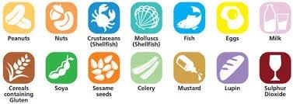

References:
"AllRecipes" -Available online : www.allrecipes.com
"Ciao Italia" - Available online : www.ciaoitalia.com
"Epicurious" - Available online : www.epicurious.com
"Food Network" - Available online : www.foodnetwork.com
"Jamie Oliver" - Available online : www.jamieoliver.com
"La Cucina Italiana" - Available online : www.lacucinaitaliana.com
Magnini, V.P. and Kim, S., 2016. The influences of restaurant menu font style, background color, and physical weight on consumers’ perceptions. International Journal of Hospitality Management, 53, pp.42-48.
Morrison, P., 1996. Menu engineering in upscale restaurants. International Journal of Contemporary Hospitality Management.
Raucci, D., Lepore, D. and Sabatiello, R., 2020. Activity-based pricing in small and medium-sized restaurants. Evidence from the Italian context. International Journal of Culture, Tourism and Hospitality Research, 14(4), pp.565-577.
Restored medieval kitchen inside Verrucole, A. and Castle, T., Italian cuisine.
Sharp, A., 2018. The Mindful Glow Cookbook: Radiant Recipes for Being the Healthiest, Happiest You. Penguin.
Smith, C.J., 2023. Season to Taste: Rewriting Kitchen Space in Contemporary Women’s Food Memoirs. Univ. Press of Mississippi.
Trostler, N. and Gvion, L., 2007. Trends in restaurant menus: 1950-2000. Nutrition today, 42(6), pp.255-262.

