Syeda Nessa Begum
Id 2109894
BMIH5004
Management and Organizational Behavior

Assignment Title: Hotel Organizational Audit – A Case Study On Hilton Hotel Group

Report

Contents
Introduction 3
A Brief Overview of the Hilton Hotel Group 4
Hilton Hotel Group's structure, culture, and goals 4
Organizational structure 4
Organizational Culture and Goals 5
Hilton Hotel Group's recent change initiatives and Their Impact 6
Hilton Hotel Group's strategic direction and current business performance 10
Strategic Directions of the Organisation 10
Current Business Performance 11
Conclusion 12
References 13

Introduction
A hotel organisation audit refers to the examination of various aspects of the hotel organisation. This includes various topics such as organizational structure, process practices, hotel objectives and goals, strategic direction, business performance, etc. In this report, an organizational audit of one of the hotel brands, Hilton Hotel Group, will be completed. As part of this activity, the organisation's structure, cultural goals, recent change initiatives, and their impact will be discussed (Mullins and Dossor, 2013). Also as part of monitoring the internal operations of this organisation strategic direction and current business performance will be monitored and information will be presented.

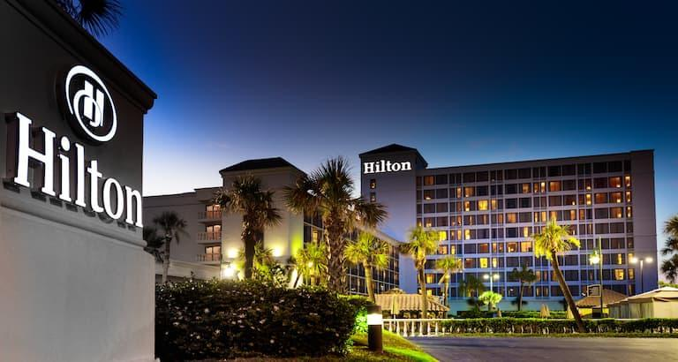

A Brief Overview of the Hilton Hotel Group
Hilton Hotels and Resorts is one of the leading hotel brands worldwide and was founded by Conrad Hilton in 1919 and named Hilton Hotels. It is one of the largest and fastest growing hospitality companies in the world and operates around 19 brands worldwide and has operations across 122 countries and territories and has 7215 properties as part of the group. In 2020, Fortune magazine ranked the Hilton Hotel company number 1 among the top 100 companies in the hospitality industry based on an employee satisfaction survey (Mullins, 2023). The properties under Hilton are in different categories which include luxury hotel services, upper upscale, upscale, upper midscale, etc.

Hilton Hotel Group's structure, culture, and goals
The key to an organizational audit of a company is to understand the company's structure, culture, and goals. For this reason, the structure, culture, and goals were highlighted to complete the organizational audit of the Hilton Hotel Group.
Organizational structure
Organizational structure refers to the way a company organizes and organizes the internal roles and responsibilities to manage its operations (Bloisi et al., 2017). There are different types of organizational structure, these include functional structure, matrix structure, divisional structure, team-based structure, etc.
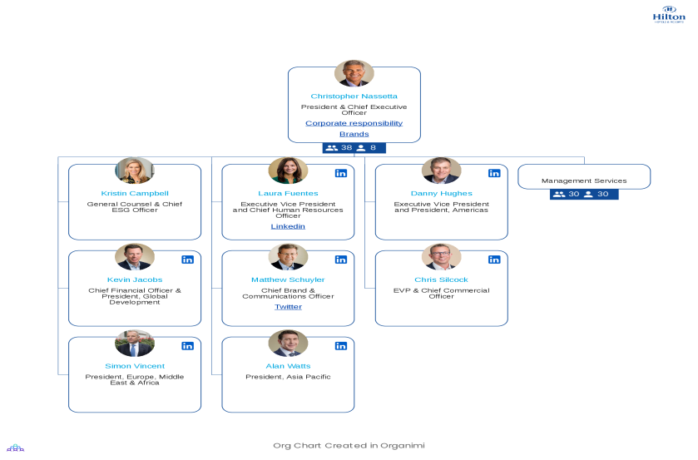
Figure: Divisional Organizational structure of Hilton Hotel Group
The organizational structure of Hilton Hotels Group can be described at the level of departmental structure. This is because it manages geographic divisions at different levels and the business itself manages properties and operations. A divisional structure means that companies offer different types of products or services (Robbins and Judge, 2016). An organization operates entirely in different business units based on geographic regions or customers. Also, according to this structure, each department functions as a separate entity with its own properties and decision-making authority and manages organizational activities. The operations of Hilton Hotels are completely managed according to this structure. Because this hotel group is managed according to different geographical divisions.
It has three main areas. These are ownership, management and franchise, and timeshare. Ownership includes properties directly owned by Hilton and the Management and Franchise category includes properties that Hilton manages or franchises from someone else. And timeshares are considered completely separate entities after leaving the resort (Anthony, 2014).
Organizational Culture and Goals
Organizational culture refers to a culture of values, beliefs, attitudes, and behaviors by which employees are influenced and act (Oliver, 2021). As one of the leading hotel brands in the global hospitality industry, the Hilton Hotel Group has its own culture and values ​​ in conducting its operations:
Core Values: Values ​​as the core culture of a company is a very important factor in considering a company's goals and activities. The company has different types of values, among them the core value extends the company's activities towards a goal. Hilton Hotel Group's core values ​​are to be one of the leading brands in the hospitality industry by providing exceptional customer service.
Teamwork: As one of the organizational cultures, teamwork is very important in the company. Hilton Hotel Group attaches great importance to their activities as a hospitality company. "We are business serving people and our team members extend their passion for hospitality beyond the hotel walls every day," said Chris Nassetta, president and CEO of the company (Munsch and Martchenko, 2020).
Integrity and innovation: This company is committed to maintaining the highest standards of integrity in conducting all of its operations. Also as a leading local hospitality company fosters innovation as an important culture and innovates to stay ahead of the competitive market (Svare et al., 2019).
Goals of Hilton Hotel Group
Every business organization sets specific goals and objectives for conducting their activities. All these goals and objectives are carried out to establish themselves. Hilton Hotel Group has several strategic goals that help them achieve long-term success:
- It aims to expand and strengthen the hotel business through global expansion and entry into new markets (Krosinsky, 2012).
- Achieving customer satisfaction is the main goal of this company and therefore always provides services by providing an exceptional experience.
- Employee development plan to manage all activities is one of the activities of this company and due to this, it has been recognized as the number one brand in the world several times.
Hilton Hotel Group's recent change initiatives and Their Impact
Business organizations are constantly diversifying their operations and change initiatives impact their business in different ways. Hotel business companies included in the hospitality industry take various types of sustainable initiatives to manage their operations in detail (Bütüner and Seemiller, 2021). Also manages and changes various activities including supply chain management to gain recognition as a global brand. At this stage of the report, the recent changes of the Hilton Hotel Group will be discussed and their implications will be highlighted:

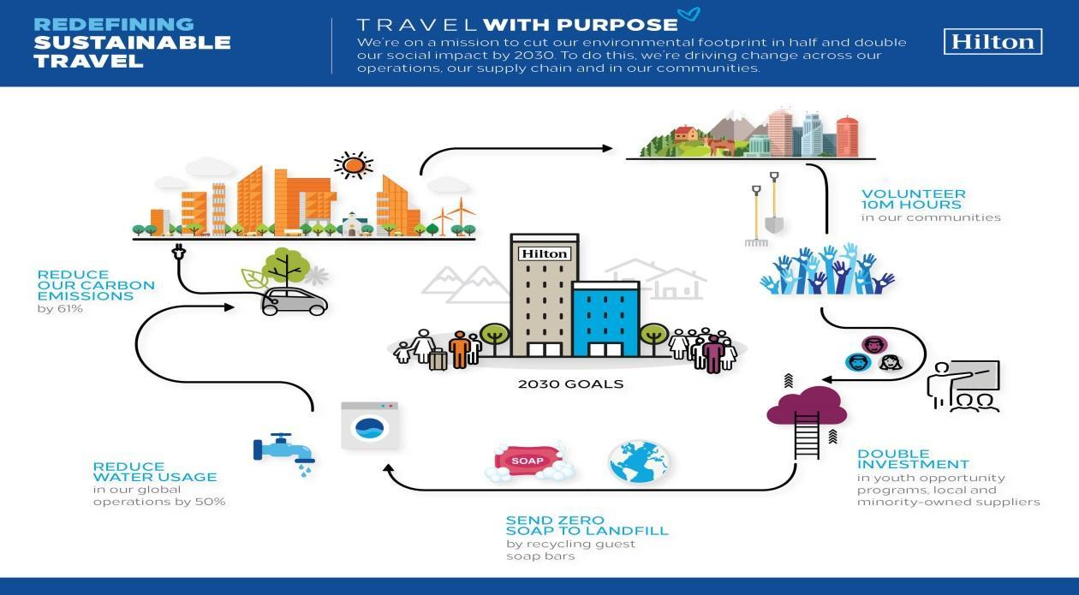
Figure: Recent Sustainable change initiatives Of Hilton Hotel Group
ESG Strategy Development
Keeping in mind the commitment to implement by 2023, Hilton Hotels has taken initiatives to implement the new ESG strategic framework. One of these initiatives is the Travel with Purpose 2030 goals that will redefine the purpose of travel and incorporate environmental, social, and governance activities into sustainable activities. It will also maintain the continuity of operations by implementing environmental, social, and governance objectives (Edwards, 2019).
Impact: This change initiative will have a very positive impact on the operations of the Hilton Hotel Group. Because sustainable development goals are very important to survive in today's business environment. Environmental social initiatives of any kind are generally more accepted. Through these changes, the organization will be able to create a positive work culture and also achieve long-term sustainability as a global brand worldwide.
Science Based initiative (SBTi)
- Among the science-based targets, initiatives include reducing the carbon 1 and 2 emission intensity of hotels by 25 percent Impact.
- 56 percent reduction in emissions intensity from Hilton Hotel Group's franchise hotels.
- Addressing climate change and decarbonizing as a partner by investing in ESG technologies.
Impact: This science-based initiative of the Hilton Hotel group is very commendable and effective. Because such environmental initiatives to manage the business will help to manage the business in the long run. Also, they will play an important role in carbon emissions by maintaining environmental balance and preventing the wastage of energy.
Social development initiative
- Social enterprises include initiatives to create an engine of opportunity.
- As part of this program, 5 million learning and career growth opportunities will be created for team members and the community by 2030.
- Achieve 50% gender diversity at all global leadership levels by 2027.
- The goal of achieving 25% racial diversity at leadership levels in the United States will be met by 2027.
Impact: Social enterprises are usually an internal activity of the organization by targeting and focusing on team members and specific groups to help them improve. The Hilton Group will also help the company create its own ethnic identity as well as achieve gender diversity. Also achieving gender diversity will create a unique level of leadership for them globally (Drolet, 2014).
Governance change initiative
- Laws and regulations have been proactively formulated with the advancement of ESG goals to implement corporate objectives to remain competitive in business.
- Recruited to advocate for public policies that will advance travel with the mission and goals of Hilton Hotels.
- The upcoming government regulations regarding the requirements for the implementation of ESG projects are monitored at all times and travel restrictions are taken into account (Kettl, 2023).

Impact: All these initiatives will help Hilton Hotel Group to stay competitive in the business. It will also help to achieve sustainability by carrying out activities of Corporate Social Responsibility.
Hilton Supply Management (HSM) Advantages
Hilton's supply and management for the entire global procurement and supply chain are also continuously developed. Quality and value are created across the source of goods and services, keeping in mind various objectives and goals. Currently Hilton Supply Management (HSM) with more than 85000 suppliers worldwide and supplies more than 482000 products (Adams and Yoshpe, 2015).
Impact: Supply management is one of the core operational activities of a business and plays a role in the overall growth of the business. Because of this, Hilton's advanced supply management facilities are playing a greater role in global expansion and impacting operations more.
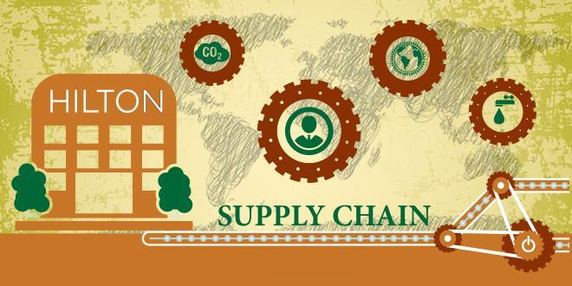
Figure: Hilton Supply Management

Hilton Hotel Group's strategic direction and current business performance
Strategic direction plays a very important role in the success and overall growth of the Hilton Hotel Group. For this reason, this global hotel brand always gives more importance to its activities. Also, strategic directions are of immense importance to increasing business performance because they directly contribute to performance.
Strategic Directions of the Organisation
Strategic directions are very important for running a business. They help an organisation achieve certain goals as well as help maintain business performance appropriately (Gattorna, 2018). Some of the strategic directions of the Hilton Hotel group are:
Advanced and technological innovation
These hospitality companies use technological innovations to improve their operational activities (Sahal and Nelson, 2021). And any kind of innovations used in the hospitality industry such as artificial intelligence, optimizing operations, etc.
Employee engagement and satisfaction
One of the tools for this hotel group to achieve success is employee satisfaction. Because to maintain performance, it emphasizes the recruitment and development activities of the employees as a whole and provides opportunities and recognition for their improvement (Lencioni, 2016).
Competitive Advantages
Nowadays the hospitality industry is a very prosperous sector and hence the reputed hotel brands have a lot of competition (Stone and Hun, 2015). Hilton Hotels has several high-quality competitors including IHG Hotels and Resorts, Marriott Hotels, Hyatt, etc. Because of this, as a unique strategy to survive with these brands, the company places much importance on customer relationships and provides exceptional experiences to the customers.
Ability to drive demand
Keeping pace with the times, this company always provides customers with advanced and differentiated customer service. Due to this, it can manage the demand and also manage the best revenue to stay with the competing companies.

Current Business Performance
At present, Hilton Hotels are considering strategic strategies very seriously to manage their strong performance and manage any type of activities appropriately. It uses advanced technology as part of its business performance, also global scale, key partnerships, and driving demand strategies help them maintain performance by building a strong customer relationship (Eichel and Bender, 2014). Hilton Hotel is in a very good position in terms of current business performance. Because it is doing business as one of the top ten companies in the United States. It represents 58% in terms of number of rooms and market share. Also, as an international hotel company, Hilton's businesses worldwide generated revenue of approximately $8.77 billion in 2022. And this figure is much higher than the previous year's total of 5.79 billion.
Also, one of the characteristics of this company is that it always provides better quality customer service to the customers than the competing companies. It also differentiates the services on the basis of quality thereby being able to maintain the highest level of quality. Also, these hospitality organizations use all kinds of digital tools to gain competitive advantages. And the technical facilities make its operation more advanced. Also, this company provides all kinds of facilities to the employees. Because of this it has a different demand from the customers and also the employees as a team complete the activities very well (Fogli, 2016). Today, as a business performance, it can adapt very quickly to customer demands while achieving much improved performance and competitive advantages. And provide different religious services to customers. These hotels always support the needs of the customers and therefore maintain the ability to manage the demand by always using uptodate technologies to maintain performance

Conclusion
In conclusion, Hilton Hotel Group's organizational audit structure, culture, goals, including overall operational activities and performance is a very important Audit. This report conducted an organizational audit on the Hilton Hotel Group, describing its divisional structure and also presented its customer-oriented culture. Among its recent change initiatives, ESG strategic development has been highlighted and its impact discussed. Also, the strategic directions of this Hotel Group have been discussed in detail and information about business performance has been presented .

References
Adams, G.C. and Yoshpe, H.B. (2015) Supply Management. Washington: Industrial College of the Armed Forces.
Anthony, P. (2014) Managing culture. Buckingham England: Open University Press.
Bloisi, W., Cook, C.W. and Hunsaker, P.L. (2017) Management and organisational behaviour. London: McGraw-Hill Education.
Bütüner, H. and Seemiller, C. (2021) ‘Strategic objectives and goals’, Strategic Planning [Preprint]. doi:10.4135/9781071869123.
Drolet, J.L. (2014) Social Protection and Social Development: International Initiatives. Dordrecht: Springer Netherlands.
Edwards, T. (2019) Sustainable development. Sydney, N.S.W.: NSW Parliamentary Library Research Service.
Eichel, E. and Bender, H.E. (2014) Performance appraisal: A study of current techniques. New York: Research and Information Service, American Management Associations.
Gattorna, J. (2018) Strategic Supply Chain Alignment: Best Practice in Supply Chain Management. Aldershot, Hampshire, England: Gower.
Kettl, D.F. (2023) Sharing power: Public governance and private markets. Washington, D.C.: The Brookings Institution.
Krosinsky, C. (2012) Evolutions in sustainable investing: Strategies, funds and thought leadership. Hoboken, NJ: Wiley.
Lencioni, P. (2016) The truth about employee engagement: A fable about addressing the three root causes of job misery. San Francisco, CA: Jossey-Bass, Wiley.
Mullins, L.J. (2023) Organizational behavior in the Workplace. Harlow, England: Pearson.
Mullins, L.J. and Dossor, P. (2013) Hospitality Management and Organizational Behavior. Harlow: Pearson.
Munsch, R.N. and Martchenko, M. (2020) Teamwork. Toronto, ON: North Winds Press, an imprint of Scholastic Canada Ltd.
Oliver, G. (2021) ‘The significance of organizational culture’, Organizational Culture for Information Managers, pp. 7–31. doi:10.1016/b978-1-84334-650-0.50001-1.
Robbins, S.P. and Judge, T.A. (2016) Organizational behavior. Melbourne, Vic.: Pearson Australia.
Sahal, D. and Nelson, R.R. (2021) Patterns of technological innovation. Reading, MA: Addison-Wesley Pub. Co., Advanced Book Program/World Science Division.
Stone, P.B. and Hun, L.J.S. (2015) Competitive advantages: Do you have it? Singapore: Faculty of Business Administration, National University of Singapore.
Svare, H., Gausdal, A.H. and Möllering, G. (2019) ‘The function of ability, benevolence, and integrity-based trust in Innovation Networks’, Industry and Innovation, 27(6), pp. 585–604. doi:10.1080/13662716.2019.1632695.

