Student Name: Md Ahsan Alahi Rafi
Student ID :2511326
Word Count: 3930
Supervisor Name: Ian Brown
Date of Submission: 23/01/2026

Building Services and Energy Audit

Table of Contents
Part 1 4
1.0 Introduction and Purpose 5
2.0 Case Study Building Overview 5
2.1 Location and Context 5
2.2 Building Purpose and Functional Requirements 5
2.3 Unique Building Features 6
3.0 Significance of Building Engineering Services 6
3.1 Role of Building Engineering Services 6
3.2 Contribution to Occupant Comfort and Health 6
3.3 Safety, Reliability, and Life Protection 6
3.4 Importance of Energy Efficiency and Lifecycle Performance 7
4.0 Schematic Diagrams and Photographic Evidence 7
4.1 Importance of Schematic Diagrams 7
4.2 Photographic Evidence of Services 8
5.0 Major Items of Plant – Schedule and Analysis 10
5.1 Introduction to Plant Schedule 10
5.2 Major Plant Schedule 10
5.3 Critical Evaluation of Plant Assets 10
6.0 Narrative Description of Engineering Services Operation 11
6.1 HVAC Systems 11
6.2 Electrical Services 11
6.3 Plumbing and Water Services 11
6.4 Fire Protection Systems 11
7. Interaction and Integration of Building Services 12
7.1 Systems-Based Approach to Building Services 12
7.2 Interaction Between HVAC, Fabric, and Controls 12
7.3 Integration of Lighting and Occupancy Control 12
7.4 Coordination of Fire, Ventilation, and Power Systems 12
7.5 Benefits and Risks of Integration 13
8.0 Existing Maintenance Strategy 13
8.1 Maintenance Approach 13
8.2 Importance of Maintenance for Energy Efficiency 13
8.3 Evaluation of Current Strategy 13
9.0 Summary 13
Part 2: Energy Performance Audit and Performance Improvement Strategy 15
2.0 Introduction to Energy Audit and Modelling Approach 15
2.1 Current Energy Performance 15
2.1.1 Thermal Modelling Methodology and Assumptions 15
2.1.2 Baseline Energy Consumption Data 16
2.1.3 Analysis of Energy Usage Patterns and Major Energy Consumers 16
2.2 Performance Analysis 17
2.2.1. Evaluation of Current Energy Performance 17
2.2.2. Areas of Inefficiency and Potential Improvements 18
2.2.3. Role of Maintenance Strategies in Energy Efficiency 19
2.3. Recommendations 19
2.3.1 Improved Thermal Model and Performance Enhancements 19
2.3.2 Cost–Benefit Analysis of Recommendations 20
2.3.3 Integrated Maintenance Strategy 20
10.0 Reference List 22

Part 1: Overview and Significance of Building Engineering Services

1.0 Introduction and Purpose
Part 1 of this report forms a background report of the case study building and the foundation of the Building Services and Energy Audit. The main objective of this section is to provide a critical structural analysis of designing and delivering building engineering services, operations, and maintenance that are in the building.
The contemporary buildings are heavily relying on combined engineering services in order to guarantee acceptable levels of occupant comfort, health, safety, and functionality. Heating, ventilation, and air conditioning (HVAC), electrical installations, plumbing, and fire protection systems are important in ensuring the conditions on the inside of the environment are maintained, the day-to-day operations, and statutory needs.

2.0 Case Study Building Overview

2.1 Location and Context
The IM Building is located at the UWTSD SA1 Waterfront Campus. The postcode of the site is SA1 8EW. The IM Building is situated approximately 10 metres above sea level. The case study building lies in a university campus setting, and the building is a part of a broader learning and research estate. The building is a campus-based one, and this gives it the advantage of having good infrastructure that ensures that systems of electrical power, water supply, data networks, as well as drainage systems, are in place (West et al. 2024).
Environmentally, the building has a temperate climate, with a mean shift in the seasonal temperatures. Autumn and winter months are characterized by high cooling requirements and high heating requirements, whereas cooling and ventilation demand and heating demand are higher during warm seasons and when the building is occupied (Himeur et al. 2023).

2.2 Building Purpose and Functional Requirements
The main task of the structure is to sustain the educational and research processes, such as teaching rooms, shared working areas, offices, and special facilities. Students, academic personnel, researchers, and administrative staff are some of the occupants, and this creates fluctuating occupancy levels during the day (Larsen et al. 2022).
Such operative requirements directly determine the design and the capacity of the engineering systems. Various types of spaces that need HVAC systems should be able to offer sufficient thermal comfort and indoor air quality, including both crowded areas of instruction and those that do not need as high an occupancy density as does a typical office (Omrany et al. 2023).

2.3 Unique Building Features
The building also has various architectural and sustainability-based designs that are aimed at improving performance and efficiency. These might encompass a high-performance building envelope, widespread use of glazing to allow as much daylight as possible to penetrate, open interior plan, which is conducive to flexible space utilisation (Chen et al. 2024).
These characteristics have a tremendous effect on the building services design and integration. Concretely, the well-designed facade conserves heating energy and can use a smaller size of the plant, and more availability of daylight can be used to reduce the use of artificial lighting (Hosamo et al. 2022).

3.0 Significance of Building Engineering Services

3.1 Role of Building Engineering Services

Building engineering services are critical systems that help buildings to operate safely, efficiently, and comfortably. They are structures that facilitate the operations of citizens on a daily basis and also ensure that the norms are met as stipulated (Ogunwole et al. 2023). All of these services contribute to the operational foundation of the contemporary buildings and have a direct impact on the occupant's well-being, building performance, and long-term asset value.

3.2 Contribution to Occupant Comfort and Health
One of the other important roles played by the building engineering services is that it provides thermal comfort via heating-ventilation- air-conditioning (HVAC) systems. These systems control the external climatic conditions and the internal heat gain in order to control internal temperatures and levels of humidity (Ukoba et al. 2024).

3.3 Safety, Reliability, and Life Protection

Electrical services provide reliable distribution of energy to the lighting, electrical equipment, and other vital systems, including emergency and backup supply. Water services facilitate water hygiene and ensure that there is safe, drinkable water and proper disposal of wastewater. The use of fire protection systems like detection, alarm, and suppression systems is the most important part of life safety control, as it aims to save human lives and protect property in case there is a fire (Elahi et al. 2023).

3.4 Importance of Energy Efficiency and Lifecycle Performance
Modern building engineering services design and operation have made energy efficiency a key factor as a result of the increased energy cost, carbon reduction demands, and sustainability laws. Efficient systems minimise consumed energy, carbon emissions, and boost the performance of the lifecycle (Kor et al. 2023).

4.0 Schematic Diagrams and Photographic Evidence

4.1 Importance of Schematic Diagrams
Another tool that is necessary in depicting the manner in which the building engineering services are laid out, distributed, and integrated is through the use of schematic diagrams. They give a detailed and simplified view of the complex systems, which makes it possible to understand how the services can be coordinated all over the building. Schematics are useful in determining system interfaces, flow paths, and points of control, which are essential in both operating and maintenance planning by displaying services diagrammatically.
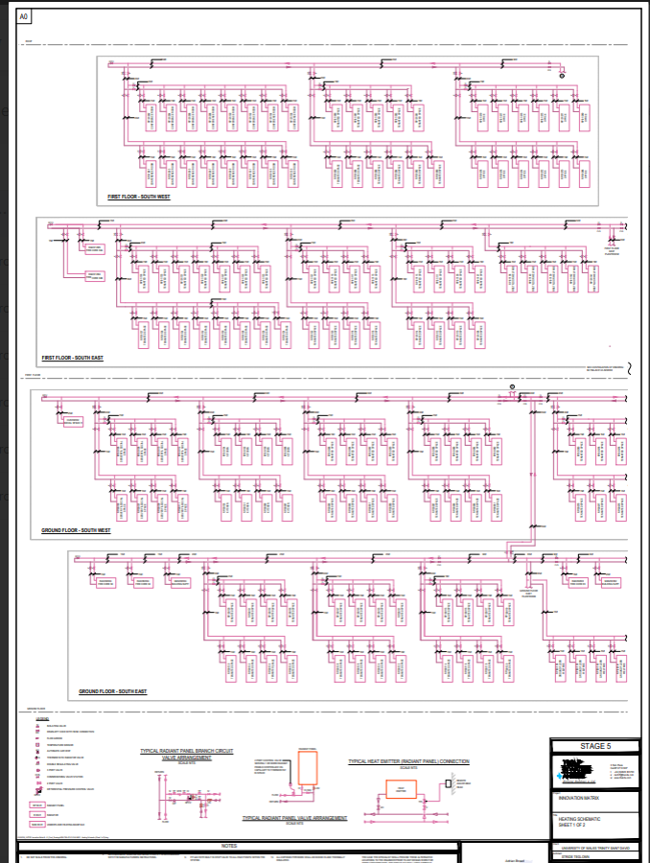
Schematic Diagram
.
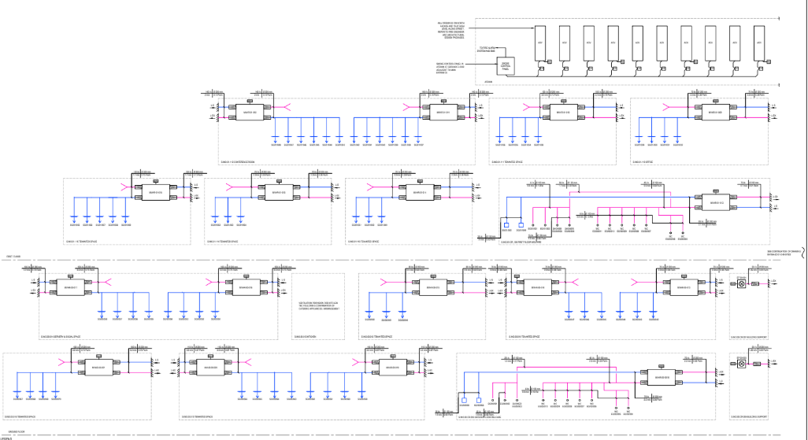
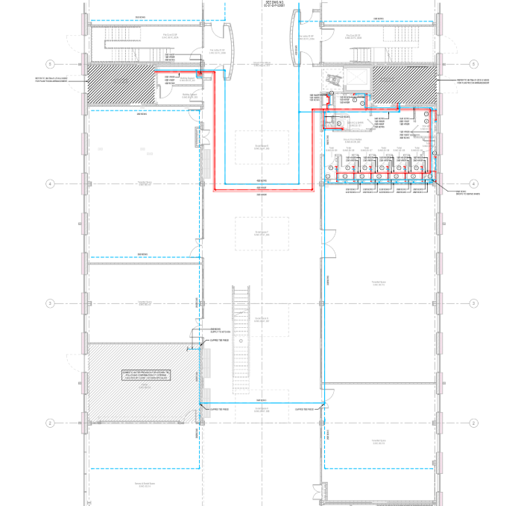
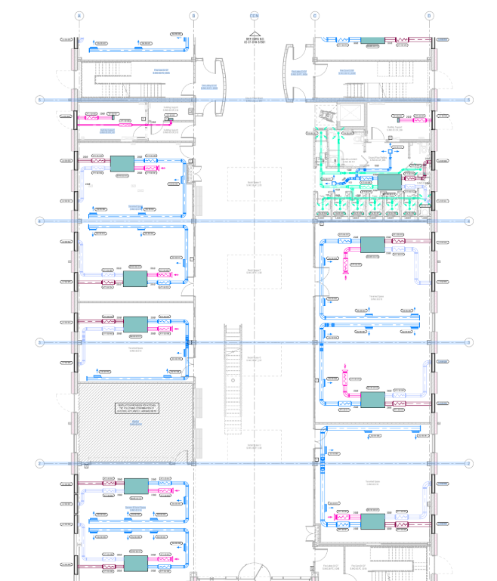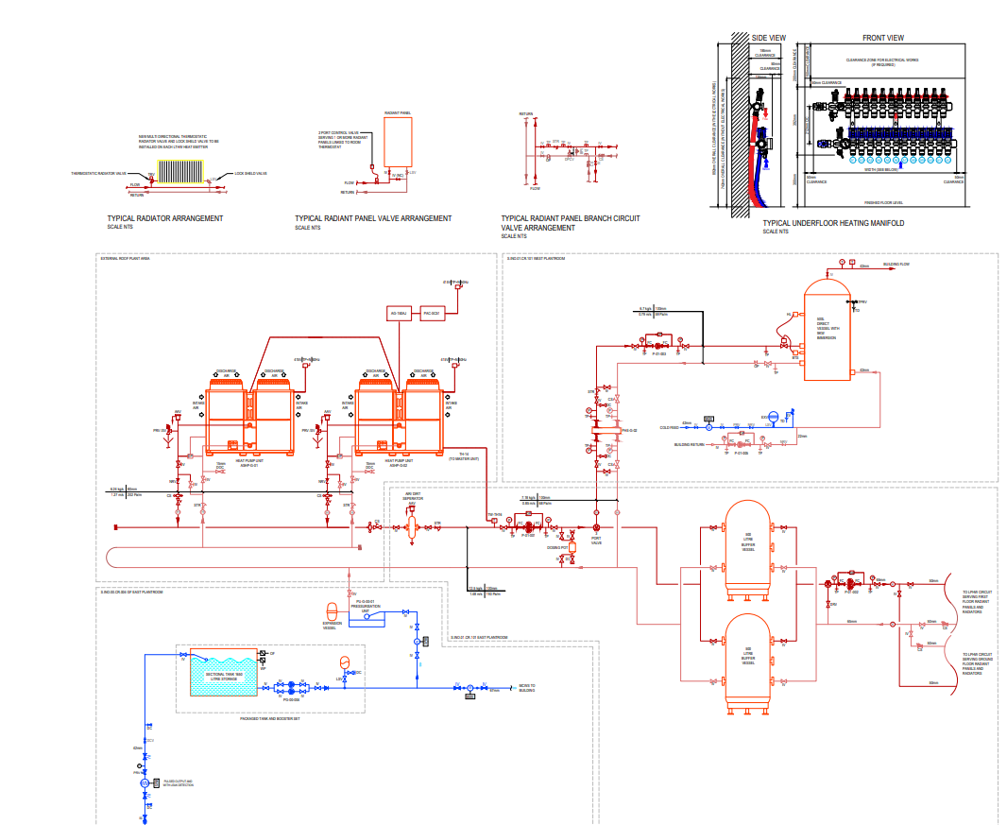
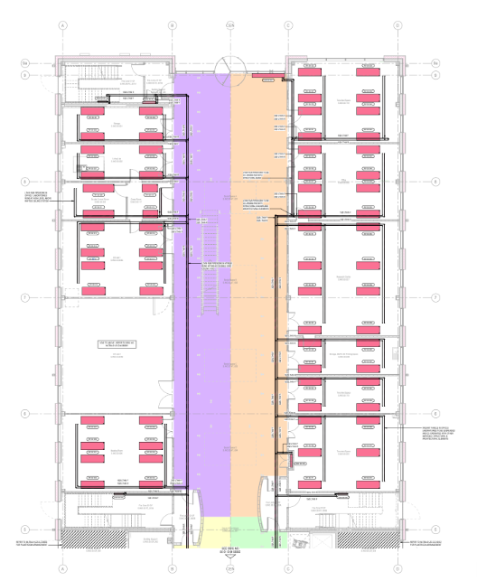
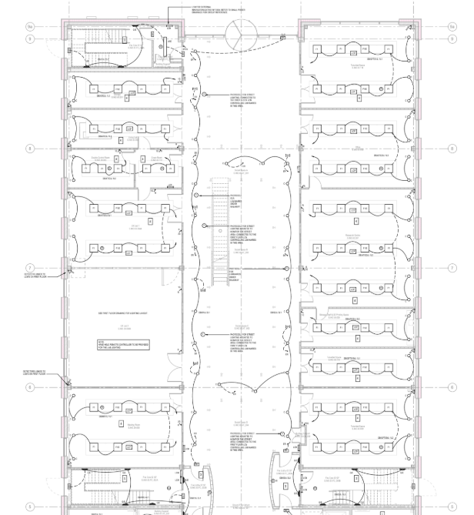

4.2 Photographic Evidence of Services
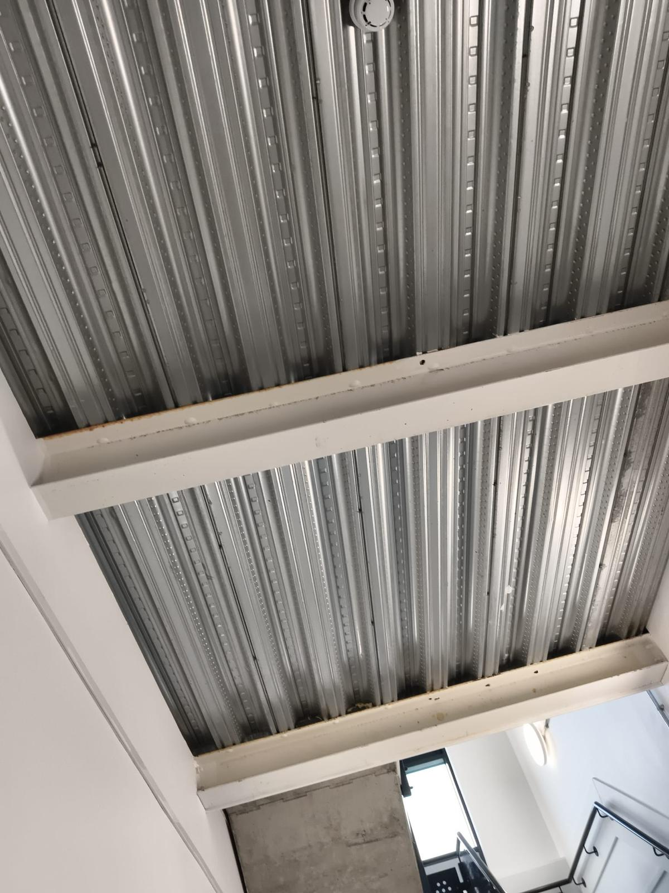
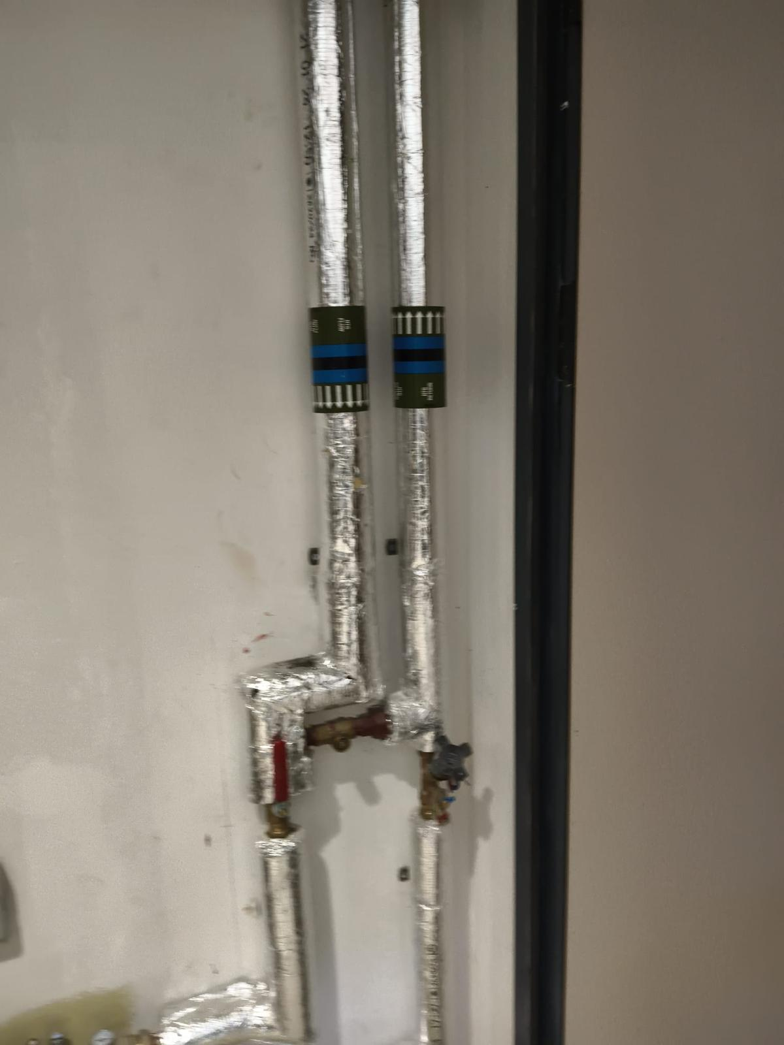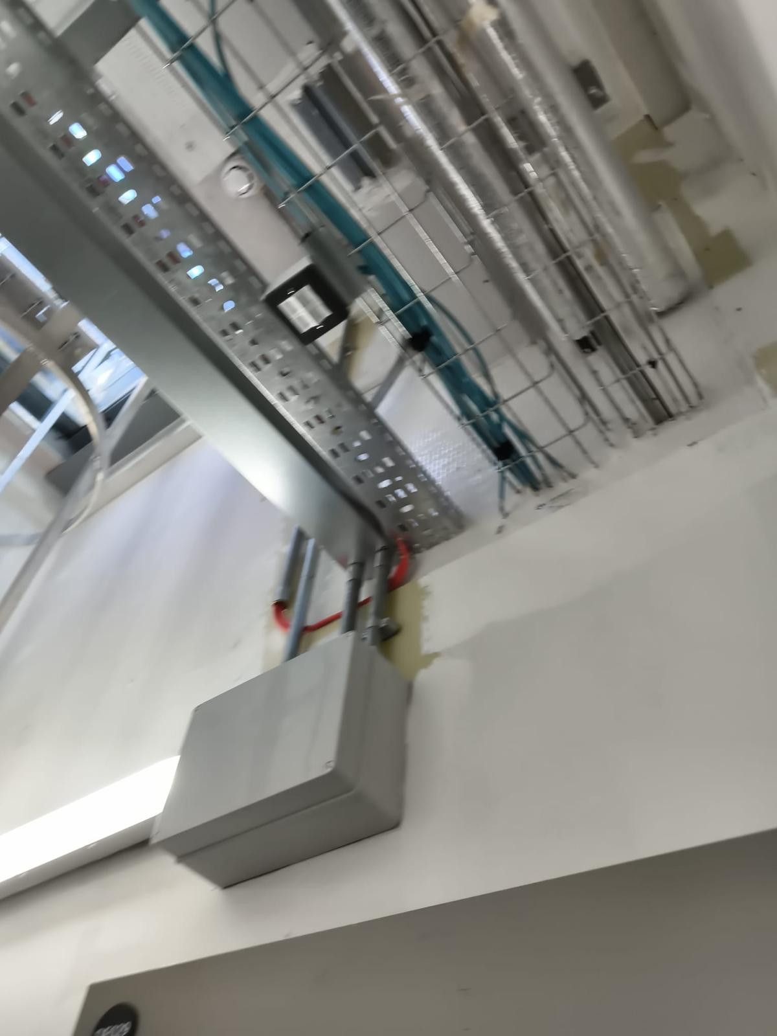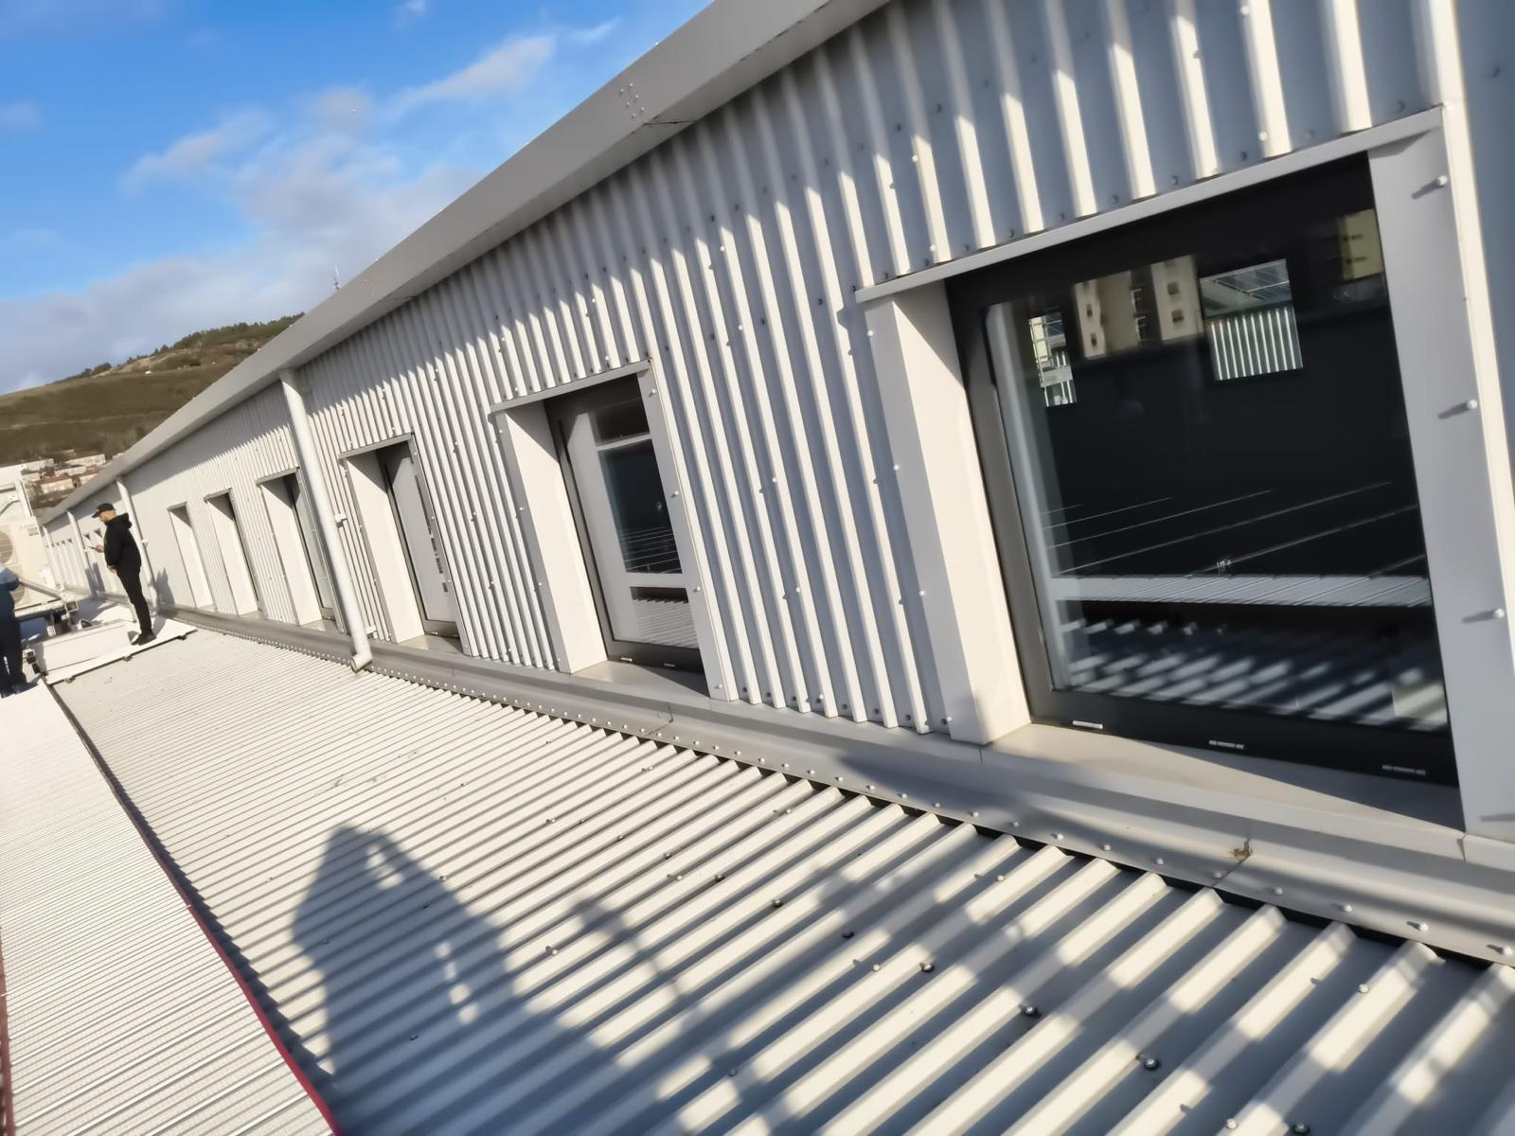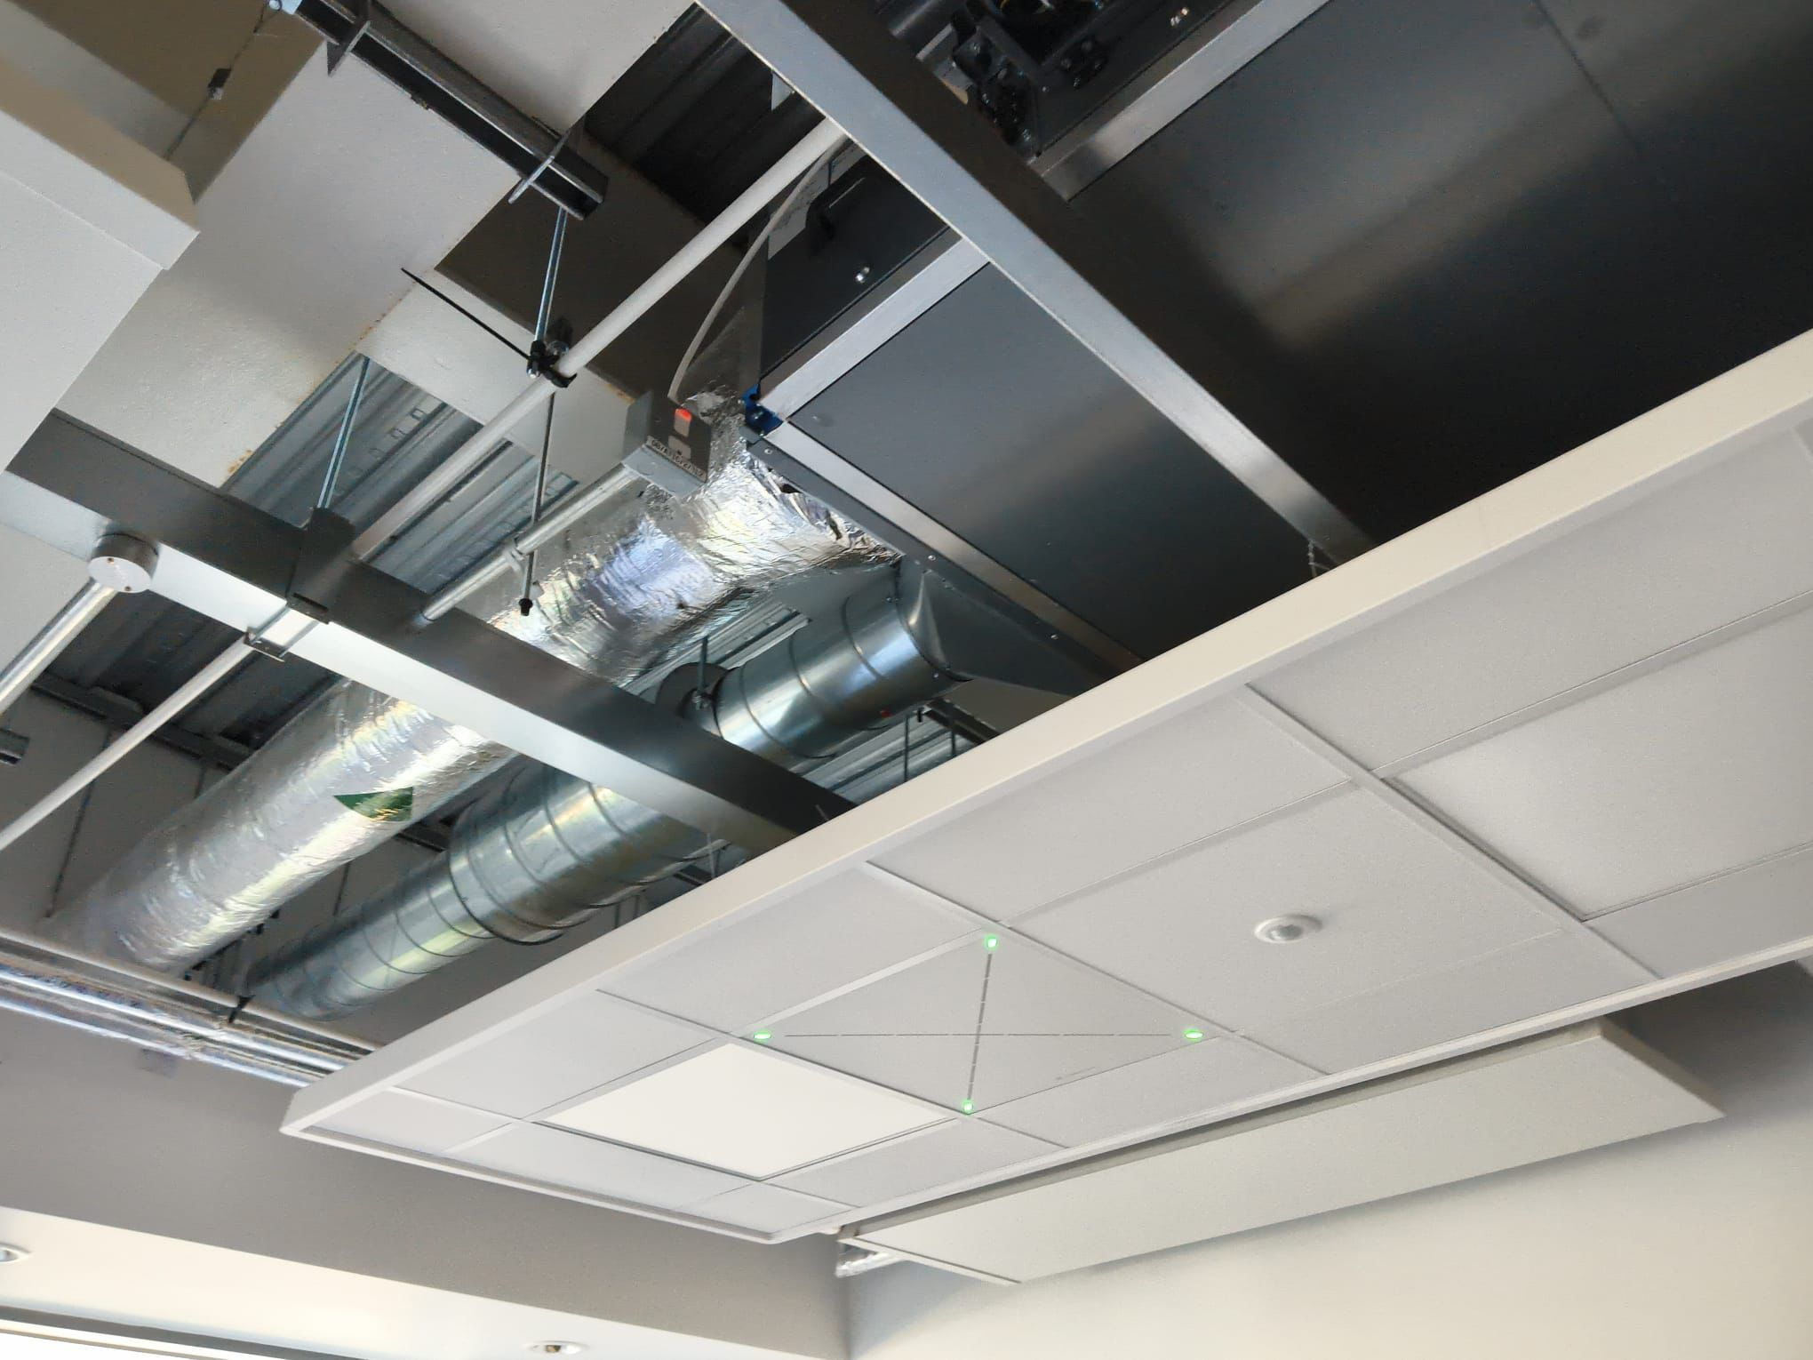
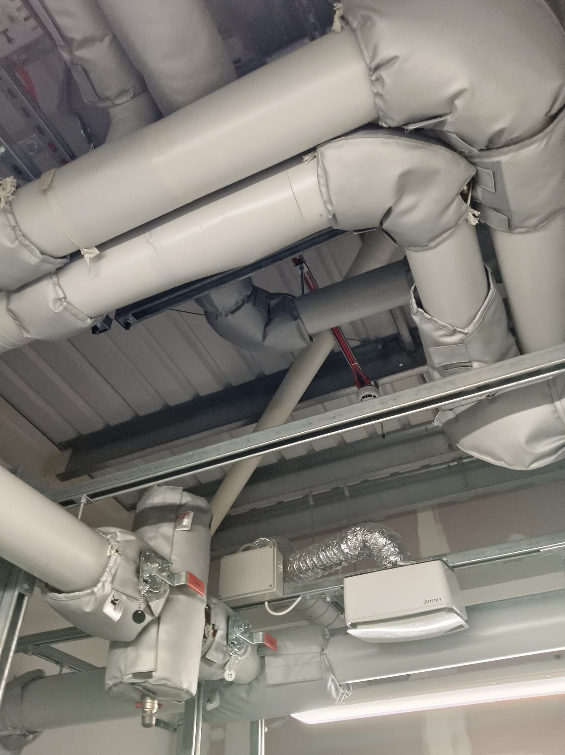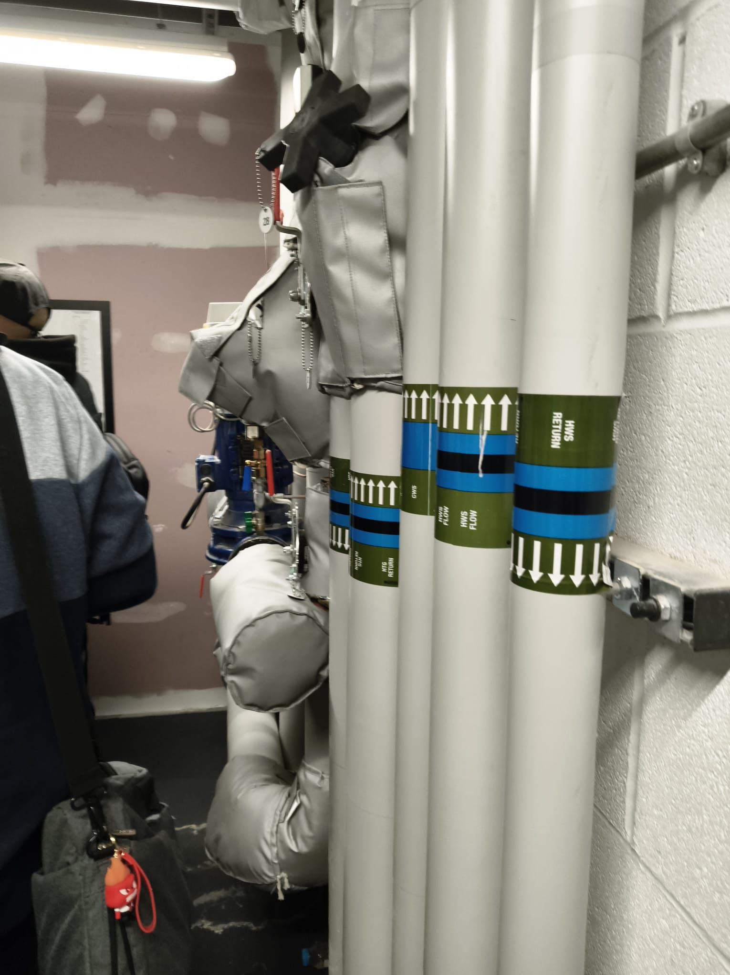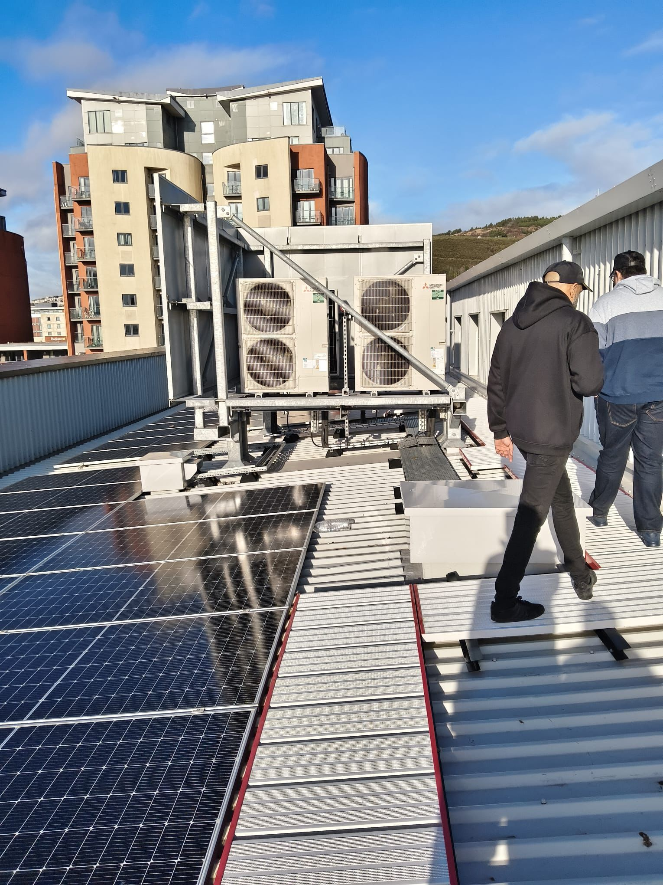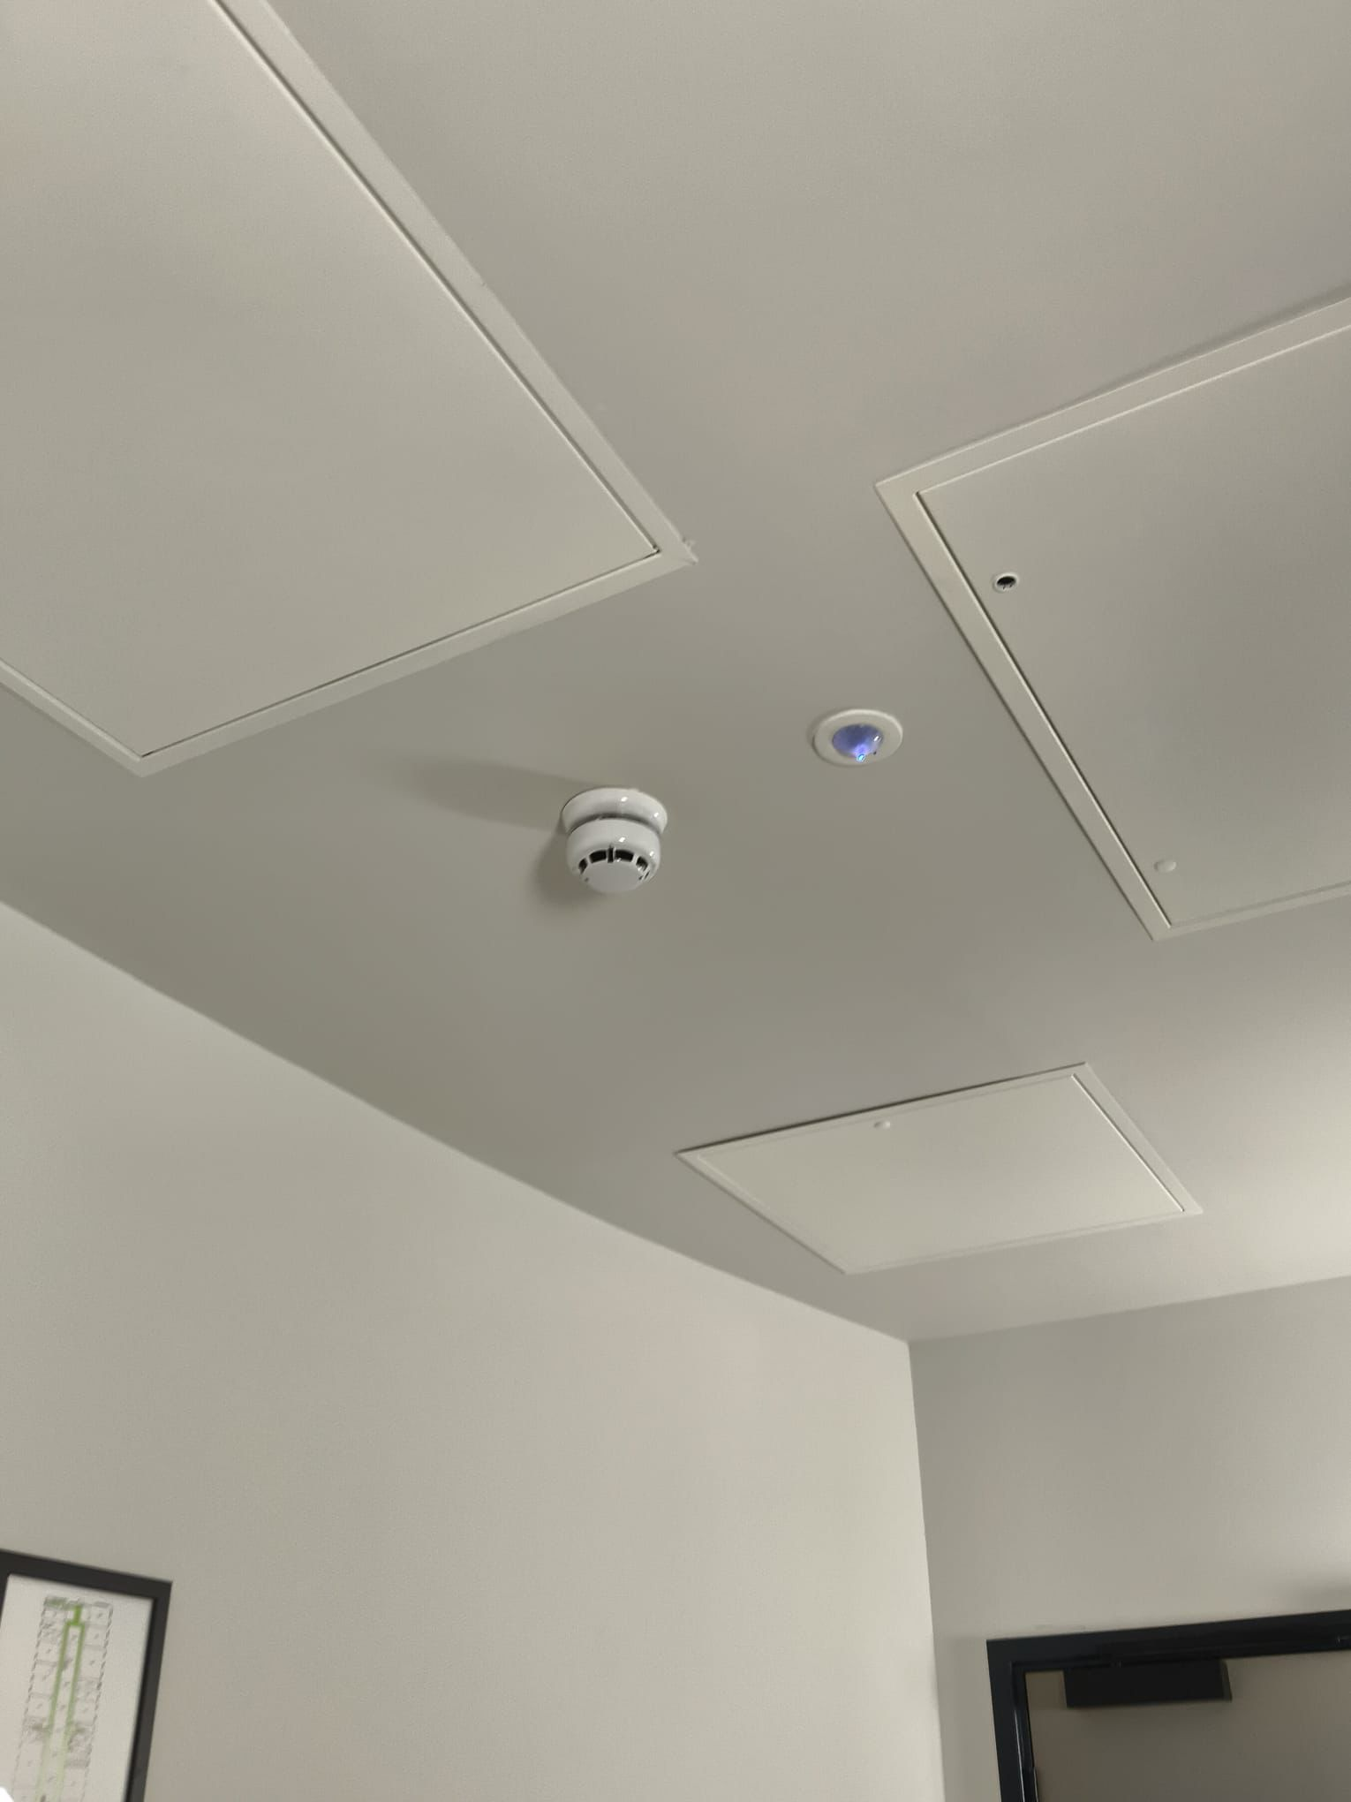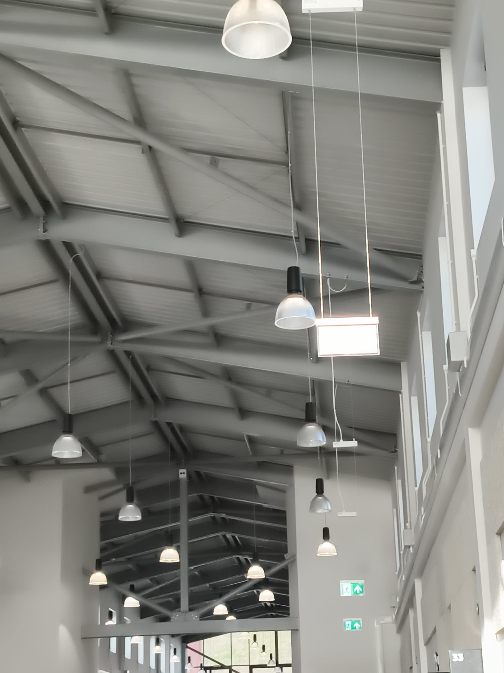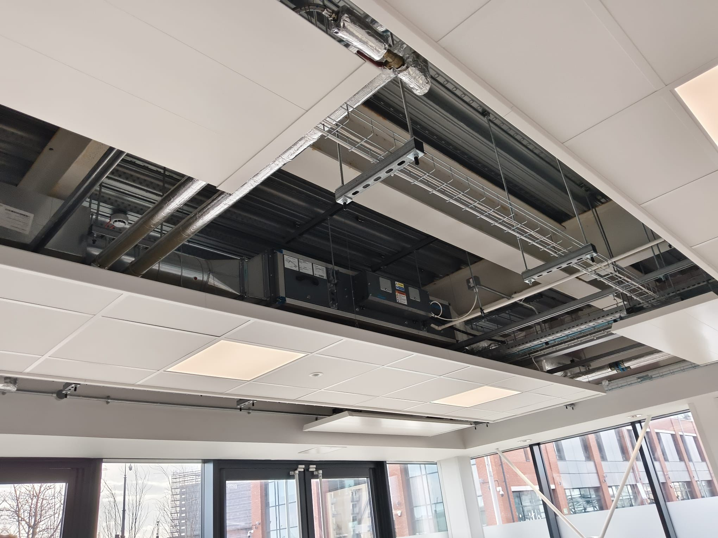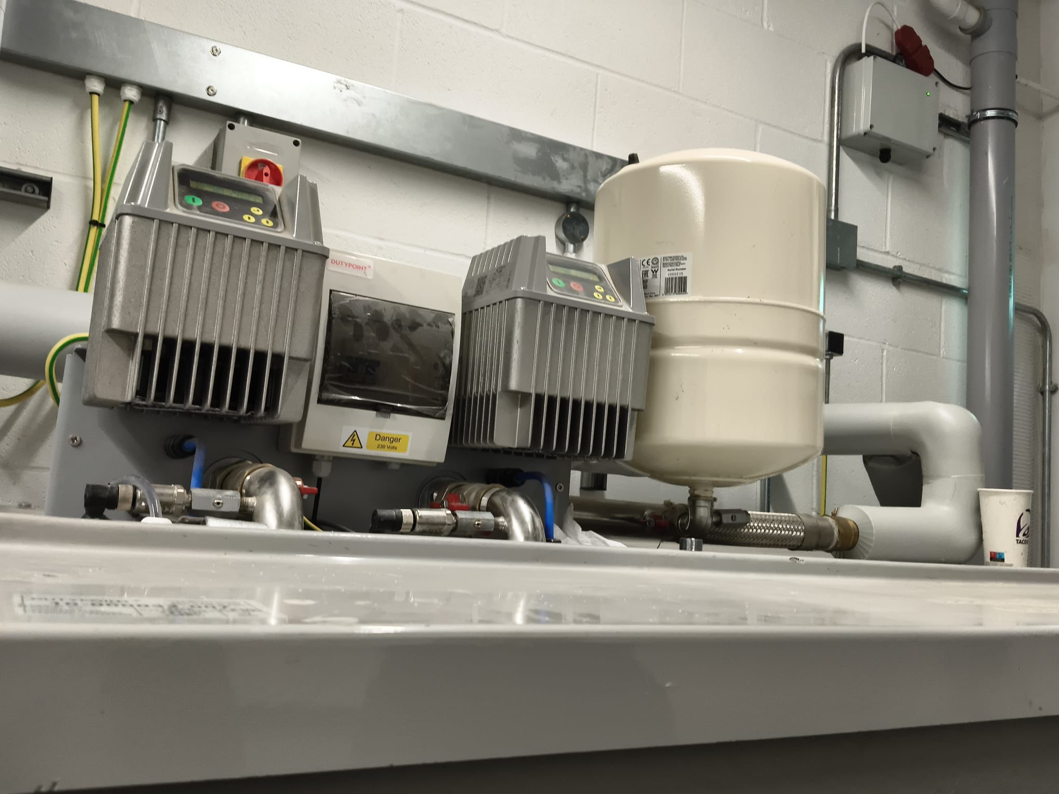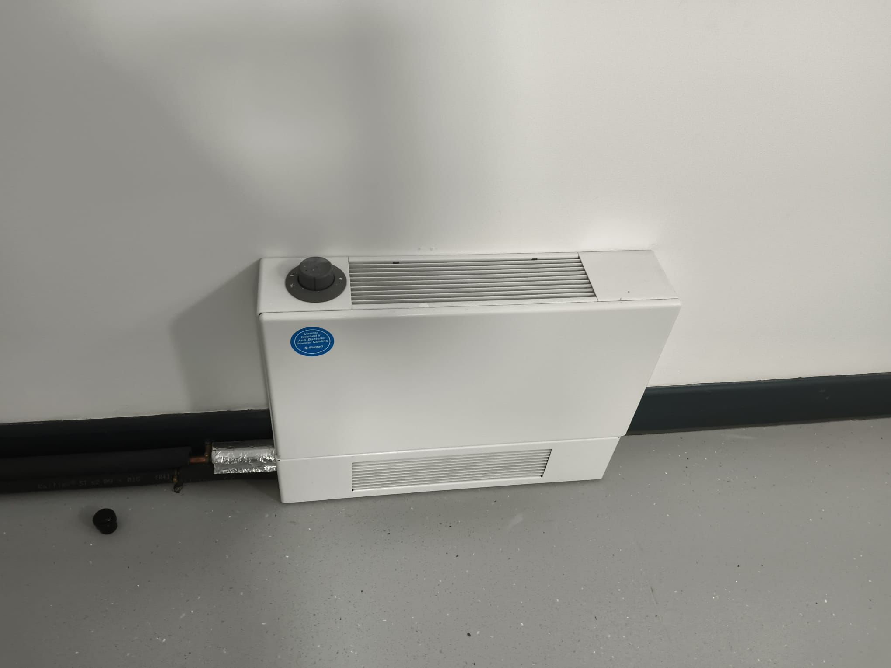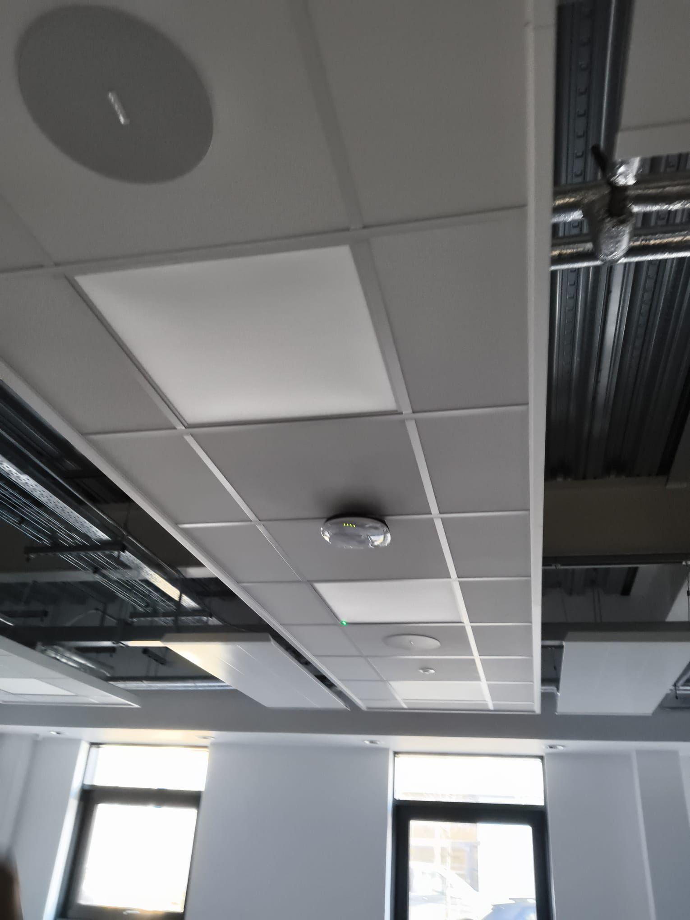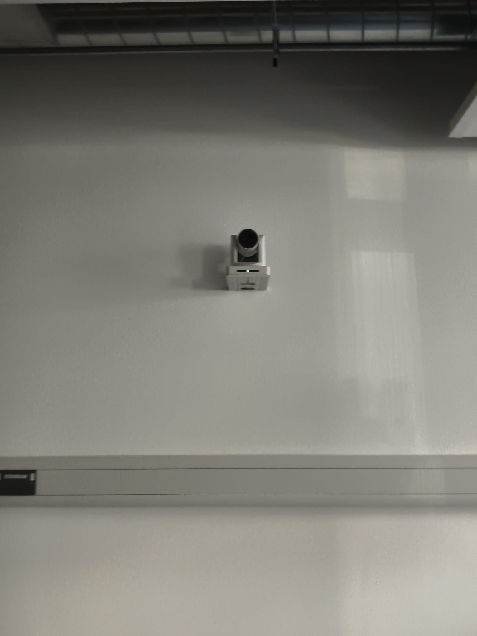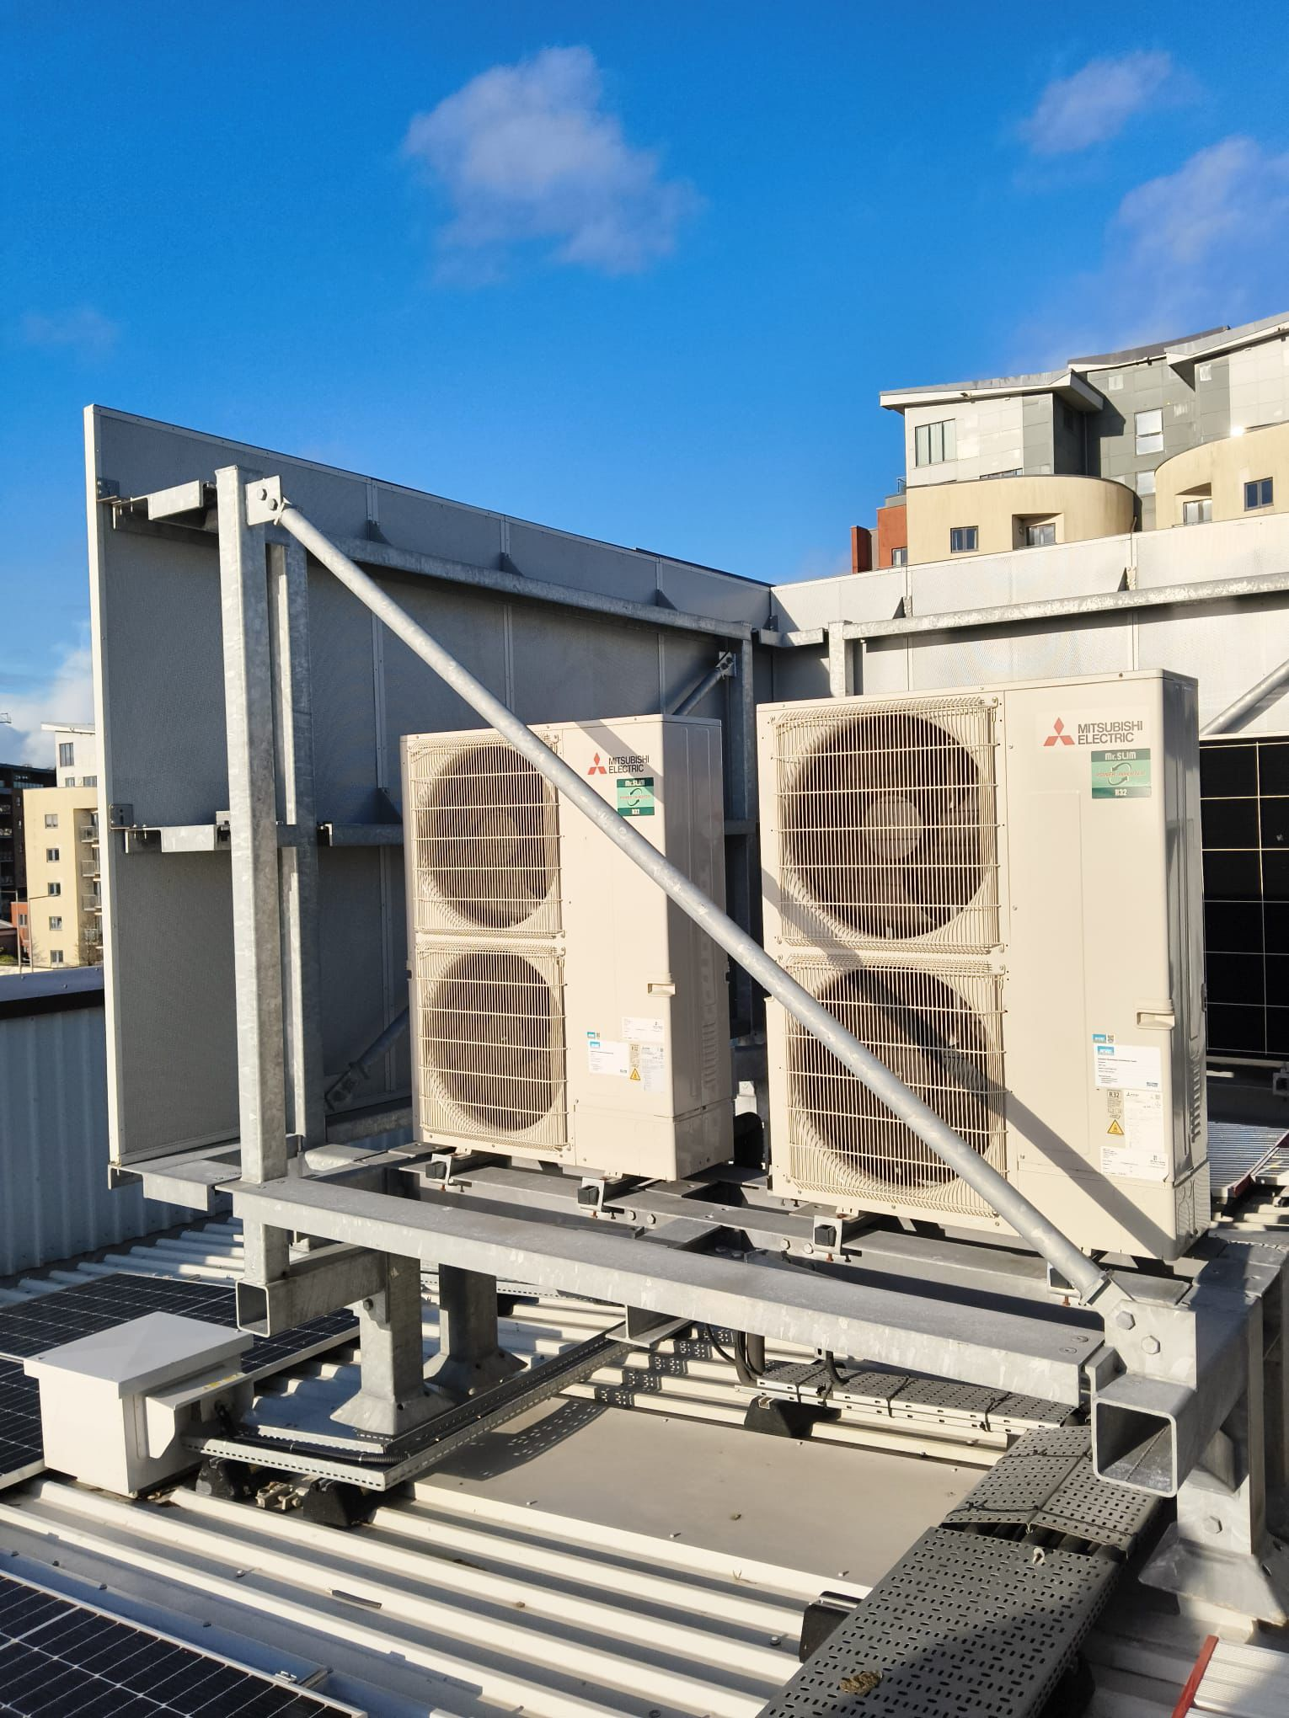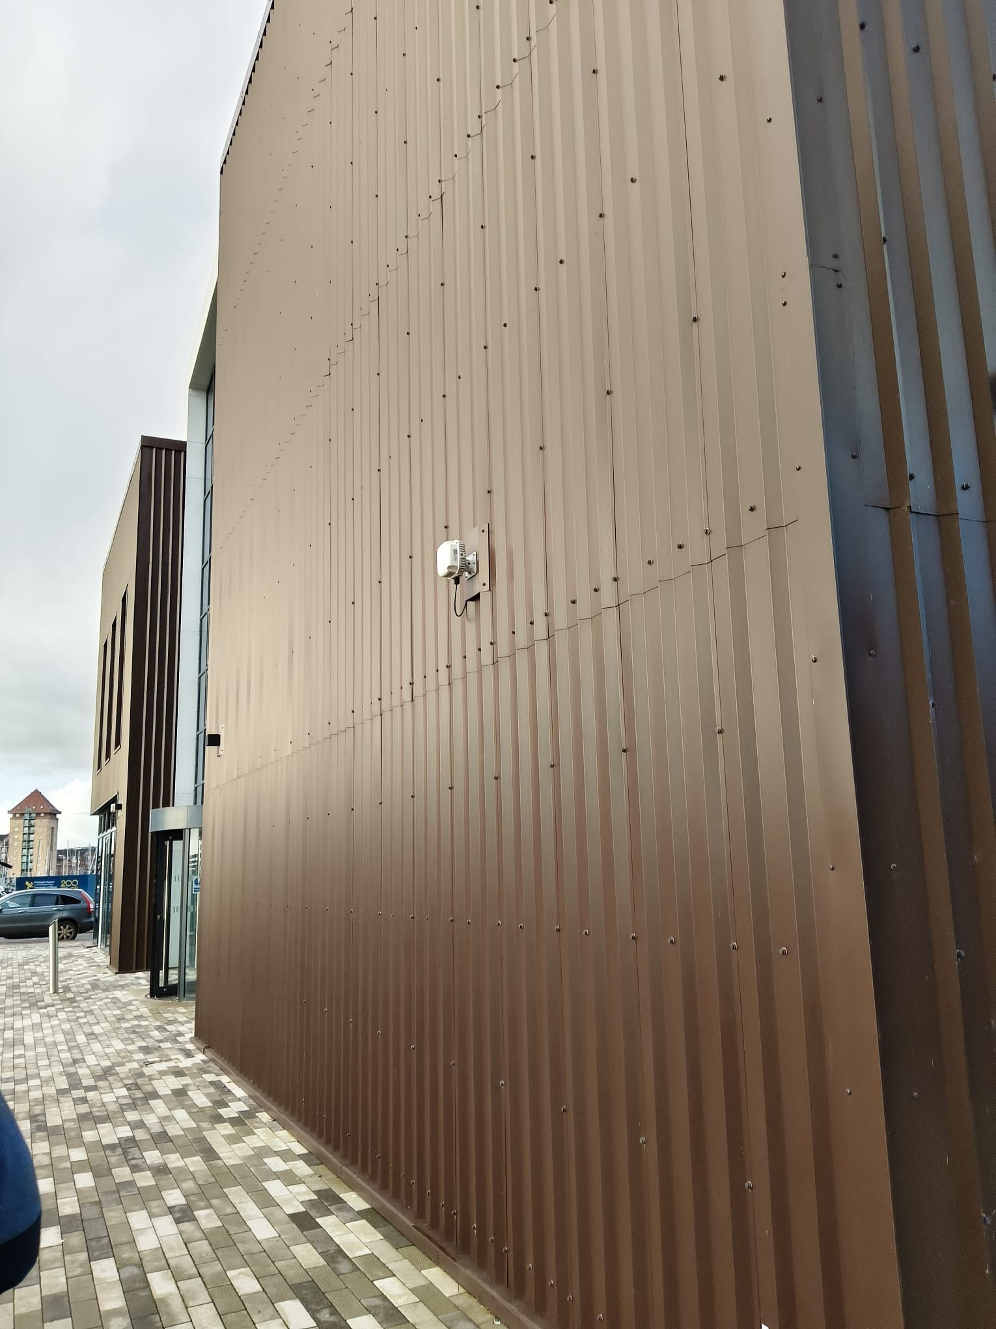

5.3 Critical Evaluation of Plant Assets
The plant that has been installed has to be evaluated critically to determine how suitable and efficient it is in terms of meeting building demand. This entails having in place an element of whether the size of pathways of the plants is being right-sized to suit peak and part- load loads without the heavy use of energy (Larsen et al. 2022).
Long-period operational efficiency is also influenced by the anticipated lifespan of the plants. Properly furnished equipment that has the right durability and performance patterns is also beneficial to the sustainable nature of asset management and lowers the repetition.

6.0 Narrative Description of Engineering Services Operation

6.1 HVAC Systems
The heating, ventilation, and air conditioning (HVAC) system is set in such a way that it responds to the occupancy and outside climatic incorporating the response of appropriate conditions in the internal environment throughout the building structure. Mechanical ventilation systems provide fresh air to the workplace, and air handling units filter, condition, and pump air into the various zones (Omrany et al. 2023).

6.2 Electrical Services
The electrical system works on the supply of the incoming utility that is sent through the main switchgear and distribution boards to the lights, power outlets, and specialist equipment. The lighting systems assume sufficient lighting and reduce energy use by installing energy-efficient luminaire and lighting control measures, including occupancy control, and daylight control measures (Chen et al. 2024).

6.3 Plumbing and Water Services
Water services distribute clean water within the mains to the sanitary fixtures and equipment through a managed network. Consumption is minimised through water saving practises like low flow fittings and still ensures hygiene. The drainage keeps wastewater and surface water safely in the drain, which does not contaminate and ensures stable building operation (Hosamo et al. 2022).

6.4 Fire Protection Systems
The fire protection plan will also include detection and alarm systems that will give a warning of the occurrence of a fire early enough. The presence of a suppression system and emergency lights facilitates the evacuation process, whereas coordination between the HVAC and electrical systems facilitates the occupant's safety through coordination between the two units (Ogunwole et al. 2023).

7. Interaction and Integration of Building Services

7.1 Systems-Based Approach to Building Services
Designing engineering services to be interrelated is one way of making them work best, as opposed to designing them to be walls untouched by each other. Systems-based approach appreciates the interdependence of services and the overall building's performance efficiency, reliability, and occupant comfort at the contact point of their concerted efforts (Ukoba et al. 2024).

7.2 Interaction Between HVAC, Fabric, and Controls
The building fabric and building control systems are in close interaction with HVAC systems. High-performance building envelopes prevent loss of heat and unnecessary heating and cooling through unwanted heat gains, and this allows the HVAC systems to operate more efficiently and with low capacities (Elahi et al. 2023).

7.3 Integration of Lighting and Occupancy Control
Occupancy sensors and daylight-responsive controls are being combined with lighting systems. The integration lowers electricity usage as lighting is only on when needed and also dimmed depending on the supply of natural light. Less energy in the lighting also decreases internal heating, thereby leading to reduced cooling loads on the HVAC systems indirectly (Kor et al. 2023).

7.4 Coordination of Fire, Ventilation, and Power Systems
The ventilation and electrical services have to be well coordinated with the fire protection systems. The ventilation systems can be operated to reduce the expansion of the smoke throughout a fire incident, whereas the emergency power supply keeps the alarm systems and emergency lights running (Zhang et al. 2024).

7.5 Benefits and Risks of Integration
Proper integration enhances energy efficiency, reliability in the operations, and comfort to the occupants. Conversely, a lack of coordination may lead to high energy usage, incompatibility of the system, and additional maintenance requirements that negatively affect building performance (Stonig et al. 2022).

8.0 Existing Maintenance Strategy

8.1 Maintenance Approach
The current building maintenance plan is mainly in a planned preventive maintenance (PPM) scheme, which is backed by the reactive maintenance in case of the occurrence of unplanned faults (West et al. 2024). The scheduled time of PPM activities is done after every schedule is in line with statutory requirements, manufacturer requirements, and in accordance with the industry best practise.

8.2 Importance of Maintenance for Energy Efficiency
The successful operation of the building engineering services in terms of energy efficiency is premised upon effective maintenance. Systems that are well-maintained run at their design capacity and consume less energy, and they do not experience excess wear (Larsen et al. 2022).

8.3 Evaluation of Current Strategy
Generally, the current maintenance plan is suitable for the size and functional complexity of the building offered a systematic structure of reliability and system compliance. Nevertheless, ambitions can also be curtailed when maintenance is relatively fixed in time as opposed to being performance-based (Himeur et al. 2023). The limited application of condition-based monitoring may limit early fault capturing, which may influence the future performance of energy and the reliability of the whole system.

9.0 Summary
Some of the key insights into the case study building and its building engineering services have been made in Part 1 of this report. The discussion has presented the background of the building, programme, and functionalities of the building, along with the delivery of the main services, such as the HVAC, electrical, plumbing, and fire protection systems. Significant plant assets have been determined and assessed based on functionality, applicability, and output to operating performance, whilst the current maintenance policy has also been analysed relative to reliability and energy efficiency.

Part 2: Energy Performance Audit and Performance Improvement Strategy

2.0 Introduction to Energy Audit and Modelling Approach
The section is the pivotal point where the qualitative analysis of building systems and maintenance strategy is applied in Part 1, and then a quantitative analysis of energy performance is provided in Part 2. The aim of the energy audit is to assess the performance of the Innovation Matrix II building in operation, identify some sources of inefficiency, and evaluate the prospects of optimizing the energy management and long-term optimization of the performance at the University of Wales Trinity Saint David.
Part 2 of the audit expands upon Part 1 by connecting the building services design, the use of control strategies and maintenance practices to their contribution to energy use and their carbon performance. In order to do it, the dynamic thermal simulation strategy has been chosen, and it has made it possible to provide realistic modelling of building fabric, occupancy, services, and climate conditions. In part 2, find the baseline energy performance, modelling assumptions, analysis of results and evidence-based recommendations for improvement.

2.1 Current Energy Performance

2.1.1 Thermal Modelling Methodology and Assumptions
The building’s baseline energy performance was established using a dynamic thermal simulation model developed in IES-VE 2022, in accordance with Part L (Wales) Stage 4 compliance requirements and CIBSE modelling guidance. The model represents the Innovation Matrix II as an NCM B1 office building and incorporates detailed geometry, occupancy profiles, internal gains, and operational schedules (Hosseini et al., 2021). Fabric performance assumptions include high-performance external walls, roof and floor constructions, low air permeability, and high-efficiency glazing. Mechanical systems modelled include air source heat pumps, MVHR units with heat recovery, DX cooling for critical spaces, energy-efficient lighting with controls, and roof-mounted photovoltaic generation (Real et al., 2021). These assumptions provide a robust and industry-validated baseline for energy analysis.
The baseline energy performance of the building was determined through a dynamic thermal simulation model that was created in the IES-VE 2022 and meets the Part L (Wales) Stage 4 compliance standards and the CIBSE modelling conformance. The model reflects Innovation Matrix II as an NCM B1 office building and includes elaborate geometry, occupancy schedules, internal gains, and operational schedules. The assumptions on the performance of fabrics are high-performance external wall, building roof and floor, low air permeability and high-efficiency glazing (Yang et al., 2018). Models of mechanical systems are air source heat pumps, heat recovery MVHR units, and DX cooling critical space, energy-saving lighting that can be controlled and photovoltaic generation on a roof. These assumptions offer a strong and industry-tested platform of energy analysis.

2.1.2 Baseline Energy Consumption Data
In the Innovation Matrix II building, the IES-VE / SBEM Part L compliance model was taken as the basis of the calculation of baseline energy consumption, which proved to be 118 percent better than the Part L notional building, EPC of A+, and controlled carbon-negative performance. Since there is no operational metered data available, the modelled outputs are used as the baseline, which is a regular practice for new buildings which have already been completed (Ma et al., 2024). Power consumption mostly involves electricity obligatory because air source heat pumps are used to heat the space and provide domestic hot water, and are assisted by MVHR systems, lighting, and specialized equipment. Sanitary provision and use of cafes/kitchens are the power behind water consumption. Such values offer a strong metric against which further performance will be evaluated, and further improvement modelling will be possible.
Energy Type | Annual Consumption | Unit | Primary End Use
Electricity | ≈ 209382 | Kw/h/a | HVAC (ASHP, MVHR), lighting, small power, equipment
Water | ≈ 70 | KH/H/m^2/A | Sanitary use, café and kitchen facilities

2.1.3 Analysis of Energy Usage Patterns and Major Energy Consumers
According to the energy model used as a base, the main source of energy consumed in the Innovation Matrix building is electricity, as all the major services of the building are electric. This has a direct result of the all-electric design approach, used to provide space heating and household hot water with air source heat pumps (ASHP) and mechanical ventilation with heat recovery (MVHR). Consequently, no consumption of natural gas is registered.
During occupied daytime periods (08:00-18:00), it is the time when the energy demand is the greatest, as HVAC actions and lighting, as well as the intensive small-power loads related to offices, laboratories, print centres, and the cafe, are the most common (Zhang et al., 2023). Seasonal variation is also observed, and there is higher electrical demand in the winter seasons because of space heating, and in summer, as ventilation and cooling requirements have to be provided, especially in high-gain spaces.
The principal energy-consuming systems are summarised below.
System / End Use | Relative Contribution | Key Drivers
Space heating & DHW (ASHP) | High | Winter operation, SCOP 2.7
Ventilation (MVHR & AHUs) | High | Continuous airflow, fan power
Lighting | Medium | Long occupancy hours, controls
Small power & equipment | Medium–High | Labs, servers, print centre
Pumps & auxiliaries | Low | Variable-speed control
This usage profile highlights HVAC and ventilation systems as the primary targets for efficiency optimization and maintenance-led performance improvement.

2.2 Performance Analysis

2.2.1. Evaluation of Current Energy Performance
The recording of the Innovation Matrix building shows that it has high energy performance in accordance with an advanced low-energy design. Using PHPP analysis (v10.6, Swansea climate) download gives an annual space heating requirement of 31.7-35.0 kWh/m²·yr for a treated floor area (TFA) of 2679.2 m². This puts the building significantly lower than the average UK university standards and reverberates ultra-low-energy standards. Incidents of building envelope relate to heat losses due to transmission (QT ≈ 96-136 MWh/yr based on method), and ventilation relates to a large proportion of heat losses (QV ≈ 42-63 MWh/yr). The effective MVHR systems and the original fabric of high quality (walls 0.139 W/m²K, roof/floor 0.15 W/m 2 K) significantly restrict all the losses. The approximate contributions of the solar and interior gains are around 43 kWh/m²·yr, covering a huge percentage of the heating demand.

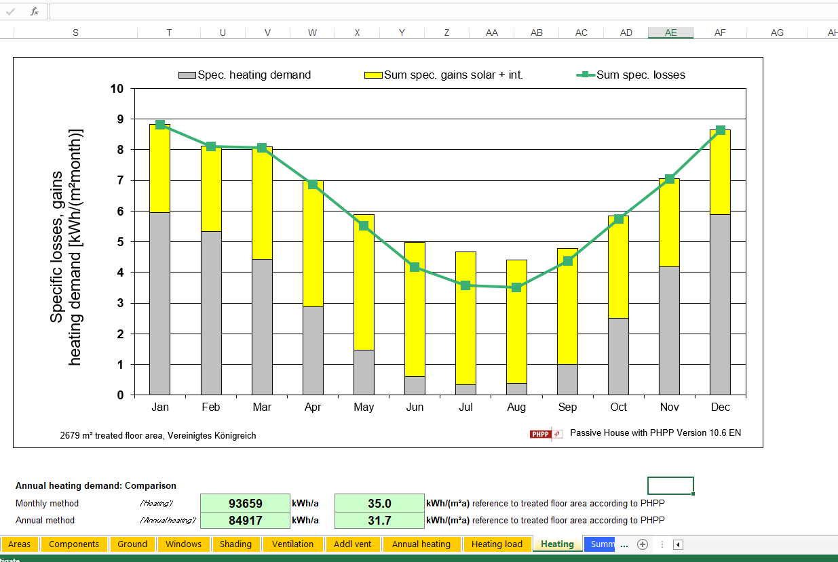 Specific losses and gains
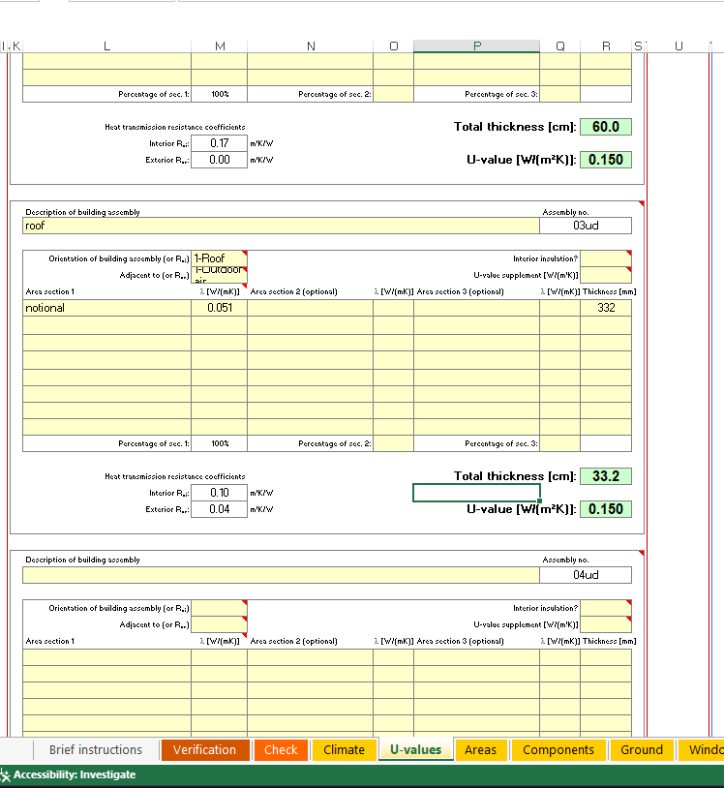

BASE LINE ‘U’ VALUE OF ROOF

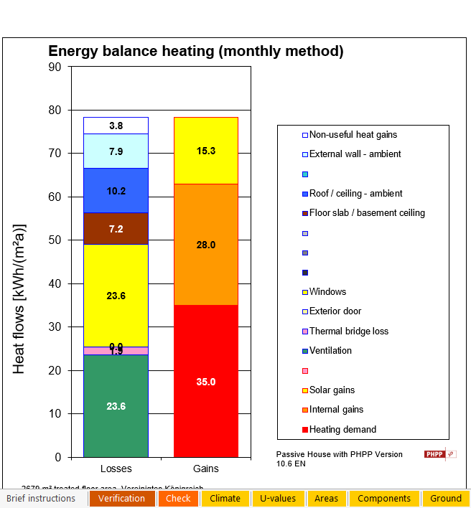
Energy Balance Heating

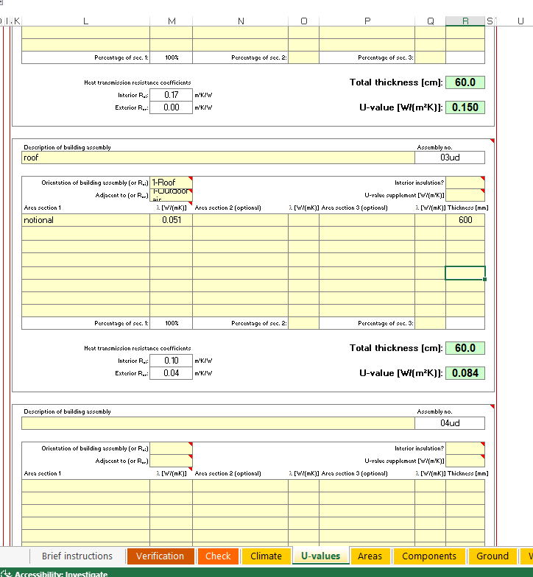

AFTER CHANGING ‘U’ VALUE OF ROOF

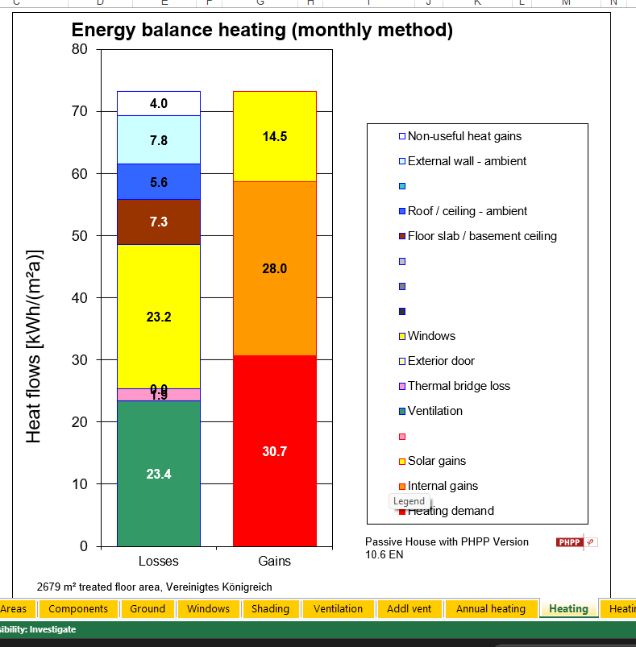

Energy Balance Heating(After Changing U-value )

2.2.3. Role of Maintenance Strategies in Energy Efficiency
The maintenance is also important in maintaining the low-energy performance of the building. Frequent changing of MVHR filters, heat exchanger remedies, and airflow recovery is necessary to avoid worsened efficiency and an increase in fan energy (Simpeh et al., 2022). Passage of refrigerant and cleaning of the heat exchanger are some of the maintenance tasks conducted by the ASHP to ensure that the planned seasonal coefficient of performance (SCOP ≈ 2.7) is achieved. Unnecessary heating and ventilation processes can be reduced by continuous optimization of BMS, seasonal commissioning, and monitoring of internal temperatures (Gudlaugsson et al., 2023). All these maintenance measures are aimed at safeguarding the design purpose of the building, minimizing the lifecycle operating energy and enhancing long-term operating reliability.

2.3. Recommendations

2.3.1 Improved Thermal Model and Performance Enhancements
A better thermal model was worked out through proposed improvements to the existing PHPP/IES baseline model in the case of building the Innovation Matrix. The aim was to continue decreasing the operational energy requirements, risk of overheating in future and improving the system reliability over a long duration and cost effectiveness.
The energy-saving technologies were aimed at optimizing the existing systems instead of their complete change. They involved better control approaches to the MVHR system (optimization of night purge and demand-controlled ventilation) and better BMS scheduling in order to make HVAC work more in line with occupancy patterns (Hosseini et al., 2021). These steps enable reducing the heat losses of the ventilation, which can be up to 23.6 kWh/m²·yr, without reducing the quality of the air in buildings.
Enhancement of the fabric was modelled by enhancing the glazing. Although the opaque envelope already has a high level of performance (walls 0.139 W/m²K, roof/floor 0.15 W/m²K), glazing is the source of highest transmission losses (≈17–24 kWh/m²·yr). A combination of decreasing window g-values on west- and south-facing facade to about 0.25 and external shading demonstrated that it significantly decreased both heating loss and overheating of the building as a result of the sun (Real et al., 2021).
The optimization of renewable energy was done by maximizing the available photovoltaic facility. The roof-mounted PV system (465 m², 21% efficiency, 10° inclination) was maintained, but re-modelled with an increased inverter efficiency and much better monitoring. This adds on-site generation of electricity that can be used to compensate for the all-electric power needs of the building coming out of ASHPs, MVHR, lighting and equipment.
Improvement of MVHR Efficiency
Mechanical Ventilation with Heat Recovery (MVHR) systems play a significant role in the building’s energy balance, with ventilation losses identified as one of the dominant contributors to heat demand. Although the existing MVHR units demonstrate good baseline performance, their effectiveness is highly dependent on heat recovery efficiency, airflow rates, and operational control strategies.
Increase in Solar Energy Utilisation
The analysis identified an opportunity to increase the contribution of solar energy to the building’s overall energy balance. While the building already benefits from photovoltaic (PV) generation, the effective utilisation of solar gains—both passive and active—can be further enhanced.
Boiler Efficiency Improvement
Although the building primarily adopts an all-electric heating strategy, any remaining boiler-based systems or auxiliary heating components should be reviewed for efficiency improvements. Where boilers are present, upgrading to high-efficiency condensing boilers with seasonal efficiencies exceeding 90% can significantly reduce energy losses associated with combustion and flue gas discharge.
Improvement in Building Fabric Insulation (U-Values)
Thermal modelling results highlight that transmission heat losses through the building envelope remain a notable component of total heat demand, particularly through glazing and junctions. Improving insulation performance by reducing U-values is therefore a critical strategy for enhancing thermal efficiency.
Window Specification Upgrade (Triple Glazing)
Windows were identified as one of the largest sources of transmission heat loss within the building. Upgrading existing glazing to high-performance triple-glazed units presents a substantial opportunity for energy savings.
Thermal Blinds and Internal Shading Improvements
Thermal blinds represent a cost-effective and flexible measure to improve both thermal performance and occupant comfort. When deployed, thermal blinds introduce an additional insulating air layer at window interfaces, reducing night-time heat losses during winter and limiting solar gains during summer.

2.3.2 Cost–Benefit Analysis of Recommendations
Measure | Initial Cost (£) | Annual Energy Saving | Payback (yrs) | ROI | Ongoing Maintenance
Demand-controlled MVHR & BMS optimization | 18,000 | ~12,000 kWh/yr (£3,000) | 6 | High | Filter & sensor calibration
Solar control glazing / external shading | 35,000 | ~8,500 kWh/yr (£2,100) | 16–17 | Medium | Minimal (inspection)
PV optimization & monitoring upgrade | 22,000 | ~14,000 kWh/yr (£3,500) | 6–7 | High | Inverter servicing
ASHP performance optimization | 12,000 | ~6,000 kWh/yr (£1,500) | 8 | Medium–High | Annual servicing
Energy savings are based on PHPP heating demand of 31.7–35.0 kWh/m²·yr, ventilation losses, and electrical offset from PV generation.
The cost–benefit analysis was undertaken to assess the financial viability of the proposed energy efficiency measures alongside their technical benefits. Initial capital costs were derived from a combination of industry benchmark data, published cost guides, and typical UK commercial building installation rates, as demonstrated in the provided instructional video. Sources include recent industry averages for mechanical and electrical upgrades, photovoltaic installations, glazing improvements, and control system optimisation.
The Return on Investment (ROI):
$$\text{ROI (\%)}=\left(\frac{\text{Annual Financial Saving (£/yr)}}{\text{Initial Capital Cost (£)}}\right)×100$$Annual energy savings were calculated based on reductions in electricity demand predicted by the thermal and energy models and converted into monetary savings using an assumed average electricity tariff of £0.25/kWh, consistent with current UK commercial energy prices. The results indicate that MVHR and BMS optimisation delivers the highest ROI (16.7%), reflecting its relatively low capital cost combined with substantial energy savings achieved through reduced ventilation heat losses and improved system control. Similarly, PV optimisation demonstrates a strong ROI of 15.9%, benefiting from direct electrical offset in an all-electric building.
ASHP performance optimisation provides a moderate ROI of 12.5%, justified by improved seasonal efficiency and reduced electrical input during peak heating periods. In contrast, solar control glazing and external shading, while offering clear comfort and overheating mitigation benefits, exhibits a lower ROI of 6.1% due to higher capital costs and longer payback periods.

2.3.3 Integrated Maintenance Strategy
Performance improvements are combined with an active maintenance program to be able to guarantee long-term efficiency. Constant change of the MVHR filters, rebalancing of airflow and servicing of the ASHP maintain efficiencies of the system and avoid performance drift. BMS-based monitoring can be used to minimize unplanned fault detection, reducing the lifecycle costs and unplanned downtime. All these steps will guarantee that the energy performance benefits are preserved throughout the lifespan of the building alongside the promotion of long-term dependability and adherence to low-carbon targets.

10.0 Reference List
Part 1
Chen, L., Hu, Y., Wang, R., Li, X., Chen, Z., Hua, J., Osman, A.I., Farghali, M., Huang, L., Li, J. and Dong, L., 2024. Green building practices to integrate renewable energy in the construction sector: a review. Environmental Chemistry Letters, 22(2), pp.751-784.
Elahi, M., Afolaranmi, S.O., Martinez Lastra, J.L. and Perez Garcia, J.A., 2023. A comprehensive literature review of the applications of AI techniques through the lifecycle of industrial equipment. Discover Artificial Intelligence, 3(1), p.43.
Himeur, Y., Elnour, M., Fadli, F., Meskin, N., Petri, I., Rezgui, Y., Bensaali, F. and Amira, A., 2023. AI-big data analytics for building automation and management systems: a survey, actual challenges and future perspectives. Artificial intelligence review, 56(6), pp.4929-5021.
Hosamo, H.H., Imran, A., Cardenas-Cartagena, J., Svennevig, P.R., Svidt, K. and Nielsen, H.K., 2022. A review of the digital twin technology in the AEC‐FM industry. Advances in civil engineering, 2022(1), p.2185170.
Kor, M., Yitmen, I. and Alizadehsalehi, S., 2023. An investigation for integration of deep learning and digital twins towards Construction 4.0. Smart and Sustainable Built Environment, 12(3), pp.461-487.
Larsen, V.G., Tollin, N., Sattrup, P.A., Birkved, M. and Holmboe, T., 2022. What are the challenges in assessing circular economy for the built environment? A literature review on integrating LCA, LCC and S-LCA in life cycle sustainability assessment, LCSA. Journal of Building Engineering, 50, p.104203.
Ogunwole, O., Onukwulu, E.C., Joel, M.O., Adaga, E.M. and Ibeh, A.I., 2023. Modernizing legacy systems: A scalable approach to next-generation data architectures and seamless integration. International Journal of Multidisciplinary Research and Growth Evaluation, 4(1), pp.901-909.
Omrany, H., Al-Obaidi, K.M., Husain, A. and Ghaffarianhoseini, A., 2023. Digital twins in the construction industry: a comprehensive review of current implementations, enabling technologies, and future directions. Sustainability, 15(14), p.10908.
Stonig, J., Schmid, T. and Müller‐Stewens, G., 2022. From product system to ecosystem: how firms adapt to provide an integrated value proposition. Strategic Management Journal, 43(9), pp.1927-1957.
Ukoba, K., Olatunji, K.O., Adeoye, E., Jen, T.C. and Madyira, D.M., 2024. Optimizing renewable energy systems through artificial intelligence: Review and future prospects. Energy & Environment, 35(7), pp.3833-3879.
West, J., Evangelista, A., Siddhpura, M. and Haddad, A., 2024. Asset maintenance in Australian commercial buildings. Frontiers in Built Environment, 10, p.1404934.
Zhang, M., Tao, F., Huang, B., Liu, A., Wang, L., Anwer, N. and Nee, A.Y.C., 2024. Digital twin data: methods and key technologies: [version 2; peer review: 4 approved]. Digital Twin, 1(1), p.2.
Part 2
Hosseini, S.M., Shirmohammadi, R., Kasaeian, A. and Pourfayaz, F., 2021. Dynamic thermal simulation based on building information modeling: A review. International Journal of Energy Research, 45(10), pp.14221-14244.
Real, J.P., Rasmussen, C., Li, R., Leerbeck, K., Jensen, O.M., Wittchen, K.B. and Madsen, H., 2021. Characterisation of thermal energy dynamics of residential buildings with scarce data. Energy and buildings, 230, p.110530.
Yang, S., Pilet, T.J. and Ordonez, J.C., 2018. Volume element model for 3D dynamic building thermal modeling and simulation. Energy, 148, pp.642-661.
Ma, C.Q., Xue, C.H., Guo, X.J., Shi, W., Wang, H.D., Huang, M.C., Wan, L., Wu, Y.G. and Cheng, J., 2024. Fabrication of passive cooling fabric as thermal management curtain for building energy-saving. Chemical Engineering Journal, 497, p.154431.
Zhang, K., Lei, X., Mo, C., Huang, J., Wang, M., Kang, E.T. and Xu, L., 2023. A zero‐energy, zero‐emission air conditioning fabric. Advanced Science, 10(11), p.2206925.
Franco, A., Miserocchi, L. and Testi, D., 2021. HVAC energy saving strategies for public buildings based on heat pumps and demand controlled ventilation. Energies, 14(17), p.5541.
Simpeh, E.K., Pillay, J.P.G., Ndihokubwayo, R. and Nalumu, D.J., 2022. Improving energy efficiency of HVAC systems in buildings: a review of best practices. International Journal of Building Pathology and Adaptation, 40(2), pp.165-182.
Gudlaugsson, B., Ahmed, T.G., Dawood, H., Ogwumike, C., Short, M. and Dawood, N., 2023. Cost and environmental benefit analysis: An assessment of renewable energy integration and smart solution technologies in the InteGRIDy project. Cleaner Energy Systems, 5, p.100071.

