Author: Liliya Hristova
Student ID: 1816238
Date: 15.12.20
Professor’s name: C. Oham
Programme of study (LCBB5004)


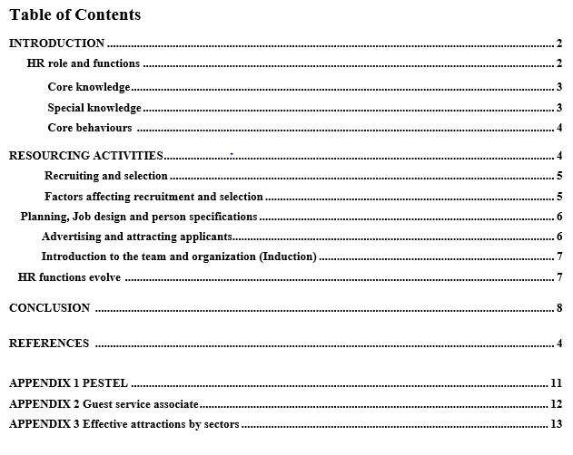

INTRODUCTION
This report will give a brief explanation of what is current CIPD profession map, HR professional's role, and the organisational resourcing within the resourcing activities, e.g. planning, attracting, recruiting, and selection. It will state briefly how the functions of HR have evolved and are evolving. The CIPD Professional Map is a framework, which is evolving to address the changes in people's behaviour and attitude, change of MACRO and MICRO factors at the workplace. (CIPD, 2018). The CIPD adjust and update the principles and values to help HR professionals to make a fair judgment and informed decisions in any situation within their role. The Professional Map outlines what they need to know, how to do it, and their general behaviour. The main responsibilities of HR professionals are to manage people and to be a strategic partner in the organisation. There are four levels of HR: Fundamental, Associate, Chartered member, and Chartered fellow, and each level have different functions, responsibilities, and accountabilities. (CIPD, 2018).
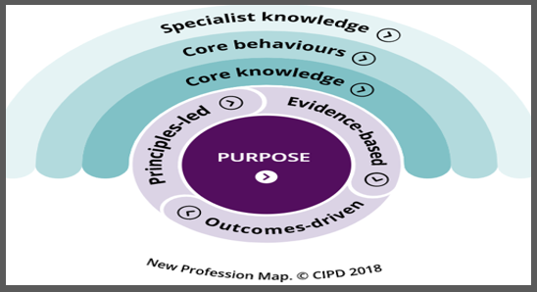
Source: CIPD. [Online] Available at: https://peopleprofession.cipd.org/profession-map

HR PROFESSIONAL ROLE & FUNCTIONS
They use strategies their knowledge and competence to manage people, talents, and make sure that everyone is treated fairly and feel included. People are the most important asset and HR professionals know that. Improving and helping people will improve organisation’s performance and society. Their impact depends on the HR professional personality, at what stage, career maturity and culture, and value of the organisation they work for. HR introduces changes that will impact to some extent everyone in the organisation. (CIPD, 2018)
In reality the factors impacting HR professionals to some extent are, not to be able to meet these high stadards set in the current proffesion map. They are pressured by the organisation and event their good intentions they make mistakes. And as an employ in the organisation they fear they might be dismised. The complexity in the relationship between HR, employers and employees is dinamic and for various reasons leads to missunderstandings, misconducting, unethical and unfair treatment, which led to increase of claims brought to employment tribunal (Kenner, 2018).

Core-knowedge
HR professionals are knowledgeable people regaarding relevant poslicies, regulations and laws and how to introduce and implement them in the organisation. The leading thing they must understand are the culture, behaviour, purpose, priority, and objectives of the organisation, so they can manage people better and contribute to their well-being, diversity, and inclusion. They are following the MACRO and MICRO changes and how they can act and react on them. They use digital technology and keep up to date their knowledge to improve communication, recruitment, selection, process of work. (CIPD, 2018)

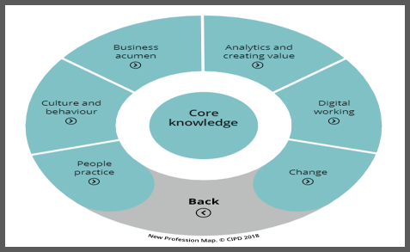
Source: CIPD. [Online] Available at: https://peopleprofession.cipd.org/profession-map

Special Knowledge
They work in partnership with the organisation to create good environment, to enhance employees’ experience, well-being, and engagement. They build, develop, and maintain a relationship between employees and employer by advising them regarding legislations and policies. They guide and help fixing when this relationship is broken. They use and analyse data to understand people’s behaviour. Some of the functions they have are resourcing process, Rewarding system and talent management. (CIPD, 2018)

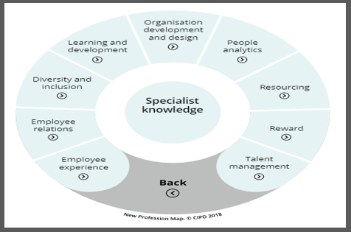
Source: CIPD. [Online] Available at: https://peopleprofession.cipd.org/profession-map

Core behaviours
HR professionals are Ethical practice refferes to ’doing the right thing’, by estabishing and improving moral and integrity, even under pressure, because their decision will impact their image and the company’s’ image, which makes them courageous and good example. They are constantly learning and developing to improve the way they introduce changes, new approaches and innovativeness. Moreover, they value people and communicate clearly, build reletionship and understanding individuals’ views, needs and concerns.. Globalization made working enviroment more divers, employees have different backgroung, experience, culture, nationality, and to work together is a key part of the HR role to support and enhance in the organsiation. As a buseness partners they have comercilal mind-set enabling change to create value, mitigate risk and maximise the competitive advantages. (CIPD, 2018)

In reality HR could be root cause by impacting the culture, behaviour, and management in an organisation negatively by not setting their main functions up to standard as B. Mitesh (2014) mentioned it will lead to monetary lost, job lost and damaging company reputation as it happened with Toyota, which shows how important is the HR role in the organisation.
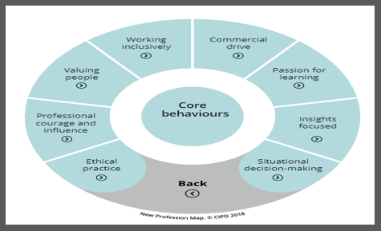
Source: CIPD. [Online] Available at: https://peopleprofession.cipd.org/profession-map

RESOURCING ACTIVITIES
The objective of resourcing is to ensure that the organisation has the workforce they need by recruiting, selecting, and promoting suitable people for the roles. The ‘right’ management and ‘right’ HRM practices will encourage individuals to do their best, be engage, and developing their skills. By retaining talents, the organisation will achieve competitive advantage. (Withers, Williamson and Reddington, 2010) Ultimately the goal should not be just to find people to fill the gap, but those people to be the right fit for the organisation this will save money, energy, and time. And as to do so HR professionals have to know how to recruit looking first at the attitude and then skills. (Leary-Joyce, 2007, p.199).

RECRUITMENT & SELECTION
Resourcing is a two stage process recruiting and selecting, which includes 1) Identify the job and service needed, the salary , knowledge, experience and skills, 2) preparing a job description and the required specifications, 3) Advertising, 4) Interview process, selecting and hiring, 5) Introducing the candidate to the job. (Macdonald, 2016).

Recruiting is the process of generating a pool of qualified candidates and selection is the process of choosing the candidate that is suitable to be hired.

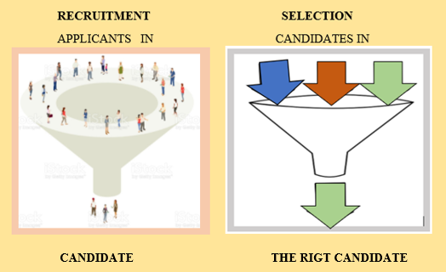

Factors affecting recruitment
The two factors of recruiting and selecting process are MACRO and MICRO and changes at the workplace, changes in employees’ circumstances, such as retiring, resigning, promotions, dismissals, etc. Others are expansion, acquisition, merges, and technology integration in operations can lead to changes and redesigning the work process, and the number of employees needed. (Nickson, 2007)
Some factors are the size of the organisation, employment conditions, organisational growth or decline, past recruitment, working conditions, salary and benefit offered, pandemic (such as Covid-19) etc. The recent pandemic had impact on employment relationships, government interventions and HR functions (See Appendix 1). And some of the constrains of recruitments are image of the organisation, job attractiveness, internal policies, government policy and laws, recruitment cost, etc. (Nickson, 2007)
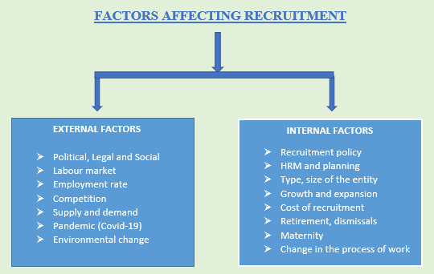

PLANING, JOB DESING & PERSON SPESIFICATION
In preparing the job design and personal specification HR professionals should not understate or overstate the requirements, because if they do so they will have inadequate applicants. It must be so clear that the potential candidate can consider their suitability to the role prior to applying. (Macdonald, 2016).
HR role and functions are usually cover by managers or employers in a small company while in the big companies there is an HR professional. Some of the main functions of HR role are to recruit and select the right candidate. In both cases the individual dealing with the recruitment should be well informed of the laws, policies and procedure that impact employee and employer relationship and must comply with them, because if they do not they can be fined and even go to jail (see Appendix 1). (Armstrong, and Taylor, 2014).
For instance, at Marriott Int. there is an HR department, which has HR manager and HR associate. HR works in collaboration with the General and line managers of each department decide how many employees, the skills set, and experience needed and by when the position must be filled, so the Hotel can function properly. Managers report to HR if there are any changes within their department, and changes in employees’ circumstances. Once they decide what is need they create the job description/design and person specifications, which explain the overall purpose of the role, term & conditions, pay rate, type of the contract, special requirement (travel time, non-social hour of work). The person specification – know how, skill set, and experience, their qualification, and trainings- academic, technical, or professional, depending on the job vacancy (see example: Appendix 3). The designed job description should specify the essential and the desirable attributes. (Marriott International Inc., 2020)

Advertising and attracting applicants
The vacancy can be fill from another organisation, educational institution(externally) or from within the organisation (internally) and depending on the priority and strategy of the company they decide to try first advertising the vacancy internally and then externally (Greer, 2001). At Marriot Int. the internal recruiting is employee can be promoted or change departments. When the vacancy is not filled, HR look for an external candidate. The advantages of internal recruiting are they already know the company value, culture, and people and is cheaper comparing to external recruitment. The advantage of external recruiting is, they bring something new, diversity and fresh into the organisation. The disadvantage is that there is a risk not to be suitable for the company and the culture and feel misfit and leave shortly, which will trigger new recruiting and selecting process.
The findings from the report CIPD (2017) that is harder to recruit people with high skill professionals/ specialist roles , which means position that required high level education and trainings, such us pilots, etc. and there are few applicants, e.g. ‘tight’ labour market. And ‘loose’ labour market means law skilled position don’t required specific education so there are plenty of applicants. Both are impacted by demographic, the talent pool available and the state of the Economic in the country. There are a few ways to fill the vacancy - word of mouth, social media, job-search websites, window advertise, open days, organisation’s platforms, wall boards, etc. (see Appendix 2). At Marriott the following are used to advertise vacancies - social media, their platforms, word of mouth, and agencies. (Brandemix, 2015). Marriott have embedded a strong culture of internal promoting, by encouraging their existing employees to be part of learning and developing programmes and be able to progress within the company. (Marriott International Inc 2020).
The use of Social media as a screening candidate in the process of recruiting and selecting has risks and challenges, such as the reliability, validity and relevancy of the information shared. Another issue is to what extend this is legal or ethical. (Landers, and Schmidt, 2016). And as the survey conducted by Hasis Poll (2016), found that 60 % of employers do screen check of their candidates, and 21 percent admit they are looking for reason not to hire the individual. The author of the report said that the information recruiters (managers) find on the social media about the applicant’s impact their decision. (Career Builder, 2016).
The selection criteria at Marriott include Interview(s), tests or tasks related to the job (problem-solving, scenario, and trial shift). People conducting this process are HR, manager(s), employer(s) a team-member. To avoid bias and to make the interview process fairer so to ensure the right candidate is selected. The longer the interview process the better results. Filling the position is an investment in performance, talents, and recruiter’s reputation. (Arnold et al., 2005). The disadvantages are the cost and sometimes there is the disagreement among the interview panel members due to subjectivity, criteria, and inability to make decision. There should be various stages - interviews, tests, trial shifts, mock exercises, and references. (Macdonald, D. 2016). Moreover, Araoz, F. (2007) described that from his observation the culture plays a role in the priorities set by companies to look for in a potential candidate, Europeans focus on education background and strong resume, while for North America the priorities are performance on the job and achievements. (Araoz, 2007., p.117- 120)

Induction/ introduction to the organisation and introduction to the team
Probation period is to test whether the new staff is suitable for the role and team. It is better to recruit someone with less or no experience on a short-term contract (with a clause to extend) but with potential and train them. (Macdonald, 2016)
In fact, not always interviewers conduct, and achieve fairness in the attempt to recruit applicants. There are many challenges, obstacles, and issues, such as applicants are different, insufficient time for the procedure, peer and superior pressure, and personal attributes of the interviewer, etc.

HR FUNCTIONS EVOLVE
The constant change of people, organisation and the internal and external factors that impact the relationship between employer and employees at work enforce the expansion of HR functions. In the past their main functions were personnel management and now they are strategic partner, introducing and implementing changes in the organisation in order to add value to people, the environment at work and to organisation. They support the business with activities such resourcing, planning strategies and decision making. At Marriott they work together with The General manager and line managers to ensure that the departments had the right number of employees with the right skills, knowledge, and experience. In the past the recruitment and selection process were done by manually filling out all the necessary paperwork and face-to-face interviews. At present almost all application forms and CV-attachments are done online and mainly the interview process is done via Skype, Teams, etc.

CONCLUSION
HR professionals is important part of the organisation, because is responsible for people, organisation ana community. The main function they have are to manage and nourish people, to be strategic partner and to add value. They keep up to date their knowledge regarding the laws and policy related to employees, organisation, and the relationship between them. They use data to analyse and make informed and evidence base decisions. Another important function is resourcing (planning, recruiting and selection) process. HR professionals and managers must decide the selecting process, type of interview, tests and the criteria of selection and the participants of interview panel. People are changing end everything in and around the company change, which leads to changes to be introduced to address. Technology are evolving with make HR professionals to be up-to-date and to use them to be able to do their role in the best possible way so they can add value to people’s life, organisation, and community.

REFERENCES

Arnold, J., Silvester, J and Patterson, F. (2005). “Work psychology understanding human behaviour in the workplace”, 4th edition., pdf. Published by Pearson Education limited, UK, Edinburg.
Araoz, C.F. (2007). “Great people decisions”, p.117- 120, pdf. Published by John Wiley & Sons, Inc., Hoboken, New Jersey.
Armstrong, M. and Taylor, S. (2014). “Armstrong’s Handbook of Human resource management practice” 13th edition. Published by Koganpage, UK, London and USA, Philadelphia
Brandemix (2015). “Why Marriott is a Social media recruiting superstar”, March 2015 [Online] Available at: https://www.brandemix.com/why-marriott-is-a-social-media-recruiting-superstar/ (Accessed: 26 November 2020)
Career Builder, (2016). “Number of employers using Social Media to screen candidates has increased 500 percent over the last decade” Annual social media recruitment survey conducted by Harris Poll, between 10 Feb. and 17 March 2016. Available at https://www.careerbuilder.ca/share/aboutus/pressreleasesdetail.aspx?sd= 4%2F28%2F2016&id=pr945&ed=12%2F31%2F2016 . (Accessed: 20 November 2020)
CIPD (2018) Current professional map, 2018. [Online] Available at: https://peopleprofession.cipd.org/profession-map (Accessed: 15 October 2020)
CIPD (2017). Resourcing and Talent Planning.- survey report [Online] Available at: https://www.cipd.co.uk/Images/resourcing-talent-planning_2017_tcm18-23747.pdf (Accessed: 15 October 2020)
Greer, Ch. (2001) “Strategic human resource management”, 2nd edition, pdf. Published by Prentice-hall, Inc
Kenner, M., People management (2018). “Employment tribunal claims up 90 per cent year on year”- 9 Mar.2018. [Online] Available at: https://www.peoplemanagement.co.uk/news/articles/employment-tribunal-claims-increase-90-percent (Accessed 12.11.2020)
Leary-Joyce, J. (2007). “Inspirational manager – how to build relationships that deliver results”, p.199, pdf. Published by Pearson education limited, UK, Edinburg
Landers, R. and Schmidt, G. (2016). “Social Media in employee Selection and recruitment – theory, practice and current challenges”, pdf. Published by Springer Nature, AG, Switzerland.
Macdonald, D. (2016). “Human resources management in social enterprise managing people in C. Oham and D. Macdonald(eds.) “Leading and managing a social enterprise in health and social care community training partners”. Published by Community training practice, UK, London
Marriott International Inc (2020). Marriott careers, Guest Service associate. [Online] Available at https://jobs.marriott.com/thehosts/jobs/20070702?lang=en-us (Accessed: 21 November 2020)
Marriott International Inc (2020). Marriott careers path. Available at [Online] https://careers.marriott.com/en-GB/career-paths/ (Accessed: 18 November 2020)
Mitesh, B., (2014). “A leadership case study – How HR caused Toyota crash” [Blog] 10 September 2014. Available at https://www.linkedin.com/pulse/20140910121649-31890108-a-leadership-case-study-how-hr-caused-toyota-crash (Accessed: 17.November 2020)

Nickson, D. (2007) “Human resource management for the hospitality and tourist industries”, pdf. Published by Elsevier Ltd.
Personnel today (2002). “How HR has evolved” 5th February 2002. [Online] Available at: https://www.personneltoday.com/hr/how-hr-has-evolved/ (Accessed: 23 November 2020)
Withers, M, Williamson, M., Reddington, M (2010). “Transforming people – creating value through people” 2nd edition, pdf. Published by Elsevier Ltd, UK

APPENDIX 1: PESTEL
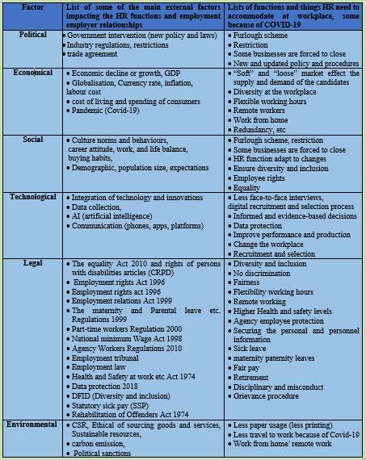
Source: [Online] https://www.gov.uk/ & www.CIPD.com & https://www.cipd.co.uk/knowledge/strategy/organisational-development/pestle-analysis-factsheet

APPENDIX 2: Effective attraction methods, by sector
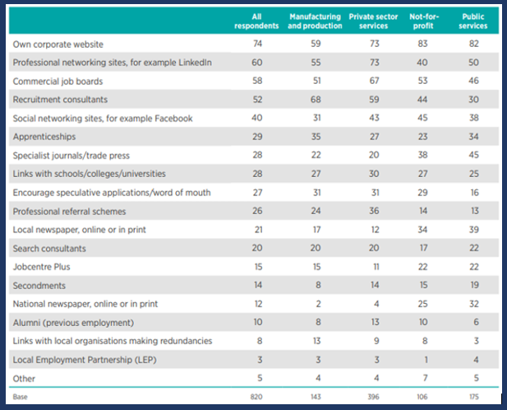

Source: available [online] at: https://www.cipd.co.uk/Images/resourcing-talent-planning_2017_tcm18-23747.pdf

APPENDIX 3:
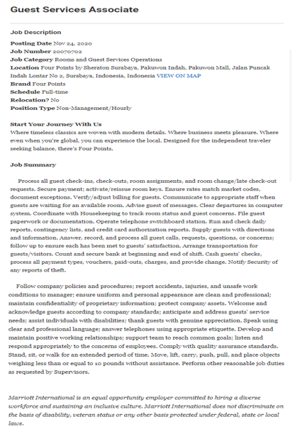
Source: available [online] at: https://jobs.marriott.com/marriott/jobs?lang=en-US

