
The continental hotel budget planner


November 16, 2022
University of Wales Trinity Saint David

Rujina Akther
Student Number: 1704854
Module: Financial Management for the Hotel Industry
Module Code: BMIH5007
Lecturer: Dale Clarke

Table of Contents
Introduction…………………………………………………………………………………3
Task 1 The Continental Hotel Month by Month cash budget forecast January 2022 to december 2023…………………………………………………………………………...4
Task 2 Zero based budget tequnique……………………………………………………..5
- The understanding of traditional based budgeting 5
- The process of zero based budget and how this be implameted 6
- Can budgeting control support sustainability 8
Conclusion 9
References 10

Introduction

Any firm has to exercise monetary management. Planning, organising, regulating, and monitoring monetary capability to undertake organisational targets is known as monetary useful resource management (Block, 2022). It is a technique for regulating an organisation's economic operations, which includes money-related purchases, expenditures, accounting, payments, and danger analysis. Setting targets will assist the hard choices that come with budgeting. You must outline short-, medium-, and long-term goals and display your growth towards them a budget is assembled (Brigham and Houston, 2014). You might also accomplish your monetary and mental goals through the use of a budget. Incremental, activity-based, value-proposition and zero-based budgets are the 4 famous types of budgeting methods used by businesses.
Traditional-based budgets and zero-base budgets will be in contrast in this report. The zero-base finances strategy and how it can also be put into practice. The implementation of sustainable finance management will also take place.

Task 1
The Continental hotel budget planner showing month-by-month cash budget forecast for January 2022 to December 2023.
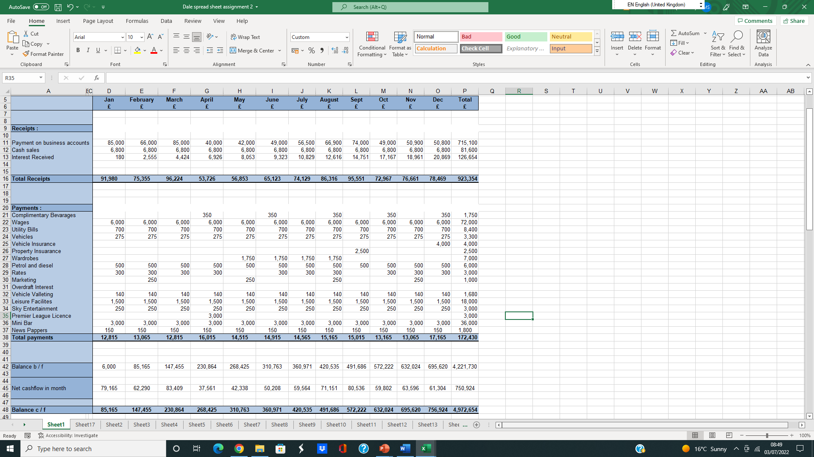

Task 2 Zero- Based Budgeting Technique

(a) The understanding of traditional based budget and zero-base budget.
The tactical execution of a corporation approach is budgeting. One requires a thorough, complete route map of the strategic planning that establishes overall performance measurements and warning signs to accomplish the goals in a company's strategic plan (Chandra, 2011). Finance is a written diagram that is created to decide how plenty cash will be spent every month. There may also make sure that you have ample cash every month by using the usage of a budget. You can run out of cash earlier than your subsequent payday if you do not have a budget. Your earnings and spending habits are each published by way of your budget.

Traditional Budgeting
Traditional budgeting is a method that bases its current-year budgeting on the closing year's expenses. The ease of the usage of this technique of budgeting is the sole benefit. A commercial enterprise that makes use of this technique of budgeting does not have to rethink every issue on the list. Instead, they can evaluate fees from the prior year and then add or subtract the inflation rate, market conditions, patron demand, etc. The majority of shoppers and corporations use this technique of budgeting seeing that they can take a seat down with anything records they have on hand and hastily construct a budget (Oak, 2017). Traditional budgeting is pretty famous because it saves time and lets you straight away decide how a whole lot you may also have to spend as a commercial enterprise or person. You will word that the common inclination is to go lower back and analyse how you did have spent your funds if you take a second to mirror how you prepare your spending. Most folks replicate it in the final year and use it as a beginning factor when growing a spending or profits budget (Madura, 2017). They consider a few variables that may additionally affect their expenditure or income whilst developing the budget. These factors may also be below you manipulate or now and then not.

Zero-based budgeting
Zero-based budgeting (ZBB) is a means of planning a price range in which every new period's spending should be supported. Every characteristic interior of a business enterprise is examined for its needs and expenses as a phase of the "zero-based budgeting" approach. Then, irrespective of whether or not each finance is larger or smaller than the preceding one, the budgets are built around what will be required for the following term (McMillan, 2013). Zero-based budgeting is the commercial enterprise which allows top-level cited goals to be built into the budgetary manipulation through attaching them to unique organisational useful areas, the place fees may also be first aggregated and then assessed towards prior overall performance and modern expectations (Khan and Jain, 2017). Zero-based budgeting ought to be a rolling procedure carried out over many years, with a few applicable factors being assessed at a time through executives or team leaders, due to its detail-oriented nature. By stopping wide rises or falls in the price range from a preceding time period, zero-based budgeting planning can resource in value reduction. The technique is prolonged and takes appreciably longer than more cost-based and conventional budgeting. As their accomplishments are less complicated to justify than these of departments like patron carrier and lookup; innovation, the approach additionally prioritises divisions that generate direct income or output. Families and persons can hire zero-based budgeting, which is usually used in business.

(b) The process of zero-base budget and how can this be implemented
The zero-based budget process includes different steps. Those are discussed below.

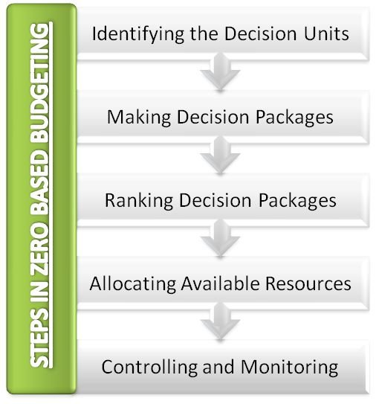
Figure: Process of zero-based budget (McMillan, 2013).

Identifying the Decision Units
Finding the choice unit is the first and most vital stage in the zero-based budgeting process. A motion or team of moves which can be one after the other and meaningfully identified can each be viewed as selection units (Petty, 2011). This method is essential in aiding every line object in the budget. Each selection unit's supervisor has to shield the charges and essential finances allocation for his preferred unit.

Making Decision Packages
The choice devices that had been found in the first stage are cut up into a variety of choice applications in this step (Rachmat and Setin, 2020). These choice programs want to help the organisation's goals. Each selection bundle features a stand-alone request for cash that is persuasive. The processes, actions, and features of the notion are described in every selection package.

Ranking Decision Packages
The 1/3 stage of the zero-based budgeting technique is this one. All choice programs interior the desired unit and amongst unique selection devices are ranked in this step-in accordance to their viewed as one of the leading (Block, 2022). To correctly distribute confined resources, choice programs are prioritised. The cost-benefit evaluation is used to charge choice package deal options.

Allocating Available Resources
The preceding stage is being persevered with this zero-based budgeting step. In this stage, monies are allotted amongst the selection applications which had been rated in the preceding step (Brigham and Houston, 2014). Companies must additionally declare that financing choices are made at this stage. The ranking of selection programs serves as the groundwork for distributing funding and different resources.

Controlling and Monitoring
This completes the procedure of developing a zero-based budget. Decision bundle overall performance and output are tracked and assessed in the course of this stage (Chandra, 2011). The administration can decide whether or not or now not the aid allocation is correct by monitoring the effectiveness of the selected packages.
As zero-based budgeting is a fee administration strategy, the implementation strategies must be cautiously and successfully carried out. There ought to be a thorough clarification of how the cash would be used with the aid of every branch and how the corporation as an entire would income from them. The zero-based budgetary manipulation takes a lot of hard work; however, it provides a pleasant, geared way to allocate a company's cash.

(c) Can budgeting control support sustainability

Budgetary control in finance is referred to as managing revenue and expense. In reality, this involves making a comparison between actual revenue and expenses regularly to those that were anticipated to see whether or not remedial action is necessary. Companies are groups that prioritise making money. They can't thrive if there is now no adequate profit. Decision-making is appreciably influenced by expectations and projections. A situation has created the use of these anticipations and projections. Finance has been created if a situation consists of monetary information. A price range is a kind of company monetary simulator (Oak, 2017). A key instrument in money choices for sustainable improvement is budgeting. The efficacy of the company's capital and assets is additionally maintained by budgeting. Every area or enterprise has an exclusive budget. Budgeting differs in many industries, which include manufacturing, logistics, aviation, construction, and hospitality. By taking non-monetary overall performance metrics for the surroundings and society into consideration, budgeting manipulates aids groups in being greater sustainable. It is a machine of accounting that takes into consideration the proper moves before setting up indicators. Additionally, the economic supervisor is given fundamental accountability for sustainable performance (Khan and Jain, 2017). When a client's income equals or surpasses their costs, they have a sustainable budget. Based on predicted or genuine charges and income, it is possible. If finances display that the purchaser may also or may additionally now not have enough money to dwell in their current housing and outlines a route to a favourable internet income, it can also additionally be deemed sustainable. A sustainable price range presents the patron with clear preferences below difficult circumstances. So, it can be said that budgeting control can support sustainability.

Conclusion
Any association relies upon its economic stability. But cash is continually finite, simply as most different resources. On both hands, needs are unbounded. As a result, nice monetary administration is indispensable for businesses. Finance is an estimate of earnings and spending for a sure future time length that is frequently created and reviewed on an everyday basis. An individual, a bunch of people, a corporation, a government, or especially lots something else that earns and spends cash may additionally all have budgets. Here, traditional based fully budgets and zero-base budgets are contrasted. The zero-base financing approach is assessed, along with the many implementation options. A review of sustainable budget control is conducted.

References

- Block, S. (2022) Foundations of Financial Management. Columbus: McGraw-Hill US Higher Ed USE.
- Brigham, E. and Houston, J. (2014) Fundamentals of financial management. London: Kogan Page
- Chandra, P. (2011) Financial Management. Tata McGraw Hill Education Pvt. Ltd.
- Dong-Seok Oak (2017) Legislation-based Budget and Accountability. Journal of Budget and Policy, 6(1), pp.1-39.
- Investopedia. 2022. Zero-Based Budgeting (ZBB). [online] Available at: <https://www.investopedia.com/terms/z/zbb.asp> [Accessed 20 October 2022].
- Khan, M. and Jain, P. (2017) Financial management. New Delhi: Tata McGraw-Hill.
- Madura, J. (2017) International financial management. New Delhi: New Age Publishing
- McMillan, E. (2013) Not-for-profit budgeting and financial management. Hoboken, N.J.: Wiley.
- Petty, J. (2011) Financial Management. Melbourne: P. Ed Australia.
- Rachmat, R. and Seyin, S. (2020) Budget based bonus, budget emphasis, budget gaming, and the impact on budget value. Jurnal Keuangan dan Perbankan, 24(3), pp. 136
- Not-for-profit budgeting and financial management (no date) Google Books. Google. Available at: https://www.google.co.uk/books/edition/Not_for_Profit_Budgeting_and_Financial_M/oUkGPn2DHGkC?hl=en&gbpv=1&dq=PROCESS%2BOF%2BMCMILAN%2BBUDGETING&printsec=frontcover (Accessed: October 20, 2022).
- The big zero Google Books. Google. Available at: https://www.google.co.uk/books/edition/The_Big_Zero/lmR_DwAAQBAJ?hl=en&gbpv=1&dq=PROCESS%2BOF%2BZERO%2BBUDGET&printsec=frontcover (Accessed: October 21, 2022).
- Handbook of budgeting (no date) Google Books. Google. Available at: https://www.google.co.uk/books/edition/Handbook_of_Budgeting/uMyQTystkswC?hl=en&gbpv=1&dq=PROCESS%2BOF%2BZERO%2BBUDGET&printsec=frontcover (Accessed: October 22, 2022).
- Brilliant budgets and forecasts (no date) Google Books. Google. Available at: https://www.google.co.uk/books/edition/Brilliant_Budgets_and_Forecasts/je7DpgTHexYC?hl=en&gbpv=1&dq=how%2Bto%2Bdo%2Bbudget%2Bforecasts&printsec=frontcover (Accessed: October 20, 2022).
- Sustainability SABIC. Available at: https://www.sabic.com/en/collaboration/trend/sustainability?gclid=Cj0KCQiA99ybBhD9ARIsALvZavUYyMOxF3XVkR5Hywa8iQV4EY6iWg8HuVvlN8HlQjaWh_rlCz_gtkkaArZgEALw_wcB (Accessed: October 22, 2022).

