Student Name: Morgan Hall
BEng (Hons) Engineering Portfolio
Module: L4 – Quality & Business Improvements
Module code: ACEA4001
Lecturer: Richard Morgan
Assignment title: Process Improvement Methodologies
Task: You are required to write a report which focusses on Lean and Six Sigma methodologies for process improvement. Your report should clearly identify and discuss the main stages or elements of Six Sigma process improvement initiatives. The report should also discuss the principles of Lean implementation with a focus on how associated principles can be utilised to optimise operational performance. Wherever possible, identify examples of where such approaches could be used in your workplace.
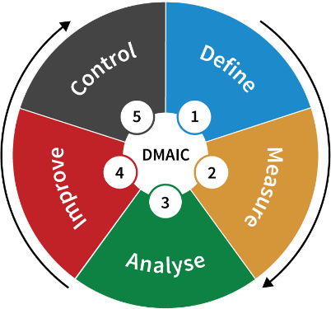
Six sigma is a set of techniques and tools for process improvement within an organisation. It was created back in 1986 by an American engineer while working for Motorola. Six sigma as a whole is a means of stabilising and optimising operations in the business in order to save money and improve their profit margin. However, this wont just better the profit margin of the business, as some businesses look to stabilise the business in order to improve business operation e.g. process of production. Six sigma is also a key way of solving business problems within an organisation through the performance enhancing methods that the business can adopt. For example, using the DMAIC method in order to solve business problems so operations can flow more freely and easily, this is due to a business being able to take a step-by-step process of solving a problem that may be complex and effects the business’ production or output. Six sigma also provides training for people who want to learn how to use the tools and techniques in order to try and better their organisation. There is also certification, these include green belts, those who are involved mainly in the implementation and are assisted by the a black belt. A black belt is responsible for the design and management of the improvement system. There are many tools and techniques that can be linked to the six sigma methodology, one example would be DMAIC which stands for: Define, measure, analyse, improve, control. DMAIC is used for improving, optimising and fixing business processes and designs. DMAIC is very important in the six sigma methodology, this is because a business can use it as a criteria in order to better their business, reduce waste and improve operation which is very important when helping a business grow. DMAIC is usually only used by a business when a problem is very complex and the risk is high as business decisions are usually made quickly and autocratically by senior members of staff. DMAIC is incredibly useful in many different types of business, it can be used my working environment at TATA steel as there are many day-to-day problems that come up in my area that need to be overcame as efficiently as possible in order to maintain a good rate of production within the plant.
O'Farrell, Renee. "Who Started Six Sigma?" Small Business - Chron.com, http://smallbusiness.chron.com/started-six-sigma-16865.html. Accessed 11 February 2020.
Hart, Robert. “When should DMAIC be your go-to problem-solving tool?” Continuous Improvement – Traccsolution.com https://traccsolution.com/blog/dmaic-problem-solving/. Accessed 12 February 2020.
Lean is a manufacturing methodology very similar to the six sigma methodology, it is completely focussed on the waste (Muda) reduction within the business. This allows the organisation to save on resources due to the reduction of waste, primarily leading to an increased profit and a more efficient operation of the production process. The lean approach is mainly based on the thorough evaluation of a business’ manufacturing process, this involves aspects like evaluation of production, delivery of goods, labour and factory layout. It is extremely important that when using this business improvement method doesn’t compromise the quality of the finished product. This is because even though the business would be saving money on reducing waste, they may lose customers due to a lack of quality in their product portfolio this is because when carrying out a lean change within the business, a business must make sure that they carry out the same job to make the same product just more efficiently, otherwise the business may just find a cheaper way of making a product that isn’t the same quality as the previous. The idea of lean derives from the “father” of lean manufacturing; Taiichi Ohno. He was the creator of the Toyota Production System which inspired the lean manufacturing concept in the automotive industry in the US. The term “lean” was coined by John Krafcik and later defined by James Womack in 1996 to the Five Key Principles of lean, these are:
- Identify value – The constant review of value of a product in the eyes of a customer, does the product work? What does the customer need?
- Map the value stream – How value flows through the business and where the value is added in the business.
- Create flow – A smooth production process with maximum amount of output. This ensures the most products are made the workforce and machinery that the business owns.
- Establish pull – when does the customer actually want the product? If this can be found, then stocks won’t be full when the customer is not demanding the product.
- Seek perfection – The complete elimination of waste in the workplace, making sure all activities create value for the customer through Kaizen (continuous improvement)
As previously mentioned, the key principle of lean is reduce waste in the business. The idea of the eight manufacturing wastes were developed by Taiichi Ohno. The eight wastes are as follows:
- Defects – Waste from failures in the manufacturing process that don’t meet customer specification.
- Overproduction – Waste from overproducing more products than customers demand.
- Waiting – Waste from time spent waiting for next step in the production process.
- Transportation – Waste from time, resources and cost when unnecessarily moving the product.
- Inventory – Wastes from products and goods that aren’t being processed.
- Unused talent – Waste from not using people talents to improve business operation.
- Motion – Waste from movements of employees that aren’t needed.
- Extra Processing – Wastes that are related to putting more work into a product or making it higher quality.
Shkmot, Nawras “The 8 Wastes of Lean” https://theleanway.net/The-8-Wastes-of-Lean. Accessed 12 February 2020.
“The 5 Principles of Lean” https://leankit.com/learn/lean/5-principles-of-lean/. Accessed 12 February 2020.
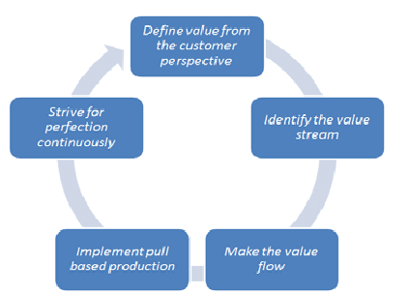

The principle of lean can be seen all over site in TATA. This is because following the lean principles will lead to an organisation with a better production flow and more cash to invest elsewhere in the business e.g. renewal of assets. One example where I have seen the use of lean principles in the workplace is in the material stockyards and the sinter plant. This is because any spillage from the stockyards and the sinter plant is used to go back into the system. The biproducts from the production of steel are also recycled and turned into sinter for the furnaces so no material is wasted. Another good example of waste reduction is the biproduct of the making iron in the blast furnace, slag. This is recycled by being taken to Tarmac on-site and sold to them. This therefore reduces waste in the business, removes the need for a large stockyard to hold the slag and doesn’t lead to a stoppage in production due to build-up of slag.
Due to the many different techniques and tools within the six sigma and lean methodology, TATA has the opportunity to use them on a daily to improve business operation. Examples of these tools and techniques include; FMEA – Failure Mode Effective Analysis, QFD – Quality Function Deployment, Fishbone diagram (Ishikawa diagram), and Flowcharts.
FMEA – Failure Modes and Effects Analysis
A failure modes and effects analysis is the analysis of how a product could fail to meet the customer requirements. An FMEA usually takes place in the early stages of the products development. It is an in-depth look at the product and how it can be improved to become a higher quality. The effects is how these failures can lead to things like waste, defects or potentially harmful incidents for the customer. Failure Mode and Effects Analysis is designed to identify, prioritize and limit these failure modes. The FMEA also tells the business what the potential causes of the failure would be, an example of this would be excessive use. A business could also find out the severity of this outcome on the customer depending on how bad the failure is. An FMEA help an engineering business understand the controls that are needed to be taken in order to control the risk of the failure occurring. This could potentially lead to a change to the design of the product and help to stop that failure occurring when being used by a customer. The FMEA is also very useful as after the potential failure has been found in the product, a team can then give a member of the team responsibility to fix the problem with the product before it is given to the customer, the team can identify the date that the responsible person/persons must complete the task by. The responsible members that can feedback to the team and let them know what actions were taken in order to fix the problem before going to the customer.
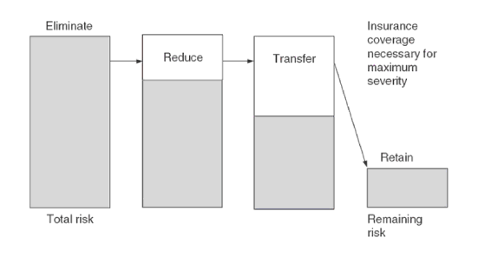
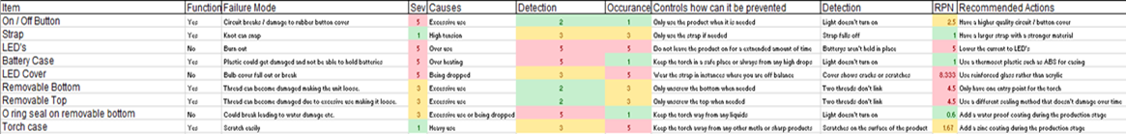
Usually, the sooner a failure in the product is identified, the less it will cost. This is because if the business has already produced an amount of products that had the potential to fail, they couldn’t sell it to the customer as if the outcome to the customer is potentially dangerous, then the business could face legal action. By finding the problem early on, the business has multiple choices on how they want to mitigate the risk of the product failing and it will obviously cost less.

“Failure Mode and Effects Analysis (FMEA)”, Quality-One International, https://quality-one.com/fmea/, accessed 12 February 2020.
Stamatis, D.H., 2003. Failure mode and effect analysis: FMEA from theory to execution. Quality Press.
QFD – Quality Function Deployment
A QFD is an improvement tool used in business to create a better quality product by comparing different aspects of the product and how they affect each other. An example of this would be how a demand quality is affected by a quality characteristic e.g. How does hardness and durability of the material affect the cost of the material for the business. QFD was first developed in Japan in the late 1960’s by Yoji Akao when working in Mitsubishi’s shipyard in the Japanese automobile industry. It has been used around the world in large businesses ever since. The main aim of the QFD is to efficiently define customer requirements for the product and gain a specification for a product which the customer would be happy with and be able to use. QFD is also used to change customer requirements into reachable design targets that could improve sales in the business and increase profit margin due to the higher quality product being sold. Meeting customer needs also shows the public that the business is listening to its target audience possibly leading to a better brand image and popularity. QFD also lowers the likelihood of late design changes which could possibly affect the product negatively. Product development is also a large part of the QFD as after completing one, a business can clearly understand what they need to do develop the product to make it higher quality. This is usually done through mass amounts of research and development which may include looking at products that are already on the market or existing customer specifications for a given product. Dr.Mizuno described QFD as a “step-by-step deployment of a job function or operation that embodies quality, into their details through systematization of targets and means.”
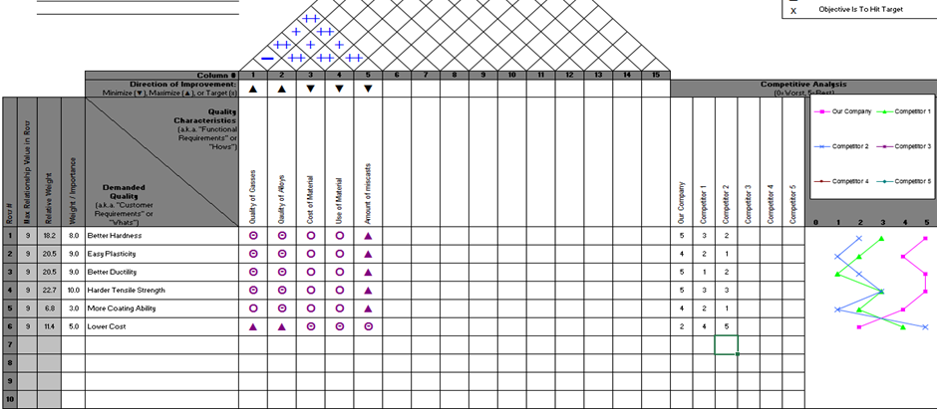
QFD may be used in my area but mostly in the work of the technical team. This is because raw material is mixed on a bed to make sinter, this make up of chemicals on the bed changes after every bed is reclaimed so it is important the technical team lays a bed with the correct chemistry to make good quality sinter that is then turned iron for the steelmaking process. Thus, a QFD could be used in order to meet the customers specification, as a member of the technical team could understand how the finished product (sinter or iron) is affected by the chemicals in the bed and understand what he customer requirements are for the next bed and what to put in it for the best possible product.
“Introduction to Quality Function Deployment” https://quality-one.com/qfd/. Accessed 13 February 2020.
Akao, Y., 1997, October. “QFD: Past, present, and future. In International symposium on QFD” (Vol. 97, No. 2, pp. 1-12).

Fishbone diagram (Ishikawa diagram)
A fishbone diagram is a graphical technique used to show the several causes of a specific event that has happened with the business. Called a fishbone diagram due to the shape, the Ishikawa diagram is a tool to help find the potential root causes of an event in the business, giving an organisation an idea of what next step to take to fix the problem and reduce the risk of it happening again. This diagram is extremely important when it comes to finding the root cause as the business can save money due to knowing exactly where the problem came from and mitigate it immediately. The business will also need to use a fishbone diagram if a product fails in the hands of a customer, this will lead to them finding why the product failed and whether it was down to the customer or manufacturer. This needs to be found immediately as if the manufacturer was the problem then they could face legal action and a tarnished brand image. A fishbone diagram could be used within my area of work due to the failure of parts in the manufacturing area. For example, if a conveyor snapped or ripped in the sinter plant there could be many reasons why it has broken e.g. Foreign bodies on the conveyor, material rubbing the belt or general wear from using the belt. So this tool would then help engineering and production teams understand why the incident occurred after observing the scene and how to mitigate the risk of it happening again.

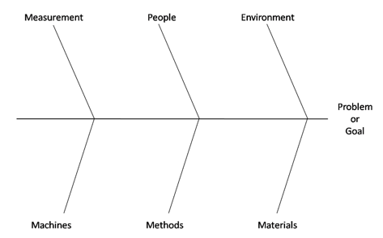
Coccia, M., 2018. The Fishbone diagram to identify, systematize and analyze the sources of general purpose Technologies. Journal of Social and Administrative Sciences, 4(4), pp.291-303.
“Fishbone Diagram” https://qilothian.scot.nhs.uk/pc-resource-fishbone-diagram Accessed 13 February 2020.

Flowcharts
Process flowcharts are usually used in process and chemical engineering are a way to understand the flow of manufacture within a business, this will give the business an idea on where it can improve in certain areas, therefore, becoming more efficient as a business and also a way to reduce waste within the organisation. This will help the business become more lean and operate to a higher quality. The main aim of the process flowchart is to find internal opportunities in order to better the manufacturing process and then take action on the process and change it. This could include the steps in the process, change of assets or possibly changing the business organisation. The use of process flowcharts will help to give the business a better brand image and a higher morale of workers, this could be linked to Herzberg’s two factor theory as employees may feel more satisfied in their jobs if the business is changing in order to become more efficient. Process flowcharts can be very useful within TATA steel. This is because we can check whether we are missing any opportunities within the manufacturing process for example, if we are utilising our assets to full capability or whether we are using one asset more than we should. This helps us understand how we can change the business in order to become more efficient and produce higher quality sinter on a daily basis.

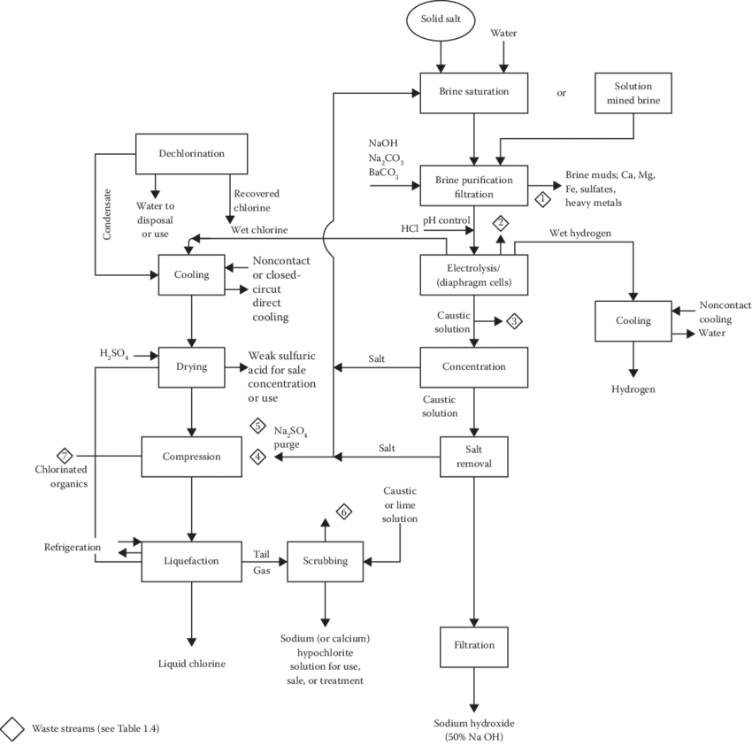

Yu, H., Al-Hussein, M. and Nasseri, R., 2007, December. Process flowcharting and simulation of house structure components production process. In 2007 Winter Simulation Conference (pp. 2066-2072). IEEE.
“Process flow diagram” https://www.researchgate.net/figure/Process-flow-diagram-for-diaphragm-cell-process-From-World-Bank-and-United-Nations_fig3_319466961. Accessed 13 February.
To conclude, lean and six sigma methodologies have changed the world of manufacturing, making the production process of every product a business produces a higher quality with less waste through the process. It has also changed my organisation, as I can understand lean and six sigma from first-hand experience due to the practices of TATA throughout the steelmaking process.

Reference no. | Use of reference | Reference type | Reference | Date of use
1 | Expand Knowledge | Website | O'Farrell, Renee. "Who Started Six Sigma?" Small Business - Chron.com, http://smallbusiness.chron.com/started-six-sigma-16865.html. Accessed 11 February 2020. | 12/02/2020
2 | Expand Knowledge | Website | Hart, Robert. “When should DMAIC be your go-to problem-solving tool?” Continuous Improvement – Traccsolution.com https://traccsolution.com/blog/dmaic-problem-solving/. | 12/02/2020
3 | Expand Knowledge | Website | Shkmot, Nawras “The 8 Wastes of Lean” https://theleanway.net/The-8-Wastes-of-Lean. | 12/02/2020
4 | Image | Website | “The 5 Principles of Lean” https://leankit.com/learn/lean/5-principles-of-lean/. | 12/02/2020
5 | Expand Knowledge | Website | “Failure Mode and Effects Analysis (FMEA)”, Quality-One International, https://quality-one.com/fmea/. | 12/02/2020
6 | Expand Knowledge | Website | Stamatis, D.H., 2003. Failure mode and effect analysis: FMEA from theory to execution. Quality Press. | 12/02/2020
7 | Expand Knowledge | Website | “Introduction to Quality Function Deployment” https://quality-one.com/qfd/. | 13/02/2020
8 | Expand Knowledge | Book | Akao, Y., 1997, October. “QFD: Past, present, and future. In International symposium on QFD” (Vol. 97, No. 2, pp. 1-12). | 13/02/2020
9 | Expand Knowledge | Book | Coccia, M., 2018. The Fishbone diagram to identify, systematize and analyze the sources of general purpose Technologies. Journal of Social and Administrative Sciences, 4(4), pp.291-303. | 13/02/2020
10 | Image | Website | “Fishbone Diagram” https://qilothian.scot.nhs.uk/pc-resource-fishbone-diagram Accessed 13 February 2020. | 13/02/2020
11 | Expand Knowledge | Book | Yu, H., Al-Hussein, M. and Nasseri, R., 2007, December. Process flowcharting and simulation of house structure components production process. In 2007 Winter Simulation Conference (pp. 2066-2072). IEEE. | 13/02/2020
12 | Image | Website | “Process flow diagram” https://www.researchgate.net/figure/Process-flow-diagram-for-diaphragm-cell-process-From-World-Bank-and-United-Nations_fig3_319466961. | 13/02/2020

