Business Plan for

Blazing BBQ Mobile

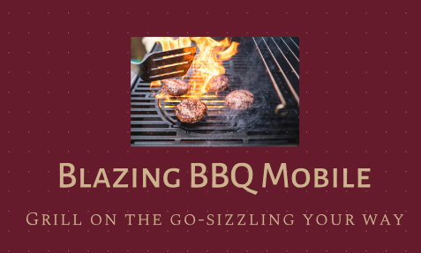

Produced By:

GROUP MEMBERS:
Student Name | Student No.
MIHAELA CARADAN | 2218469
GHEORGHE PLESCAN | 2234901
MARIA MIHAELA HIRS | 2226556
BASEM ISSAM ELHERSH | 22342445

Dated: _10/06/2024_____________

Module Name: Entrepreneurship
Module Code: BMIH5001
Lecturer Name: ____NEIL DYER_____________

CONTENTS

 |  |  |  | PAGE
1. | Executive Summary |  |  | ………2………….
2. | The Business Idea |  |  | ………3………….
3. | The Team |  |  | ………4………….
4. | Market Research |  |  | ………6………….
5. | Marketing Plan |  |  | ………9………….
6. | Key Resources |  |  | ………10………….
7. | Finances & Start-Up Support |  |  | ………12………….
APPENDICES:
Appendix A |  |  |  | SWOT Analysis
Appendix B |  |  |  | PEST Analysis
Appendix C |  |  |  | Copy of Pitch Supporting Material

1. EXECUTIVE SUMMARY
Blazing BBQ Mobile is a gourmet BBQ food truck that operates in Nottingham and Tamworth, UK. It has a broad menu that includes quality smoked meats, classic barbecue meals, and creative culinary alternatives such Cypriot cheese and Romanian sausages (mici). The market potential is enormous, with a focus on young professionals, families, and the Romanian population looking for high-quality, quick eating experiences. Our competitive edge stems from the mobility of our service, which enables us to serve to a wide range of events and venues, as well as an emphasis on health-conscious and experience eating. Financial predictions for the first year predict a total revenue of £285,800 against expenditures of £249,150, yielding a profit of £36,650. The funding comprises a £50,000 grant from the UK government's New Enterprise Allowance initiative. Short-term objectives include having a prominent presence at local events, growing our client base, and increasing brand awareness via smart marketing strategies.

2. THE BUSINESS IDEA

2.1 The Product/Service
Blazing BBQ Mobile is a gourmet BBQ food truck that serves a selection of premium smoked meats and classic barbecue recipes. The company caters to BBQ lovers and casual eaters looking for excellent, freshly cooked meals in a convenient, on-the-go setting. The core target market consists of families, young professionals, and Romanian communities who appreciate both flavour and convenience. The menu includes smoked meats including ribs, pulled pig, brisket, and chicken, as well as Cypriot cheese, Romanian sausages, Seafood, vegetarian alternatives, and typical side dishes like coleslaw, cornbread, and baked beans. Each dish is thoughtfully cooked with high-quality ingredients, resulting in genuine BBQ flavours that guests adore. Blazing BBQ Mobile's primary advantages are its portability, high quality, and numerous options (Timmons and Spinelli, 2008). Customers like the convenience of gourmet barbecue without the overhead and formality of a restaurant setting. The value proposition consists on offering delicious, freshly smoked BBQ meals that are readily accessible, moderately priced, and suitable for any casual outing or event from various parts of the world. Blazing BBQ Mobile distinguishes itself from typical BBQ restaurants and other mobile food vendors by offering quality, convenience, and innovative menu offerings.

2.2 SWOT Analysis Summary
Blazing BBQ Mobile will strategically place at high-traffic events and different locales to maximise exposure and consumer access using its customisable business strategy. This strategy maximises their mobility, a key service model component (Burns, 2022). The firm will also add innovative, health-conscious items to its menu to meet customer desire for better eating and broaden its appeal (Mintel, 2024). To increase brand recognition and income, Blazing BBQ Mobile will form strategic event catering partnerships for weddings and corporate events (Nelson, 2013). Blazing BBQ Mobile will use innovative logistics and supply chain management techniques to save expenses. The solutions will improve mobile operations efficiency and dependability. The firm will put up semi-permanent premises in covered venues to allow continuous operation regardless of weather and increase client seating and storage capacity. Blazing BBQ Mobile will teach all workers regularly to comply with food safety and health rules and maintain good food quality (Mobile Cuisine, 2023). Blazing BBQ Mobile will create a unique brand identity and customer loyalty programmes to stand out from competitors.

3. THE TEAM

3.1 Key Personnel

Name and Company Position: Gheorghe Plescan, Operation manager
Skills and Experience:
- Wide restaurant management experience
Role and Responsibilities:
- Manages static and mobile units
- Manages logistics and service quality
- Improves workplace via leadership and problem-solving

Name and Company Position: Mihaela Cardan, Quality Control Specialist and Sales
Skills and Experience:
- Product labelling and packaging expert
Role and Responsibilities:
- Enforces strict quality and safety requirements
- Manages culinary preparation and packaging
- Ensures consumer pleasure via operations.
- Sales

Name and Company Position: Maria Mihaela Hirs, Head Chef and Sales
Skills and Experience:
- Chef and food prep expertise
- Strong sales and customer connection management abilities,
- Strong interpersonal and communication skills.
- Proven ability to manage culinary staff.

Role and Responsibilities:
- Manage food preparation and quality.
- Manage sales and customer contacts to ensure satisfaction.
- Maintain customer connections
- Manage culinary personnel and daily activities

Name and Company Position: Basem Issam Elshersh, Business Development Advisor
Skills and Experience:
- Experienced restaurant entrepreneur with market analysis and strategic business planning skills.
- Capable of assessing market trends and creating corporate strategy.
- Ability to negotiate and think creatively about company development
Role and Responsibilities:
- Use market analysis to find growth possibilities.
- Create and execute strategic business strategies
- Assess market trends and adjust corporate plans.

3.2 Skills Gaps & Key Partners

3.2.1 Additional Staff Requirements (Roles and Responsibilities):
- Assistant Chef Full time
- To assist the head chef in meal preparation and maintain quality, particularly during peak periods (Prospects, n.d.).
- The culinary crew is insufficient to manage big quantities. Assistant chefs help maintain meal quality and service speed.

3.2.2 Training and Development:
- Food Hygiene Training (Level 1, 2, and 3), provided by CPD Online College, (n.d.)
- Hazard Analysis and Critical Control Point (HACCP) Training provided by High Speed Training Limited, (n.d.).
- Allergen Awareness Training, provided by CPD Online College (n.d.).
- Fire Safety, provided by High Speed Training Limited, (n.d.).

    - Outsourced Support / Key Partners:

- R&M Wholesale Electrical and Maintenance Services
- Mobile kitchen equipment is maintained and repaired by R&M Wholesale to maximise efficiency and reduce downtime (R&M Electrical Group, n.d.).
- Equipment maintenance, emergency repairs, and component replacement.

4. MARKET RESEARCH

4.1 Market Information, Trends and External Factors
Blazing BBQ Mobile uses PEST analysis to manage risks and seize opportunities. Sustainable packaging helps the company comply with local food safety and environmental laws and build brand loyalty among eco-conscious customers (GOV UK, 2023). Blazing BBQ Mobile provides budget-conscious clients with affordable solutions to meet economic volatility in eating out consumption (ONS, 2022). The post-pandemic economic rebound offers hospitality growth potential (Ramuni, 2021). The firm offers healthy grilled fish and vegetables to the expanding health-conscious generation (Mintel, 2024). It also meets the growing desire for experiential food by offering unique eating experiences (The Grocer, 2024). Technically, digital procurement systems improve client convenience and operational efficiency. Energy-efficient appliances meet environmental objectives and save operating costs, while advanced cooking and food preservation technology maintain high-quality offers (The Grocer, 2023). Blazing BBQ Mobile promotes itself for mobile catering market development and competitive advantage by carefully addressing these aspects.

  - Customer Profiles

- Middle-aged individuals who take pleasure in hosting gatherings at their residence.
- Elicits convivial dining experiences that are both convenient and distinctive (The Grocer, 2024).
- Attractive feature of Blazing BBQ Mobile: premium, in-home service that is both convenient and expedient.
- A preference for home-hosted social events is highlighted in post-pandemic trends in domestic entertainment (Kramer, 2023).

- Young adults (16–34 years old) who prioritize nutritional value (Mintel, 2024).
- Prioritises ethical procurement of food and health benefits.
- Attractive features of Blazing BBQ Mobile include healthful grilled options and locally sourced, fresh ingredients (The Grocer, 2023).
- There is a growing emphasis among consumers, particularly among younger demographics, on health and diet quality (Mintel, 2024).

- Romanian communities (16-55 years old) who typically enjoy BBQ’s and utilize it for various celebrations.
- Taps into Romanian community's nostalgia and cultural preferences (Condrea, 2015).
- Offers authentic Romanian dishes like mici.
- Targets loyal, home-supporting customers.
- Engages with community through cultural events and festivals.

4.3 Competitor Profiles

Hickory's Smokehouse, In Nuthall, Nottingham
- Strengths: The restaurant serves authentic Southern barbecue in a family-friendly setting with sufficient parking and a large menu.
- Weaknesses: The permanent location may hinder clients who want fast or transportable solutions (Hickory's Smokehouse, 2024).
- Competitive Edge: Blazing BBQ Mobile's mobility lets them serve more consumers at events and venues, creating a dynamic dining experience.

Red Dog Saloon, City centre of Nottingham
- Strengths: Prime location, meat-heavy American BBQ for barbecue fans.
- Weaknesses: Meat prominence may turn off health-conscious customers (Red Dog Saloon, 2024).
- Competitive Edge: Blazing BBQ Mobile offers healthy options like grilled fish and fresh sides to accommodate more diets.
Reds True BBQ, Victoria Street, Nottingham
- Strengths: Popular for its broad American BBQ cuisine, lively environment, and convenient location.
- Weaknesses: Like Red Dog Saloon, hefty barbecue may turn off health-conscious customers (Reds True Barbecue, n.d.).
- Competitive Edge: Blazing BBQ Mobile's flexibility and range of event venues and healthier menu alternatives give an competitive advantage.

5. MARKETING PLAN

5.1 Price
Blazing BBQ Mobile will use premium pricing to represent its excellent quality and stay competitive (Rae, 2008). A £12 BBQ brisket sandwich and £10 vegetarian grilled veggie wrap are examples. Local rivals like Hickory's Smokehouse and Red Dog Saloon charge similar costs, but with mobility and distinct foreign menu options. Blazing BBQ Mobile hopes these rates will attract quality-conscious clients ready to spend more for freshly cooked, gourmet meals.

5.2 Product
Blazing BBQ Mobile's brand will be visually attractive and unified. The food truck will have bright flame-themed graphics to grab attention and indicate BBQ. Eco-friendly, recyclable containers will include the Blazing BBQ Mobile brand. Beautifully prepared dishes with fresh ingredients and brilliant colours will show the quality and attention put into them (Blackwell 2011). A consistent colour design, logo, and slogan "Grill on the Go - Sizzling Your Way" will be utilised across all marketing materials and social media channels to build brand recognition.

5.3 Placement
Blazing BBQ Mobile will strategically place its food truck at high-traffic events and locations to maximise publicity and customer access for offline sales. The company's mobility lets it serve clients in many locations and events (Burns, 2022). Blazing BBQ Mobile will also use its website to announce its locations and activities. This web presence will allow consumers to verify where the food truck is, improving accessibility and enticing customers who want freshly prepared, gourmet barbecue meals on the move.

5.4 Promotion
Blazing BBQ Mobile will use a complete promotional campaign to increase awareness and engagement. Digital channels, such as the company's website, will act as a centre for information about its products and locations. Active participation on social media channels such as Instagram and Facebook will include frequent updates on menu items, event schedules, and customer testimonials in order to increase community engagement and loyalty (Aaker and Moorman, 2023). Search Engine Optimisation (SEO) approaches will be used to guarantee that the website ranks high in search engine results, hence increasing exposure (Quesenberry, 2020). In terms of conventional advertising, Blazing BBQ Mobile will distribute eye-catching fliers at local events and high-traffic places to attract attention and tell prospective clients about its services. Television commercials on local networks will increase its reach by showing mouthwatering imagery of its premium smoked meats and BBQ products. Furthermore, newspaper advertising will reach a larger audience, particularly those who may be less engaged online (Kotabe and Helsen, 2022). The firm will also promote feedback and loyalty by providing incentives for customer evaluations and developing a loyalty programme that rewards repeat customers with discounts or special deals.

6. KEY RESOURCES

6.1 Premises
Blazing BBQ Mobile needs a new food truck to run smoothly and fulfil client demand. A new food truck in the UK normally costs between £95,000 (Ebay, n.d.). This pricing includes basic kitchen equipment such grills, fryers, freezers, and safety features for food preparation and serving . Furthermore, truck customisation choices, such as customised graphics and layout changes, might affect the final pricing. Ensuring that the vehicle is equipped with modern technology and conforms with health and safety laws is critical for smooth operations and customer satisfaction (Square, 2024). Investing in a new food truck provides dependability and current amenities, which are critical for starting a successful mobile food company.

6.2 Equipment
Blazing BBQ Mobile need a new food truck complete with grills, fryers, and refrigeration units. Additional things required include a professional oven (£1,500 to £5,000) for flexible cooking, a ventilation system (£2,000 to £5,000) to assure air quality and safety, and a POS system (£500) for quick transaction processing. Potential vendors include Prois, which offer full commercial kitchen solutions at low prices while maintaining high operating standards and food safety (Prois, 2024).

  - Key Suppliers

UK supplier Valahia
- Valahia UK sells fresh and smoked Romanian meats, excellent for genuine Romanian recipes like mici (Valahia, n.d.).
- Regular delivery of high-quality Romanian beef.
- Prices vary by product and amount.
- Vegetable supplier
- Romanian Beverages

Supplier: MKG Foods
- MKG Foods' wide assortment of fresh veggie ensures quality and freshness for our side dishes and vegetarian alternatives (MKG Foods, n.d.).
- Fresh veggies like coleslaw and other important sides are supplied.
- Bulk-order pricing: Competitive.
- Beverages
Supplier: LWCDrinks
- LWC Drinks, the UK's biggest independent drinks distributor, sells wines, beers, spirits, and soft drinks that match our meals (LWC Drinks, n.d.).
- Service Provided: Variety of drinks to satisfy customers.
- Prices vary by beverage and order amount.
Supplier: Maxy Cash & Carry
- Maxy Cash & Carry, a UK-based distributor of Romanian culinary goods, offers a broad range of products that taste like Romania (Maxywholesale, n.d.)
- Romanian meats like mici and other culinary needs are supplied.
- Products and order size determine cost.

7. FINANCES AND START-UP SUPPORT

EXPENDITURE | Year 1  £
Company Registration | 12
Van purchasing | 95,000
Staff Wages | 18,000
Travel/Accomodation | 10,000
Telephone (mobile) | 650
Broadband | 600
Utilities | 6,500
Marketing and materials | 18,000
Insurance | 3,500
Capital Expenditure/Equipment | 30,000
Training & Development | 3,000
Accounting/Legal | 1,400
Outside Services | 2,000
Stock/Materials Purchases | 50,000
Bank Charges | 500
Office Consumables | 0
Loans Repayments | 10,000
Total Expenditure | £ 249,150
INCOME | Year 1  £
Sales A | 115,200
Sales B | 150,000
Sales C | 20,800
Capital Introduced | 0
Funding | 50,000
Loans/Borrowing | 50,000
Total Income | £ 285,800

YEAR ONE PROFIT/LOSS | £
Total Income | 249,850
Total Expenditure | 285,800
Profit/Loss | £36,650

7.1 Financial Summary
Blazing BBQ Mobile's financials reflect market research and the company plan's strategic aims. Due to the requirement for high-quality, dependable mobile culinary facilities, the first investment comprises £95,000 for vans and £30,000 for capital equipment. The anticipated staff salary is £18,000, considering competitive remuneration to attract competent workers. Marketing expenses of £18,000 assure strong brand awareness promotions. Income estimates are Sales A, B, and C. Based on local demand and pricing tactics, Sales A (£115,200) targets seafood and vegetarian alternatives, Sales B (£150,000) meat, and Sales C (£20,800) drinks. The UK government's New Enterprise Allowance plan provides a £50,000 subsidy for company start-ups (GOV.UK, 2024).

APPENDICES

Appendix A – SWOT Analysis

Strengths | Weaknesses
- Blazing BBQ Mobile implements a distinctive business model by offering a mobile catering services which offers customers with the added benefits of adaptability and convenience, which may appeal to a diverse clientele (Burns, 2022).  - In contrast to conventional barbecue rivals, the incorporation of grilled seafood and fresh, nutritious sides accommodates the expanding demographic of health-conscious consumers (Mintel, 2024).  - Blazing BBQ Mobile has the potential to appeal to individuals in search of novel dining experiences and those who are inclined towards global barbecue flavours (The Grocer, 2024). | - Managing logistics for a mobile unit may be difficult, possibly resulting in higher operating expenses and the requirement for tight coordination. This involves managing parking laws and maintaining consistent supply chain operations (Rushton, Croucher and Baker, 2014)  - Mobile food trucks are heavily reliant on weather conditions. Inclement weather, such as severe rain or extreme cold, has the potential to drastically affect client turnout and income.  - Operating a food truck in a small location restricts the range of menu items that may be made and served, which may not appeal to all customers. Furthermore, storage space for supplies and equipment is restricted.  - Complying with health and safety requirements may be difficult and expensive. Mobile food trucks must follow strict hygiene standards and get the relevant permissions, which may be time-consuming and costly.
Opportunities | Threats
- The market for mobile dining is experiencing substantial development due to the rising demand for food trucks and mobile catering services (The Grocer, 2023).  - The increasing emphasis that consumers place on health and wellness presents prospects for restaurants to broaden their selection of nutritious menu items and appeal to a more extensive clientele (Mintel, 2024).  - Event catering is a strategic approach that can augment brand visibility and generate additional revenue streams for various types of occasions, including weddings and corporate functions (Nelson, 2013). | - Revenue may be adversely affected by economic downturns, which can lead to a reduction in consumer expenditure on dining out (ONS, 2022).  - Adherence to regional food safety and environmental policies can pose significant difficulties, potentially necessitating ongoing investments and revisions (Blackwell, 2011).  - Hickory’s Smokehouse and Red Dog Saloon are well-established businesses that possess devoted clientele and robust brand recognition, which pose significant obstacles to market entry (Hickory’s Smokehouse, 2024; Red Dog Saloon, 2024).

Appendix B – PEST Analysis

Political Aspects:
- Local food safety and environmental regulations must be followed .
- Adherence to sustainability policies, such as the net-zero emissions target established by the United Kingdom for 2050 (GOV.UK, 2023).
- It is imperative to implement environmentally sustainable packaging and practices (GOV.UK, 2023).
Economic Aspects:
- Consumer expenditure on dining out is influenced by economic fluctuations (ONS, 2022).
- Mobile catering provides economical options for gatherings, which attracts consumers who are mindful of their budgets.
- The recovery of the economy following the pandemic offers prospects for expansion within the hospitality industry (Ramuni, 2021).
Social Aspects:
- Consumers are emphasising healthier eating practices as interest in health and wellness increases (Mintel, 2024).
- Providing health-conscious demographics with grilled options that are nutritious, such as seafood and vegetables, is beneficial (Mintel, 2024).
- The demand for experiential cuisine is increasing as individuals seek out novel and engaging culinary encounters (The Grocer, 2024).
Technological Aspects :
- Customer convenience and operational efficiency are both improved through the integration of digital procurement systems.
- Technological advances in cookery and food preservation enhance consistency and quality.
- Investing in energy-efficient appliances and innovative grilling equipment is consistent with both technological and environmental objectives (The Grocer, 2023).
Appendix C – Copy of Pitch Supporting Material

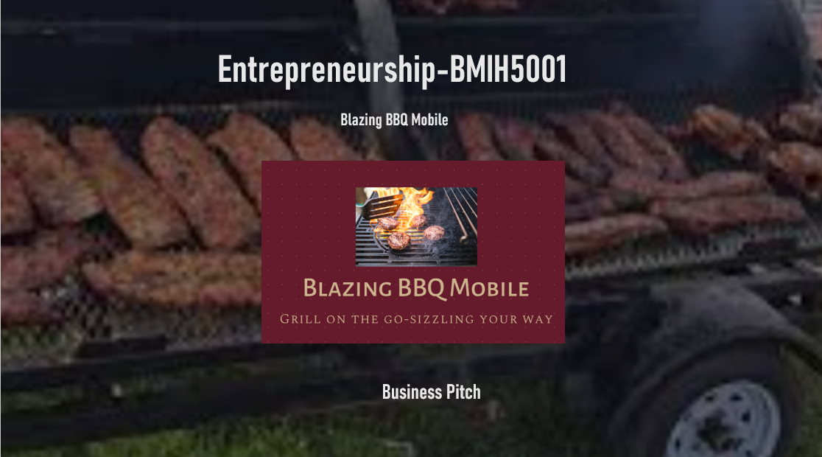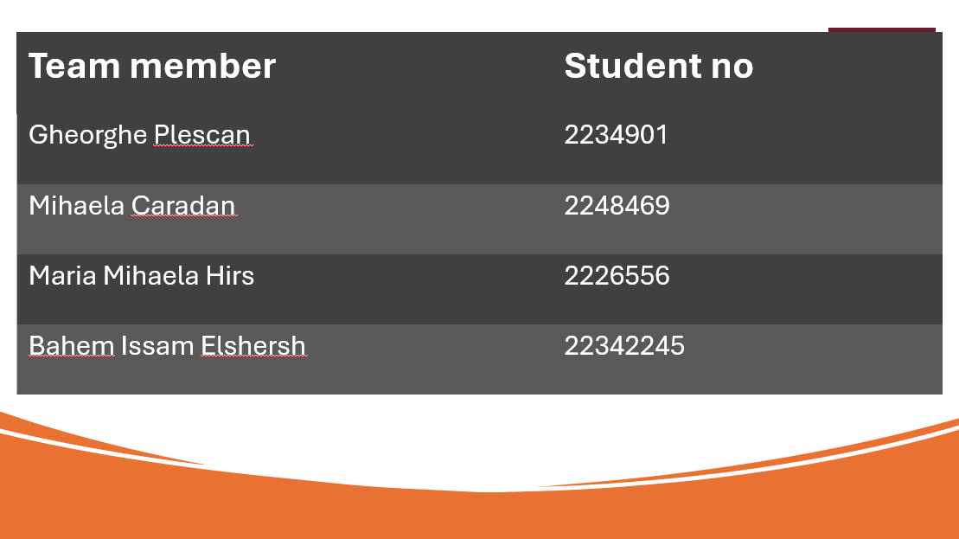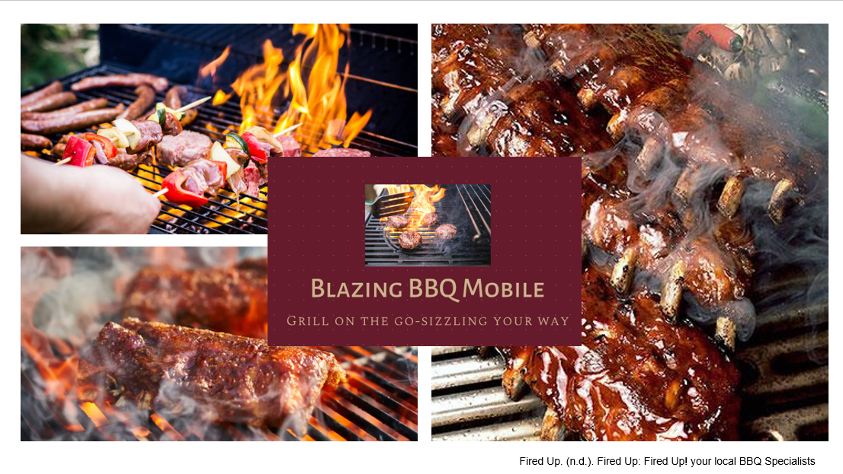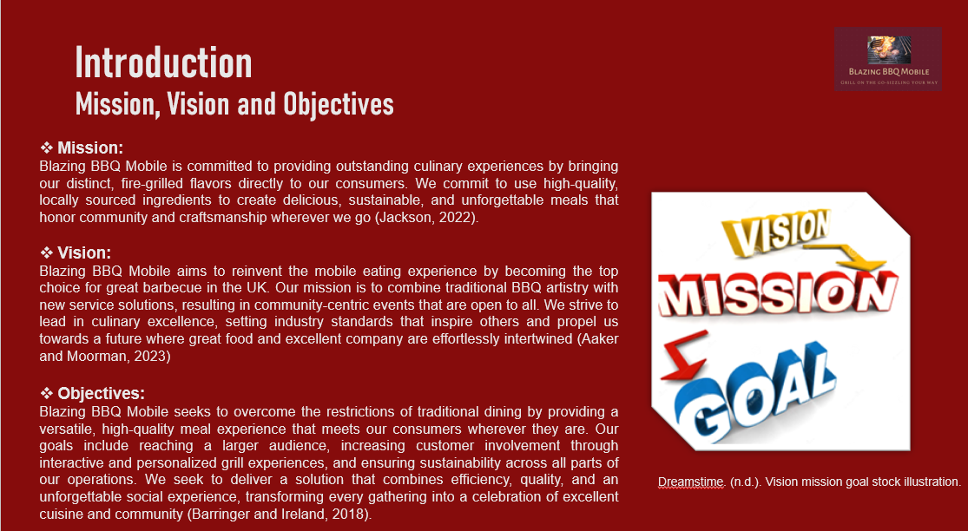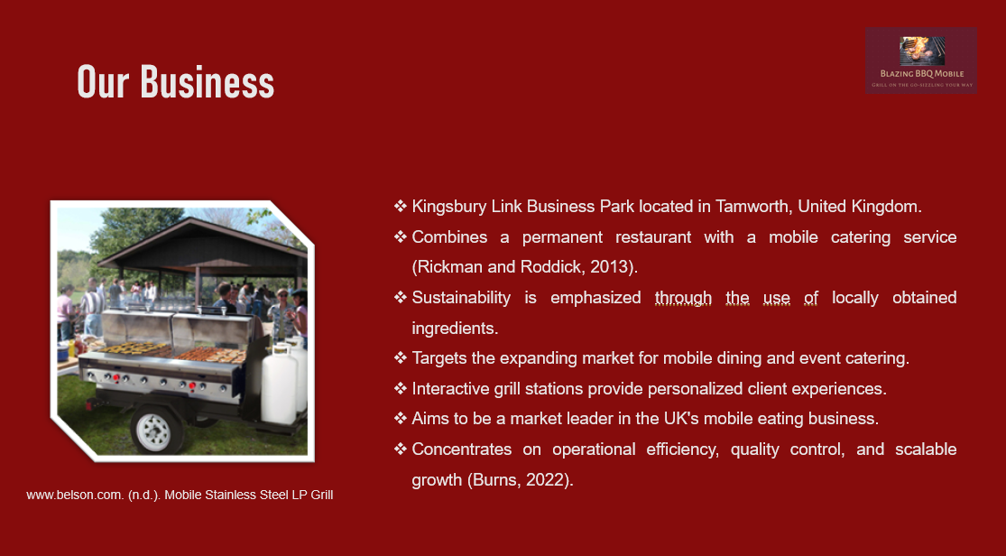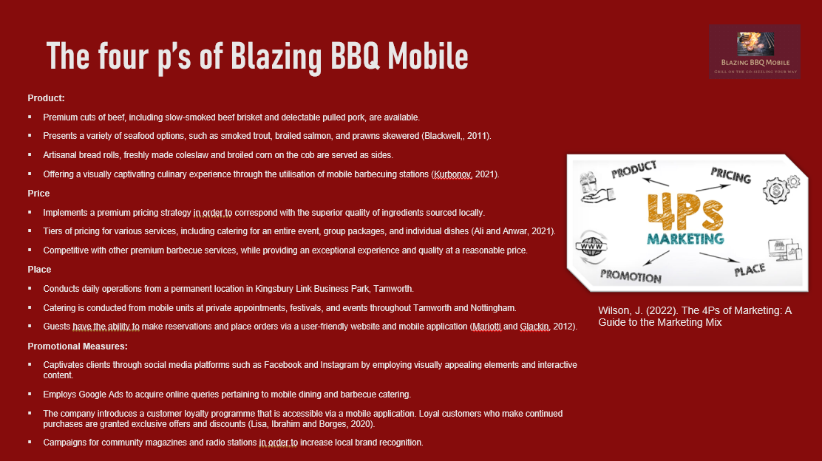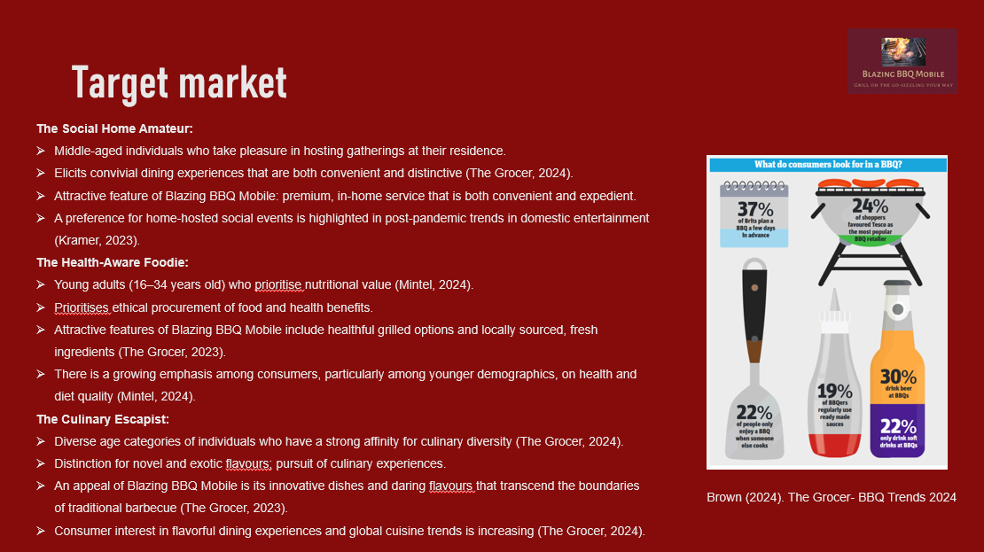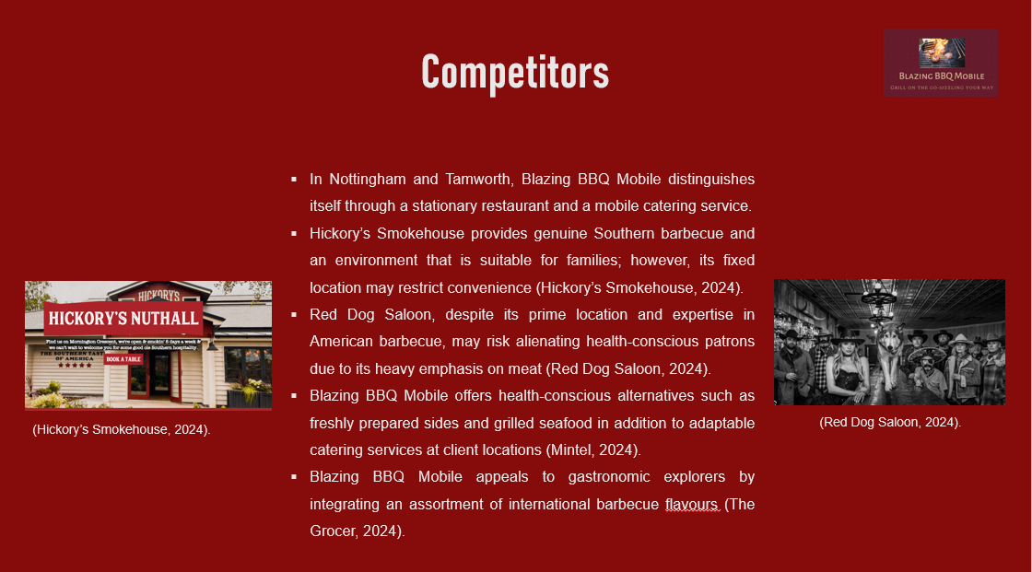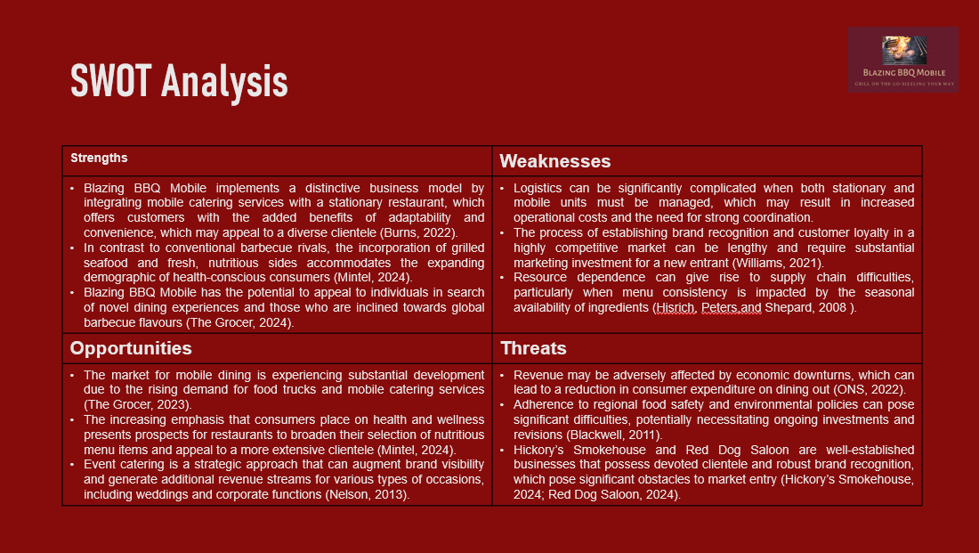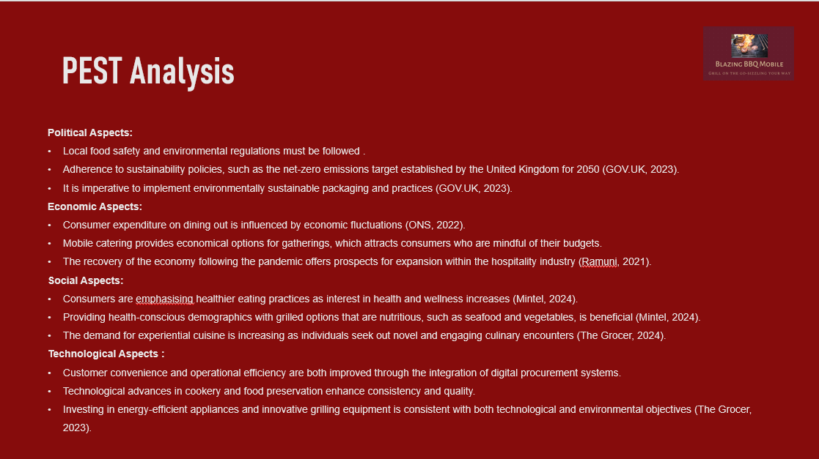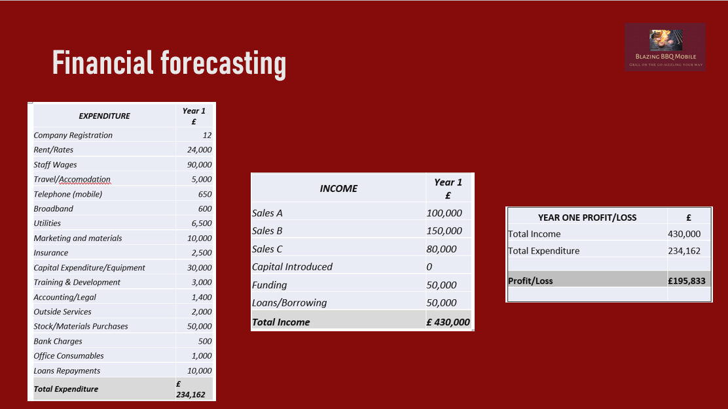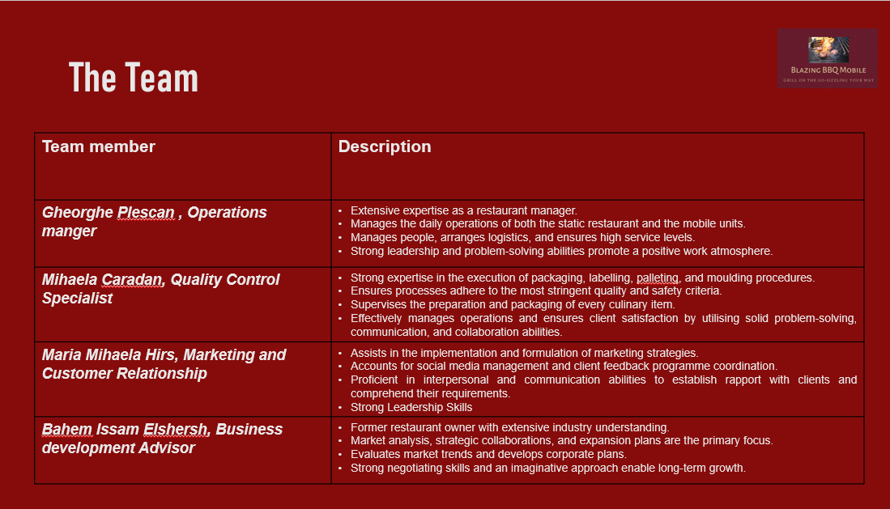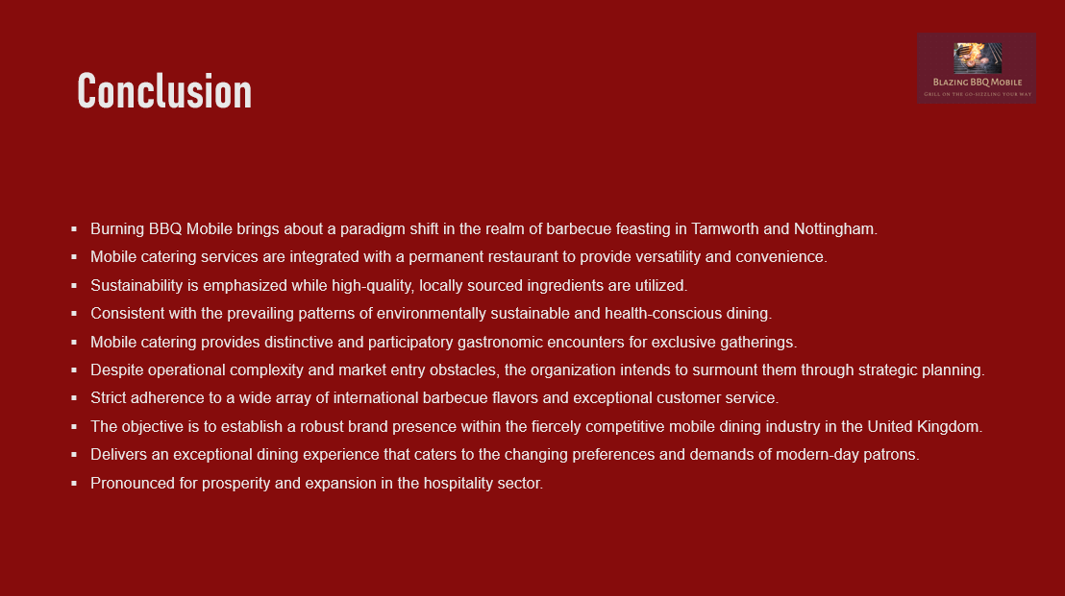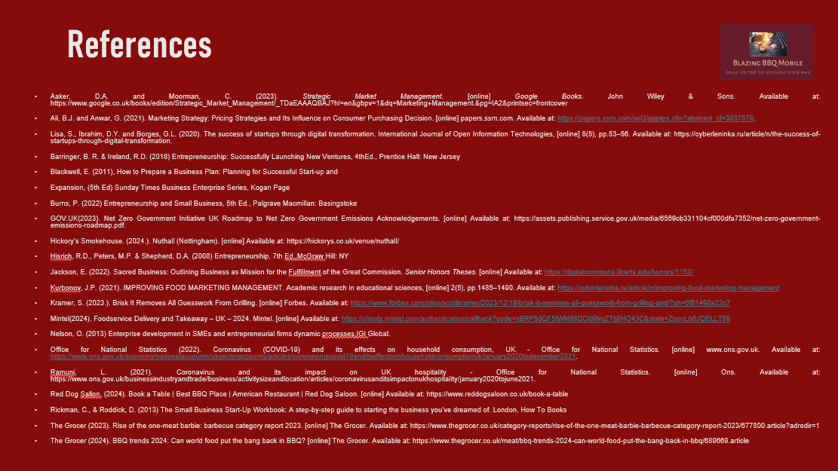

Prices:

BBQ Brisket Sandwich: £12
Pulled Pork Roll: £11
Grilled Vegetable Wrap: £10
Romanian Sausages (Mici) Plate: £13
Pork Steak Menu: £18
Grilled Halloumi Plate: £12
Grilled Seafood Plate: £15
Side of Coleslaw: £4
Soft Drinks: £3

REFERENCE LIST:

Aaker, D.A. and Moorman, C. (2023). Strategic Market Management. [online] Google Books. John Wiley & Sons. Available at: https://www.google.co.uk/books/edition/Strategic_Market_Management/_TDaEAAAQBAJ?hl=en&gbpv=1&dq=strategic+marketing%27&pg=IA2&printsec=frontcover
‌Blackwell, E. (2011), How to Prepare a Business Plan: Planning for Successful Start-up and Expansion, (5th Ed) Sunday Times Business Enterprise Series, Kogan Page

Burns, P. (2022) Entrepreneurship and Small Business, 5th Ed., Palgrave Macmillan: Basingstoke

Condrea, A.D. (2015). Romanian Food: A Mouth-Watering Journey Across Cultures. [online] Uncover Romania. Available at: https://www.uncover-romania.com/about-romania/gastronomy/culinary-experiences/romanian-food/.

CPD Online College. (n.d.). Food Safety for Catering Level 3. [online] Available at: https://cpdonline.co.uk/course/food-safety-for-catering-level-3/?gad_source=1&gclid=CjwKCAjwyJqzBhBaEiwAWDRJVKBivJi_O_KS12PKMrsS5kB5aPIMBEKSb173_NQwA7_0oqcyyf-71BoCd5kQAvD_BwE

eBay (n.d.). Catering trailer. Available at: https://www.ebay.co.uk/itm/204354956613?var=0&_trkparms=ispr%3D1&amdata=enc%3A1ZnACA2J3QfeEpn5kn1iSbg89&&mkcid=1&mkrid=710-53481-19255-0&siteid=3&campid=5339004016&customid=jkp_CjwKCAjwyJqzBhBaEiwAWDRJVDkQ9I2ovTVK0-Plor6gOIgiwEM3KTLBHXEbnf4Dyn8knSHIihPVgRoCwV8QAvD_BwE&toolid=10001&mkevt=1&gad_source=1&gclid=CjwKCAjwyJqzBhBaEiwAWDRJVDkQ9I2ovTVK0-Plor6gOIgiwEM3KTLBHXEbnf4Dyn8knSHIihPVgRoCwV8QAvD_BwE&gclsrc=aw.ds
GOV.UK(2023). Net Zero Government Initiative UK Roadmap to Net Zero Government Emissions Acknowledgements. [online] Available at: https://assets.publishing.service.gov.uk/media/6569cb331104cf000dfa7352/net-zero-government-emissions-roadmap.pdf.
GOV.UK (2024). Apply for a Start Up Loan for your business. [online] GOV.UK. Available at: https://www.gov.uk/apply-start-up-loan.

Hickory’s Smokehouse. (2024.). Nuthall (Nottingham). [online] Available at: https://hickorys.co.uk/venue/nuthall/
High Speed Training Limited. (n.d.). High Speed Training | Over 160 Online Training Courses. [online] Available at: https://www.highspeedtraining.co.uk/courses/haccp/?gad_source=1&gclid=CjwKCAjwyJqzBhBaEiwAWDRJVNw4DLSl4Zf3kUjXPG9I3ZWTnMvEDu9IbCR2zwngOZ6tSOob-vxNERoCZtAQAvD_BwE

High Speed Training Limited. (n.d.). High Speed Training | Over 160 Online Training Courses. [online] Available at: https://www.highspeedtraining.co.uk/ppc/fire-marshal?gad_source=1&gclid=CjwKCAjwyJqzBhBaEiwAWDRJVKN9-lgLygxYzz7ouXsREQGpcHrAwIc5IR2GJ0TNaMmA_tmNk1JyHBoCdYkQAvD_BwE
Kotabe, M. (Mike) and Helsen, K. (2022). Global Marketing Management. [online] Google Books. John Wiley & Sons. Available at: https://www.google.co.uk/books/edition/Global_Marketing_Management/doCFEAAAQBAJ?hl=en&gbpv=1&dq=marketing+management%27&pg=PA19&printsec=frontcover
‌Kramer, S. (2023.). Brisk It Removes All Guesswork From Grilling. [online] Forbes. Available at: https://www.forbes.com/sites/scottkramer/2023/12/19/brisk-it-removes-all-guesswork-from-grilling-and/?sh=6f81498a23c7
LWC drinks (n.d.). LWC Drinks Ltd | The UK’s Largest Independent Drinks Wholesaler. [online] Available at: https://www.lwc-drinks.co.uk/.

Maxywholesale (n.d.). Maxy Cash & Carry Ltd | Romanian Food Supplier. [online] Available at: https://maxywholesale.com/ [Accessed 10 Jun. 2024].

Mintel(2024). Foodservice Delivery and Takeaway – UK – 2024. Mintel. [online] Available at: https://clients.mintel.com/authentication/callback?code=xBRP5dQF5lWM88DO89Nq2Ttj8HO43C&state=ZtynrLh6JQELLT58

MKG Foods. (n.d.). Your Foodservice Partner. [online] Available at: https://www.mkgfoods.co.uk/ [Accessed 2 Jun. 2024].

Nelson, O. (2013) Enterprise development in SMEs and entrepreneurial firms dynamic processes.IGI Global.

Office for National Statistics (2022). Coronavirus (COVID-19) and its effects on household consumption, UK - Office for National Statistics. [online] www.ons.gov.uk. Available at: https://www.ons.gov.uk/economy/nationalaccounts/uksectoraccounts/articles/coronaviruscovid19anditseffectsonhouseholdconsumptionuk/january2020todecember2021.

Prois. (2024). Commercial Kitchen Equipment | Commercial Kitchen Installers | Prois. [online] Available at: https://www.prois-uk.com/ [Accessed 1 Jun. 2024].

Prospects (n.d.). Hospitality jobs | Prospects.ac.uk. [online] Available at: https://www.prospects.ac.uk/jobs-and-work-experience/job-sectors/hospitality-and-events-management/hospitality-jobs.

Quesenberry, K.A. (2020). Social Media Strategy: Marketing, Advertising, and Public Relations in the Consumer Revolution. [online] Google Books. Rowman & Littlefield. Available at: https://www.google.co.uk/books/edition/Social_Media_Strategy/QWTyDwAAQBAJ?hl=en&gbpv=1&dq=strategic+marketing%27&pg=PR3&printsec=frontcover

Rae, D. (2008) Entrepreneurship: from opportunity to action, 2nd Ed., Basingstoke: Palgrave Macmillan

Ramuni, L. (2021). Coronavirus and its impact on UK hospitality - Office for National Statistics. [online] Ons. Available at: https://www.ons.gov.uk/businessindustryandtrade/business/activitysizeandlocation/articles/coronavirusanditsimpactonukhospitality/january2020tojune2021

Red Dog Sallon. (2024). Book a Table | Best BBQ Place | American Restaurant | Red Dog Saloon. [online] Available at: https://www.reddogsaloon.co.uk/book-a-table

Red’s True Barbecue. (n.d.). BBQ Restaurant. [online] Available at: https://truebarbecue.com/ [Accessed 1 Jun. 2024].

Rushton, A., Croucher, P. and Baker, P. (2014). Logistics & Distribution ManageMent 5th EDItION Logistics Distribution MAnAgEMEnt THE HANDBOOK OF & i. [online] Available at: https://industri.fatek.unpatti.ac.id/wp-content/uploads/2019/03/149-The-Handbook-of-Logistics-and-Distribution-Management-Understanding-the-Supply-Chain-Alan-Rushton-Phil-Croucher-Peter-Baker-Edisi-1-2014.pdf.

R&M Electrical Group. (n.d.). Independent Electrical Distributors. [online] Available at: https://www.rm-electrical.com/.

Square. (2024). How to Start a Food Truck Business. [online] Available at: https://squareup.com/gb/en/townsquare/how-to-start-food-truck.
The Grocer (2023). Rise of the one-meat barbie: barbecue category report 2023. [online] The Grocer. Available at: https://www.thegrocer.co.uk/category-reports/rise-of-the-one-meat-barbie-barbecue-category-report-2023/677800.article?adredir=1
The Grocer (2024). BBQ trends 2024: Can world food put the bang back in BBQ? [online] The Grocer. Available at: https://www.thegrocer.co.uk/meat/bbq-trends-2024-can-world-food-put-the-bang-back-in-bbq/689669.article

Timmons, J. & Spinelli, S. (2008) New Venture Creation: Entrepreneurship for the 21st Century, McGraw Hill: Boston

Valahia. (n.d.). ValahiaUK - Traditional Romanian Meats. [online] Available at: https://valahiauk.com/en/ [Accessed 2 Jun. 2024].
‌

