
Skills for the Workplace
Module Assignment Submission
Student Name: | Ewa Kowalewska
Student Number: | 2017236
Module No: | BMSK4007
Module Title: | Digital Skills and Personal Branding

Statement of Confirmation of Authenticity
By the act of making this submission, the student declares that this is the work of the student named above. The work has not, in whole or in part, been knowingly presented elsewhere for assessment, or where assessment has been built on a previous assessment, this has been identified. Where materials have been used from other sources it has been properly acknowledged. If this statement is untrue, the student acknowledges that an assessment offence has been committed.
Attention is drawn to the plagiarism and unfair practice policies of both the University and of ILM.
Permission for ILM to use this script
ILM uses learners’ submissions – on an anonymous basis – for assessment standardisation. By submitting, both the centre and the learner agree that ILM may use this script on condition that identifying information is removed. However, if you are unwilling to allow ILM use this script, pleaseds\e refuse by ticking the box: □

Table of Contents
What has been the impact of 21st Century Technologies on the modern workplace? 3
Evaluate the appropriate use of modern technologies and social media in the workplace generally 3
Explore the use of modern technologies and social media in own workplace 3
How can Personal branding help YOU? 4
Your LinkedIn Profile to promote your Personal Brand 4
Evaluate the value of other social media platforms to enhance networking and career prospects 4
Examine the impact of Personal Branding on your own employability 4
Discuss personal and professional security and safety online. 4
References 6
Appendix 1 7
Appendix 2 8

Introduction
During this Assignment we research the use and impact of modern technology used in 21st century in workplace. We need to discuss the positive and negative impact of the technology and social media in the workplace to present our work more objective and truthful. We need to use sources that successfully pass C.R.A.A.P test (Currency, Relevance, Authority, Accuracy and Purpose).

What has been the impact of 21st Century Technologies on the modern workplace?

“The internet becoming a time square for global village of tomorrow” Bill Gate
In 21st century we have been using more and more of modern technology and it has become so significant when comparing the 20th century towards today we see people back then were using only pen and paper and been strict to the office building and hours of work, but today we use internet access, laptop, smartphones, tablets, wi-fi, software, iClouds which make our lives easier and we can work much more efficiently and quickly. Also store all important files on iCloud storage as well as using the software to perform specific tasks such as process control, word processing, graphic design, and project management. Through the use of an office suite Microsoft Office 365, businesses are able to benefit and enhance their productivity and IT control. In today’s era we can access the internet from anywhere around the world and connect to our workplace and explore different ways of communication and work from any location which increases our chances to find our dream jobs or continue with our existing employment. As many positive aspects that modern technology brings, there is another side to it where there are disadvantages such as replacing physical work with automated machinery which result in job losses. Although automation has it disadvantages i.e. job losses it also has it advantages as it creates new employment in the technology sphere.
As the research shows modern technology could put 30% of jobs at risk in Britain due to the “automation as well as further globalisation” (Ben Chapman 2018)

The research done back in 2018 by Ben Chapman (article by Independent magazine by Ben Chapman) might be not up to date with what happened during the pandemic as it continues in 2020. The report writer strongly believes the world during the pandemic showed the different side to the picture, and instead of putting the jobs at risk by technology we have been able to carry on with them by simply working from home through modern technologies like computers, internet access, wireless communication and Wi-fi platform that connect us with other employers which eventually caused prevention of job losses.

Evaluate the appropriate use of modern technologies and social media in the workplace generally

General overview of the workplace in the 21st century.
There are legal considerations which are required when using social media in the workplace, some of the UK laws are:
The Data Protection Act of 1988, which covers how the information about the job applicants as well as the employees can be collected, handled as well as how its used.
The Human Rights Act of 1998, which sets out the fundamental rights as well as freedoms that everyone within the UK is entitled towards. It incorporates the different rights set out within the European Convention on Human Rights (ECHR) into the domestic British law.
The Regulation of Investigatory Powers Act of 2000, which regulates the powers of the public bodies to carry out surveillance as well as investigations that cover the interception of communications

The expansion of modern technology had a massive impact of the workplaces and the way we work. The technologies in the 21st century become an important part of businesses. Having access to the internet and smartphones, tablets and social media platform like Facebook, Instagram, Twitter or LinkedIn etc. help us to work more effectively and can drive the business to success and better incomes. When the report writer was writing the assignment, the whole world was suffering with a global pandemic which is still having a negative impact on all aspect of our lives and all business as well. On the other hand the world pandemic shows us that we are capable to communicate in many ways through technology and that can be used more efficiently and allows us to work from home or from anywhere.
In today’s world we cannot imagine living without mobile devices or internet access. Wi-Fi is accessible in most places and even free of charges so we can stay connected. A mobile device is simple small handheld computer. The are other electronic devices that have been designed with portability as a priority. The most common daily used devices are:
- Smartphone in variety of sizes and design.
- Tablets.
- Smart Watches.
- Laptops.
- Internet Access.

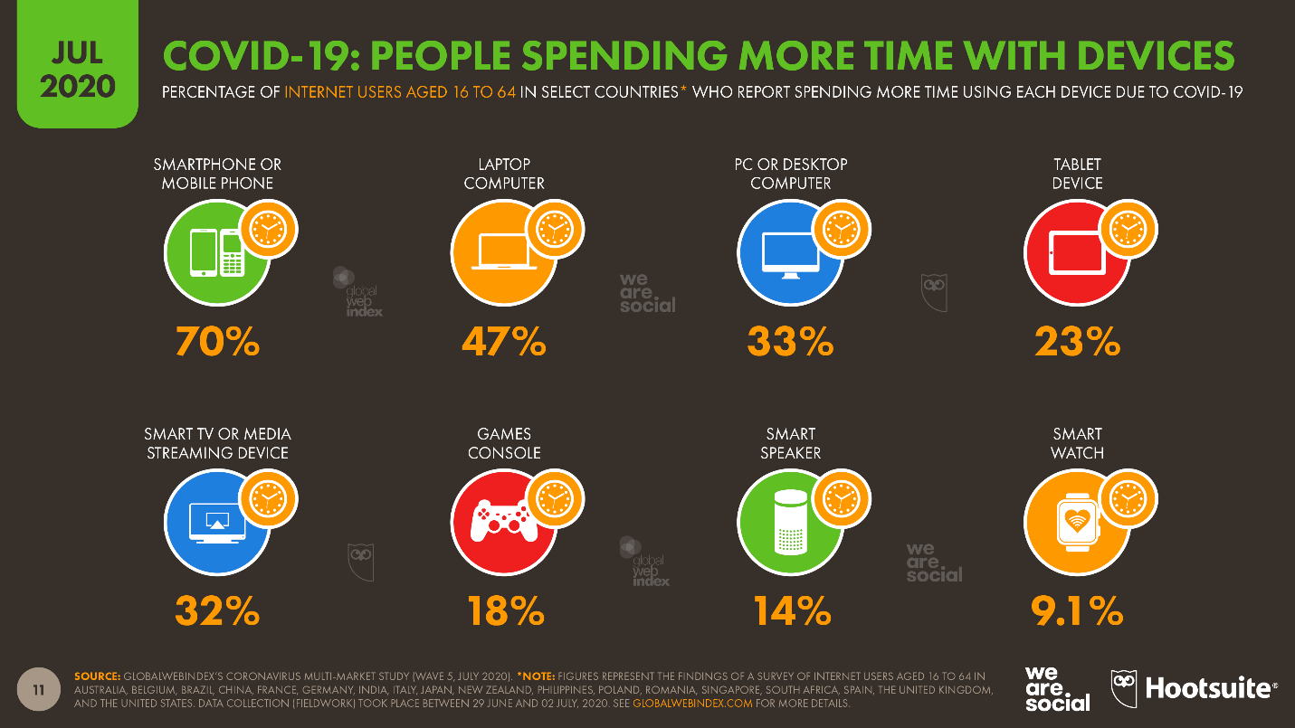

Using the chart from the Digital Around the World 2020. We can see that people during the pandemic use the modern technologies more. Over 70% spend more time on they smartphone or mobile phones and 33% of people spend more time on they computers.

The are many varieties of technology. There are programs to help organise work for others and keep track of records needed and use for storage of the important information as well as time management. By using the modern technology, we become more creative.
As example of these modern devices, we can receive information like invoices, manager assets and record digital signatures which are very safe to do so as they are created in safe programs. We are also able to create online meetings.
On over all we been able to use the modern technology in training new staff or upgrade existing employers’ skills. Being able to communicate faster and easier through emails. Modern technology is also very advantages when it comes to deal with money e.g., salary pays or any invoice payments by secure programs like PayPal, Kani and Bacs. The employer can transfer money safely and quickly even if they are in a different currency and even if there are in a different countries.

Additionally, technology within the workplace has also its disadvantages such as the loss of direct communication skills. With other technology such as phones, emails and social media replacing all types of face to face communication. The author believes that direct person to person communication is vital for productivity.
With technology constantly being updated, regular upgrades can be quite daunting for some people and that might require training to be provided by the employers to keep employees up to date with the constant changes.
There also exists a possibility of security risk from things such as hacking and internal threats of information theft for the business, employees or even a client. The impact of modern technology can change the way the business is conducted and is constantly reshaping the business and the workplace.
The author is currently not working, but in previous employment modern technology was highly relied on.
“Social media has been able to spread across many aspects of organising and has been able to generate many new ways of connecting with the customers, collaborating as well as innovating.” (Cisco, 2010; Dunn, 2010; Wilson, Guinan, Parise, & Weinberg, 2011).

Explore the use of modern technologies and social media in own workplace

The report writer has variety of manufacturing experience. Currently is unemployed but by previous employment can use the experience learned in the exploration in the use of modern technology in workplace. Using the last employer, the report writer can identify use of technology at first hand. The fist advantage that was very visible is advanced internal and external communication technology and customer service which was able to problem solve at any point of the production process, selling process and customer service enquires. Technology they used to communicate were emails, mobile phone also landline and social media communicators like What’s App and Viber. By using those modern technology, the company was able to produce fantastic outcomes in branding on social media platforms. The platforms they used are Facebook, Twitter, Instagram, Snapchat, YouTube, and LinkedIn. The primary social media used within the workplace was Facebook which was used to build the image of the company, receiving engagement from the client as well as receiving information in form of feedback. The secondary social media platform the workplace used was LinkedIn which was used for the purpose of public relations and analysing the growth of the company locally and worldwide as well as new opportunities for business partners. They were also able to find possible employees through those platforms quicker and with the specific qualification requirements. The most benefit the company gained from social median platforms was free access so they could improve all those aspect stated above free of charge. The other side of social media is a fast reaction toward sharing information and the outcome could be positive or negative which the company had no impact on. “Social media is the ultimate equaliser. It gives a voice and a platform to anyone willing to engage.” (Amy Jo Martin, Founder and CEO of Digital Royalty).

By using the research from MarketingChart.com the report writer presents a chart of How Often Costumers Read Local Businesses Feedback. That was published in January 2021. The charts shown that over 33% of costumers read the feedback regularly and only 23% read them occasionally.

How can Personal branding help YOU?

“Think about what people are doing on Facebook today. They’re keeping up with their friends and family, but they’re also building an image and identity for themselves, which in a sense is their brand. They’re connecting with the audience that they want to connect to. It’s almost a disadvantage if you’re not on it now.” (Mark Zuckerberg, Co-founder and CEO of Facebook).

Personal branding is especially important in today’s world because most people use online platforms like Facebook, Twitter, Instagram, Snapchat to get to know us personally. In our days we are mostly judged by our virtual profiles. Personal branding can help us by being more in control of what we showing to other users or potential employers. As in a modern world most people are online, and they believe everything they see on it, so we need to be incredibly careful what we put on to social media ‘‘Remember that the Internet is not anonymous, not does it forget’’ (Baker Daniels). Personal branding can help us in many ways the most common way will be finding a dreamed job by “selling” ourselves in a correct way but also finding new connections and promote ourselves in a professional way. By using people who are expert in self selling techniques and personal branding, we able to present ourselves in a positive manner and create an honest first impression. The most common techniques that have been promoted are as follows:
- ‘‘Do not post material that is harassing, obscene, defamatory, libellous, threatening, hateful, or embarrassing to any person or entity. Do not post words, jokes, or comments based on an individual’s gender, sexual orientation, race, ethnicity, age, or religion.’’ (Razorfish)
- Use professional photography
- The professional profile should also include the ability and skills as well as reflection of the person personality.
- Previous job position with employer history.

Your LinkedIn Profile to promote your Personal Brand

Personal profile on LinkedIn was created to gain professional connections and promote an individual and personal brand. It is very important to keep your platform profile very professional and consistent. This is an actual professional LinkedIn profile of the report writer screen-print.

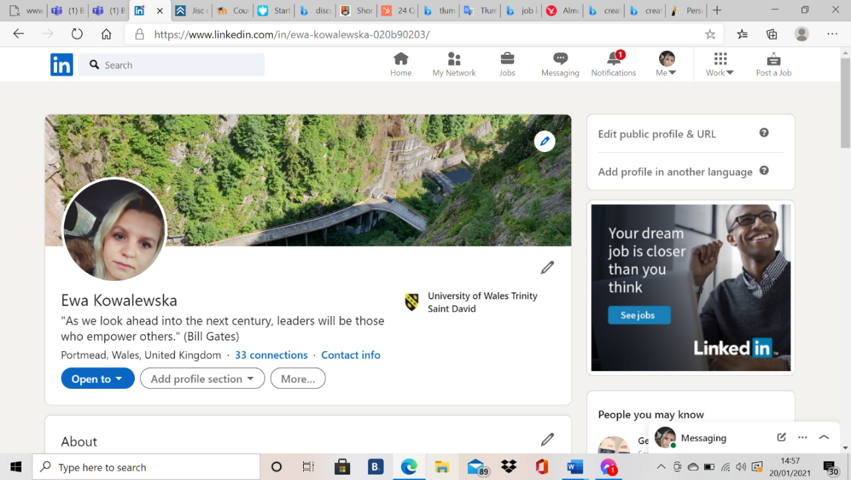

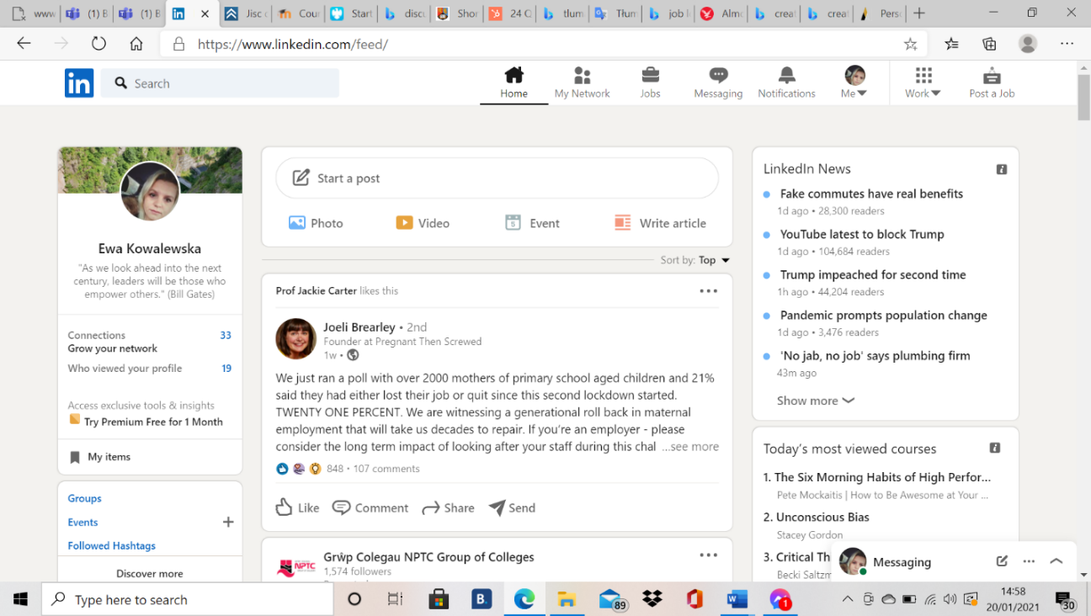

Evaluate the value of other social media platforms to enhance networking and career prospects

The proper use of social media can enhance and develop our careers in a positive way. As a professional, the use of social media is crucial. An active online presence is a great way to gain and retain existing customers. Using social media platforms can provide many opportunities for self-advertising as well as promotion as an employee. Taking advantage of this can be used when applying for a new job that provides potential employers with the necessary information, such as the skills and skills they need. Moreover, it leads to a much higher recruiting shift than people who may not have a social media profile. The social media that can enhance our networking and career perspective are Facebook, Snapchat, Instagram, Twitter, LinkedIn, What’s App, etc.

The author used MarketingCharts.com, 2020 to create its own chart. The charts shows that over 89% of people using Facebook as a social media platform and only 21% use Snapchat as a social media enhancing platform.

Examine the impact of Personal Branding on your own employability

The impact of personal branding on the report writer’s employability gives them the opportunity to promote themselves whilst trying to attract attention from potential employers. Personal branding on social media platforms, including LinkedIn profile, gives opportunities to show professional skills to a wider audience. It allows the chance to connect with people with similar professions, knowledge and to share experience. Additionally, it gives the opportunity to identify capabilities and to make self-improvements in the future or gain other experiences that could be beneficial towards a new career. It also gives a chance to connect with certain groups and be part of virtual conferences and training which supports employability.
Unfortunately, being exposed on social media can create a possible threat. As we open our personal lives in the public domain, public opinion can have a negative impact on our private and family lives. This can lead to discrimination in employability processes. Users of social media platforms might disagree with our opinions.
Overall, the author believes spending time and branding ourselves online can have negative impact on our lives. Being on social media deprives us from our private lives and we spend more time virtually and we do not spend enough time in real situations with our friends and family. The boundaries between work and homelife are becoming more and more blurred.
To be active on social media and being able to “sell” ourselves we need to be positive, open minded and have a strong self belief. We are aware that social media can be unfavourable toward us and can cause depression, self-harming and discrimination that could accrue from our ethnic background, age, religion, or sexual orientation.

Discuss personal and professional security and safety online.

Technology has been extremely beneficial in today’s world but there are important aspects that we need to bear in mind and be extremely careful about what are the personal and professional securities online. Our safety is important when sharing on social media and other used platforms. We should choose wisely who has access to our profiles online and what those profiles contain. The professional profiles should not share our personal information as it is possible to become targets for dangerous situations and discrimination in the workplace due to ethnic background, language, religion or politic points of view.
GDPR stands for General Data Protection Regulations which is a European Union law that protects our personal and private information. We should only use safe sites to transfer money to any individual and be very careful who and how we send money to prevent online fraud. When using the social media platforms, we should not connect our personal and professional profiles together to prevent sharing information of our personal life that could make us vulnerable to exploitation e.g. our children’s images should be kept safe from public view.
Importantly, always make sure when setting up private settings on social media platforms to control who can view your published data.
“The internet is a wonderful tool, but technology increase faster than the safety massage is”
(Pam Waver).
“Don’t say any thing online that you wouldn’t want to be plastered on a billboard with your face on it” (Erin Bury blogspot.com 2012).

Conclusion

Overall, technology has been extremely beneficial both in the workplace and business management world, and it will continue to change the way we work. Social media platforms have been able to help users to improve career prospects. When used properly and in a safe way it will be able to make tremendous advances in our lives. The COVID-19 pandemic shows us how important technology is to carry on with our work and communication. It has hi-lighted how much we depend on it in our day to day life, and in the new normality which is world of pandemic. Technology has had more of a positive than negative impact.

References

Almost 30% of jobs in towns including Sunderland and Wakefield at risk by 2030 due to automation and globalisation | The Independent | The Independent (Accessed 20.12.2020).
Business Feedback. MarketingChart.com (Accessed 24.01.2021).
Bury E., blogspot.com (Accessed 29.01.2021).

Conley, C. A., Zheng, W. (2009). Factors critical to knowledge management success. Advances in Developing Human Resources, 11, 334-348. ( Accessed 12.12.2020).
Google Scholar | SAGE Journals
Daniels B., F., Practical Law 2015. (Accessed 12.01.2021).

Data Protection Act 1988
in A Dictionary of Business and Management ( Accessed 03.01.2021).
Digital Around The World 2020 charts (online) ( Accessed 13.01.2021).
Doyle, A. (2017) Learn how to make a better LinkedIn Profile, [online] available at https://www.thebalance.com/tips-to-make-a-better-linkedin-profile-2062332 (Accessed 02.01.2021).

Gill, R. (2010). Conceptual framework for using computers to enhance employee engagement in large offices. Human Resource Development Review, 9(2) 115-143. doi:10.1177/1534484309354707 (Accessed 24.12.2020).
Google Scholar | SAGE Journals

General data protection regulation (GDPR) infrastructure for microservices and programming model available at : US10839099B2 - General data protection regulation (GDPR) infrastructure for microservices and programming model - Google Patents
Nations, D. (2017) What is LinkedIn and why should you be on it?, [online] available at: https://www.lifewire.com/what-is-linkedin-3486382 (Accessed 15.01.21).

Social Media Platforms. Maretingcharts.com (Accessed 25.01.2021).
System and Method for Displaying users in a visual conference between locations.
US7707247B2 - System and method for displaying users in a visual conference between locations - Google Patents ( Accessed 15.12.2020).
Orlikowski, W. (2007) Scoiomaterial practices: exploring technology at work. Organization Studies 28: 1435-1448. (Accessed 24.12.2020).
Perlow L (2012) Sleeping with your Smartphone. Boston: Harvard Business Review Press. (Accessed 29.12.2020).
Piotrowski, C. (2012). Where is the organizational-business research regarding Facebook? Organization Development Journal, 30(2), 79-84. (Accessed 30.12.2020).
Google Scholar
Razorfish Marketing Transformation Helping Brands Connect With People available at : razorfish.com (Accessed 28.12.2020).
The Circle Netflix Official Side ( Accessed 20.01.2021).

The Human Rights Act 1998
The Human Rights Act 1998 - Wikipedia ( Accessed 21.12.2020)

The Regulation of Investigatory Powers Act 2000
Regulation of Investigatory Powers Act 2000 (RIPA) - GOV.UK (www.gov.uk) (Accessed 21.12.2020)
Wellman, J. (2009). Organizational learning: How companies and institutions manage and apply knowledge. New York, NY: Palgrave Macmillan. ( Accessed 28.01.2021).
Google Scholar | Crossref

Zuckerberg M., “Making the World more open and connected” available at : SAGE Journals.(Accessed 20.01.2021).

Bibliography

Long, J.S. and Freese, J. Regression Models for Categorical Dependent Variables using Stata (2nd Edition). College Station, Texas: Stata Press.
Morgan P., (2017) The Business Student’s Guide to Study and Employablity. SAGE Publications Ltd, London.
Mound A., Schriek M., Tinkler P., K., (2017) Certificate in Higher Education: Skills for the Workplace Student Yearbook. SAGE Publications Ltd, London.
Rosa H (2013) Social Acceleration: A New Theory of Modernity. New York: Columbia University Press.
Urry J (2000) Sociology Beyond Societies: Mobilities for the Twenty-First Century. London: Routledge.
Wajcman J (2015) Pressed for Time: The Acceleration of Life in Digital Capitalism. Chicago: Chicago University Press.

