April 10, 2019
Irfan Onur
University of wales trinity saint david
Dr. Carlene Campbell
Design, Simulate and evaultion of a pottiential real life communication systems
Emerging network technologies

Abstract

The author was obligated to produce a two-part report following the basis on part 1 the design and evaluation of computer networks by producing three different digital modulation schemes, QAM (Quadrature Amplitude Modulation), PSK (Phase shift Keying), ASK (Amplitude-shift Keying) that operate within the physical layer of a network the modulation schemes using Simulink software which is provided by MATLAB software tool. The author had focused on digital modulation schemes as a tremendous technological transformation during the last decades has provided potential growth in the area of digital communications.
The secondary part of the report was conducted to show the simulation of a smart wireless monitoring system option which is provided by University of Wales Trinity Saint David (UWTSD) with the use of wireless sensor networks to provide a safer and improved labor work method for farmers. Both of the experiments were tested using simulation-based software’s once both simulations were conducted the results that outputted by the three modulation schemes was to be compared with the smart farm results and analyzed to compare the final outcome of the effect of digital modulation schemes to wireless sensor networks.

Table of Contents
Abstract 2
Table of figures 4
Introduction 6
Related work 7
Experiment A – Digital modulation 7
Amplitude-Shift Keying (ASK) 8
Phase-Shift keying (PSK) 9
Quadrature Amplitude Modulation (QAM) 11
Comparison of ASK, PSK & QAM modulation schemes 12
Experiment B – Wireless network design 13
Wireless networks and communication systems 13
Internet of Things (IoT) & Smart Cities 13
Security imaging technology 14
Planning 15
Experiment A – Digital modulation 15
Experiment B – Wireless network design 15
Analysis of findings 17
Experiment A – Digital modulation 17
ASK 17
PSK 19
QAM 20
Experiment B – wireless network design 22
Comparison of findings with experiment A & B 29
ASK 29
PSK 30
QAM 31
Final comparison 32
Conclusion 33
References 34

Table of figures
Figure 1 - Modulation Schemes 6
Figure 2 - ASK Mathematics 7
Figure 3 - ASK signal example 8
Figure 4 - PSK signal example[22] 9
Figure 5 – Generation of QAM signal 10
Figure 6 – Mathematical term of QAM 11
Figure 7 – Simulation Blue print[50] 14
Figure 8 – ASK Block View 15
Figure 9 – ASK scope 16
Figure 10 – ASK Scope zoomed in 16
Figure 11 – PSK design 17
Figure 12 – PSK scope 17
Figure 13 – PSK scope zoomed in 18
Figure 14 – QAM Modulation 18
Figure 15 – QAM modulated and demodulated transmission 19
Figure 16 – Netsim Design 20
Figure 17 – Netsim design(Application view) 21
Figure 18 – Metrics output view 22
Figure 19 – Application Setting 23
Figure 20- Through put graph 1 24
Figure 21 - Through put graph 2 24
Figure 22 – Packet analysis 25
Figure 23 – payload analysis 25
Figure 24 – Throughput (Mbps) 26
Figure 25 – Delay (microsecond) 26
Figure 26 – ASK analyzation 27
Figure 27- ASK graph 27
Figure 28 – PSK analyzation 28
Figure 29 – PSK graph 28
Figure 30 – QAM analyzation 28
Figure 31 – QAM graph 29
Figure 32 – comparison analyzation 29
Figure 33 – comparison graph 29

Introduction

This report was conducted to incorporate to be completed as two parts the first part of the report was based on understanding the knowledge of digital modulation schemes such as functions, concepts and principles in comparison to wireless networks. The second part of the report was conducted to produce a smart environment simulation with the use of wireless networks and that can be incorporated with the digital modulations scheme to analyze the output outcome.

The first part of this report required the author to produce three different modulation schemes, the three modulation schemes are ASK, PSK and QAM. These modulation schemes were produced with the use of Simulink tool which is provided within the MATLAB software.
The second part of this report was used to produce a physical smart and safe environment which will be for urban area found in the Caribbean islands, the aim of the simulation is to produce safer and better protected environments for farmers due to a rapid increase of theft. The author produces a thorough research on the understanding of wireless network communications to ensure a potential successful production of a simulated smart environment simulation.
The completion chapter of this report is to investigate the potential output outcome and to understand if the completed simulations and digital modulations schemes meets the baseline requirements. Once both part of the report is completed and analysed the author will compare the simulation results with the digital modulation results and also try to ensure the operational modulations to be inserted to the simulation to see the potential outcome of the results and show a detailed comparison.

Related work

Experiment A – Digital modulation

This subchapter will discuss the knowledge and understanding of digital modulation schemes to give a stronger understanding on the work that will be completed, the report also briefly discusses the analog modulation schemes which were used prior of discovering digital modulation schemes.

Analog modulation schemes were introduced as a process of an analog baseband (also known as “low frequency”) signal which is used to of amending one signal based on another which will be used to transmit data from one ideal site to another[1]–[5]. Digital modulation schemes are used within many people of the society due to the high of constant transmission of communication such as audio, video, data and etc. with the use of digital modulation schemes it allows everyday users the capability to transmit sets of data from one site to another without any disruption or congestion[6]–[9]. The author demonstrates some digital and analog modulations as shown on figure 1.
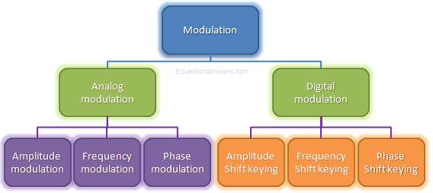
Figure 1 - Modulation Schemes

The term known as digital modulation schemes is referred to the concept of modulating a carrier signals over a carrier wave or a medium. Within digital modulation the use of complex signal conditioning and processing methods are found[10]–[13]. The author was required to obtain a necessary knowledge and understanding of the following modulation techniques ASK, PSK, QAM to ensure to produce a successful simulation[13]–[16].

Mathematical Term for digital modulation:
if m(t) is the message signal and c(t)=Acosw_{c}t then AM signal F(t) is written as
F(t)= Acosw_{c}t+m(t) cosw_{c}t
F(t)=[A+m(t)] cosw_{c}t[17]

Amplitude-Shift Keying (ASK)
The term recognised as ASK is a known amplitude modulation technique which can be described as the strength of the signal that binary figure is administrated by. ASK modulation is commonly used within applications encountered with fibre optical transmitter and receiver, plus within infrared remote controls[18]–[21]. This amplitude fluctuates while the frequency and phase remain equivalent, below is a mathematical demonstration:
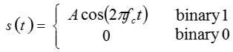
Figure 2 - ASK Mathematics
ASK is one binary value, at a constant amplitude, that is characterised by the existence of the carrier. The carrier signal is defined as Acos (2πfct) as shown on figure 2. Some of the common known advantages found within ASK are the use of low implementation cost, simpler than other known modulation such as Binary Frequency-Shift keying (BFSK) and also doesn’t require much bandwidth like other known modulation such as Frequency Shift Keying (FSK).

Some of the known disadvantages is that ASK is a linear and sensitive to atmospheric noise, distortion, propagation condition on diverse routes in Public Switched Telephone Network (PSTN). It demands unnecessary bandwidth and is hence an excess of power.

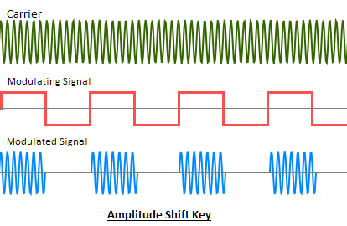
Figure 3 - ASK signal example

Figure 3 above show an example of the modulated and demodulated signal of ASK, the carrier signal's prompt amplitude is varied in proportion to message a signal m(t). the modulated carrier m(t)cosw_{c}t where cosw_{c}t is the carrier signal. Information that is transmitted is registered as an on-off signal where both input and output is also known as a on-off signal, the carrier is only present if the presented data is 1 and the carrier is absent if the data is shared as 0 meaning that there is no current information (0 justifies no data, 1 justifies data). ASK is also known as on-off Keying (OOK).

Phase-Shift keying (PSK)

The terminology PSK is a known modulation technique used for the factor of the phase of a carrier signal is improved to encounter the representation of the binary or bit value of 0 or 1 at specific sets of time, this method is also completed with the use of a finite number of phases. PSK is widely used within the areas of wireless and wired communications systems the most common types of applications PSK can be found within are, ADSL broadband modem, bio metrics, RFID, Wireless LANs satellite communications and mobile phones this is due to PSK allowing the use of the conveyance of radio transmission hence over other modulation schemes.

Advantages known with the use of PSK is able to carry data over a Radio Frequency (RF) signal, it is also known to be less prone to errors compare to alternative modulations.

Disadvantages known with PSK is the use of lower bandwidth efficiency, Multi-level PSK modulations are sensitive towards phase variations.
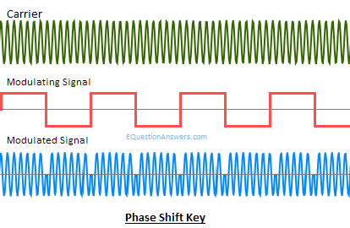
Figure 4 - PSK signal example[22]

Figure 4 shows the phase of the carrier which is shifted when a modulated signal is transmitted using the PSK modulation technique. If the base band signal m(t) =1 carrier in phase is transmitted. If m(t)=0 carrier with out of phase is transmitted i.e. cos (w_{c}t+П). When using PSK if it completed using 4 different quadrants this will justify that only 2 bits of information will be able to be sent at a time[23]–[28].

PSK is also known to having two different types depending of the use that it is required to be done in the two different type are Binary Phase Shift Keying (BPSK) and Quadrature Phase Shift Keying (QPSK). Ideally phase shift keying technique involves the varying of the binary shift, the preceding bit values determine if the phase shift remains the same move continues as before or consistent as 0 or 1, if the phase shift passes a 180-degree condition of transition, the carrier signal goes astray from 0 to 1 or the other way around.

Quadrature Amplitude Modulation (QAM)

QAM is a is a modulation method of combining two amplitude-modulated signals to be in one signal channel, this is because of the modulation scheme using the two varieties of amplitude and phase in connection to the carrier signal. When using QAM modulation technique the client uses a technique to make a quadrature impact by consolidating two amplitude modulated signal and coordinating these signs through one transporter channel, this thusly produces a double data transfer capacity also known as dual bandwidth. Normally utilized nearby pulse amplitude modulation with radio communications.in specialized terms the meaning justifies that there will be two carriers maintaining the constant frequency in a signal which will be with a differentiated phase shift of 90 degrees[29]–[31]. This ideally is known to allow the client to obtain the outputs of an amplitude variations and the phase.

QAM is known to be detected in use of digital and analog modulation schemes but the use of the modulation scheme is with alternative terminology, which ideally QAM analog modulation transmission allows a client to implement several analogue carrier signals which will be used to transmit on a single signal carrier transmission.

QAM modulation technique can be identified in many different applications such as Wi-Fi technology, AM radio transmission, WiMAX, cellular phone networks and various types of different technologies which are dedicated and designed for future communication systems such as Long-Term Evolution (LTE) and other types of protocols such as Wide Local Area Network (WLAN) standards of 802.11ac.
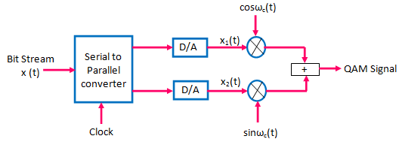

Figure 5 – Generation of QAM signal
Figure 5 demonstrates an example of a creation of an QAM signal which allows the user for a better understanding of an QAM transmission. Some of the recognized advantages of QAM modulation is that it appears to increase the efficiency of transmission/bandwidth for radio other known advantages are communication systems by utilizing both amplitude and phase variations. The disadvantages located within QAM is that the position of the modulations is required to be much closer from one point to another as QAM modulation is more vulnerable to the noise[32], [33]. This also encounter the complexity of QAM creation compared to alternative modulation techniques. Other known disadvantages of QAM is associated with the amplitude component of the signal[34]. When information is modulated into a signal is amplified in a radio transmitter so there is no purpose of the use of linear but whereas in QAM the user is required to use a linear.
Figure 6 – Mathematical term of QAM

Comparison of ASK, PSK & QAM modulation schemes

After a thorough research was conducted the author proposes a comparison of the three digital modulation schemes to show a better understanding in what is ideally more efficient to be used.

The author suggests that QAM modulation technique is preferably the best out of ASK and PSK modulation but can be debated according the scenario it will be required to be used, the author suggest that QAM is better compared to others is the use of QAM within the future use of communication systems. Other suggestions of QAM better use is that QAM can provide better Bit Error Rate (BER) performance than many other modulations.

Experiment B – Wireless network design

The author was required to conduct an analysis of some of the following fields shown below to ensure better understanding in creating smart environment’s and ensuring perfection within the networking factor.

- Wireless networks and communication system (long/short range, WLAN, ZigBee, WI-FI, Cellular, Satellite)
- Internet of Things (IoT) & Smart cities
- Security imaging technology

Wireless networks and communication systems

Wireless Local Area Network (WLAN/Wireless LAN) is a computer network which uses the Institution of electrical and electronic engineering (IEEE) 802.11 protocol and is used to connect more than one device within a wireless spectrum which is ideally limited to such areas as schools, home, office building etc[35]–[38].

ZigBee is a network type used as a high-level communication protocol with the use of personal area networks, ZigBee network uses low-power digital radios to transmit data hence the use of ZigBee network is used for low -bandwidth use. ZigBee network protocol is classified as IEEE 802.15.4[39], [40].

Cellular network also known as mobile network is a network type which is used with the aid transceiver stations which is distributed over land areas called channel cells, each cell is served with at least one fixed location within a X amount of distance depending of the transceiver closest to the end device[41], [42]. A transceiver is interconnected with many other base stations which is used to send and receive data.

Internet of Things (IoT) & Smart Cities

IoT is a rapidly growing field within computing as every device connect to a live network is classified as IoT device in other terms the definition of IoT is the extension of internet connectivity[43], [44]. The advantage use of IoT is that it enables one IoT device to communicate with another IoT device with the aid of the internet and with the beneficial use of remote monitoring and control.

The definition of a smart city is an urban area that uses many different variations of IoT devices such as sensors and controllers[45]–[47]. The aid of IoT devices is used to collect significant data then to use the collected data to manage other IoT device. This is to enable easier accessibility to racecourses and to utilities time or money saving features by decreasing the amount of physical work load.

Security imaging technology

Security imaging technology is a physical device which is used to detect illegal concealed weapons or drugs and etc. These types of equipment can vary from CCTV cameras to X-ray machine.[48], [49]

Planning

Experiment A – Digital modulation

The author had conducted a very strong research based on the creation and understanding of ASK, PSK and QAM digital modulations, the author had ensured to research with aid of video clips, books, research papers, articles, lecture notes and etc. after the majority of the research was completed it was to the authors knowledge that the modulation schemes will be created using blocks to produce a successful transmission.

Experiment B – Wireless network design

The author was required to produce a wireless monitoring system using simulation technology this had given the complexity of researching a suitable network simulation tool and to ensure the correct environment setting was selected to be used. After a brief research was conducted the author had chosen to use Netsim simulation tool using the internetwork environment scenario.

The author had approached the use of Netsim due to extensive capability of metric collection of data which enable the author to have very approximate metric results to analyze and compare. The selection of internetwork was chosen due to advancement capability of use of routers, layer 2 or 3 switches, access points and wireless devices which many of the other scenarios were limited.

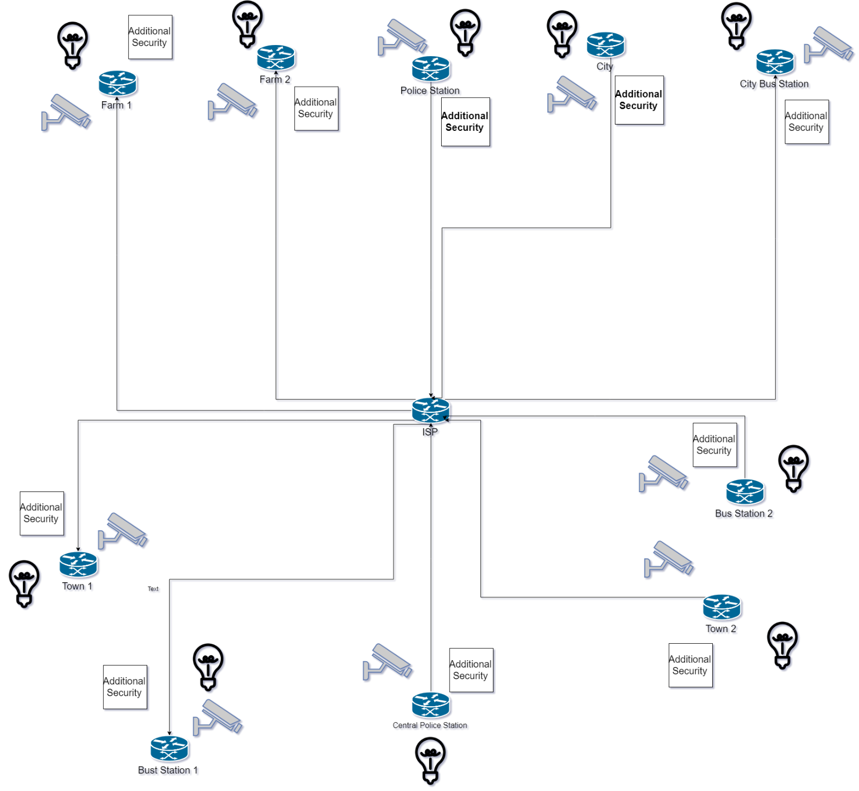
Figure 7 – Simulation Blue print[50]

Demonstrated on figure 7 shows the finial initial blue print plan for the successful creation of the simulation, the author had tried to his best capability to ensure the most realist environment for the simulation. The blocks described as additional security represents IoT devices that will be used to protect the physical environment.

Analysis of findings

This chapter is used to show the completed work and the potential successful output outcome, the author will also analyze the data and briefly explain the output that had been given after the modulation scenarios and simulations were completed.

Experiment A – Digital modulation

ASK

Figure 8 shown below demonstrates the final design of the completed ASK digital modulation scheme, the block parameters that was used within the modulation are: Bernoulli binary, Sine Wave, AWGN (noise interface), Ber, Scope, Switch, Product, Constant, Sum, Filter design.

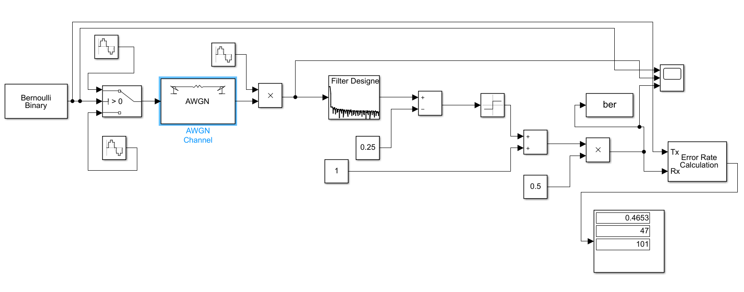
Figure 8 – ASK Block View
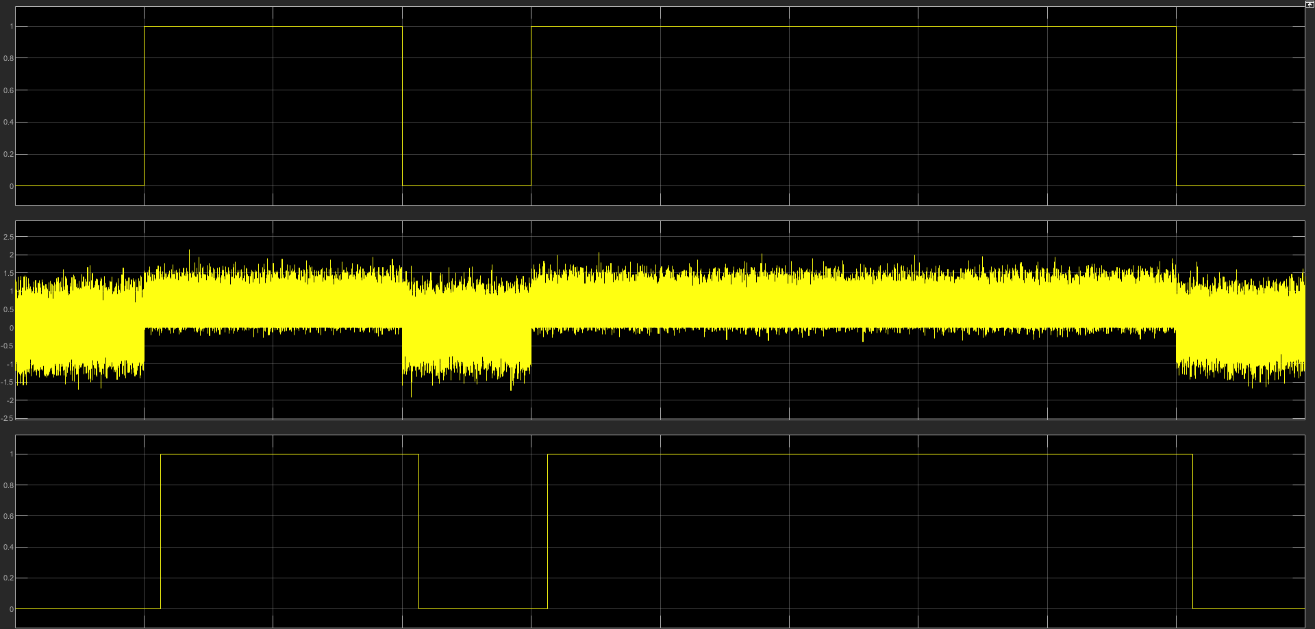
Figure 9 – ASK scope

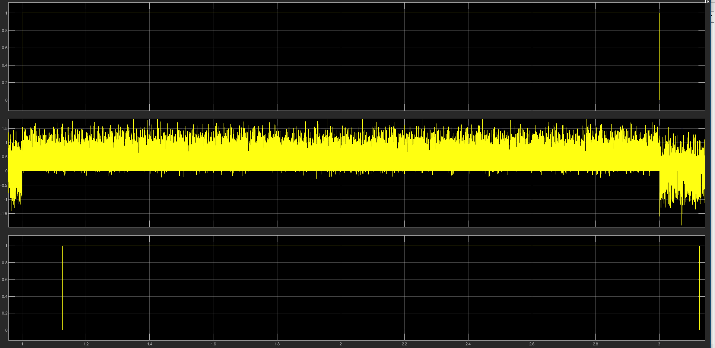
Figure 10 – ASK Scope zoomed in
Figure 9 and 10 demonstrate the output result of the modulated signal, the three layout found on the scope is to show the modulated signal which is located at the top layout, the middle layout is used to show the carrier signal which is also aided with noise interference, the bottom layout is used to show the demodulated signal.

PSK

Figure 11 demonstrates the final design of the completed PSK digital modulation scheme, the block parameters that was used within the modulation are: Sine Wave, AWGN (noise interface), Ber, Scope, Product, Constant, Sum, Filter design, unipolar to bipolar converter, integer, saturation, random integer, error rate calculation, display, demux, signum, integer to bit converter, Bit to integer converter.

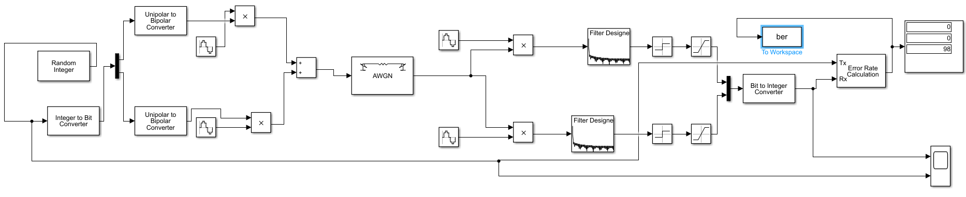
Figure 11 – PSK design
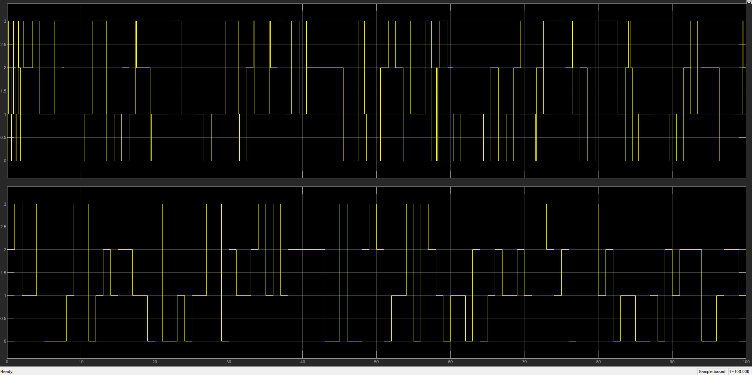
Figure 12 – PSK scope

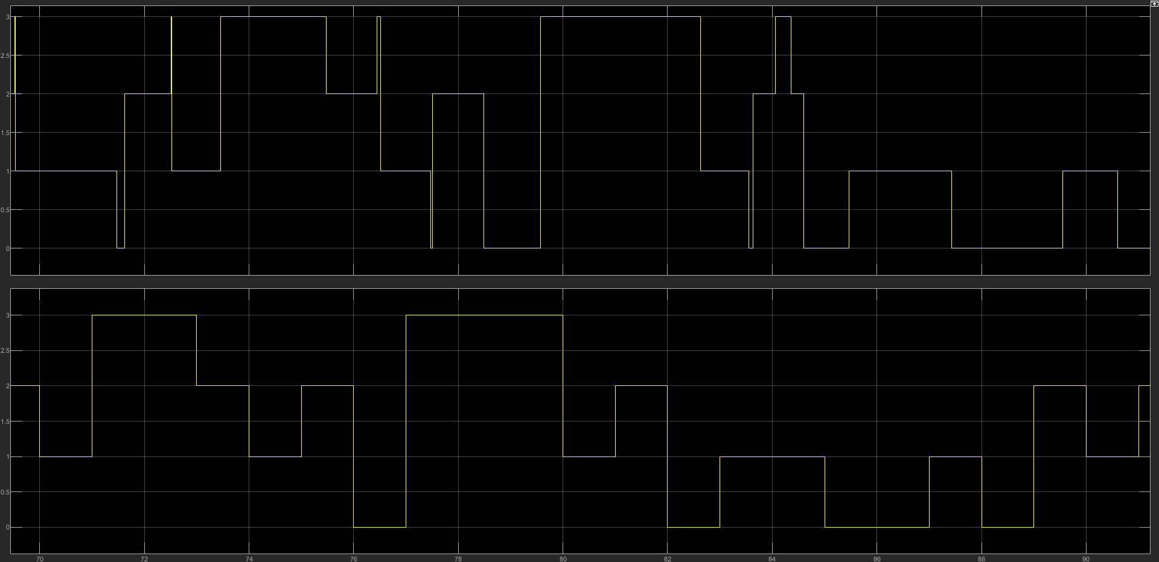
Figure 13 – PSK scope zoomed in

Figure 12 and 13 show the demonstrated transmission signal, in figure 13 the author shows a more detailed version of the modulated and demodulated signal. The bottom layer on both figures are the modulated signal and the upper layer demonstrates the demodulated signal. As shown on the figures there is about an average of 1 second delay.

QAM

Figure 14 demonstrates the completed design of the QAM modulation scheme, the modulation had been conducted using the following blocks random integer, rectangular 16-QAM, AWGN (noise interference), transmitter diagram, received diagram, error rate calculation, display.
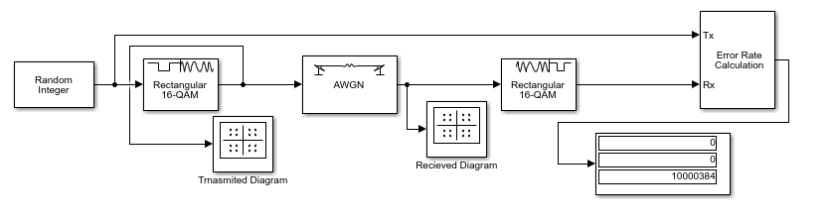
Figure 14 – QAM Modulation

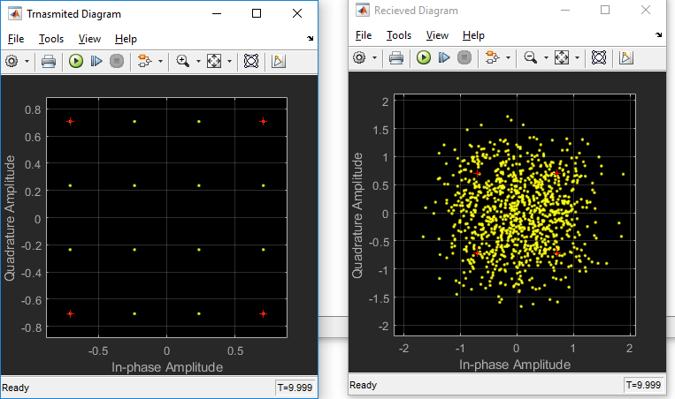
Figure 15 – QAM modulated and demodulated transmission
Figure 15 demonstrates the output given by QAM modulation, the output scope shown on the left shows the modulated signal and the scope by the left is the demodulated signal. The shown output is with the scope noise interference at Eb/No 10. The author runs 3 different modulations for the testing of the QAM modulation the three modulation

Experiment B – wireless network design

Figure 16 below demonstrations the final network design that was completed for the production of a smart environment that had needed to be completed, initially the smart environment was produced to help aid the protection of farmers in the Caribbean islands. The author was obligated to brain storm initial threats and security flaws to expand on after an initial blue print design the author had completed the final design shown on figure 16. Figure 17 shows the same design as figure 16 but the added extra is the application view which enables the view of where data is being sent to. The application view helps show where the author has created data to be sent from source to destination for testing purposes of the simulation.

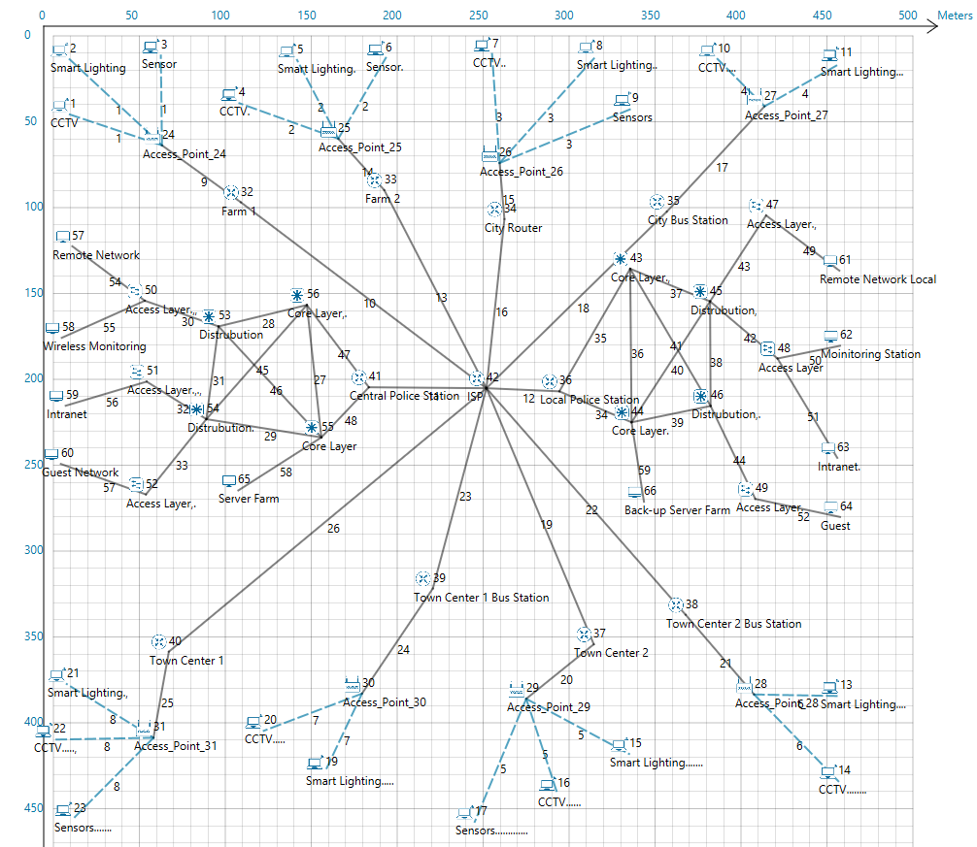
Figure 16 – Netsim Design
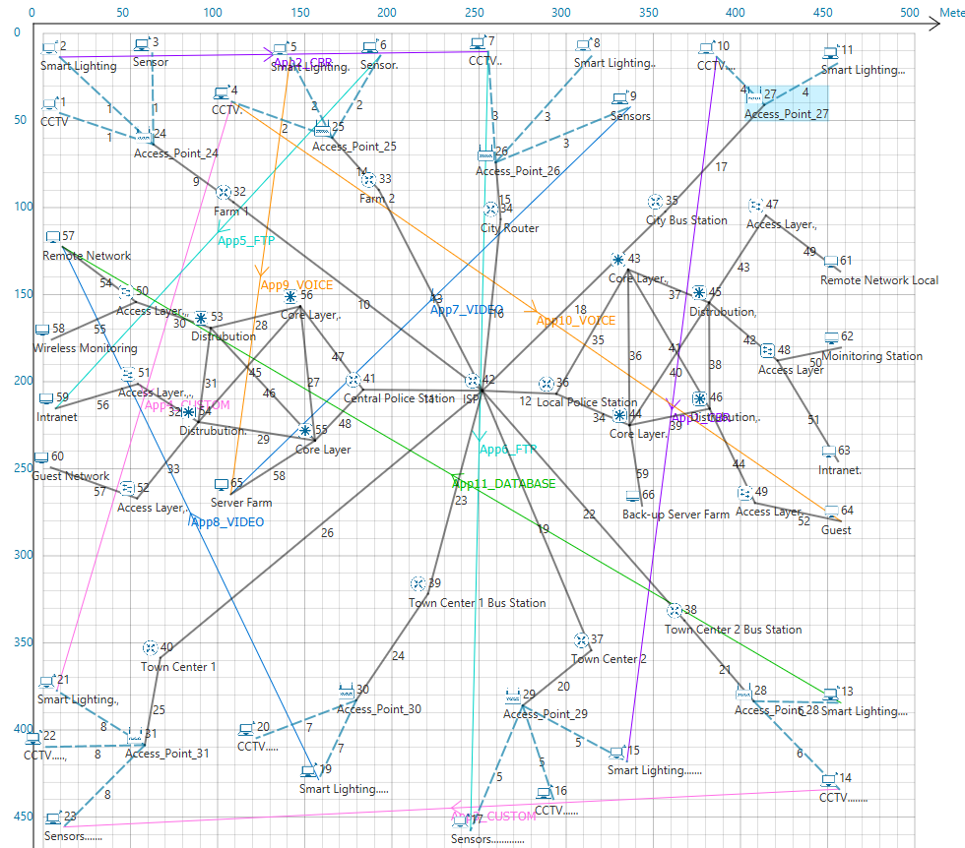
Figure 17 – Netsim design(Application view)

Figure 16 and 17 also show the method type the author had proceeded with for the production of the network. The author initially uses CCTV cameras, Smart IoT lighting, Sensors (trip sensors, motion sensors, ultrasonic detectors), Server farms (FTP server, AAA server, HTTP server, Email server, IoT Server, SYSLOG server, NTP server, DNS server, TFTP server, DHCP server, RADIUS EAP server, DHCPv6 server), routers, layer 2 and layer 3 switches. The author had only proposed all the sensors and server farms as one due to the limitations caused by Netsim simulation software.
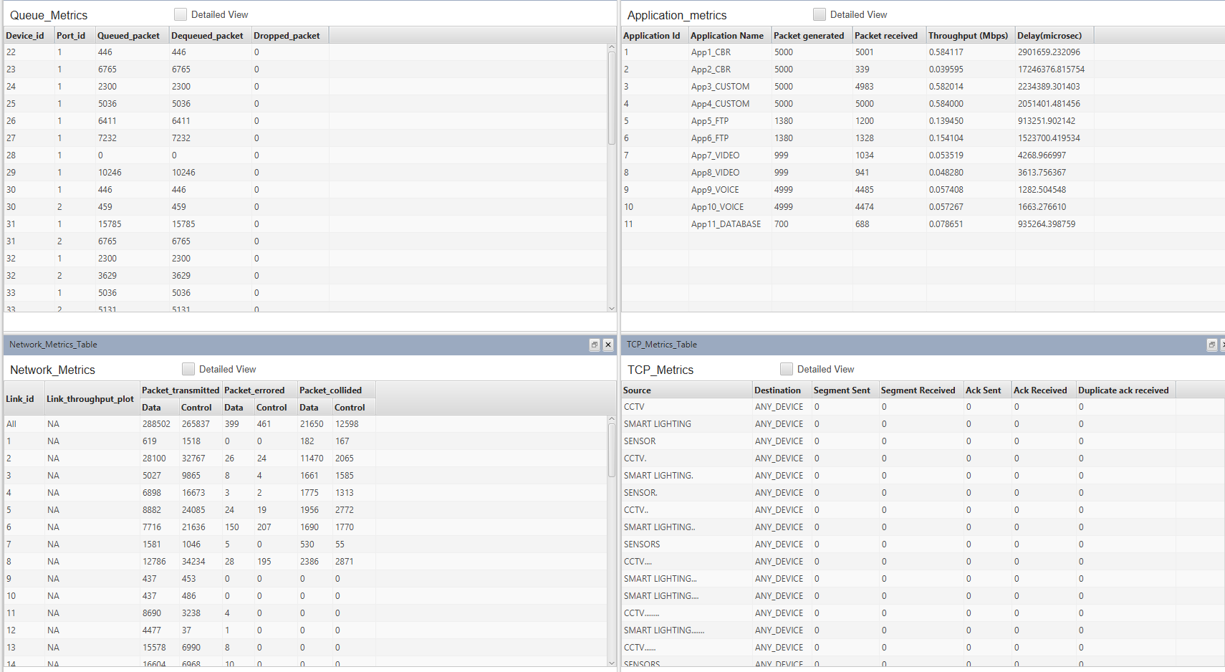
Figure 18 – Metrics output view
Figure 18 above shows the initial output of the given applications which were set by the author a quick initial view of the data shows the successful rate percentage of the simulation, the author suggest that the simulation is an 100% success. The author has many different options of application setting when producing an application to be sent from a source ID to destination ID.

Figure 19 below demonstrates an application configuration setting, the author is able to change multiple types of setting such as network application type. There are several types of network application types for packet transfer on Netsim simulation tool such as File Transfer Protocol (FTP), Constant Bit Rate (CBR), VIDEO, VOICE, EMAIL, DATABASE, HyperText Transfer Protocol (HTTP), CUSTOM, PEER_TO_PEER and COAP. The author had only chosen to use FTP, CBR, VIDEO, VOICE, DATABASE, CUSTOM as these application methods were only suitable for the testing of the simulation.

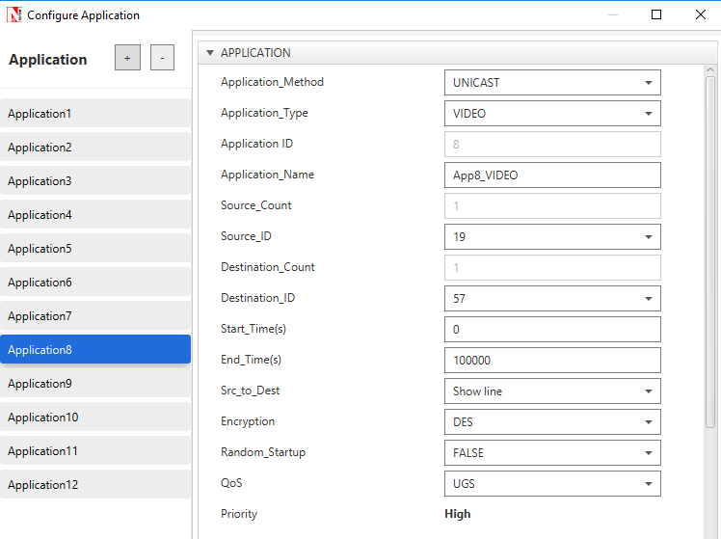
Figure 19 – Application Setting

Figure 19 shows the example on how the author uses the different configuration types of application type and also types of Quality of Service (QoS) setting, Encryption types. The author tweaks multiple configurations to test the integrity of all sorts of information being sent on the simulation which helps aid the purpose of the simulation on assuring the simulation is a 100% successful. As shown on figure 19 the author had changed both encryption type and QoS, on an application, the author had produced 12 applications to use two application types for each chosen application type.

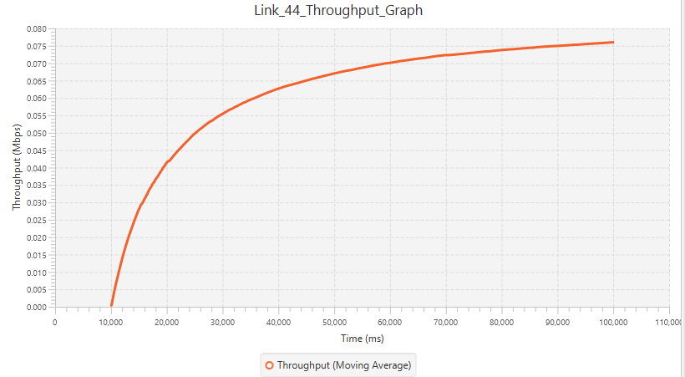
Figure 20- Through put graph 1
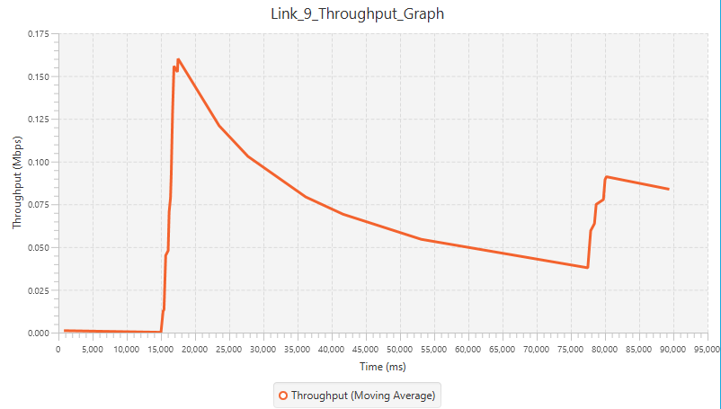
Figure 21 - Through put graph 2
Figures 20 and 21 show different applications that had been tested to show the integrity of application integrities. As shown on figure 21 some applications faltering this can be due to the amount of congestion created within the particular access points or routers. Figure 20 shows the throughput outcome of an application close to the access point and within a less congestion path which also proves the hypothesis of the author of why there is low throughput within figure 21 and why the disadvantage is produced.

Figure 22 – Packet analysis
The figure shown above (22) provides information of the set applications, the given data shows information on the generated, received and lost information. As show above application 2 has the highest packet loss this can be due a variety of issues such as congestion on the link and distance between wireless transmission.

Figure 23 – payload analysis
Figure 23 demonstrates the average payload analysis provided by the simulation as shown, as shown again on application two there is the highest payload loss.

Figure 24 – Throughput (Mbps)
As shown on figure 24 the best given examples of data were given by application 1, 3 and 4, the throughput information passes along data on how much information was passed on the link. All other application has given an average amount of data that is acceptable in an average network simulation.

Figure 25 – Delay (microsecond)

Figure 25 demonstrates the delay given by the output of the simulation as shown on the figure the worse given application result was by the second application, this could be the main cause of the given range from the end device to the access point. Delay in a wireless spectrum is mainly caused by the amount of distance given from the device to the access point.

Comparison of findings with experiment A & B

The author produces this subchapter to understand the comparison of experiment A in comparison of experiment B, the author produces an assessment of experiment A to test the success ability percentage with noise and without noise to understand what digital modulation technique will be better to be used within the Netsim network simulation. The following three headings will indicate the given results of the tested digital modulations.

ASK
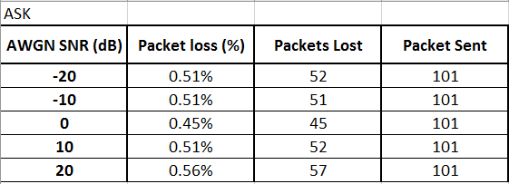
Figure 26 – ASK analyzation

Figure 27- ASK graph
Figure 26 and 27 show the given output of the ASK modulation with noise interference, as demonstrated on the graph the best given output is given when noise interference is at 0.

PSK

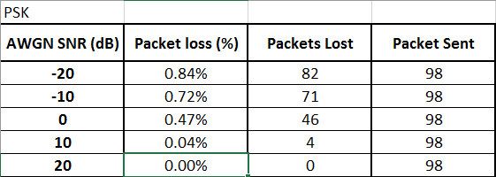
Figure 28 – PSK analyzation

Figure 29 – PSK graph

Figure 28 and 29 show the given output of the PSK modulation with noise interference, as demonstrated on the graph the best given output is given when noise interference is at 20 with 0 packet loss which ensures it is a 100% success.

QAM

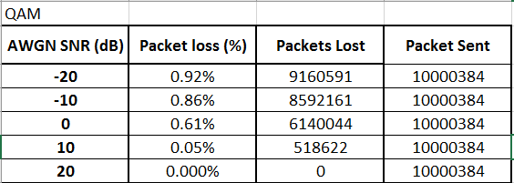
Figure 30 – QAM analyzation

Figure 31 – QAM graph

Figure 30 and 31 show the given output of the QAM modulation with noise interference, as demonstrated on the graph the best given output is given when noise interference is at 20 with 0 packet loss which ensures it is a 100% success.

Final comparison
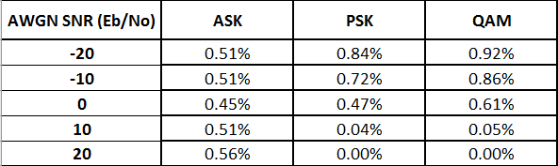
Figure 32 – comparison analyzation

Figure 33 – comparison graph

Figure 32 and 33 demonstrate the comparison of all given modulation schemes the given output is shown with altered noise interference. As shown on the given numerical output and graph the best given output out of all three of the modulations will be the QAM modulation. In the final decision the QAM modulation will be for the best use in the Netsim network simulation to be used. Due to QAM not supporting high bandwidth capacity it will be recommended for the use of PSK in an extreme complex network with high bandwidth requirements as therefore both PSK and QAM may be used for the simulation.

Conclusion

In the final conclusion of the report, the author had produced a through research literature for the given two experiments, this was to ensure the integrity and success of the final outcome of this report. The final given results had ensured that the report was conducted to a 100% success and that the author had obtained the key elements of the report. The author was able to produce all three digital modulation schemes with the use of Matlab Simulink tool, all modulation schemes used were produced with the aid of the given custom blocks within Simulink. The author had also produced graphical charts and graphs of all three modulations with different noise interference to test the ability and integrity of the given modulations to have a clearer understanding and knowledge on how the data may be corrupted or how the signal is transmitted.

The author had also produced a successful Netsim simulation although the author was not able to implement his own Internet Protocol (IP) address scheme. The author had produced two simulations with one having a dedicated IP address scheme, which was not able to work due to the limitations produced by Netsim simulation tool hence the author had not demonstrated the use of the non-working simulation. The operational Netsim simulation was produced to an 100% success with the data flow given without any errors or high data delay. In the overall outcome the author suggest that the report was conducted to a formal success as the given results has proven and that the results that were given to be compared for further analysation.

References
[1] CSIRO (Australia), 2000 Asia Pacific Microwave Conference : APMC 2000 : proceedings : expanding the world of microwaves beyond 2000 : 3-6 December, 2000, the Wentworth Hotel, Sydney, Australia. IEEE, 2000.
[2] P. S. Mundra, T. L. Singal, and R. Kapur, “The choice of a digital modulation scheme in a mobile radio system,” in IEEE 43rd Vehicular Technology Conference, pp. 1–4.
[3] D. Chadha and P. K. Rathore, “Performance of pulse modulation schemes for infrared wireless communications,” in 2000 Asia-Pacific Microwave Conference. Proceedings (Cat. No.00TH8522), pp. 946–949.
[4] A. Wittneben, “A new bandwidth efficient transmit antenna modulation diversity scheme for linear digital modulation,” in Proceedings of ICC ’93 - IEEE International Conference on Communications, vol. 3, pp. 1630–1634.
[5] J. Stigwall and S. Galt, “Interferometric analog-to-digital conversion scheme,” IEEE Photonics Technol. Lett., vol. 17, no. 2, pp. 468–470, Feb. 2005.
[6] H. B. Peek, “Multirate Modulation: A Bandwidth- and Power-Efficient Modulation Scheme,” IEEE Trans. Commun., vol. 53, no. 10, pp. 1679–1687, Oct. 2005.
[7] Institute of Electrical and Electronics Engineers., 1997 IEEE International Conference on Communications : towards the knowledge millennium : ICC ’97, 8-12 June 1997, Montréal, Québec, Canada, conference record. Institute of Electrical and Electronics Engineers, 1997.
[8] Y. Suzuki and T. Shirato, “Novel multilevel modulation scheme for high capacity digital wireless access,” in Proceedings of ICC’97 - International Conference on Communications, vol. 3, pp. 1527–1531.
[9] M. N. Rajesh, B. K. Shrisha, N. Rao, and H. V. Kumaraswamy, “An analysis of BER comparison of various digital modulation schemes used for adaptive modulation,” in 2016 IEEE International Conference on Recent Trends in Electronics, Information & Communication Technology (RTEICT), 2016, pp. 241–245.
[10] B. Kanmani, “Laboratory implementation of some analog and digital modulation schemes using single circuit,” in 2013 IEEE International Conference in MOOC, Innovation and Technology in Education (MITE), 2013, pp. 399–404.
[11] P. P. Sotiriadis, C. Basetas, and N. Temenos, “32-QAM all-digital RF signal generator based on a homodyne sigma-delta modulation scheme,” in 2017 Joint Conference of the European Frequency and Time Forum and IEEE International Frequency Control Symposium (EFTF/IFC), 2017, pp. 603–604.
[12] B. Chirag, A. Lohith, and H. S. Prashantha, “Comparative performance analysis of various digital modulation schemes in AWGN channel,” in 2017 Innovations in Power and Advanced Computing Technologies (i-PACT), 2017, pp. 1–5.
[13] Institute of Electrical and Electronics Engineers, 2017 Innovations in Power and Advanced Computing Technologies (i-PACT) : 21-22 April 2017. .
[14] Institute of Electrical and Electronics Engineers., International Conference on Ubiquitous and Future Networks : [proceedings]. Institute of Electrical and Electronic Engineers.
[15] Technische Universität Wien, Institute of Electrical and Electronics Engineers, IEEE Communications Society, and Han’guk T’ongsin Hakhoe, ICUFN 2016 : the Eighth International Conference on Ubiquitous and Future Networks : July 5(Tue.)-July 8(Fri.), 2016, Technische Universität (TU) Wien, Vienna, Austria. .
[16] Dong-Yeol Choi, Won-Kyung Kim, J.-H. Kim, and Huirae Cho, “Performance of analog and digital modulation schemes under sweep jamming,” in 2016 Eighth International Conference on Ubiquitous and Future Networks (ICUFN), 2016, pp. 13–15.
[17] P. . Kar Heng Lee, “ELEC3540 Lecture 3 Analog Amplitude Modulation.” .
[18] A. Djemouai and M. Sawan, “Integrated ASK Demodulator Dedicated to Implantable Electronic Devices,” in 2003 46th Midwest Symposium on Circuits and Systems, vol. 1, pp. 80–83.
[19] H. Zhang, X. Chen, M. Chen, and G. Wang, “A wide-input-range low-power ASK demodulator for wireless data transmission in retinal prosthesis,” in 2016 IEEE Biomedical Circuits and Systems Conference (BioCAS), 2016, pp. 492–495.
[20] Y. Aiying, X. Yao, and S. Yunan, “Phase noise due to ASK amplitude un-equality and Kerr nonlinearity in optical ASK-DPSK, ASK-DQPSK systems,” in 2006 Asian Optical Fiber Communication & Optoelectronic Exposition & Conference, 2006, pp. 1–3.
[21] Choi Myoeng-Jae and Jin Sung-Eon, “Design of low power ASK CMOS demodulator circuit for RFID tag: Design of All-MOSFET low power ASK demodulator,” in 2010 IEEE International Conference of Electron Devices and Solid-State Circuits (EDSSC), 2010, pp. 1–4.
[22] “Modulation, Analog modulation, Digital modulation, AM,FM,PM, ASK,FSK,PSK explained.” [Online]. Available: http://www.equestionanswers.com/notes/modulation-analog-digital.php. [Accessed: 12-Apr-2019].
[23] 2016 IEEE Wireless Communications and Networking Conference : 3-6 April 2016. .
[24] A. A. Mahesh and B. S. Rajan, “Index coded PSK modulation,” in 2016 IEEE Wireless Communications and Networking Conference, 2016, pp. 1–7.
[25] M. I. Quinteros, E. J. Kaminsky, and K. V. Cartwright, “Performance and spectral analysis of Q&lt;sup&gt;2&lt;/sup&gt; PSK and CEQ&lt;sup&gt;2&lt;/sup&gt; PSK systems in ideal bandlimited channels,” in 2014 IEEE Global Communications Conference, 2014, pp. 3862–3867.
[26] J. J. Komo and W. J. Reid, “Evaluation of three- and five-phase PSK,” in IEEE Proceedings of the SOUTHEASTCON ’91, pp. 1030–1033.
[27] M. I. Khairullin, I. M. Lerner, R. R. Faizullin, V. V. Kadushkin, and M. M. Fatykhov, “Selection of the initial shift for PSK signal constellation in the presence of intersymbol interference,” in 2017 Systems of Signal Synchronization, Generating and Processing in Telecommunications (SINKHROINFO), 2017, pp. 1–5.
[28] F. Xu, Y. Wang, and L. Qiu, “Design of PSK carrier recovery loop under large frequency offset,” in 2012 5th International Congress on Image and Signal Processing, 2012, pp. 1709–1712.
[29] S.-J. Ra, J. Song, J. Bae, J. Jung, N. Hur, and C.-S. Kim, “Implementation and performance analysis of QAM modulator applicable to the HFC network,” in 2016 International Conference on Information and Communication Technology Convergence (ICTC), 2016, pp. 1213–1215.
[30] Qi Pan and R. J. Green, “Simplified analysis of QAM BER impairment in hybrid AM/QAM lightwave systems,” IEEE Trans. Commun., vol. 47, no. 4, pp. 498–499, Apr. 1999.
[31] K. Pappi, A. Lioumpas, and G. Karagiannidis, “θ-QAM: A parametric quadrature amplitude modulation family and its performance in AWGN and fading channels,” IEEE Trans. Commun., vol. 58, no. 4, pp. 1014–1019, Apr. 2010.
[32] J. R. Cardenas-Valdez, J. A. Galaviz-Aguilar, J. C. Nunez-Perez, and C. Gontrand, “Amplification of 4-, 8-, 16-, 32- and 64-QAM through the Memory Polynomial-Model as Special Case of the Volterra Series Implemented in a RF Satellite Link,” in 2012 IEEE Ninth Electronics, Robotics and Automotive Mechanics Conference, 2012, pp. 349–352.
[33] A. Farzamnia, N. W. Hlaing, M. Mariappan, and M. K. Haldar, “BER Comparison of OFDM with M-QAM Modulation Scheme of AWGN and Rayleigh Fading Channels,” in 2018 9th IEEE Control and System Graduate Research Colloquium (ICSGRC), 2018, pp. 54–58.
[34] S. Ovadia, “The effect of interleaver depth and QAM channel frequency offset on the performance of multichannel AM-VSB/256-QAM video lightwave transmission systems,” IEEE Photonics Technol. Lett., vol. 10, no. 8, pp. 1174–1176, Aug. 1998.
[35] J. Nam, J. Shin, and B. Kim, “Load modulation power amplifier with lumped-element combiner for IEEE 802.11b∕g WLAN applications,” Electron. Lett., vol. 42, no. 1, p. 24, 2006.
[36] Institute of Electrical and Electronics Engineers., International Telecommunication Union., and I. Cisco Systems, Proceedings of the 2010 ITU-T Kaleidoscope Academic Conference : beyond the internet? : innovations for future networks and services : Pune, India, 13-15 December 2010. [IEEE], 2010.
[37] P. Nobles and P. A. Horrocks, “Vulnerability of IEEE802.11 WLANs to MAC layer DoS attacks,” in 2nd IEE Secure Mobile Communications Forum: Exploring the Technical Challenges in Secure GSM and WLAN, 2004, pp. 14–14.
[38] Y. Zheng, T. Shi, X. Xu, H. Yuan, and T. Yao, “Research on WLAN planning problem based on optimization models and multi-agent algorithm,” in 2017 IEEE International Conference on Cybernetics and Intelligent Systems (CIS) and IEEE Conference on Robotics, Automation and Mechatronics (RAM), 2017, pp. 249–254.
[39] G. Pan, J. He, Q. Wu, R. Fang, J. Cao, and D. Liao, “Automatic stabilization of Zigbee network,” in 2018 International Conference on Artificial Intelligence and Big Data (ICAIBD), 2018, pp. 224–227.
[40] Li Xiaoman and Lu Xia, “Design of a ZigBee wireless sensor network node for aquaculture monitoring,” in 2016 2nd IEEE International Conference on Computer and Communications (ICCC), 2016, pp. 2179–2182.
[41] K. RahimiZadeh, “Design of a Cluster-Based Routing for Integrated Cellular and Ad Hoc Networks,” in 2009 Seventh Annual Communication Networks and Services Research Conference, 2009, pp. 422–424.
[42] S. Pandi, R. T. Arranz, G. T. Nguyen, and F. H. P. Fitzek, “Massive video multicasting in cellular networks using network coded cooperative communication,” in 2018 15th IEEE Annual Consumer Communications & Networking Conference (CCNC), 2018, pp. 1–2.
[43] S. Park, N. Crespi, H. Park, and S.-H. Kim, “IoT routing architecture with autonomous systems of things,” in 2014 IEEE World Forum on Internet of Things (WF-IoT), 2014, pp. 442–445.
[44] Y. Benazzouz, C. Munilla, O. Gunalp, M. Gallissot, and L. Gurgen, “Sharing user IoT devices in the cloud,” in 2014 IEEE World Forum on Internet of Things (WF-IoT), 2014, pp. 373–374.
[45] D.-H. Park, H.-C. Bang, C. S. Pyo, and S.-J. Kang, “Semantic open IoT service platform technology,” in 2014 IEEE World Forum on Internet of Things (WF-IoT), 2014, pp. 85–88.
[46] A. R. Biswas and R. Giaffreda, “IoT and cloud convergence: Opportunities and challenges,” in 2014 IEEE World Forum on Internet of Things (WF-IoT), 2014, pp. 375–376.
[47] M. A. Ikram, M. D. Alshehri, and F. K. Hussain, “Architecture of an IoT-based system for football supervision (IoT Football),” in 2015 IEEE 2nd World Forum on Internet of Things (WF-IoT), 2015, pp. 69–74.
[48] W. Wu, G. Liu, Z. Zhou, and Z. Gu, “Image quality assessment software of security screening system,” in 2008 42nd Annual IEEE International Carnahan Conference on Security Technology, 2008, pp. 107–111.
[49] S. Kolkoori, N. Wrobel, and U. Ewert, “A new X-ray backscatter technology for aviation security applications,” in 2015 IEEE International Symposium on Technologies for Homeland Security (HST), 2015, pp. 1–5.
[50] “draw.io.” [Online]. Available: https://www.draw.io/. [Accessed: 12-Apr-2019].

