Valentine’s Day menu
Trinity Hotel

Student: Vasile Alexandru Vasile
Student ID number: 2207749
The module title: Food and Beverage Operations
Lecturer: Tristan Hawkins
Date: 16 February 2023

Word count: 268

Trinity Hotel, Manchester

Welcome to Trinity Hotel, Manchester. Our hotel offers top-notch amenities and exceptional services to make your stay comfortable and unforgettable.

As soon as you arrive, our friendly staff at Trinity will greet you and assist with your check-in. Our modern rooms are spacious, elegantly designed, and equipped with all the necessary amenities such as free Wi-Fi, a flat-screen TV, a minibar, and comfortable beds for a relaxing night's sleep, all equipped and prepared for your dreams stay.

At the Trinity hotel we emphasis greatness and our hotel features a fine dining restaurant that offers a wide selection of delicious cuisine, from local to international delicacies, prepared by our expert chefs. You can also unwind in our trendy bar, which offers a variety of cocktails, wines, and beers, or order room service for a more private dining experience.

We have a state-of-the-art fitness centre with modern equipment for your daily workout routine, and a spa where you can rejuvenate and relax with a variety of wellness treatments.

Our hotel is conveniently located near various local attractions, making it an ideal base for exploring the city. We also provide a shuttle service to the airport and other nearby destinations for your convenience.

In addition to our high-quality services, our hotel also has meeting and event spaces, perfect for business meetings, conferences, or special events.

At Trinity, 4-star hotel, we are dedicated to providing you with a memorable and enjoying stay. You only need to come and see us, and we will do the rest, as you are our special guest. We look forward to hosting you soon!

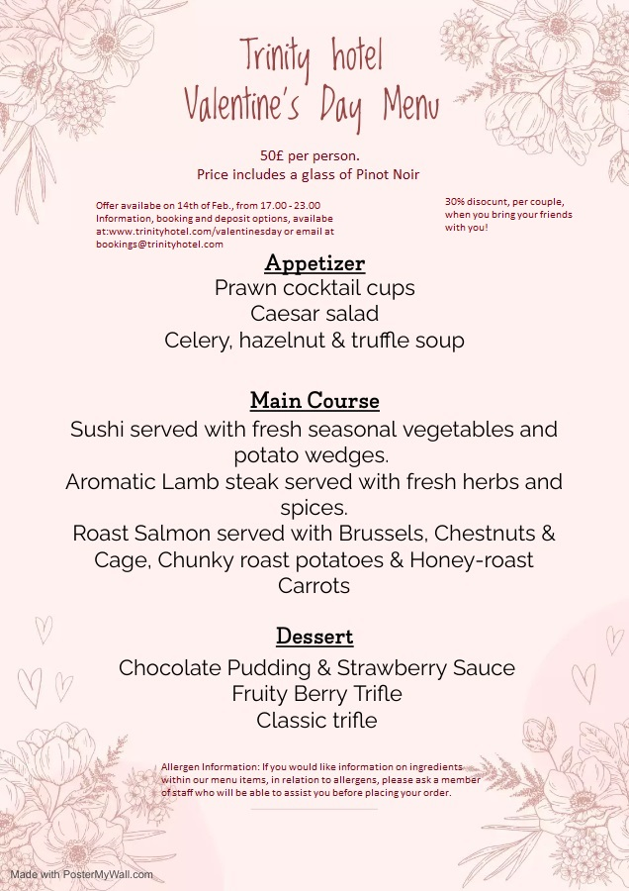

REFERENCES:
Poster My Wall. Valentine’s Day Menus. (2023) Available at: https://www.postermywall.com/index.php/posterbuilder/load/7139c19cf51718b88753a42298200e20#.Y-o0tMfP3Dc Accesed:11.02.2023
Audrey Bruno, (2016). This Is What A Serving Of Wine Actually Looks Like. Available at: https://www.self.com/story/this-is-what-a-serving-of-wine-actually-looks-like Accessed:12.02.2023
Good food team, (2023). Pairing wine with food: a simple guide. Available at: https://www.bbcgoodfood.com/howto/guide/pairing-wine-food-simple-guide Accessed: 12.03.2023
Qhotels, (2023). Evening menu. Available at: https://www.qhotels.co.uk/media/8988/90651_almarose_evening_menu_june_2020_proof04.pdf Accesed:11.02.2023
Brakes, (2023). Valentine’s Day menu ideas. Available at: https://www.brake.co.uk/inspirational-food/special-occasions/valentines?msclkid=49a4b07c89021631e5a2d396cb838b7b&utm_source=bing&utm_medium=cpc&utm_campaign=All%20Pages%20-%20DSA&utm_term=brake%20co&utm_content=All%20Pages Accessed: 13.02.2023
Binwise, (2023). Table d’haute menu. Available at: https://home.binwise.com/blog/table-dhote-menu Accessed: 12.02.2023
Carlyon Bay Hotel, (2023). Available at: https://carlyonbay.com/?utm_source=bing&utm_medium=cpc&utm_campaign=Carlyon%20-%20General&utm_term=Cornwall%20Hotels%204%20Stars&utm_content=Hotel%20-%204%20Star Accessed: 13.02.2023
Booking.com, (2023). 4 stars hotels Manchester. Available at: Booking.com : Hotels in Manchester . Book your hotel now! Accessed: 13.02.2023
Janine Jones. Hotel stars and what they mean. Webstaurant store blog. Available at: https://www.webstaurantstore.com/blog/3566/hotel-star-explained.html Accessed: 13.02.2023
Patrick Landman. 4 star hotel. Xotels (2023). Available at: https://www.xotels.com/en/glossary/four-star-hotel Accessed:13.02.2023

