Student Name: | Gheorghe Mihalka
Student Number: | 1711806
Module No: | BMSK4003
Module Title: | DIGITAL SKILLS AND RESEARCH METHODS
Lecturer: | Ze Zook
Digital Skills and Research Methods

31 August 2018
Contents
Introduction 2
Digital Era and Social Media Marketing 2
Social Media and Integrated Marketing 3
Necessity of Social Media Marketing 4
Marketing: Traditional VS Social Media 5
Required skills in implementing Social Media Marketing in Organization 6
Conclusion 8
Reference 9

Introduction
Social media is popular among people. For this popularity the users are increasing and people are making it their lifestyle. The wave of digitalization with social media is occurring everywhere and the business are catching up. The technology use is increasing and the increase is occurring due to the cost reduction of the technologies. The use of social media is touched in the day-to-day operations of organizations. The marketing process now considers social media as a part of the media to be explored to reach its targeted audience.

Digital Era and Social Media Marketing
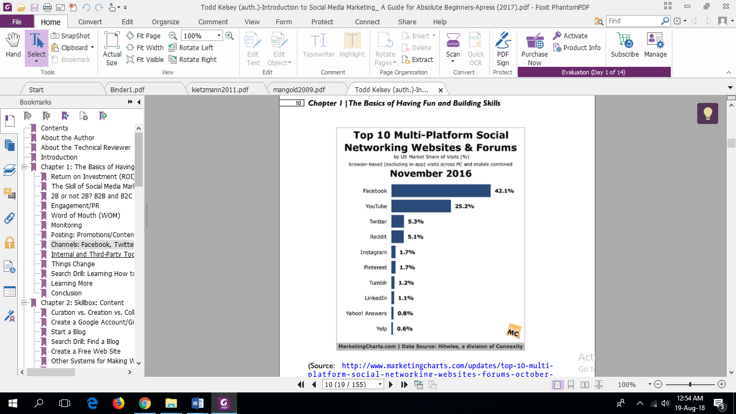Social media is some form of website or application that is designed for the users to connect, share contents quickly in real-time(Hudson, 2018). Social media has different types of platform where there can be social networking sites, creative work sharing sites, user-sponsored blogs, business networking sites, virtual world sites, commerce community, and more types exists (Mangold and Faulds, 2009). The platform of social media is on the rise. But not all platform is widely used or get same level of popularity. The popular platform that are currently used is given below:
Figure 1 Top 10 Multi-Platform Social Networking Websites and Forums ( source: (Kelsey, 2017))
The most dominating of the social media is Facebook andYouTube. The Facebook and YouTube both are providing advertisement opportunity along with the existing networking services. The presence of the genuine target market exists in this platform and advertising here helps the business to find and convert the potential lead to customers (Kelsey, 2017).
The marketing in social media has become essential. The social media has seven functionalities of which most popular social media fulfils. These functionalities are identity, reputation, groups, conversations, share, and present. Not all website canfulfilall the functionalities,butsome functionality is touched by all the existing social media. Identifying this functionality is essential to create a marketing strategy for better capturing the target market (Kietzmann et al., 2011). The presence of social media has redefined the interaction between the customer and the retailer, brands. The influential social media can help create and flourish brand community. The social media helps the organisation to operate outside of its physical base and reach the customers who deemed as unreachable due to distance(Clark, Black and Judson, 2017).

Social Media and Integrated Marketing
The presence of social media has made a meaningful impact on the promotion mix. The social media is helping to integrate the marketing communication. The integrated marketing communication is referred as coordinated effort to create a single program that helps to maximise the impact on related stakeholders and the customers. The well designed integrated marketing communication plan can only be executedwith the utilisation of social media platforms (Clow, 2018). Though before integration can be done, the digital marketing has to be analysed using different tools like Porter’s five forces, brand positioningmapping, customer lifetime value, segmentation and positioning etc. (Kingsnorth, 2016). The integrated marketing is helpful for creating community and maintaining the community in the online arena. Research has found that community building strategy can pay off in satisfying customer in the long run. It is suggested that different social media should focus on building community-based on that site where the customer will regularly visit(Clark, Black and Judson, 2017). The integrated marketing helps the organisation to communicate what it intends to communicate in all media and platforms but some platformneeds different approaches in connection with its target audiences.

The necessity of Social Media Marketing
The social media can reach the target customer higher than the traditional existing marketing strategies. Even in the USA election, the social media marketing has been used in a methodological manner (Williams, 2017). Social media’s use is increasing in the context of reaching direct consumers by the B2C organisation. The necessity of social media marketing is given below:
Increase Traffic:the social media has been used by 2.46 billion people in the world(Statista, 2018). The number is increasing,and the people are always shifting to the popular social media.
Customer intelligence:listening to the needs of the customer is essential in delivering a superior product. Social listening is enlightening information for serving the customer keeping in mind of their need is essential. Though the negative comments can turn down the interest of the business.However,these comments can provide insightinto what the customer wants. The customer intelligence is a great way to understand and predict the need of the consumers. The marketing strategy and the design of the new product can be helpful through this intelligence(Clow, 2018).
Brand Image: the image of the brand can be promoted and maintained in the social media using controlled communication. Clark, Black and Judson (2017) argues that community building can be helpful for creating a long-term brand image. The web platform well designed can be used to flourish the brand image among the user. The intended communication can be tested by interacting with the customers and correction in the marketing effort can be done through understanding the consumers’ responses through social media (Clark, Black and Judson, 2017).
Lead and converting into customers: lead is the people who are interested in the brand and its offering. The effective meeting effort can help to turn them into customers. The social media marketing helps to connect same minded users to be connected in a community and to a brand. That can be helpful for understanding their need and communication to fulfil their needs (Clow, 2018).
Brand Loyalty: the brand loyalty can be achieved through building community and community. There is another essential part that has to be keptin mind- the customer service. The brand loyalty will be increased if the customer service is good and satisfactory for the users(Kingsnorth, 2016). Web platform has to be analysed before the brand starts to utilise a social platform. Not all types of communication are welcomed in all social media. Some social media requires specific types of post or communication method. The same strategy for Twitter and Facebook will not work due to communication style. Understanding these things and communicatecorrectly will help the brand to reach and maintain its customer base (Clark, Black and Judson, 2017).

Marketing: Traditional VS Social Media
Traditional marketing has been around for more extended period whereas the social media marketing is newer.However, the importance of social media is on the rising. There is the differencebetween these marketing. The difference is described below:
Traditional Marketing | Social Media Marketing
Traditional marketing isa direct promotion to the customer where the use of the internetis not used. | Social media marketing takes into account utilising the social media/social network to market some product, brand, or organisation(Clow, 2018).
Billboard, street signs, television advertisement, newspaper advertisements etc. are the primary media of advertisement | A platform such as Facebook, YouTube, Twitter, Instagram, etc. are the leading media in social media
The reach is limited to some demographic and all the customer related and unrelated to the target market are reached through this media | The reach of the target audience can be achieved with higher accuracy through this marketing
The average cost is higher than social media and conversion of lead to the customer is somewhat lower than the social media marketing | The cost is lower than the traditional marketing and conversion of lead to the customer is higher than that of traditional marketing.
Use of the internet is none or minimum | Use of the internet is high and reaching of the audiencecan be done anytime of the day
The table provides the brief comparison of social media marketing with traditional marketing. The effectiveness of social media lays with the use of the internet,andthe reaching of interested parties of the brand can be reached and converted into a customer at low cost with higher success. For this effectiveness, more and more marketers are adopting social media marketing with traditional marketing.

Required skills in implementing Social Media Marketing in Organization
Implementing social media marketing is not a tough task. However, implementing an active social media marketing is a tough task. The organisation to organisation varies how it will implement the social media marketing.However,several posts and actives are needed to create a social media marketing. These are:
Framework for marketing: not mandatory but can be helpful for the organisation. The medium and large size organisation use frameworks to integrate the marketing efforts. The social media marketing can be complicated where cross-functional activates is needed. The framework is still work-in-process,and there isprogress in this sector (Felix, Rauschnabel and Hinsch, 2016).
Customer Relationship Management (CRM): the online community is vast and easy to lose sight of how to manage the customer. The customer relationship management is essential to manage the customer relationship along with focusing the marketing efforts. For this, a dedicated manager is required,and the post and communication should go through the organizations established customer relationship manager. There is evidence that adopting CRM alongside social media marketing is helpful in attracting more customers, improve business performance and higher satisfaction level in consumers(Charoensukmongkol and Sasatanun, 2017).
Designer and copywriter: the content of the brand or organization should look professional. The design of the post in visual media should consult designer to have greater impact. The copywriter is responsible for greater impacting with words. The scenariois changing. The creative professional is also changing in the digital age. The social media marketing has created more opportunities for the markets along with some challenges. The opportunities are to create more content that require creativity and have personal appeal. The threat is that meeting demand on time and delivering and investigating the needs which might require traditional approaches of investigations (Lee and Lau, 2018).
Digital Marketing: the digital marketing consists of internet marketing, social media marketing, and mobile marketing. The e-commerce, social media, mobile internet etc. has created a vast area for communication for the organisations. For this, the digital marketing is designed with integrated communication(Clow, 2018). Along with CRM, digital marketing can help the organisation grow in the future.
Spokesperson: a spokesperson is essential in the event of a crisis. Though it is not necessary, it will be helpful. The social media can naturally turn against the brand. The spokesperson can be a medium to reduce the negative impact and help gain the confidence of the users. However, for this, the spokesperson has to be present in the social media along with the brand’s social media effort(Austin and Yan, 2018).

Conclusion
Businesses need to adapttoa changingthe environment. The age has connected the people through social media. It is the job of the business to connect with the consumer through this media. The social media is an opportunity to have a meaningful relationship with the consumer and the brand. It can help each party to understand each other. The traditional media still has importance,but the increasing presence of the user online cannot be ignored. The organisation can find frameworks, establish CRM, an integrated digital marketing strategy can help create social media marketing. The social media marketing can be implemented by anyone but getting success since it requires much hard work along with doing things that others might not have done to achieve success. The result will be bond creation with the customer through community building.

Reference
Austin, L. and Yan, J. (2018). Social media and crisis communication.
Charoensukmongkol, P. and Sasatanun, P. (2017). Social media use for CRM and business performance satisfaction: The moderating roles of social skills and social media sales intensity. Asia Pacific Management Review, 22(1), pp.25-34.
Clark, M., Black, H. and Judson, K. (2017). Brand community integration and satisfaction with social media sites: a comparative study. Journal of Research in Interactive Marketing, 11(1), pp.39-55.
Clow, K. (2018). Integrated advertising, promotion, and marketing communications.
Felix, R., Rauschnabel, P. and Hinsch, C. (2016). Elements of strategic social media marketing: A holistic framework.
Hudson, M. (2018). Learn What Social Media Is and How to Use It to Grow Your Business. [online] The Balance Small Business. Available at: https://www.thebalancesmb.com/what-is-social-media-2890301 [Accessed 13 Aug. 2018].
Kelsey, T. (2017). Introduction to Social Media Marketing. s.l: Springer Verlag.
Kietzmann, J., Hermkens, K., McCarthy, I. and Silvestre, B. (2011). Social media? Get serious! Understanding the functional building blocks of social media. Business Horizons, 54(3), pp.241-251.
Kingsnorth, S. (2016). Digital marketing strategy.
Lee, P. and Lau, K. (2018). A new triadic creative role for advertising industry: a study of creatives’ role identity in the rise of social media advertising. Creative Industries Journal, pp.1-21.
Mangold, W. and Faulds, D. (2009). Social media: The new hybrid element of the promotion mix. Business Horizons, 52(4), pp.357-365.
Statista. (2018). Number of social media users worldwide 2010-2021 | Statista. [online] Available at: https://www.statista.com/statistics/278414/number-of-worldwide-social-network-users/ [Accessed 12 Aug. 2018].
Williams, C. (2017). Introduction: Social Media, Political Marketing and the 2016 U.S. Election. Journal of Political Marketing, 16(3-4), pp.207-211.

