Tutorial Tasks

Library Management System: Table Creation Worksheet in MSaccess

Scenario : A small library needs to keep track of the books it lends to members. They want to store information about the books, members, and the loans.
Worksheet Objectives:
- Create the necessary tables(Entities) in MSAccess with validation rules applied to necessary columns(attributes)
- Define the appropriate primary keys for each table.
- Establish the foreign key relationships(Hint: loans table should refer both the other tables)

Books table

Field Name | Data Type | Description
BookID | AutoNumber | Unique identifier for each book (Primary Key)
Title | Short Text | Title of the book
Author | Short Text | Author of the book
ISBN | Short Text | ISBN number of the book
PublishedYear | Number | Year the book was published
AvailableCopies | Number | Number of copies available

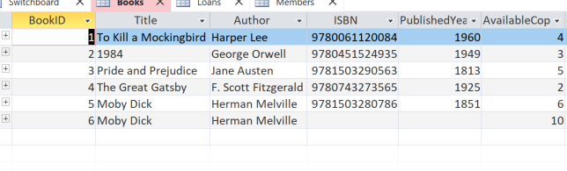
Members table:

Field Name | Data Type | Description
MemberID | AutoNumber | Unique identifier for each member (Primary Key)
FirstName | Short Text | First name of the member
LastName | Short Text | Last name of the member
PhoneNumber | Short Text | Member's contact number
Email | Short Text | Member's email address
DateJoined | Date/Time | Date the member joined the library

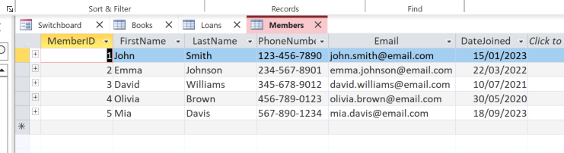

Loans Table:

Field Name | Data Type | Description
LoanID | AutoNumber | Unique identifier for each loan (Primary Key)
BookID | Number | Foreign key referencing Books table
MemberID | Number | Foreign key referencing Members table
LoanDate | Date/Time | Date when the book was loaned
DueDate | Date/Time | Date when the book is due
ReturnDate | Date/Time | Date when the book was returned (if applicable)

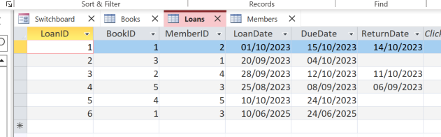

Establishing foreign key Relationships
- Go to Database Tools > Relationships.
- Add the Books, Members, and Loans tables.
- Define Relationships:
  - Drag BookID from the Books table to the BookID field in the Loans table.
  - Drag MemberID from the Members table to the MemberID field in the Loans table.
  - Ensure Enforce Referential Integrity is checked for both relationships.
4. Save the Relationships.

