Module Name: Foreign Languages and Cultural Awareness
Module Leader: Lisa Bassler

Assignment 2 Intercultural Competence Report
Student Name: Tatiana Raileanu
Student ID: 2211942

Executive summary
The following report will highlight the barriers to foreign language and cultural awareness for growing countries outside of the barrier. There are many difficulties if any organisation wants to open or expand their business in any foreign country. The general manager of Diversity Hotel & Spa London has visited a hotel in France, during the visit, he faced many difficulties with the language and cultures of that country. The report has highlighted the business culture of France along with the country analysis to discuss the business culture of the country.

Table of Contents
Introduction 4
Culture overview 5
Country analysis 6
The Business Environment 8
Conclusion 10
Recommendations 11
References 12

Introduction
The following report will highlight the foreign language as well as cultural awareness in business development. If any business is about to expand its business from outside its borders for this it can face many barriers in a foreign country. Discussing the cultures of that particular country the context will move forward by discussing the GLOBE project of that particular country as well. A country analysis will be taken forward by the context as well. After concluding the whole part of the report, the following context will state some sort of recommendations by which that newly ventured business gets help to increase their business operation in foreign countries as well.

Culture overview
The chosen country for the context is France which is highly diverse and rich in cultures and influences from many other different regions as well as the historical periods. The business culture of the chosen country has also been influenced by this kind of economic culture of the country as well (Hampden-Turne and Trompenaars, (2020). There are many characteristics of French business culture which are such as the business culture of the particular country being very formal. The titles that are related to any business should be written to any person for discussion. Moreover, professionalism is highly valued in this country, and hard work is admired by the workaholic spirit of any person as well. Focusing on the long-term relationships the business can discuss intellectual exercises as well as logic dominates (Maheshkar and Sharma, 2018).

Comparison of France with the UK
Both two countries have several differences in their culture, they have differences in their greeting method. Interest in culture is also different in both countries, in France, people genuinely have an interest in other cultures and love to debate on various points of view. Differences in the workplace can also be seen in both of the countries, British workplace is more hierarchical than France. Moreover, they separate their working time from their free time more than the British employees do generally. These differences between both countries will be expanded in the country analysis of the report (Globe Project, 2023).

Country analysis
The Political, economic, social and Legal aspects
The political aspect of France
France is a republic as well as a parliamentary democracy, the president of the republic is the Head of State. The politics of France is notorious and problematic, the revolution occurred because of the gap between the wealthy as well as poor people in the country. The government of France has kept a tight administration to control the discrimination of this. Moreover, France plays an important role in international politics as well as the Western world. The French Union is also a key to European development. Diplomatic alliances and stable politics on the other hand have given many advantages to the country and its business environment.
The Economic aspect of Franch
During the world recession, France faced bankruptcy like all other European countries. The strong government invasion has helped to restore the banking and financial sectors of the country as well. However, it still suffers from the invasion and deficiency caused by years of Raymond Barres. Moreover, The French business community have made a significant contribution to the European economy as well. Trade partners, high GDP, trade partners and trade partners are other important reasons that align the economic aspects of the country as well (FRUE, 2019).
The Social Aspect of France
The economy of France is affected the social class as well, the disparity between many classes in the country can increase the crime rate in the country as well. Workers are often on strike for the reduced income as well as productivity in business. The chosen country is very modern and French culture, perfume, and fashion are very significant and copied by many people throughout the world (Christiansen et al., 2020).
The legal aspect of France
The working weeks of the worker in France comprise 35 hours, and French law and regulation provisions for sabbatical leaves. There are no sick leaves or overworking time in this country as well.

Importance of cultural intelligence and sensitivity
Cultural intelligence is the ability to deal with new people who are from different cultural backgrounds. Maintaining sensitivity in this case is important for any hotel industry as well as personnel. Both of them are very important aspects of the modern hospitality industry, this leads to help in customer as well as employee comfort. Additionally, increased guest satisfaction, employee comfort and retention can be fostered by these two aspects (Kainzbauer and Hunt, 2019).

The Business Environment
France is a very industrialiser and advanced country and is placed as the third largest economy in Europe. The pro-business environment and sophisticated financial market have helped the country be placed in the market. Being one of the largest markets in the world the French government has implemented many resources to attract investment through advanced marketing policy incentives, overseas and investor support.
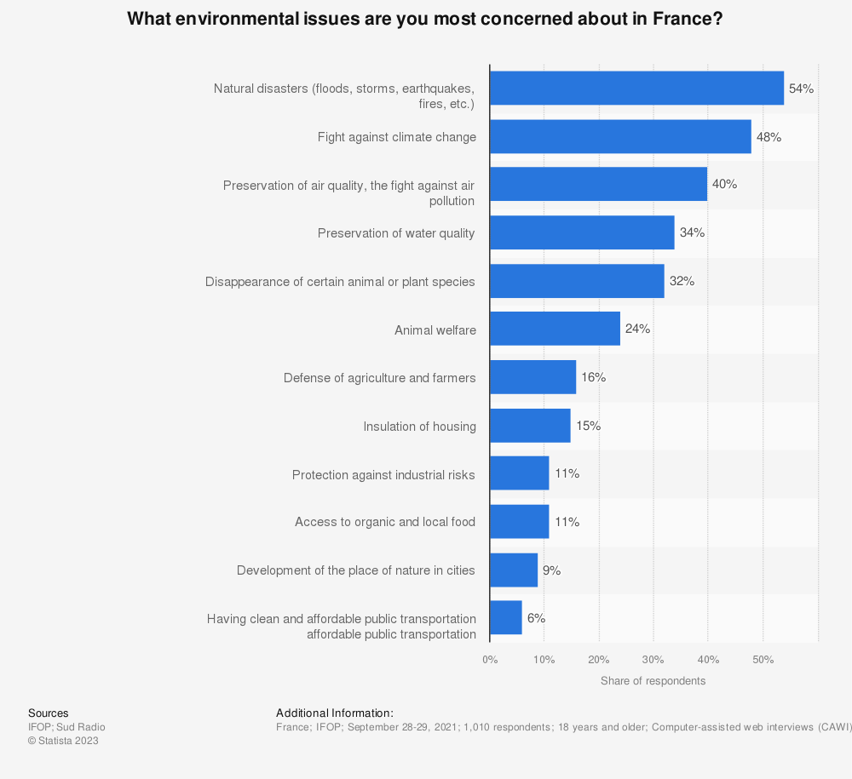
(Source: (Statista, 2023)
The production system in France is the most important in Europe, the total goods as well services that are produced in France amounted to 2.5 trillion euros. The French economy has made more than four million companies in Europe (Statista, 2023).
The level of development in the country
France is a developed country with a high level of human development, the human development index (HDI) has scored 0.903 which is higher than the average of 0.724. The country has also ranked 22nd in the corruption perceptions index as well. It has a good educational as well as health system and high life expectancy with low infant mortality. All development makes the country to be better developed in the business market throughout the world (Conceição, 2023).

Conclusion
The following report has highlighted the foreign language as well as cultural awareness in business development. Discussing the cultures of that particular country the context has moved forward by discussing the country analysis of that particular country as well. After concluding the whole part of the report, the following context has stated some sort of recommendations by which the ventured business gets help to increase their business operation in foreign countries as well.

Recommendations
France is a very modern and sophisticated country to grow business from outside, there are many recommendations that any business organisation should know to be productive there. The important recommendations for growing business in France are going to be discussed further.
- Market research
Understanding the market of any country is important for growing any business outside the border. The research gives a clear idea about the market, so the marketers know the competition of the market and adapt their service as well as products as per it (Musayeva et al., 2021).
- Language and cultural proficiency
Language can be a great barrier to expanding business in a foreign market, apart from that cultural proficiency is also important to know the culture along with their needs. It is highly recommended to the business organisation to be proficient in the French language which help in building relationship and navigating with customers.

References
BBC, (2023). Language. [Online] Available at: https://www.bbc.co.uk/languages/learn/index.shtml#:~:text=There's%20no%20single%20universal%20foolproof,longer%20session%20once%20a%20week. [Accessed 11 October 2023].
Christiansen, B., Branch, J.D. and Karmowska, J. (2020) Cultural Factors and Performance in 21st Century Businesses. Hershey: IGI Global.
Conceição, P., (2023). Human Development Report 2020-The Next Frontier: Human Development and the Anthropocene. In Human Development Report 2020-The Next Frontier: Human Development and the Anthropocene: Conceicao, Pedro. [Sl]: SSRN.
FRUE, K., (2019). A Look into the French Politics and Economy. [Online] Available at: https://pestleanalysis.com/pestle-analysis-of-france/ [Accessed 11 October 2023].
Globe Project, (2023). A unique large-scale study of cultural practices, leadership ideals, and generalized and interpersonal trust in 150 countries in collaboration with nearly 500 researchers.. [Online] Available at: https://globeproject.com/ [Accessed 11 October 2023].
Hampden-Turner, C. and Trompenaars, F. (2020) Riding the Waves of Culture. 4th Ed. London: John Murray Press.
Kainzbauer, A. and Hunt, B., (2019). Meeting the challenges of teaching in a different cultural environment–evidence from graduate management schools in Thailand. In Teachers’ Perceptions, Experience and Learning (pp. 55-67). Routledge.
Maheshkar, C. and Sharma, V. (2018) Handbook of Research on Cross-Cultural Business Education. Hershey: IGI Global.
Musayeva, S.A., Usmonova, D.I. and Usmanov, F.S., (2021). Problems with Marketing Research in the Furniture Market. Eurasian Journal of Academic Research.
Ordorica, S., (2021). Bilingual Organizations: The Leaders Of Global Expansion. [Online] Available at: https://www.forbes.com/sites/forbesbusinesscouncil/2021/03/23/expanding-your-business-to-a-bilingual-organization/?sh=70684bfc4f88 [Accessed 11 October 2023].
Statista, (2023). Companies in France - statistics & facts. [Online] Available at: https://www.statista.com/topics/6681/companies-in-france/#topicOverview [Accessed 11 October 2023].

