University of Wales Trinity Saint David
School of Engineering
Motorsport Engineering BEng

Analytical Assessment of Engine Internal Components
Contemporary Powertrain Design (ACHA6006)

Priveshnan Soemani Segaran
2204879
March 2025

Word Count: 2469 after excluding cover page, table of contents, equations, tables, titles, and captions

Table of Contents
1. Introduction 3
2. Increasing Engine RPM 4
3. Fatigue 9
3.1. Causes of Fatigue 9
3.2. Fatigue Safety Factors 9
3.3. Preventing Fatigue Failures 10
4. Components and Materials 11
4.1. Connecting Rod 11
4.2. Gudgeon Pin 12
4.3. Connecting Rod Bolt 13
4.4. Material Selection 14
5. Analysis 15
Material Changes 15
Connecting Rod Goodman Diagram 15
Gudgeon Pin Goodman Diagram 17
Bolt Goodman Diagram 19
Geometric Changes 21
Bolt Length 21
Bolt Cross Sectional Area 22
Bolt Stiffness 23
6. Flat-Plane vs Cross-Plane 24
Torque & Power Graphs 25
Inertia Torque 25
Inertia Torque Analysis 28
Gas Torque 29
Gas Torque Analysis 32
Crank Torque 33
Crank Torque Analysis 36
Power 37
7. Conclusion 38
8. References 39

Introduction
The continuous evolution of internal combustion engines (ICEs) is driven by the demand for improved performance, enhanced fuel efficiency, and stringent environmental regulations. As automotive and motorsport industries strive to push the boundaries of powertrain design, engineers must analyse and optimize engine components to withstand high mechanical stresses, reduce weight, and improve durability. In the case of motorsport, the need to increase engine revolutions per minute (RPM) is highly prevalent in motorsport and high-performance automotive applications. An engine that can perform at a higher RPM is highly sort after in the motorsport industry. A higher RPM range usually indicates increased power output. With that being said, a higher RPM range will also amplify the mechanical loads acting on internal components, accelerating wear and increasing the likelihood of failure due to fatigue. This assignment will thoroughly investigate the forces exerted on the component of the Ford 1.6 Sigma components, mainly the connecting rod (conrod), gudgeon pin, and connecting rod bolts, to ensure they meet safety and durability requirements and the potential design optimizations to improve them. Furthermore, an extended RPM range analysis up to 9000 RPM will be conducted to assess the impact of increased operating speeds on component longevity and performance. Based on these findings, the geometry of the connecting rod bolts will be redesigned to maintain a safety factor comparable to the original RPM range or better.

Increasing Engine RPM
For this assignment, it will be investigated how increasing the Ford Sigma’s RPM from 6000 to 9000 affects the engine components. Firstly, we will discuss the benefits of increasing and engines RPM limit. The need for greater engine power, efficiency, and power density has mandated higher engine speeds (RPM) in the new internal combustion engines. Increasing an engine's RPM limit provides several performance benefits, primarily by extending the powerband and allowing the engine to produce more horsepower (carthrottle, 2016). A higher rev limit enables the vehicle to stay in lower gears longer, maximizing acceleration and reducing the need for frequent gear shifts. It also allows the engine to operate within its peak power range for a longer duration, improving overall speed and responsiveness. This increased speed, however, introduces more mechanical stresses and fatigue loads on the important components such as connecting rods, crankshaft, and bolts (bajajallianz, 2025).
The figures below display the force acting on the components of the engine. The force in question are Piston Acceleration, Inertia Force, Gas Force and Net Force.

Piston Acceleration
$$\frac{d^{2}S}{dt^{2}}=Rω^{2}cosθ+ \frac{R^{2}}{L}ω^{2}cos2θ$$

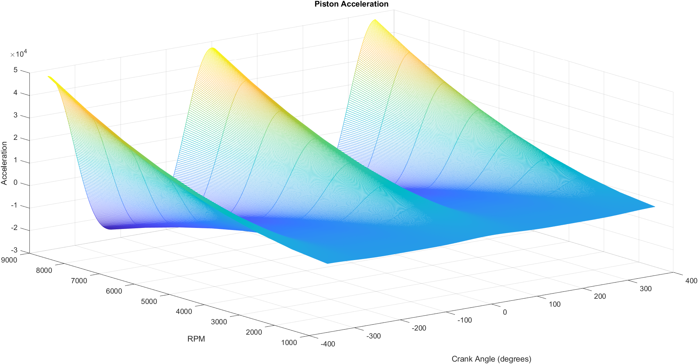
Figure 1: Piston Acceleration Graph from 1000 to 9000 RPM

Inertia Force
$$m_{rec}=Reciprocating Mass (Kg)$$

$$F_{inertia= m_{rec} × }\left(Rω^{2}cosθ+ \frac{R^{2}}{L}ω^{2}cos2θ\right)$$

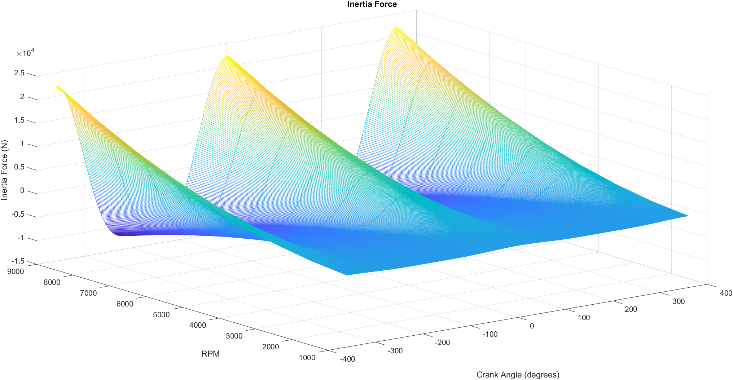
Figure 2: Inertia Force Graph from 1000 to 9000 RPM

Gas Force
$$F_{gas}= P_{cyl} ×Area$$

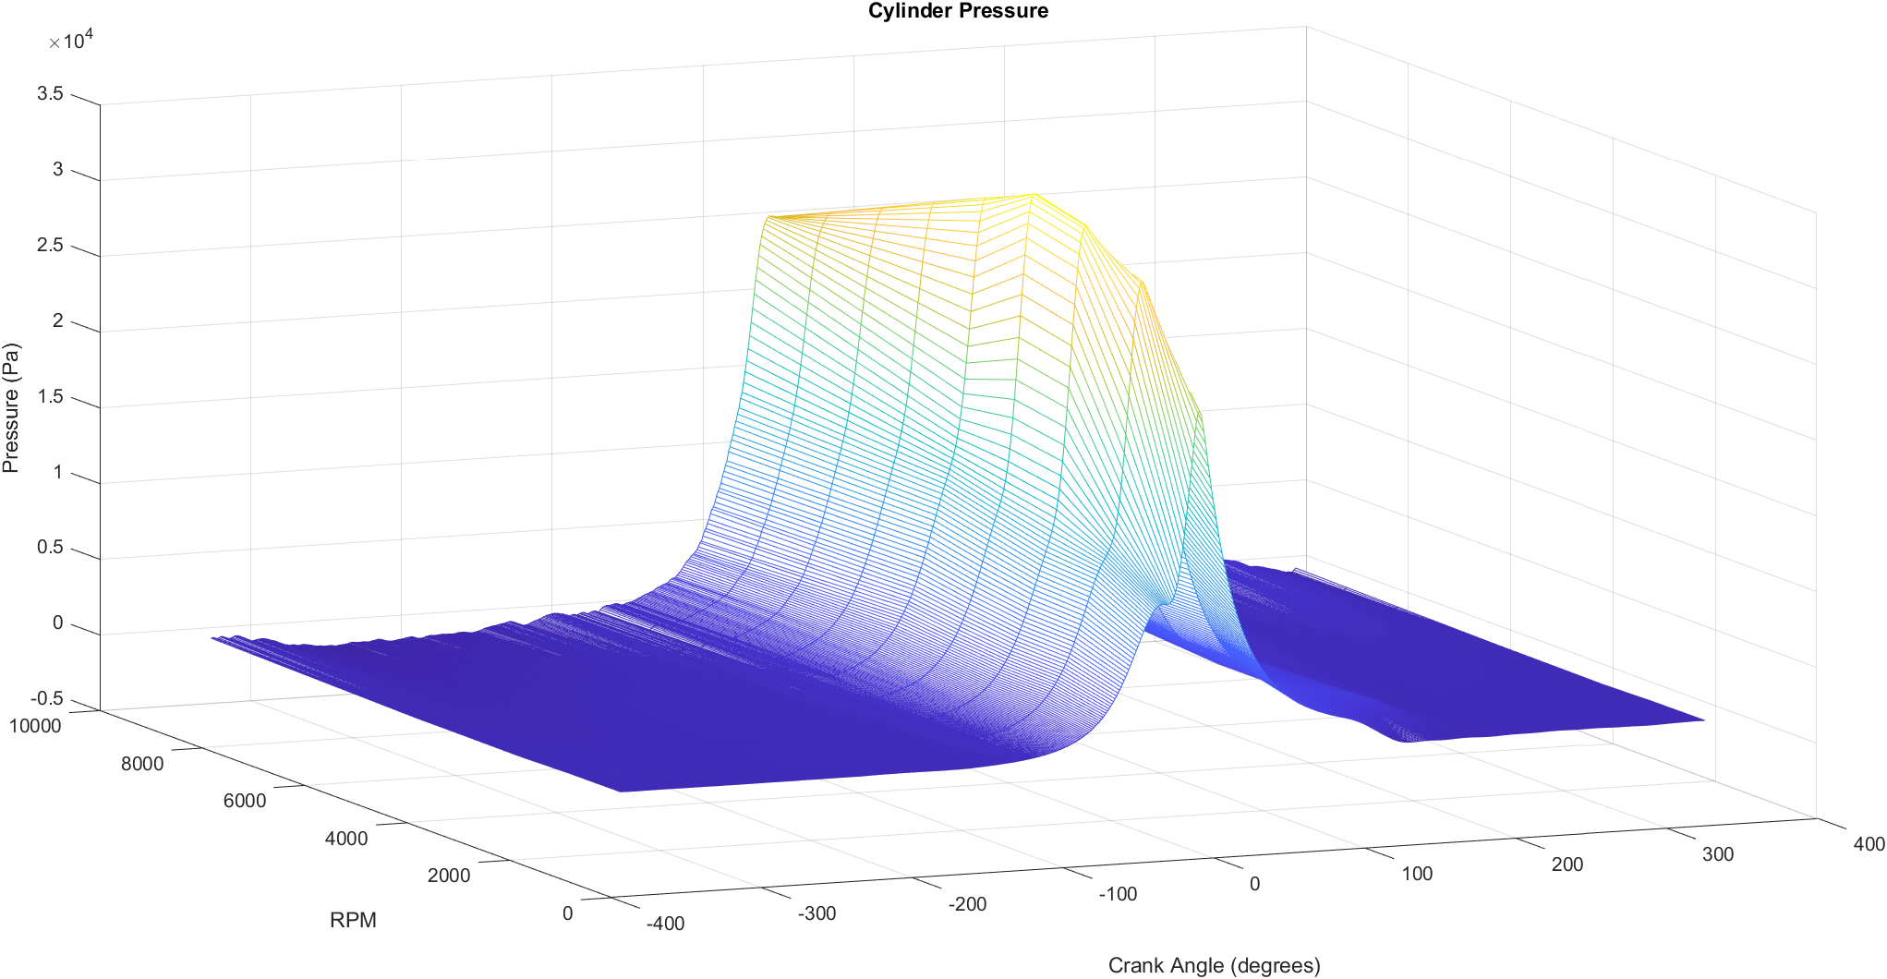
Figure 3: Gas Force Graph from 1000 to 9000 RPM

Net Force
$$F_{net}= F_{inertia }- F_{gas}$$

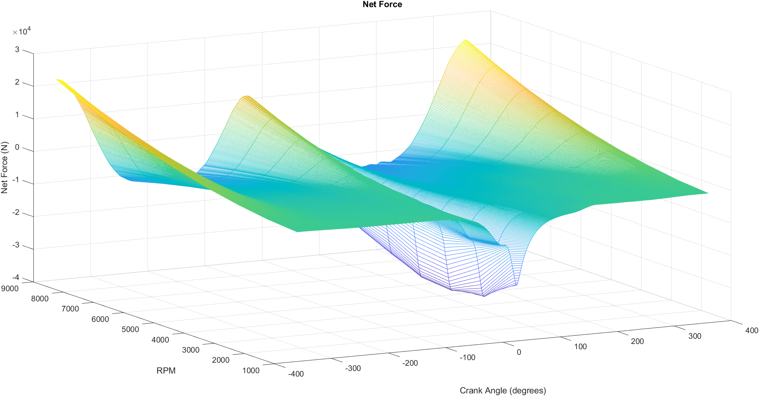
Figure 4: Net Force Graph from 1000 to 9000 RPM

Fatigue
Fatigue of a material is defined as a progressive structural damage when the material is subjected to cyclic or fluctuating loads. When the experienced stress range falls below the material strength, structural damage and failure will occur. Fatigue is the most common source behind failures of mechanical structures. The best way to comprehend fatigue is to understand the Fatigue Cycle. The fatigue cycle is when a material is experiencing a repeated amounts of loading and unloading in a continuous cycle. Each cycle introduces microscopic damage, accumulating over time and ultimately leading to the formation of cracks (comsol, 2016).

Causes of Fatigue
The primary cause of fatigue can be narrowed down to 4 main factors, those being Cyclic Loading, Material Selection, Environmental Factor and Design Flaws. For this assignment the main factor that will be studied is cyclic loading and material defect. Cyclic loading is the most prevalent cause of fatigue. Cyclic loading is the repeated application of stress over time, which can lead to material fatigue failure even when the stress is significantly lower than the ultimate tensile strength (UTS) of the material. Cyclic loading is intensified when the magnitude and frequency is increased. This is one of the segments that will be investigated in this assignment. The RPM of the ford sigma engine which currently tops out at 6000 RPM will be increased to 9000 RPM and an investigating will be carried out. The other factor that will be investigated in this assignment is the Material Selection. In this segment, different material with different UTS will be used on different component to investigate how they compare to each other when subject to a load of 9000 RPM (sdcverifier, 2025).

Fatigue Safety Factors
The fatigue safety factor is a measure used in engineering design to ensure that a component can withstand cyclic loading without experiencing fatigue failure during its intended service life. It accounts for uncertainties in loading conditions, material properties, environmental effects, and manufacturing defects. The maximum Factor of Safety is 15. For Fatigue Safety Factor, values less than one indicate failure before the design life is reached. (Zhang, 2023).

Preventing Fatigue Failures
Preventing fatigue failures is a multifaceted challenge. There are several methods that can be implemented, such as Material Selection, Stress Reduction and Surface Finishing. For this assignment, material selection will be one of the methods studied. Selecting the appropriate material is crucial. High fatigue strength materials, such certain alloys or composites, can sustain more stress cycles before breaking (sdcverifier, 2025).

Components and Materials

Connecting Rod
The connecting rod connects the piston to the crankshaft and consists of the small end and big end bores as well as the shank. As the crucial link transferring forces and motion between the piston and crankshaft, the connecting rod is subjected to significant alternating loads. It endures compressive forces from the piston due to the dominant gas pressure and tensile forces, primarily caused by inertia effects. It must also possess sufficient structural strength to withstand the vigorous conditions of engine operation (MAHLE, 2016).
For this investigative process, the manipulated variable will be the stock connecting rod material which is Powder Metal Steel. The other comparison materials that will be used is Ti-6Al-4V Titanium. Ti-6Al-4V Titanium is an excellent choice for a high-performance connecting rod, particularly for engines operating at 9000 RPM due to its exceptional combination of high strength, low weight, and fatigue resistance. The next comparison material that will be investigated is 4340 Forged Steel. For a 9000 RPM Ford Sigma 1.6 engine, 4340 Forged Steel is a practical and highly durable choice that balances high strength, fatigue resistance, and affordability, making it one of the best materials for a long-lasting and high-performance connecting rod.

Gudgeon Pin
The piston pin is the link between the piston and the connecting rod. Owing to the oscillating motion of the piston and the overlay of gas and inertial forces, it is subjected to high loads in alternating directions. The pin withstands shear and bending stresses, compressive and impact loads, especially during the combustion stroke when the piston is subjected to high gas pressure (MAHLE, 2016).
The stock gudgeon pin material used in the Ford Sigma engine is case-hardened steel. For this investigation, the two materials that will be used for comparison are the AISI 9310 Tool Steel and Ti-10V-2Fe-3Al Titanium. The AISI 9310 Tool Steel has a high ultimate tensile strength of 930 MPa and endurance limit of 550 MPa, which is greater than most standard steels. This ensures that the pin will not fail or deform when it is subjected to the high compressive and bending stresses that it is experiencing at 9000 RPM. The Ti-6Al-4V possesses a maximum tensile strength of 1000 MPa and an endurance limit of 510 MPa, sufficient to withstand excessive loads and pressures inside the combustion chamber.

Connecting Rod Bolt
The connecting rod bolt is a significant fastener that secures the big end of the connecting rod to the crankshaft. It is a vital component in maintaining the strength of the rod-to-crankshaft assembly, ensuring the smooth and reliable operation of the engine. The connecting bolt rod is also experiencing harsh cyclic loads, maximum tensile loading as it bends when deformed during extension through the reciprocation of crankshaft-piston and shear on rotation of crankshaft (MAHLE, 2016).
The material for the connecting rod bolt in the Ford Sigma engine is high-strength alloy steel. The material used currently might not be able to withstand an engine output of 9000 RPM. Thus, ARP 2000 Alloy Steel and Custom Age 625+ will be used as comparison materials. One of the most noticeable attributes of ARP 2000 steel is the extremely high ultimate tensile strength (UTS) 1517 MPa that is much improved over standard high-strength alloy steel. This ensures that rod bolts will be capable of withstanding the massive inertial loads generated by the reciprocating action of the piston and connecting rod assembly. Custom Age 625+ has an extremely high ultimate tensile strength (UTS) 1795 MPa which is far better compared to regular steel alloys like 8740 or ARP 2000. This extreme strength allows the rod bolts to withstand the excessive loads experienced during high-RPM application.

Material Selection
Components | Material | Ultimate Tensile Strength (MPa) | Endurance Limit (MPa)
Connecting Rod | Ti-6Al-4V Titanium | 1000 | 510
Connecting Rod | 4340 Forged Steel | 1275 | 690
Gudgeon Pin | AISI 9310 Tool Steel | 930 | 550
Gudgeon Pin | Ti-10V-2Fe-3Al Titanium | 1300 | 700
Connecting Rod Bolt | ARP 2000 Alloy Steel | 1517 | 760
Connecting Rod Bolt | Custom Age 625+ | 1796 | 800

Analysis

Material Changes

Connecting Rod Goodman Diagram
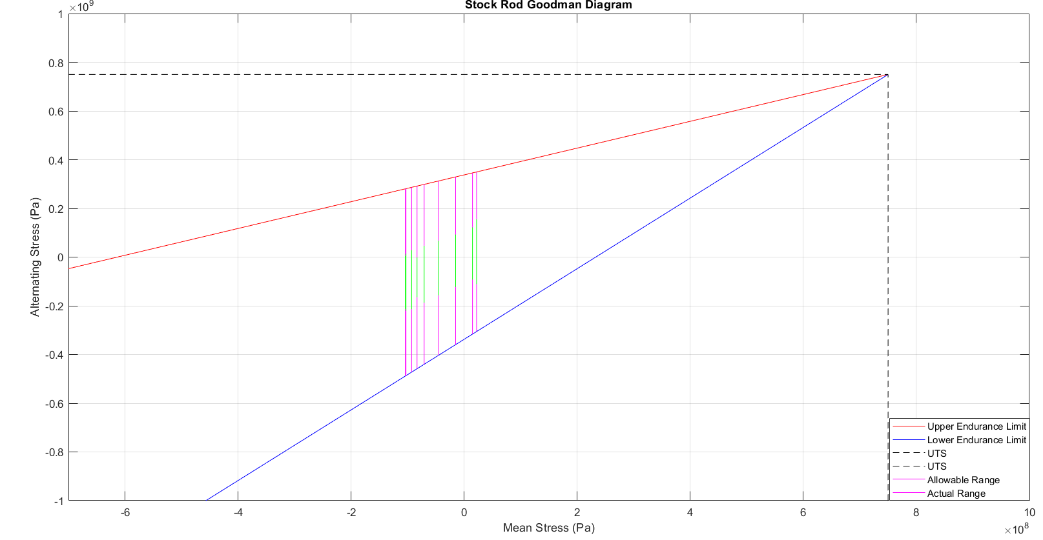
Figure 5: Goodman Diagram (Powder Metal Steel Connecting Rod)
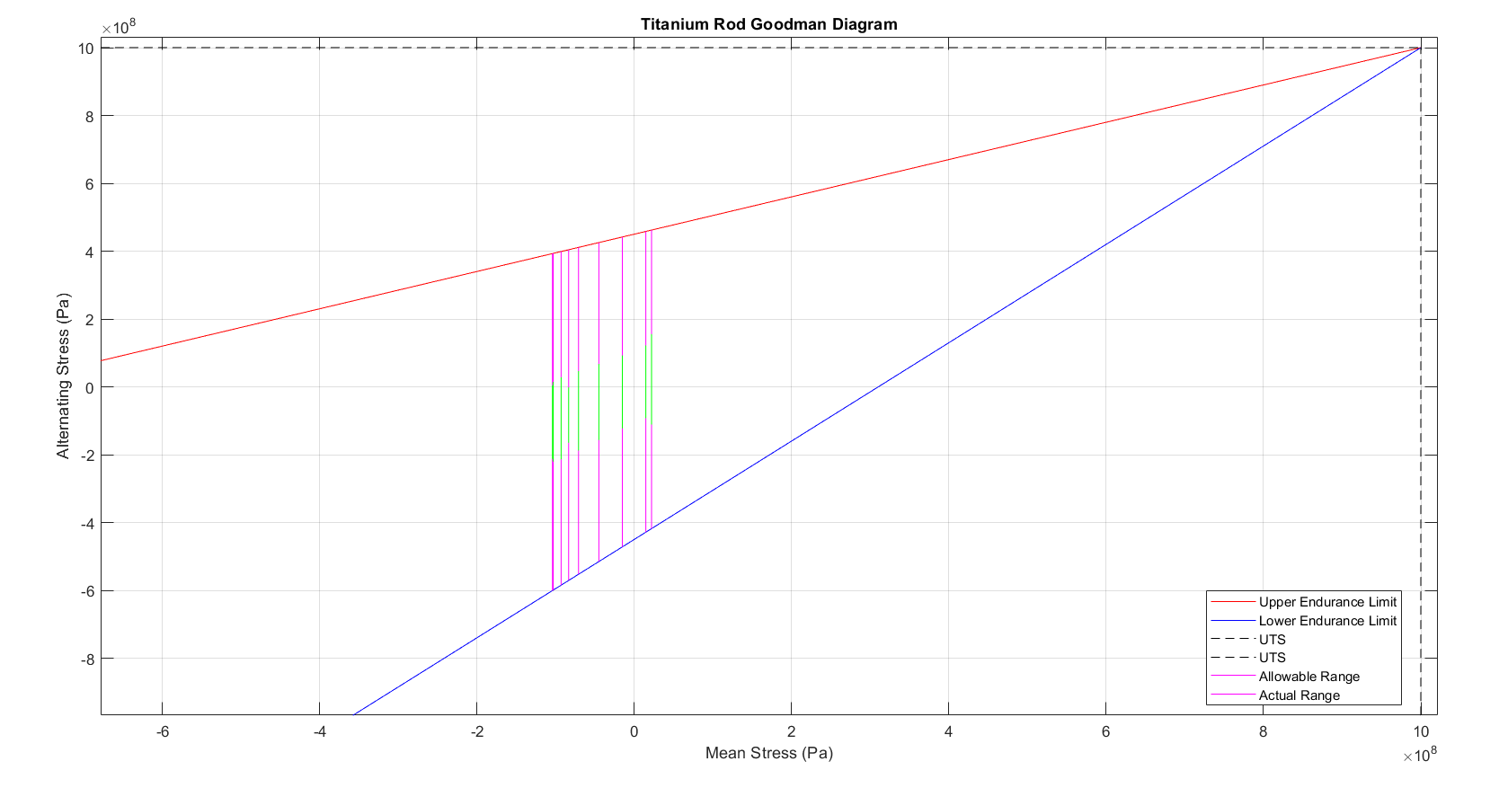
Figure 6: Goodman Diagram (Titanium Connecting Rod)
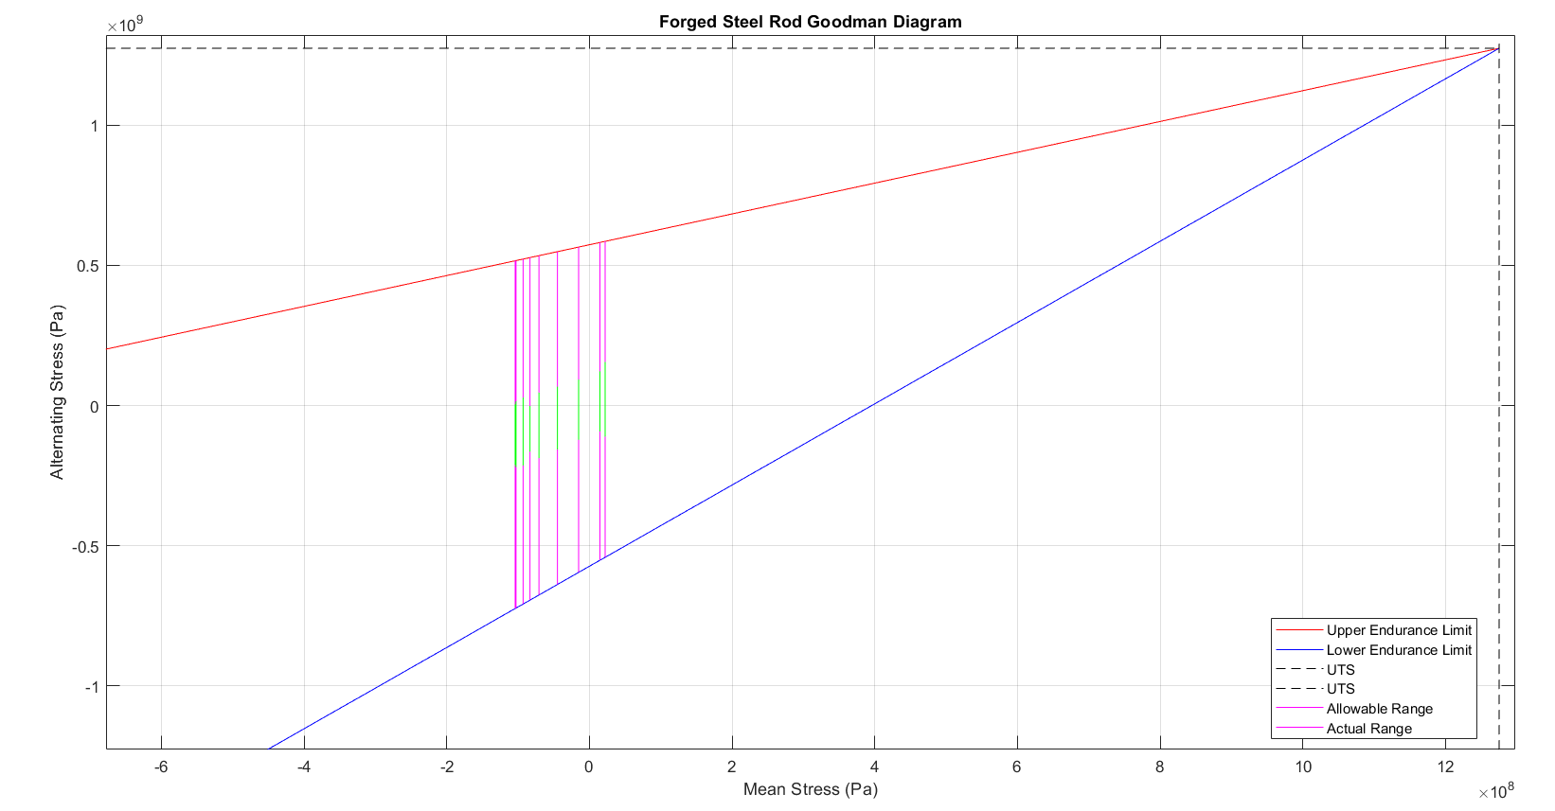
Figure 7: Goodman Diagram (Forged Steel Connecting Rod)

From figure 3, 4 and 5, The Powder Metal Steel Connecting Rod shows that the actual operating stress range remains within the allowable stress limits, indicating that the stock material operates safely under normal conditions. It has a relatively lower endurance limit compared to alternative materials. The titanium rod Goodman diagram displays improved mechanical properties over the stock rod. The endurance limits are higher, indicating better fatigue resistance, and the UTS is significantly greater, meaning the material can handle higher tensile stresses before failure. The forged steel rod Goodman diagram presents the highest endurance limit and UTS among all three materials. The upper and lower endurance limits are significantly higher than those of both the stock and titanium rods, meaning forged steel has the greatest fatigue resistance. The actual stress range remains well within the safe operating limits, giving it the highest margin of safety. After comparing the Goodman diagrams for all three materials, forged steel emerges as the best material for the connecting rod.

Gudgeon Pin Goodman Diagram
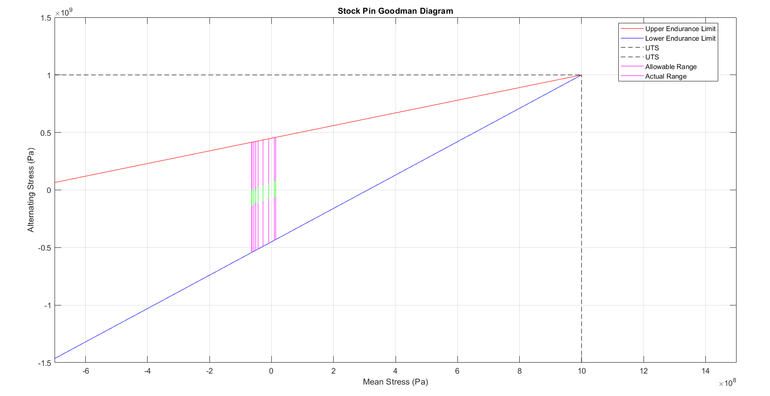
Figure 8: Goodman Diagram (Case-Hardened Steel Gudgeon Pin)

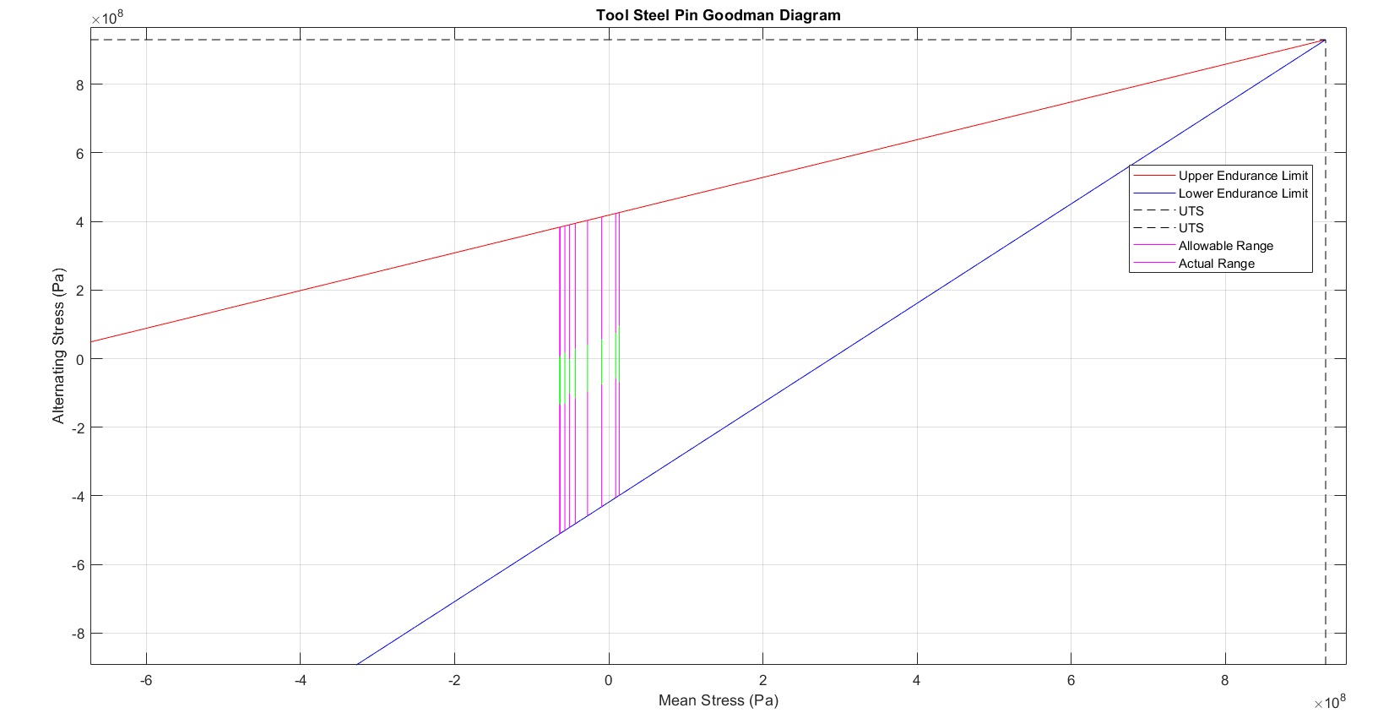
Figure 9: Goodman Diagram (Tool Steel Gudgeon Pin)
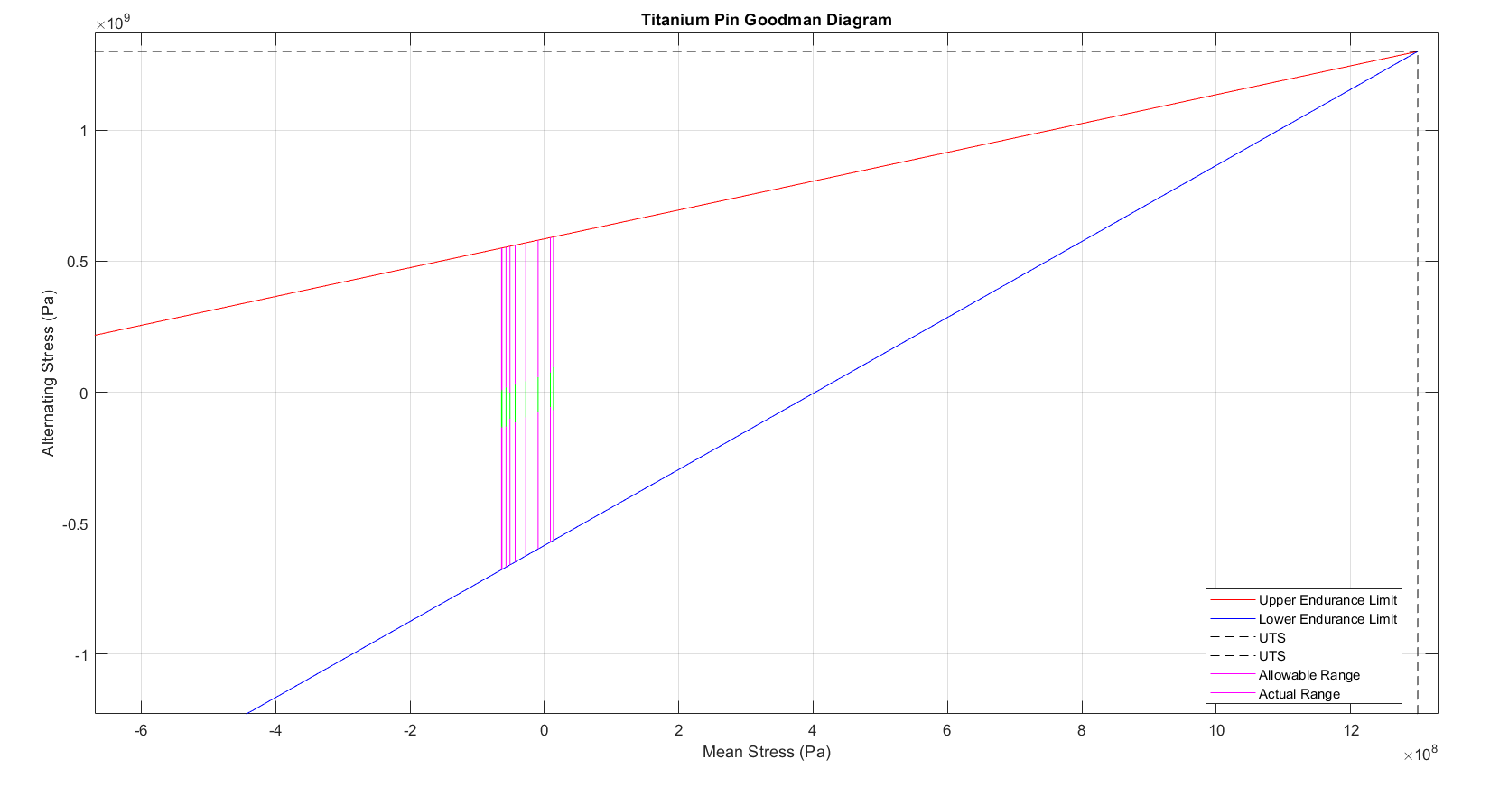
Figure 10: Goodman Diagram (Titanium Gudgeon Pin)

From figure 6,7 and 8, the Case-Hardened Steel gudgeon pin has an adequate but not impressive ultimate tensile strength (UTS). It will perform adequately under normal conditions, but its limited endurance margin suggests that it may be more susceptible to fatigue failure under prolonged or extreme stress conditions. Tool steel has higher endurance limits, allowing it to withstand greater cyclic stresses before experiencing fatigue failure. The UTS is also considerably higher, meaning that it can sustain greater loads before reaching its breaking point. The titanium pin can sustain the highest alternating and mean stresses before failure, making it the most robust and durable choice for extreme conditions. The actual stress range remains well within the allowable limits, demonstrating a superior safety margin compared to both the stock and titanium pins. After comparing the Goodman diagrams for all three materials, titanium emerges as the best choice for the gudgeon pin.

Bolt Goodman Diagram
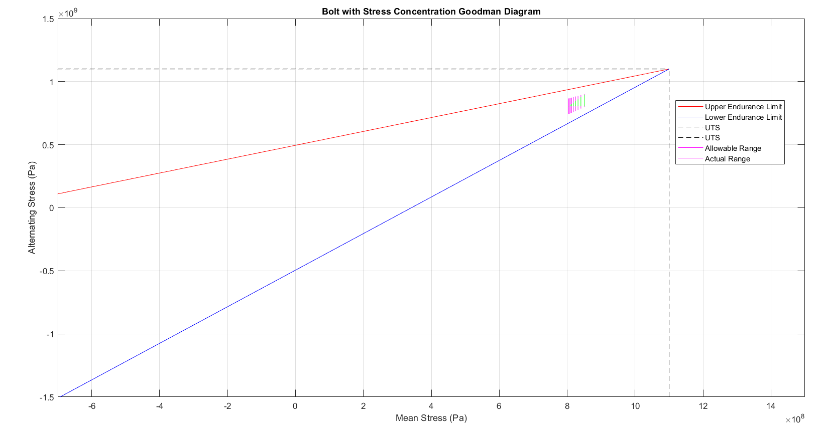
Figure 11: Goodman Diagram (High-Strength Steel Bolt)

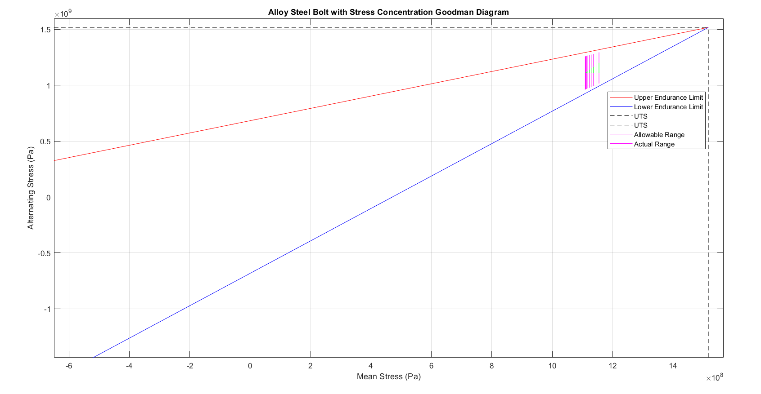
Figure 12: Goodman Diagram (Alloy Steel Bolt)
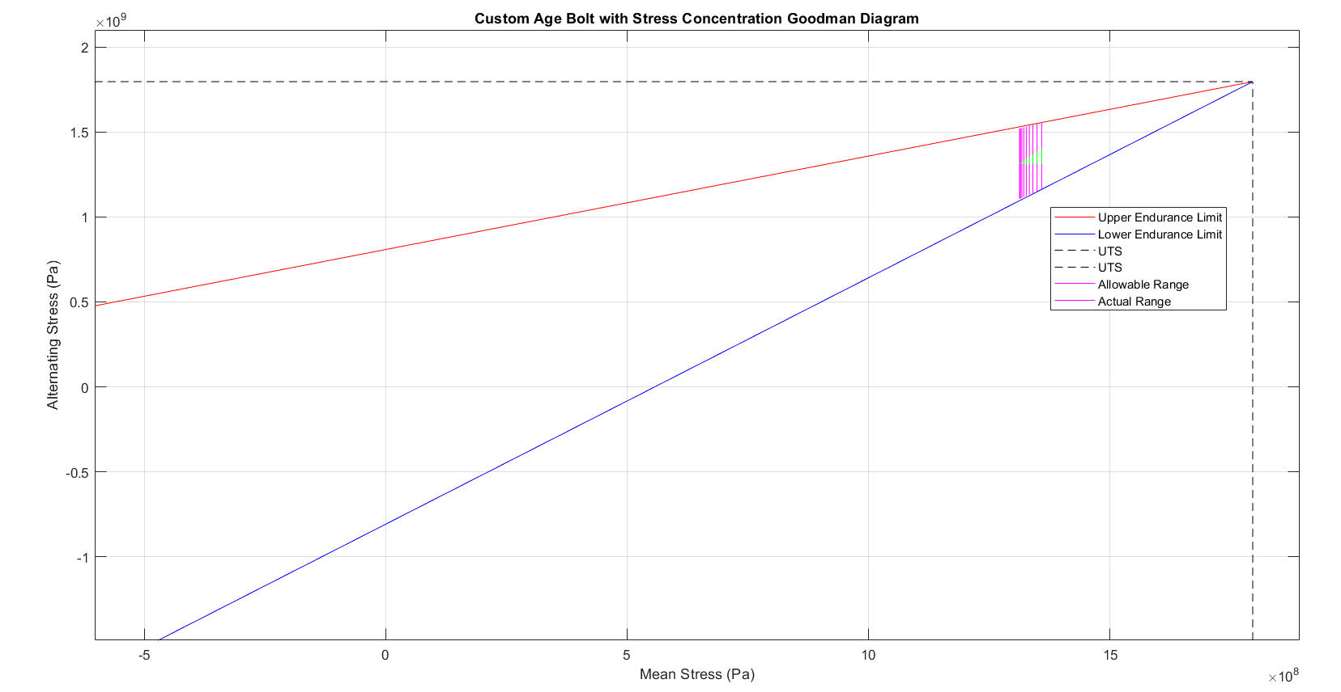
Figure 13: Goodman Diagram (Custom Age Alloy Bolt)

Looking at figures 9,10 and 11, the analysis shows the UTS of the High-Strength Steel bolt is reasonable but not particularly high, which means it may be prone to failure under extreme loading conditions. Additionally, the stress range is positioned close to the endurance limit, implying that the stock bolt may experience fatigue failure over time if subjected to high cyclic stresses or prolonged use. The alloy steel bolt’s endurance limits are higher, meaning alloy steel can withstand greater cyclic stresses before fatigue failure occurs. The UTS is also substantially greater, allowing it to handle higher loads without breaking. The Custom Age alloy bolt Goodman diagram presents the highest endurance limits and UTS among the three materials. The upper and lower endurance limits are significantly higher than those of the stock and alloy steel bolts, meaning the Custom Age alloy exhibits the best fatigue resistance. This allows it to endure extreme cyclic stresses without failure, making it the most durable and reliable option for connecting rod bolts.

Geometric Changes

Bolt Length

Figure 14: Bolt Length (m) vs Fatigue Safety Factor at different RPM

From figure 14, the length of the bolt significantly effects the bolt fatigue safety factor (FSF). From the graph above, it is proven that when length of the bolt is increased the FSF decreases. The starting length of bolt was 0.02726 m. A reduction of 50% has been done to the initial length, shorter bolts lead to stiffness increase which improves fatigue life but may introduce excessive stress concentrations. A further 150% increment of the original length shows increasing bolt length decreases stiffness, which affect fatigue life negatively.

Bolt Cross Sectional Area

Figure 15: Bolt Cross-Sectional Area (m²) vs Fatigue Safety Factor at different RPM

Referring to figure 15, the graph shows when the Bolt Cross-Sectional Area (CSA) is increased, the FSF also increases. This occurs because stress is inversely proportional to CSA, increasing the bolt diameter which increases CSA reduces the stress in the bolt which in turn increases the fatigue safety factor. To validate this graph, the starting point of bolt CSA which is 0.00004243 m^2 is then increased by 50% as it is a realistic upper limit to see if increasing CSA continues improving FSF or if the improvement levels off.
Equations used:
$$σ=\frac{F}{A}$$
σ = Stress (MPa)
F = Force applied on the bolt (N)
A = Cross-sectional area (m²)
$$FSF=\frac{σendurance limit}{σapplied}$$

Bolt Stiffness

Figure 16: Bolt Stiffness (N/m) vs Fatigue Safety Factor at different RPM

From figure 16, it can be confirmed bolt stiffness increases FSF confirming that reducing bolt elongation minimizes stress fluctuations. It can also be seen at higher RPMs there is a greater FSF variations, indicating that stiffness improvements are more beneficial at higher engine speeds. To produce this graph, bolt stiffness of 327000000 N/m was increased by 50% to see if increasing stiffness continues improving FSF or if the improvement levels off.
Equations to calculate Bolt Stiffness:
$$K=E\frac{A}{L}$$
$$\frac{1}{K_{bolt}}=\frac{1}{K_{1}}+\frac{1}{K_{2}}+\frac{1}{K_{3}}$$

Flat-Plane vs Cross-Plane
A flat-plane crankshaft has a 180-degree crankpin arrangement, which generates an even firing order for better high-RPM efficiency and exhaust scavenging. It is designed to be lighter, allowing faster revving but with increased vibration and reduced low-end torque. It is common in high-performance V8s and inline engines and offers a sharp, high-pitched exhaust note but requires additional balancing. A cross-plane crankshaft, on the other hand, has a 90-degree crankpin layout, which inherently balances vibrations and provides smoother operation with better low-end torque. Its larger counterweights, however, contribute rotational inertia, limiting high-RPM performance. Employed in most V8s. (carthrottle, 2024).

Torque & Power Graphs

Inertia Torque
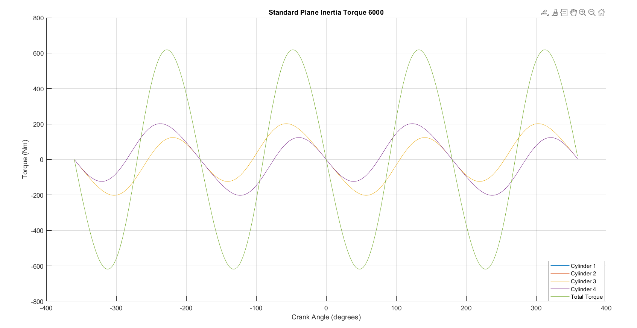
Figure 17: Flat Plane Inertia Torque at 6000 RPM

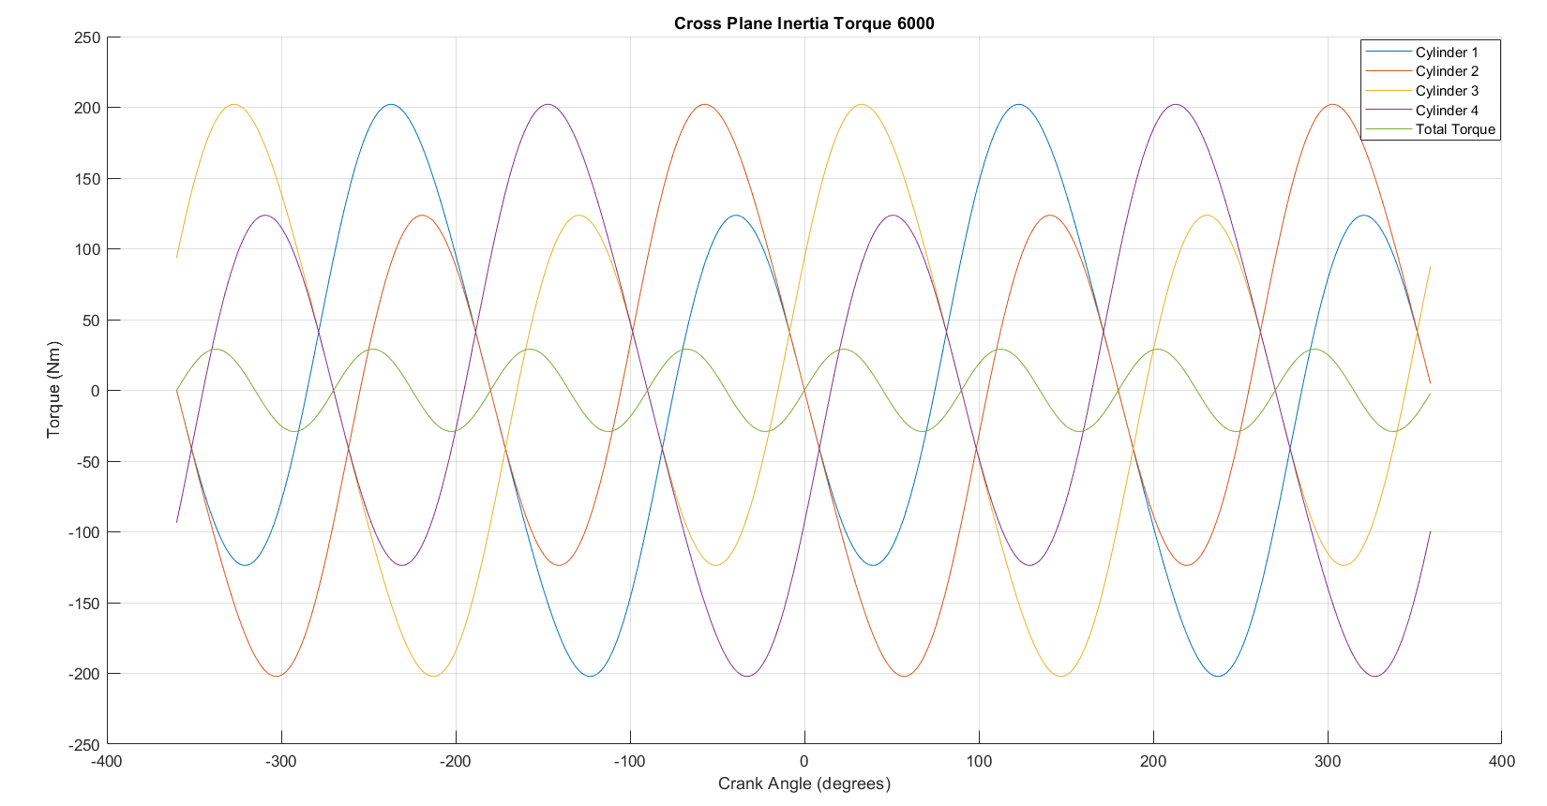
Figure 18: Cross Plane Inertia Torque at 6000 RPM

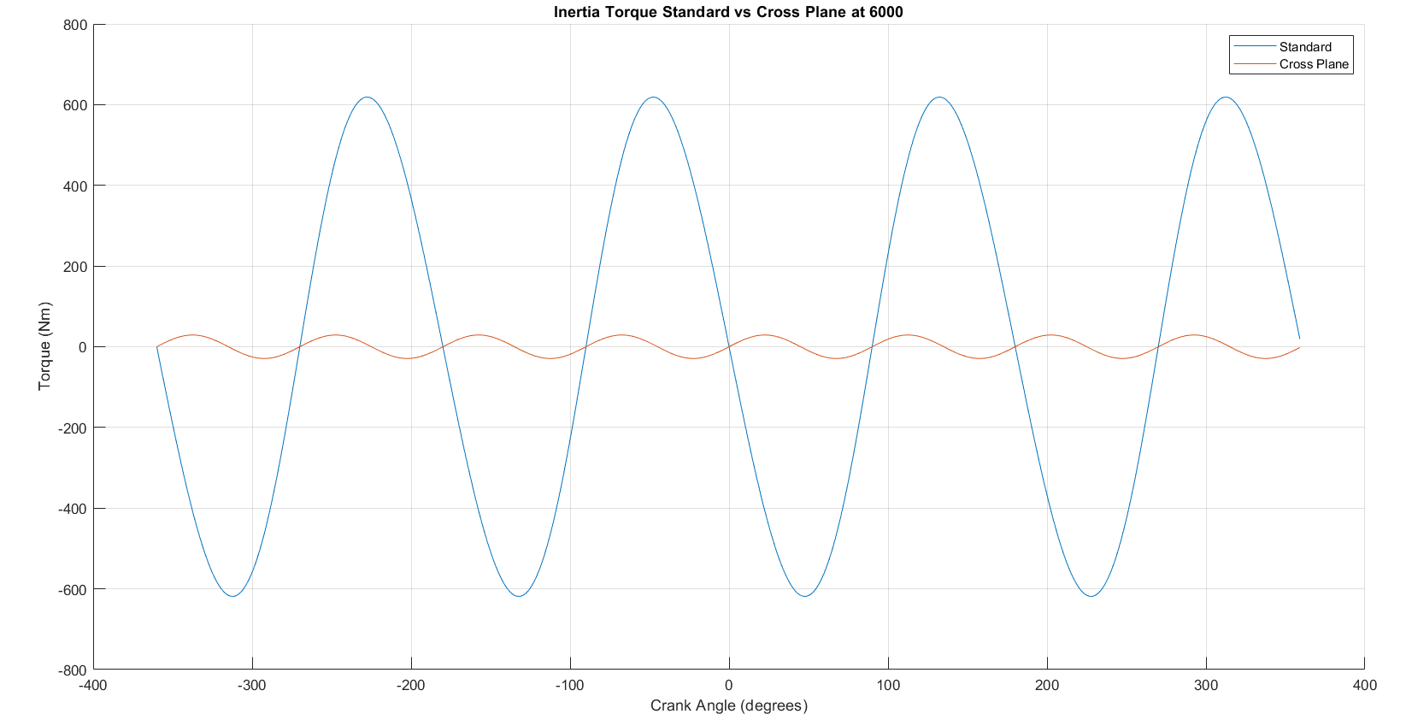
Figure 19: Inertia Torque Standard vs Cross Plane at 6000

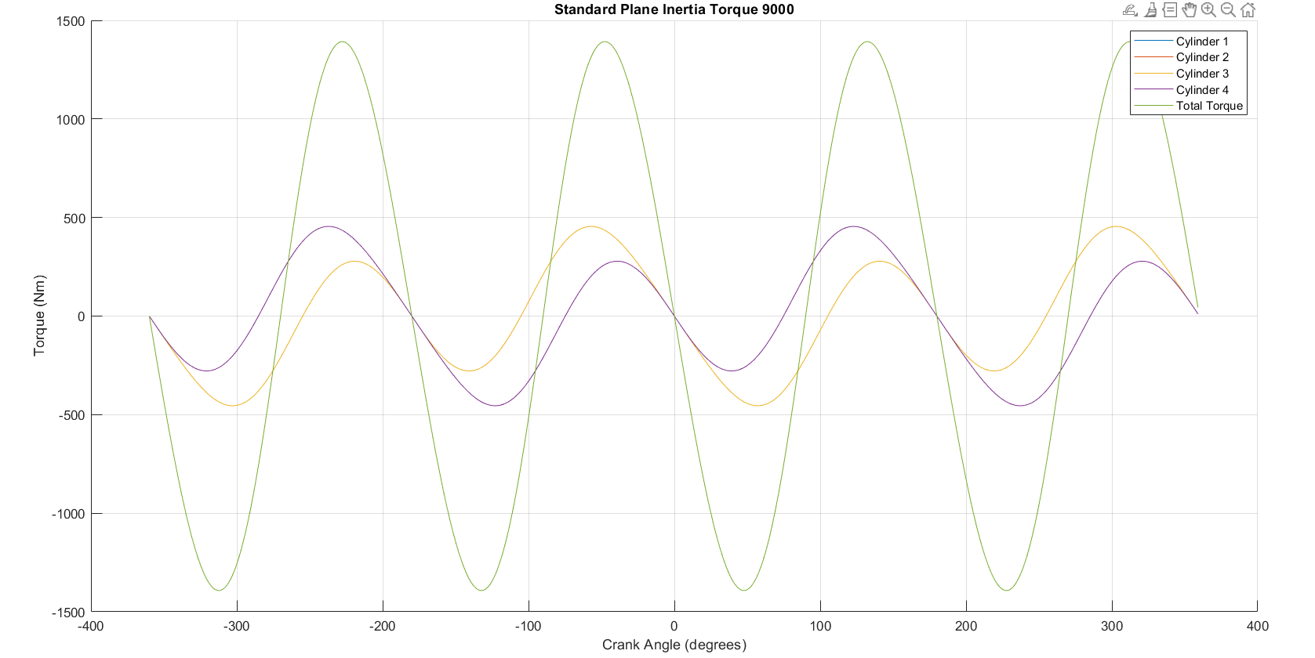
Figure 20: Flat Plane Inertia Torque at 9000 RPM

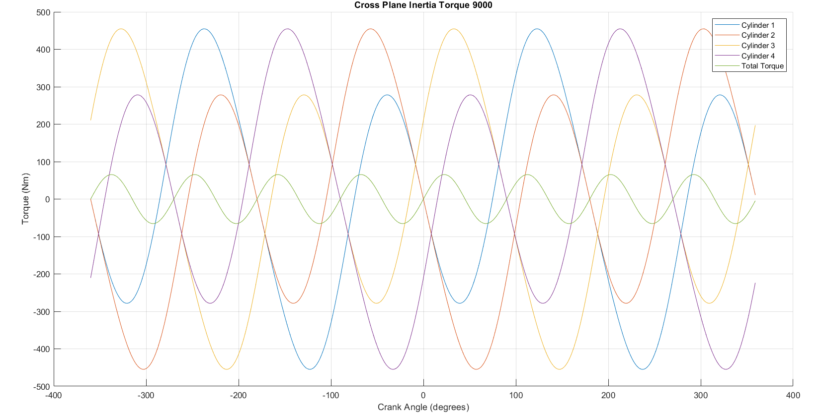
Figure 21: Cross Plane Inertia Torque at 9000 RPM

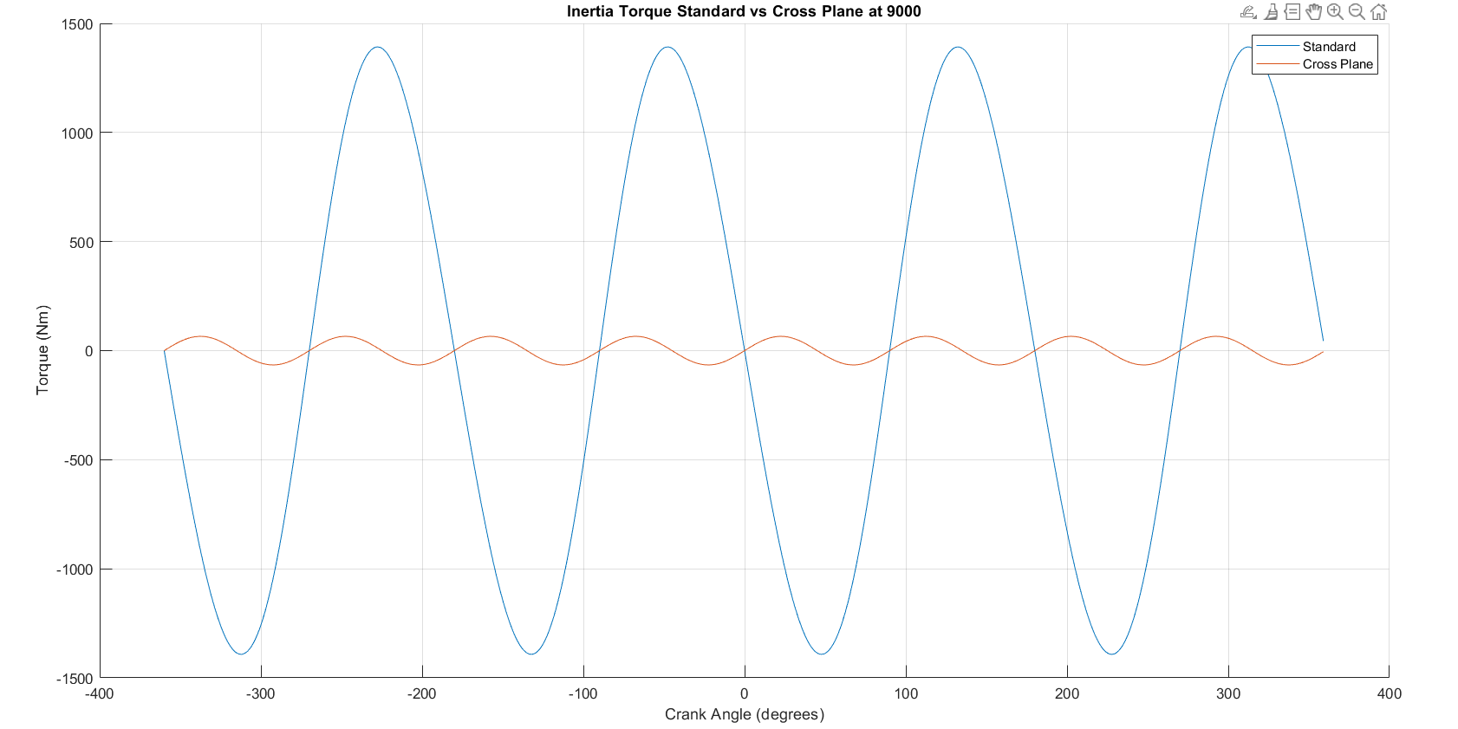
Figure 22: Inertia Torque Standard vs Cross Plane at 9000

Inertia Torque Analysis
After analysing figures 17 to 22, it can be concluded that at 6000 RPM and especially at 9000 RPM, the cross-plane configuration shows a clear advantage in reducing torque fluctuations, which can translate to better drivability and lower mechanical stress. However, flat-plane engines might still be preferred in high-performance applications due to their lightweight design and firing order characteristics that favour higher-revving behavior.

Gas Torque

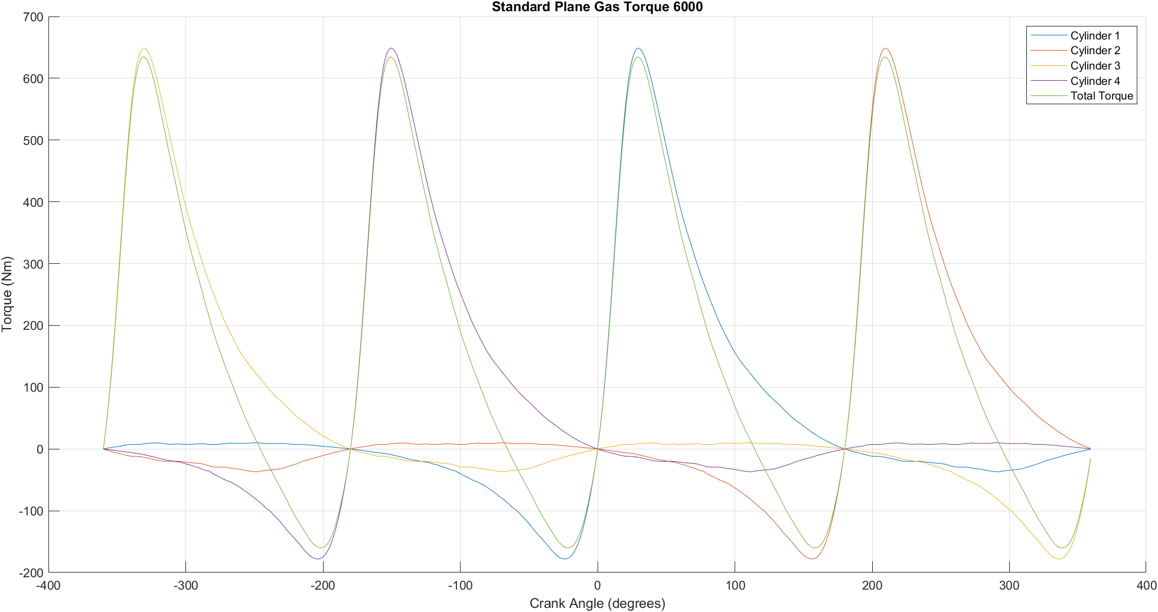
Figure 23: Flat Plane Gas Torque at 6000 RPM

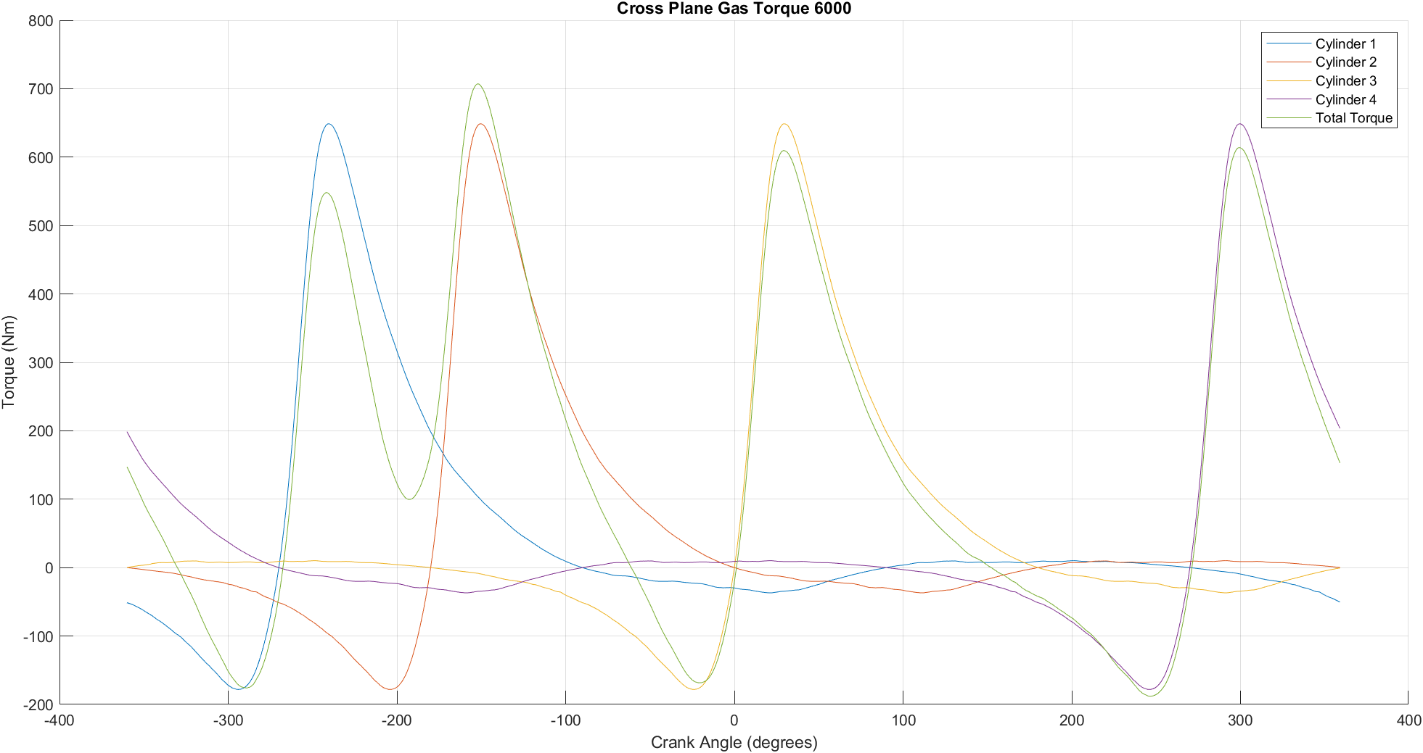
Figure 24: Cross Plane Gas Torque at 6000 RPM

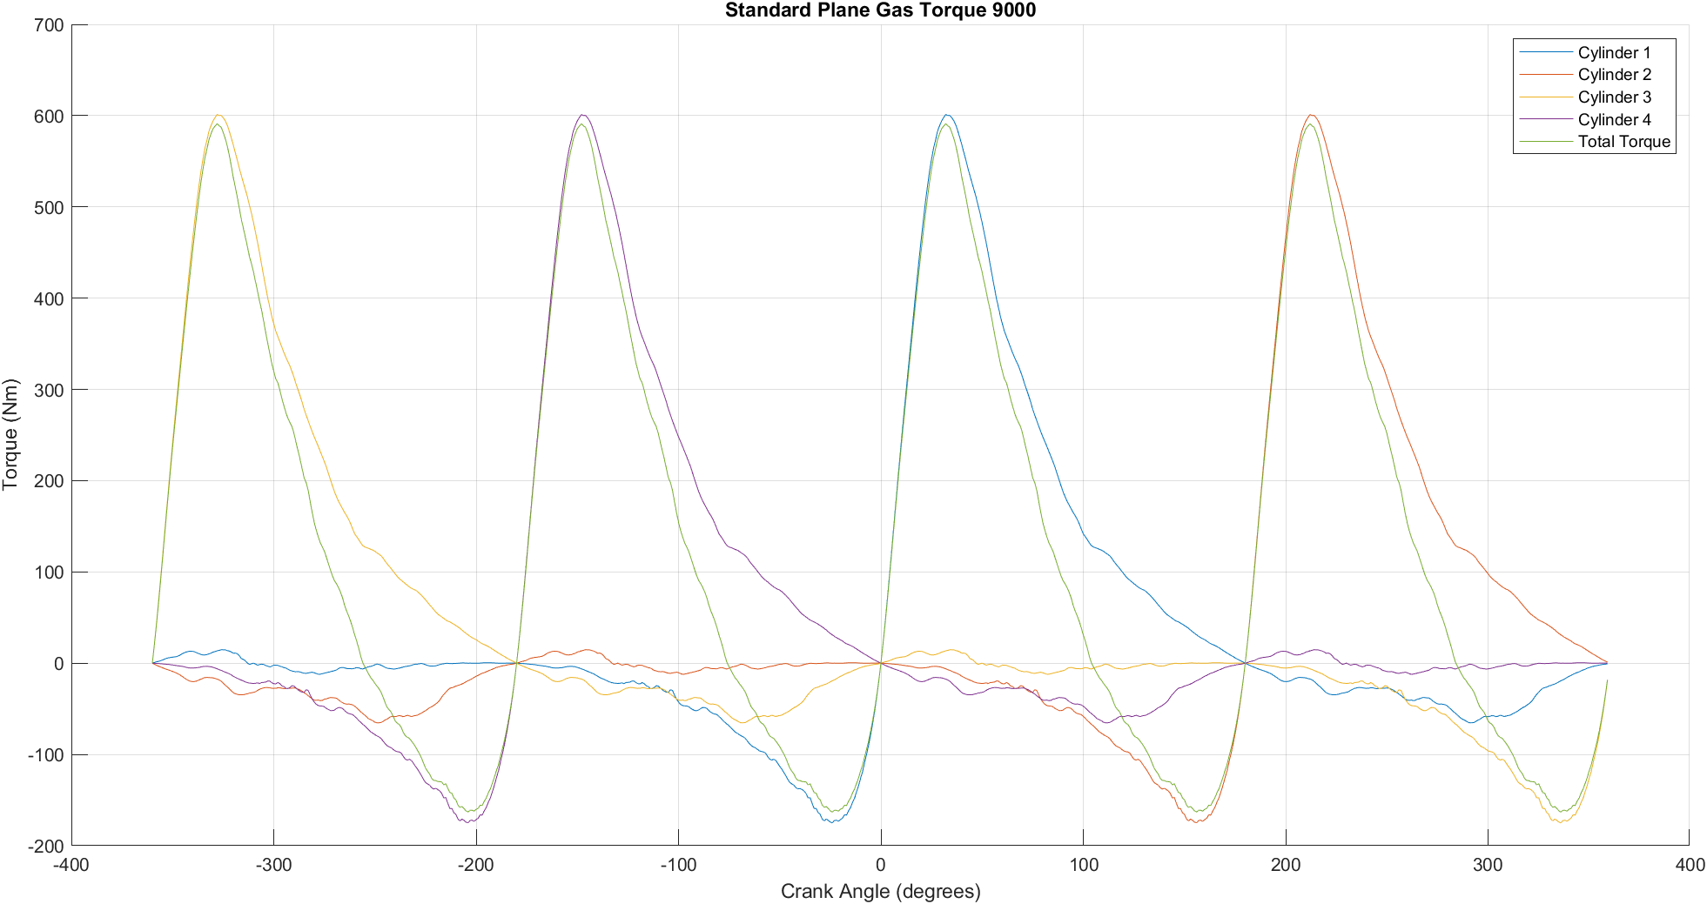
Figure 25: Flat Plane Gas Torque at 9000 RPM

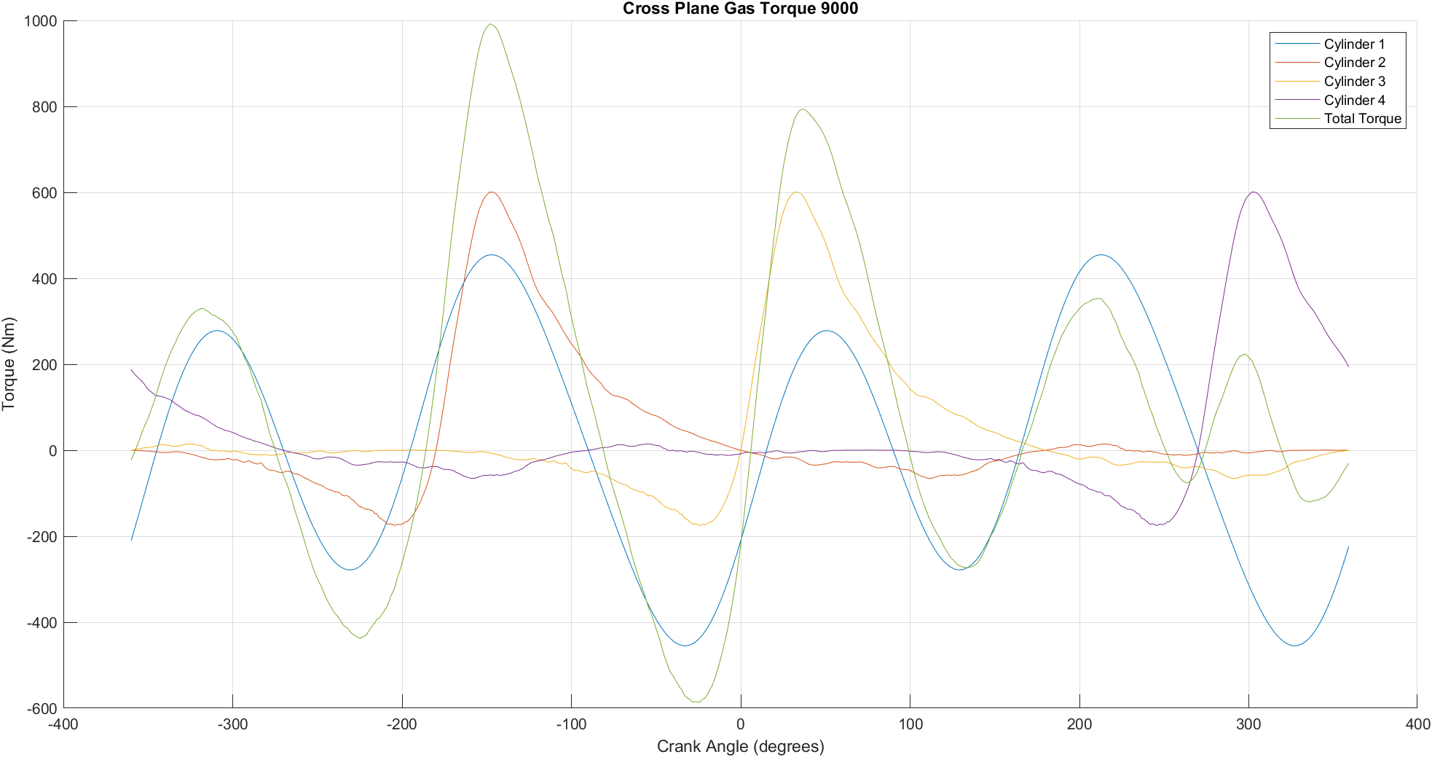
Figure 26: Cross Plane Gas Torque at 9000 RPM

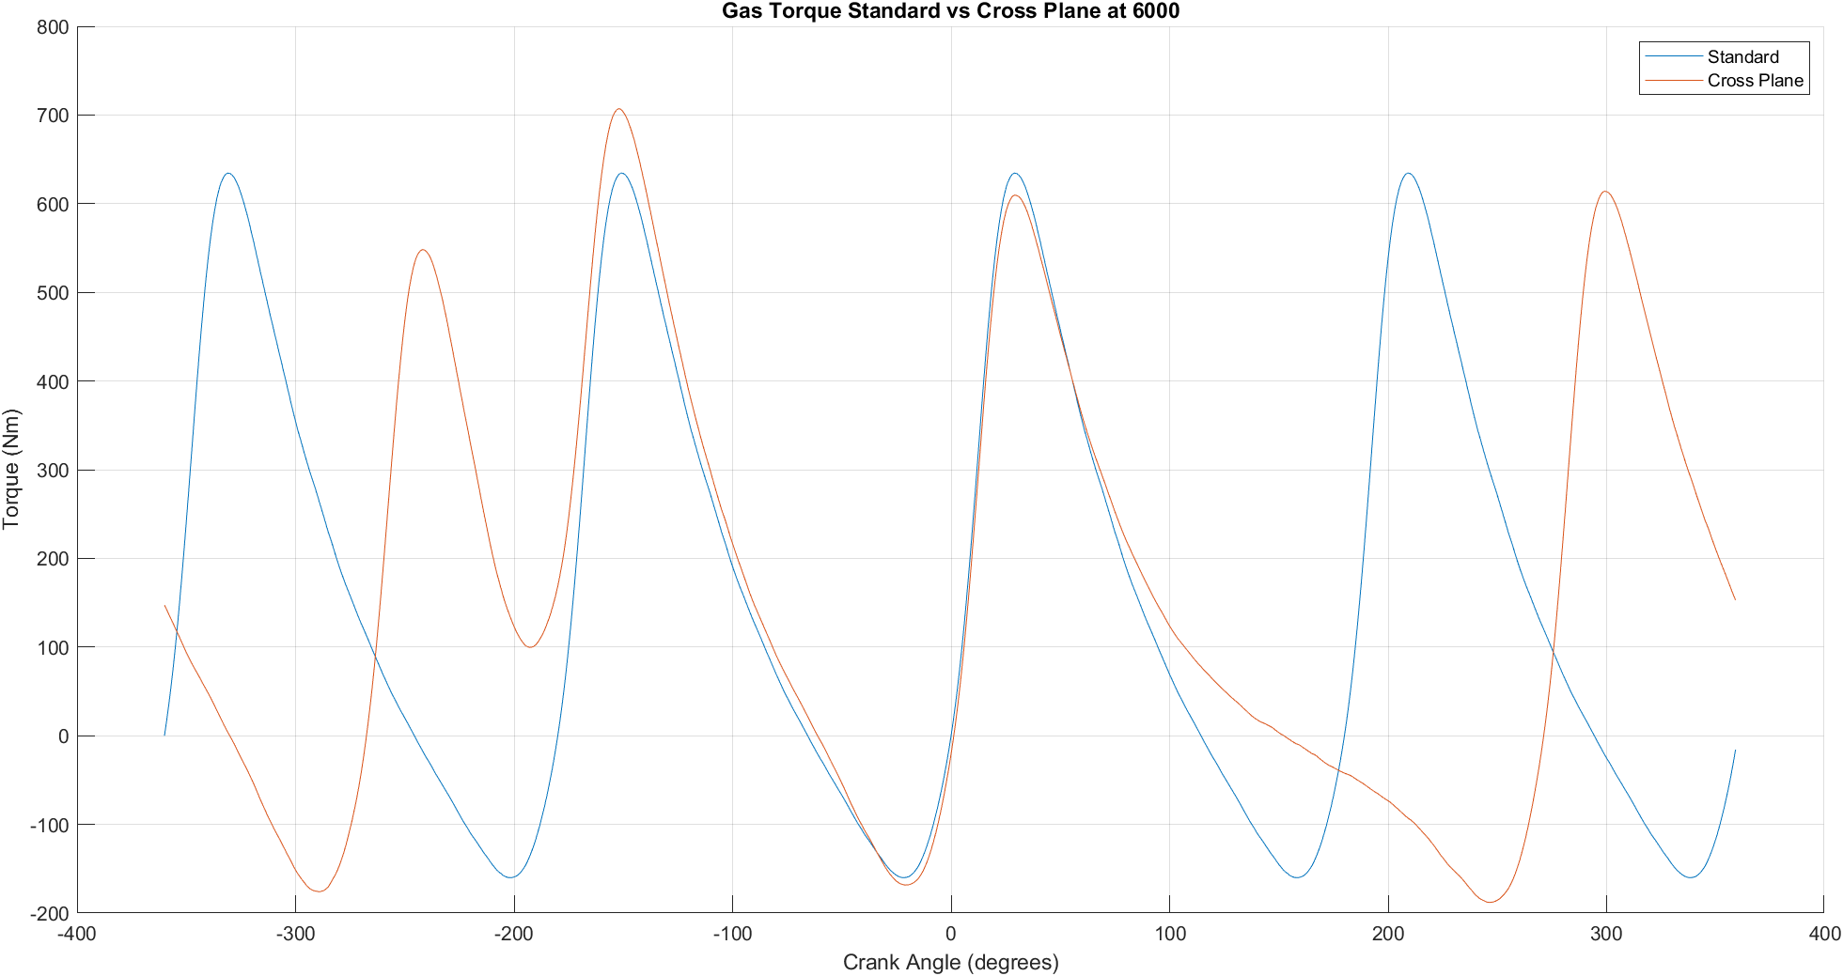
Figure 27: Gas Torque Flat vs Cross Plane at 6000 RPM

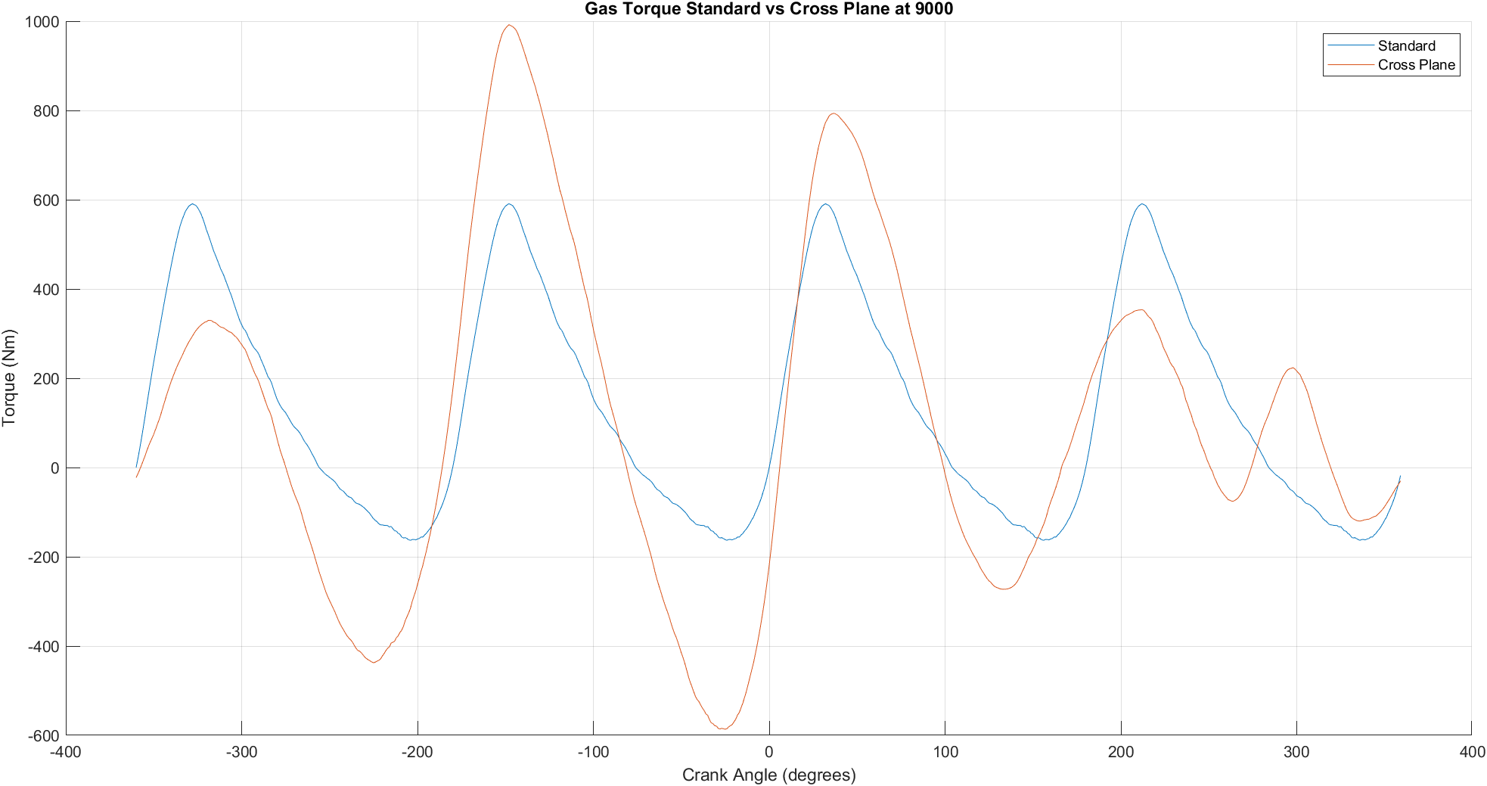
Figure 28: Gas Torque Flat vs Cross Plane at 9000 RPM

Gas Torque Analysis
From figure 23 to 28, at both 6000 RPM and 9000 RPM, the cross-plane configuration offers better torque smoothness, while the flat-plane design provides more aggressive and instantaneous torque delivery.

Crank Torque
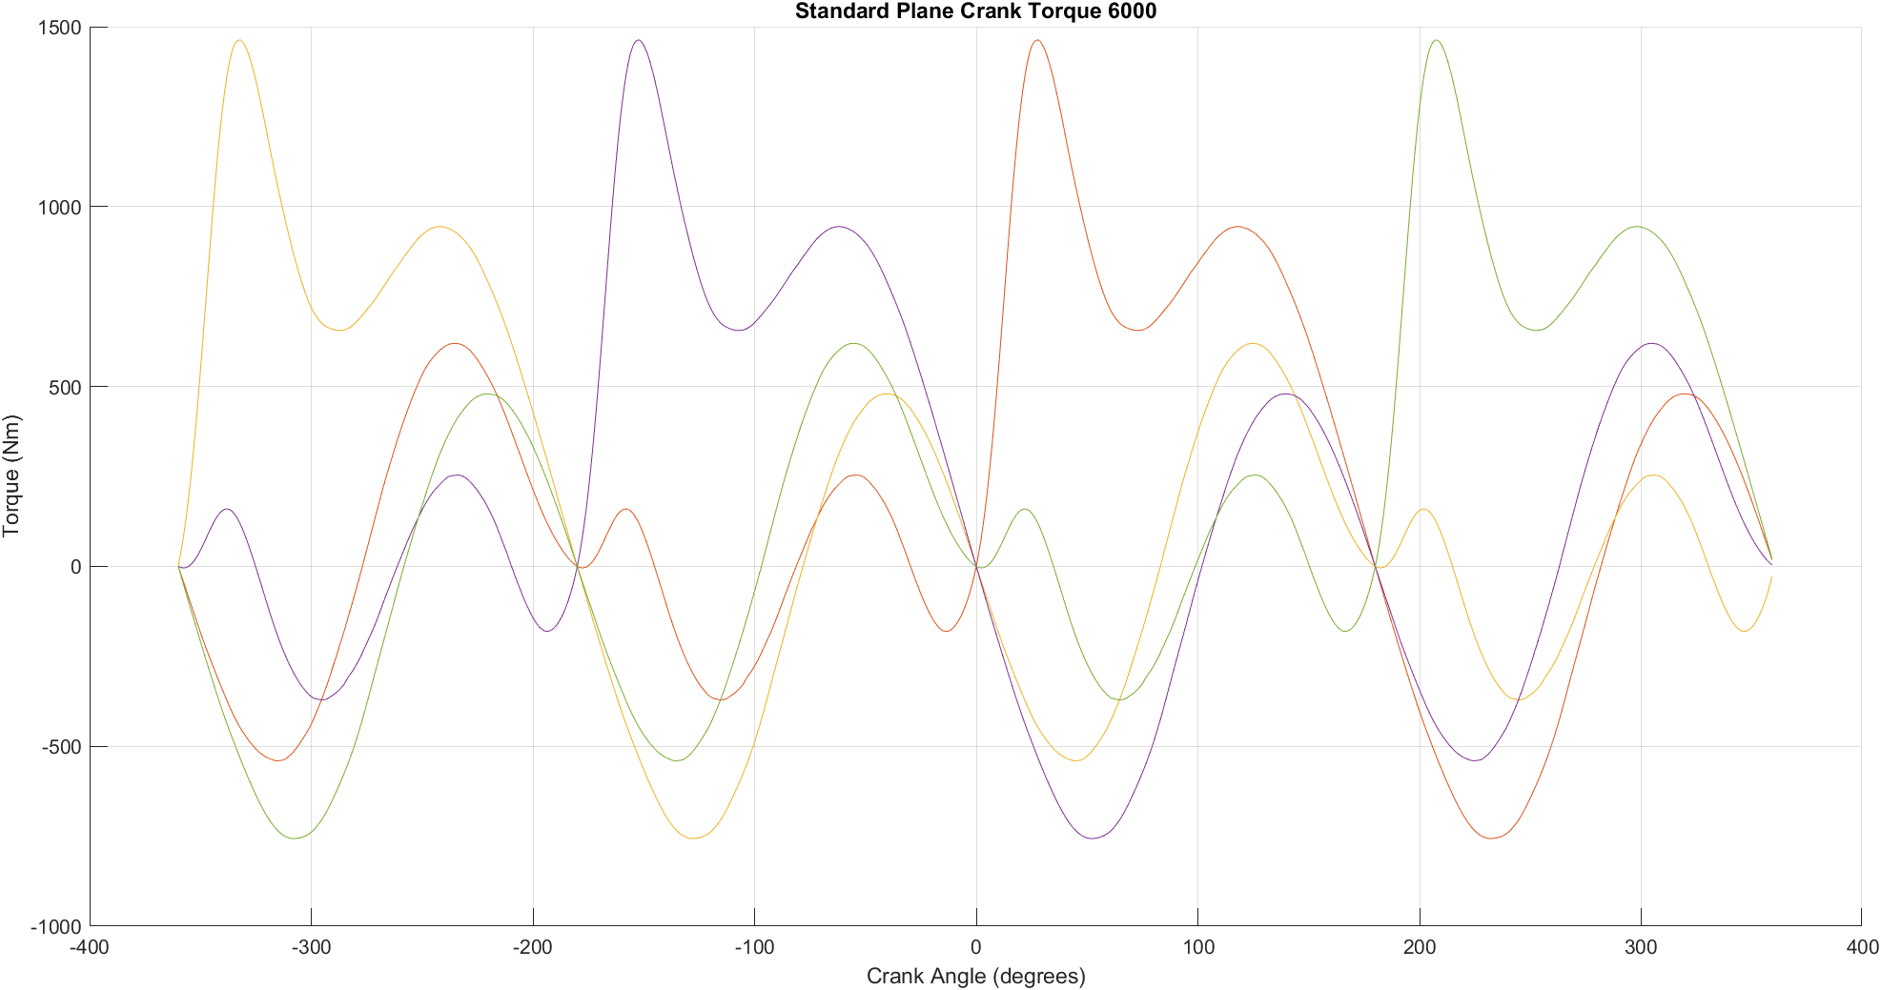
Figure 29: Flat Plane Crank Torque at 6000 RPM

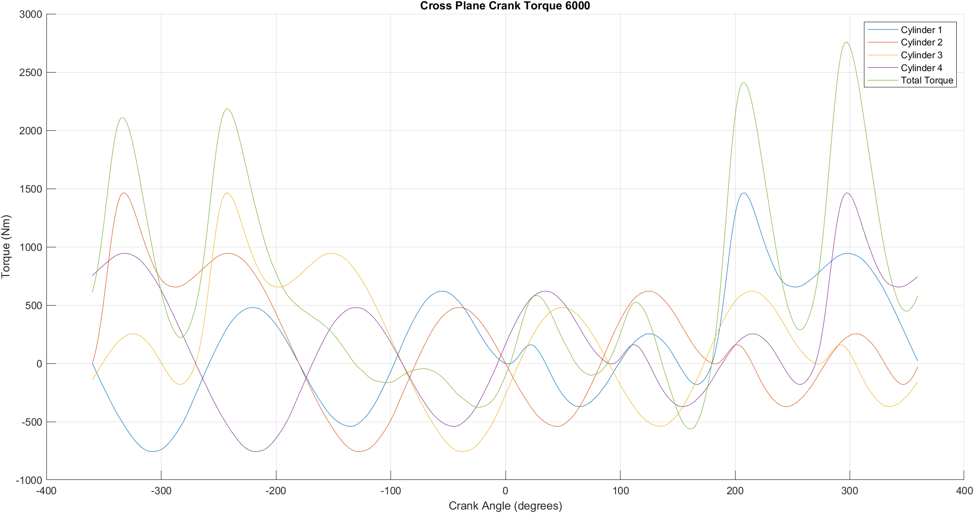
Figure 30: Cross Plane Crank Torque at 6000 RPM

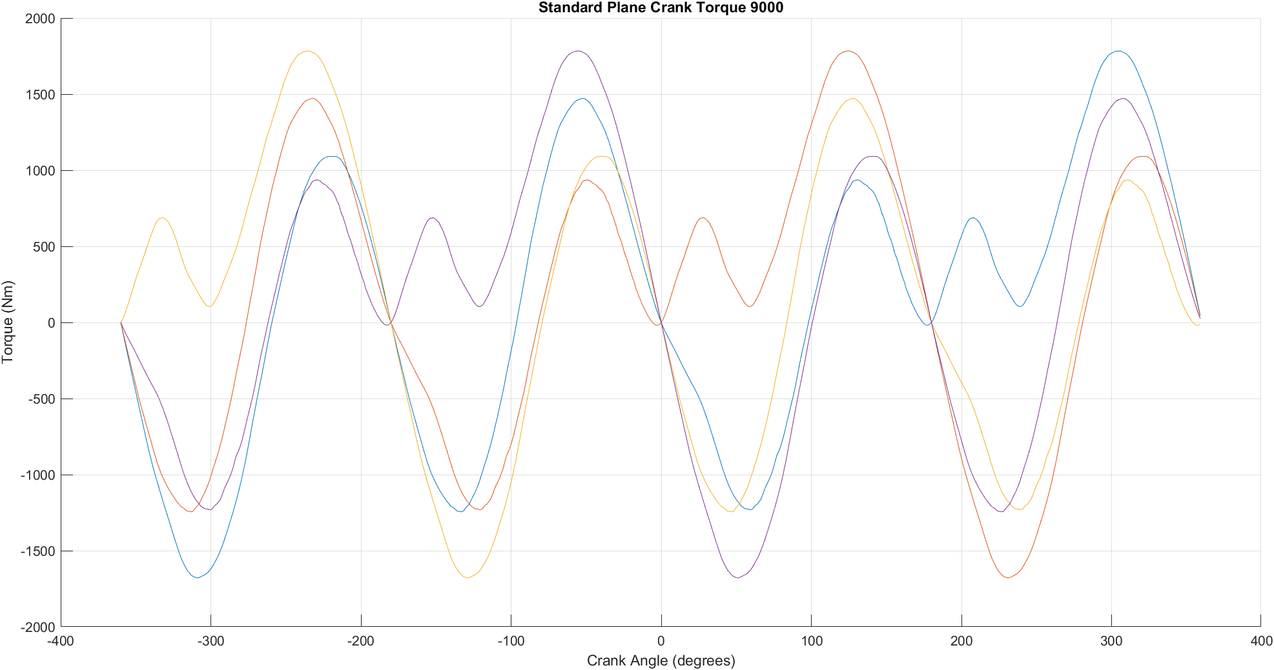
Figure 31: Flat Plane Crank Torque at 9000 RPM

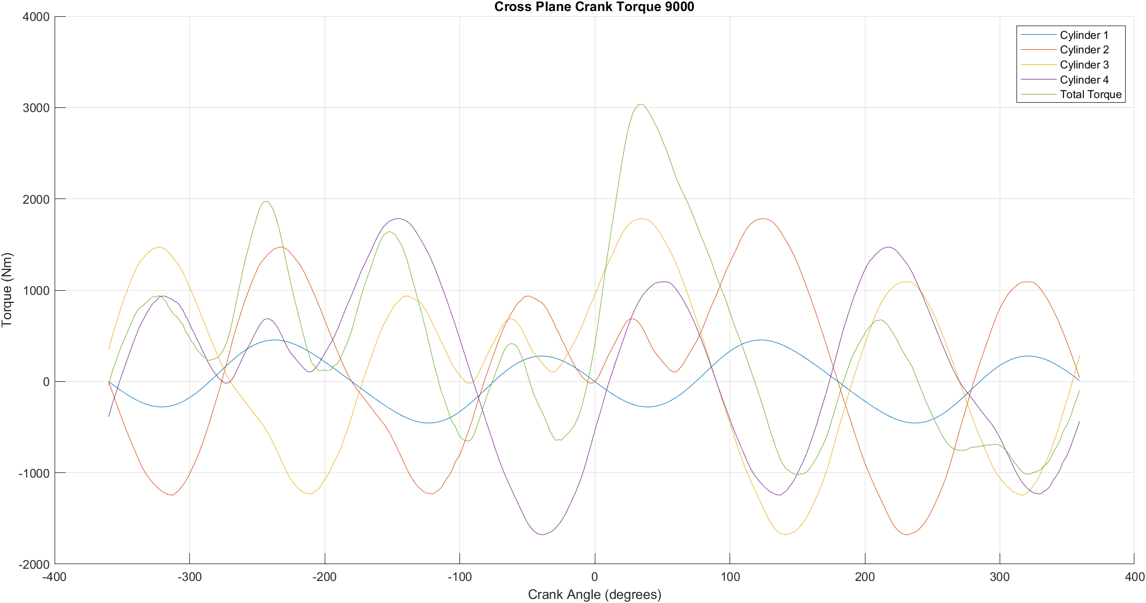
Figure 32: Cross Plane Crank Torque at 9000 RPM

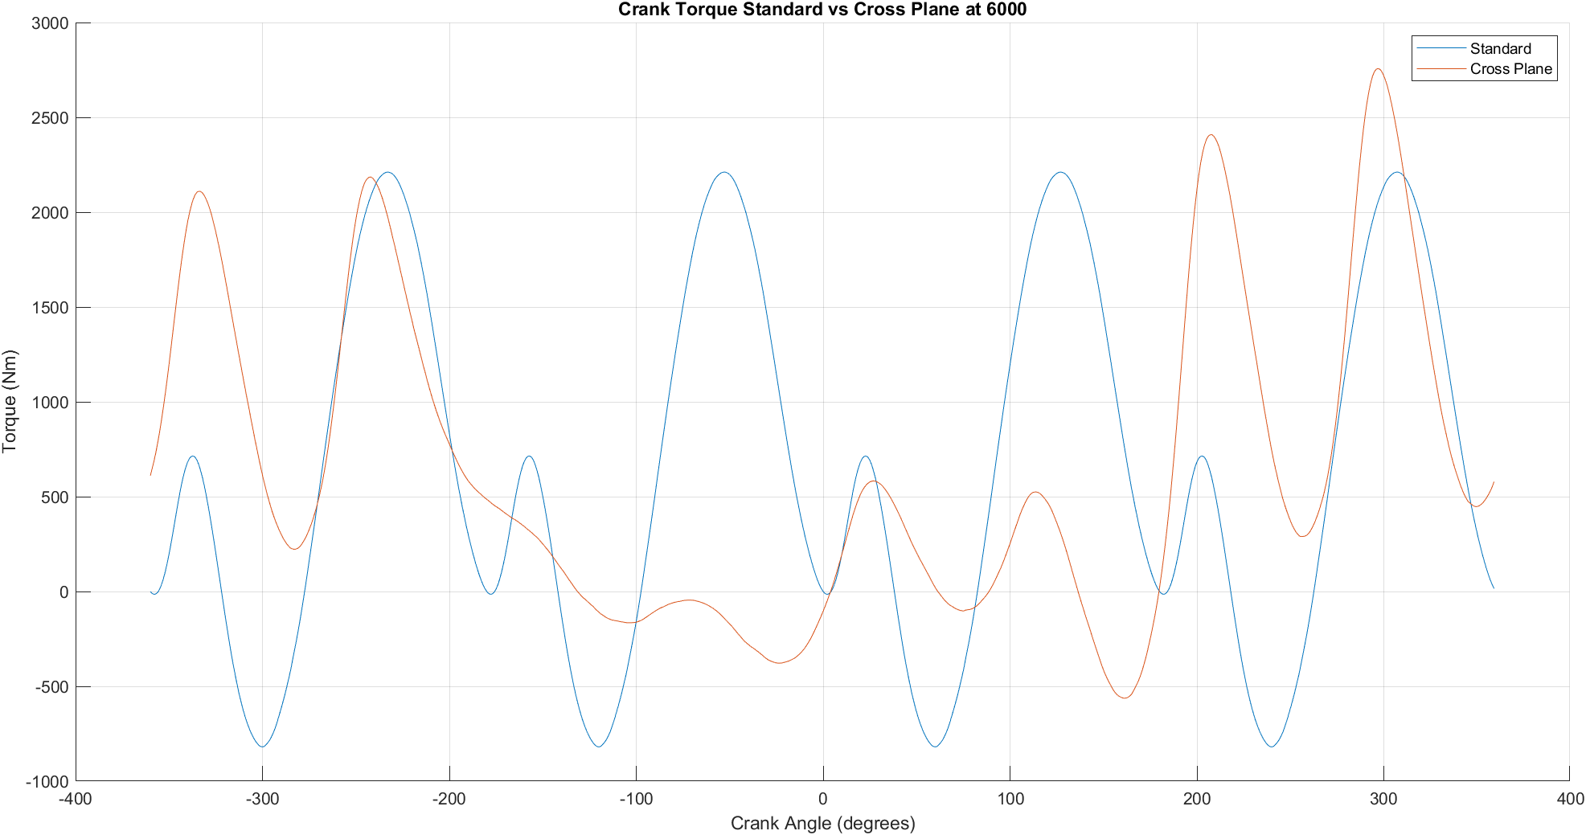
Figure 33: Crank Torque Flat vs Cross Plane 6000

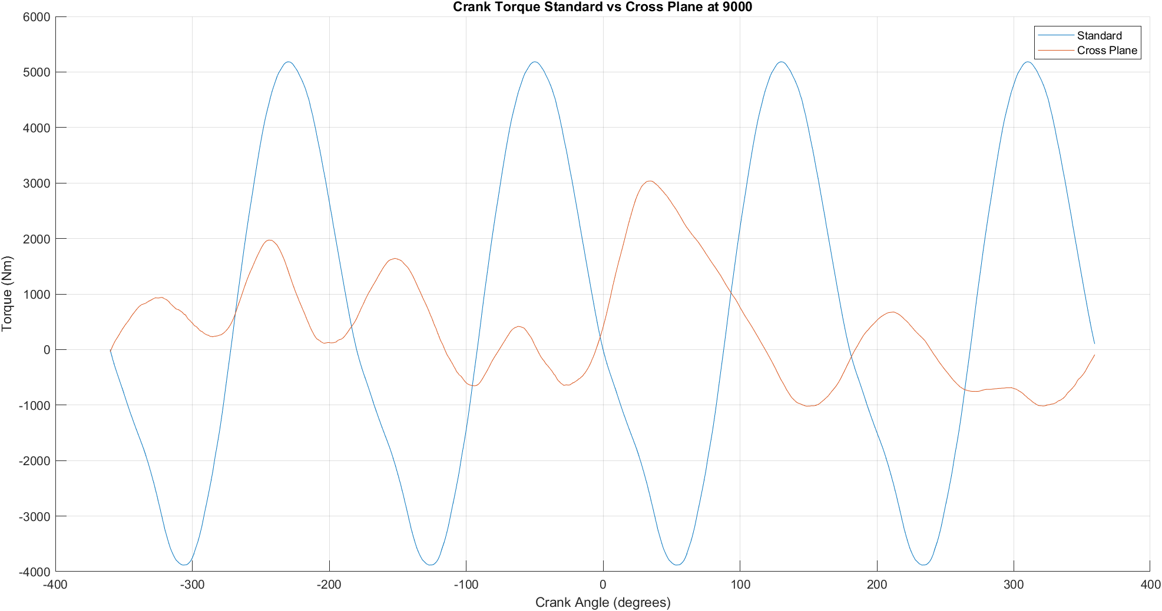
Figure 34: Crank Torque Flat vs Cross Plane 9000

Crank Torque Analysis
From figures 29 to 34, at both 6000 RPM and 9000 RPM, the cross-plane configuration clearly demonstrates better torque stability, whereas the flat-plane design generates higher torque fluctuations that can increase engine stress.

Power
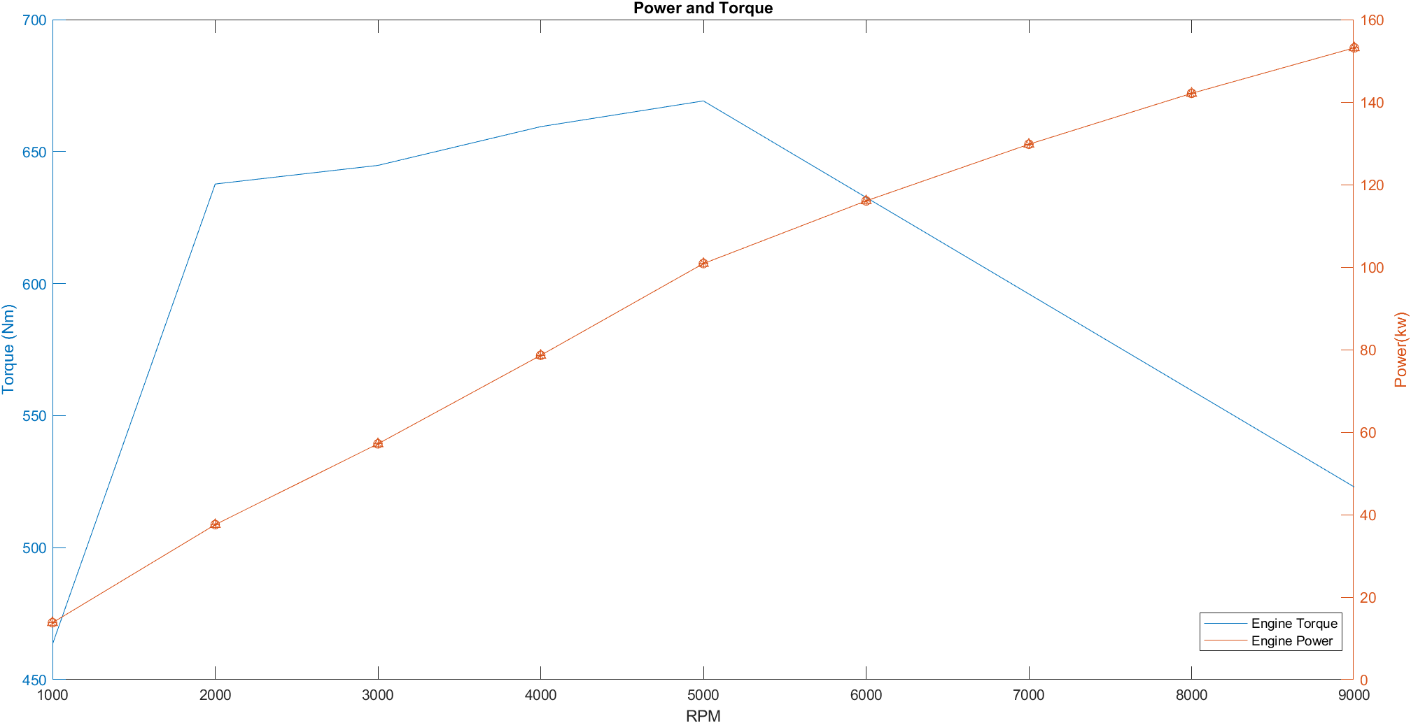
Figure 35: Power and Torque Graph

From figure 35, it can be seen that maximum torque is available early in the RPM range, but power continues to rise steadily to the redline. The declining torque at high RPMs is counteracted by increasing engine speed, allowing the engine to maximize power output at high revolutions.

Conclusion
In conclusion, there are several benefits of increasing an engines RPM. The most notable ones are, extending the powerband and allowing the engine to produce more horsepower and reduced NOx emissions. However, a major drawback is the increased cyclic stress and loading on materials, which can lead to premature failure of critical components. From this assignment, it is proven that several methods can be taken to improve a components FSF. The first method being material change. This assignment demonstrates that several methods can be employed to improve a component’s Factor of Safety (FSF). The first method involves selecting a material with a higher Ultimate Tensile Strength (UTS) and endurance limit, which significantly enhances FSF, as shown in the Goodman diagrams. The second method is implementing geometric modifications to components. For instance, in the case of the connecting rod bolt, increasing its cross-sectional area (CSA) or reducing its length improves stiffness, thereby increasing its FSF. In summary, multiple precautionary measures can be taken to ensure an engine operates at peak performance while minimizing the risk of component failure.

References
acornwelding, 2024. Fatigue Analysis In Aircraft Engine Mounts. [Online]
Available at: https://www.acornwelding.com/blog/post/fatigue-analysis-aircraft-engine-mounts/
[Accessed 13 March 2025].
bajajallianz, 2025. RPM in Cars and Bikes: All You Need To Know. [Online]
Available at: https://www.bajajallianz.com/blog/motor-insurance-articles/understanding-rpm-in-cars-and-bikes.html#:~:text=Higher%20RPMs%20provide%20more%20power,cruising%20speeds%20helps%20conserve%20fuel.
[Accessed 14 March 2025].
carthrottle, 2016. Engineering Explained: Why Some Engines Rev High And Their Benefits. [Online]
Available at: https://www.carthrottle.com/news/engineering-explained-why-some-engines-rev-high-and-their-benefits
[Accessed 13 March 2025].
carthrottle, 2024. What’s The Difference Between Flat-Plane and Cross-Plane Crankshafts?. [Online]
Available at: https://www.carthrottle.com/post/8q56kje
[Accessed 15 March 2025].
comsol, 2016. Material Fatigue. [Online]
Available at: https://www.comsol.com/multiphysics/material-fatigue
[Accessed 10 March 2025].
Hossain, D. A. R. &. R., 2024. International Journal of Mechanical and Thermal Engineering. Thermo-mechanical fatigue analysis of engine components in heavy-duty vehicles , 5(2), pp. 34-36.
hotrod, 2022. Difference Between Cross-Plane and Flat-Plane Cranks. [Online]
Available at: https://www.hotrod.com/how-to/difference-between-cross-plane-and-flat-plane-cranks/
[Accessed 13 March 2025].
Huizhi Qi, Y. L. S. S. Q. X., 2022. Fatigue Reliability Analysis System for Key Components of Aero-Engine. [Online]
Available at: https://onlinelibrary.wiley.com/doi/10.1155/2022/1143901
[Accessed 13 March 2025].
MAHLE, 2016. Cylinder components: Properties, applications, materials.. 2nd ed. Wiesbaden: Springer Fachmedien Wiesbaden.
sciencedirect, 2016. Goodman Diagram. [Online]
Available at: https://www.sciencedirect.com/topics/engineering/goodman-diagram?utm_source=chatgpt.com
[Accessed 14 March 2025].
sdcverifier, 2025. What is Fatigue? Definitions, Types, Causes. [Online]
Available at: https://sdcverifier.com/structural-engineering-101/what-is-fatigue-definitions-types-causes/
[Accessed 10 March 2025].
ultmeche, 2024. Goodman Diagram. [Online]
Available at: https://ultmeche.com/goodman-diagram/
[Accessed 15 March 2025].
Zhang, 2023. Methods for fatigue-life estimation: A review of the current status and future trends. Nanotechnology and Precision Engineering, 6(2), pp. 48-50.

