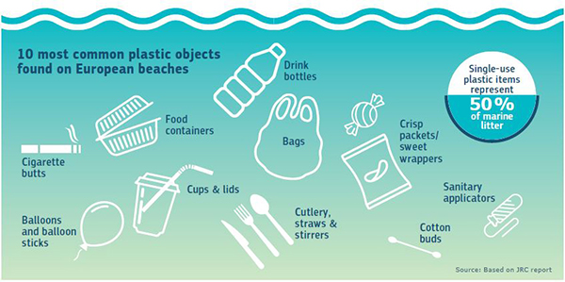

Economics of sustainability
  - single use plastic
Alexandra Olivia Safadi | Economics of sustainability | 18th May 2020

Word count – 2,728
Contents page

1.0 - Introduction 2
2.0 – Findings 2
2.1 - Single use plastics 2
2.1.1 - The positive and negative impacts of single use plastic 3
2.2 - The Plastic bag charge 7
2.2.1 - Plastic bags in relation to economics 10
2.2.2 - Externalities of plastic bags 10
2.2.3 - Benefits of the solution 12
2.2.4 - The social cost of implanting tax solutions 13
2.3 - Advantages and Disadvantages of single use bag tax 13
3.0 - Conclusion 15
References 16

Report analysis regarding a solution to single use plastic

1.0 - Introduction
This report aims to assess the well-known environmental externality brought about by the market failure of single use plastic within industries today. The report will discuss evidence regarding decisions made to implement solutions to the market failure. This evidence will then be assessed and linked to hypothetical benefits and cost models studied within this module.

2.0 – Findings

2.1 - Single use plastics
Single use plastics are created to be used then disposed of or recycled (European Commission, 2018). Individuals whom use single use plastics may argue that these items can be recycled therefore do not negatively impact the environment, however, professional Megan Weldon states, ‘In reality, very few plastic items can be processed into new materials and products,’ she says, ‘Unlike glass and aluminum, plastic isn't processed into the same item it was when it was collected by a recycling center. The quality of plastic is downgraded, so eventually, and inevitably, that plastic will still end up in a landfill’ (Vermillion, 2020).
Research suggests that out of 10 plastic bottles 7 will end up in landfill, this issue expanded once China took the decision to not recycle or accept plastic in 2018 (Vermillion, 2020). This meant that for municipalities recycling became much more expensive. According to The Atlantic, municipalities are therefore deciding to landfill instead of recycling.
The image below demonstrates the purchase behavior of plastic bottles and results show that they are bought very frequently at 43% meaning that there is a high risk of increased levels of negative externalities from this product, this is worrying having assessed the statistics above.
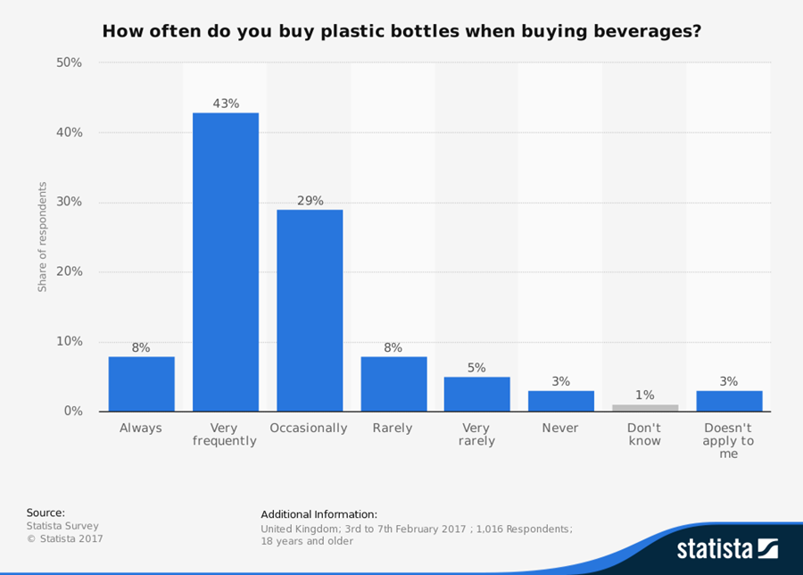 (Riley, 2017)

2.1.1 - The positive and negative impacts of single use plastic
Individuals are encourage banning single use plastic for many reasons. Firstly, landfills do not eliminate the plastic, instead it is hidden. Weldon suggests that plastic bags can take between ten to twenty years to break down and plastic bottles can outlive us by lasting up to five hundred years (Vermillion, 2020).
The university of Plymouth assessed eighty single use plastic bags created from biodegradable plastic throughout three years as they hope to see at what extend are these bags biodegradable. Results demonstrated that four biodegradable bags could still hold 5 pounds after the experiment was over which demonstrates that biodegradable bags must take a long period of time to break down.
Individuals suggest that we should begin reusing plastic however this is not necessarily safe for example in plastic bottles. The environmental health perspectives found that single use plastics used in bottles or within the food industry release dangerous chemicals once reused (Edie, 2020).
Companies such as Iceland and Morrisons have been reducing their single use plastic since 2017 as they wish to create changes due to consumer demand. Lord Deben has warned organisations that consumers are beginning to demand plastic free items without consideration of the benefits of plastic such as preventing food waste, creating longer life for food produce and to protect items from possible damage through the transportation process (Edie, 2020).
Statistics have determined that plastic is cheaper and safer than glass or paper. Originally, plastic was created using materials from fossil fuels. However, today plastic is used in mass amounts therefore professionals are concerned regarding the longevity of resources used to produce plastic.
Consumers want to lessen the consumption of plastic which has driven large well known organisations such as McDonald’s to go plastic straw free by 2020. McDonalds state, ‘The government's ambitious plans, combined with strong customer opinion, has helped to accelerate the move away from plastic and I'm proud that we've been able to play our part in helping to achieve this societal change’ (Beament, 2018).
According to the U.N. Environment, the most pollutant materials discovered within the eco system are bottles caps, plastic bottle, takeout containers, plastic bags and wrappers (Wales, 2018).
The U.N. Environment discovered that 9% of 9billion tones of plastics globally are being recycles as most of the material end up in the sea, polluting the streets and in landfills (Wales, 2018).
Research suggests that single use plastic produces toxic chemicals such as ‘Styrofoam’ which often seeps into soils and water. This toxin is often then consumed by animals and then enters our food chain. This toxin is extremely harmful and affects organs such as the lungs, reproductive system and the nervous system.
The image below illustrates the market failure of plastic. The green triangle hypothetically shows the social welfare loss and this is the result of the market output being more than the social optimum situation. Hypothetically speaking, deadweight loss of social welfare would be created if the marginal private cost is less than the marginal social cost.
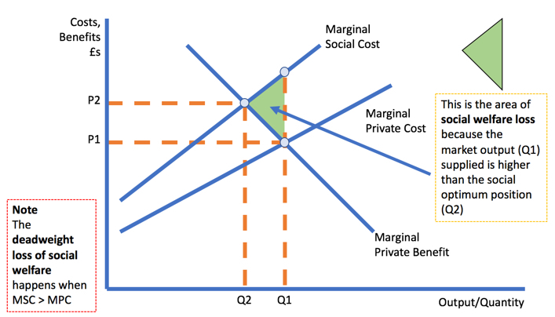 (Tutor2u, 2020)
Social welfare loss

Global Citizen, plastic production has estimated that single use plastics have tripled since the 90s. They also found that over half of the universe’s plastics were created after 2003.
The Government of Canada has estimated that by 2050 plastic in the ocean will overrule the sea life (Wales, 2018).
The image below demonstrates statistics of the ocean’s pollution of plastic (Riley, 2017).
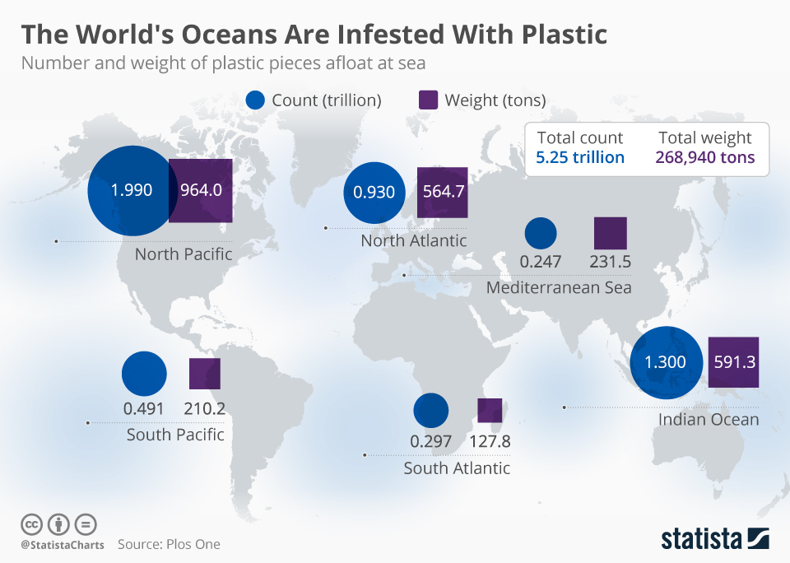
UN environment reports 2015 found that tons of millions of plastics disposed of in the sea per year. The plastics are then broken into millions of toxic micro-plastic segments. They estimated that annually over 100,000 sea life animals and birds die as a result from plastic pollution. (Pettinger, There's no such thing as a free plastic bag, 2015)

2.2 - Policy placed in regards to reducing single use plastics
Economic factors from regulations placed can be measured using the supply and demand curve. Often tax implementations such as a bag tax will show a reduction in output and growth in cost on the graph. This inefficiency is known as loss, ‘deadweight’.
(Finance Train , 2020)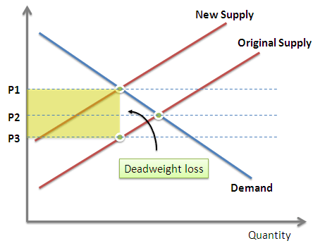

2.2 - The Plastic bag charge
The United Kingdom (UK) used 8.4 billion plastic bags last year, meaning that each person will use one plastic bag and throw it every three days (HaywardEcon , 2016).
Due to the problems associated with single use plastic the government are trying to implement strategies to reduce its uses.
The plastic bag tax placed by the UK has been implemented as a solution to the market failure. Market failure is extremely important to consider when looking at industries from an economic perspective today especially when they are creating negative externalities. A negative externality is defined as a cost which is created as a result of consumption or manufacturing of a good which creates harm on individuals involved (HaywardEcon , 2016).
The bag levies in the UK created effective solutions in decreasing and internalising the cost of single use plastic bags. For example, the 5p fee dropped bag usage by 80% less in Northern Ireland and Scotland and 78% in Wales.
The UK have placed multiple policies in the attempt to lessen single use plastics negative effects. For example, implementing a 5p fee for plastic bags in 2015. This policy resulted in 86% fewer plastic bags distributed in England and a decrease of 121 purchases of bags in 2018 compared to statistics regarding 2015.
The UK’s government are now assessing whether to increase the charge to 10p on bags and to include SMEs which are exempt if they have less than 250 workers (Mace, 2018).

Implementing plastic bag taxes will internalise the cost which will increase the price of the good. The laws of demand supply will demonstrate a reduction of consumption and production.

The graph below demonstrates that bags at a fee of £0 creates a supply of ‘perfectly inelastic’ which means the price of product has no affect on the supply. The supply of bags is noted on the graph in red as ‘supply private’ as the cost pf manufacturing the bag is not included in the manufacturing of the bag.
The demand curve is noted as ‘demand private’ as the cost of using plastic bags is not incorporated in the price buyers spend for bags.
When the price of bags is nothing the amount demanded is the number of plastic bags present at ‘A’. Therefore, ‘A’ shows that the amount supplied equals the amount demanded at a price of zero (the market equilibrium).

Once a 5p tax levied is placed by the government the price of bags itself does not change. The store is still offering them for a price of ‘0’. Therefore, this illustrates that the tax affected the market for the bags. The tax internalises the external cost to society for the use of plastic bags which then shifts the demand curve.
The supermarket will continue to provide the quantity supplied which buyers demanded at a price of £0 however now buyers will be paying the 5p tax added, creating ‘B’.

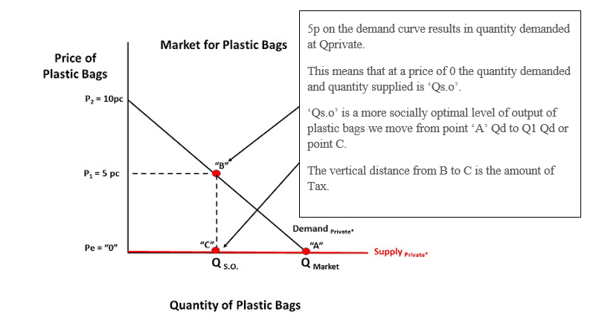

This will result in the demand curve moving left creating a new demand creating a market equilibrium at a more socially favourable level at ‘C’.
The new demand curve illustrates the demand of bags with the social costs of consuming bags internalised.

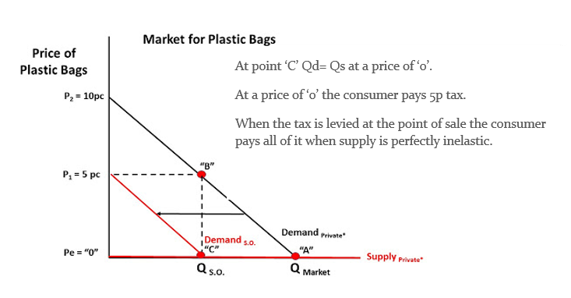
The blue square on the graph illustrates the tax placed by the policy. The green triangle illustrates the lost surplus to consumers.
The graph demonstrates that with tax consumers use ‘Qs.o’ and without tax consumers will use ‘Qmarket’ without societal compensation.
Using the supply and demand curve it is clear that this solution of placing a tax on plastic bags reduces the manufacturing and consumption of bags which therefore decreases the negative externalities produced.

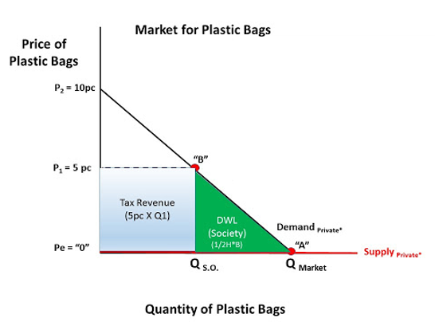

(HaywardEcon , 2016)

2.2.1 - Plastic bags in relation to economics
From an economic perspective when a product or service is £0 individuals will use the good until the marginal benefit is zero. Consumers will keep taking plastic bags even if the benefits from taking them are low. However, private costs in relation to the production of bags does apply. When the price of a plastic bag is free, they will be overconsumed by consumers which will result in an inefficient assignment of resource.

2.2.2 - Externalities of plastic bags

External costs of plastic bags can be negative such as pollution, wildlife affects, unpleasant waste and resources used in the manufacturing of plastic bags. This leads to the social marginal cost being more than the private. Stores are in the position to be able to buy bags for 5p therefore it is not worth the stores charging for this. Although, when the externalities are considered the social cost is a lot higher.

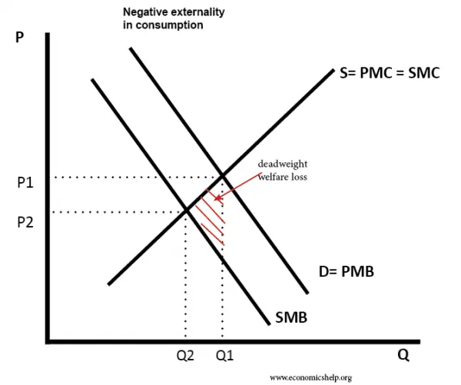

This graph demonstrates that social benefits are lower than private benefits if a product has negative externalities of consumption. However, within a ‘free market’ consumption would hypothetically be placed at Q1 which creates over consumption of a product.
Decreasing the external cost can be through implementing the bag tax as this forces buyer to pay the full social cost. From an economic perspective it is also useful to view the opportunity cost of plastic bags being free. When shops produce ‘free’ bags they instead create larger costs for society as society will have to pay to clean pollution caused from the bags.
Therefore, it is important to view consumer trends and buying behaviour. Having a charge on bags can alter buyer’s behaviour significantly as many consumers will attempt to avoid an increased charge to their usual shopping.

2.2.3 - Benefits of the solution
Hypothetically speaking, when the price of plastic bags were free with a price of £0 the consumption was high. According to statistics over 7 billion bags were dispensed by seven main stores in the UK a year before the charge was placed.
Once the price of plastic bags expanded to 5p the consumption decreased hugely to just 500m being sold within the first six months (Smithers, 2016).

The graph below was created to hypothetically show the result that the solution will create from an economic perspective. The graph below demonstrates that when the price was at £0 the consumption was high at 10 million, however once the solution was placed increasing the price to 5p the consumption decreased to 4 million. When the price equals the marginal cost of consumption this creates allocative efficiency however this is not present when the cost is £0.
The graph displays that when the cost is £0 and consumption is at 10million deadweight welfare loss is created and the marginal cost of creating more bags is more than the marginal usefulness individuals have from more bags.
Often when goods cost nothing, consumers take more of that good. It is also more convenient to throw bags and instead get a new one rather than recycle, these two elements work together and can create large market failures such as pollution.
Charging 5p has forced buyers to pay the marginal cost which is more effective because this allows the price to equal the marginal cost.

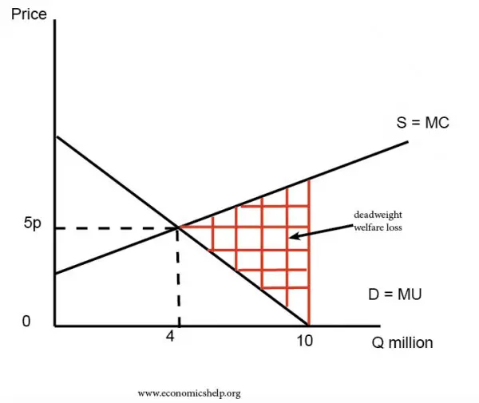 (Pettinger, There’s no such thing as a free plastic bag, 2015)

2.2.4 - The social cost of implanting tax solutions
Findings demonstrate that money raised is allocated to local causes (Pettinger, There’s no such thing as a free plastic bag, 2015). Evidence suggests, ‘Marks & Spencer has also favoured environmental charities so far. In Scotland, the retailer has given £88,446 to the Marine Conservation Society, £88,446 to WWF, including the Orkney sustainable Fishery Improvement Programme, and a further £37,482 to a range of local charities. In Wales, the retailer has equally supported WWF and the Marine Conservation Society’ (Cahalane, 2015).

2.3 - Advantages and Disadvantages of single use bag tax
Advantages of plastic bag tax | Disadvantages of plastic bag tax
-Reduce supermarket costs as customers are likely to bring their own bag.  -Decreases litter.  -Reducing plastic bags is better for the environment as plastic takes a long period of time to break down or is disposed of through the use of landfills. According to research it takes 10-20years to break down (Perreault, n.d.).  -Plastic bags harm wildlife. conservationists predict that a minimum of 100,000 mammals die from plastic bags each year (McNamee, 2008).  -Tax will increase revenue.  -Tax will force individuals to pay the social cost (Pettinger, There’s no such thing as a free plastic bag, 2015).  -Statistics reveal that the tax decreases the estimation of plastic bags consumed by consumers, ‘The total number of single-use plastic bags sold by all 249 retailers who reported in 2017-18 was 1.75 billion – down from 7.6 billion in 2014’ (ITV, 2018).  -Stores are provided with the choice as to where the proceeds go and it is expected that they go to good causes, ‘Between April 2016 and 2017, almost two-thirds of retailers reported giving more than £66 million to good causes’ (ITV, 2018).  - Wales introduced the bag charge on the 1st of October 2011, studies demonstrated that in the first six months positive results occurred. According to the Welsh Government the charge resulted in an increase of consumers using their own bags from 61% to 82% (Lets Recycle, 2017).  -Professionals suggest that the tax will create: £60m savings in litter clean-up costs and £13m in carbon savings (Howell, 2016). | -Plastic bags can sometimes be useful in preserving items and transportation.  -Plastic is often stronger than alternative paper bags (All About Bags, n.d.).  - The affect on manufacturers, loss of jobs (Bag the ban, 2020).  -Increased upfront cost for consumers.  -The plastic bag tax does not completely eliminate the use of plastic bags therefore the negative externalities still exist.  -Plastic bag charges were placed to encourage the reuse of bags however plastic bags are not extremely durable therefore can only be reused for limited time before they break (My Daily Alerts, 2020).

3.0 - Conclusion

Single use plastic goods are creating negative externalities for the environment, it is important that strategies are implemented to control the market failures brought upon by single use plastics. The plastic bag tax policy was implemented by the government in the hope to reduce externalities. Having assessed both the positive and negative aspects of a tax being placed on plastic bags it is clear that a tax creates multiple positive effects and solutions to the issues relating single use plastics. The plastic bag tax demonstrates that a clear policy is affective. Placing the tax on plastic bags is an affective approach to lessen the purchase of plastic bags and to create greater benefits for the environment. Having assessed the economy from an environmental perspective it is clear that no price is free. However, implementing the bag charge creates better economic efficiency as buyers pay the social cost.

References

All About Bags. (n.d.). Paper vs. Plastic Bags. Retrieved from All About Bags: http://www.allaboutbags.ca/papervplastic.html
Bag the ban. (2020). Plastic Bag Recycling and Manufacturing Supports Thousands of Jobs. Retrieved from Bag the ban: https://www.bagtheban.com/learn-the-facts/jobs-and-economy/
Beament, E. (2018, June 15). McDonalds to ban plastic straws in all of its restaurants in UK and Ireland. Retrieved from Independent : https://www.independent.co.uk/news/business/news/mcdonalds-plastic-straws-ban-uk-ireland-pollution-environment-eu-rules-a8399841.html
Cahalane, C. (2015, October 1). Plastic bag charge: where will the money go? . Retrieved from The Guardian : https://www.theguardian.com/voluntary-sector-network/2015/oct/01/plastic-bag-charge-charities-levy-money
Edie. (2020). Single- use plastics. Retrieved from https://www.edie.net/definition/Single-use-plastics/245
European Commission. (2018, May 28). Single-use plastics. Retrieved from European Commission: https://ec.europa.eu/commission/news/single-use-plastics-2018-may-28_en
Finance Train . (2020). Government Regulation, Deregulation, and Regulatory Behaviour. Retrieved from Finance Train : https://financetrain.com/government-regulation-deregulation-and-regulatory-behaviour/
Foundation, T. D. (2020). The price tag of plastic pollution. Retrieved from Deloitte: https://www2.deloitte.com/nl/nl/pages/strategy-analytics-and-ma/articles/the-price-tag-of-plastic-pollution.html
George, S. (2018, November 7). University of Leeds unveils plan to become 'plastic-free' by 2023. Retrieved from Edie Newsroom: https://www.edie.net/news/5/University-of-Leeds-unveils-plan-to-become--plastic-free--by-2023/
HaywardEcon . (2016, June 10). Plastic Bag Tax in the UK. Correcting for a Market Failure. Retrieved from HaywardEcon Blog: http://haywardeconblog.blogspot.com/2016/06/plastic-bag-tax-in-uk-correcting-for.html
Howell, D. (2016, July 30). The 5p plastic bag charge: All you need to know. Retrieved from BBC News: https://www.bbc.co.uk/news/uk-34346309
ITV. (2018, August 25). Plastic bag charge: Why was it introduced and what impact has it had? Retrieved from ITV Report : https://www.itv.com/news/2018-08-25/plastic-bag-charge-why-was-it-introduced-and-what-impact-has-it-had/
Lets Recycle. (2017, September 13). The bag charging debate. Retrieved from Lets Recycle: https://www.letsrecycle.com/news/latest-news/the-bag-charging-debate/
Mace, M. (2018, October 15). IHG commits to global phase-out of plastic straws. Retrieved from Edie Newsroom: https://www.edie.net/news/5/IHG-commits-to-global-phase-out-of-plastic-straws/
McNamee, G. (2008, December 8). Plastic Bags and Animals. Retrieved from Advocacy for animals: http://advocacy.britannica.com/blog/advocacy/2008/12/plastic-bags-and-animals-making-the-wild-safe-for-wildlife/
My Daily Alerts. (2020, February 19). Positive and negative effects of plastic. Retrieved from My Daily Alerts: https://mydailyalerts.com/positive-negative-effects-plastic
Perreault, D. (n.d.). The Life Cycle of Trash. Retrieved from Cleaning service New York: https://www.cleaningservicenewyorkcity.com/life-cycle-of-trash.html
Pettinger, T. (2015, September 30). There’s no such thing as a free plastic bag. Retrieved from Economicshelp: https://www.economicshelp.org/blog/14665/economics/theres-no-such-thing-as-a-free-plastic-bag/
Pettinger, T. (2015, September 20). There's no such thing as a free plastic bag. Retrieved from Economics help: https://www.economicshelp.org/blog/14665/economics/theres-no-such-thing-as-a-free-plastic-bag/
Riley, G. (2017, December 30). Plastic Planet - An Economic and Human Crisis. Retrieved from Tutor2u: https://www.tutor2u.net/economics/blog/plastic-planet-an-economic-and-human-crisis
Smithers, R. (2016, July 20). England's plastic bag usage drops 85% since 5p charge introduced . Retrieved from The Guardian : https://www.theguardian.com/environment/2016/jul/30/england-plastic-bag-usage-drops-85-per-cent-since-5p-charged-introduced
Tutor2u. (2020). External Costs of Pollution from Plastic. Retrieved from Tutor2u: https://www.tutor2u.net/economics/reference/external-costs-of-pollution-from-plastic
Tutor2u. (2020). External Costs of Pollution from Plastic. Retrieved from Tutor2u: https://www.tutor2u.net/economics/reference/external-costs-of-pollution-from-plastic
Vermillion, S. (2020, January 28). What Are Single-use Plastics and Should They Be Banned? Retrieved from How Stuff Works: https://science.howstuffworks.com/environmental/conservation/issues/single-use-plastics.htm
Wales, M. (2018, July 18). Why Single-Use Plastics Are Bad—And What You Can Do About It. Retrieved from Natures Path: https://www.naturespath.com/en-us/blog/single-use-plastics-bad-can/

