

UNIVERISTY OF WALES TRINITY SAINT DAVID
School of Engineering

Economic and Environmental Impact of Insulation types in Residential Buildings: A Comparative Study

By Milena Tomaszewska
BEng Energy and Environmental Engineering
2023

Declaration

This work has not previously been accepted in substance for any degree and is not being concurrently submitted in candidature for any degree.

Signed: Milena Tomaszewska
Date: 28/04/2023

STATEMENT 1
This thesis is the result of my own investigations, except where otherwise stated. Where correction services have been used the extent and nature of the correction is clearly marked in a footnote(s). Other sources are acknlowedged by footnotes giving explicit references. A bibliography is appended.
Signed: Milena Tomaszewska
Date: 28/04/2023

STATEMENT 2
I hereby give consent for my thesis, if accepted, to be available for photocopying and for inter-library loan, and for the title and summary to be made available to outside organisations.
Signed: Milena Tomaszewska
Date: 28/04/2023

STATEMENT 3
I hereby give consent for my thesis, if accepted, to be available for deposit in the Univeristy’s digital repository.
Signed: Milena Tomaszewska
Date: 28/04/2023

Acknowledgments

Abstract

The UK's 2050, net-zero decarbonisation target requires reducing greenhouse gas emissions. Residential buildings account for 26% of total emissions (Watkins, 2022). Recommendations made in the report, if achieved, would reduce the British carbon footprint by 7,655,188,000 kg of CO2. The study explains unconventional materials and their functions, directs industry practices and standards, supports more sustainable construction practices, and reducing environmental impact. The thermal performance of a building depends on the U-value of its walls. Insulation reduces heat transfer and contributes to achieving the net-zero target. The dissertation provides practical benefits for homeowners, who could save around £94.49 a year on heating oil.

CONTENTS

1. Timing plan. 1
1.1 Initial Gantt chart 1
1.2 Updated Gantt chart 2
2. Introduction 3
2.1. Aims 3
2.2 Objectives 3
2.2 Overview of the Structure and Organisation of the Dissertation 4
2.3 Background Information 6
2.4 Stakeholders 7
2.5 Basic Principles of Insulation 8
2.5.1 Thermal conductivity 10
2.5.2 Thermal resistance 11
2.6 Importance of insulation 11
2.7 Future applications of the research findings 12
3. Methodology 13
3.2 Data analysis methods 13
3.4 Limitations 13
3.5 Choice of insulation materials for the research 13
4. Literature Review 14
4.1 Identification of gaps in the literature that the study aims to fill 14
4.1.1 What is the gap, and why is it important? 14
4.1.2 Why is there a gap? 14
4.1.3 How will this dissertation aid to fill that gap? 14
4.2 Raw-sourced insulating materials 15
4.2.1 Wood fibre insulation 15
4.2.2 Wheat straw 17
4.3 Conclusion of the literature review 20
5. Environmental and Economic analysis of wall insulation 21
5.1 Importance of Environmental and Economic analysis of wall insulation 21
5.2 UK housing statistics 21
5.3 Heating fuel loss from British dwellings. 22
5.4. Economic analysis of insulation 27
5.4.1 Economic benefits of insulation 27
5.4.2 Economical drawbacks of insulation 29
5.5 Environmental analysis of wall insulation 31
5.5.1. Environmental benefits of insulation 31
5.5.2. Environmental drawbacks of wall insulation 32
6. Lifecycle assessment (LCA) 36
6.1 Cradle-to-cradle (C2C) approach 36
6.2 Circular economy 36
6.3 Life Cycle Assessment Methodology 37
6.3.1 LCA goals and scope – system boundaries 37
6.3.2 Product information 37
6.4 Inventory analysis 39
6.4.1 Raw material acquisition 39
6.4.2 Raw material transportation 40
6.4.3 Manufacturing 42
6.4.4. Transportation 43
6.4.5 Construction 44
6.4.6 Use, maintenance, repair 45
6.4.7. End-of-life, transport, waste disposal 46
6.4.8. Reuse, recycle, repurpose 47
6.5 Interpretation 48
6.6 Uncertainty and limitations 51
6.7 Recommendations 52
7. Conclusion 53
7.1 Summary of the main findings of the study 53
7.2 Contributions to the field 53
7.4 Implications for practice 53
7.5 Future directions 54
7.6 Conclusion of the dissertation 54
9. References 55
10. APPENDIX 70
10.1 Appendix 2 – Impact categories for LCA. 70

List of Figures

Figure 1. Initial Gantt chart produced prior to beginning the dissertation. 1
Figure 2. Last version of the Gantt chart for end of dissertation review. 2
Figure 3. Comparison between ‘End user’ (user of residential property) and ‘By source’ (power supply operations) of greenhouse gas emissions in the UK between 1990-2019, (Department for Business, Energy & Industrial Strategy, 2019). 6
Figure 4. Heat transfer diagram and building codes required to meet the legal standards of the insulation (City of Edmonton, 2023). 9
Figure 5. A visual representation of an old wood-constructed house (Borràs, 20AD). 15
Figure 6. Example of a construction supported by bamboo materials (Manandhar, Kim, and Kim, 2019). 16
Figure 7. Rectangular bales of wheat straw used for construction purposes (Bennett et al., 2022). 18
Figure 8. Part of eco-friendly architecture in Leeds, all insulated by straw bales (Matcalf, 2022). 18
Figure 9. The structure within a straw bale gets built on the same idea as a loaf of bread full of air bubbles that have created holes in the bread (The Fresh Loaf, 2018). 20
Figure 10. UK cost of heating oil fluctuations throughout the year (Fuel Fighter, 2023). 24
Figure 11. Graph showing how much heating oil dwellings in the UK lose depending on whether they are insulated or not. 25
Figure 12. Graph representing monetary loss due to lack of insulating in heating oil fuelled dwellings. 26
Figure 13. World population growth predictions (Roser, 2019). 27
Figure 14. An analysis of British imports of fossil fuels from January 2020 to April 2022 (Donnarumma, 2022). 29
Figure 15. Graph showing the supply and demand for fossil fuels and renewable energy in Britain to achieve the Paris Agreement's aim (IRENA, 2019). ‘The Paris Agreement is a legally binding international treaty on climate change. It was adopted by 196 Parties at 30
Figure 16. Aluminium Vapour Barrier for moisture control in straw bale insulated structures (Amazon, 2023). 31
Figure 17. Outside cladding as a rain screen system, shown on a wall structure (GreenSpec, 2023). 31
Figure 18. Life cycle stages (Golsteijn, 2018). 33
Figure 19. Visual representation of how embodied energy & carbon is involved in the life cycle of a building (Forestry Innovation Investment, 2017). 33
Figure 20. Graph representation of embodied carbon by weight for straw, expanded polystyrene and wood fibre. 34
Figure 21. Operations emissions of wood fibre and straw bale. 35
Figure 22. Waste economy approaches (Zero Waste Scotland, 2019). 36
Figure 23. Wood fibre LCA. Raw material acquisition input and output flow chart. 40
Figure 24. Wood fibre LCA. Raw material transportation input and output flow chart. 42
Figure 25. Wood fibre LCA. Manufacturing input and output flow chart. 43
Figure 26. Wood fibre LCA. Transportation input and output flow chart. 44
Figure 27. Wood fibre LCA. Construction input and output flow chart. 46
Figure 28. Wood fibre LCA. Use, maintenance, repair input and output flow chart. 47
Figure 29. Wood fibre LCA. End-of-life, transport, waste disposal input and output flow chart. 49
Figure 30. Wood fibre LCA. Reuse, recycle, repurpose input and output flow chart. 50
Figure 31. GWP of wood, straw, and expanded polystyrene over 100 years. 53

List of Tables

Table 1. Break-down of UK wood fibre imports from other countries, EU and non-EU. Data obtained from Forest Research (2023). 17
Table 2. Thermal conductivities of commonly used building insulation materials. Data obtained from The Open University (2013). 19
Table 3. Average wall area of British dwellings. 23
Table 4. Embodied carbon across natural and non-conventional insulation materials. 34
Table 5. Natural fibre insulation and conventional insulation materials, manufacturer information. 38
Table 6. global warming potential emissions breakdown for wood fibre, straw bale and expanded polystyrene. 51

1. Timing plan.

1.1 Initial Gantt chart
At first, the plan was to start the dissertation the week beginning January 30, 2023. Already starting later than most peers' and against university recommendations, the beginning of the process was rushed. After the initial viva, I started my initial research on the topic, which took around a week, as intended. Research around the case studies was planned for the following three to four weeks, but in the week beginning April 10, 2023, an LCA is a more appropriate and thorough method for the topic. The LCA research and write-up started that same week.
The research did not last four consecutive weeks as intended. During the dissertation write-up, instead of utilising a traditional literature review, some research was done weekly to provide informed claims throughout the dissertation. At first, an experiment was planned. However, due to a lack of resources, time, and materials, a comparative analysis using the information found online, looking at other scholars' research was deemed more appropriate. Data found online is neatly organised, quantified, and categorised. Overall, the rest of the plan was on track in terms of having some drafts, and the project ended on the intended schedule. The updated Gantt chart is in the following section, Figure 2.
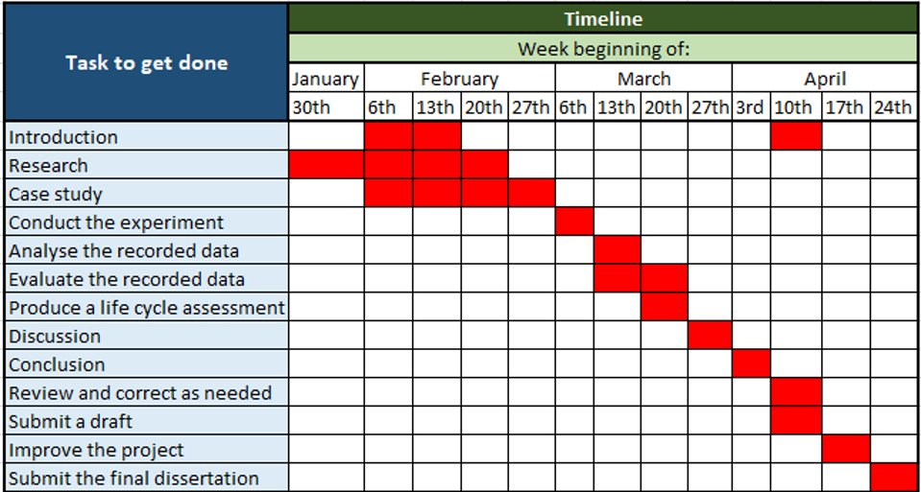
Figure 1. Initial Gantt chart produced prior to beginning the dissertation.

1.2 Updated Gantt chart
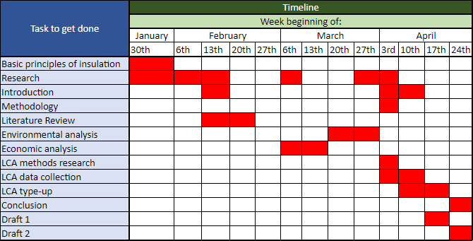
Figure 2. Last version of the Gantt chart for end of dissertation review.

2. Introduction
As the UK is on the route to achieving net zero by 2050, the dissertation looks at heating oil-fuelled dwellings, which account for 1.5 million (Garside, 2020) of the British housing stock. It is essential that the research supporting the 2050 goal gets done efficiently, and within a narrow scope. The dissertation specifically studies this part of the inventory and makes recommendations on how to deal with the remaining inventory.
The UK government recommends conventional building materials as the best retrofit practice, and filling the knowledge gap about non-conventional materials will seriously impact UK emissions (Palmer and Terry, 2017).

2.1. Aims
The aims are as follows:
i. Show that natural insulation materials can ge used instead of conventional materials.
ii. Fill a gap in knowledge about natural insulation types for homeowners and contractors.
iii. Address the cost-of-living crisis by providing retrofitting recommendations and quantify their economic benefit to homeowners.
iv. Help achieve the 2050 net zero goal. Quantify the emissions impact and illustrate the benefits of achieving the 2050 net-zero target.

2.2 Objectives
The objectives are as follows:
i) Insulation background, including the physics behind it.
ii) An in-depth study of the economic and environmental aspects of insulation.
iii) Examine the embodied carbon and operations' emissions.
iv) Perform a life cycle analysis of conventional and non-conventional materials.
v) Compare advantages and disadvantages of wood fibre and straw bale.

2.2 Overview of the Structure and Organisation of the Dissertation
introduction
The UK aims to reach a net-zero decarbonisation target by 2050 to combat the climate crisis, with the housing sector accounting for 26% of total emissions (Watkins, 2022). Research on energy efficiency is critical to reducing energy consumption, fuel poverty, and GHG emissions. The introduction discusses the basic principles of insulation and how it reduces heat transfer. Using natural insulation helps create a sustainable, low-carbon built environment.

Literature Review
The literature review discusses the significant challenge posed by the gap in research and expertise about natural building insulation materials, which impedes the progress towards more sustainable and energy-efficient buildings. The limited understanding of the properties and characteristics of natural insulation materials can make it difficult for builders and contractors to select the appropriate materials for a specific project and optimise their performance for maximum energy efficiency. The research focuses on wood fibre insulation and straw bale, their properties, and their advantages and disadvantages. It highlights the need for investment in research and expertise in natural insulation and the potential benefits of using extracted virgin insulation to accelerate progress towards a low-carbon future.

Environmental and Economic analysis of wall insulation
The analysis discusses the importance of thermal insulation in building design to improve energy efficiency and reduce carbon emissions, which has significant long-term economic benefits for building owners and occupants. Sustainable insulation practices can create new economic opportunities and support the growth of sustainable industries. This dissertation provides calculations for heating oil losses and energy bill savings for homeowners who use heating oil. It is important to break down the Decarbonisation 2050 targets into small plans and strategies rather than just one big plan. This idea will allow for personalisation of a widely varied UK source of emissions. The British government has set an ambitious target of reducing the country’s energy use in buildings by 15% before 2030 (UK Climate Change Act, 2008) and improving the insulation of current dwellings is crucial for achieving this goal.

Lifecycle assessment (LCA)
The LCA evaluates the environmental impacts of a product at each stage of its life cycle. Wood fibre and straw bale are similar materials and were analysed together to provide a condensed analysis.

2.3 Background Information
Research on the energy efficiency of residential buildings is critical to reaching the UK's 2050 net-zero decarbonisation target set in the UK Climate Change Act (2008). The 30-year program aims to reduce fuel poverty by reducing energy consumption and, in turn, GHG* emissions. The cities will become more sustainable and promote good health and well-being across communities (Decarbonisation of Homes in Wales Advisory Group, 2019).
* GHG emissions are greenhouse “gases in the earth’s atmosphere that trap heat” (National Grid, 2022).
To combat the climate crisis in the UK, the Committee on Climate Change (2008) commits by law to reduce greenhouse emissions by 100% compared to 1990 baseline levels. In 2016, as shown in Figure 3 UK emissions were already 41% lower than in the 1990s (Green et al., 2020), meaning that the beginning of working toward the target starts with almost half of it already achieved. However, the second half is going to be much more difficult as the rest of the road is more complex.
The housing sector currently accounts for 26% of total emissions, so success in the net zero goal would make a massive CO² cut down for the UK (Watkins, 2022). Considering the law of supply and demand, reducing the need for energy use would decrease the supply rate. Less energy sold to the residential sector means a significant drop in GHG emissions by the power grid. Considering end users and power sources have many overlaps, and their emissions influence one another, more research is essential.
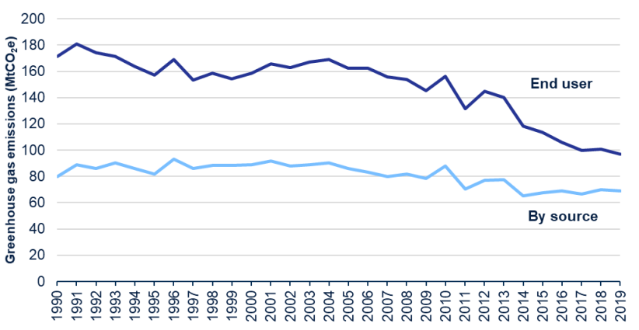
Figure 3. Comparison between ‘End user’ (user of residential property) and ‘By source’ (power supply operations) of greenhouse gas emissions in the UK between 1990-2019, (Department for Business, Energy & Industrial Strategy, 2019).

In 1990, the emissions created by energy users in the residential sector accounted for 170 MtCO²e. If the decarbonisation plan aims for an 80% reduction by 2050 (Department for Business, Energy & Industrial Strategy, 2019), the end-user emissions must get lowered to 34 MtCO²e. In 2019, an emissions level of 95 MtCO²e got achieved (Department for Business, Energy & Industrial Strategy, 2019), so in around 30 years, there was a 44.1% reduction which is optimistic and means that the target is on the right course, having another 30 years to go and only 35.9% more of the target to achieve. The next 30 years encapsulate the strategies to reduce emissions, the actions must maintain then current pace and not slow down as that could extend the project by many more years.
It is important to retrofit all applicable dwellings to ensure a smoother journey, but, retrofitting every single dwelling can be difficult due to, for example, historical reasons (STBA, 2015). The biggest issue homeowners and housing associations face is the cost of retrofit and lack of funding from the government (National Housing Federation, 2020). If retrofitting is not possible, the buildings must change how they consume power (Graigner, 2022).
The research findings and insights gained from this report on insulation types can help to advance the understanding of the several types of insulation materials, their properties, and how they perform in different applications. Applying the already existing knowledge and data about insulation, the analysis conducted for this research can get used as new guidance for industry practices and standards. By improving the understanding of insulation types and how they perform, this report promotes using more sustainable building practices and contribute to a more energy-efficient and environmentally friendly built environment.

2.4 Stakeholders
This study has practical benefits for several stakeholders.
- Homeowners can make informed decisions about retrofitting their homes, reducing the impact of their actions on the environment, and lowering their energy bills.
- Building managers can also make informed decisions about retrofitting residential buildings and identify cost-effective supplies for quick and cheap transformations.
- Manufacturers of raw insulation materials would also benefit from increased demand for their products as builders and contractors become more familiar with their properties and performance characteristics.
- Policymakers can benefit from this research by developing building energy efficiency policies and regulations and promoting energy-efficient solutions. Under the new PAS2035 standard, the party responsible for the retrofit of property must use energy-efficient measures and renewable options, where possible (Social Housing Retrofit Accelerator, 2023). The dissertation adds valuable knowledge for policymakers to develop better building energy-efficiency policies and natural insulation materials.
- Society will benefit from the improved energy efficiency of buildings, resulting in lower greenhouse gas emissions resulting in lower impact on the environment. Finally, filling the gap in research and expertise about raw extracted building insulation materials could lead to developing new and innovative solutions that could transform the insulation industry and contribute to the overall goal of creating a more sustainable and low-carbon built-environment.
- Furthermore, students, post-graduates, and researchers can gather valuable data about the performance of natural insulation materials to explore further research opportunities.

2.5 Basic Principles of Insulation
The purpose of wall insulation is to reduce or prevent the conduction and convection of heat, and the effectiveness of an insulation is measured by its U-value (1). The higher the U-value, the more the insulating material reduces heat transfer. As shown in Figure 4, buildings need high U-values to be considered net zero by building codes (U.S. building codes refer to U-values as R-values (2)), and insulation can help with this. “U-values range from 0.1 (very little heat loss) to 1.0 (high heat loss)” (Glass, 2023).
The thermal performance of buildings is dependent on the thermal transmittance or U-value of their walls. The theoretical U-value of a building’s wall is calculated as the reciprocal of the summation of thermal resistance values of different layers of the wall, where thermal resistance is a function of thermal conductivity and thickness of the layers.
(Sen and Al-Habaibeh, 2021)

U-value
$U=\frac{1}{R_{i}+\frac{d_{1}}{k_{1}}+\frac{d_{1}}{k_{1}}+…+R_{e}}$ * (1)
*(Sen and Al-Habaibeh, 2021)

Where,
k = Thermal conductivity (W/mk)
d = Thickness of the wall (m)
$R_{i}$ = thermal resistance of air at internal surface °C/W (Section 2.5.2)
$R_{e}$ = thermal resistance of air at external surface °C/W (Section 2.5.2)

R-value to U-value conversion
$R-value=\frac{1}{U-value}$ * (2)

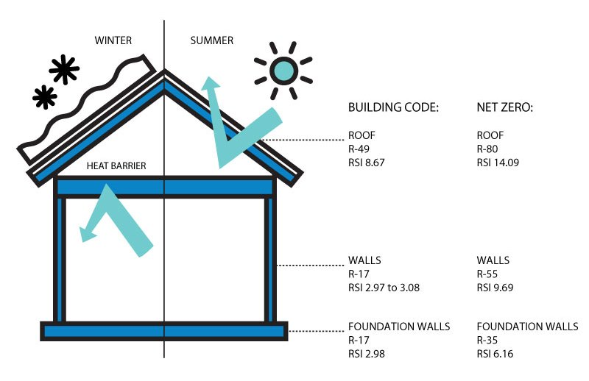
Figure 4. Heat transfer diagram and building codes required to meet the legal standards of the insulation (City of Edmonton, 2023).
Most sun energy enters the home through the roof and sun-orientated windows, as shown in Figure 4. Putting insulation in between the outer and inner layers of the walls reduces conduction (By increasing the thermal insulation and convection and blocking air infiltration paths). Insulating materials do not transfer energy well, whether cold or warm, keeping the house cool in the summer and warm in the winter.
Materials with high thermal resistance and low thermal conductivity (Orwell, 2011) are often good insulators. These are defined in the following section.

2.5.1 Thermal conductivity
The ability of a substance to transmit heat or the rate at which heat may pass through the material defines as thermal conductivity (3). A substance with a high thermal conductivity allows heat to pass through more quickly than one with a low conductivity.
$k = \frac{P × L}{A × ∆T}$ (W/mK) (3)
Where,
k = Thermal conductivity (W/mK)
P = Rate of energy transfer (W)
L = thickness of material (m)
A = Area of thermal conductivity (m2)
= Change in temperature (K)
$P = \frac{Q}{∆t}$ (4)
Where,
P = Rate of energy transfer (W)
Q = energy transfer (J)
$∆t$ = Change in time (s)

2.5.2 Thermal resistance
The ability to resist the flow of heat defines as thermal resistance. A substance with a high thermal resistance resists heat flow more slowly than a material with a low thermal resistance.
$R = \frac{L}{kA}$ (mK/W) (5)
Where,
R = thermal resistance in °C/W
L = thickness of the plate in meters (m)
k = thermal conductivity W/(m·K)
A = surface area in square meters (m²)
Owing to the air pockets that get trapped inside the structures of efficacious insulation materials (such as cellulose or sheep wool), heat cannot easily pass through them. Due to the insulating material barrier between the inside and outside of the structure, it is difficult for heat to enter the building in summer or escape in winter. Fiberglass is a common insulating material consisting of fine glass fibres with a low U-value.

2.6 Importance of insulation
Insulating the walls of a building reduces heat gain and loss, enhancing energy efficiency and, therefore, lowering energy costs (BBC, 2022). Furthermore, wall insulation can reduce drafts, improve indoor air quality, and decrease noise transmission, improving occupant comfort.
From the perspective of homeowners, insulation significantly reduces energy consumption and utility bills while allowing a comfortable indoor environment without over-reliance on heating or cooling appliances. Yet, insulation is not only a vital material for retrofit for homeowners but also plays a crucial role in reducing greenhouse gas emissions and meeting carbon reduction targets. Through reduced energy consumption, insulation reduces the need for fossil fuels to generate electricity and heat homes (Bennett, 2022), thereby decreasing associated GHG emissions and addressing the climate emergency.
Insulation is instrumental in enabling grid decarbonisation by reducing the overall energy demand. By decreasing the energy consumption of buildings, insulation mitigates the pressure on the power grid, increasing the feasibility of entirely provision end-user demand with renewables.

2.7 Future applications of the research findings
This research offers significant potential for climate tech companies to enhance their operations, particularly in retrofitting residential properties in Britain. After consulting with Tallarna, a climate-tech company in the field, has confirmed that they could further leverage this research for several purposes, including,
- extending risk modelling to less common insulation types for large-scale retrofit projects; mitigating deployment obstacles of natural insulation materials through the provision of new insurance products;
- integrating life-cycle analysis into analytics software to enable dynamic assessments of carbon payback periods on insulation materials and demonstrate the added benefits of natural insulation;
Climate tech businesses might advance the adoption of sustainable and environmentally friendly practices in dwelling retrofitting using the research in this dissertation.

3. Methodology
3.1 Research design
An analysis, with a focus on wood fibre and straw insulation. Qualitative research methods are appropriate for this dissertation because they allow for an in-depth exploration of the properties, advantages, and limitations of materials. This design allows for the understanding of the data through an examination of patterns, themes, and relationships (Tenny and Sharts-Hopko, 2022).
Quantitative research involves collecting data (Bhandari, 2022) on the environmental impact of wood and straw insulation materials, such as their carbon footprint, energy consumption, and waste generation.

3.2 Data analysis methods
Data analysis methods include tables and graphs to draw conclusions. They are appropriate because tables and charts in data analysis help organise and present data visually. Tables are useful for presenting large amounts of numerical data in a structured and easy-to-read format, while graphs are helpful for visually displaying trends, patterns, and relationships in the data.

3.4 Limitations
The findings are not generalisable, as they are specific to wood fibre and straw insulation materials. As with any research project, there is potential for bias, especially during data collection. To mitigate these limitations, the findings are contextualised and presented within the scope of the research problem, providing transparency about the research process and findings.

3.5 Choice of insulation materials for the research
The chosen materials – wood fibre and straw bale – are more environmentally friendly than artificial insulation products, if used well can reduce bills for homeowners, and reduce the carbon footprint of heating oil-fuelled homes. Wood fibre and straw are renewable and abundant resources that have gotten used as building materials for centuries. Hence, studying the comparison of these materials can provide valuable insights into their suitability as sustainable alternatives to traditional building materials.
Currently, for retrofitting, the UK government only recommends non-conventional materials (Palmer and Terry, 2017). For this paper, expanded polystyrene was used for comparison with products of natural origin.

4. Literature Review

4.1 Identification of gaps in the literature that the study aims to fill

4.1.1 What is the gap, and why is it important?
The gap in research and expertise about natural building insulation materials is a significant challenge for the construction industry as it impedes progress toward more sustainable and energy-efficient buildings. The limited understanding of the properties and characteristics of natural insulation materials can make it difficult for builders and contractors to select the appropriate materials for a specific project and to optimise their performance for maximum energy efficiency.

4.1.2 Why is there a gap?
One reason for the gap is that the industry has traditionally relied on commonly used insulation materials, which are thoroughly researched and well-established in the market. Hence, there is little incentive to spend money investigating new or different insulating materials.
Many builders and contractors may not be familiar with the properties and performance characteristics of these materials and may be hesitant to use them. Likewise, they may have no experience with the physical installation process and unique risks or issues that could arise with new materials. Builders want to stick with what they know works and lower the risk of them being responsible for costly remediation work.

4.1.3 How will this dissertation aid to fill that gap?

This dissertation fills the knowledge gap by providing a comprehensive analysis of the properties of natural insulating materials and how they perform as construction materials. Although wood fibre and straw were used for construction purposes for many years, in-depth studies on their comparative performance and applicability as sustainable building materials are lacking. The study helps bridge this gap by providing detailed information on the environmental and economic advantages and disadvantages of using wood fibre and straw as building materials.

4.2 Raw-sourced insulating materials

4.2.1 Wood fibre insulation
In the past, unprocessed raw materials served as insulators for housing, providing warmth before more sophisticated insulation methods. The earliest known use of wooden structures for insulation dates back about 10,000 years (Yell, 2019), thus establishing wood as a foundational component in the evolution of insulation techniques. The heat conductive properties of wood are attributed to its high concentration of free ions and air pockets, as said by Cope (2022). However, it is essential to note that when wood becomes moist, it can conduct electricity, potentially causing harm. Water molecules are responsible for this conductivity, not the wood itself. A damp environment might encourage the substance to rot, which can potentially cause health problems. Unfortunately, maintaining the dryness of wood can be challenging in fluctuating climates. To mitigate its conductivity while maintaining its efficiency as an insulator, it is best to use wood with other materials that offer moisture resistance, such as outer wall cladding.
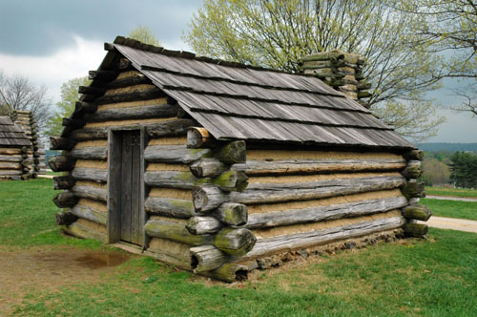
Figure 5. A visual representation of an old wood-constructed house (Borràs, 20AD).

Bamboo, an accessible and sustainable material, widely used historically as an effective insulator in certain regions, including the Philippines, Colombia, and Indonesia. The material possesses notable strength and tensile properties, rendering it an ideal insulator. Because of its abundance in the mentioned areas and ease of harvesting and regeneration, bamboo makes a superior insulating material. Owing to its tensile qualities and capacity to sustain pressure up to 358.53 MPa, it was originally a primary building material (Manandhar, Kim, and Kim 2019).
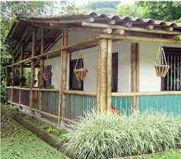
Figure 6. Example of a construction supported by bamboo materials (Manandhar, Kim, and Kim, 2019).
From an environmental perspective, wood waste as an insulation material is highly sustainable. A wood slab can get produced by grinding and pressing down materials like sawdust or wooden crates. Wood is easily recyclable and renewable, due to its organic nature. Because wood-fibre insulation is biodegradable, less waste will end up in landfills as it breaks down naturally over time.
Moreover, wood fibre insulation possesses superior fire resistance, making it an excellent choice for construction purposes compared to raw wood. According to Segovia et al. (2020), combustible protection is a direct result of the material density, which varies from 332 to 338 kg/m³, and the thermal conductivity, which ranges from 0.064 to 0.066 W/m²K. However, it is essential to note that the thermal conductivity of timber fibre, specifically, is even lower than that of wood fibre, measuring at 0.050 W/mK (Dickson and Pavía, 2021).
Wood is a raw, composite material that makes up the tree, whereas timber is a type of crushed wood processed into a material (Mahajan, 2021). Timber is not easily accessible in the UK, but other countries could benefit from using timber over wood (Ward, 2021).
Despite all the advantages of using wood as an environmentally benign material, its use has many environmental drawbacks. Owing to its limited availability compared to other insulating materials, wood-fibre insulation gets transported over longer distances to building sites, increasing transportation costs, and having an adverse effect on the environment. Some wood fibre insulation products get treated with chemicals to improve fire resistance or resistance to pests, which could have potential environmental impacts.
Natural habitats may get harmed due to the initial harvesting, and over time, this issue could lead to the extinction of certain species. The extended harvesting process produces greenhouse gas emissions through energy-intensive machinery and vehicles. To mitigate these issues, using recycled materials may be preferable, as it would reduce the need for harvesting.
From an economical perspective, producing wood fibre insulation can be costly. Wood fibre boards get transported from other countries, which increases their embodied carbon emissions, and if treated with wax, it might not be as easy to recycle them (Sadler, 2020).

Table 1. Break-down of UK wood fibre imports from other countries, EU and non-EU. Data obtained from Forest Research (2023).
Source | % of total UK imports
Germany | 20
Ireland | 29
Spain | 13
Latvia | 7
Poland | 5
Other EU countries | 20
Non-EU | 6

Installation costs could rise due to the labour-intensive nature of the original wood harvest, and the subsequent production process. Wood-fibre insulation requires maintenance with protective coatings to function at its best, which might result in additional costs.

4.2.2 Wheat straw
Wheat straw consists of dried stalks of the wheat plant (Triticum aestivum). When wheat gets harvested, the grain gets separated from the stalks (threshing), and then left in the field to dry. Once the straw has dried, it gets baled and used for several things, such as insulation, bedding, and animal feed.
Wheat straw is a renewable resource, as it is a by-product of wheat production. It is non-toxic, free of VOCs*, (Roberts, 2017) and has a low carbon footprint, making it an environmentally friendly material.
*VOC - volatile organic compounds (Roberts, 2017).
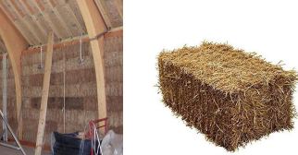
Figure 7. Rectangular bales of wheat straw used for construction purposes (Bennett et al., 2022).

People in various parts of the world have used wheat straw insulation for centuries. In the United States, wheat straw insulation gained popularity during the energy crisis of the 1970s (Frommer, 2022) & (Lymath, 2016), when people were looking for more energy-efficient ways to insulate their homes. Today, it gained renewed interest as a sustainable and renewable insulation material for building applications, as it offers good thermal resistance properties.
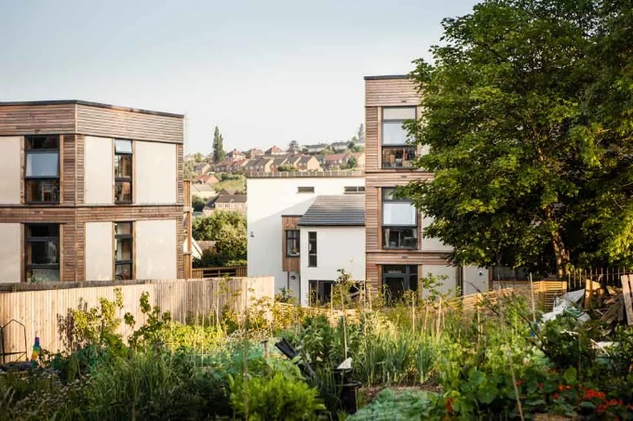
Figure 8. Part of eco-friendly architecture in Leeds, all insulated by straw bales (Matcalf, 2022).
Wheat straw's thermal conductivity ranges from 0.025 to 0.075 W/mK (Czajkowski, et al., 2022), suggesting its exceptional insulating properties. Furthermore, a study, Thermal Resistivity of Straw Bales for Construction by McCabe (1993), showed that “the thermal conductivity of the straw bales is 0.048 W/mK when the heat flow is perpendicular to the fibres and 0.061 W/mK when it is parallel”. In comparison, some other commonly used insulation materials have thermal conductivity values that range from 0.022 to 0.55 W/mK, as shown in Table 2, which means that wheat straw bale falls within a similar range, indicating that it can be an effective insulation material when used in building applications.
Table 2. Thermal conductivities of commonly used building insulation materials. Data obtained from The Open University (2013).
Insulation material | Thermal conductivity (W/mK)
Foamed wool | 0.045–0.055
Sheep wool, cellulose fibre, mineral wool, glass fibre wool | 0.032–0.040
Expanded and extruded polystyrene foam | 0.030–0.040
Polyurethane foam | 0.025
Polyisocyanurate (PIR) foam | 0.023
Phenolic foam | 0.022

A density of 60 kg/m³ (Díaz Fuentes, Pérez Rojas and Mancilla, 2020) for a wheat straw bale is low, suggesting it is lightweight, not compacted and is porous. In terms of insulation abilities, a less dense straw bale can have both advantages and disadvantages. On the one hand, a more porous bale can trap more air, which improves its insulation properties. On the other hand, a less dense bale may also have a lower compressive strength, making it more susceptible to settling and deformation over time.
Specific heat is the energy required to raise the temperature of a material by one degree Celsius per unit of mass (BBC, 2023). A specific heat value of 1600 J/kgK for wheat straw bale (Czajkowski et al., 2022) means that it requires 1600 joules of energy to raise the temperature of one kilogram of the wheat straw bale by one degree Celsius.
In terms of insulation abilities, the specific heat of a material does not relate to its thermal insulation performance. Instead, it relates to how the material responds to changes in temperature. Materials with a high specific heat have a greater capacity to retain heat, making them suitable for thermal mass applications since they can absorb lots of heat energy before their temperature rises appreciably.
Straw is not a material with much thermal mass. Thermally massive materials, such as brick or concrete, can store and slowly release lots of heat due to their low density and high specific heat capacity.They have a low specific heat capacity and low mass, which limit their ability to retain and release heat. Straw bales get used as insulation in buildings because they offer efficient thermal insulation through their trapped air pockets, even though their thermal mass features are not usually exploited.
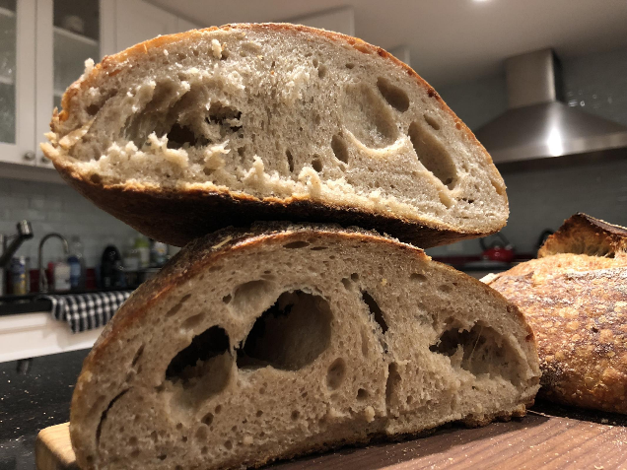
Figure 9. The structure within a straw bale gets built on the same idea as a loaf of bread full of air bubbles that have created holes in the bread (The Fresh Loaf, 2018).
In conclusion, wheat straw got used for centuries for several purposes, including insulation. It is also renewable and ecologically benign. Its good thermal resistance properties and low carbon footprint make it an ideal choice for energy-efficient building applications. It is also a long-lasting material, with a peak performance expected to last at least 100 years (Roberts, 2017).

4.3 Conclusion of the literature review
In conclusion, the literature review reveals a significant gap in research and expertise about natural building insulation materials, which impedes the construction industry's progress towards more sustainable buildings. The lack of understanding of natural insulation materials' properties and characteristics makes it challenging for builders and contractors to select the appropriate materials and optimise their performance for maximum energy efficiency.
The review highlights the strengths and weaknesses of the existing literature, such as the lack of awareness and education about natural insulation materials and the limited funding available to support research in this area. However, the dissertation fills the gap by providing a comprehensive analysis of the properties of traditional insulating materials and how they perform as construction materials.

5. Environmental and Economic analysis of wall insulation

5.1 Importance of Environmental and Economic analysis of wall insulation
Building insulation is crucial for an energy-efficient building design and significantly reduces energy consumption and carbon emissions. Reducing carbon emissions is essential for mitigating its adverse effects. It has a direct impact on the cost-effectiveness of building construction and operation. By reducing the energy required to heat and cool buildings, insulation can help lower energy bills and reduce maintenance costs, leading to significant long-term economic benefits for building owners and occupants.
Adopting sustainable insulation practices can help create new economic opportunities and support the growth of sustainable industries. The production and installation of natural insulation materials can provide new opportunities for local producers and installers while promoting sustainable land use and resource management practices.
The impact of insulating walls gets determined by calculating how much CO2 a regular British home produces with and without insulation, as explained in Section 3.3.1.

5.2 UK housing statistics

First, take a square root of the floor area to calculate the width of one of the walls in a 4-wall room. Multiply the result by 4 to get the perimeter of the room. The perimeter of a room gets multiplied by the floor-to-floor height plus the ceiling thickness to determine the room wall area. If unable to measure the height and thickness, the average floor-to-floor height in the UK is 2.7m (BRE, 2014). Ceiling thicknesses in the UK are typically 0.25m (BRE, 2014). Subtract the window and door area if there are any on the outside walls of the room.
Average wall area (m2) of a bedroom with no windows or doors:
$\left(\sqrt{Floor area}×4\right)×\left(Floor to floor height×Ceiling thickness\right)$ (6)
Average wall area (m2) of a bedroom with windows and/or doors:
$\left(\sqrt{Floor area}×4\right)×\left(Floor to floor height×Ceiling thickness\right)- \left(Window area + Wall area\right)$ (7)
Table 3. Average wall area of British dwellings.
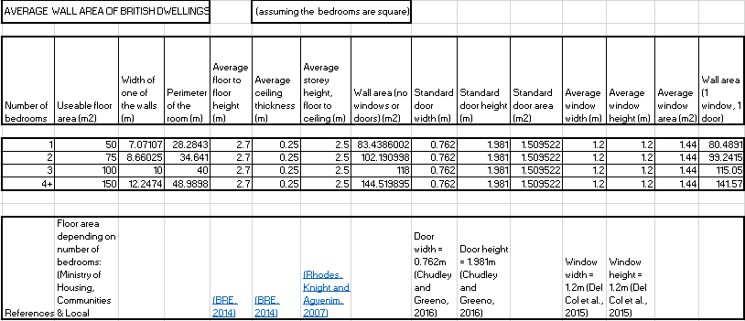
Note: The useable floor area does account for kitchen, bathroom, and hallway.
Table 3 was populated using data from sources provided on the bottom of the table and using the following Excel formulas:
- Width of one of the walls: =SQRT(Useable floor area)
- Perimeter of the room: =SUM(Width of one of the walls * 4)
- Wall area (no windows or doors): =SUM(Perimeter of the room* (Average floor to floor height + Average ceiling thickness))
- Standard door area: =Standard door height* standard door width
- Average window area: =Average window height * Average window width
- Wall area (1 window, 1 door): =Wall area (no windows or doors) - Standard door area - Average window area
The average number of bedrooms in a British house is 2.95 rooms (Statista, 2018). Therefore, the average wall area with 1 window and 1 door is between 99-115m^2.

5.3 Heating fuel loss from British dwellings.
The British housing market accounted for 27.8 million residential properties in 2015 (Office for National Statistics, 2015). 1.5 million houses are fuelled with heating oil (Ingrams, 2022).
The key difference between gas from the grid and heating oil (as well as liquefied petroleum gas or LPG) is that heating oil is delivered by road and stored in a tank. If your home has an oil boiler, it runs on heating oil.
(Ingrams, 2022).
Reducing energy use in a home can significantly reduce cost savings on energy bills, which is especially important for homeowners who use heating oil as a heating fuel. Heating oil prices can fluctuate and are often more expensive than other heating fuels, so reducing energy use can help to offset the costs of heating oil. Looking at Figure 10, heating oil costs more during March, May, June, and September compares to other months, because less heating oil gets used, the demand goes down and the price fluctuates so that the companies can still make profit even if it is not during winter. On the other hand, for homeowners who are not able to retrofit their dwellings. If the rest of the country retrofits theirs, they will be paying extortionate amounts of money for heating oil. Respectively, such rises in the prices will motivate the remaining homeowners to retrofit and save money on bills.
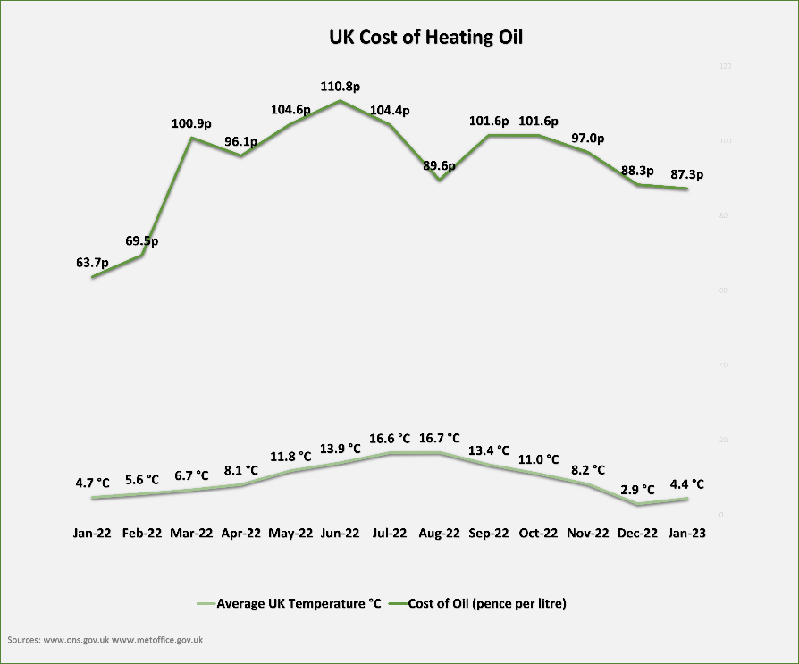
Figure 10. UK cost of heating oil fluctuations throughout the year (Fuel Fighter, 2023).
A recent report by the Federal Environment Agency in Germany (Rulhoff, 2022) revealed that an uninsulated wall loses 158 litres of heating oil per square metre over 20 years, while a well-insulated wall loses only 20 litres per square metre (Those figures were used as a basis for the UK calculations, in section 5.2). The 88% decrease in the heat loss rate from insulated buildings compared to uninsulated ones represents a substantial improvement in energy efficiency.
Based on the data from Table 3, if an average British dwelling has a floor area of 99-115m²:
- Heating oil loss for an un-insulated house: 15642 litres – 18710 litres
- Heating oil loss for a well-insulated house: 1980 litres – 2300 litres
Median quantities for easier data interpretation (Refer to Figure 11 for a chart representation of data).
- Heating oil loss for an un-insulated house: 17176 litres
- Heating oil loss for a well-insulated house: 2140 litres
Conclusively, there is a saving of 15036 litres of heating oil per household. Considering around 1.5 million residential dwellings in the UK use heating oil (Garside, 2020), retrofitting the insulation in all heating fuelled households would save the UK 22.554 billion litres of heating oil.
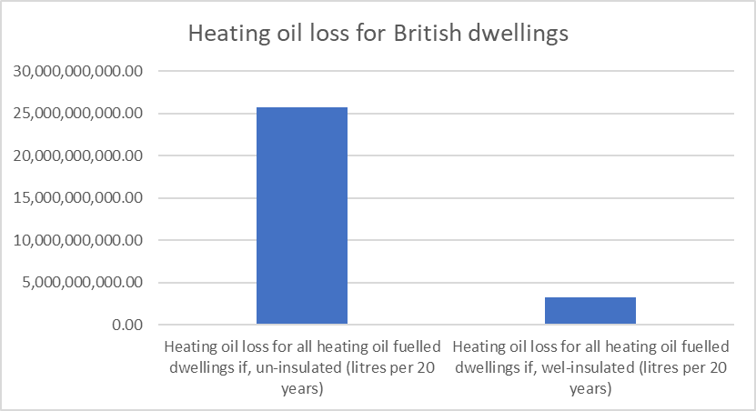
Figure 11. Graph showing how much heating oil dwellings in the UK lose depending on whether they are insulated or not.
Figure 11 shows that if all the heating oil dwellings were uninsulated there would be an overall loss of 25,764,000,000 litres of oil every 20 years (1,288,200,000 litres yearly), and if they were all insulated there would be an overall loss of 3,210,000,000 litres (160,500,000 per year). An overall saving of 22,554,000,000 litres of heating oil every 20 years (1,127,700,000 a year).
Currently, the average price of heating oil is 88312 pence per 1000 litres i.e., £0.88312 per litre (Payne, 2023). The high price of heating oil underscores the importance of insulation in reducing energy costs, with well-insulated buildings being more cost-effective to maintain than those with inadequate insulation. Conclusively, the cost savings can be seen in Figure . If all the heating oil fuelled dwellings were un-insulated, they would result in a loss of £22,752,703,680 every 20 years (£1,137,635,184 yearly) and if they were all insulated, they would only result in a loss of £2,834,815,200 (£141,740,760 yearly). Insulating all heating oil fuelled dwellings would result in a yearly saving of £995,894,424.
Considering that each heating oil fuelled household uses 1700-1800 litres of heating oil per year (Median is 1750 litres), every homeowner could save 107 litres of oil per year if they insulated their homes. So, they would save £94.49, compared to spending £1545.46 now, they’d spend £1450.97.
According to Mostyn (2020) people in Britain may save up to £94.49 in annual heating costs by retrofitting their houses. Based on the calculations in this report, Mostyn was right and the figure is correct.
Additionally, burning heating oil produces 970 grams (0.97kg) CO2 per kWh produced. Considering the heating oil loss (assuming all hoses are not insulated well enough) is 1,288,200,000 litres of oil per year. To convert litres into kWh, the litres get multiplied by 7 (HESA, 2023), therefore, the loss is 9,017,400,000kWh. Likewise, if all the houses were insulated, there would only be a loss of 1,123,500,000kWh.
Ultimately, insulating all homes that burn on oil could save 7,655,188,000 kilogrammes of CO2 emissions.
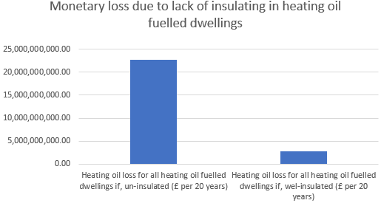
Figure 12. Graph representing monetary loss due to lack of insulating in heating oil fuelled dwellings.

The price and need for heating fuel will rise as the world population rises by 2 billion people by 2050, as seen in Figure 13 (Roser, 2019). Heating fuels are finite resources, the more depleted the reserves are, the higher the cost. Reaching the 2050 carbon zero targets is critical, predicting that heating oil runs out in the middle of that decade, gas ten years later, and coal will run out in 2090. (Kuo, 2019). Also, as the population increases, the housing stock will grow by 11% by 2050 (Drewniok et al., 2022).
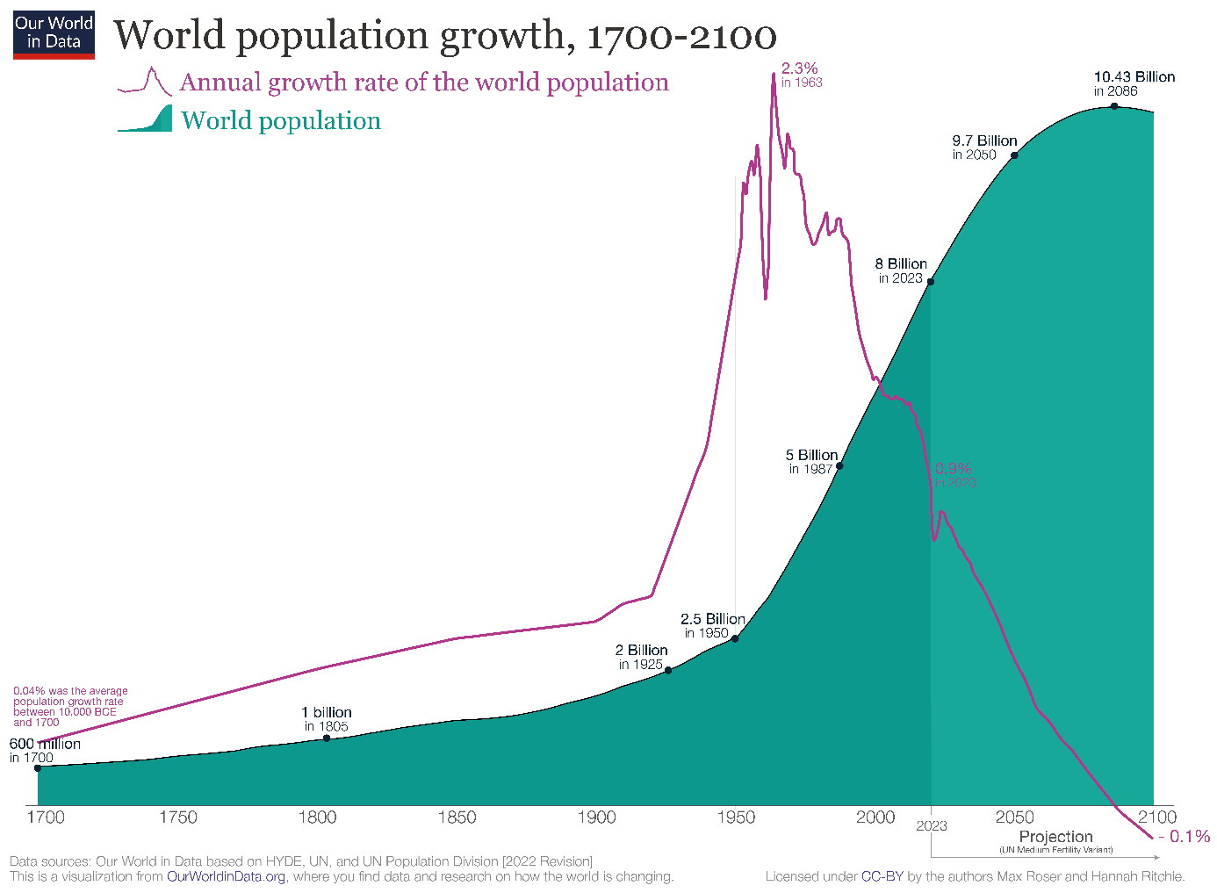
Figure 13. World population growth predictions (Roser, 2019).
The British government has set an ambitious target of reducing the country’s energy use in buildings by 15% before 2030 (Young, 2022). Improving the insulation of current dwellings and adhering to new build regulations are crucial steps towards achieving this goal. It will reduce energy use in residential properties and in power grids, accounting for a large cut.
Lack of energy-efficient housing influences the environment, and the British air suffers. An average dwelling in the UK emits 2.7 tonnes of CO2 each year, based on 3,600 kWh of electricity and 13,000 kWh of gas used annually by a typical family (Department for Energy Security and Net Zero, 2021).

5.4. Economic analysis of insulation

5.4.1 Economic benefits of insulation
Over 140,000 jobs in the building, manufacturing, and installation sectors will get generated by insulating homes (Harvey, 2022). However, after achieving the 2050 target, CLC (2021) predicts a shrinking workforce after achieving retrofit goals. Harvey (2022) did not specify whether those jobs will get sustained. It is probable that after a big surge in jobs during the retrofit journey, they will get laid off when the project is done.
The International Energy Agency (IEA) Energy Efficiency, 2021 report states that despite the significant energy efficiency improvements, “global energy consumption would still increase by 25% by 2040 under current policy settings”' (IEA, 2021).
Instead of spending work wages on gas and electricity, people can spend money on shopping, going on holidays, or even saving up to start new businesses, thereby improving the economy. The economy might grow by up to £7 billion a year by 2030 (Harvey and correspondent, 2022).
Lack of insulation increases the incidence and severity of respiratory illness (Fyfe et al., 2022) by contributing to damp, mould, and draft. The cold air that enters the house through poorly insulated walls can inflame the lungs and throat, affect circulation, and cause more health issues (WHO, 2018). Treating people who develop respiratory illnesses costs the government money. Private care is an option, but only 20% (on average) of UK residents use it (PHIN, 2022). Employers must provide sick pay for sick days, and the already strained NHS deals with extra patients that could have gotten prevented. Utilising insulation creates a barrier in the wall that limits the movement of air (including pollution) between outside and inside, reducing the risk of inhaling unhealthy substances. Also, it aids in maintaining the building temperature and humidity, which is beneficial for preventing dampness and mould growth.
The UK is currently reliant on foreign fossil fuels. For instance, 4% of gas, 9% of oil and 27% of coal transported to the UK from Russia, account for £1.3 billion in spending, in 2022-2023 (Bolton, 2022). Figure 13 shows a sharp rise in non-EU imports into the UK during the previous two to three years.
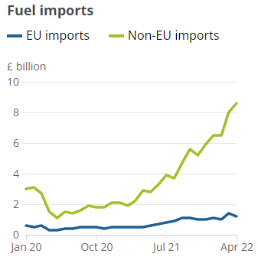
Figure 14. An analysis of British imports of fossil fuels from January 2020 to April 2022 (Donnarumma, 2022).
In 2021, 9% of British oil was imported from Russia (Bolton, 2022), the imports began decreasing towards 2022 with a complete ban of imports by 2023 (Casalicchio, 2022). Looking at Figure 13, the graph trend shows a spike in non-EU imports 2021-2022, showing how the 9% of European oil reduction affected the overall import rate. The Russian oil ban began as a protest against the Russia and Ukraine war (Casalicchio, 2022), which began on February 24, 2022 (Ray, 2023). The UK government had decided it is best to part ways with Russia as soon as threats towards Ukraine started, in that part of NATO, it seemed the most feasible at the time.
Reducing dependence on foreign fossil fuels can help the UK to reduce its exposure to price volatility. The price of fossil fuels can be volatile (Kemper and Martin, 2013) due to global supply and demand, geopolitical events, and weather patterns.
any of the world’s major oil-producing countries are in politically unstable regions (Landale, 2020), which can lead to supply disruptions and price spikes. By reducing its reliance on these countries for energy, the UK can reduce its exposure to these risks and better ensure a stable and secure energy supply.
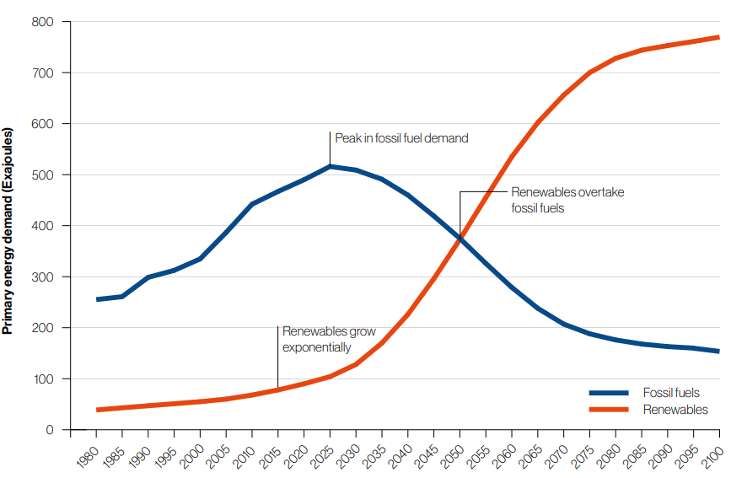
Figure 15. Graph showing the supply and demand for fossil fuels and renewable energy in Britain to achieve the Paris Agreement's aim (IRENA, 2019). ‘The Paris Agreement is a legally binding international treaty on climate change. It was adopted by 196 Parties at the UN Climate Change Conference (COP21) in Paris, France, on 12 December 2015. It entered into force on 4 November 2016.’ (UNFCCC, 2022).
Figure 15 shows that in the next two to three years, the demand for fossil fuels will be at its highest level but renewable energy will be at its lowest level since the 1980s. By 2050—the year the UK hopes to achieve net zero energy—the demand for fossil fuels would decline, and the need for renewable energy sources would rise rapidly. Decreasing demand through insulation can reduce the amount of capacity that needs to be provided by renewable sources.

5.4.2 Economical drawbacks of insulation
Straw bale insulation is not as durable as other insulation, susceptible to damage from moisture, pests, and fire, increasing the long-term cost of the insulation if it needs replacing or repairing.
Straw bale insulation requires a moisture barrier to prevent moisture from penetrating the walls and causing damage. At a low price, it now costs £1.24 per m² on Amazon (Amazon, 2023).
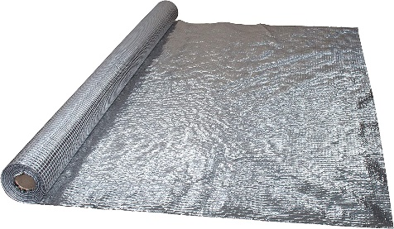
Figure 16. Aluminium Vapour Barrier for moisture control in straw bale insulated structures (Amazon, 2023).
Also, straw bales need secure mounting to the walls and often need a rain screen system (outside cladding) to protect them from water damage. The screen provides a barrier from the rain, and a drainage system, thus protecting the wall. Finally, a finish coat of plaster or stucco will provide a protective outer layer. Installing straw bale insulation requires skilled labour, which can be more expensive than traditional insulation installation because it can be time-consuming, which adds to the cost of the insulation.
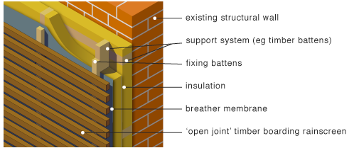
Figure 17. Outside cladding as a rain screen system, shown on a wall structure (GreenSpec, 2023).
Wood fibre insulation needs a wall fixing and mounting system to hold it in place, and a rain screen system to protect the exterior of the building.
Straw and wood fibre insulation can be less fire-resistant than other insulation materials, increasing the cost of fire safety systems and insurance.

5.5 Environmental analysis of wall insulation

5.5.1. Environmental benefits of insulation
Insulating the built environment benefits the natural environment by reducing greenhouse emissions, thus reducing carbon footprint. Insulating also decreases energy consumption in British homes, saves people money, and acts as a barrier to pollutants (American Chemistry Council, 2023) and noises outside, providing cleaner air at home and peacefulness.
Studying the environmental benefits of different insulation types can help to identify the most sustainable insulation options because it allows for an assessment of the life cycle impacts of each material, including evaluating raw material sourcing, manufacturing, transportation, installation, use, maintenance, and disposal (Golsteijn, 2018).
Through an LCA (Life cycle assessment) the dissertation compares the most common raw extracted insulation materials.
LCA is a “Lifecycle assessment refers to a methodology used to measure the impact of products (or systems), components or even whole buildings over a lifecycle” (McPartland, 2017). It considers every stage of a material lifecycle, as shown in Figure 17.
The goal of LCA is to provide a comprehensive and objective analysis of the environmental performance of a product or service, identifying opportunities for improvement in terms of reducing its environmental impact.
Renewable resources usually have a lower environmental impact than those made from synthetic materials like polyurethane foam and expanded polystyrene (Yale, 2018). Production of synthetic materials requires more energy and generates more GHG emissions. Also, some insulation materials are more difficult to recycle or dispose of, which can negatively impact the environment.
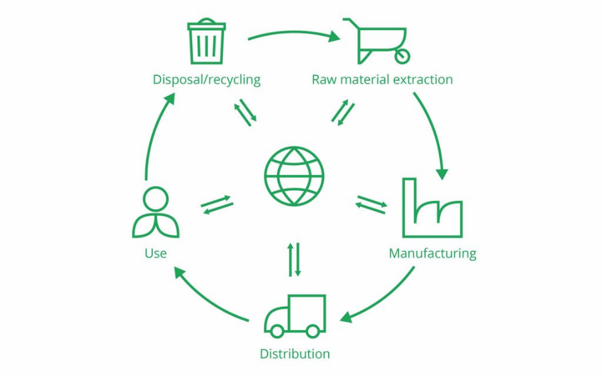
Figure 18. Life cycle stages (Golsteijn, 2018).

5.5.2. Environmental drawbacks of wall insulation
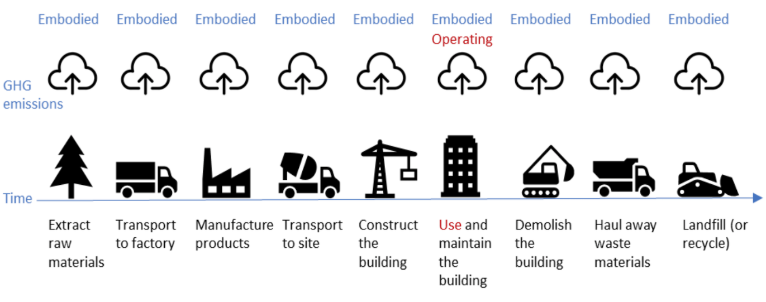
Figure 19. Visual representation of how embodied energy & carbon is involved in the life cycle of a building (Forestry Innovation Investment, 2017).
Looking at Figure 19 with the sole exception that it is lower when the building is in use, embodied carbon is present throughout the whole life cycle of the building.
“Embodied carbon comes from the consumption embodied energy consumed to extract, refine, process, transport and fabricate a material or product (including buildings)” (Circular Ecology, 2019).
Embodied carbon (measured in terms of carbon dioxide equivalents, CO²e - a unit used to express the impact of greenhouse gas emissions, including not only carbon dioxide but also other gases) refers to the carbon emissions associated with the production, transportation, and disposal of materials used in the construction of buildings and other structures. It includes the emissions released during the extraction and manufacturing of raw materials, the processing and transportation of materials to construction sites, and the eventual disposal of materials at the end of a building life cycle.

Table 4. Embodied carbon across natural and non-conventional insulation materials.
Material | Embodied carbon by weight (CO2e/kg) | Embodied energy by weight (MJ/kg) | Embodied carbon for 4m x 8m wall (kgCO2e) | Embodied carbon (GHG) (kgCO2e/kg)
Straw | 0.01* | 0.24*** | 8* | -
Expanded polystyrene | 2.55* | 88.6* | 38.5* | 3.29*
Wood fibre | 0.128** | 173*** | - | -
Product information accessed from the following:
*(Hammond et al., 2011)
** (Spear et al., 2019)
*** (GUTEX Holzfaserplattenwerk H. Henselmann GmbH + Co KG, 2015)
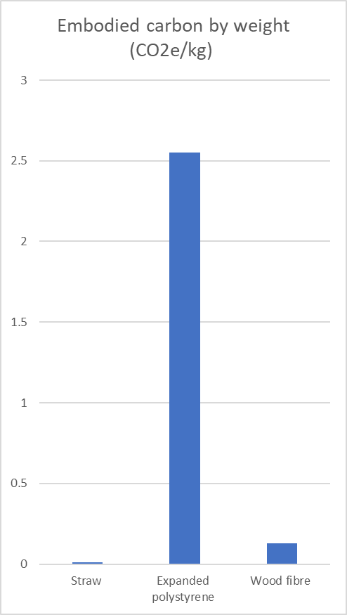
Figure 20. Graph representation of embodied carbon by weight for straw, expanded polystyrene and wood fibre.

Looking at Figure 19 straw and wood, both have a much lower embodied carbon than expanded polystyrene (roughly 2.25 CO²e/kg less). Either could be classified as particularly good insulation in terms of carbon footprint.
Operations emissions refer to the carbon emissions associated with the ongoing operation and maintenance of a building, such as heating, cooling, lighting, and ventilation. These emissions are distinct from embodied carbon, which refers to the emissions associated with the production and disposal of building materials.
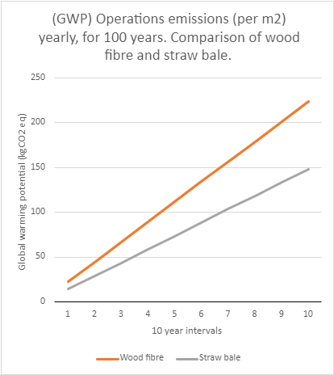
Figure 21. Operations emissions of wood fibre and straw bale.
Figure 21 shows how the operations emissions differ for wood fibre and straw bale (Data obtained from Table 6. Straw bale produces approximately 75kgCO2 less after 100-year passes. However, it is worth nothing that the overall GWP (Global warming potential) emissions) during the lifecycle of the material are lower. This is because the raw material acquisition for natural products has a negative emissions factor. That is because, when natural material are acquired (usually plants) the plant itself reduces CO2 emissions, driving the overall GWP down.

6. Lifecycle assessment (LCA)

6.1 Cradle-to-cradle (C2C) approach
C2C is a concept developed by William McDonough and Michael Braungart that promotes designing products and processes in a way that mimics nature's circular systems, where waste from one process becomes a resource for another (McDonough, 2023). In a cradle-to-cradle approach, products get designed with the goal of being fully recyclable or biodegradable, with materials and components designed for a closed-loop system. This idea means that at the end of their useful life, products can get recycled or returned to the natural environment without creating wastage or pollution. C2C focuses on creating products that are not only environmentally friendly, but also economically and socially responsible.

6.2 Circular economy
Waste economy can get defined in three different approaches: linear economy, recycling economy a circular economy, as seen in Figure 21.
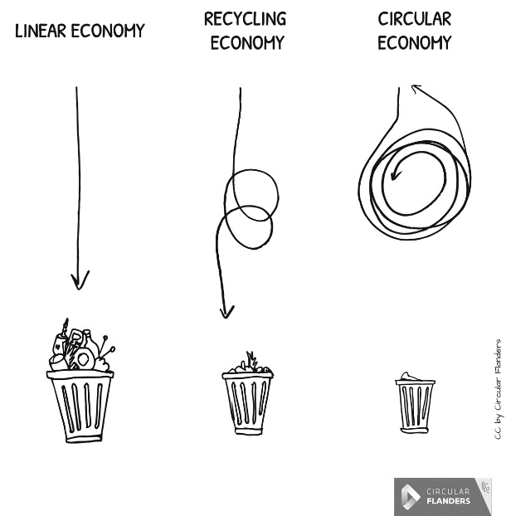
Figure 22. Waste economy approaches (Zero Waste Scotland, 2019).
The scope of LCA revolves around the most sustainable approach, the circular economy. The different approaches vary depending on how the material life cycle is controlled.. Linear economy is the simplest and least efficient, rubbish goes straight into a black bin, without recycling and ends up in the landfill. Recycling economy is a slightly better concept where plastics, glass and carboard get recycled and then manufactured for re-using and repurposing. The circular economy is the most efficient due to a variety of factors. This approach ensures sustainability right from the manufacturing process. Materials get designed and produced using more sustainable materials, to make repurposing and reusing easier. If the materials end up in the landfill because they are non-recyclable, they will decompose quicker than ordinary materials, reducing pollution and wastage.

6.3 Life Cycle Assessment Methodology

6.3.1 LCA goals and scope – system boundaries
- Raw material acquisition: Extraction and processing of raw materials.
- Raw material transportation.
- Manufacturing.
- Transportation: Energy consumption and emissions from transportation vehicles.
- Construction.
- Use, maintenance, repair: During this phase, the building is occupied and used by people.
- End-of-life, transport, waste disposal.
- Reuse, recycle, repurpose.

6.3.2 Product information
Table 5. Natural fibre insulation and conventional insulation materials, manufacturer information.
 | Natural fibre insulation (NFI) Materials
Material | Wood fibre | Straw bale
Production country | UK* | UK***
Thermal Conductivity W/mK | 0.039* | 0.064***
Density (kg/m3) | 173**** | 123***
Specific Heat Capacity (J/kg2K) | 2300-2800* | -
U-value (W/m2k) | 0.19* | 0.1***
Price (£) | 33.45* | 5**
Size (sqm) | 0.747 * | 0.61**

Product information accessed from the following:
*(Black Mountain Insulation, 2023);
**(Wadswick, 2023);
***(Costes et al., 2017)
**** GUTEX Holzfaserplattenwerk H. Henselmann GmbH + Co KG, 2015)

6.4 Inventory analysis
Inventory analysis focuses on quantifying the environmental impacts of a product by analysing its inputs, outputs, and emissions at each stage of its life cycle. Wood fibre and straw bale are similar materials in terms of sourcing and producing. After reviewing the lifecycle process of both materials, it is more efficient to produce one inventory analysis for both. A condense analysis is far better than two similar analyses, which will produce the same conclusion.

6.4.1 Raw material acquisition
Environmental impacts
Emissions to air, water, and soil from the harvesting and processing of wood can negatively affect human health and the environment. The waste streams generated during this stage, need proper disposal or repurposing to reduce their environmental impact.
Economic impacts
Raw materials, energy, and water and any labour costs associated with harvesting and processing vary depending on factors such as the location of the source, the availability of labour and equipment, and the efficiency of the harvesting methods. The outputs include the finished product's value and any revenue generated from selling waste streams. However, the waste streams that cannot be repurposed may incur extra costs. Gate fees, which account for waste disposed by the local authorities cost between £40 to £45, and Landfill tax costs £98.60 per tonne (Shackleton, 2023).
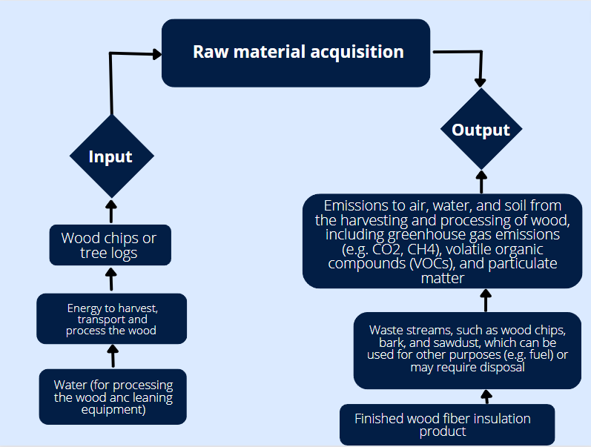
Figure 23. Wood fibre LCA. Raw material acquisition input and output flow chart.

6.4.2 Raw material transportation
Environmental impacts
Resources required include water, fuel, and electricity.
Greenhouse gas emissions contribute to climate change. Also, transportation vehicles produce noise pollution, which can have negative impacts on wildlife and human well-being.
Economic impacts
On the economic side, fuel, and energy are costly. The cost of transporting the vehicle and maintaining it also plays a part. Greenhouse gas emissions may be subject to carbon pricing or carbon taxes, which can increase costs for the company. Air pollution may also result in fines or other regulatory penalties, adding to the overall cost of production. Noise pollution can also have economic costs, such as reduced property values or increased healthcare expenses.

A carbon tax of £75 per tonne on polluting manufacturing and construction businesses, with some funding to invest in new technologies, supported by 94% of people.
(Carrington, 2021)
According to Carrington (2021) a survey was conducted on public thoughts around carbon tax. The £75 per tonne. In 2020, the manufacturing sector in the UK has produced over 75000 tonnes of carbon (Statista, 2017). Conclusively, the sector spends around £5625000 (5.6 million) a year. Thus, information shows that the carbon tax is an extreme expense and thus all companies would save an extortionate amount of money. When the UK reaches the net-zero target, the savings could get invested into healthcare and agriculture highly improving the country economy.
For straw bales, the distance from the field to the construction site is 85km (EPD, 2021) travelled using truck. Presuming the fuel used was petrol, the average cost of petrol in the UK right now is £1.24 a litre (BBC, 2019). A truck uses 30 litres of petrol per 100km, so the cost of fuel for transporting the resources between the field and construction site accounts for 25.5 litres of petrol, costing £31.62. Additionally, burning 1 litre of petrol produces 2.3kg of CO2 meaning that, one trip produces 59kg of CO2. The average carbon footprint of a truck per year accounts for over 201 000 of kgCO2 (Sharkey, 2021).
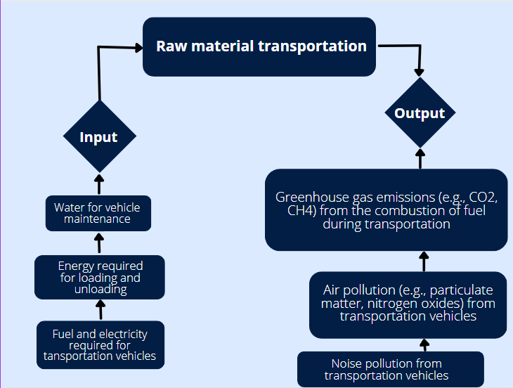
Figure 24. Wood fibre LCA. Raw material transportation input and output flow chart.

6.4.3 Manufacturing
Environmental impacts
The manufacturing stage is a critical stage in the production where the raw materials are processed and transformed into the final product. The inputs for this stage include energy, water, chemicals, and raw materials.
Emissions to air, water, and soil contribute to air and water pollution and climate change. Additionally, waste streams such as scraps or trimmings may contribute to pollution, as disposal methods for these materials can be resource-intensive and may contribute to pollution and waste.
Economic impacts
On the economic side, the inputs for this stage, such as energy, chemicals, and the manufacturing equipment and labour can be costly.
The finished wood fibre insulation product has economic value and can generate revenue for the company. Additionally, waste streams can be repurposed for other uses, such as energy production or as raw materials for other products, which can generate additional revenue and reduce disposal costs
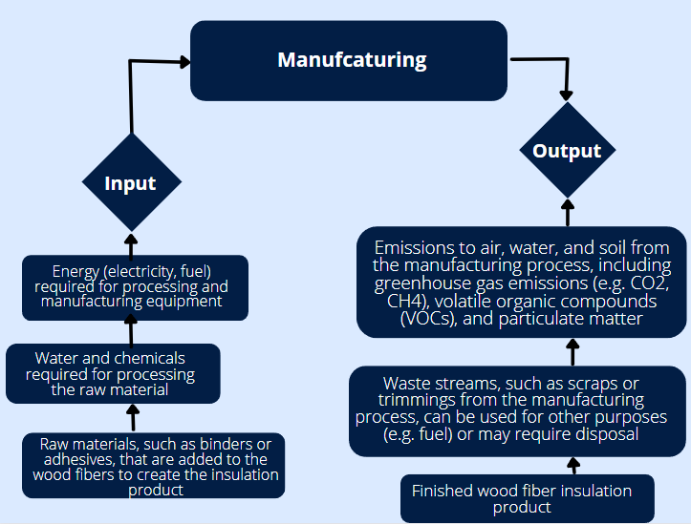
Figure 25. Wood fibre LCA. Manufacturing input and output flow chart.

6.4.4. Transportation
Environmental impacts
The transportation stage includes inputs such as energy, packaging materials, and water and other resources for the maintenance of vehicles.
Greenhouse gas emissions from the combustion of fuel contribute to climate change and air pollution. Additionally, air pollution can contribute to smog, which can have a range of negative impacts on human health and the environment. Waste from packaging materials can also contribute to pollution and waste.
Economic impacts
On the economic side, the inputs for transportation, such as fuel and packaging materials, can be costly. The cost of transportation vehicles and labour also need considering.
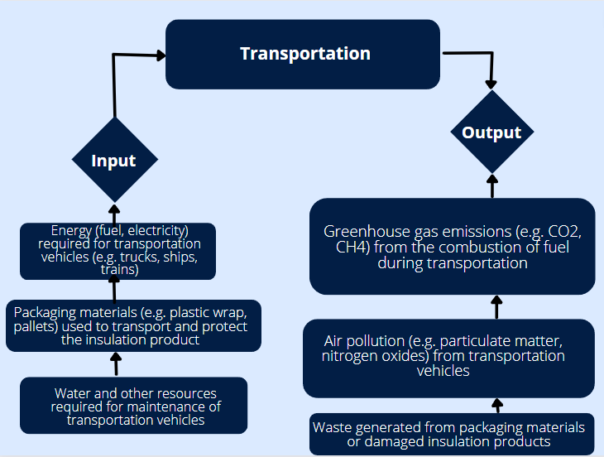
Figure 26. Wood fibre LCA. Transportation input and output flow chart.

6.4.5 Construction
Environmental impacts
Inputs for construction include energy, tools, equipment, water, chemicals, and energy required for heating and cooling the building.
Waste generated contributes to pollution and waste. Greenhouse gas emissions from building operations contribute to climate change and air pollution. Emissions to air, water, and soil from the use of chemicals during installation and building operations can also harm human health and the environment.
Economic impacts
On the economic side, the inputs for construction, such as energy, tools, and equipment, can be costly. Additionally, the cost of heating and cooling a building can be significant.
By reducing waste and optimizing the use of resources, companies can reduce costs and improve the sustainability of their products. Furthermore, reducing greenhouse gas emissions from building operations can result in cost savings due to reduced energy use and efficiency improvements.
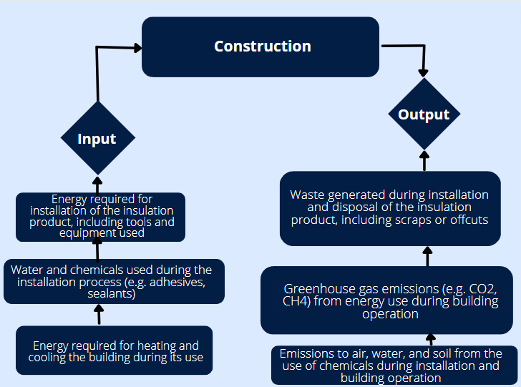
Figure 27. Wood fibre LCA. Construction input and output flow chart.

6.4.6 Use, maintenance, repair
Environmental impacts
The use of energy for heating and cooling the building during operations contributes to greenhouse gas emissions. The maintenance and repair of the insulation product require the use of water and chemicals, which can result in emissions to the air, water, and soil. Waste generated during maintenance and repair, such as scraps and offcuts, can contribute to environmental impacts.
Economic impacts
Economically, the energy required for heating and cooling the building during operations can result in increased utility costs for building owners or occupants. The maintenance and repair of the insulation product can also result in additional costs for the purchase of materials, and the hiring of professionals to perform the work. If the insulation product becomes damaged and requires repair or replacement, it can result in additional costs.
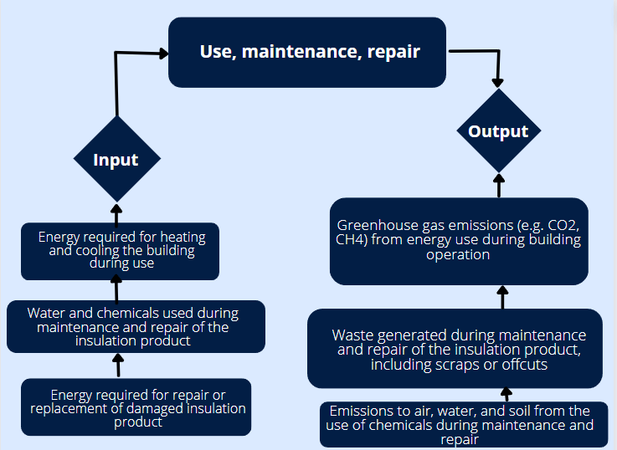
Figure 28. Wood fibre LCA. Use, maintenance, repair input and output flow chart.

6.4.7. End-of-life, transport, waste disposal
Environmental impacts
The recycling process requires energy and resources, to break down the product and remanufacture it into a new product. The disposal process requires energy for transportation to waste management facilities and additional energy for incineration or landfilling. The greenhouse gas emissions from this stage can contribute to climate change.
Economic impacts
Recycling the insulation product can be a cost-effective option as it can reduce the need for virgin materials in the manufacturing process. However, recycling requires specialised equipment and infrastructure, which can increase the overall cost. Disposal, on the other hand, can incur significant costs, including transportation, landfilling or incineration fees, and potential fines for non-compliance with waste regulations.
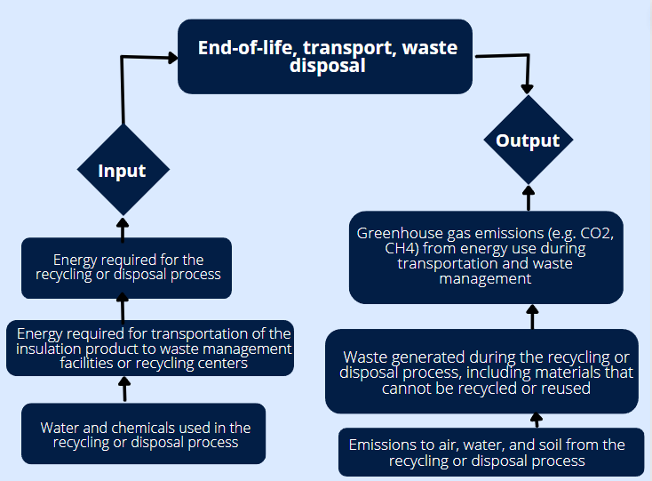
Figure 29. Wood fibre LCA. End-of-life, transport, waste disposal input and output flow chart.

6.4.8. Reuse, recycle, repurpose
Environmental impacts
Recycling and repurposing used insulation reduce the demand for new insulation production, thereby reducing the environmental impact associated with new product manufacturing. However, the recycling process requires energy, water, chemicals, and resources, and waste may still be generated, including materials that cannot be recycled or reused. Cleaning or refurbishing the insulation may also require energy and resources.
Economic impacts
While reusing or recycling the insulation product can reduce the demand for new insulation production, the process requires resources, labour, and energy, which can add to the overall cost. However, the cost of producing new insulation products is higher than the cost of recycling or reusing the existing insulation product. Additionally, repurposed materials can be used in other products or applications, generating additional economic benefits. The economic impact depends on factors such as the availability of recycling and reuse options, the cost of new product production, and the market demand for repurposed materials.
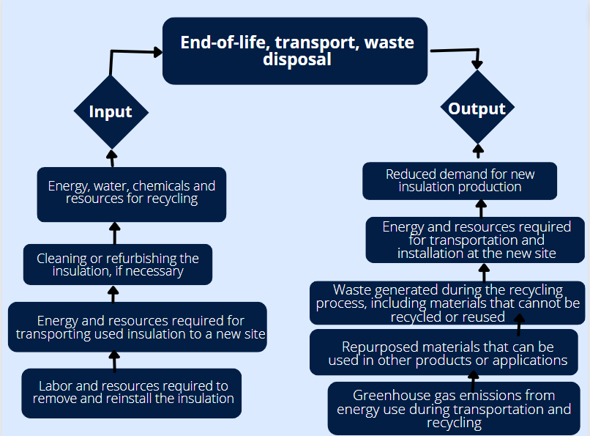
Figure 30. Wood fibre LCA. Reuse, recycle, repurpose input and output flow chart.

6.5 Interpretation
The goal of interpretation is to provide context and understanding to the results of the LCA study, so that they can be used for decision-making. It includes the key environmental impacts of the insulation, evaluating the strengths and weaknesses, and provides recommendations for improvement.
GWP allows comparisons of the global warming impact of different gases. It is a measure of how much energy the emissions of one ton of a gas will contribute to climate change over 100 years compared to the emissions of one ton of carbon dioxide (CO2). The higher the GWP, the more that a gas warms the Earth compared to CO2 over that time period. In other words, GWP provides a scale for telling how bad the emissions of a given gas are for the planet.
(Emerson, 2020)

Table 6. global warming potential emissions breakdown for wood fibre, straw bale and expanded polystyrene.
Impact Category | LCA boundaries for wood fibre (per m2,) | LCA boundaries for straw bale (per m2) | LCA boundaries for expanded polystyrene (per m2)
Global warming potential (GWP)  Unit: (kgCO2 eq) | Raw material acquisition  -1.85E+2*  Raw material transportation  2.43E+0*  Manufacturing  1.01E+2*  Transportation  N/A  Construction  1.70E+1*  Use, maintenance, repair  N/A  End-of-life, transport, waste disposal  Transport: 4.06E-1*  Waste processing: 2.22E+2*  Reuse, recycle, repurpose.  -1.05E+2* | Raw material acquisition  -1.17E+02**  Raw material transportation  1.13E+00**  Manufacturing  0.0E+00**  Transportation  0.00E+00**  Construction  0.00E+00**  Use, maintenance, repair  0.00E+00**  End-of-life, transport, waste disposal  Transport: 1.99E+00**  Waste processing: 1,.4E+02**  Reuse, recycle, repurpose.  N/A
Overall: | 102.6 | 35 | 3060.15***

Data for Table 6 was obtained from:
* (STEICO SE, 2020)
** (EPD, 2021)
*** (Lim et al., 2021)
As mentioned in previous sections, the kgCO² is negative for raw material acquisition as plants naturally reduce CO² in the air. Utilising natural materials therefore reduces the overall carbon emissions. Wood fibre and straw bale are both great natural materials, which due to their natural properties, before harvested, reduce CO². Raw material transport generates more wood fibre emissions, possibly because only a few forests in the UK are designated to produce this material. On the other hand, the straw bale has a lower raw material transportation emission because farms are widely available around most of the UK and the straw does not need processing. Although, it is not possible to reuse, recycle or repurpose straw bales, it does not negatively affect the environment as the product even if it dumped in the landfill, will only disintegrate.
Figure 31 shows the decisive difference in GWP emissions between wood, straw and the UK government recommended material, expanded polystyrene. All three of the materials are easy to acquire and are just as simple, if not simpler than artificial products to install and dismount. Additionally, the natural materials will not negatively affect the environment when their lifecycle comes to an end, whereas expanded polystyrene would.
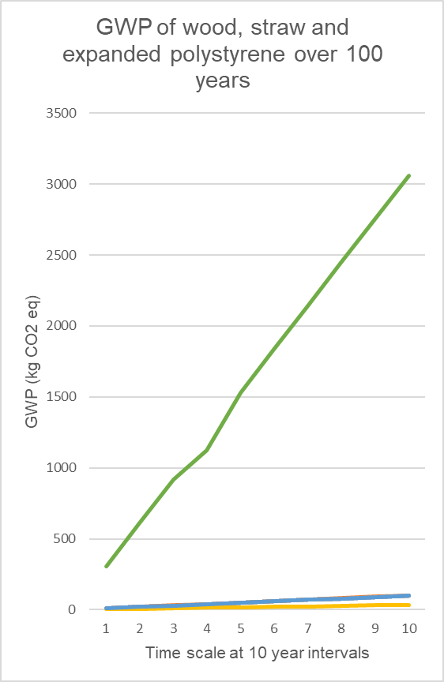
Orange – Straw bale
Blue – Wood fibre
Green – Expanded polystyrene
Figure 31. GWP of wood, straw, and expanded polystyrene over 100 years.

6.6 Uncertainty and limitations
The dissertation was based on a single functional unit of insulation material (per square meter) and does not consider other functional units or system boundaries.
- The inventory data used in the study was from a limited number of suppliers and may not be representative of the entire industry.
- The study assumes that the insulation materials were used in a typical building construction scenario and does not consider other applications or scenarios.
- Some of the data in Table 6, obtained for the boundaries for straw bale doesn’t seem quite right. Manufacturing, transportation, construction, and use boundaries should get defined as ‘N/A’, as those processes are not actually involved in the LCA process of straw bales. It is a natural material that does not get processed in any way and is instantaneously ready to get fitted as wall insulation. Hence there is some uncertainty as to why (EPD, 2021) described those emissions as 0.00E+0.

6.7 Recommendations
Based on the results and limitations of this study, the following recommendations are for future research on wood fibre and straw bale insulation materials:
- Increase the sample size and diversity of the inventory data to improve the accuracy and representativeness of the results.
- Investigate the potential environmental impacts of the transportation of the insulation materials to the construction site, considering the distance travelled and the mode of transportation.
- Consider other functional units and system boundaries to provide a completer and more holistic picture of the environmental impacts of the insulation materials, such as the amount of energy saved by the insulation over the building's lifetime.
- Evaluate the potential benefits and trade-offs of using different impact assessment methods to ensure the most appropriate method is used for each impact category, such as assessing the impacts of the insulation materials on indoor air quality or occupant health. Appendix 1 was populated with the remaining impact categories, not considered in this dissertation and may be used for further research.

7. Conclusion

7.1 Summary of the main findings of the study

The study showed that natural insulation materials such as wood fibre and straw bale can get used instead of conventional materials and provided valuable information for homeowners and contractors on the economic and environmental aspects of insulation. The study also addressed the cost-of-living crisis by providing retrofitting recommendations and quantified their economic benefit to homeowners. The UK could save £995,894,434 if all heating oil fuelled dwellings were insulated, and such retrofitting can get achieved using non-conventional materials. Furthermore, the study illustrated the emissions impact and benefit towards achieving the 2050 net-zero targets. Not only would homeowners save a lot of money, but the carbon footprint would also get reduced by about 7,655,188,000kg of CO2 (assuming heating oil fuelled dwellings are currently not sufficiently insulated).

7.2 Contributions to the field

The study makes several important contributions to the field of sustainable construction and building materials, particularly in relation to life cycle assessment (LCA) methodologies. One of the novel aspects of the study is its focus on natural insulation materials such as wood fibre and straw bale, which have received relatively little attention in previous retrofits. By comparing the environmental impacts of these materials to those of conventional insulation materials, the study provides valuable insights into the potential benefits of using natural materials in building construction.

Another innovative aspect of the study is its consideration of both embodied carbon and operation emissions in the LCA analysis. This idea allows for a more comprehensive understanding of the environmental impacts of insulation materials over their entire lifecycle, including both the production and use phases.

7.4 Implications for practice

The adoption of natural insulation materials may also face some barriers. One potential barrier is the availability and accessibility of these materials, which may vary depending on location and market demand. Additionally, there may be concerns about the durability and fire resistance of these materials, which could impact their use in certain building applications.

To overcome these barriers, there may be opportunities for policy interventions or incentives to promote the use of natural insulation materials in building construction. For example, governments could offer tax incentives or subsidies for the production and use of sustainable building materials or set up regulations and standards to ensure the safety and quality of these materials.

7.5 Future directions

Companies can use this paper to assist in their transformation journey. Considering CO2 emissions and the UK government's financial costs, it is recommended to study the establishment of grants for homeowners who retrofit with natural insulation. The government can use the money saved by reducing imports to give back to society.

7.6 Conclusion of the dissertation
In conclusion, the dissertation presents a comprehensive analysis of the potential benefits of natural insulation materials such as wood fibre and straw bale in building construction. The study demonstrates that these materials can provide a cost-effective and sustainable alternative to conventional insulation materials, with significant environmental, economic, and social benefits for homeowners and the construction industry.

9. References
Department for Business, Energy & Industrial Strategy (2019). UK Becomes First Major Economy to Pass Net Zero Emissions Law. [online] Gov.uk. Available at: https://www.gov.uk/government/news/uk-becomes-first-major-economy-to-pass-net-zero-emissions-law [Accessed 17 Feb. 2023].
Department for Energy Security and Net Zero (2021). Greenhouse gas reporting: conversion factors 2021. [online] GOV.UK. Available at: https://www.gov.uk/government/publications/greenhouse-gas-reporting-conversion-factors-2021 [Accessed 17 Mar. 2023].
Amazon (2023). Aluminium Vapour Barrier - 1.5m Wide - Fiberglass Mesh Reinforced Insulation Membrane - Roof, Attic Rooms Thermal Insulation (1.5m x 30m) : Amazon.co.uk: DIY & Tools. [online] www.amazon.co.uk. Available at: https://www.amazon.co.uk/Aluminium-Vapour-Barrier-Fiberglass-Reinforced/dp/B08JGYWMNF?source=ps-sl-shoppingads-lpcontext&ref_=fplfs&smid=A1LQ3UR3FY7PMT&th=1 [Accessed 16 Apr. 2023].
American Chemistry Council (2023). Continuous Insulation. [online] Green Building Solutions. Available at: https://www.greenbuildingsolutions.org/green-building-materials/insulation/#:~:text=By%20reducing%20air%20infiltration%20of%20outside%20air%2C%20we [Accessed 3 Apr. 2023].
BBC (2019). Fuel price calculator: How much do you pay? BBC News. [online] 23 Dec. Available at: https://www.bbc.co.uk/news/business-21238363 [Accessed 27 Apr. 2023].
BBC (2022). Home insulation: How can it cut energy bills? BBC News. [online] 6 Oct. Available at: https://www.bbc.co.uk/news/explainers-60289396 [Accessed 15 Apr. 2023].
BBC (2023). Specific heat capacity - Temperature changes and energy - Edexcel - GCSE Physics (Single Science) Revision - Edexcel. [online] www.bbc.co.uk. Available at: https://www.bbc.co.uk/bitesize/guides/zpjpgdm/revision/4#:~:text=The%20specific%20heat%20capacity%20of [Accessed 15 Apr. 2023].
Bennett, H. (2022). The UK needs better insulated homes to free us from Putin and the fossil fuel giants. The Guardian. [online] 13 Sep. Available at: https://www.theguardian.com/commentisfree/2022/sep/13/uk-better-insulated-homes-putin-fossil-fuel-giants [Accessed 14 Apr. 2023].
Bennett, J., Butler, J., Jones, B. and Sutherland, E. (2022). STRAW CONSTRUCTION IN THE UK Technical Guide First Edition 2022. [online] Available at: http://schoolofnaturalbuilding.co.uk/wp-content/uploads/2022/03/Technical-Guide-UK-Feb-2022-1.pdf [Accessed 18 Feb. 2023].
Bhandari, P. (2022). An introduction to quantitative research. [online] Scribbr. Available at: https://www.scribbr.co.uk/research-methods/introduction-to-quantitative-research/ [Accessed 19 Apr. 2023].
Black Mountain Insulation (2023). NATURAL WOOD FIBRE INSULATION. [online] www.blackmountaininsulation.com. Available at: https://www.blackmountaininsulation.com/NatuFlex_Brochure.pdf [Accessed 16 Apr. 2023].
Bolton, P. (2022). Imports of energy from Russia. House of Commons Library. [online] Available at: https://commonslibrary.parliament.uk/research-briefings/cbp-9523/ [Accessed 13 Feb. 2023].
Borràs, X. (20AD). Breve historia de la madera como material de construcción. [online] Interempresas. Available at: https://www.interempresas.net/Madera/Articulos/44265-Breve-historia-de-la-madera-como-material-de-construccion.html [Accessed 17 Feb. 2023].
BRE (2014). SAP 2012 The Government s Standard Assessment Procedure for Energy Rating of Dwellings 2012 edition. [online] Available at: https://files.bregroup.com/SAP/SAP-2012_9-92.pdf [Accessed 15 Mar. 2023].
Carrington, D. (2021). ‘Overwhelming’ backing for strong climate action, UK study shows. [online] The Guardian. Available at: https://www.theguardian.com/environment/2021/oct/11/uk-public-backs-carbon-tax-high-flyer-levy-and-heat-pump-grants-study-shows [Accessed 24 Apr. 2023].
Casalicchio, E. (2022). UK to ban Russian oil imports. [online] POLITICO. Available at: https://www.politico.eu/article/uk-to-ban-russian-oil-imports/ [Accessed 24 Apr. 2023].
Centre for Sustainable Energy (2013). Cavity wall insulation | Centre for Sustainable Energy. [online] www.cse.org.uk. Available at: https://www.cse.org.uk/advice/advice-and-support/cavity-wall-insulation [Accessed 17 Mar. 2023].
Chudley, R. and Greeno, R. (2016). Building construction handbook. London: Routledge, Taylor & Francis Group, p.475.
Circular Ecology (2019). Embodied Carbon Footprint Database. [online] Circular Ecology. Available at: https://circularecology.com/embodied-carbon-footprint-database.html#.VN4yPmdyZYc [Accessed 14 Apr. 2023].
City of Edmonton (2023). Building Envelope | City of Edmonton. [online] www.edmonton.ca. Available at: https://www.edmonton.ca/city_government/urban_planning_and_design/building-envelope [Accessed 17 Mar. 2023].
CLC (Construction Leadership Council) (2021). Greening Our Existing Homes National retrofit strategy A consultative document. [online] Available at: https://www.constructionleadershipcouncil.co.uk/wp-content/uploads/2021/05/Construction-Leadership-Council-National-Retrofit-Strategy-Version-2.pdf [Accessed 12 Apr. 2023].
Climate Change Committee (2008). A legal duty to act. [online] The CCC. Available at: https://www.theccc.org.uk/what-is-climate-change/a-legal-duty-to-act/ [Accessed 19 Apr. 2023].
Committee on Climate Change (2019). UK housing: Fit for the future? Committee on Climate Change. [online] Available at: https://www.theccc.org.uk/wp-content/uploads/2019/02/UK-housing-Fit-for-the-future-CCC-2019.pdf [Accessed 15 Mar. 2023].
Cope, L. (2022). Is Wood A Conductor or An Insulator? (Complete Guide). [online] Engineer Fix. Available at: https://engineerfix.com/is-wood-a-conductor-or-an-insulator/ [Accessed 13 Feb. 2023].
Costes, J.-P., Evrard, A., Biot, B., Keutgen, G., Daras, A., Dubois, S., Lebeau, F. and Courard, L. (2017). Thermal Conductivity of Straw Bales: Full Size Measurements Considering the Direction of the Heat Flow. Buildings, [online] 7(4), p.11. doi:https://doi.org/10.3390/buildings7010011.
Czajkowski, Ł., Kocewicz, R., Weres, J. and Olek, W. (2022). Estimation of Thermal Properties of Straw-Based Insulating Panels. Materials, 15(3), p.1073. doi:https://doi.org/10.3390/ma15031073.
Decarbonisation of Homes in Wales Advisory Group (2019). Better Homes, Better Wales, Better World. [online] Welsh Government. Available at: https://www.gov.wales/sites/default/files/publications/2019-07/independent-review-on-decarbonising-welsh-homes-report.pdf [Accessed 17 Feb. 2023].
Del Col, D., Azzolin, M., Benassi, G. and Mantovan, M. (2015). Energy efficiency in a ground source heat pump with variable speed drives. Energy and Buildings, 91, pp.105–114. doi:https://doi.org/10.1016/j.enbuild.2014.12.048.
Department for Business, Energy & Industrial Strategy (2019). Annex: 2019 UK Greenhouse Gas Emissions, final figures by end user and fuel type. [online] GOV.UK. Available at: https://www.gov.uk/government/statistics/final-uk-greenhouse-gas-emissions-national-statistics-1990-2017 [Accessed 10 Mar. 2023].
Díaz Fuentes, C.X., Pérez Rojas, M.C. and Mancilla, J.J. (2020). Physical-thermal straw properties advantages in the design of a sustainable panel-type construction system to be used as an architectural dividing element. Journal of Physics: Conference Series, 1587. doi:https://doi.org/10.1088/1742-6596/1587/1/012032.
Dickson, T. and Pavía, S. (2021). Elsevier Enhanced Reader. [online] reader.elsevier.com. Available at: https://reader.elsevier.com/reader/sd/pii/S1364032121000472?token=CC89D7D9A7CBCBF56E564B5AADAC184A0436844CF764AA1E041B004C1ED725D90ED82E13D44234B86F031487773F5BAF&originRegion=eu-west-1&originCreation=20230214001854 [Accessed 14 Feb. 2023].
Director-General Education and Justice (2020). Scottish household survey 2019: annual report. [online] www.gov.scot. Available at: https://www.gov.scot/publications/scottish-household-survey-2019-annual-report/ [Accessed 15 Mar. 2023].
Donnarumma, H. (2022). Trends in UK imports and exports of fuels - Office for National Statistics. [online] www.ons.gov.uk. Available at: https://www.ons.gov.uk/economy/nationalaccounts/balanceofpayments/articles/trendsinukimportsandexportsoffuels/2022-06-29 [Accessed 14 Apr. 2023].
Drewniok, M.P., Dunant, C.F., Allwood, J.M., Ibell, T. and Hawkins, W. (2022). Modelling the embodied carbon cost of UK domestic building construction: Today to 2050. Ecological Economics, [online] 205. doi:https://doi.org/10.1016/j.ecolecon.2022.107725.
Emerson, J. (2020). Does Your Insulation Have Low Embodied Carbon? [online] GreenBuildingAdvisor. Available at: https://www.greenbuildingadvisor.com/article/does-your-insulation-have-low-embodied-carbon#:~:text=Extruded%20polystyrene%20%28XPS%29%2C%20used%20in%20Dow%20Styrofoam%20%28%E2%80%9Cblueboard%E2%80%9D%29 [Accessed 27 Apr. 2023].
EPD (2021). Environmental product declaration Straw as insulation material-UK Up-Straw -School of Natural Building (SNaB). [online] pp.11–21. Available at: https://asbp.org.uk/wp-content/uploads/2022/02/Data-4.pdf [Accessed 26 Apr. 2023].
Few, J., Pullinger, M., McKenna, E., Elam, S., Webborn, E. and Oreszczyn, T. (2022). Smart Energy Research Lab: Energy use in GB domestic buildings 2021. [online] Smart Energy Research Lab, London, UK: Smart Energy Research Lab , pp.23–27. Available at: www.serl.ac.uk [Accessed 11 Jan. 2023].
Fore, M. (2011). What Type of Heat Transfer Occurs in Liquids & Gases? [online] Sciencing. Available at: https://sciencing.com/type-transfer-occurs-liquids-gases-8286613.html [Accessed 17 Mar. 2023].
Forest Research (2023). Origin of wood imports. [online] Forest Research. Available at: https://www.forestresearch.gov.uk/tools-and-resources/statistics/forestry-statistics/forestry-statistics-2018/trade-2/origin-of-wood-imports/#:~:text=Sawn%20hardwood%20and%20wood%20pulp%20imports%20originated%20from [Accessed 4 Apr. 2023].
Forestry Innovation Investment (2017). C40 Knowledge Community. [online] www.c40knowledgehub.org. Available at: https://www.c40knowledgehub.org/s/article/Embodied-Carbon-of-Buildings-and-Infrastructure-International-Policy-Review?language=en_US [Accessed 16 Apr. 2023].
Frommer, F. (2022). How the 1970s Energy Crisis Drove Innovation. [online] HISTORY. Available at: https://www.history.com/news/energy-crisis-1970s-innovation#:~:text=via%20Getty%20Image- [Accessed 18 Feb. 2023].
Fuel Fighter (2023). Domestic Heating Oil Prices In The UK | Fuel Fighter. [online] Available at: https://www.fuelfighter.co.uk/uk-heating-oil-prices [Accessed 24 Apr. 2023].
Fyfe, C., Barnard, L.T., Douwes, J., Howden‐Chapman, P. and Crane, J. (2022). Retrofitting home insulation reduces incidence and severity of chronic respiratory disease. Indoor Air, 32(8). doi:https://doi.org/10.1111/ina.13101.
Garside, R. (2020). Coronavirus: Winners and losers from oil price drop. BBC News. [online] 29 May. Available at: https://www.bbc.co.uk/news/uk-wales-52833745 [Accessed 19 Apr. 2023].
Glass, V.A. (2023). What’s the Difference Between U-Value and R-Value? [online] glassed.vitroglazings.com. Available at: https://glassed.vitroglazings.com/topics/the-difference-between-r-value-and-u-value#:~:text=The%20lower%20the%20number%2C%20the [Accessed 15 Apr. 2023].
Golsteijn, L. (2018). LCA basics: life cycle assessment explained. [online] PRé Sustainability. Available at: https://pre-sustainability.com/articles/life-cycle-assessment-lca-basics/ [Accessed 13 Feb. 2023].
Graigner, G. (2022). For net-zero cities, we need to retrofit our older buildings. Here’s what’s needed. [online] World Economic Forum. Available at: https://www.weforum.org/agenda/2022/11/net-zero-cities-retrofit-older-buildings-cop27/ [Accessed 14 Apr. 2023].
Green, E., Lannon, S., Patterson, J. and Iorwerth, H. (2019). Homes of today for tomorrow STAGE 2: Exploring the potential of the Welsh housing stock to meet 2050 decarbonisation targets. [online] p.19. Available at: https://orca.cardiff.ac.uk/id/eprint/115442/8/Homes%20of%20Today%20for%20Tomorrow%20stage%202%20report.pdf.
Green, E., Lannon, S., Patterson, J., Variale, F. and Iorwerth, H. (2020). Decarbonising the Welsh housing stock. Buildings and Cities, 1(1). doi:https://doi.org/10.5334/bc.19.
GreenSpec (2023). GreenSpec: Housing Retrofit: Insulation: Rainscreen Cladding. [online] www.greenspec.co.uk. Available at: https://www.greenspec.co.uk/building-design/rainscreen-cladding/ [Accessed 16 Apr. 2023].
GUTEX Holzfaserplattenwerk H. Henselmann GmbH + Co KG (2015). Wood Fibre Insulating Boards GUTEX Holzfaserplattenwerk H. Henselmann GmbH + Co KG. Declaration number EPD-GTX-20140222-IBC2-EN .
Hammond, P., Jones, C., Lowrie, E. and Tse, P. (2011). A BSRIA guide Embodied Carbon The Inventory of Carbon and Energy (ICE). [online] Available at: http://www.emccement.com/pdf/Full-BSRIA-ICE-guide.pdf [Accessed 14 Apr. 2023].
Harvey, F. (2022). Energy-saving measures could boost UK economy by £7bn a year, study says. The Guardian. [online] 20 Sep. Available at: https://www.theguardian.com/environment/2022/sep/20/energy-saving-measures-could-boost-uk-economy-by-7bn-a-year-study-says#:~:text=Insulating%20homes%20in%20Britain%20and [Accessed 13 Feb. 2023].
Heath, O. (2017). This is the average size home in England and Wales – and how it compares to the EU & USA. [online] House Beautiful. Available at: https://www.housebeautiful.com/uk/lifestyle/property/news/a2590/average-uk-property-size-comparison/ [Accessed 14 Mar. 2023].
HESA (2023). Estates management 2017/18 - Energy consumption - D38aEnergyConsumption | HESA. [online] Available at: https://www.hesa.ac.uk/collection/c17042/a/energyconsumption [Accessed 25 Apr. 2023].
Historic England (2016). Energy Efficiency and Historic Buildings Insulating Early Cavity Walls. [online] Available at: https://historicengland.org.uk/images-books/publications/eehb-early-cavity-walls/heag083-early-cavity-walls/ [Accessed 5 Apr. 2023].
Howell, B. (2022). The Top 5 Problems with Cavity Wall Insulation. [online] The Eco Experts. Available at: https://www.theecoexperts.co.uk/insulation/cavity-wall-problems [Accessed 15 Apr. 2023].
IEA (2021). Energy Efficiency 2021 – Analysis. [online] IEA. Available at: https://www.iea.org/reports/energy-efficiency-2021 [Accessed 17 Mar. 2023].
Ingrams, S. (2022). What is heating oil? [online] www.which.co.uk. Available at: https://www.which.co.uk/reviews/heating-oil/article/heating-oil-explained/what-is-heating-oil-axKFs4A8aH5V [Accessed 18 Apr. 2023].
IRENA (2019). A New World - The Geopolitics of the Energy Transformation. [online] Available at: https://www.irena.org/-/media/Files/IRENA/Agency/Publication/2019/Jan/Global_commission_geopolitics_new_world_2019.pdf [Accessed 14 Apr. 2023].
John Clegg Consulting LTD (2016). Wood Fibre Availaility & Demand in Britain 2013 – 2035. [online] www.confor.org.uk, pp.30–40. Available at: https://www.confor.org.uk/media/246292/wood-fibre-availability-demand-report-2016-final.pdf [Accessed 16 Apr. 2023].
Kemper, A. and Martin, R. (2013). Volatile fossil fuel prices make renewable energy more attractive. The Guardian. [online] 21 Mar. Available at: https://www.theguardian.com/sustainable-business/blog/fossil-fuel-prices-renewable-energy-attractive [Accessed 14 Apr. 2023].
Kuo, G. (2019). When fossil fuels run out, What then? [online] MAHB. Available at: https://mahb.stanford.edu/library-item/fossil-fuels-run/ [Accessed 14 Mar. 2023].
Landale, J. (2020). What will the end of oil dependence mean for geopolitics? BBC News. [online] 3 Jan. Available at: https://www.bbc.co.uk/news/world-50974609 [Accessed 14 Apr. 2023].
LearnMetrics (2022). U-Value To R-Value: How To Convert U-Factor To R? (Calculator + Chart). [online] LearnMetrics. Available at: https://learnmetrics.com/u-value-to-r-value-how-to-convert-u-factor-to-r-value/ [Accessed 15 Apr. 2023].
Lim, Y.S., Izhar, T.N.T., Zakarya, I.A., Yusuf, S.Y., Zaaba, S.K. and Mohamad, M.A. (2021). Life cycle assessment of expanded polystyrene. [online] IOP Publishing Ltd, p.6. Available at: https://iopscience.iop.org/article/10.1088/1755-1315/920/1/012030 [Accessed 27 Apr. 2023].
Lymath, A. (2016). Guide to straw bale construction. [online] NBS. Available at: https://www.thenbs.com/knowledge/guide-to-straw-bale-construction [Accessed 18 Feb. 2023].
Magwood, C. (2016). Carbon Smart Straw Bale Structural Insulated Panels. [online] www.greenbuildermedia.com. Available at: https://www.greenbuildermedia.com/blog/carbon-smart-straw-bale-structural-insulated-panels [Accessed 8 Mar. 2023].
Mahajan, B. (2021). Difference Between Wood And Timber | What Is Wood | What Is Timber | What Is Lumber. [online] www.civiconcepts.com. Available at: https://civiconcepts.com/blog/difference-between-wood-and-timber [Accessed 3 Apr. 2023].
Manandhar, R., Kim, J.-H. and Kim, J.-T. (2019). Environmental, social and economic sustainability of bamboo and bamboo-based construction materials in buildings. Journal of Asian Architecture and Building Engineering, 18(2), pp.1–11. doi:https://doi.org/10.1080/13467581.2019.1595629.
Matcalf, H. (2022). Eco Insulation: 8 Sustainable Options for Insulating Your Home. [online] Homebuilding & Renovating. Available at: https://www.homebuilding.co.uk/advice/eco-insulation [Accessed 4 Apr. 2023].
McCabe, J. (1993). The thermal resistivity of straw bales for construction. [online] Available at: https://www.mdpi.com/2075-5309/7/1/11#B5-buildings-07-00011 [Accessed 4 Apr. 2023].
McDonough, W. (2023). Cradle to Cradle . [online] www.mcdonough.com. Available at: https://mcdonough.com/cradle-to-cradle/ [Accessed 5 Apr. 2023].
McPartland, R. (2017). What is lifecycle assessment? [online] NBS. Available at: https://www.thenbs.com/knowledge/what-is-lifecycle-assessment [Accessed 4 Apr. 2023].
Ministry of Housing, Communities & Local Government (2013). English Housing Survey. [online] GOV.UK. Available at: https://www.gov.uk/government/collections/english-housing-survey [Accessed 15 Mar. 2023].
Mostyn, M. (2020). How to insulate your home: costs, savings and grants | OVO Energy. [online] www.ovoenergy.com. Available at: https://www.ovoenergy.com/guides/energy-guides/home-insulation-guide [Accessed 3 Apr. 2023].
National Grid (2022). What are greenhouse gases? [online] National grid. Available at: https://www.nationalgrid.com/stories/energy-explained/what-are-greenhouse-gases [Accessed 15 Apr. 2023].
National Housing Federation (2020). New NHF research highlights barriers to retrofitting homes. [online] Available at: https://www.housing.org.uk/resources/barriers-retrofitting-homes/ [Accessed 24 Apr. 2023].
Northern Ireland Housing Executive (2016). The Housing Executive - House condition survey. [online] Nihe.gov.uk. Available at: https://www.nihe.gov.uk/Working-With-Us/Research/House-Condition-Survey [Accessed 15 Mar. 2023].
Office for National Statistics (2015). Housing and home ownership in the UK - Office for National Statistics. [online] Ons.gov.uk. Available at: https://www.ons.gov.uk/peoplepopulationandcommunity/populationandmigration/internationalmigration/articles/housingandhomeownershipintheuk/2015-01-22 [Accessed 8 Mar. 2023].
Ofgem (2022). Default tariff cap level: 1 April 2022 to 30 September 2022. [online] Ofgem. Available at: https://www.ofgem.gov.uk/publications/default-tariff-cap-level-1-april-2022-30-september-2022 [Accessed 11 Jan. 2023].
Orwell, M. (2011). Properties of Thermal Insulators. [online] www.sciencing.com. Available at: https://sciencing.com/properties-thermal-insulators-8002460.html [Accessed 15 Apr. 2023].
Palmer, J. and Terry, N. (2017). Solid Wall Insulation: Best Practice and Innovation. Department of Business, Energy and Industrial Strategy.
Patel, M. (2019). Cavity Wall: Its Purpose, Advantages & Disadvantages. [online] www.gharpedia.com. Available at: https://gharpedia.com/blog/cavity-wall-advantages-and-disadvantages/ [Accessed 22 Mar. 2023].
Payne, C. (2023). RPI: Ave price - Heating oil, per 1000 litres - Office for National Statistics. [online] www.ons.gov.uk. Available at: https://www.ons.gov.uk/economy/inflationandpriceindices/timeseries/kj5u/mm23 [Accessed 8 Feb. 2023].
PHIN (2022). PHIN - Private market update: March 2022. [online] www.phin.org.uk. Available at: https://www.phin.org.uk/news/private-market-update-march-2022 [Accessed 4 Apr. 2023].
Ray, M. (2023). Russia-Ukraine War. [online] www.britannica.com. Available at: https://www.britannica.com/event/2022-Russian-invasion-of-Ukraine [Accessed 24 Apr. 2023].
Rhodes, M., Knight, I. and Agyenim, F. (2007). Categorising the existing Welsh housing stock in terms of heating and cooling demand and thermal storage capacity. [online] citeseerx.ist.psu.edu. Available at: https://citeseerx.ist.psu.edu/viewdoc/download?doi=10.1.1.576.696&rep=rep1&type=pdf [Accessed 15 Mar. 2023].
Roberts, T. (2017). We’ve got Hay Fever! A Guide to Building Using Straw Bale. [online] Rise. Available at: https://www.buildwithrise.com/stories/how-to-build-a-home-using-straw-bale [Accessed 17 Feb. 2023].
Roser, M. (2019). Future Population Growth. [online] Our World in Data. Available at: https://ourworldindata.org/future-population-growth [Accessed 14 Mar. 2023].
Rulhoff, A.D.S. (2022). Building regulations: Thermal insulation more important than ever. [online] www.haltermann-carless.com. Available at: https://www.haltermann-carless.com/blog/building-energy-thermal-insulation-more-important-than-ever [Accessed 8 Feb. 2023].
Sadler, A. (2020). What is wood fibre insulation and is it worth using? [online] BuildPass. Available at: https://buildpass.co.uk/blog/what-is-wood-fibre-insulation-and-is-it-worth-using/ [Accessed 4 Apr. 2023].
Segovia, F., Blanchet, P., Auclair, N. and Essoua Essoua, G.G. (2020). Thermo-Mechanical Properties of a Wood Fiber Insulation Board Using a Bio-Based Adhesive as a Binder. Buildings, [online] 10(9), p.152. doi:https://doi.org/10.3390/buildings10090152.
Sen, A. and Al-Habaibeh, A. (2021). A Novel Approach for U-Value Estimation of Buildings’ Multi-layer Walls Using Infrared Thermography and Artificial Intelligence. Springer Proceedings in Energy, pp.35–43. doi:https://doi.org/10.1007/978-3-030-63916-7_5.
Shackleton, P. (2023). The Real Cost Of Business Waste Disposal In The UK. [online] Available at: https://www.brother.co.uk/business-solutions/insights-hub/blog/business/2017/business-waste-cost [Accessed 28 Apr. 2023].
Shah, H. (2021). National Energy Efficiency Data-Framework (NEED): consumption data tables 2021. [online] GOV.UK. Available at: https://www.gov.uk/government/statistics/national-energy-efficiency-data-framework-need-consumption-data-tables-2021 [Accessed 11 Jan. 2023]. Headline consumption tables: England and Wales, 2019 (Excel) - Tables 3-19.
Sharkey, G. (2021). What is the carbon footprint of a truck? [online] FreightWaves. Available at: https://www.freightwaves.com/news/what-is-the-carbon-footprint-of-a-truck [Accessed 27 Apr. 2023].
Sivarajah, S. (2021). The UK has some of the least energy-efficient housing in Europe – here’s how to fix this. [online] The Conversation. Available at: https://theconversation.com/the-uk-has-some-of-the-least-energy-efficient-housing-in-europe-heres-how-to-fix-this-151609 [Accessed 8 Feb. 2023].
Social Housing Retrofit Accelerator (2023). Understanding PAS2035. [online] socialhousingretrofit.org.uk. Available at: https://socialhousingretrofit.org.uk/knowledge-hub/preparation/understanding-pas2035 [Accessed 3 Apr. 2023].
Spear, M., Hill, C., Norton, A., Price, C. and Ormondroyd, G. (2019). Wood in Construction in the UK: An Analysis of Carbon Abatement Potential Extended Summary. [online] www.theccc.org.uk, p.8. Available at: https://www.theccc.org.uk/wp-content/uploads/2019/07/Wood-in-Construction-in-the-UK-An-Analysis-of-Carbon-Abatement-Potential-BioComposites-Centre.pdf [Accessed 18 Apr. 2023].
Statista (2017). Manufacturing: CO2 emissions 1990-2017 . [online] Available at: https://www.statista.com/statistics/486100/co2-emission-from-manufacturing-uk/ [Accessed 24 Apr. 2023].
Statista (2018). Average number of bedrooms in new British houses 1930-2020. [online] Available at: https://www.statista.com/statistics/1056041/average-number-bedrooms-new-british-houses-1930-2020/#:~:text=From%20the%201930s%20until%20the [Accessed 25 Apr. 2023].
STBA (2015). Planning responsible retrofit of traditional buildings Responsible Retrofit Series. [online] www.historicengland.org.uk. Available at: https://historicengland.org.uk/images-books/publications/planning-responsible-retrofit-of-traditional-buildings/responsible-retrofit-trad-bldgs/ [Accessed 15 Apr. 2023].
STEICO SE (2020). Wood fibre insulation boards manufactured in a dry process STEICO SE. [online] pp.7–8. Available at: https://asbp.org.uk/wp-content/uploads/2021/10/STEICO-Wood-fibre-insulation-boards-manufactured-in-a-dry-process.pdf [Accessed 25 Apr. 2023].
Tenny, S. and Sharts-Hopko, N.C. (2022). Qualitative Study. [online] www.ncbi.nlm.nih.gov. Available at: https://www.ncbi.nlm.nih.gov/books/NBK470395/ [Accessed 19 Apr. 2023].
The Fresh Loaf (2018). Massive air pockets in loaf - thoughts? [online] The Fresh Loaf. Available at: https://www.thefreshloaf.com/node/55669/massive-air-pockets-loaf-thoughts [Accessed 4 Apr. 2023].
The Open University (2013). Energy in buildings. [online] www.open.edu. Available at: https://www.open.edu/openlearn/nature-environment/energy-buildings/content-section-2.2.3 [Accessed 18 Feb. 2023].
UNFCCC (2022). The Paris Agreement. [online] UNFCCC. Available at: https://unfccc.int/process-and-meetings/the-paris-agreement [Accessed 14 Apr. 2023].
Wadswick (2023). Wadswick Straw Bale Small | Wadswick Country Store Ltd. [online] www.wadswick.co.uk. Available at: https://www.wadswick.co.uk/shop/pets/smallholding/wadswick-straw-bale-small?utm_source=Google+Shopping&utm_medium=cpc&utm_campaign=Google+Shopping+Master [Accessed 15 Apr. 2023].
Ward, B. (2021). Construction materials: the current state of play. [online] ww3.rics.org. Available at: https://ww3.rics.org/uk/en/journals/construction-journal/construction-materials--the-current-state-of-play.html [Accessed 3 Apr. 2023].
Watkins, A. (2022). Climate change insights, families and households, UK - Office for National Statistics. [online] Official for National Statistics. Available at: https://www.ons.gov.uk/economy/environmentalaccounts/articles/climatechangeinsightsuk/august2022#:~:text=Households%20are%20a%20big%20emitter [Accessed 30 Mar. 2023].
Welsh Government (2020). Main points. [online] Available at: https://www.gov.wales/sites/default/files/statistics-and-research/2020-02/welsh-housing-conditions-survey-headline-results-april-2017-march-2018-update-570.pdf [Accessed 15 Mar. 2023].
Welsh, D., Green, E., Lannon, S., Patterson, J. and Iorwerth, H. (2019). Homes of today for tomorrow STAGE 2: Exploring the potential of the Welsh housing stock to meet 2050 decarbonisation targets. [online] www.orca.cardiff.ac.uk, p.4. Available at: https://orca.cardiff.ac.uk/id/eprint/115442/8/Homes%20of%20Today%20for%20Tomorrow%20stage%202%20report.pdf [Accessed 12 Apr. 2023].
WHO (2018). Low indoor temperatures and insulation. [online] www.ncbi.nlm.nih.gov. World Health Organization. Available at: https://www.ncbi.nlm.nih.gov/books/NBK535294/#:~:text=Cold%20air%20inflames%20lungs%20and [Accessed 17 Feb. 2023].
Yale, K. (2018). StackPath. [online] www.buildings.com. Available at: https://www.buildings.com/insulation/article/10185831/7-green-insulation-types-for-new-and-existing-buildings [Accessed 13 Feb. 2023].
Yell, Y. (2019). A brief history of Wooden Buildings. [online] Kirton Sectional Buildings. Available at: https://kirtonbuildings.co.uk/2019/07/02/a-brief-history-of-wooden-buildings/#:~:text=Early%20uses%20for%20wood%20in [Accessed 13 Feb. 2023].
Young, S. (2022). Britain targets energy efficiency with consumption cut goal. Reuters. [online] 17 Nov. Available at: https://www.reuters.com/business/energy/britains-hunt-sets-out-plans-reduce-energy-consumption-by-15-by-2030-2022-11-17/ [Accessed 8 Feb. 2023].
Zero Waste Scotland (2019). What is the circular economy? [online] Available at: https://www.zerowastescotland.org.uk/circular-economy/about [Accessed 24 Apr. 2023].

10. APPENDIX

10.1 Appendix 2 – Impact categories for LCA.
Acidification potential (AP) (SO2 eq)* | Raw material acquisition  7.22E-2*  Raw material transportation  1.02E-2*  Manufacturing  2.04E-1  Transportation  N/A  Construction  2.86E-3*  Use, maintenance, repair  N/A  End-of-life, transport, waste disposal  Transport: 1.70E-3*  Waste processing: 1.00E-2*  Reuse, recycle, repurpose.  -1.05E-1* | Raw material acquisition  1.36E-01**  Raw material transportation  6.57E-03**  Manufacturing  0.00E+00**  Transportation  0.00E+00**  Construction  0.00E+00**  Use, maintenance, repair  0.00E+00**  End-of-life, transport, waste disposal  Transport: 1.15E-02**  Waste processing: 2.97E-02**  Reuse, recycle, repurpose.  N/A | Raw material acquisition  Raw material transportation  Manufacturing  Transportation  Construction  Use, maintenance, repair  End-of-life, transport, waste disposal  Transport:  Waste processing:  Reuse, recycle, repurpose.
Depletion potential of the stratospheric ozone layer (ODP)  Unit: (kg CFC11 eq)* | Raw material acquisition  1.41E-7*  Raw material transportation  4.04E-16*  Manufacturing  3.25E-13*  Transportation  N/A  Construction  6.62E-15*  Use, maintenance, repair  N/A  End-of-life, transport, waste disposal  Transport: 6.76E-17*  Waste processing: 3.67E-16*  Reuse, recycle, repurpose.  -3.06E-12* | Raw material acquisition  7.96E-07**  Raw material transportation  2.50E-07**  Manufacturing  0,0E+00**  Transportation  0.00E+00**  Construction  0.00E+00**  Use, maintenance, repair  0.00E+00**  End-of-life, transport, waste disposal  Transport: 4.39E-07**  Waste processing: 1.07E-07**  Reuse, recycle, repurpose.  N/A | Raw material acquisition  Raw material transportation  Manufacturing  Transportation  Construction  Use, maintenance, repair  End-of-life, transport, waste disposal  Transport:  Waste processing:  Reuse, recycle, repurpose.
Eutrophication potential (EP)  Unit: (g (PO4)3 eq)* | Raw material acquisition  1.34E-2*  Raw material transportation  2.56E-3*  Manufacturing  2.41E-2*  Transportation  N/A  Construction  6.08E-4*  Use, maintenance, repair  N/A  End-of-life, transport, waste disposal  Transport: 4.28E-4*  Waste processing: 2.17E-3*  Reuse, recycle, repurpose.  -1.83E-2* | Raw material acquisition  N/A  Raw material transportation  N/A  Manufacturing  N/A  Transportation  N/A  Construction  N/A  Use, maintenance, repair  N/A  End-of-life, transport, waste disposal  Transport: N/A  Waste processing: N/A  Reuse, recycle, repurpose.  N/A | Raw material acquisition  Raw material transportation  Manufacturing  Transportation  Construction  Use, maintenance, repair  End-of-life, transport, waste disposal  Transport:  Waste processing:  Reuse, recycle, repurpose.
Formation potential of tropospheric ozone photochemical oxidants (POCP)  Unit: (kg ethene)* | Raw material acquisition  1.15E-2*  Raw material transportation  -4.28E-3*  Manufacturing  4.06E-2*  Transportation  N/A  Construction  1.47E-4*  Use, maintenance, repair  N/A  End-of-life, transport, waste disposal  Transport: 7.16E-4*  Waste processing: 9.82E-4*  Reuse, recycle, repurpose.  -1.02E-2* | Raw material acquisition  3.75E-02**  Raw material transportation  7.29E-03**  Manufacturing  0.0E+00**  Transportation  0.00E+00**  Construction  0.00E+00**  Use, maintenance, repair  0.00E+00**  End-of-life, transport, waste disposal  Transport: 1.28E-02**  Waste processing: 4.14E-02**  Reuse, recycle, repurpose.  N/A | Raw material acquisition  Raw material transportation  Manufacturing  Transportation  Construction  Use, maintenance, repair  End-of-life, transport, waste disposal  Transport:  Waste processing:  Reuse, recycle, repurpose.
Abiotic depletion potential for non-fossil resources (ADPE)  Unit: (KgSb) | Raw material acquisition  8.13E-5*  Raw material transportation  2.05E-7*  Manufacturing  1.06E-5*  Transportation  N/A  Construction  3.29E-7  Use, maintenance, repair  N/A  End-of-life, transport, waste disposal  Transport: 3.42E-8*  Waste processing: 1.02E-7*  Reuse, recycle, repurpose.  -3.04E-5* | Raw material acquisition  N/A  Raw material transportation  N/A  Manufacturing  N/A  Transportation  N/A  Construction  N/A  Use, maintenance, repair  N/A  End-of-life, transport, waste disposal  Transport: N/A  Waste processing: N/A  Reuse, recycle, repurpose.  N/A | Raw material acquisition  Raw material transportation  Manufacturing  Transportation  Construction  Use, maintenance, repair  End-of-life, transport, waste disposal  Transport:  Waste processing:  Reuse, recycle, repurpose.
Abiotic depletion potential for fossil resources (ADPF)  Unit (MJ) | Raw material acquisition  9.74E+2 *  Raw material transportation  3.35E+1 *  Manufacturing  1.29E+3 *  Transportation  N/A  Construction  5.34E+0*  Use, maintenance, repair  N/A  End-of-life, transport, waste disposal  Transport: 5.61E+0 *  Waste processing: 1.49E+1 *  Reuse, recycle, repurpose.  1.76E+3* | Raw material acquisition  7.03E+01**  Raw material transportation  1.71E+01**  Manufacturing  0.0E+00**  Transportation  0.00E+00**  Construction  0.00E+00**  Use, maintenance, repair  0.00E+00**  End-of-life, transport, waste disposal  Transport: 3.00E+01**  Waste processing: 8.62E+00**  Reuse, recycle, repurpose.  N/A | Raw material acquisition  Raw material transportation  Manufacturing  Transportation  Construction  Use, maintenance, repair  End-of-life, transport, waste disposal  Transport:  Waste processing:  Reuse, recycle, repurpose.

