MODULE TITLE: BUSINESS SKILL

M4X01917

ASSIGNMENT TITLE: LEGAL LEGISLATIVE RISK TO CONSIDER IN THE HOTEL AND HOSPITALITY INDUSTRY

STUDENT NAME: EMANUELA STAN

STUDENT ID NUMBER: 1815346

LECTURER NAME: DALE CLARK
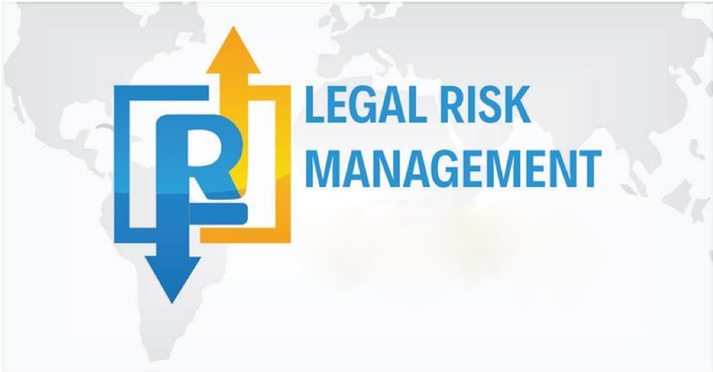

Table of Contents

Introduction........................................................................................................... 3
Analysis and Discussion.......................................................................................4
1.Data protection...................................................................................................4
2.Health and Safety...............................................................................................4
3.Food Hygiene.....................................................................................................5
4.Risk management...............................................................................................5
5.Licensing.............................................................................................................6
6.Hotel Proprietors Act 1956..................................................................................6
Conclusion...............................................................................................................7
Reference ................................................................................................................8

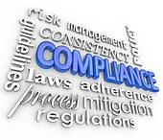

During the course we developed a lot of data about Hospitality and Hotel Industry having the choice to take a gander at in this report thoughts of peril the administrators and real commitment in the movement business and convenience. We'll review speculative risk thoughts and sound judgment danger the board applications while researching appropriate locales of standard and contract law. Prosperity and security, data protection, sustenance neatness, approving, including key game plans Hotel Property Act of 1956 are in like manner discussed. They will give a foundation to working in the Hotel and Hospitality Industry,

Introduction
Regardless of whether a nation is wealthy in verifiable landmarks, in social structures, in regular vacation destinations, it has vacationer promulgation associations that functions admirably, it implies open vehicle, so on, on the off chance that it doesn't have the convenience framework which is the reason for visitor openings, the financial focal points of the travel industry hazard being undermined (Purdea Dumitru, Fleseriu Adam, Methods and Techniques of Tourism and Public Food, Ed. George Baritiu, Cluj-Napoca, 1998).
The lodging is the gathering structure masterminded in structures, which gives to the voyagers appropriately prepared rooms, studios or condos, gives explicit administrations and has gatherings and open providing food offices on the premises (Sandu Petru, Management in the travel industry and Services, Ed. Suceava University, 1998).
In the Hotel Proprietors Act 1956 distributed in England, the lodging is characterized as an office given by the proprietor to give sustenance, drinks and, if essential, resting convenience with no uncommon contract to any traveller who presents himself and needs (Sue Baker, Pam Bradley, Jeremy Hayton, Principles of Operations at the Hotel's Reception - The Tourism Collection - All Beck Publishing House, 2002).
The neighbourliness business through the adaptability of its administrations, by adjusting to the requirements of its customers, can add to the advancement of the travel industry or to its humiliation, contingent upon the expansion or lessening of the nature of the administrations offered to the vacationers.
At present, the lodging business of the world possesses a huge number of lodgings and various specific staff. This branch relies upon other traveller exercises and is in this manner straightforwardly identified with the travel industry advancement when all is said in done. Along these lines, the lodging business is planning with its different accomplices: travel offices, transport organizations, congress coordinators and different activities.
In the inn business the most significant administrations offered are nourishment and drink (bars and cafés) and convenience (rooms and normal regions). It is difficult to convey these administrations, and administrators and representatives have some lawful commitments to consider.
Hazard is omnipresent in all everyday issues and hazard the board is something we as a whole need to do, regardless of whether we deal with a significant association or basically cross.
There is no particular meaning of legitimate dangers, yet the feelings of certain creators portray and clarify the procedure. Legitimate hazard covers all regions of movement wherein guideline and law influence activities and choices. Lawful dangers emerge from the drafting and the executives of agreements,direction of controllers on conduct, just as consistence, administrative and question dangers.
Analysis and Discussion

1.Data protection.
GDPR (General Data Protection Regulation)
GDPR is a developmental augmentation of the Data Protection Directive (DPD) issued by the European Commission in 2016. The new guideline expects to bind together and fortify information assurance for EU natives. It additionally details new guidelines for sending out information outside the EU.
The cordiality business offers sustenance, settlement and diversion to a wide assortment of supporters in a few settings. Your staff will consistently deal with the classified data of their visitor and learn things about benefactors that ought to be remained careful. There are no particular laws overseeing security in the accommodation business, yet your agreements and strategies ought to obviously manage what level of secrecy clients can anticipate.
Business accommodation normally drag customers' charge cards and acquire other touchy money related information, for example, data about a customer's financial balance. On the off chance that you lose this information accidentally, you might be legitimately subject for your carelessness, bringing about costly procedures.

2.Health and Safety.
Any fruitful inn business will see a consistent stream of visitors arrive and withdraw. Ideally all will have had a pleasant remain at your premises and will leave with no mishaps or wounds coming to pass for them.
Running an inn can be very hard for both the proprietor and the staff, regularly errands being done in a rush, particularly if the lodging offers providing food since it isn't directly for the customers to hold up long while remaining at your inn, dealing with them and their own belongings.
In any case, just as visitors remaining with you, the hotelier is likewise in charge of guaranteeing that the spaces are ok for representatives to have the option to play out their obligations
Obligations regarding labourer wellbeing are by and large administered by word related wellbeing and security laws, which obviously direct wellbeing models. Bosses who neglect to cling to these principles might be punished or fined (WorkSafeBC, 2015a).
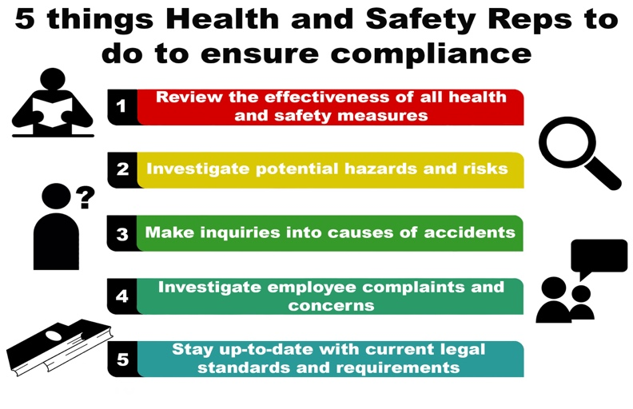
WorkSafeBC has broad assets for the travel industry and cordiality laborers to keep away from working environment damage. These incorporate aversion devices for settlement, experience the travel industry, nourishment and refreshment, and occasions.

3.Food Hygiene.
Food Hygiene as a definition is the study of keeping up wellbeing and includes cleanliness to decrease the danger of disease.
The expression "nourishment cleanliness" is utilized to depict the safeguarding and planning of sustenance in a manner that guarantees that sustenance is alright for human utilization.
To oversee nourishment cleanliness and wellbeing methodology in your sustenance business, you ought to pursue Hazard Analysis and Critical Control Point (HACCP) standards.
Great sustenance cleanliness is fundamental to ensure that the nourishment you serve is protected to eat. It averts food contamination. When you are setting up a nourishment business, you have to present methods for working that will enable you to guarantee great sustenance cleanliness is directly from the begin.
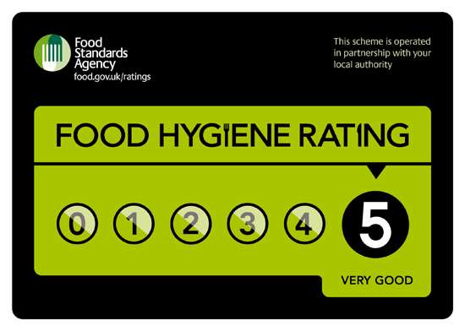

4.Risk administration.
As per Cloutier hazard the executives alludes to practices, arrangements and methodology intended to limit or take out unsatisfactory dangers (Cloutier, 2000, CTC, 2003a, Heshka and Jackson, 2011). Contingent upon the kind of activity and the business associated with the hazard the board procedure, they can differ a great deal.
Thus, it is helpful to think chance administration as a hazard deciding procedure and after that start chance minimization or disposal (Enterprise Risk Management, 2004).
Powerful legitimate hazard the executives is fundamental for associations that need to amplify esteem, while lessening cost and introduction to lawful misfortune.
A ton of hazard the board is the preparation staff, ensuring your workers recognize what they are doing and how they do, methodology is set up to guard everybody.
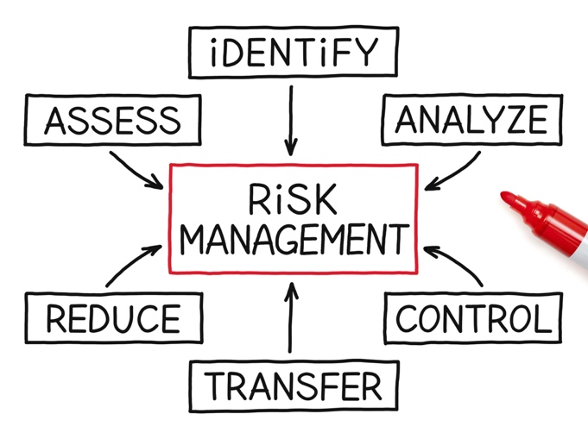

5.Licensing.

Permit is a grant from a specialist to possess or utilize something, complete a specific thing, or carry on an exchange (particularly in mixed drinks).
A permit is, fundamentally, a device, and when utilized well, it's a very savvy showcasing device.



6.Hotel Proprietors Act 1956.

The Hotel Owners Act of 1956 fills in as a guide and directs the inn's obligation for property having a place with clients or some other individual inside the structure.
Under the Hotel Proprietors Act 1956, a lodging owner may in specific conditions be subject to make great any loss of or harm to a visitor's property despite the fact that it was not because of any shortcoming of the owner or staff of the inn.
The risk of a settling client for the great misfortune or harm of a client is firmly identified with the time of remain, including the period between 12 PM quickly going before 12 PM and following the customer was a visitor and was qualified for utilize the settlement and lodging. (Legislation.gov.uk, 2019)
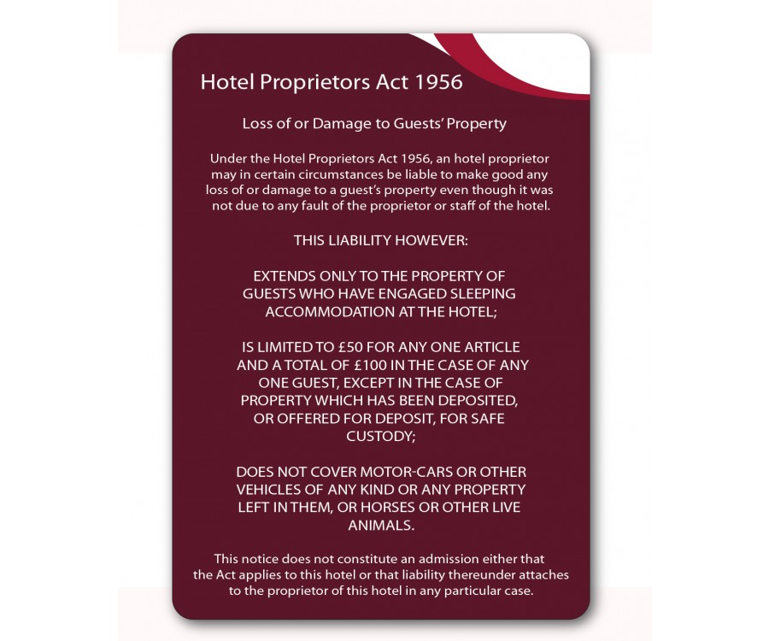

Conclusion
In end Tourism and Hospitality Risk Management is unpredictable, including issues identified with consistence with legitimate prerequisites, taking measures to guarantee that wellbeing and security necessities are met and an explanatory way to deal with moderating potential obligations. A large portion of the fundamental activities must be proactive for administrators; in the event that you don't, it can negatively affect your notoriety, harm to your property, fines, forms, or the saddest outcome - damage to your visitors or representatives. Organizations have not just a good and moral duty to rehearse powerful hazard the board, neglecting to do as such, can prompt money related ruin and the discontinuance of tasks.

Reference

Place for Curriculum Transfer and Technology (CCTT). (2003a) Health and security in experience the travel industry [PDF].. accessible @ http://bhudak.com/Health%20and%20Safety%20Guide.pdf(accessed (23/07/19)

Cloutier, R. (2000). Legitimate obligation and hazard the board in experience the travel industry. Winnipeg, MB: Hing Printing

Endeavor Risk Management. (2004). A down to earth manual for hazard appraisal. [PDF], accessible @ http://hwww.pwc.com/en_us/us/issues/undertaking hazard the executives/resources/risk_assessment_guide. Pd, (accessed 23/07/19)

Nourishment Hygiene Regulation – The Law and Legal Responsibilities, accessible @ https://www.food-cleanliness certificate.co.uk/sustenance cleanliness regulations.aspx (accessed 27/07/19)

Heshka, J. and Jackson, J. (2011). Overseeing hazard: Systems making arrangements for outside experience programs. Palmer Rapids, ON: Direct Bearing Incorporated

Legislation.gov.uk (2019). Inn Proprietor Act 1956., accessible @ http://www.legislation.gov.uk/ukpga/Eliz2/4-5/62/segment/1 (got to 23/03/19)

The Data Protection Officer (DPO) control, devoted to the General Data Protection Regulation, available @
http://www.dataprotection.ro/wervlet/ViewDocument?id=184 (accessed 23/07/19)

WorkSafeBC BC the travel industry and Hospitality Resources: accessible @ www2.workafebc.com/Portal/Tourim/Home.asp, (accessed 22/07/19)

