Programme: BA(Hons) International Hotel Management
Module code: BMIH6005
Organization Consultancy
Consulting on Premier Inn hotel

Name of the consultancy company: Businex Consultants
Name of the client: Premier Inn Hotel
Date report delivered to client:

Executive summary
The concerned report aims to serve one consulting report on one client organisation. The client firm for the present consulting report is Premier Inn Hotel. Extensive research will be initiated here on the client firm for gathering extensive and relevant datasets and information on it. The innate aim behind making progress with this report is to understand how the client firm is operating at present as well as identifying its existing issues. The identified issues will then be discussed in great detail, leading to understanding the exact reasons contributing to those issues’ prevalence. The report will also be using notable strategic management frameworks for contributing to the critical discussion premise. This assignment has researched and identified some issues which Premier inn is facing at the current period. It is identified that the organization is facing the issue of negative reputation in the market. The concerned study had thus got initiated with the end goal of identifying Premier Inn Hotel’s pressing business issues in present times and sketching some highly rationalised recommendations for rectifying those. Having been initiated on such a backdrop, the client firm, Premier Inn Hotel was found to have three major issues. First of all, the organisation’s financial position was struggling because of losing major revenue margin, the menace of Covid-19 outbreak as well as facing many debts. Thereafter, the negative brand reviews attained on digital platforms had only indicated how pathetic and disappointing the hotel groups’ service was, causing much visitors’ resentment. Having gone through such negative reviews, it was also becoming tough to attract more potential consumers and improve its financial earning. Moreover, the long-pressing issue of skilled staff shortage in the hospitality sector was contributing to the plight of Premier Inn Hotel. In addition, the inability of the organisation to arrange necessary training facilities for the staff had added to much employee dissatisfaction, boosting their turnover intention. The prevalence of these issues had thus taken a severe toll on Premier Inn Hotel’s existing operations as well as future viability.
As of the findings, it has been identified that there are certain focus areas which bear huge importance to Premier Inn Hotel, especially in relation to its existing issues. The identified areas for improvement come as customer experience journey, IT management, marketing and sales management, booking process management, customer management and many more. First of all, the hotel group is found to have major discrepancies in its booking system. Many visitors had put question marks on the faulty and misleading booking process. Many visitors had even reviewed not to get their booking amount back. In such a scenario, the organisation can only fulfil the goals of ensuring full-on customer satisfaction and having more visitors’ footfall through improving its booking process management. With having undertaken focus on this key area, the trust of the consumers can also be entitled for Premier Inn Hotel once again. Thereafter, IT management also remains another major focus area for the client firm as it is mandatory to have incorporated better IT infrastructure for enabling visitors to enjoy highly advanced stay experiences. Driven by such service, improved customer satisfaction and loyalty can be attained by the hotel and that too in the highly competitive sector. Thereafter, the need for better customer management also comes from the context of enabling customers’ motivation to try out the concerned hotel group. Moreover, the identified shortcomings in customer service for the hotel group also make this a major focus area for sure. In addition, marketing and sales had been identified as another price focus area in relation to the identified issues. The financial instability of Premier Inn Hotel had actually emerged from the provision of facing less visitors’ footfall. The negative WOM had only intensified this issue at large. In such a scenario, having strengthened the marketing and sales unit can help Premier Inn Hotel to have become more popular among the potential consumers as well as making them lured to book the hotel. As of the analysis section, the concerned issues for Premier Inn Hotel had been gone through a detailed evaluation. The key underlying reasons contributing to those issues had been clearly articulated henceforth, contributing to the thematic discussion in an effective manner. The identification of key underlying themes related to the discussion had thus been facilitated herein.
The consulting report had also proposed some highly justified recommendations against the analysis of the key issues. It had thus been proposed that the hotel group must take resources for robust marketing strategy on key social media platforms. When it was identified that the hotel group also had secured positive customer reviews, it was proposed to showcase/ promote those to have combated the negative WOM. In the modern-day era of digitisation, the proposal of SMM had been highly justified simply to offer more visibility to the hotel group. Thereafter, the proposals such as offering industry-oriented training provisions to the staff had been justified in terms of boosting staff skill as well as enabling to demonstrate best-in-the-industry hospitality service to the guests. Furthermore, it had been suggested to have don more reliable and transparent hotel booking, cancellation and other services for overcoming the customer grievance concerns. Lastly, it had been recommended to incorporate varied brand campaigning on multiple platforms for developing brand awareness for the Hotel Group.
The concerned consulting report had thus successfully fulfilled all the major learning outcomes and came up with one professional and highly justified consultation on Premier Inn Hotel. Not only the key issues of the client firm got discussed here in great detail, but also their most probable solutions had got enlisted herein.

Table of Contents
1.0 Introduction 6
Purpose of the report 6
Problems to be addressed 6
Methods to be used for analysing the problems 6
2.0 Scope and analysis 7
PESTLE analysis 10
SWOT analysis 11
Analysis of the findings 12
3.0 Describing and analysing the issues 13
Reputation of the brand 13
Staff shortage and appropriate training issues 15
Financial performance 16
4.0 Findings 17
Customer management 17
Booking process management 18
Marketing and sales management 19
IT management 20
Customer experience journey 20
5.0 Action plan 21
6.0 Recommendations and conclusion 22
6.1 Recommendations 22
6.2 Conclusion 23
References 24

1.0 Introduction

Purpose of the report
The term ‘Consulting report’ can be defined as the document that contains the consultant expert’s advice and understanding of any certain subject. Simply put, the consulting report is more as a document which offers expert solutions and knowledge on any problems. This concerned consultancy report also aims to critically evaluate the existing operations of Premier Inn Hotel, the biggest hotel brand in the UK. The actual purpose of this detailed and evidence-based consulting report will be to identify the existing problems of the concerned hotel chain along with evaluating the underlying reasons behind those issues. Lastly, the report will sketch some highly feasible recommendations to have overcome those issues for the client firm.

Problems to be addressed
The prime problems of the concerned client, Premier Inn Hotel comes as negative brand reputation, staff shortage and training issues as well as financial burdens. First of all, the client firm had attained much negative WOM “Word of Mouth” recently owing to its bad customer service facilities. Many visitors had openly expressed their disappointments and grievances in online portals over the hotel group’s bad service. Thereafter, it had been found how the concerned hotel group is facing financial debts owing to lost revenue margin and enhanced operational cost. Lastly, the issue of staff shortage and ineffective training facility comes in tandem with the hotel and hospitality sector’s ever-increasing skill and labour gap problem.

Methods to be used for analysing the problems
These identified problems for the client firm will be analysed in a qualitative data gathering and evaluation context. That is why PESTEL and SWOT frameworks will be used here. The intention of using these frameworks is to demonstrate the external operating environment’s impacts for the hotel group, generating both opportunities and threats as well as identifying the client firm’s strengths and weaknesses.

2.0 Scope and analysis
Premier inn: Premier inn is the UK limited service hotel chain as well as the largest hotel company in the UK, with over almost 72,000 rooms as well as almost 800 hotels. Premier Inn runs hotels in multiple places containing city centres, airports and suburbs competing with Ibis hotels and Travelodge (Ghandour et al. 2015). The organization was established in the year 1987. At the current period, the company has almost 30,000 employees. Whitbread plc is the parent company of Premier inn and the CEO of the hotel chain is Alison brittain. Premier inn serves multiple vital markets, like, the UK, UAE, Ireland, Germany, Jersey, Qatar, Guernsey and “Isle of Man”.
Issues and reviews on media and feedback: the organization has attracted multiple bad reviews from its consumers as well as media controversies. The images are displaying the bad reviews of the company given on popular websites, like, trustpilot and glassdoor. Trustpilot has provided a 2 star to the company on the basis of the negative feedback and Glassdoor has provided a 3.7 star.

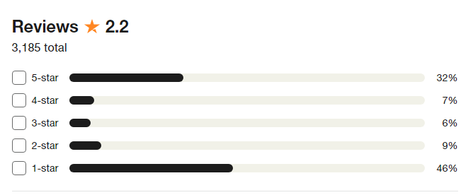
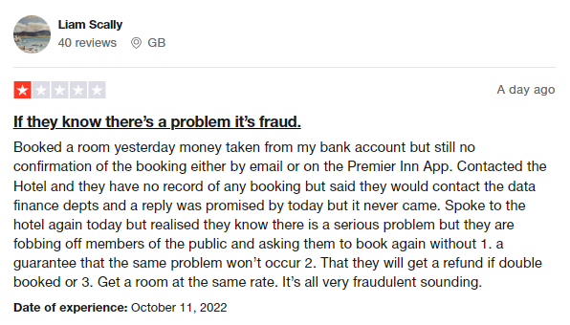
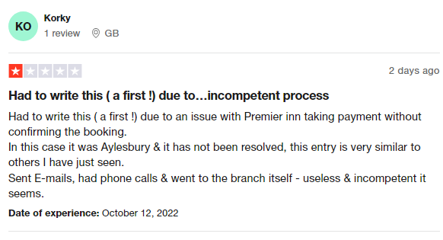
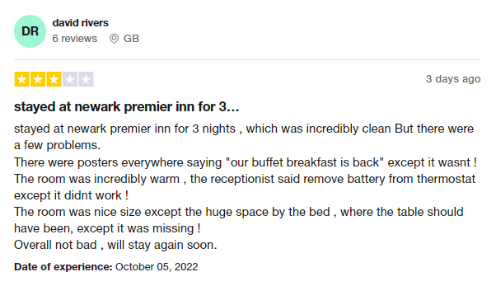
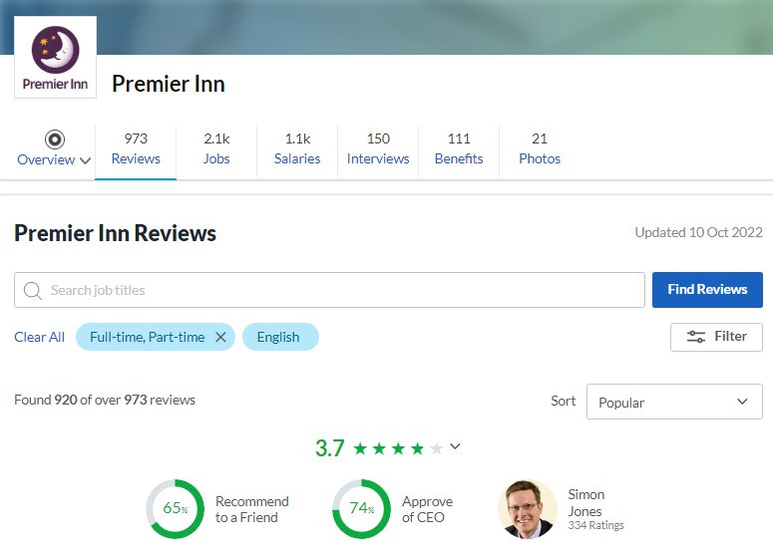

Premier inn has highlighted that the hotel chain is facing an employee shortage issue in the current period and a material amount of vacancies totally remain unfilled. It is recommended to recruit almost 2,000 employees to the current headcount of almost 30,000, containing in reception, kitchens and housekeeping (trustpilot, 2022). The revenue of the organization remains almost 39 percent down. The hotel is also highlighting its concerns related to the inflation in the world, especially in the UK.
Positive reputation: Premier inn multiple positive feedback from multiple news media houses for its launch of “wedding vending machine”. For instance, according to, “independent, 2022”, the wedding vending machines of Premier inn provide solutions to some basic wedding mishaps and issues. Apart from that, Premier inn has a good reputation for managing wedding activities (Holt, 2022). Tripadvisor has rated “Premier inn Livingston” 5 star for its effective and creative accommodation for weddings. “Bridemagazine, 2022” applauded Premier inn for the practical solutions provided by its “wedding vending machine”. Apart from that. Multiple individuals highlighted their support after the change of logo by Premier inn for the support of “LGBTQ community ahead of pride month”. It is identified that Premier inn launched a special website page to guide the visitors who went to Manchester to attend Manchester pride. Such initiatives have attracted positive feedback from the individuals and the media houses.

PESTLE analysis
Political | - The government of the UK began “the eat out to help out initiative” to attract more individuals to restaurants and hotels after the restriction of covid.  - The current Russia and Ukraine war has created unnecessary issues for the hospitality sector. | (Ben Hassen and El Bilali, 2022).
Economical | - In the UK, some uncertain environments of the economy are leading to the decline of GDP.  - The UK and multiple other regions in which Premier inn provides its services are going through inflation. | (Carnevali and Deleidi, 2022).
Social | - Covid situation is effectively managed in the Indo-Pacific region and the hotel sector is prospering in the region.  - Human rights issues across the international supply chain. | (Pal et al. 2022).
Technology | - Premier inn is creating a digitally effective and managed supply chain process of the upcoming period.  - Enhancing the effectiveness of the kitchen through technology. | (Zhang et al. 2022).
Legal | - GDPR law and data privacy.  - “Management of health and safety at work regulations 1999” in the UK. | (Piscitelli and Maat, 2022).
Environmental | - Decrease in carbon emissions.  - Decreasing “single utilization plastic”. | (Hornby et al. 2022).

SWOT analysis
Strengths  - The existence in the market of the UK is very powerful.  - High aim at stakeholder engagement.  - “Force for good” initiative enhancing sustainability reputation.  - Low cost of consumer acquisition. | Weaknesses  - High costs decrease the reserves of cash.  - Fail to retain employees.
Opportunities  - High scope for enhancement in Germany and India.  - Further spread of the UK pipeline. | Threats  - Service interruption because of supplier actions.  - Poor reviews on multiple websites related to services.  - “Tightening labour market”.  - Competitors.

Analysis of the findings
Recommendation on the PESTLE analysis: from the analysis of the outer environment of Premier inn it is identified that some outer environments, like, the technology and social needs are helping the hotel company to sustain in the competitive market, however, some factors, like, the political factors and the current economic situations are effective the company negatively. For instance, travel and hospitality sectors around the globe are facing forces from the conflict between Russia and Ukraine which contain fuel cost enhancement to shifted company services in Ukraine and Russia. Apart from that, the government of the UK had begun “the eat to help out” initiative after all initial restrictions were lifted as the economic recovery analysis to support the hospitality sector reopen as well as get revenue. It is identified that this initiative began to inspire more individuals to effectively eat out and create much required revenue for hotels and restaurants which faced large losses at the period of lockdown. Premier inn not just took part in the initiative, however went some steps further effectively by removing and decreasing the cap of discount which was put totally by the country’s government. Another issue facing by Premier inn is the enhancing inflation in the UK. The hotel company enhances the rates of room to compat almost 8 percent cost inflation. Almost 1.4 B GBP of “the FTSE 100 group’s base of cost”, from wages, power bills and food is totally vulnerable to effectively looming hikes of price, however the company tries to offset those prices through higher costs, effectiveness savings as well as estate enhancement. However, there are some vital advantages for Premier inn which have been identified from the PESTLE analysis. For instance, the covid situation is effectively managed in the Indo-pacific region, specially, in India and Premier inn can utilize the market to provide more services in more places and recover from the losses. The hotel company also has a large scope in the market of Germany. Germany is a much larger market compared to the UK as well as Germany is the home to almost 16 M more individuals. It identifies that the need for the rooms of a hotel per night is almost 25 percent larger. This assignment also has analyzed the internal aspects of the hotel company. For instance, Premier inn has the strength of a good leadership. It is the capability of its leaders which has helped the company to run services in a diverse environment. The company has multiple small and large scale hotels in multiple markets. The UK is the vital market for Premier inn and it has captured a large share in the UK. Premier inn is the largest hotel chain company in the UK. Stakeholders are largely valued in the hotel chain and its approach to value its stakeholders has helped it to manage conflict between them. However, multiple websites has provided very poor reviews to the company which is destroying its reputation.

3.0 Describing and analysing the issues

Reputation of the brand
As identified in the analysis section, it can be stated that one of the main problem areas of the organization Premier Inn has been the brand reputation which can affect the business of the brand. Many of the negative reviews had been regarding the inefficient and unavailable services of the hotel which has been an important issue. The example of the same can be the unavailability of the proper room heating system, buffet breakfast although it has been written everywhere that it is back, and many others. There are so many negative reviews where Premier Inn has charged money although it was not booked. Despite many phone calls, email, and others the customer was not able to get back the refund which has been a major area of brand reputation problem. Besides, faulty and inappropriate employee and security management has been another problem within the operations of Premier Inn Hotel. As an instance, the report published in The Mirror on 5th October 2022 can be considered. A London marathon runner, Matthew Clarke of 39 had booked a room in London Docklands Travelodge on September 30. While checking in, a message 'Welcome to Premier Inn. Please don't wet bed' was displayed on the TV. The message is quite utter to welcome guests in the hotel and according to Clarke, “it does make you wonder what's gone on there before. It's a strange thing to see when you turn your telly on.” After all, it is never an act which a responsible and sensible customer would do anyway. On the same day, the hotel authority had commented “we are very sorry to hear that Mr Clarke saw an unauthorised message on a television in one of our hotels. We take the security of our guests and systems seriously and whilst this is an isolated incident, we have launched a full investigation.” The same incident can be considered as an issue regarding the operations within the organisation (Bennett and Adamson, 2022).
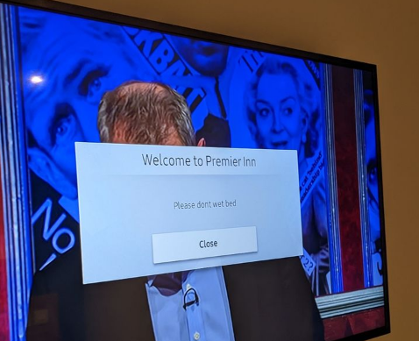
Source: Kennedy News and Media
While there are some significant issues with the brand reputation and customer experiences, there are also myriads of positive reviews which can indicate that there are also initiatives and employee management for the positive experience of the customers. One of such reviews by a customer had indicated the comfortable stay experiences where the customer left a treasured bear crumble which was returned at the home of the customers with a personal message from Premier Inn London Kensington (Olympia) hotel. The customer was really touched by the gesture which indicates positive intent of the management to offer a good experience to the customers. One of the positive reviews of the customers for Premier Inn Llanelli Central West in recent time stated, “I stayed at this Inn as I was on a walking holiday with the Holywell Ramblers club. The Inn is in a very good location and is beside a beautiful lake and near the Welsh coastal path. I have stayed at many Premier Inns and I can honestly say the staff at this Inn and Restaurant were genuinely friendly and helpful-The best Premier Inn I have stayed at.” Besides, there are many positive reviews regarding the cleanliness and the quality of the rooms which indicate there are some positive aspects of the brand reputation of Premier Inn (Suffield, 2022).

Staff shortage and appropriate training issues
One of the most contemporary issues with the operations at Premier Inn has been shortage of staff which overall affect the operations. As per the statistics of the UK government, the staff shortage in the hospitality industry has been at the record high where the vacancy has been 1.1mn between July and September 2021 and the same has been the highest since 2001 (BBC, 2021). The brand had around 30000 staff across 1200 hotels in the UK and there was an additional need for 2000 staff following by the rise in the business situation after the restriction of Covid 19 issues was eased on 17th May.
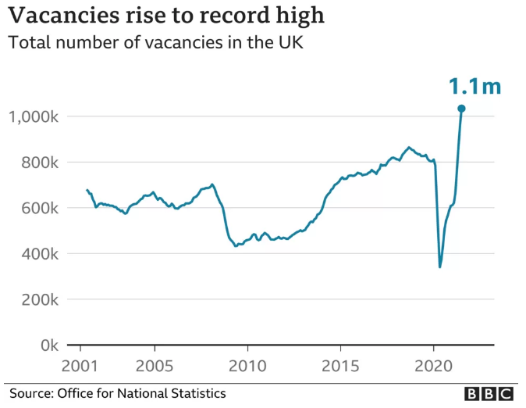
As per the CEO of the group Allison Brittain, “the operating environment during the summer and into autumn has been challenging largely as a result of our very high occupancy levels, market-wide supply chain issues and a tighter labour supply in the hospitality sector.” Thus, the same urges the companies like Premier Inn to hire temporary or hourly paid staff, the training to which has been an issue. As an instance, Britain also stated “overall within the industry there is a shortage of people who are available for work, particularly experienced people where the training load is less.” For the same, the training issues are there with the staff which is mainly incurred by the staff shortage (Muvija and Peters, 2021).
While the staff training for high turnover has been an issue, there have also been some factors which have affected the staff training. Premier Inn has been accused of not paying the housekeeping staff for the training days which has been a significant issue regarding training of the staff. The investigation by Katherine Price in 2018 revealed that the issue has prevailed mainly with the agency workers. While the agencies cover the cost of two or three training days, it was not present in some cases and the hotels involved (i.e., Premier Inn) are often unable to ensure the same. However, one of the positive signs against the same has been the prompt action of the Premier Inn Dorchester hotel at London Park Lane. As per one of the spokesperson, “it is part of our commercial arrangement with our agencies that they meet the agency workers' rate while they are being trained at the Dorchester. Timesheets are submitted to the agencies to provide payment for this training. The fair treatment of our staff, including agency workers, is a top priority for the hotel.” While the issue regarding unpaid training hours has been prevalent to some extent within the agency workers of the housekeeping, the main reason according to a spokesperson has been the leaving of job after three months (Price, 2018). Premier Inn had also clarified their position that they provide appropriate and high standards of training which has used time allocation for room cleaning for many years. As per the officials of Premier Inn, they have paid the staff as per the National Living Wage and "industry-leading training and development".

Financial performance
While the staff training and shortage has been an operational issue within the organisation Premier Inn, the financial performance has also been affected by the same. As per the report of BBC (2021), the labour shortages have caused “material number of vacancies” which remained unfilled. Many of the firms within the hospitality industry (including Premier In) are forced to increase the pay rates and sign in bonuses which can cause an extra burden to the companies. As per the Premier Inn owner Whitebread, the same will cost around £12m-£13m more while it has been incurring around £10m for retention bonus. Despite the rise in the revenue from the earlier years, the revenue of the Premier Inn hotel group has been down by 39% in 2021 compared to the revenue two years ago. The pre-tax loss has narrowed to £19.3m in H1, 2021 compared to £724.7m in the last year. The figure is of a stark difference from the profit of £219.9m made before the pandemic of Covid 19.
As the annual report of the company indicates, the effect of Covid 19 and staff shortage has been significant on the company where the statutory revenue of the group was down by more than 71.5% and the same resulted in the adjusted loss before tax of £635.1 million. In the FY2021, the revenue of the group was mainly down due to the closure of the vast majority of the businesses while the issue with decreasing demand had also affected the group. However, despite the weak revenue collection, the company had arranged for around £1000mn of cash through issuing of green debt bonds and others. Besides, the debts also decreased to around £46mn from £322mn in the earlier year. From the statistics, it can be stated that the operations problem with the group has been the decrease of revenue where the additional burden to increase pay and offering retention bonus will further result in widening of the operating loss (Whitbread, 2022). The issues like uncertainty after Covid 19, negative feedback from customers, and others can affect the operations of the group which can further worsen the financial scenario.

4.0 Findings

Customer management
Customer management according to Hospitality.net (2022) most important elements related to successful hospitality and tourism industry management. It is very common for organisations to invest up to 20% of their annual income for the purpose of marketing sales and customer service management. However, from the previously cited evidence it is clear that Premier Inn hotel has been experiencing various levels of problems specially considering standardised customer management and customer reception operations across all of its business structure. Given the fact that the hospitality and tourism industry is largely dependent upon customer support and B2C financial interactions it is imperative that the company applies proper strategic Framework in order to mitigate any issues stemming out of customer management or more specifically customer expectations management. According to Hancock (2021) customers are most likely to perceive service provisions on the account of the average services provided within the context of the industry. In some cases the customers might have their own preemptive priorities while on the other hand some might be purely motivated in terms of financial benefits and rewards. It is important for the business to understand the particular market it serves and the behaviour pattern of the customers in terms of their preferences and customer persona. On top of that the impact of the Covid-19 pandemic on the global tourism and hospitality industry had left a staggering impact on the financial conditions and co dependency within the industry itself. In the UK alone there has been a reduction of 84% from 2017 to 2020. The recent reports have also suggested that with a compounding annual growth rate of 1.9% and a collective worth of 59.3 billion GBP the tourism and hospitality sector industry will continue to support the UK economic output by 3%. However 2021 reports have related 42% lower occupation and a collective damage of 11.5 billion GBP within the two years of covid. Under all of these circumstances the importance of customer management and customer retention play a very vital role towards the success of not only Premier Inn but also the hospitality and tourism industry of the UK in general (Hospitality.net, 2022).

Booking process management
The importance of the hotel reservation system is crucial for the financial inflow and service provision for any given brand. This point of the various challenges a hotel might face the integrity of the reservation system under all circumstances should be thoroughly examined and supported with all available resources. There are some inherent benefits for having a properly functional hotel reservation system as pointed out by several academic and media sources. these benefits can be equally applied in the case of the current company-
- First of all, the process of the hotel reservation system allows the customers to book the hotel and the particular property without any manual interactions. a provides them with an overall understanding of the facilities and the amenities. Online travel agents and their inclusive service have estimated that travellers tend to prefer organisations more when there is appropriate information in their websites especially in terms of the reservation process, reservation policy, extension policy and refund policy. customers also like those businesses better who maintain a proper communication transparency in terms of the hidden charges, cancellation charges and complementary services charges.
- Online hotel booking systems provide an ecosystem where online travel agents can consider the particular business and their services as appropriate recommendations depending upon the specifications of the destination and the priorities of the guest in prospect. Having third party organisations and websites handle the hotel reservation system decreases profitability over time and so has been stipulated by various online sources. Visibility of the services especially in the digital domain is one of the most important elements related to the modern hospitality and tourism industry that cannot be ignored.
- Lastly, the provision of hotel reservation systems provides ample opportunity for both the customers as well as the company to arrange their engagement with complete customisation. There is an inherent flexibility and convenience where the customers can get more than they anticipate. And all of these facilities and benefits have a deeper impact on customer retention rate and customer loyalty.
- The availability of the IT hubs in London and greater London definitely allows for various levels of hotel booking systems to be applied in the context of Premier Inn Hotels. There are various kinds of methodologies and assistance which are specifically targeted towards perfecting the hotel reservation systems. For example property management system, Central reservation system, channel manager, booking engine and drive direct booking. The implementation of the same can be applied in the context of the case company Premier Inn as well in order to address the problems stemming out of the booking management process head on.

Marketing and sales management
The findings from the previous sections have clearly highlighted a lack of experience and resources at the disposal of Premier Inn hotels. The findings from the previous sections have really highlighted that in various instances the employees do not have a concrete understanding in terms of providing neutral and logical feedback against negative reviews in various online platforms and forums. Given the low experience of the stakeholders, especially in terms of customer response, management is directly related to the marketing and sales management capabilities of the organisation as well. There is a lack of the variety when it comes to marketing channel adaptation by the administration of Premier Inn. It also indicates that the company has a very weak presence in various social media platforms. All of these performance issues are creating various levels of operation problems for the company and its stakeholders. it is time that the company as well as its administrative core understands the importance of marketing and sales performance management with the help of strategic training and development for customer service execution that meets the expectations of the customer and reflects the international standards for hospitality management.

IT management
The integrity of its management is another issue as identified within the context of Premier Inn hotels. The lack of support from the website and the IT Department of the company has led to several negative reviews in social media and travel and tourism forums. If continued this can easily be seen as a point of weakness for the company. Therefore the competence of the IT management is directly related towards the online customer booking process for the. These two individual processes feed off each other. Possible action plan related to the IT management and customer reservation process management can be seen in the following sections.

Customer experience journey
Customer experience journey plays a very vital role towards determining how the services and the facilities of a company will be perceived and experienced by the customer on a regular basis. It is essential for business operating from more than just one specific location. The negative reviews of the customers and the inability of the stakeholders to mend or change the customer experience outcomes illustrates that Premier Inn is facing a critical situation. This is evident that Premier Inn needs to make some constructive changes in order to make the customer experience journey much more suitable for the users who are either new or in the process of making a switch from other hotels. Some solutions and suggestions can be seen in the following action plan which will directly link back to the customer experience journey. This also goes to show the interconnectedness of all the individual problems with which the business is associated. This explains why some of the competitors of Premier Inn have been experiencing compounding improvements in terms of their customer experience management initiatives simply due to increased government support and resource allocation especially after the financial stagnation of Covid-19 pandemic.

5.0 Action plan
No. | Problem | Solution | Desired Outcome | Time Scale | Planned budget
1 | Customer management | Employee T&D on customer management  Setting global CSM service metrics  Customer discussion forum like ‘Wow wall’ | The customers and the stakeholders will have an even plain to have discussions in terms of feedback and response  The employees will most likely develop a better understanding of effective customer management within due parameters. | 12 months | 200,000 GBP
2 | Booking process management | Implementing a better booking process management for the convenience of the customers with the help of better IT resources  Providing 24*7 customer support for the new and old customers | The customers as well as the employees of the company will be benefitted by the streamlined process of booking and the reservation system in place. This will make sure that the customers get the most out of the CX journey. | 6 months | 75,000 GBP
3 | Marketing and sales management | Investing significant and strategic resources in order to transform the marketing and sales related competencies of the company is the most important task at hand.  The company might take assistance from a third party consultancy service organisation | This will allow the company to make huge improvements in terms of their marketing and sales performance management | 6-12 months | 500,000 GBP
4 | IT management | Having help from third party IT service providers  Using tools like IoT and big data for making better and informed decisions | The prospect of IT management is one of the most important elements which is related to the functionality of the business as a whole especially considering the needs of industry 3.0 and 4.0. | 6 months | 150,000 GBP
5 | Customer experience journey | Providing the best possible customer experience with continued support from the management | This will reward existing customers and will aid in the decision making process of those trying to change or try new companies for a change. | 3 months | 50,000 GBP

6.0 Recommendations and conclusion

6.1 Recommendations
In accordance with the articulated findings, some highly justified recommendations are being proposed below against the issues of Premier Inn Hotel:
Firstly, it is recommended to Premier Inn Hotel to have used robust promotion and marketing strategy for attracting more potential visitors. The usage of active SMM or Social Media Marketing strategy is thus proposed to Premier Inn Hotel (Li et al., 2021). The Hotel Group must promote the positive customer reviews and salient features such as room décor, facilities and others in popular social media platforms. Only by using aggressive SMM strategy, more potential customers can be lured, initiating their decision to choose Premier Inn Hotel over others.
That the client firm has already witnessed the wrath of negative WOM, it must come up with robust brand campaigning on multiple platforms for improving its brand reputation. In that context, it would be highly beneficial for the hotel group to have ensured the visitors to enjoy supreme customer service and stay experience. Only by reassuring customers’ trust, the hotel group can attain more visitors’ footfall, improving its financial revenue generation context eventually.
It is also recommended to Premier Inn Hotel to put huge focus on improving its customer service (Kefalas, 2019). The in-room gadgets and facilities must be checked regularly to ensure no fault. Moreover, a direct and transparent hotel booking and customers’ handling facility must be incorporated by the Group. Furthermore, the visitors must be welcomed in a more heartfelt and warm manner, making them satisfied.
Lastly, it is recommended to Premier Inn Hotel to offer industry-specific training facilities to its existing staff. The importance of staff training comes in the context of enriching the hotel’s customer service experience, adding to customer satisfaction (Olimovich et al., 2020). In addition, staff engagement level can be boosted in terms of getting skill development scopes, reducing their turnover intention at large.

6.2 Conclusion
In this detailed study premise, it had been consulted how Premier Inn Hotel had been witnessing some pressing issues/ challenges in its current operations. The existing capabilities of the client hotel group had been discussed in the very first part. Thus, it becomes evident that the hotel chain group is having so many hotels in vast geographic contexts. Being operated in the hospitality sector, the need of customer satisfaction only remains paramount for Premier Inn Hotel. It had although been found that the hotel group had garnered negative media reviews from its past visitors. The reviews posted on popular travel portals clearly indicated how the hotel group had unavailable and ineffective customer service. The underlying reasons for such compromised hotel service facilities come as faulty in-room gadgets, fraudulent booking system, insulting check-in message and many more. Thereafter, it has been documented how the group of hotel chains has a smaller number of staff to deal with rush of consumers, also contributing to the issue of deteriorated hotel service. Premier Inn Hotel was thus found to witness the staff shortage problem in accordance with the burst of skill gap concern in the entire UK hospitality sector. The peak seasons thus become hard to be managed with less staff. Ineffective and non-transparent training facilities in the hotel group had only contributed to the high turnover rate, contributing to the staff shortage menace. The financial capability of the client firm also seemed to struggle at large simply because of its lost revenue margin, high operational cost and debt-run scenario, driven by customers’ bad reviews and Covid-19 outbreak. With the help of the proposed action plan as well as recommendations, it had been assumed to overcome all these issues by the client firm, ensuring more growth, profit and long-term sustainability in near future.

References
- BBC, 2021. Premier Inn owner Whitbread warns of staff shortages as demand recovers. [online] BBC News. Available at: <https://www.bbc.com/news/business-59048014> [Accessed 4 October 2022].
- Ben Hassen, T. and El Bilali, H., 2022. Impacts of the Russia-Ukraine war on global food security: towards more sustainable and resilient food systems?. Foods, 11(15), p.2301.
- Bennett, F. and Adamson, D., 2022. Travelodge guest baffled by welcome sign at hotel urging him not to wet the bed. [online] mirror. Available at: <https://www.mirror.co.uk/news/weird-news/travelodge-guest-baffled-welcome-sign-28157373> [Accessed 4 October 2022].
- bridemagazine, 2022. Premier Inn launches UK's first Wedding Vending Machine. [online] Bride. Available at: <https://www.bridemagazine.co.uk/articles/premier-inn-launches-first-wedding-vending-machine> [Accessed 15 September 2022].
- Carnevali, E. and Deleidi, M., 2022. The trade-off between inflation and unemployment in an ‘MMT world’: an open-economy perspective. European Journal of Economics and Economic Policies: Intervention, 1(aop), pp.1-35.
- Ghandour, R., Bilal, J. and Mudassar, H., 2015. Relationship between Service Quality, Customer Retention and the role of Social Media-Case study Premier Inn Hotel (UK). Journal of Organizational Studies and Innovation, 2(4), pp.1-12.
- Hancock, A., 2021. UK hospitality industry yet to recover to pre-covid trading levels. [online] Subscribe to read | Financial Times. Available at: <https://www.ft.com/content/ac6266ed-3977-4d51-88bf-d60768ee8c7a> [Accessed 10 Oct. 2022].
- Holt, J., 2022. Premier Inn hits back after being accused of 'box ticking' with Pride logo. [online] Manchester Evening News. Available at: <https://www.manchestereveningnews.co.uk/news/uk-news/premier-inn-hits-back-after-24124958> [Accessed 15 October 2022].
- Hornby, S., Benn, J., Vinkenoog, R., Goldberg, S. and Pound, M.J., 2022. Methods in melissopalynology: colour determination of pollen pellets for colour vision deficient individuals. Palynology, pp.1-7.
- Hospitality.net, 2022. Two years of covid does £115bn damage to UK Hospitality Industry. [online] Hospitality Net. Available at: <https://www.hospitalitynet.org/news/4109030.html> [Accessed 10 Oct. 2022].
- Independent, 2022. Wedding Vending Machines' that offer solutions to common wedding mishaps unveiled by Premier Inn. [online] www.independent.co.uk. Available at: <https://www.independent.co.uk/life-style/premier-inn-wedding-vending-machines-resizeable-ring-flip-flops-gift-a8336951.html> [Accessed 15 September 2022].
- Kefalas, S., 2019. Quality Service in the Hospitality Industry: Achieving Effective Service Processes and Designs. In Strategic Innovative Marketing and Tourism (pp. 39-47). Springer, Cham.
- Li, F., Larimo, J. and Leonidou, L.C., 2021. Social media marketing strategy: definition, conceptualization, taxonomy, validation, and future agenda. Journal of the Academy of Marketing Science, 49(1), pp.51-70.
- Muvija, M. and Peters, C., 2021. Labour shortages cloud Premier Inn owner's bullish outlook. [online] www.reuters.com. Available at: <https://www.reuters.com/world/uk/premier-inn-owner-eyes-full-uk-recovery-2022-losses-narrow-2021-10-26/> [Accessed 4 October 2022].
- Olimovich, D.I., Bakhtiyorovich, T.M. and Salimovna, N.G., 2020. Improving of personnel training in hotel bussines. Academy, (2 (53)), pp.18-19.
- Pal, R., Khobragade, A.W. and Mandal, M., 2022. How India has managed the COVID-19 first and second waves?. Journal of Education and Health Promotion, 11.
- Piscitelli, G. and Maat, E.P., 2022. The Right to Be Forgotten in the UK: A Case Note on the English and Welsh High Court Reasoning in NT1 & NT2 v. Google and the Post-Brexit Prospects in the GDPR era. European Review of Private Law, 30(2).
- Price, K., 2018. Housekeeper pay scandal: agencies accused of not paying staff for training. [online] The Caterer. Available at: <https://www.thecaterer.com/news/hotel/housekeeper-pay-scandal-agencies-accused-of-not-paying-staff-for-training> [Accessed 4 October 2022].
- Suffield, A., 2022. Every Premier Inn in Wales ranked from best to worst according to TripAdvisor reviews. [online] www.walesonline.co.uk. Available at: <https://www.walesonline.co.uk/whats-on/travel/premier-inn-ranked-worst-best-24005779> [Accessed 4 October 2022].
- trustpilot, 2022. Premier Inn is rated "Poor" with 2.2 / 5 on Trustpilot. [online] Trustpilot. Available at: <https://www.trustpilot.com/review/www.premierinn.com> [Accessed 15 October 2022].
- Whitbread, 2022. Whitbread Plc: ANNUAL REPORT AND ACCOUNTS 2020/21. [online] Cdn.whitbread.co.uk. Available at: <https://cdn.whitbread.co.uk/media/2021/05/05141427/23076_Whitbread_AR2020_web.pdf> [Accessed 4 October 2022].
- Zhang, X., Tavitiyaman, P. and Tsang, W.Y., 2022. Preferences of Technology Amenities, Satisfaction and Behavioral Intention: The Perspective of Hotel Guests in Hong Kong. Journal of Quality Assurance in Hospitality & Tourism, pp.1-31.

