

ADAA7000 Coexistent Perspectives Module

Name: LI XINYU

Student number: 2405473

Word Count: 4138

- Please keep all drafts of your essay. You may be asked to produce these as evidence of your writing process.

- Please ensure you follow the AI guidance on the assessment brief and note when and how you are able to use AI.

- Please also note the guidance regarding plagiarism on your assessment brief also refers to referencing the source of your material and that includes the use of AI.

For this assessment,
I confirm that I have not used Generative AI to support me in structuring my submission, including creating a draft argument structure, identifying parts and headings.
I confirm that I have not used Generative AI to create text for my submission.
I confirm that I have not used Generative AI for creative materials, such as images.

Student Signature: 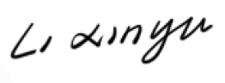

Research Question: How does Makoto Shinkai’s 5 Centimeters per Second (2007) transform waiting into an palpable form of time through slow temporal rhythms and visual stillness?

Thesis Statement: Through slow pacing, delayed shots, and visual stillness, Shinkai transforms animation into a subjective experience of time, allowing temporality to be felt. Drawing on Bergson’s concept of duration, Barthes’s notion of punctum, and theories of cinematic time proposed by Mary Ann Doane and Gilles Deleuze, this essay examines how time in 5 Centimeters per Second is perceived, suspended, and extended, forming an aesthetic of emotional temporality.

Essay Title: Experiencing Waiting: Slow Temporality and Visual Stillness in Makoto Shinkai’s 5 Centimeters per Second

Abstract
This article explores how 5 Centimeters per Second (2007), directed by Makoto Shinkai, constructs a distinctive temporal aesthetic centred on waiting. It focuses on key sequences such as train delays, the slow falling of cherry blossoms, and missed encounters on railway platforms, examining how the film’s structural design transforms waiting from a narrative interval into a perceptible and emotionally inflected form of time. Rather than functioning as empty pauses between events, these moments are organised to foreground time itself as an experiential presence. Drawing on Henri Bergson’s concept of duration, the article analyses how the film’s slow pacing and emphasis on bodily sensation render time as a continuous and subjective state, rather than as measurable clock time. Through Roland Barthes’s notion of punctum, it explores how minor, non-functional visual details—such as drifting cherry blossom petals and light framed by windows—enter the viewer’s memory as affective moments. Finally, by engaging with the cinematic theories of time proposed by Mary Ann Doane and Gilles Deleuze, the article examines how moments of failed action or narrative suspension allow time to emerge directly as the subject of the image. Overall, these strategies redefine waiting as a temporal mode with aesthetic and experiential significance, encouraging the viewer to feel time rather than merely observe narrative events.

Themes: Duration、Punctum、Cinematic Temporality

Introduction

In contemporary animation and film studies, time is no longer recognized as a linear device that serves to advance narrative events for narrative development. Instead, it has increasingly been approached as an aesthetic object—one that can be perceived, experienced, and reflected upon through the act of viewing. Compared with traditional narrative models that privilege causality, action, and plot progression, a growing number of audiovisual works deliberately weaken the centrality of events by employing slow pacing, pauses, and moments of visual stillness. Through these formal strategies, attention is shifted away from what happens in the story toward how time itself is felt, experienced, and emotionally registered during the viewing process. Within this critical context, concepts such as “slow temporality” and “affective temporality” have emerged as important perspectives for understanding contemporary time aesthetics in animation and cinema (see Bergson, 1910; Deleuze, 1989).

The works of Japanese animation director Makoto Shinkai are frequently regarded as emblematic of this aesthetic shift in the representation of time. His films are widely recognized for their slow rhythms, meticulous depictions of everyday environments, and extensive use of still and empty shots. Rather than prioritising action-driven storytelling or dramatic plot turns, Shinkai’s animation places greater emphasis on the emotional textures produced by the passage of time itself. Among his works, 5 Centimeters per Second (2007) stands out as a particularly revealing example. The film does not rely on strong narrative conflicts or clearly defined climaxes to propel its story forward. Instead, it immerses the viewer in an elongated temporal experience shaped by train delays, the rhythm of walking and breathing, seasonal transitions, and the repeated presentation of visually static moments. Through these elements, time appears not as a neutral backdrop for events, but as a sensible presence that structures the viewer’s emotional engagement with the film.

Within 5 Centimeters per Second, “waiting” is not treated as a transitional gap or an empty interval between narrative events. Rather, it is continuously foregrounded and intensified as a distinct temporal experience. This form of waiting does not signal a pause in storytelling, nor does it indicate an absence of meaning. On the contrary, it is carefully constructed as a subjective state of time that can be directly perceived and felt by the viewer. Through the precise control of rhythm, visual composition, sound, and environmental detail, the film temporarily detaches time from linear narrative progression. Time instead manifests through delay, suspension, and stillness. Rather than unfolding around clearly identifiable events, it accumulates within seemingly minor, non-eventful moments, prompting the viewer to sense the ongoing passage of time even as it resists clear measurement.

This article takes 5 Centimeters per Second as its primary object of analysis and examines how Shinkai transforms “waiting” into an experiential form of time through slow temporal rhythms and visual stillness. The discussion focuses on several key visual and rhythmic sequences in the film, including the empty time produced by train delays, the pacing of characters’ walking and breathing, and the moment when snow and cherry blossoms slowly fall. Although these moments are not central to narrative causality, they play a crucial role in shaping a perceptual mode of temporality in which time itself becomes the object of aesthetic attention. At a theoretical level, this study draws on Henri Bergson’s concept of duration (durée), Roland Barthes’s notion of the punctum, and the writings of Mary Ann Doane and Gilles Deleuze on cinematic time. By bringing these theoretical frameworks into dialogue with the film’s formal strategies, the article aims to demonstrate how 5 Centimeters per Second constructs a distinctive animation time aesthetic centered on waiting, in which time is no longer subordinated to narrative outcomes but is instead experienced as a continuous, affective presence.

- Duration and Subjective Waiting: The Presence of Bergson’s Durée in 5 Centimeters per Second

In the first episode of 5 Centimeters per Second, the narrative device of a train delay is not treated as a simple obstacle to narrative progression. Rather than functioning as a minor inconvenience to be quickly resolved, the delay is transformed by Shinkai into an extended temporal process—one that is stretched, perceived, and actively experienced. In this sequence, time no longer operates as objective, measurable “clock time,” but instead gradually takes the form of a subjective duration saturated with anxiety, anticipation, and bodily sensation. Through this treatment, waiting itself becomes a central experiential component of the film, rather than a narrative gap between meaningful events.

From a narrative perspective, the train delay could easily have been conveyed through brief exposition and swiftly passed over. Instead, the film repeatedly lingers on images of empty railway platforms, trains that move slowly only to come to another halt, and distant tracks and landscapes buried beneath heavy snow (Figure 1). The recurring station announcements and delay broadcasts, combined with the repeated deceleration and stopping of the train, significantly reduce any sense of narrative advancement. Although, in objective terms, the duration of this waiting period may amount to only a few minutes, the experience of audience is markedly prolonged. Through the sustained presentation of a situation in which “nothing happens,” time gradually loses its function as a tool for narrative progression and instead emerges as a perceptible presence in its own right.
Figure 1. Composite stills of empty railway platforms, delayed trains, and snow-covered tracks in 5 Centimeters per Second (Shinkai, 2007), emphasizing suspended movement and the experience of waiting.

This temporal expansion is first manifested through the film’s control of rhythm. In this sequence, the editing pace is noticeably slowed, with infrequent and restrained cuts. Many shots that are not strictly necessary for narrative comprehension are nevertheless retained in full. The train repeatedly stops, and the characters move back and forth between the platform and the carriage (Figure 2), yet never succeed in reaching their destination. Action is rendered inefficient through repetition, and purposeful movement is continuously deferred. It is precisely within this condition—where action fails to be completed and narrative progression is repeatedly postponed—that time itself begins to surface as the core of the viewing experience.
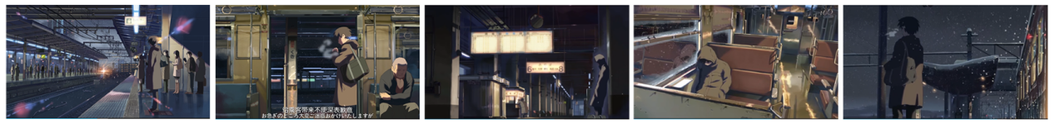
Figure 2. Composite stills depicting repeated movements between the railway platform and the train carriage during the train delay sequence in 5 Centimeters per Second (Shinkai, 2007).

At the same time, the film further transforms time into something that is actively “lived through” by foregrounding bodily perception. The rhythm of the male protagonist’s walking through the snowy night, his increasingly laboured and hurried breathing, the fatigue produced by prolonged standing, and the sensation of cold gradually penetrating the body are all depicted in careful detail (Figure 3). Time is no longer marked by subtitles or clocks, but is instead registered through physical burden. Sensations such as coldness, exhaustion, and drowsiness constitute the concrete substance of waiting. As a result, the viewer does not merely observe a character who is waiting; rather, through an affective resonance with bodily experience, the viewer is compelled to remain within the state of delay alongside the character.
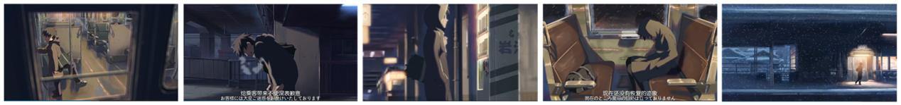
Figure 3. Composite stills showing bodily fatigue and sensory discomfort during the delay sequence in 5 Centimeters per Second (Shinkai, 2007).

On both the auditory and visual levels, the film further weakens the directional movement of time. The sound design is dominated by environmental sounds: the mechanical noise of the train, the wind and falling snow, and the repetitive rhythm of footsteps. These sounds recur in a cyclical rather than progressive manner, forming an auditory structure that lacks forward momentum. Such repetition diminishes time’s orientation toward the future and presents waiting as a continuous, enduring condition. Visually, the sequence is characterised by cold colour palettes and low-saturation winter night scenes. The lighting on the platform remains almost constant, offering few visual cues by which time might be clearly demarcated. This audiovisual stability makes time difficult to divide or measure, leaving it to be experienced only as a continuous flow of perception.

This mode of duration, grounded in bodily rhythm and perceptual density, is not limited to the situation of forced waiting created by the train delay. In the latter half of the first episode, the same temporal experience reappears in a different form in the snow-covered night walking sequence, after the protagonists’ brief reunion at the station and their subsequent removal from the platform. At this point, the necessary narrative actions have largely been completed: the station is closing, the characters no longer face a clear external obstacle, and the story could have moved efficiently toward the next narrative node. However, rather than compressing this transition, Shinkai allows the camera to linger on the two characters walking side by side through the snowy night, once again detaching time from narrative efficiency and transforming it into a process that is continuously experienced (Figure 4).
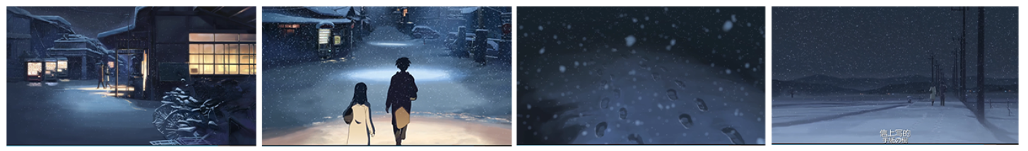
Figure 4. Composite stills of the two characters walking side by side in the snow at night in 5 Centimeters per Second (Shinkai, 2007).

Formally, this sequence markedly weakens the functional role of action. The characters’ walking pace is deliberately slowed, and their bodily movements are restrained and unhurried. Snow falls with extreme slowness and persistence, while footsteps leave clear but fleeting traces in the snow. Walking no longer appears to function as a means of “getting somewhere,” but instead becomes a bodily state that simply occupies time. It is precisely through this de-functionalised action that time is experienced as a continuous and indivisible flow rather than a series of measurable units.

On the level of sound, the film further reinforces this sense of temporal continuity. Background music is almost entirely absent in this passage; what remains audible are primarily the sounds of footsteps pressing into the snow, the faint and persistent ambience of the winter night, and the bodily rhythm implied by the characters’ breath, visible as white vapour in the cold air. Sound no longer guides emotional progression or anticipates forthcoming events, but works together with the image to produce a calm and non-directional temporal structure. Time here neither accelerates nor moves toward a clear future outcome, but unfolds slowly, accompanied rather than driven.

In contrast to the anxiety-laden waiting produced by the train delay, the duration of the snow-night walk approaches a state of quiet and gradual co-presence. Time is no longer stretched through external obstruction, but unfolds organically through bodily rhythm, environmental repetition, and perceptual density. What the viewer experiences in this sequence is not narrative progression, but the mode of existence of time itself. In this sense, these two seemingly different moments together exemplify Henri Bergson’s concept of durée: real time is not an objective entity that can be segmented and measured, but a continuous state that can only be perceived and lived through experience (Bergson, 1910).

Through the careful modulation of rhythm, embodied perception, and audiovisual elements, Shinkai temporarily releases time from narrative structure and allows it to emerge as something that is felt and experienced in its own right. The viewer is no longer merely watching a story about waiting, but is compelled, in the act of viewing, to inhabit time alongside the characters.

- Affective Temporal Moments: Barthes’s Punctum

If Bergson’s concept of durée helps to explain how waiting is continuously extended through rhythm and embodied experience, Roland Barthes’s notion of punctum offers a way to understand which specific visual moments allow time to enter memory. For Barthes, the punctum is not a narratively encoded or symbolically determined meaning within an image, but rather a minor, contingent detail that unexpectedly “pierces” the viewer at the level of perception (Barthes, 1981). It is precisely through such moments that time ceases to be understood as narrative progression and is instead experienced and remembered in an affective mode.

In 5 Centimeters per Second, the recurring images of cherry blossom petals falling slowly through the frame constitute the most representative affective temporal moments in the film (Figure 5). These images do not serve to advance the plot, nor do they explain changes in character relationships. Nevertheless, they occupy a highly prominent position within the viewer’s perceptual field. From a formal perspective, such scenes are often composed in an almost static manner: the camera remains fixed or moves only imperceptibly, while the petals enter the frame from above and complete their descent with minimal editorial intervention. The falling speed of the petals is deliberately slowed, allowing the moment to detach itself from everyday temporal rhythms , and instead become a slice of time held for contemplation.
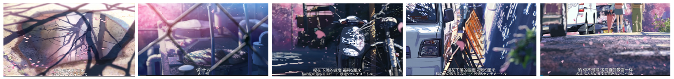
Figure 5. Composite stills depicting the slow descent of cherry blossom petals in 5 Centimeters per Second (Shinkai, 2007).

In terms of composition, the cherry blossoms are typically positioned in the foreground or at the visual center of the image, while the background remains relatively static. This formal strategy effectively separates the petals from their surrounding environment, transforming them into isolated, non-functional visual events. Within this isolation, narrative time is briefly interrupted, and the viewer’s attention shifts from the question of “what will happen next” to an intensified awareness of “what is happening now.” Rather than explaining time, the falling blossoms interrupt it, drawing the viewer out of narrative temporality and into a purely affective experience of time.

The design of colour and sound further reinforces this punctum effect. The pale pink of the cherry blossoms forms a soft yet distinct contrast with the predominantly cool-toned backgrounds, rendering the moment visually fragile and seemingly unrepeatable (Figure 6). On the auditory level, environmental sounds are often weakened, while music is either absent or introduced with extreme restraint. Sound no longer guides emotional interpretation but instead recedes to make space for the visual moment itself. Under this audiovisual structure, the falling of the blossoms ceases to function as a decipherable symbol and instead becomes a temporal experience that is difficult to articulate, yet remarkably easy to remember.
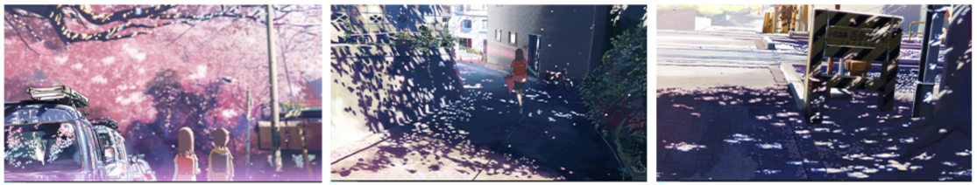
Figure 6. Composite stills showing the contrast between pale pink cherry blossom petals and the cool-toned background in 5 Centimeters per Second (Shinkai, 2007).

Such affective puncta are not limited to the motif of cherry blossoms but recur throughout the film in other detail shots that are not narratively central yet possess a high degree of perceptual density. For example, the slanting light entering through a classroom window (Figure 7) is frequently presented in static compositions: characters remain almost motionless, and the frame lacks any clear direction of action. What remains is the presence of light lingering within space. These images convey little narrative information, yet through visual suspension they render time as something momentarily held and contemplated. What the viewer experiences here is not the development of an event, but the presence of time itself at a specific moment.
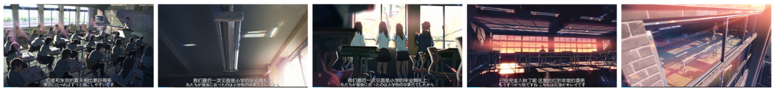
Figure 7. Composite stills depicting the slanting light through classroom window frames in 5 Centimeters per Second (Shinkai, 2007).

A similar sense of time can be found in the lingering shots of gazing on the railway platform (Figure 8). Characters face into the distance without any action, and the camera often maintains the shot for an extended duration. The tension arises not from movement, but from the contrast between bodily stillness and the extension of the gaze. In these moments, looking ceases to be oriented toward future events and instead becomes a temporal posture in its own right. Time neither advances nor gives way to recollection; it remains suspended in the present, functioning as an affective filling rather than a narrative connector.
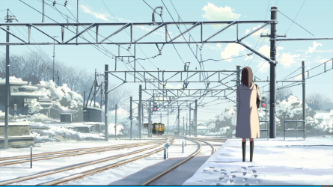
Figure 8. A still frame showing the character gazing into the distance on a train platform in 5 Centimeters per Second (Shinkai, 2007).

This sense of fragile temporality is further intensified in the scene in which Akari falls asleep while waiting at the station (Figure 9). This moment does not coincide with a narrative climax, nor does it involve any decisive action, yet it carries a striking emotional density. Sleep signifies the suspension of action, while waiting implies a state of temporal indeterminacy. Their combination creates the impression that time itself has momentarily paused. The image offers no clear sense of temporal progression and provides no anticipation of an imminent event. It is precisely this vulnerable and unguarded state that allows the moment to strike the viewer at the level of perception.

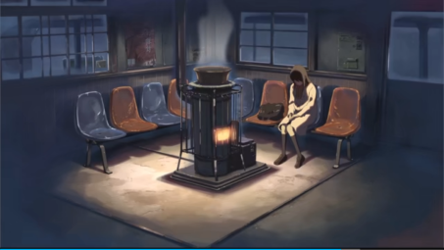
Figure 9. A still frame showing Akari falling asleep while waiting at the station in 5 Centimeters per Second (Shinkai, 2007).

As Barthes observes, the power of the punctum lies in its resistance to complete explanation (Barthes, 1981). These moments do not advance the narrative, establish causality, or point toward the future. Instead, they enter the viewer’s memory through contingency and affect. In 5 Centimeters per Second, time is remembered through such minor and non-functional moments—not as the outcome of narrative development, but as an affective experience that is perceived, triggered, and retained.

3.Suspension and Manifestation: Doane’s Cinematic Time and Deleuze’s Time-Image

At the end of the third episode of 5 Centimeters per Second, the scene in which the two characters pass each other on the railway platform without recognising one another constitutes the most concentrated moment of temporal suspension in the film, as well as a key point at which narrative action completely fails (Figure 10). The anticipated “encounter,” originally organised by narrative expectation, is abruptly interrupted. The characters’ actions remain incomplete, and the causal chain that would normally propel the story forward is effectively broken. Instead of attempting to repair this failed action through subsequent plot developments, Shinkai employs formal delay and suspension, allowing time—once stripped of its narrative function—to manifest itself and emerge as the primary subject of the image.
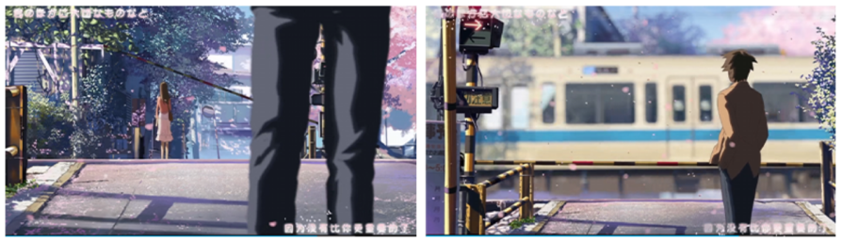
Figure 10. Composite stills showing the two characters passing by each other without recognition at the train platform in 5 Centimeters per Second (Shinkai, 2007).

From the perspective of film form, this sequence significantly weakens the organising power of action over time. The characters’ movements across the platform are deliberately slowed, and after the missed encounter occurs, the film does not immediately shift toward a new narrative event. Instead, it extends the temporal pause that follows the completion of the action. The sequence then transitions into a series of prolonged empty shots (Figure 11): deserted platforms, motionless streets, and skies that change only gradually over time. These images carry little to no narrative information. Human action is entirely removed from the frame, and time no longer points toward a future outcome. Instead, it persists in a sustained yet unanchored state, existing without a clear narrative destination.
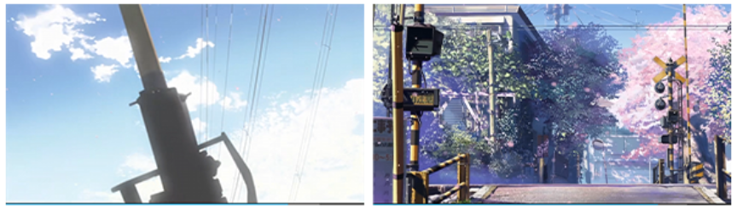
Figure 11. Composite stills showing empty shots: a slowly changing sky and a vacant street in 5 Centimeters per Second(Shinkai, 2007)

As Mary Ann Doane has argued in her discussion of cinematic temporality, when narrative action is delayed, obstructed, or rendered impossible, time ceases to function solely as a mechanism for narrative progression and instead detaches itself from functional structure, becoming perceptible in its own right (Doane, 2002). In the platform-miss sequence, the viewer is compelled to “wait for a time that no longer has a result.” The encounter is no longer possible, action cannot continue, yet time nevertheless continues to unfold. This form of waiting is not designed to generate suspense or anticipation. Rather, by suspending narrative progression, the film foregrounds time itself as the core of the viewing experience.

This approach also resonates strongly with Gilles Deleuze’s concept of the “time-image.” For Deleuze, the time-image does not simply refer to non-linear storytelling, but to moments in which action no longer organises the image and causal relations collapse, allowing time to appear directly (Deleuze, 1989). In the platform sequence, action has already failed, and the narrative logic of cause and effect is interrupted. What the viewer confronts is no longer the question of “what will happen next,” but the presence of time as an object of the image itself. Time is no longer subordinated to action, but is presented directly through stillness, empty space, and duration.

In contrast to this moment of failed action stands the kissing scene beneath the cherry blossom tree on a snowy night at the end of the first episode (Figure 12). On the surface, this scene appears to complete an emotional action: the characters finally meet and share a kiss, and the narrative seems to reach a moment of fulfilment. However, the film’s temporal treatment of this emotional climax similarly refuses to return to linear progression. Instead, time is once again placed into a state of suspension.
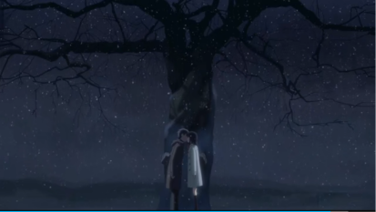
Figure 12. A still frame of the kiss under the cherry tree in the snow at night in 5 Centimeters per Second (Shinkai, 2007).

In this scene, the film adopts a predominantly cool blue colour palette, which, together with the white snow, creates an atmosphere of profound stillness and nocturnal quiet. The characters’ movements are significantly slowed, and even after the kiss occurs, the camera continues to linger on their bodies and the surrounding environment (Figure 13), rather than cutting rapidly to a new narrative segment. The sound design is equally minimal: dialogue nearly disappears, leaving only faint and continuous ambient sounds and the soft noise of falling snow. These formal elements collectively weaken the momentum of narrative advancement, ensuring that this moment of apparent “completion” does not become the starting point for new action, but is instead extended into a perceptible temporal state.
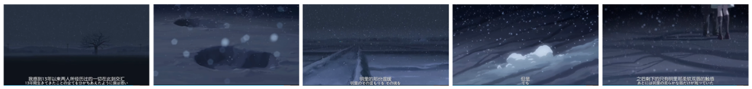
Figure 13. A still frame of the characters and the surrounding snowscape after the kiss in 5 Centimeters per Second (Shinkai, 2007).

In this sense, the scene exemplifies another cinematic temporal structure emphasised by Doane. Although the action has been completed, the shot does not end, and time is not “resolved.” Instead, it is prolonged and held open. At the same time, this moment also accords with Deleuze’s description of the time-image: when action has ceased but the image continues, what the viewer is compelled to watch is not the event itself, but the flow of time (Doane, 2002; Deleuze, 1989). In what appears to be an emotional climax, the film offers no clear orientation toward the future and no renewed causal progression. What remains is a delayed, frozen, and perceptible “present.”

Through the juxtaposition of the missed encounter on the platform and the snow-night kiss, Shinkai repeatedly articulates a consistent temporal aesthetics throughout the film: whether action fails or emotional fulfilment is achieved, time does not automatically return to narrative order, but remains in a suspended state. Waiting, in this context, is not a process that leads toward an outcome, but a mode of temporal existence that is watched, perceived, and experienced.

Conclusion

Through an analysis of key temporal sequences and visual moments in 5 Centimeters per Second, this article has examined how Shinkai Makoto transforms “waiting” from a transitional state within narrative structure into a temporal form that can be perceived and experienced in its own right. In contrast to traditional narrative time, which is primarily organised around the progression of events, the film places greater emphasis on how time is lived through rhythm, perception, and affect. Rather than directing the viewer’s attention toward what happens, 5 Centimeters per Second repeatedly draws attention to the presence of time itself as an experiential condition.

By drawing on Henri Bergson’s concept of durée, this study has shown how the film slows down rhythm, foregrounds embodied perception, and employs repetition in sound and environment to transform waiting from measurable clock time into a “thickened” subjective temporal experience. Through Roland Barthes’s theory of punctum, the analysis has further demonstrated how non-functional moments—such as falling cherry blossoms, lingering light, sustained gazes, and sleep—enter the viewer’s perception in an affective manner, allowing time to be remembered rather than merely narrated. Finally, within the theoretical frameworks provided by Mary Ann Doane and Gilles Deleuze, the film’s scenes of failed action and emotional completion reveal how time emerges directly as the subject of the image when action no longer organises narrative progression, appearing instead in suspended and prolonged forms.

Taken together, the examination of duration, punctum, and suspension suggests that 5 Centimeters per Second is not simply a story about growth, separation, or missed connections. Rather, through animation-specific strategies of rhythmic control, visual stillness, and temporal delay, the film constructs a temporal aesthetic centred on waiting. Within this aesthetic, time no longer serves narrative outcomes or resolutions, but persists as something to be watched, felt, and lived—an experiential presence that remains anchored in the present.

More broadly, Shinkai’s work offers contemporary animation a way to rethink the representation of time, and provides insight into how moving images can articulate the relationship between affect, memory, and temporality. In a cultural context increasingly dominated by acceleration, efficiency, and forward-oriented productivity, 5 Centimeters per Second proposes an alternative mode of spectatorship grounded in slowness, stillness, and suspension. By inviting viewers to dwell with time rather than move through it, the film reconfigures waiting as a state with aesthetic and emotional value. It is precisely this reorientation of temporal experience that allows the film to continue resonating within discussions of contemporary animation and cinematic time.

Bibliography

Filmography
Shinkai, M. (dir.) (2007) 5 Centimeters per Second. Japan: CoMix Wave Films.

Books
Barthes, R. (1981) Camera Lucida: Reflections on Photography. Translated by R. Howard. New York: Hill and Wang.
Bergson, H. (1910) Time and Free Will: An Essay on the Immediate Data of Consciousness. Translated by F.L. Pogson. London: George Allen & Unwin.
Bergson, H. (1991) Matter and Memory. Translated by N.M. Paul and W.S. Palmer. New York: Zone Books.
Deleuze, G. (1989) Cinema 2: The Time-Image. Translated by H. Tomlinson and R. Galeta. London: The Athlone Press.
Denison, R. (2015) Anime: A Critical Introduction. London: Bloomsbury.
Doane, M.A. (2002) The Emergence of Cinematic Time: Modernity, Contingency, the Archive. Cambridge, MA: Harvard University Press.
Lamarre, T. (2009) The Anime Machine: A Media Theory of Animation. Minneapolis: University of Minnesota Press.
Marks, L.U. (2000) The Skin of the Film: Intercultural Cinema, Embodiment, and the Senses. Durham, NC: Duke University Press.
Merleau-Ponty, M. (1964) Eye and Mind. Translated by C. Dallery. Evanston: Northwestern University Press.
Napier, S.J. (2005) Anime from Akira to Howl’s Moving Castle: Experiencing Contemporary Japanese Animation. New York: Palgrave Macmillan.
Sutton, D. (2009) Photography, Cinema, Memory: The Crystal Image of Time. Minneapolis: University of Minnesota Press.

Websites
Carruthers, L. (2003) ‘Antonioni’s L’avventura and Deleuze’s Time-image’, Senses of Cinema, 28. Available at: https://www.sensesofcinema.com/2003/feature-articles/l_avventura_deleuze/ (Accessed: 15 December 2025).
Barotsi, R. (2025) Time and the Everyday in Slow Cinema. Berlin: ICI Berlin Press. Available at: https://press.ici-berlin.org/doi/10.37050/ci-34/Slow-Cinema.pdf (Accessed: 15 December 2025)

