Stephen Hutchings
P148299
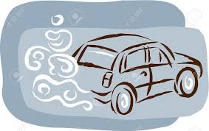
University of Wales Trinity Saint David
School of Engineering
BSC in Automotive Engineering
Research Methods and Project - M6X02206
29th April 2019
From 70mph to 50mph: What effect does lowering the speed limits on motorways have on the reduction of emissions and fuel consumption in diesel passenger cars?

Acknowledgements

Completing my dissertation project has been an academically challenging yet interesting process. It would not have been possible without the support of several individuals.

First, I wish to thank and offer my appreciation to my dissertation supervisor Andrew Gibson. His expertise and guidance have assisted me greatly throughout this module. He had also provided great encouragement during my time at UWTSD and I am truly thankful for this. I would also like to thank Abigail Summerfield who has always been supportive. A massive thank you is also owed to the workshop technicians at UWTSD.

On a personal level I would like to thank my wife Laura Hutchings, who persuaded me to take the leap back into education, she has been extremely understanding and patient whilst I have turned her grey over the past four years! A special thank you goes to my sons Cameron and Thomas Hutchings; they mean the world to me and have inspired me throughout my journey in higher education.

Finally I would like to dedicate this piece of work to my father Philip Hutchings who passed away in 2007. He has always taught me to try my best in every situation and be determined; these qualities have provided me with the emotional strength needed to complete all pieces of academic work.

Abstract
In an attempt to lower NO₂ emission levels and meet limit values of 40µg/$m^{3}$set by the EU Ambient Air Quality Directive, the Welsh Government have lowered the speed limit from 70MPH to 50MPH on several motorways and trunk roads in Wales. The purpose of this report is to analyse the sustainability of this measure and establish the effect that a range of speed limits has on NO₂ and fuel consumption, Research from other countries that have deployed similar measures has shown that traffic congestion, driver behaviour and vehicle maintenance all adversely affect NO₂ levels and fuel consumption. During this study, a live drive cycle and chassis simulation was utilised to determine the impact that lowering speed limits and driver behaviour has on NO₂ and fuel consumption levels. Further technical analysis took place on a Euro 4 and a Euro 5 diesel vehicle before and after a 76 point vehicle service to establish whether regular vehicle maintenance has an effect on fuel consumption and NO₂ levels emitted from exhaust tailpipes. Results analysis revealed that a reduction of speed from 60MPH to 50MPH lowered NO₂ PPM volume by 3-6% for both vehicles. Lowering speeds from 70MPH to 50MPH decreased NO₂ readings for the Euro 5 vehicle by approximately 60% throughout. However, NO₂ levels were increased by 4% during the second part of Euro 4 vehicle testing when speed was reduced from 70MPH to 50MPH. It was also found that late gear changing and acceleration caused increased fluctuations in NO₂ levels. NO₂ levels decreased significantly following the servicing of vehicles; an average reduction of 15% in NO₂ was observed for the Euro 4 vehicle during the live cycle simulation and PPM volume decreased by 115% towards the end of the live cycle simulation test for the Euro 5 vehicle. Vehicle servicing also reduced fluctuations in NO₂ data on all tests. Servicing did not affect fuel consumption and was not significantly influenced by a reduction of speed limit; a decrease of 0.2 – 1% was measured for both vehicles when speed was reduced 70MPH to 50MPH. The report concluded that 50MPH was the most efficient speed for fuel consumption in both vehicles and saw the greatest reduction in NO₂ for the Euro 5 vehicle. However, 70MPH was determined to be the most efficient speed in NO₂ reduction for the Euro 4 vehicle. Also, smooth driving conditions and driving patterns greatly impacted on NO₂ levels. Overall, the study demonstrated that regular vehicle maintenance caused the greatest reduction in NO₂ emissions for both Euro 4 and Euro 5 vehicles.

Contents pages

- Introduction……………………………………………………………………………….Page 1
1.1Aims………………………………………………………………………………...……….Page 2
1.2 Case Study…………………………………………………………………………....……Page 3

- Literature Review…………………………………………………………………...…...Page 4
2.1 Analysis of government documentation, legislation and policy that links to the reduction of speed limits on Motorways in Wales……………………………………………………….Page 4
2.1.1 Implementation and government analysis of the reduction of speed limits .....…Page 6
2.2 Review of similar measures in different countries……………………………………Page 6
2.3 The effects that driver behaviour has on NO₂ and fuel consumption…………....…Page 8
2.4 The influence vehicle maintenance has on emissions and fuel consumption…….Page 9

3.0 Methodology…………………………………………………………………………….Page 10
3.1 Research Design……………………………………………………………………...…Page 10
3.2 Research Strategy……………………………………………………………………….Page 11
3.3 Work Programme………………………………………………………………………..Page 13
3.3.1 Questionnaires…………………………………………………………………….…..Page 13
3.3.2 Test preparation.………………………………………………………………………Page 13
3.3.3 Servicing before second set of testing………………………………………………Page 15
3.4 Experimental Work.……………………………………………………………………...Page 15

4.0 Results and Analysis………………………………………………………………….Page 18
4.1 NO₂ levels and fuel consumption during live drive cycle simulation………………..Page 18
4.2 NO₂ levels and fuel consumption at 50MPH………………………………………….Page 26
4.3 NO₂ levels and fuel consumption at 60MPH……………….…………………………Page 31
4.4 NO₂ levels and fuel consumption at 70MPH.…………………………………………Page 36

5.0 Conclusion and recommendations……………………………………………….Page 41
5.1 Further work and recommendations……………………….………………………....Page 42

6.0 Reference List…………………………..………………………………………………Page 44

7.0 Appendices……………………………………...………………………………………Page 49
7.1 Project Plan……………...………………………………………………….…………..Page 49
7.2 Gantt Chart…………………………………………………………………………..…..Page 50
7.3 Sample of questionnaire………………………………………………………………..Page 51
7.4 Service checklist…………………………………………………………………………Page 55
7.5 Vehicle Specifications…………………………………………….……………………..Page 58
7.6 Experimental work test plan…………………………………………….………………Page 60

List of Figures

Figure 1: Location of M4 junction 41-42 (Welsh Government, 2018)…..........…………Page 3
Figure 2: Site locations of the five affected roads (Welsh Government, 2018)….……..Page 4
Figure 3: NO₂ levels between J41-42 (Welsh Government, 2018)……………………..Page 5
Figure 4: NO₂ levels in areas surrounding J41 -42 (WSP, 2018)……………………….Page 5
Figure 5: NO_{x} produced from cold starts (Emissions Analytics, 2018)…………………Page 9
Figure 6: Triangulation of research methods (Carugi, 2013)……....……………..……Page 12
Figure 7: Side of carriageway used by participants……………………………………..Page 14
Figure 8: Graph illustrating time participants were most likely to travel……….………Page 15
Figure 9 : Graph illustrating type of vehicle driven by participants…………………….Page 16
Figure 10: Graph illustrating engine size of participants vehicles…….………………..Page 17
Figure 11: Time taken for each experimental test………………………………………Page 17
Figure 12: Participants who stick to speed limit on stretch of road…….…………..….Page 19
Figure 13: Graph illustrating speed travelled by road users……….…………………..Page 19
Figure 14: Speed travelled by road users at 7:30am-9:30am………….………………Page 20
Figure 15: NO₂ and fuel consumption levels for AUDI (Euro 4) live drive cycle simulation (before service)……………………………………………………………………………….Page 21
Figure 16: NO₂ and fuel consumption levels for BMW (Euro 5) live drive cycle simulation (before service)………………………………………………………….……………………Page 22
Figure 17: NO₂ and fuel consumption levels for Audi (Euro 4) live drive cycle simulation (after service)………………………………………………...……………………………..Page 24
Figure 18: NO₂ and fuel consumption levels for BMW (Euro 5) live drive cycle simulation (after service)………………………………………………………………...……………….Page 24
Figure 19: Graph illustrating number of times participants experienced traffic congestion…………………………………...………………………………………………..Page 25
Figure 20: Graph illustrating whether using an alternative route would affect the journey of participants……………………….……………………...……………………………………Page 26
Figure 21: Participant’s main concern with using alternative route……………..……..Page 26
Figure 22: NO₂ and fuel consumption levels for Audi (Euro 4) at 50 MPH (before service)………………………………………………………………………………………..Page 27
Figure 23: NO₂ and fuel consumption levels for Audi (Euro 4) at 50 MPH (after service)………………………………………………………………………………………..Page 27
Figure 24: Graph illustrating number of times participants service their vehicle……..Page 29
Figure 25: NO₂ and fuel consumption levels for BMW (Euro 5) at 50 MPH (before service)………………………………………………………………………….…………….Page 30
Figure 26: NO₂ and fuel consumption levels for BMW (Euro 5) at 50 MPH (after service)……………………………………………………………………………..…………Page 31
Figure 27: Graph illustrating number of times participants (who drove at 60 MPH) travelled between J41-42…………………………………………………………………………..…..Page 32
Figure 28: NO₂ and fuel consumption levels for Audi (Euro 4) at 60 MPH (before service)……………………………………………………………….……………………….Page 33
Figure 29: NO₂ and fuel consumption levels for Audi (Euro 4) at 60 MPH (after service)………………………………………………………………………………….…….Page 33
Figure 30: NO₂ and fuel consumption levels for BMW (Euro 5) at 60 MPH (before service)…………………………………………………………………….………………….Page 34
Figure 31: NO₂ and fuel consumption levels for BMW (Euro 5) at 60 MPH (before service)…………………………..………………………….………………………………...Page 35
Figure 32: Graph illustrating number of times participants check oil levels…,,,,,,,,,,…Page 35
Figure 33: Graph illustrating number of times participants (who drove at 60 MPH) travelled between J41-42 per week………………………………………………..……………...….Page 36
Figure 34: NO₂ and fuel consumption levels for Audi (Euro 4) at 70 MPH (before service)………………………………………………………………………….…………….Page 37
Figure 35: NO₂ and fuel consumption levels for Audi (Euro 4) at 70 MPH (after service)…………………………………………………………………………….………….Page 38
Figure 36: NO₂ and fuel consumption levels for BMW (Euro 5) at 70 MPH (before service)……………………………………………………………….……………………….Page 39
Figure 37: Graph illustrating how often participants check tyre pressure……………..Page 39
Figure 38: NO₂ and fuel consumption levels for BMW (Euro 5) at 70 MPH (after service)………………………………………………………………………………….......Page 40

List of Abbreviations

ANPR = Automatic Number Plate Recognition
CO₂ = Carbon Dioxide
DEFRA = Department for Environment, Food and Rural Affairs
EEA = European Environmental Agency
EURO 4 = European emissions standard 4
EURO 5 = European emissions standard 5
HEX = Hexadecimal
KM = Kilometre
MPH = Miles per Hour
NO₂ = Nitrous Dioxide
NPTCBC = Neath Port Talbot County Borough Council
OBD = On-board Diagnostics
PEMS = Portable Emissions Measurement System
PPB = Parts per billion by volume
PPM= Parts per million by volume
PM₁₀ = Particulate Matter
SWWITCH = South West Wales Integrated Transport Consortium
VCDS= VAG-COM Diagnostic System
VISSIM 9 = Microscopic multi-modal traffic flow simulation software
WELTAG = Welsh Transport Appraisal Guidance
WSP = William Sales Partnership Group
4WD = Four- wheel drive
µg/$m^{3}$ = One millionth of a gram per cubic metres of air

1.0 Introduction

Legally binding limits for pollutants in the air such as NO₂ (Nitrous Dioxide) and PM (Particulate Matter) are set by the European Union Ambient Air Quality Directive, these are known as limit values and are part of European Legislation (European Commission, 2018). This means that all European countries must report their limit values annually. Concentration limits are set in an attempt to improve public health and the environment. NO₂ exposure decreases life expectancy and has been connected with respiratory illness, cancer and mortality (Committee on the Medical Effects of Air Pollutants, 2015). In Wales alone, 1108 mortalities annually are a result of exposure to NO₂ and 1604 deaths are associated with PM exposure (Public Health Wales, 2018). In addition, it is estimated that air pollution costs Wales approximately £1 billion per year in health costs and days taken off work by individuals with ill health (Welsh Government, 2017). Therefore, this indicates that measures that reduce NO₂ levels in the ambient air need to be introduced to ensure that limit values are adhered to.
At present, the only limit value that the UK is failing to meet is NO₂ (DEFRA, 2017). Furthermore, it has been established that approximately 49% of NO₂ emissions in the UK is produced by road transport (Air Quality Expert Group, 2014). Thus, suggesting that Government focus needs to be on reducing the amount of NO₂ emissions in the environment whilst paying particular attention to roadside emissions. In an attempt to improve air quality in the UK, the Air Quality Plan (2017) was published (DEFRA, 2017). The aim of the policy was to reduce statutory limits in the quickest time possible in order achieve a cleaner environment. This also relates to the Wellbeing of Future Generation Act (Wales) 2015, goals include promoting a healthier Wales and promoting globally responsible citizenship (Future Generations Commissioner for Wales, 2015). Correspondingly, the Welsh Government who implements the Air Quality Standard Regulations (2010) has attempted to reduce emissions in Wales by generating their own framework and policies on emission reduction as 28.5% of NO² emissions in Wales come from road transport (Welsh Government, 2018).
In an effort to reduce NO₂ emissions and meet EU limit values, speed limits were reduced from 70mph to 50mph on two sections of the M4 motorway in Wales and three trunk roads (WSP, 2018). This was suggested to be the most effective measure to use where the air quality was poor (DEFRA, 2017). However, to date empirical evidence has not been gathered to quantify the effectiveness of these measures. Therefore, the sustainability of reducing road speeds remains unclear. Moreover, research from countries that have previously implemented similar measures has found that reducing speed limits on motorways does not significantly decrease NO₂ emissions levels (Keuken et al, 2010; Panis et al, 2010). Furthermore, patterns in driving, speeding frequency, smooth driving conditions and the European emissions standard of vehicles have all been found to influence NO₂ emissions levels and fuel consumption on motorways (Environmental agency, 2011). Thus, signifying that measured levels of NO₂ are shaped by many factors. Additionally, several studies have shown that overall vehicle maintenance can affect fuel consumption and NO₂ emissions (Nasir et al 2014; Fontaras et al 2017). In these reports, it was established that the avoidance of regular vehicle servicing and checking of tyre pressure and oil levels could increase NO₂ produced by a vehicle and reduce fuel consumption efficiency. Also, it has been determined that traffic congestion caused by the reduction of speed limits can have an adverse effect on fuel consumption (Treiber et al, 2012). Therefore, reducing speed limits may be uneconomical for road users.

  - Aims
The aims of this project are to:

- To analyse the sustainability of reducing motorway speeds through an actual live drive cycle and chassis dynamometer simulation to replicate the effects of driver behaviour and how lowering speed limits has on NO_{²} emissions and fuel consumption.

- To compare the emissions and fuel consumption levels of the test vehicles through analytical techniques before and after a full vehicle service to establish whether regular maintenance has an effect on emitted NO₂ levels and fuel consumption.

The two aims will be achieved through a drive cycle replication of an affected stretch of road (M4 junction 41-42) and the comparison of fuel consumption and NO₂ levels emitted by two diesel vehicles (one Euro standards 4 and the other Euro standards 5) at 50mph, 60mph and 70mph during laboratory testing. The NO₂ emissions produced and fuel consumption of these vehicles will also be analysed before and after a full vehicle service in order establish whether regular maintenance had an effect on emitted NO₂ levels. Data will be gathered to evaluate the driving behaviours of road users who regularly use a speed limited stretch of motorway to evaluate the effect that lowering motorway speed limits has on driver journeys. All data will be analysed using Microsoft Excel and results will be displayed in graphical format.

  - Case study
For the purpose of this project, it was decided that Junction 41-42 of the M4 motorway would be used to obtain a live drive cycle from (see figure 1 for location of road). It was considered that it would be too ambitious to analyse all five roads affected. The researcher is familiar with this stretch of road so this improved safety and reliability during the live drive cycle. Also, it was the only stretch of road that had one site location (Welsh Government, 2018) and would therefore be less complicated to carry out testing on (see figure 2 for site locations).
The affected corridor of the M4 consists of two lanes which are subject to the national speed limit. An average speed check measure is already in place on both sides of the carriageway at J41 which reduces the speed on this part of the motorway to 50mph. The stretch of road is located in a reasonably built up residential area of an industrial town. It is also the main stretch of road used by commuters to both Swansea and Cardiff (Welsh Government, 2017).
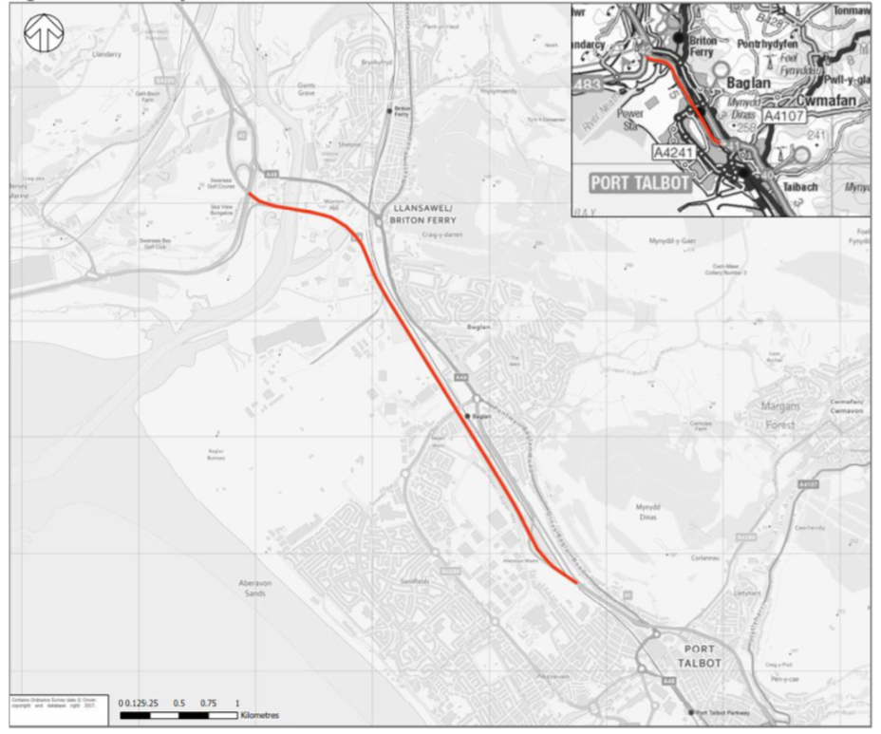Figure 1: Location of M4 junction 41-42 (Welsh Government, 2018)
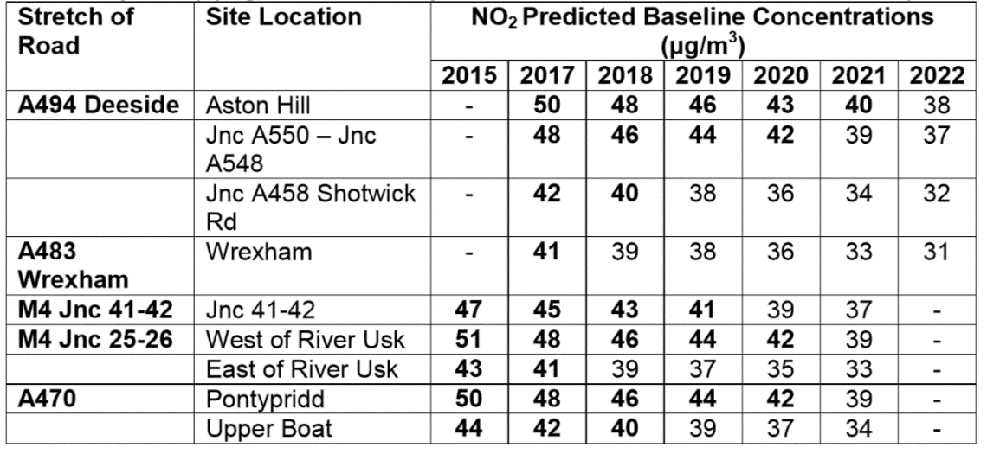
Figure 2: Site locations of the five affected roads (Welsh Government, 2018)

2.0 Literature Review

2.1 Analysis of government documentation, legislation and policy that links to the reduction of speed limits on Motorways in Wales
To critically analyse the environmental impact of reducing the speed limit between J41-42, government documentation, policy and legislation that relates to the derivation of measures must be reviewed in order to fully understand the rationale behind the reduction on motorway speed limits. According to the WSP (2018, pg12) the main objective of the implementation of the measure is to “identify potential network management measures which will assist in bringing forward reductions in NO₂ in the shortest possible time”. This suggests that the reduction of speed limits will focus specifically on reducing NO₂ levels at five road locations in Wales. In an attempt to meet the NO₂ limits of 40µg/$m^{3}$ set by the EU Ambient Air Quality Directive, the Air Quality Standards Regulations was introduced in Wales in 2010. According to the legislation, if the level of NO₂ in an area is greater than the limit values then an air quality plan must be create and implemented so that limit values can be achieved (Welsh Government, 2010). Other pieces of legislation that relate to the reduction of air pollution in Wales include the Environment Act 1995, which enforces that local authorities review and access their ambient air quality, and the Wellbeing of Future Generations Act (2015). As the levels of NO₂ between J41-42 exceed limit values (see figure 3), this implies that the reduction of NO₂ levels between J41 and J42 is a statutory requirement.
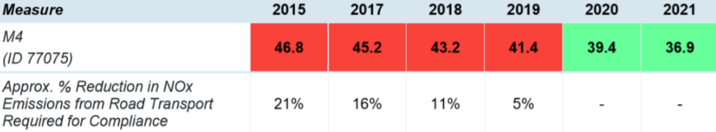
Figure 3: NO₂ levels between J41-42 on the M4 motorway (Welsh Government, 2018)

It is important to note that the areas surrounding the motorway corridor do not exceed the limit values (see figure 4). Therefore suggesting that high NO₂ levels are caused by road transportation on the M4 corridor. However, from the figure it can be seen that NO₂ levels in the locality increase as the distances away from the M4 increases. A possible explanation for this could include traffic congestion in the town or a rise in emissions from industrial plants in the town (DEFRA, 2018). Also, NO₂ levels are measured using diffusion tubes for less than two weeks at a time every six months. Therefore, these results could be affected by busy/quiet periods throughout the year.
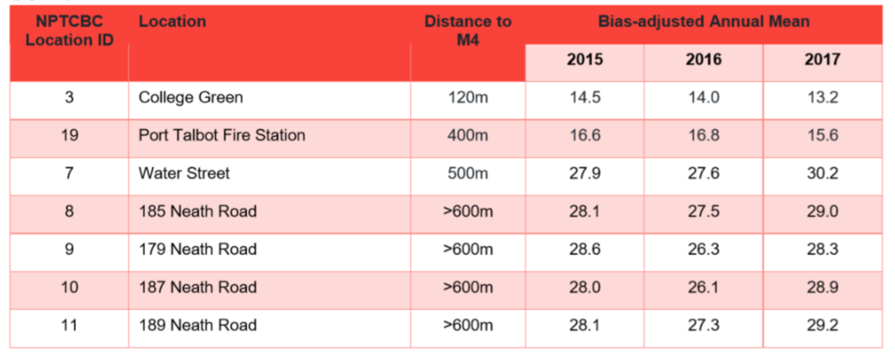
Figure 4: NO₂ levels in areas surrounding J41 -42 (WSP, 2018)

At a local policy level, the Local Regional Transport Plan implemented by Neath Port Talbot Council is associated with the reduction of speed limits between J41-42. This plan links to the improvement of individual health in the local authority and the reduction of NO₂ emissions for road vehicles (SWWITCH, 2010). Thus, suggesting that the local authority is committed to reducing NO₂ levels in the area. Furthermore, an Air Quality Action Plan was produced to review the quality of air in Neath Port Talbot (NPTCBC, 2012). However, this plan linked with emissions from the Steelworks in the area rather than solely focusing on road transport. It was also concluded in the Air Quality Progress Report that PM levels exceeded levels in Neath Port Talbot but NO₂ levels did not (NPTCBC, 2017). This indicates that NO₂ emitted from road transport is not having an adverse effect on NO₂ levels in residential areas of Port Talbot. Therefore, it remains unclear as to why the government focus is on this particular stretch of road on the M4 motorway.

2.1.1 Implementation and government analysis of the reduction of speed limits
During implementation and governmental review of the sustainability of the measure, five WELTAG reports will be produced; the next report (stage 4) is due to be published at the end of 2019. In preparation for the implementation, simulation software was used to determine the effects that reducing speed limits had on NO₂ levels. Trafficmaster data was analysed to determine average weekday vehicle speeds and annual average daily flows. It was found approximately 77,000 vehicles use the road annually. During off peak times the average speed travelled was at 92kpm/57.1mph and at peak times 67kph/41.6 mph (WSP, 2018). Thus, suggesting that on average the majority of vehicles travelling on this stretch of road did not exceed national average speed limit. Therefore, enforcing a speed limit reduction may not have a positive effect on NO₂ limits if the road users are not travelling at 70mph.
Quantification of the data occurred through VISSIM 9 traffic simulation software. This is said to realistically simulate road traffic patterns (Barcelo, 2011). However, simulation software does not accurately measure driver behaviour (Joloviec et al, 2016). Therefore, this could mean that the data gathered on the measure is not truly accurate. Furthermore, it has been highlighted in the WELTAG stage 3 report that further analysis of traffic monitoring is needed. Further recommendations of traffic monitoring provided by WSP include live data monitoring of speeds and ANPR count data to establish vehicle classification and emissions standards (Welsh Government, 2018). Thus, this suggests that NO₂ levels on this road could be affected by the age of a vehicle, it’s engine size and fuel type.

2.2 Review of similar measures in different countries
As the Welsh Government has not yet completed a full analysis of the implemented measure, literature from other countries who have put in place similar measures needs to be reviewed in order to establish the effectiveness and environmental impact of the reduction of speed limits on motorways. Research demonstrates that countries such as Switzerland, Spain and the Netherlands have also reduced speed limits on the roads in an attempt to reduce NO₂ levels (Janssen et al, 2001; Andre et al, 2005; Keller et al, 2008;Keuken et al, 2010). From these studies it was recognised that the European emissions standards of vehicles have a significant effect on NO₂ levels in the ambient air; vehicles with older EU standards tend to emit more NO₂ than vehicles with newer standards. However, a report conducted by Degraeuwe et al (2017) found that vehicles of all emissions standards, including euro 5 and euro 6a/b diesels emit more NO₂ levels than permitted. Testing for this study was conducted using PEMS so possibly provided more accurate results than laboratory testing. Though, it was concluded that high NO₂ levels were exhibited in build-up city areas and were most likely to be caused by traffic congestion.
Another study which links NO₂ levels with traffic congestion is that of Keuken et al (2010). In this research it was found that the reduction of speed limits on motorways to 50mph decreased NO₂ by 5-30% and PM₁₀ by 5-25%. However, it was established that the reduction of speed limits in areas caused an increase in traffic congestion and this had a negative impact on emission reductions. Moreover, this research provided a true representation of car sales in Europe and used two diesel and one petrol vehicle. It was found that much lower levels of NO₂ and PM₁₀ were emitted from petrol levels. This indicates that petrol vehicles do not contribute as much to the exceed levels of NO₂ in the UK. In the study it was also mentioned that the impact on air quality was larger on motorways which was used greatly by heavy duty vehicles. Thus, suggesting that reducing the motorway speeds for heavy duty vehicles may be more effective than reducing the speeds for cars. However, as only 6% of road users drive heavy-duty vehicles between J41-42 (Welsh Government, 2018), this may not have a significant effect on the implemented measure.
It is apparent that the reduction of speed limits can also have an effect on fuel consumption. Panis, et al (2010) established that lower speed limits at smooth driving conditions can improve fuel consumption. However, they unearthed that the reduction of speed limits on motorways did not dramatically decrease NO₂ emissions. Nevertheless, they did confirm that CO₂ levels decreased significantly when speed limits were reduced, suggesting that limiting the speed to 50mph could have a positive effect on both fuel consumption and CO₂ emissions. Another study that relates to reducing speed limits on motorways as a measure to decrease NO₂ emissions and fuel consumption is that of the European Environment Agency (2011). In their research they established through simulation testing that reducing speed limits from 120 KMH/75 MPH to 110 KMH/68MPH could increase fuel efficiency by approximately 12-18%. However, it is noticeable here that the original figure of 75MPH is higher than the UK national speed limit of 70MPH. Nevertheless, this still indicates that a reduction of speed limit has a positive effect on fuel consumption. On the other hand, the study concluded that the saving in fuel was based on smooth driving condition and speed limit compliance. Therefore, realistically a saving of 2-3% was assumed for real road driving conditions. Again, this suggests that factors such as driver behaviour and traffic congestion can have an adverse effect on the measure. The study did not mention the percentage drop in NO₂ levels as a result of reducing speed but did determine that lowering speed limits decreases PM_{10,} CO₂ and NO₂ in petrol and diesel vehicles. Also, the study used vehicles with Euro 4 emissions standards, therefore, the data may be a little outdated.

2.3 The effects that driver behaviour has on NO₂ and fuel consumption
From the studies previously discussed, it is apparent that driver behaviour affects effective implementation of the reduction of speed limits on motorways and fuel consumption. Heijne et al (2017) suggests that personal driving styles has a great impact on the amount of fuel consumed by a vehicle. They concluded that aspects such as appropriate breaking, maintaining a steady speed, car distance and appropriate gear shifting all had an effect on fuel consumption. When looking further into the influences of personal driving styles they found that road speed, infrastructure, traffic congestion and journey purposes all affected individual driving characteristics. Therefore, suggesting that the road layout, speed enforcements and whether the driver is using the road for social or commuting purposes could all influence fuel consumption.
Zheng et al (2017) also relates driver behaviour to traffic congestion and traffic control. They discovered that both these factors caused driver behaviour to change during a journey which subsequently had an adverse effect on both fuel consumption and NO₂ emissions. From observing acceleration/deceleration behaviour through GPS devices and comparing it against driving behaviour questionnaires, they proved that novice drivers who were cautious of speeds produce relatively lower fuel consumption and emissions, as do experienced drivers who prefer to travel at faster speeds. They concluded that aggressive and unsteady drivers were most likely to generate more emissions and poor fuel consumption. Similar research from Huang et al (2018) discovered that exceeding speed limits caused a rise in NO₂ levels and adversely affected fuel efficiency. Their research showed that on-board safety devices that warned drivers of excessive speed limits, hard acceleration and braking and frequency and intensity of acceleration reduced the amount of NO₂ emissions by 9% and increased fuel efficiency by 25%. Therefore, suggesting that many drivers on the road may not initially be aware that they are travelling faster than the set speed limit.
A study conducted by Muslim et al (2018) revealed that driver knowledge of vehicle operational characteristics was a variable that influenced fuel consumption and emissions. They found that drivers who were aware and monitored aspects such as vehicle transmission, capacity of engine, horsepower and rolling resistance were less at risk of producing high levels of emissions. However, it was acknowledged that only a small percent of drivers would be mindful of these factors, therefore, this might not have a significant effect on decrease of NO₂ emissions on motorways. Nonetheless, the research did demonstrate that awareness of the importance of regularly maintaining a vehicle was an aspect that could reduce both emissions and fuel consumption. Thus, suggesting that regular vehicle maintenance could influence the effectiveness of decreasing NO₂ emissions through the reduction of speed limits on motorways. Linking to the knowledge of vehicle operational characteristics, several studies have suggested that the amount of time allowed for engine warm up can affect emissions emitted by the vehicle (Weilenman et al 2009; Volkov and Chainikov 2018). In these studies, it was found that ambient air temperature had an effect on the amount of emissions produced during a cold start. Furthermore, EQUA index data demonstrates that a vehicle’s pollution control system will not become operational until the vehicle has had a chance to warm up (Emissions Analytics, 2018). From figure 5, it can be seen that the vehicle is not fully warm until after five minutes, in addition more emissions are emitted from the vehicle whilst it is not in optimal operating condition (DEFRA, 2016). Therefore, more emissions may be caused between J41-42 if local residents are using the road from cold start, as their vehicles may not have reached optimal operating conditions.

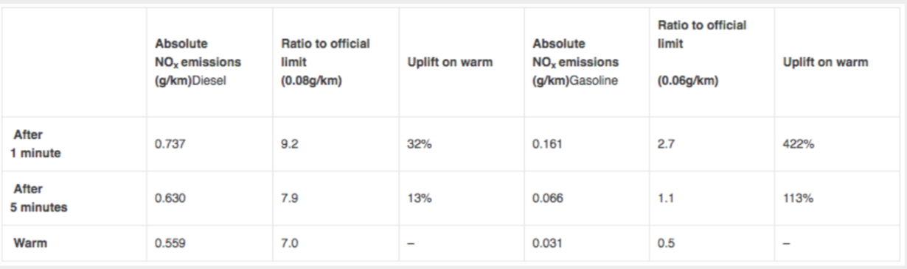
Figure 5: NO_{x} produced from cold starts (Emissions Analytics, 2018)

2.4 The influence vehicle maintenance has on emissions and fuel consumption
Research demonstrates that factors such as incorrect tyre pressure, period between oil changes and using the appropriate type of oil are all factors that affect emissions emitted from vehicles (Gao, 2007; Wu et al, 2012; Fontaras et al 2016). Thus, indicating that poorly maintained vehicles are likely to produce more emissions in comparison to vehicles that are maintained regularly. In conjunction with this, research by Nasir et al (2014) discovered that regular vehicle servicing produced a reduction in emitted NO₂ levels and increased fuel efficiency. The suggested time between services for passenger cars is once every 12 months or every 12,000 miles. As well as visual checks to engine, tyres, exhaust system, steering electrical and drive system it is recommended that the oil, oil filter, air filter and fuel filter is replaced (Hillier and Coombes, 2004). Thus, indicating that the effective operation of many vehicle components could have an effect on emissions and fuel consumption.
In addition, Fontaras et al 2016 suggests that a clogged air filter can increase fuel consumption by approximately 5%. However, a confounding experiment conducted by Thomas et al (2013) established that air filter condition did not affect the fuel economy or emissions of vehicles. In their study they compared clogged up air filters against new air filters on several diesel vehicles and concluded that there was not a significant decrease in emissions or fuel reduction when the air filter was changed. Thus, possibly implying that not all aspects of a vehicle service contribute to the lowering of emissions.
Conversely, Jang et al (2014) state that “engine oil can affect exhaust emissions because engine oil consumption in the cylinders amounts to about 0.2% of fuel consumption”. In their study, they determined that engine oil and change of oil filter does contribute towards emissions and fuel economy in both petrol and diesel engines. However, it was noticed that the type of oil used had more of an impact on emissions rather than the amount of times the oil and oil filter was changed. The fuel filter has also been a component that affects fuel efficiency, according to Mollenhauer and Tschoke (2008) a newer fuel filter provides clean fuel to the engine and improves fuel efficiency. Although the above studies link poor vehicle maintenance to emissions and fuel consumption, it is important to note that most of these studies were performed in a laboratory using low engine speeds. As the full functionality of some of these components such as the fuel filter will only be apparent in high fuel demand circumstances (Denton, 2016), it is possible that the true effects that servicing has on emission reduction has not been replicated in these studies.

3.0 Methodology

3.1 Research Design
To successfully achieve the aims of the project, appropriate methodologies must be applied; the suitability of research design and strategy used to implement the design is of great importance (Monsen and Horn, 2007). For the purpose of this project, a quantitative research design was utilised. Benthar and Cameron (2015) define quantitative research design as a method used to measure and quantify data. Furthermore, quantitative research design can improve the reliability and validity of data and takes less time to complete in comparison to qualitative research design (Deb et al, 2018). Thus, using this type of research design will improve the study’s overall efficiency. However, it appears that a large sample size is needed to obtain reliable data; therefore, this was kept in mind during the data collection process. The type of quantitative research design used in this project was an experimental design (Cash et al, 2016); this was used to determine a cause-and effect relationship between vehicle speed against fuel consumption and NO₂ levels emitted from the vehicle. During the experimental design process, several variables were quantified. Variables in research are defined as a characteristic that are measurable, these are separated into two categories; independent and dependant (Theil, 2014). Independent variables are defined by McBurney and White (2009) as a set of conditions which are manipulated by the researcher. The independent variables measured in this project were vehicle speed and vehicle maintenance (serviced and non-serviced). Dependent variables relate to characteristics that are potentially influenced by independent variables and changes caused to these are measured throughout experiments (Creswell, 2014). The dependent variables in this project were NO₂ levels and fuel consumption. In addition, it is essential that confounding variables are also taken into consideration as these potentially affect the reliability of research (Deb et al, 2018). Confounding variables are defined by Trochim et al (2015) as condition that influences the effect that independent variables have on dependent variables, this could include aspect such as the weather. However, as the experiment took place in a laboratory setting this should have allowed for the reduction of confounding variables; weather or road condition will not influence NO₂ levels or fuel consumption. Also, the same driver conducted all drive cycles. Therefore, this should ensure that data is reliable. However, as the experiment took place in a laboratory setting this may have affected the validity of the data (Theil, 2014), simulation drive cycles may not truly replicate real-road driving conditions (Keuken et al, 2010) and therefore this could be a limitation of the study.

3.2 Research Strategy
To gather data a triangulation of methods was applied. According to Carugi (2014, pg 69) “A triangulation of research methods can strengthen the quality and credibility of the evidentiary support for findings”. Therefore, a triangulation of methods is a reliable way of achieving research objectives (see figure 6 for triangulation process). The diagram illustrates that a mixture of documentation, perceptions and validation is needed in order to produce reliable findings. Documentation has been reviewed from secondary sources; these include Welsh Government documentation surrounding the reduced speed limit, research journals which relate to similar measures in other countries and the effects of vehicle maintenance on NO₂ levels and fuel consumptions. This documentation assisted in the formulation of questionnaire questions and appropriate experimental design. Questionnaires, which included a mixture of open and closed questions (McBurney and White, 2009), were issued to passenger car drivers who use the stretch of road between J41-42 in order to gather individual perceptions of the reduction of speed limit, these were also used to collect information about driving styles and vehicle. Further information regarding the distribution and analysis of questionnaires can be found in sub-chapter 3.2. Validation was conducted through experimental work that involved performing a live drive cycle and chassis dynamometer simulation. This was carried out on two diesel vehicles (Euro 4 and Euro 5) at speeds of 50mph, 60mph and 70mph before and after servicing, the same tests were also completed on the simulation of the live drive cycle. The purpose of the live drive cycle was so that real-road driving conditions could be replicated. A detailed description of experimental work carried out provided in subchapter 3.3.

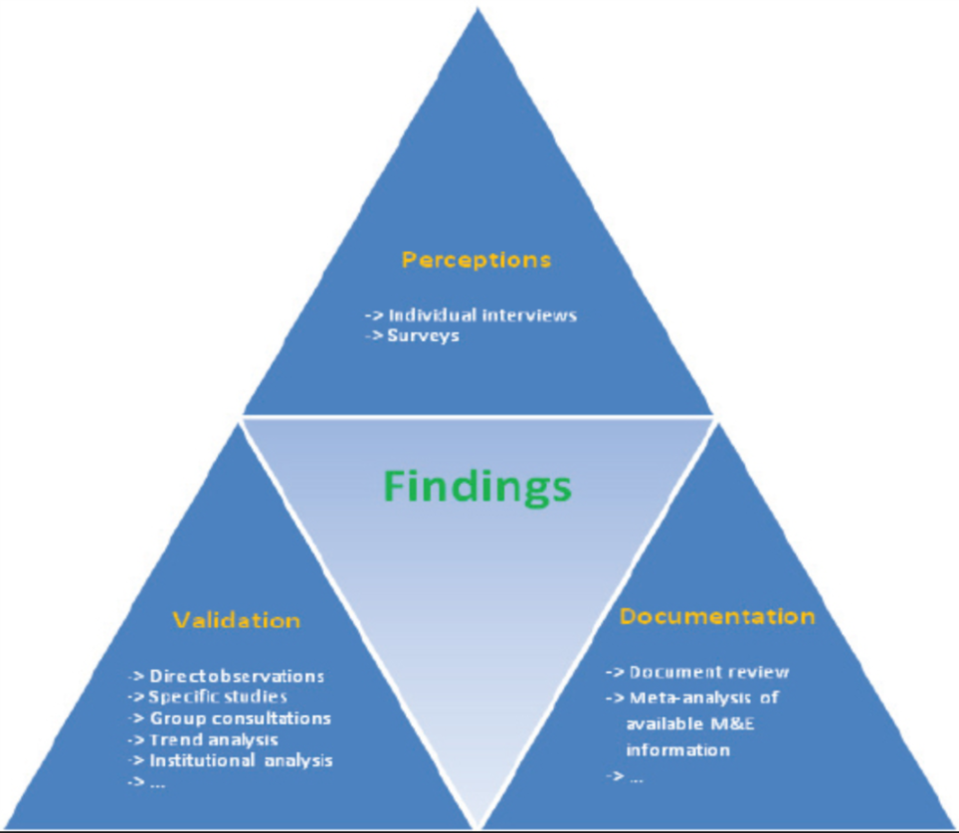
Figure 6: Triangulation of research methods (Carugi, 2013)

3.3 Work Programme
After the main aims of the project and project proposal had been formulated and approved by the project supervisor, a work programme plan was established in order to achieve the overall project objectives (See appendix A for full project plan and appendix B for Gantt chart).

3.3.1 Questionnaires
As mentioned in the previous sub-chapter, documentation and literature relating to the reduction of speed limits as a measure to reduce NO₂ and fuel consumption was reviewed to devise suitable research questions. Following this, questionnaires were designed to gather quantitative data on the perceptions of the reduction of speed limit between J41-42 from road users (see appendix C for a sample of the questionnaire). Questionnaires were distributed to road users using Survey Monkey; an online survey development software which permits the distribution of questionnaires to a large number of participants (Ruell et al, 2016). As the project specifically focused on a stretch of road a particular area, the questionnaires were distributed on social media pages whose target audience were located within distance of J41-42. Furthermore, the first question asked “are you familiar with this stretch of road”, any participant who answered no was discounted from the study. To ensure a reliable sample was obtained, paper questionnaires were also distributed within the locality and these were then uploaded to Survey Monkey for purpose of analysis. It was decided that a reliable sample would include 50 participants; however, a 5% margin of error was given to allow for any errors in the data collection method i.e. incomplete questionnaires (SurveyMonkey, No Date). Therefore, 55 responses were received; of these four questionnaires were viewed an inappropriate to use because the participants were not familiar with the measure. Ethics were considered as participants were made aware of the purpose of the questionnaire, participants were also told that they could withdraw from the study at any time (Ruell et al, 2016). Data was stored securely on SurveyMonkey and GDPR regulations were adhered to (EU General Data Protection Regulation, No Date), all responses given were anonymous.

3.3.2 Test preparation
Before laboratory testing was carried out, a live drive cycle between J41-42 was conducted. This was conducted on the westbound carriageway; as the majority of participants in the questionnaire used both west and eastbound carriageways (see figure 7), it was considered that this was a factor that would not have an adverse effect on data. The primary purpose of the live drive cycle was to gather data on the average time taken and obtainable speed travelled on the stretch of road. It also provided a further insight into the geometric layout of the road and was considered more reliable than estimating the road design from GPS mapping services (Ortiz-Soto et al, 2012).
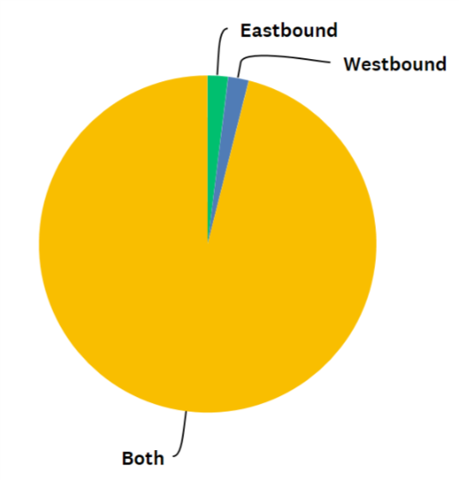
Figure 7: Side of carriageway used by participants
The live drive cycle was performed 3 times over the duration of a week to assess whether driving patterns changed on different days. These were all conducted during the peak times. This information was gathered from WELTAG stage 3 report and it was suggested that peak times were between the hours of 6:00am – 10:00am, it was also implied that the busiest time on the road was at approximately 7:45am (WSP, 2018). Questionnaire data was also used to assess when the majority of drivers used the road and it was found that 28% of participants travelled between J41-42 between the hours of 7:30am-9:30am; this was the largest percentage for this particular question (see figure 8 for travel time graph). Live cycle testing was carried out on a Monday morning, Wednesday morning and Saturday morning at approximately 7:45am on all days. It was decided that the test completed on Monday morning would be used to create a simulated drive cycle as this was viewed to be the busiest day on the road. The time taken for this test run was 3 minutes, 40 seconds and the average speed travelled was 39.4MPH. However, on reflection, testing was carried out during the half term holidays and therefore may not have provided completely accurate information about normal driving patterns as school traffic would not have been included in the study. VCDS software was utilised to collect data for speed, time taken and fuel consumed, this was connected to the OBD through HEX-V2. This data was then used to create a simulated drive cycle of the live drive cycle on a MAHA 4WD dynamometer so that the NO₂ levels of both test vehicles could be obtained. 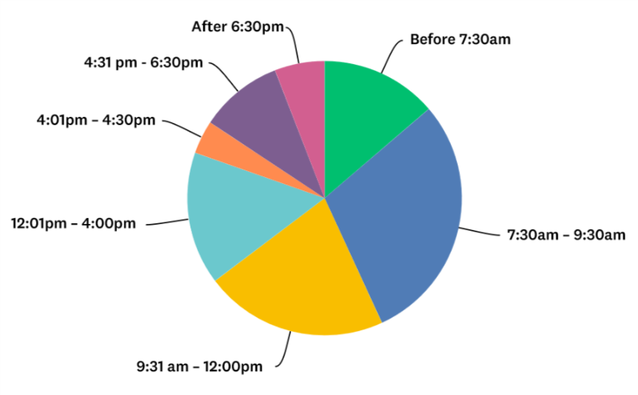
Figure 8: Graph illustrating time participants were most likely to travel

3.3.3 Servicing before second set of testing
After the first set of experimental work had been carried out, a full service was conducted on both vehicles. According to Giles (2004) a full service should be performed every 12,000 miles and consists of a 76-point check (See appendix D for service checklist). From the service checklist it can be seen that the service mainly consists of checks and visual inspections of parts, this ensured that both vehicles were running efficiently (Hillier and Coombes, 2004). Thus, this further improved the reliability of testing methods. During the service the oil, oil filter, air filter and fuel filter was replaced to determine whether regular maintenance had an effect on NO₂ levels and fuel efficiency. These parts were changed because literature suggested the replacement of these components reduced NO₂ levels and fuel consumption (Mollenhauer and Tschoke, 2008; Jeng et al, 2014; Denton, 2016).

3.4 Experimental Work
Two vehicles were used to conduct the simulated tests, these being an A3 Audi (Euro 4) and a BMW 1 Series (Euro 5) see appendix E for full specification of both vehicles. Both vehicles used were diesel vehicles as research has demonstrated that petrol vehicles do not emit large levels of NO₂ (Childs and Stobart 2005; Keuken et al 2010). Moreover, over half of questionnaire participants drove diesel vehicles (see figure 9), this could indicate that more diesel vehicles are driving between J41-42 in comparison to petrol vehicles. In addition, the majority of questionnaire participant’s vehicles had an engine size of between 1-5lr and 2.0ltr (see figure 10). As both vehicles used in this study are 2.0ltr this should ensure that data from questionnaires and the experimental work are comparable. As many of the studies discussed in the literature review have used Euro 4 emissions standard vehicles, it was considered that including a vehicle with the same standard in this would make the project comparable with other research. A Euro 5 standard vehicle was used as the age of the average car in the United Kingdom is 8.1 years old (Statista, 2017), thus, gathering data on a car with a Euro 5 emissions standard would accurately represent vehicles currently used on the road and would therefore improve test validity.

Figure 9: Graph illustrating type of vehicle driven by participants

Figure 10: Graph illustrating engine size of participants vehicles
Testing was carried out over the course of four weeks (see appendix F for test plan); this was so that data findings could be digested by the researcher and allowed plenty of time for any unforeseen circumstances which could have occurred. A MAHA 4WD dynamometer and Bosch five-gas analyser was used to measure NO₂ readings. Both vehicles endured the same test procedures under the same test conditions; this enhanced the reliability of the study (Theil, 2014). Data on NO₂ was gathered firstly on the simulated live drive cycle. Following this, tests were conducted at 50mph, 60mph, and 70mph (see figure 11 for time taken for each test), test timing were worked out by using the distance between junction 41-42; this being 2.5 miles. The formula for this is provided below:
$$time= \frac{distance}{speed}$$
(Equation 3-1: time formula)

Time | Speed | Distance
185 seconds | 50mph | 2.5 miles
155 seconds | 60mph | 2.5 miles
130 seconds | 70mph | 2.5 miles

Figure 11: Time taken for each test
Whilst carrying out experimental work it was discovered that the dynamometer did not allow fuel consumption to be tested. Therefore, fuel consumption was tested using VCDS software for the AUDI and PCM Scan for the BMW via rolling road testing.
After the first set of testing, a full service was carried out on both vehicles and the same tests were conducted. Data was analysed using microtrips that stores data as a text file (Montazeri and Nagizadeh, 2011). All data was then inputted into Microsoft Excel so that findings could be displayed in a graphical format. Data from Survey Monkey was also extracted to Excel so that questionnaire results could be analysed.

4.0 Results and Analysis
To determine the effects that lowering speed limits has on NO₂ levels and fuel consumption data was converted to graphical form on Excel so that results could be compared and analysed. In this section, results from the questionnaires will also be compared in order to provide possible explanations for findings from the experimental work.

4.1 NO₂ levels and fuel consumption during live drive cycle simulation
NO₂ levels and fuel consumption were analysed during the live drive simulation for both the Audi and BMW before and after service. As the drive cycle replicated live driving between J41-42, this differed to other testing because the vehicles did not travel at a constant speed. The average speed for this drive cycle was 39.2MPH. Thus, this suggests that a speed of 50MPH was not achievable. When looking at the questionnaire results it appears that the just over half of all participants travel at the set speed limit on the stretch of road (see figure 12). Interestingly, road users who did not stick to the speed limit on the road were more likely to travel at 70MPH (see figure 13), this is similar to the findings of Panis et al (2010) who concluded that speeding could have an adverse effect on NO₂ emissions.

Figure 12: Graph illustrating participants who stick to speed limit on stretch of road

Figure 13: Graph illustrating speed travelled by road users
However, when analysing the data further, it appears that the majority of drivers the who travelled between the hours of 7:30-9:30am (see figure 14) drove at speeds of below 50MPH. When participants were asked what influences their speed, traffic congestion was the most popular answer given. This is similar to the study by Treiber et al (2012) which determined that a reduction of speed limit causes traffic congestion, which then has a negative impact on fuel consumption and NO₂ emissions. This also provides an explanation as to why the average speed travelled on the live drive cycle was 39.2MPH.

Figure 14: Graph illustrating speed travelled by road users at 7:30am-9:30am
Figure 15 (Audi) and figure 16 (BMW) illustrates the changes in NO₂ and fuel consumption over time. This test was carried out prior to the vehicles being serviced. From figure 15, it can be seen that there is a significant spike in NO₂ levels at approximately 97 seconds. This suggests that there has been a large increase in NO₂ emitted during this time of the test. At this point of test the vehicle was accelerating, Bokare and Maurya (2012) found that NO₂ levels tend to increase as acceleration rate increases. Also, the smaller spike at approximately 15 seconds occurred during acceleration. Therefore, this could be an explanation for all spikes in NO₂ levels during testing. However, as the spike at 97 seconds is much larger than the others, this indicates that another factor has caused the NO₂ emission to increase. One possible reason for this could be engine internal formation of NO₂ (Roble et al, 2018). However, in their study they found that NO₂ formation occurs at relatively low engine speeds. Another possible cause could include late gear changing, Beck et al (2007) suggests that late gear changing will cause high engine speeds that can cause an increase in NO₂ emissions. As this did not happen in other tests this appears to be the most logical reason for the high increase in NO₂ emissions.

Figure 15: NO₂ and fuel consumption levels for AUDI (Euro 4) live drive cycle simulation (before service)
From figure 16, it can be seen that the overall NO₂ levels emitted by the BMW are similar to that of the Audi. There are a few spikes in NO₂ levels but these happen when acceleration rates increase, especially at the start of the cycle (Bokare and Maurya, 2012). In addition, there are small peaks in fuel consumption present just before the spikes in NO₂ levels, this demonstrates that more fuel is being used during acceleration (Cano, 2015) and therefore indicates that the rise in NO₂ emissions is caused by acceleration on both graphs.

Figure 16: NO₂ and fuel consumption levels for BMW (Euro 5) live drive cycle simulation (before service)
After both vehicles had been serviced there was a clear difference in NO₂ levels. When comparing figure 15 (Audi un-serviced) against figure 17 (audi serviced) it can be seen that there are fewer spikes in data. However, it has already been established that spikes in data could have been due to driving inconsistencies in the during the simulation, this is also supported by Joumard et al (2006) who states that inconsistent data during drive cycles may be a result of driver error. When looking at reletively consitent parts of both graphs (between 150-220 seconds), the NO₂ levels for Audi (unserviced) are approximately at 135% PPM and after service are approximately 115% PPM, therefore this indicates that the NO₂ levels have decreased by 15%. Therefore, this demonstrates that servicing the vehicle has had a positive effect on NO₂ levels. Also, there are less fluctuations in NO₂ levels (between 150-220 seconds) in figure 14, Degraeuwe et al (2016) found that fluctuations in NO₂ levels can relate to a build up of dirt in components. Therefore, replacing several filters and the oil during servicing has eliminated the fluctuations in NO₂ levels.
When PPM was converted to µg/$m^{3}$ (see equation 4-1) for the unserviced test it was found that the µg/$m^{3}$ values were 212500. However, this calculation was based on an atmospheric pressure of 1 and 25 degrees celsius (Boguski, 2006). As the atmospheric pressure or temperature was not measured during testing it is likely that the results of the equation do not replicate test conditions and are not reliable. The purpose of converting PPM to µg/$m^{3}$ was to compare test results against NO₂ µg/$m^{3}$ levels between J41-42. However as NO₂ levels in this study were measured from the tailpipe via a gas analyser and are measured on J41-42 by diffusion tubes in the air (WSP,2018), this suggests that the temperature between the two will be very different. Also, as the NO₂ levels are measured in the ambient air between J41-42 this also indicates that they will be much weaker than those coming directly from a tailpipe. For this reason, NO₂ levels in this study will not be directly compared with Welsh Government NO₂ readings.
µg/$m^{3}$= mg/$m^{3}$ x 1000
mg/$m^{3}$ = 0.0409 x PPM x molecular weight
0.0409 x 135 x 46 = 212.5 mg/$m^{3}$ x 1000 = 212500 µg/$m^{3}$
(Equation 4-1: PPM to µg/$m^{3}$)

Figure 17: NO₂ and fuel consumption levels for Audi (Euro 4) live drive cycle simulation (after service)

Figure 18: NO₂ and fuel consumption levels for BMW (Euro 5) live drive cycle simulation (after service)
When looking at the NO₂ levels for the BMW (see figure 18) after it had been serviced, it can be seen that there is a significant reduction in NO₂ levels. When this is compared with the before service test (figure 16), the NO₂ levels drop from 130% to 7% towards the end of the test. Thus, this indicates that vehicle servicing has been greatly beneficial in the reduction of NO₂ emissions. During all tests (serviced and un-serviced) the NO₂ levels decreased towards the end of the test. The reason for this was because the engine was running at a constant speed of 50mph and had constant airflow after 140 seconds. This is similar to the study of Zhang and Batterman (2013) who determined that when vehicles are operated at constant speed NO₂ levels decrease. Thus, these graphs demonstrate that smooth driving conditions can reduce NO₂ levels but regular gear changing could have an adverse effect on emissions. This is similar research by Treiber et al (2012), who suggest that gear changing due to congested traffic can adversely affect emissions. Furthermore, as 54% of participants who travelled between J41-42 experienced traffic congestion on almost every journey (see figure 19) this suggests that the measure will have an adverse effect on NO₂ levels.

Figure 19: Graph illustrating number of times participants experienced traffic congestion
From all graphs for the drive cycle simulation, it has been determined that there are little differences in fuel consumption on all vehicles. Fuel consumption levels increase slightly as acceleration increases; this is similar to the findings of the European Environmental Agency (2011). However, a constant high speed of 50MPH, observed after 140 seconds, it can be seen that the fuel consumption is relatively low. This is opposite to the research of the EEA who states that higher speeds cause an increase in fuel consumption; they believed that this was mainly due to aerodynamic resistance caused by an increase of wind. However, as the live cycle simulation was carried out in a laboratory wind speed was not replicated. Therefore, the effect that speed has on fuel consumption may not be accurately represented in this study. However, when participants were asked if using an alternative route would affect their journey (see figure 20) and what their concerns would be if they had to use an alternative journey (see figure 21); a measure which is suggested to improve traffic flow on the road (WSP, 2018), their main concern was traffic congestion rather than additional fuel consumption. Also, participants who answered ‘other’ stated that their main concern would be additional travel time. This could possibly suggest that road users are more concerned with time taken to travel rather than the amount of fuel consumed per journey. Thus, this could impact greatly on driving style and subsequently on NO₂ emissions (Hejine et al, 2017).

Figure 20: Graph illustrating whether using an alternative route would affect the journey of participants

Figure 21: Graph illustrating participant’s main concern with using alternative route.

4.2 NO₂ levels and fuel consumption at 50MPH
NO₂ and fuel consumption levels were measured at 50MPH to determine whether the newly implemented speed limit had a significant effect on the reduction of emissions and whether vehicle maintenance contributed to reducing NO₂ levels further. From the 50MPH test on the un-serviced Audi (see figure 22), it can be established that the NO₂ levels are lower than the levels displayed in the live drive cycle simulation. Thus, this shows that smooth driving conditions can reduce NO₂ levels as the Audi was travelling at a constant speed. However, it is apparent that there is a spike in NO₂ levels at the start of the test. This could have been caused by driver error (Journard et al, 2010). Nevertheless, this spike is present in all the tests on the Audi vehicle (before service), which could suggest that a component such as the air filter may have been blocked which would then reduce airflow and increase emissions (Fontaras et al, 2016). In addition, this spike is not present in the second set of Audi testing (serviced) and therefore this suggests that the spikes in NO₂ levels relate to vehicle maintenance.
Figure 22: NO₂ and fuel consumption levels for Audi (Euro 4) at 50 MPH (before service)

Figure 23: NO₂ and fuel consumption levels for Audi (Euro 4) at 50 MPH (after service)
The NO₂ levels are on average 5% lower after service (see figure 23). This is similar to the study of Nasir et al (2014) who found that annual vehicle servicing of vehicles reduced NO₂ emissions between 5-7%. When questionnaire participants were asked how often they serviced their vehicle, it was discovered that 70% had their vehicle serviced once a year (see figure 24). Therefore, this suggests that the majority of participants were aware of the importance of regular servicing. However, both vehicles in this study had also been serviced regularly and had not exceeded the recommended annual mileage between servicing. Thus, this could indicate that servicing needs to be carried out twice a year in order to effectively reduce emissions.
Figure 24: Graph illustrating number of times participants service their vehicle
Figure 23 also shows that there are much fewer fluctuations in NO₂ levels on the second test of the Audi. As both vehicles were travelling at a constant speed of 50MPH these fluctuations are not caused by gear changing or acceleration. Therefore, a decrease in fluctuations must be due to the replacement of the oi, oil filter, fuel filter or air filter. This has also been found in several other studies (Gao, 2007; Wu et al, 2012; Jang et al, 2014).

Figure 25: NO₂ and fuel consumption levels for BMW (Euro 5) at 50 MPH (before service)
Figure 25 demonstrates that the NO₂ emissions for the BMW are less than that of the Audi before servicing. However, vehicle specifications (see appendix E) show that the BMW has lower emissions that the Audi, also the BMW is of later Euro standards. Therefore, lower emissions during testing would be expected. When looking at the second test at 50MPH (serviced) for the BMW (see figure 26), it can be seen that there are more fluctuations in data in comparison with the second test for the Audi (figure 23). In addition, there is not a significant difference between the NO₂ readings before and after the service has taken place (on average 1% throughout), this suggests that regular servicing has not been beneficial to the reduction of emissions for the BMW at this particular speed. Also, fuel consumption has remained the same for all vehicles before and after service. This indicates that regular maintenance has no positive effect on fuel consumption at this speed.

Figure 26: NO₂ and fuel consumption levels for BMW (Euro 5) at 50 MPH (after service)

4.3 NO₂ levels and fuel consumption at 60MPH
NO₂ levels and fuel consumption was compared at 60MPH as research by Keuken et al (2010) had suggested that the optimal speed to travel on motorways in relation to NO₂ and fuel consumption efficiency was approximately 58MPH. In addition, over half of participants who travelled at 60MPH were likely to use the road more than five times a week (see figure 27), thus suggesting that their journey’s would have quite a significant effect of NO₂ levels measured.

Figure 27: Graph illustrating number of times participants (who drove at 60 MPH) travelled between J41-42
From the first test at 60MPH conducted on the Audi before servicing (see figure 28), it can be established that there are much less fluctuations than the first test on the Audi at 50MPH, this suggests that the amount NO₂ levels being emitted are constant. However, the graph also shows that there is approximately 3% more NO₂ present at 60MPH in comparison with 50MPH, this indicates as speed increases so does NO₂ levels. This is similar to the belief of DEFRA (2007) who considers that higher exhaust temperatures at greater speeds cause a rise in NO₂ emissions. When looking at the second Audi test at 60MPH (see figure 29), it can be determined that servicing has slightly decreased the NO₂ levels. The reason for this could be that a vehicle servicing improves the vehicle’s efficiency; a vehicle that is operating efficiently ensures that high temperatures are reduced by recirculating temperatures caused by combustion into the chamber (Giles, 2004).

Figure 28: NO₂ and fuel consumption levels for Audi (Euro 4) at 60 MPH (before service)

Figure 29: NO₂ and fuel consumption levels for Audi (Euro 4) at 60 MPH (after service)

The first test on the BMW (un-serviced) at 60MPH (see figure 30), shows that there are greater levels of NO₂ present at 60MPH than 50MPH, the average rise is approximately 6%. This corresponds with the previous correlation between speed increase and increased NO₂ levels (DEFRA, 2007) and is also similar to several other research findings (Keuken et al 2010; EEA, 2011; Tang et al, 2017). Therefore, providing another indication that higher speeds cause a rise in NO₂ levels. However, the NO₂ displayed on the second test are approximately 7% lower than the first test. Furthermore, the NO₂ levels emitted during the second test are less than the NO₂ emissions shown in the test for the BMW at 50MPH (after service). Thus, this suggests that vehicle maintenance can significantly decrease NO₂ emissions. This is similar to the study of Gligorijevic et al (2006) who determined that regular engine oil checks and replacement of engine oil can improve overall vehicle emissions. They concluded that old engine oil and reduced levels of engine oil do not lubricate engine efficiently and there for cause the engine to overheat; this can subsequently produce a rise in NO₂ emissions. However, when participants who drove at 60MPH between J41-42 were asked how often they check oil levels, 62% answered that levels were checked more than once a month (see figure 32), this could propose that road users who travel over the recommended speed limit are aware of the importance of regular engine oil checks.

Figure 30: NO₂ and fuel consumption levels for BMW (Euro 5) at 60 MPH (before service)

Figure 31: NO₂ and fuel consumption levels for BMW (Euro 5) at 60 MPH (after service)

Figure 32: Graph illustrating number of times participants check oil levels
When observing fuel consumption at 60MPH, it can be established from all graphs that there is a slight rise of approximately 0.2% in fuel consumed when speed is increased from 50MPH to 60MPH. This indicates as the speed increases as does fuel consumption. This corresponds with the findings of Fuc et al (2016) who discovered that vehicle speeds of above 58MPH increase fuel consumption. It is understood from their study that vehicle load had a vast impact on the results. As the Audi has a greater mass than the BMW (see appendix E),this should indicate that the BMW would be more fuel efficient. However, there are little differences in the amount of fuel consumed by the Audi and BMW in all tests at 60MPH.
4.4 NO₂ levels and fuel consumption at 70MPH
NO₂ levels and fuel consumption was analysed at 70MPH to establish the effect that the speed limit before the implementation had on these factors. It has also been reported in research that speeding frequency could have an adverse effect on NO₂ emissions (EEA, 2011; Panis et al 2010). From the questionnaire results it was recognised that 44% of participants who did not stick to the newly implemented speed limit travelled at 70MPH or above. Therefore, this indicates that final results gathered by the Welsh Government may be influenced by speeding frequency. However, when analysing data further, it can be seen that participants who travelled at 70MPH or above did not use the stretch of road regularly (see figure 33). Therefore, an increase of emissions may not be caused by speeding frequency between J41-42.

Figure 33: Graph illustrating number of times participants (who drove at 60 MPH) travelled between J41-42 per week

The first test on the Audi at 70MPH before service (see figure 34) shows that emissions during the second half of the test are approximately 4% lower than NO₂ readings taken for the Audi (before and after service) at 50MPH and. This suggests that travelling at a faster speed may actually reduce emissions. This result is opposite to the finding of similar studies (Janssen et al, 2001; Andre et al, 2005; EEA, 2011). One explanation for these results could be linked to fuel and combustion timing. Uludogan et al (2016) found that at high engine speeds air and fuel mixture is enhanced resulting in less fuel to be consumed, this makes the combustion process shorter and prevents the formations of NO_{2..} From the second test on the Audi at 70MPH (see figure 35), it can be seen that the NO₂ levels are slightly higher than the first. This indicates that servicing has not had a positive impact to NO₂ levels. One reason for this could be linked with air-fuel ratio. A clogged air filter can cause a rich mixture to occur; a rich mixture is less fuel efficient but burns at a cooler temperature (Resitoglu et al 2014), therefore, less NO₂ emissions are produced. However, the fuel consumption for the Audi is relatively the same before and after servicing. This indicates that fuel efficiency has not been influenced by air-fuel ratio.

Figure 34: NO₂ and fuel consumption levels for Audi (Euro 4) at 70 MPH (before service)

Figure 35: NO₂ and fuel consumption levels for Audi (Euro 4) at 70 MPH (after service)
The first test of the BMW at 70MPH before service (see figure 36) shows that significantly higher NO₂ levels (approximately 60%) are produced at 70MPH in comparison to all previous tests conducted on the BMW. However, fuel consumption is not higher than other tests. According to Fontaras et al (2017) an unsteady load which is influenced by tyre pressure can cause irregular patterns in NO₂ levels at high speeds. However, the tyre pressure of both vehicles was checked before each test, therefore, it is unlikely that this would be the reason behind the inconsistent pattern in the graph. Also, questionnaire participants were aware of the importance of regular tyre checks (see figure 37), this could indicate that incorrect tyre pressure is not a factor that impacts on NO₂ emissions between J41-42. Another explanation for high emissions in the BMW at 70MPH include a clogged air filter which limits air flow; this causes the engine to work harder and therefore produces more emissions (Thomas et al, 2014). The drop in NO₂ levels in the test could be because the constant speed of 70mph has allowed the engine to a sufficient amount of air into the combustion chamber.

Figure 36: NO₂ and fuel consumption levels for BMW (Euro 5) at 70 MPH (before service)

Figure 37: Graph illustrating how often participants check tyre pressure

Figure 38: NO₂ and fuel consumption levels for BMW (Euro 5) at 70 MPH (after service)
When looking at the last test for the BMW (see figure 38), it can be determined that NO₂ levels have decreased by approximately 30% throughout following the vehicle service. Thus, suggesting that regular vehicle maintenance has had a significant influence on NO₂ emissions. In the middle of the test the NO₂ levels decrease, this could be because the engine cooling system has allowed the engine to achieve ideal temperature and run efficiently (Mendoza-Villafuerte et al, 2014). Thus, meaning that the engine does not need to work as hard, subsequently less NO₂ emissions are produced. However, both tests for the BMW have greater levels of NO₂ than the Audi. This is an unexpected result as the BMW is said to produce 0.065 g/km than the Audi (see appendix E). In opposition, Carslaw et al (2016) suggests that “as vehicles age, the amount of NO₂ emissions they produce decreases”. They also found that after-treatment technologies, which are used to diminish PM, rely on NO₂ to operate efficiency. Therefore, as the Audi is older than the BMW this could be the reason behind the significant difference in the NO₂ levels of both vehicles.

5.0 Conclusion
Results from this study have clearly demonstrated that travelling at different speeds can greatly influence the amount on NO₂ emissions produced and fuel consumed; thus, theoretically indicating that reducing speeds from 70MPH to 50MPH on motorways is an effective measure to use in order to meet limit value targets set by the EU directive. However, when findings were analysed it was established that in reality the implementation of reduced speed limits on motorways might not be sustainable as originally thought. Live drive simulation and questionnaire responses have shown that traffic congestion at peak times between J41-42 reduce the speed travelled to below 50MPH. This was similar to the findings displayed in background research (Keuken et al, 2010; Panis et al, 2010). Reduced NO₂ levels were present during smooth driving conditions in the live drive cycle, indicating that NO₂ emissions can be decreased if traffic congestion is not present. Thus, implying that further implementations that relate to traffic control are needed between J41-42 in order to successfully reduce NO₂ levels.
The most efficient speed for fuel consumption was 50mph for all vehicles. This indicates that travelling at a reduced speed could be more economical for road users. However, participants who were not stuck in traffic were more likely to drive at 70MPH. Also, participant did not seem overly concerned with fuel savings and wanted to minimise the time they spent on the road. In contrast, 50MPH was not found to be most efficient speed to use in reducing NO₂ emissions for both vehicles. The lowest levels of NO₂ for the BMW (Euro 5) were viewed at 50MPH but the Audi (Euro 4) had lowest NO₂ emissions at 70MPH. After-treatment technologies and increased vehicle mileage were included as possible explanations for this (Carshaw et al, 2016).Therefore, suggesting that further work is needed to establish the effects that old and new vehicle technologies has on NO₂ at different speed ranges. Nevertheless, NO₂ levels of both vehicles were higher at 60MPH than 50MPH, proving that high speeds can have an adverse effect on NO_{2 .} Fluctuations and spikes in NO₂ emissions were present in several of the graphs for the live drive cycle and these were considered to be the result of late gear changing and acceleration. This indicated that driving patterns can negatively impact on NO_{2.} Previous background research by Heijne et al (2017) had considered that traffic congestion on the road could influence driving style. Therefore, proposing that during heavily congested times between J41-42 individuals could display a driving behaviour that would negatively influence NO₂ emissions. Thus, possibly individual driving behaviour needs to be analysed further to determine how driving patterns can decrease NO₂ levels.
A 76 point vehicle inspection was found to be more effective in decreasing NO₂ than reducing vehicle speeds. Vehicle servicing was conducted appropriately by almost all questionnaire participants. In the live drive cycle servicing decreased the PPM volume percentage of NO₂ by approximately 15% for the Audi and 121% for the BMW during smooth driving. This shows that regular maintenance is essential in order to significantly reduce NO₂ emissions. Thus, possibly suggesting that tougher legislative framework needs to be put in place with regard to annual servicing of vehicles. Also, vehicle servicing decreased the NO₂ levels in all after-service tests. Justifications of this linked to the engine’s ability to run efficiently (Gao, 2007; Wu et al, 2012; Jang et al, 2014). Components replaced in the service improved the airflow and affected the air-fuel ratio, they also ensured that the engine was well lubricated. However, as all components were changed at the same time it was not possible to determine the effect that individual components had on NO_{2 .}
To summarise, this study has demonstrated that lowering vehicles speeds from 60MPH to 50MPH can reduce NO₂ levels by 3-6% for both vehicles during smooth driving conditions. However, reducing the speed from 70MPH to 50MPH was only effective in reducing NO₂ for the Euro 5 vehicle. In addition, traffic congestion and driving patterns can have an adverse effect on NO₂ emissions. Overall, this report has established that vehicle servicing is the most effective way of reducing NO₂ emissions in diesel vehicles.

5.1 Further work and recommendations.
Test results demonstrated a saving of between 0.2-1% in fuel consumption for both vehicles which is not as significant as reductions shown in other studies (Keuken et al 2010; Fuc et al 2016). However, fuel consumption data was gathered in a laboratory setting and did not take into account the affect that load and aerodynamics had on fuel consumption. Therefore, further testing is needed which includes these variables in order to establish whether lowering speed limits from 70MPH to 50MPH influences the amount of fuel consumed by a vehicle. Furthermore, many studies reviewed in this report suggested that the optimum combustion temperature for diesel engines was achieved at 58MPH (Keuken et al 2010; Fuc et al 2016); this was said to lower fuel consumption and NO₂ levels. Thus, further investigation into fuel consumption and NO₂ is needed at this speed for before and after vehicle servicing. This report summarised that vehicle serving was the most effective measure to use to reduce NO₂ emissions. However, as the oil change and replacement of the oil, air and fuel filter were changed at the same time it was unclear as to which component caused the greatest reduction in NO_{2.} Therefore, if a similar study was conducted in the future it would be recommended that testing took place after the replacement of each individual component

6.0 Reference list

Andre,M.,Jourmard,R.,Vidon.R.,Tassel,P. and Perret,P. (2006) Real-world European driving cycles, for measuring emissions from high and low powered cars. Journal of Atmospheric Environment. Vol 40 (31), pp5944-5953
Ang, J., Lee, Y., Kwon, O., and Lee, M. (2014) The Effect of Engine Oil on Particulate Matter, Emissions and Fuel Economy in Gasoline and Diesel Vehicle. SAE Technical Paper 2014-01-2837,
Air Quality Expert Group (2014) Nitrous Dioxide in the UK. (online) available from: https://uk-air.defra.gov.uk/assets/documents/reports/aqeg/nd-summary.pdf [last accessed 03/04/2019]

Beck, C., Panis, L. and Villieger, I. (2007) The influence of gear change on vehicle exhaust emissions. Calculations with the vetess emission tool. International Conference of Urban Air Quality. Cyprus 12th March 2007
Bentahar, O. and Cameron R. (2015)Design and Implementation of a Mixed Method Research Study in Project Management The Electronic Journal of Business Research Methods . Vol 15 (1) PP3-15
Boguski, T. (2006) Understanding units of measurement. Environmental Science and Technology Brief. Vol 2. PP 1-2
Bokare, S. and Maurya, K. (2013) Study of effect of speed, acceleration and deceleration of small petrol car on its tailpipe emission. International Journal of Traffic and Transport Engineering. Vol 3 (4), PP465-478
Cano, D. (2015) What experts say about diesel vehicles. London: Lulu Press
Carslaw, D. Murrells, T., Andersson, J. and Keenan, M. (2016) Have vehicle emissions of primary NO2 peaked? Faraday Discuss. Vol 189 (0), PP439–454
Cash, P., Stonavic, T. and Storga, M. (2016) Experimental Design Research: Approaches, Perspectives, Applications. New York: Springer
Committee on the Medical Effects of Air Pollutants (2015) statement on the evidence of health effects from exposure to nitrogen dioxide. (online) available from: https://www.gov.uk/government/publications/nitrogen-dioxide-health-effects-of-exposure [last accessed 03/04/2019]

Creswell, J. (2014) Research Design: Qualitative, Quantitative, and Mixed Methods Approaches. London: Sage
Deb, D,. Dey, R. and Balas, K. (2018) Engineering Research Methodology: A Practical Insight for Researchers. New York: Springer Publications
DEFRA (2015) Annual report of air pollution in the UK. (online) available from: https://ukair.defrg/a.gov.uk/assets/documents/annualreport/air_pollution_uk_2015_issue_1.pdf [last accessed 04/04/2019]

DEFRA (2016) Vehicle emissions testing programme (online) available from: https://assets.publishing.service.gov.uk/government/uploads/system/uploads/attachment_data/file/548148/vehicle-emissions-testing-programme-web.pdf [last accessed 09/04/2019]
DEFRA (2017) UK Plan for tackling roadside nitrogen oxide concentrations. (online)availablefrom:https://assets.publishing.service.gov.uk/government/uploads/system/uploads/attachment_data/file/633269/air-quality-plan-overview.pdf [last accessed on 04/04/2019
DEFRA (2018) Air pollution in the UK 2017 (online) available from: https://uk-air.defra.gov.uk/assets/documents/annualreport/air_pollution_uk_2017_issue_1.pdf [last accessed 05/04/2019]
Degraeuwe, B., Thunis, P., Clappier, A., Weis, M. and Janseen, S. (2017) Impact of passenger car NO_{X} emissions on urban NO₂ pollution – Scenario analysis for 8 European cities. Atmospheric Environment. Vol 171. PP330-337
Denton, T. (2012) Advanced Automotive Fault Diagnosis, 4th ed: Automotive Technology: Vehicle Maintenance and Repair. London: Routledge
Emissions Analytics (2018) Why cold starts could freeze air pollution improvements (online) available from: https://www.emissionsanalytics.com/news/can-driving-styles-prove-the-smarter-route-to-better-fuel-economy-and-emissions-lr5c2 [last accessed 09/04/2019]
European Commission (2017) A European strategy for low-emission mobility. (online) available from: https://ec.europa.eu/clima/policies/tr [last accessed 23/10/2018]
European Environmental Agency (2011) Do lower speeds on motorways reduce fuel consumption and pollutant emissions. (online) available from: https://www.eea.europa.eu/themes/transport/speed-limits [last accessed 12/04/2019]
Fontaras, G.,Zacharof,N. and Ciuffo,B. (2017) Fuel consumption and co2 emissions from passenger cars in Europe- Laboratory versus real-world emissions. Progress in Energy and Combustion Science. Vol 60. Pp97-131
Gao, Y. and C. D. (2007). Experimental Measurement of On-Road CO2 Emission and Fuel Consumption Functions. SAE Technical Paper 2007-01-1610
GDPR (2018) EU General Data Protection Regulations (online) available from:https://eugdpr.org/ [last accessed 04/04/2019]
Gilles, T. (2004) Automotive Service: Inspection, Maintenance, Repair. Boston: Cengage Learning
Heijne, V., Ligterink, N. and Stelwagen, U. (2017) Effects of driver behaviour on fuel consumption. Transport and Air Pollution Conference. Netherlands, 23rd November 2017
Hillier, V. and Coombes,P. (2004) Hillier's Fundamentals of Motor Vehicle Technology. 4th (Eds). Oxford: Nelson Thornes LTD
Janssen, N., Vliet, P.,Aarts,F., Harseema, H. and Brunekeef, B (2001)Assessment of the exposure to traffic related air pollution of children attending schools near motorways. Journal of Atmospheric Environment. Vol 35 (22), pp3875-3883
Jolovc, D.,Salgado, D.,Martin, P.and Aldrete,R. (2017) Traffic microsimulation models assessment-A case study of international port of entry. Procedia Computer Science. Vol 83. Pp441-448
Joumard, R., Rapone, M. and Andre.M. (2006) Analysis of the cars pollutant emissions as regards driving cycles and kinematic parameters. Rapport de recherche. PP132-144

Keller, J., Tinguely, M.,Flemming,J., Heldstab, H., Keller,M. and Prevot, A. (2008) The impact of reducing the maximum speed limit on motorways in Switzerland on emissions and peak o zone. Environmental Modelling and Software. Vol 23(3). PP322-332
Keuken, M.,Jonkers, S., Wilmink,I. and Wesseling, J. (2010) Reduced NOx and PM10 emissions on urban motorways in The Netherlands by 80 km/h speed management. Science of the total environment. Vol 408 (12), pp 2517 – 2526
McBurney, D. and White, T. (2009) Research Methods. Boston: Cengage learning
Mendoza-Villafuerte, A., Bertoa, R., Riccobono, F., Bulgheroni, C. and PErujo, A. (2017) NO_{x}, NH₃, N₂O and PN real driving emissions from a Euro VI heavy-duty vehicle. Impact of regulatory on-road test conditions on emissions. Science of the Total Environment. Vol 669 (1). PP546-555
Mollenhauer, K. and Tschoke, H. (2008) Handbook of diesel engines. New York: Springer Publications
Monsen, E. and Horn, L. (2007) Research: Successful approaches. London: Sage
Muslim, N., Keyvanfar, A., Shafagat, A., Abudalli, M. and Khorami, M. (2018) Green Driver: Travel Behaviors Revisited on Fuel Saving and Less Emission. Journal of Sustainability. Vol 25. PP325-360
Nasir,M., Noor,F.,Kalam, M. and Masum, B. (2014) Reduction of fuel consumption and exhaust pollutant using intelligent transport systems. The Scientific World Journal. Pp63-78
Neath Port Talbot Borough Council (2012) Air Quality Action Plan for the Taibach Margam Air Quality Management Area. (online) available from: https://www.npt.gov.uk/media/4171/aqap2012.pdf [last accessed 01/04/2018]
Ng, C., Huang, Y., Hong, G. and Zhou, J. (2018) Effects of an On-Board Safety Device on the Emissions and Fuel Consumption of a Light Duty Vehicle SAE Technical Paper 2018-01-1821
Ortiz- Soto,E., Assanis, D. and Babajimbolous, A. (2012) A comprehensive engine to drive-cycle modelling framework for the fuel economy assessment of advanced engine and combustion technologies. International Journal of Engine Research. Vol 13 (3), PP287-304
Panis, L.,Beckx., Broek,S.,Vlieger,L.,Schrooten,L. and Pelkmans,L. (2011) PM, Nox and C02 emission reduction from speed management policies in Europe. Transport Policy. Vol 18 (1), pp32-37
Public Health Wales (2018) Making a Difference: Reducing Health Risks Associated with Road Traffic Pollution in Wales. (online) available from: https://www.wales.nhs.uk/sitesplus/documents/888/PHW%20Air%20pollution%20report%20%28final%20English%29.pdf [last accessed 02/04/2019]
Resitoglu, I., Altinisik, K. and Keskin, A. (2014) The pollutant emissions from diesel-engine vehicles and exhaust after treatment systems. Clean Technologies and Environmental Policy. Vol 17 (1). PP15-27
Ruel, E., William, W. and Gillespie, B. (2016) The Practice of Survey Research. London: SAGE Publications.
SWWITCH (2010) Regional Transport Plan For South West Wales (online) available from: https://www.npt.gov.uk/ldpexamination/SWW11%20South%20West%20Wales%20Regional%20Transport%20Plan%20(2010-2015).pdf [last accessed 04/04/2019]
Tang, J., McNobola, A., Misstear, B., Pilla, F. and Alam, M. (2017) Assessing the Impact of Vehicle Speed Limits and Fleet Composition on Air Quality Near a School. International Journal of Environmental Research and Public Health. Vol 16 (1). PP149-184
Theil, D. (2014) Research methods for engineers. Cambridge: Cambridge university press
Thomas, J., West, B. and Huff, S. (2013), Effect of Air Filter Condition on Diesel Vehicle Fuel Economy, SAE Technical Paper 2013-01-0311
Trochim. W., Donnelly, P. and Arora, K. (2015) Research Methods: The essential knowledge base. Boston: Cengage learning
Uludogan, A., Foster, D., and Reitz, R. (2006) Modelling the Effect of Engine Speed on the Combustion Process and Emissions in aDie sel Engine, SAE Technical Paper 962056
Welsh Government (2010) Air Quality Standards Regulations Wales. (Online) Available from:https://www.legislation.gov.uk/wsi/2010/1433/pdfs/wsi_20101433_mi.pdf [last accessed 06/04/2019]
Welsh Government (2015) Wellbeing of Future Generations Act. (online) available from: http://futuregenerations.wales/about-us/future-generations-act/ [last accessed 02/04/2019]

Welsh Government (2018) Tackling Roadside Nitrogen Dioxide Concentrations in Wales: Achieving Compliance with Nitrogen Dioxide Limit Levels on the Motorway and Trunk Road Network (online) available from: https://gov.wales/sites/default/files/consultations/2018-09/tackling-roadside-nitrogen-dioxide-concentrations-in-wales-consultation-document_1.pdf [last accessed 06/04/2019]
Welsh Government (2018) Clean Air Zone Framework for Wales. (online) available from: https://beta.gov.wales/sites/default/files/consultations/2018-04/180424-clean-air-zone-framework-en.pdf [last accessed 04/04/2019]
Welsh Government (2018) Effectiveness review : Consideration of interventions on the Welsh Government trunk road and motorway network for nitrogen oxide reduction. (online) available from: https://beta.gov.wales/sites/default/files/consultations/2018-04/180425-no2-effectiveness-review-report-en.pdf [last accessed on 04/04/2019]
WSP (2018) WELTAG Stage 1, Consideration of interventions on the Welsh Government Trunk Road and Motorway Network for Nitrogen Dioxide reduction. (online) available from: https://gov.wales/sites/default/files/consultations/2018-04/180425-no2-weltag-stage-1-m4-j41-42-port-talbot-en.pdf [last accessed 05/04/2019]
WSP (2018) WELTAG Stage 2, Consideration of interventions on the Welsh Government Trunk Road and Motorway Network for Nitrogen Dioxide reduction. (Online) available from: https://gov.wales/sites/default/files/consultations/2018-04/180425-no2-weltag-stage-2-m4-j41-42-port-talbot-en.pdf [last accessed 05/04/2019]
WSP (2018) WELTAG Stage 3, impact assessment report: Consideration of interventions on the Welsh Government trunk road and motorway network for nitrogen oxide reduction. (online) available from: https://beta.gov.wales/sites/default/files/consultations/2018-09/weltag-stage-three-impact-assessment-report_1.pdf [last accessed 04/04/2019]
Weilenmann, M., Favez, J.-Y. and Alvarez, R. (2009), ‘Cold-start emissions of modern passenger cars at different low ambient temperatures and their evolution over vehicle legislation categories’, Atmospheric Environment 43(15): 2419-2429.
Wu, Y., Zhao, P., Zhang, H., Wang, Y. and Mao, H. (2012) Assessment for Fuel Consumption and Exhaust Emissions of China's Vehicles: Future Trends and Policy Implication. Scientific World Journal. PP22-45
Zhang, K. and Batterman, S. (2014) Air pollution and health risks due to vehicle traffic. Science of the Total Environment. Vol 15 (1). PP307-316
Zheng, F.,Li, J., Zuylen, H. and Lu, C. (2017) Influence of driver characteristics on fuel consumption and emissions. Transportation Research Procedia. Vol 27. PP624-631

7.0 Appendices
7.1 Appendix A : Project plan
Start Date | Description of task
26th June 2018 | Identify project subject area
01/07/2019 | Read relevant background literature
09/07/2018 | Write project proposal
01/10/2018 | Meet with supervisor to discuss proposal
08/10/2018 | Further background research
15/10/2018 | Determine suitable experimental work
29/10/2018 | Write project seminar paper
11/05/2018 | Meet project supervisor
11/05/2018 | Create presentation on project
28/11/2018 | Present to supervisor
17/12/2018 | Complete 1st draft introduction
31/12/2019 | Complete 1st draft literature review
07/01/2019 | Complete 1st draft methodology
21/01/2019 | Draft questionnaires
28/01/2019 | Meet with supervisor to discuss questionnaires
28/01/2019 | Distribute questionnaires
18/02/2019 | Collate questionnaires and analyse data
25/02/2019 | Meet with supervisor to discuss questionnaire results and test procedures
25/02/2019 | Complete live drive cycle
01/03/2019 | Complete Audi testing (before service)
05/03/2019 | Service Audi
07/03/2019 | Complete Audi testing (after service)
11/03/2019 | Complete BMW testing (before service)
15/03/2019 | Service BMW
18/03/2019 | Complete BMW testing (after service)
30/03/2019 | Meet with supervisor to discuss test results
01/04/2019 | Complete final draft of introduction
08/04/2019 | Complete final draft of literature review
08/04/2019 | Complete final draft of methodology
15/04/2019 | Send introduction, literature review and methodology to supervisor
15/04/2019 | Analyse all data and write up results section
22/04/2019 | Write discussion section
22/04/2019 | Write conclusion section
23/04/2019 | Write report summary and abstract
23/04/2019 | Create technical poster of summary
24/04/2019 | Proof read dissertation
29/04/2019 | Submit final dissertation and poster
29/04/2019 | Prepare for viva/presentation
06/05/2019 | Present/sit final viva

7.2 Appendix B – Project Gantt Chart
7.3 Appendix C – Sample of questionnaire

Questionnaire

Please only answer questionnaire if you drive on the stretch of road between M4 junction 41 and 42

1. What is your age?

2.17-27 27-37 37-47 47-57 57-67 67+

3. What is your postcode? ……………………………………

4. Are you familiar with the introduction of a reduced speed limit between M4 junction 41-42 (Port Talbot)?

Yes No

5. What are your thoughts on this matter?

………………………………………………………………………………………………………………………………………………………………………………………………………………………………………………………………………………………………………………………………………………………………………………………………………………………………………………………………………………………………………………………………………………………………………………………………………………………………………………………………………………………………………………………………………………

6. How often do you use this particular stretch of road (Eastbound and Westbound)?

More than 5 times a week Between 3-5 times a week Once or twice a week

Less than three times per month Less than once a month A couple of times per year

7. Which side of the carriageway do you use the most?

Eastbound

Westbound

Both

8. What do you use mainly this stretch of road for?

Commuting

Social and commuting

Social

Other (please specify) …………………………………………………………………………………

9. What time of the day are you most likely to use this stretch of road?

Morning: Before 7:30am 7:30am – 9:30am 9:31 am – 12:00 midday

Afternoon: 12:01pm – 4:00pm 4:01pm – 4:30pm 4:31 pm - 6:30pm

Evening after 6:30pm

10. How often do you get stuck on traffic on this stretch of road since the implementation of the reduced speed limit?

Almost every journey more than half of all journeys taken less than half of all journeys taken

Never been stuck in traffic on this stretch

11. Do you stick to the newly implemented speed limit on this stretch of road?

Yes No

- If you answered No, what speed limit do you normally do?
60 70 70+

What influences this choice of speed limit?

………………………………………………………………………………………………………………………………………………………………………………………………………………………………………………

12. Has the introduction of the new speed limit affected your journey?

Yes No

If answered yes, please specify how:

………………………………………………………………………………………………………………………………………………………………………………………………………………………………………………………………………………………………………………………………………………………………………

12. Would the potential closure of the M4 junction 41 (Westbound) on slip affect your journey?

Yes No

13. Would using an alternative route affect your journey?

Yes No

If answered yes, what would be the main concern about using an alternative route?

Traffic congestion

Additional mileage

Additional fuel consumption

Other (please specify) …………………….................................................................

14. What vehicle do you drive (make, model and year)?

…………………………………………………………………………….

Is this vehicle (please select one):

Petrol

Diesel

Hybrid

Electric

15. What is your engine size?

Below 1ltr 1.0-1.4 ltrs 1.5-2.0 2.1-2.5 2.6-3.0 3+ ltrs

16. How often do you have your car serviced?

Twice a year

Once a year

Every two years

Every 3 years

Every 4 years

Every 5 years

Never

17. What is your approximate annual mileage?

…………...............................................................

18. How often do you check tyre pressure?

More than once a month

Once a month

Between 2 – 6 months (once)

Between 6-12 months (once)

Once a year

A year + (once)

19. How often do you check oil levels?

More than once a month

Once a month

Between 2 – 6 months (once)

Between 6-12 months (once)

Once a year

A year + (once)

7.4 Appendix D - Service checklist (Halfords, No date)
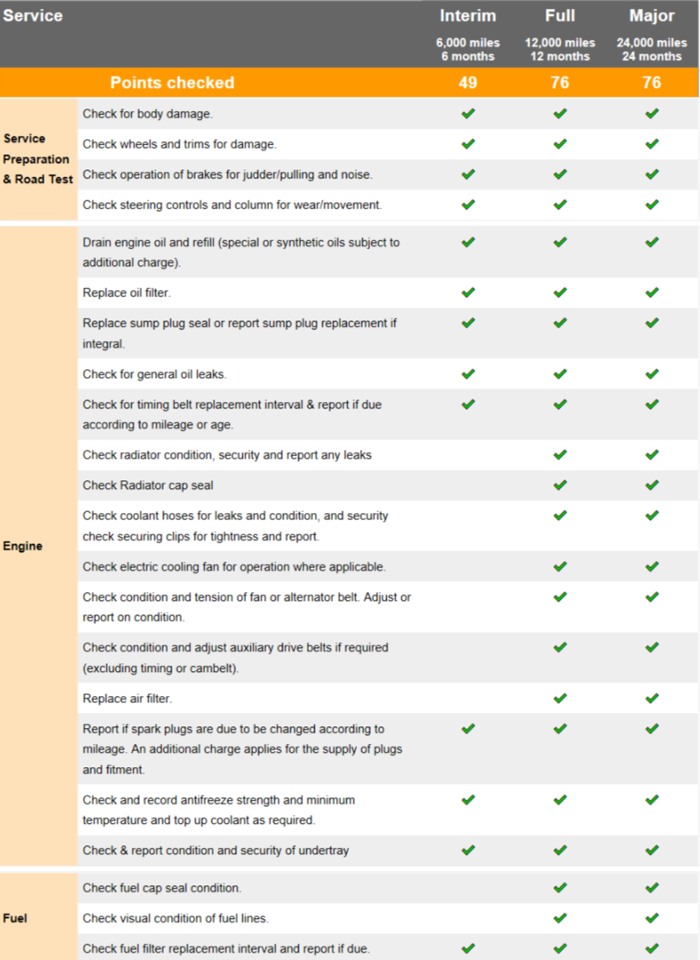

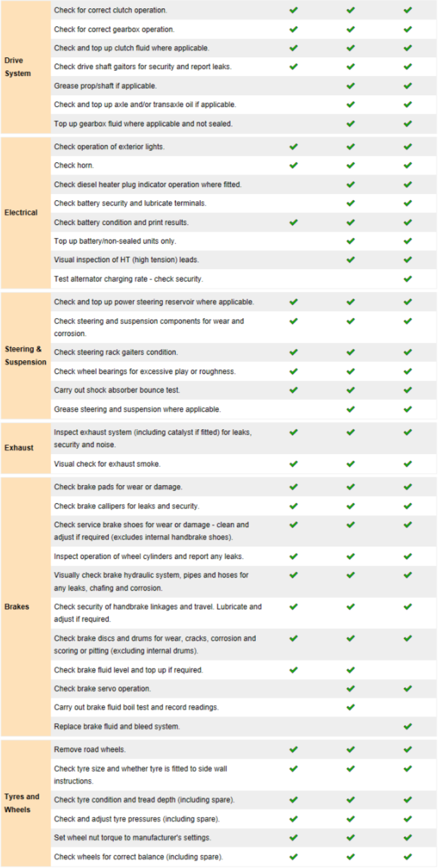
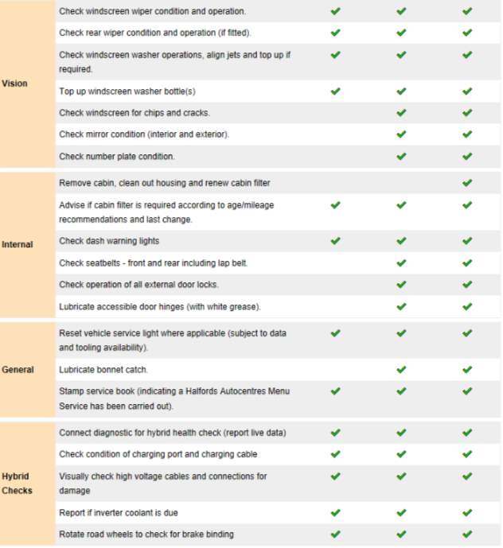

7.5 Appendix E- Specifications of vehicles used

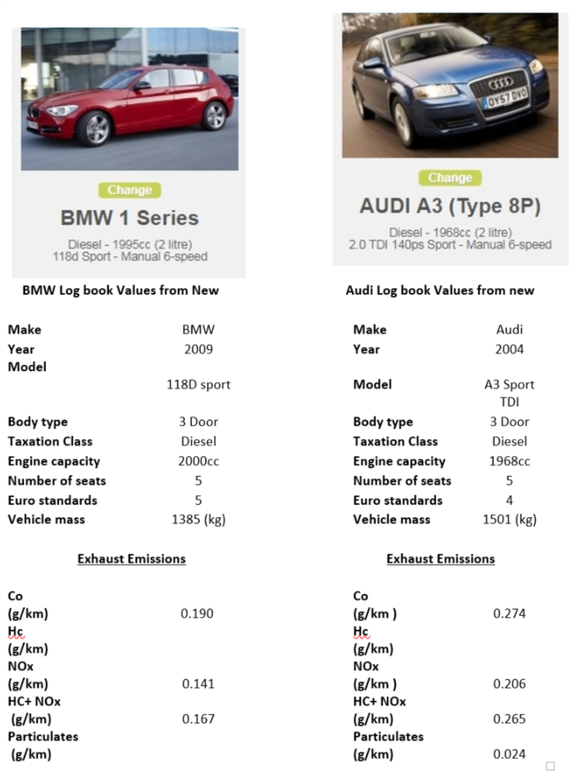

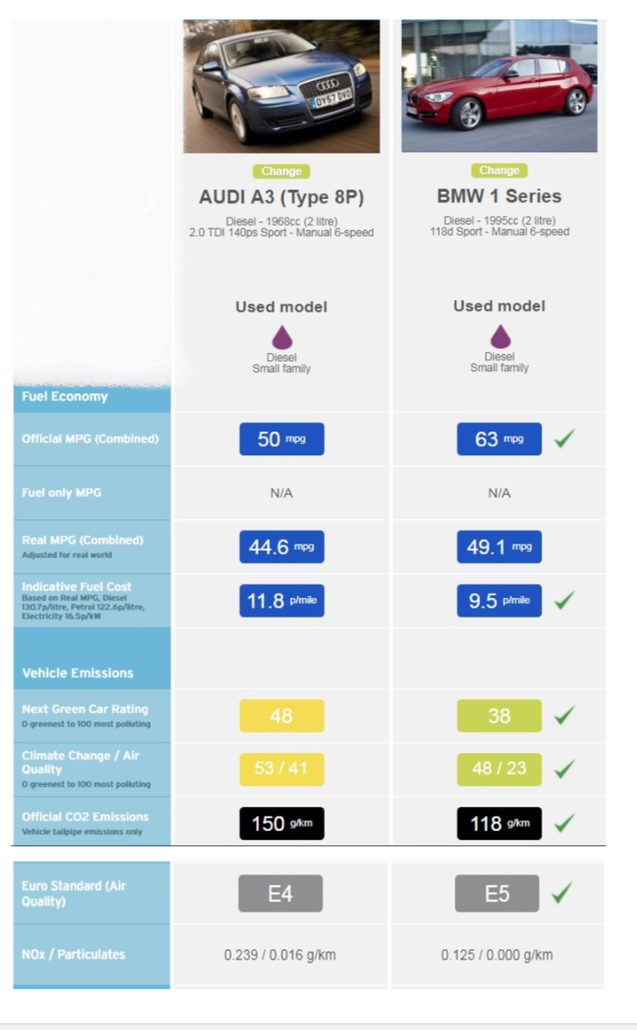
7.6 Appendix F – Experimental work test plan

Test plan
Pre-test: Live drive cycle: Audi A3 | Description:  Live testing using VCDS between J41-42 (2.5 miles) | Date (s) completed:  25th Feb 2019  27th Feb 2019  2nd March 2019 | Test purpose:  Obtainable speed and average travel time
Test 1: Audi A3 | Simulation testing: simulated live drive cycle, 50mph, 60mph 70mph drive cycle | 1st March 2019 | NO₂ levels  Fuel Consumption
Service Audi A3 | Full Service | 6th March 2019 | Visual checks
Test 2:Audi A3 (after service) | Simulation testing: simulated live drive cycle, 50mph, 60mph 70mph drive cycle | 8th March | NO₂ levels  Fuel consumption
Test 3: BMW 1 Series | Simulation testing: simulated live drive cycle, 50mph, 60mph 70mph drive cycle | 15th March 2019 | NO₂ levels  Fuel consumption
Service BMW 1 Series | Full service | 20th March 2019 | Replace oil/oil filter. Air filter, fuel filter
Test 4: BMW 1 Series | Simulation testing: simulated live drive cycle, 50mph, 60mph 70mph drive cycle | 22nd March 2019 | NO₂ levels  Fuel consumption

