Part A — Answers & Key Concepts
1. Verification and Account Setup
- Account Type: Signing in with a personal Microsoft account while verifying through your university email address decouples your subscription ownership from institutional single sign-on (SSO) locks. This ensures you retain access to your projects and resources even during academic transitions or IT policy updates.
- Payment Security: The Azure for Students offer explicitly skips credit/debit card requirements. This prevents accidental auto-renewal charges or surprise invoices if you exceed free limits.
2. The Three Azure Pricing Models Explained
Link to the Spreadsheets of this activity https://docs.google.com/spreadsheets/d/1eRmzyQqYevie0g63bdodgquhGPxmYv3eaAmOS0N31vM/edit?gid=166282880#gid=166282880 – (1)
Screenshot of my active Azure
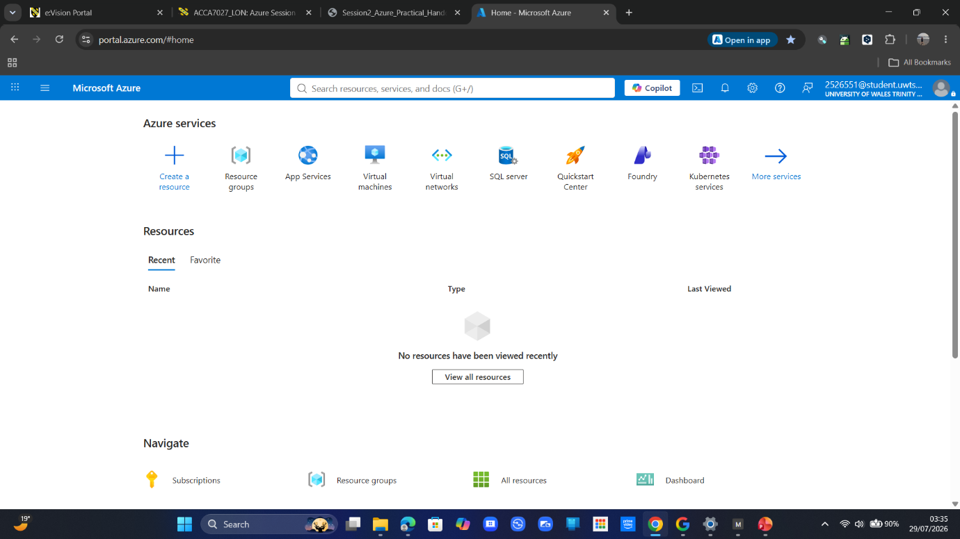
Part B — Answers & Key Concepts
1. Proactive Safeguards (Steps 5–7)
- Checking Credit Balance: Locating your remaining balance and expiration date in Cost Management + Billing gives you full visibility over your $100 allowance, ensuring no sudden service interruptions during lab work.
- Creating a Budget & Alert: Setting a £5 / $5 budget with an 80% threshold alert sends an email notification the moment usage reaches £4 / $4.
Key Insight: A budget in Azure does not cap or stop services automatically — it serves as an early-warning radar so you can turn off unneeded resources before exhausting your credit.
Link to spreadsheet
https://docs.google.com/spreadsheets/d/1WLf0W-bb0-yxlFNlw_qkntGsLg4MoPi6MRagVOCVDc8/edit?gid=870621810#gid=870621810 – (2)

3. Comparing Azure VM vs. Always Free App Service
Using the Azure Pricing Calculator allows cloud engineers to estimate OpEx before deploying infrastructure.
- Virtual Machine (IaaS - Infrastructure as a Service):
  - Cost Profile: Billed continuously for every hour the VM is running (e.g., ~$10–$30+/month depending on instance size and storage disks).
  - Why choose it? Full administrative control over the operating system, custom network configurations, security tooling, or specialized server software requirements.
- App Service - Always Free Tier (PaaS - Platform as a Service):
  - Cost Profile: $0 / £0 (if usage stays within monthly bandwidth and core limits).
  - Why choose it? Rapid deployment of web applications or microservices without the overhead of managing OS patches, background updates, or underlying infrastructure.

Screenshots of the Process
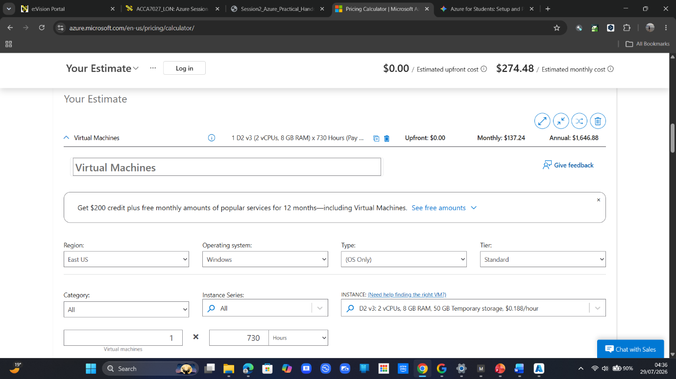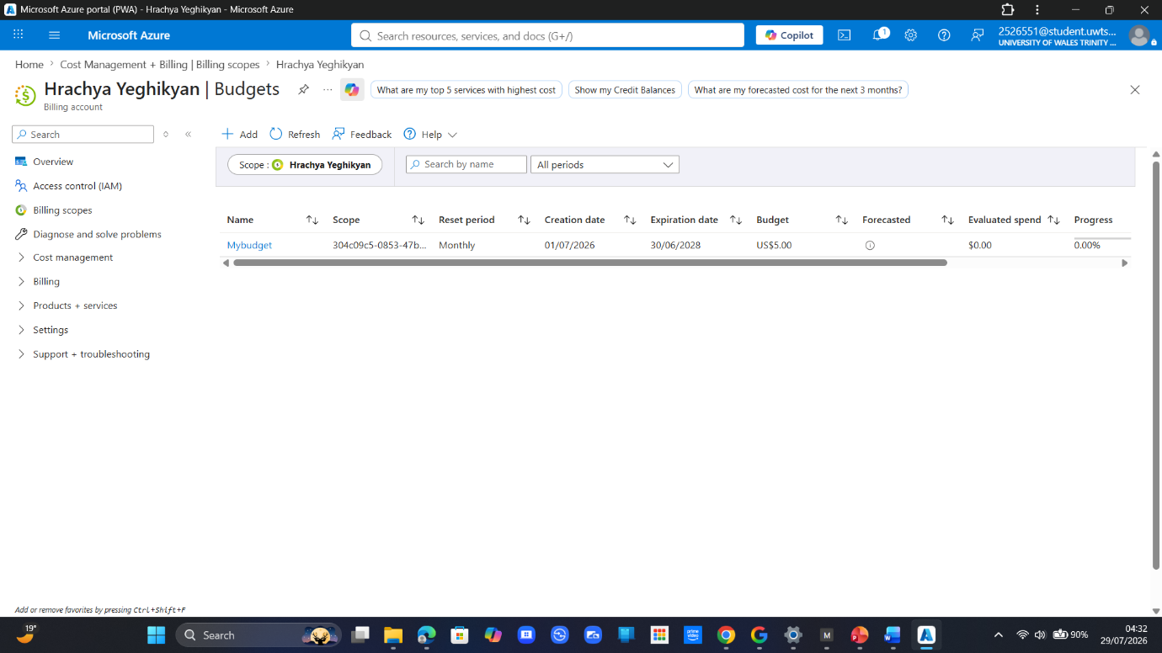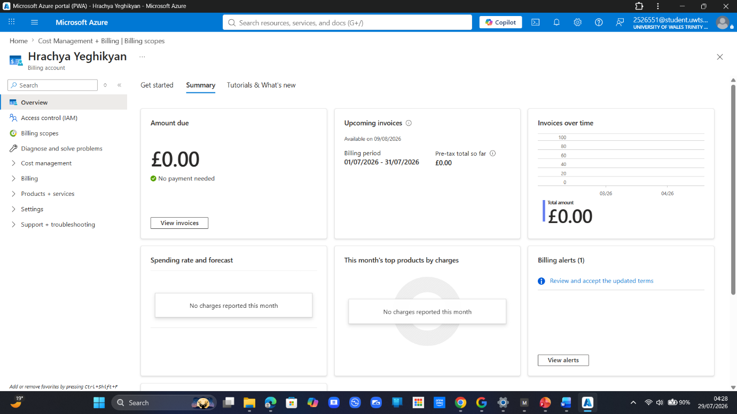
Part C — Answers & Key Concepts
1. Resource Organization & Deployment (Steps 9–13)
- Resource Groups (rg--cloudlab): In Azure, a Resource Group acts as a logical container for related assets. Placing your App Service and its associated App Service Plan in the same group makes tracking costs and cleaning up lab resources simple—deleting the resource group removes everything inside it at once.
- Pricing Tier Selection ("Free F1"): The Free F1 tier provides shared compute resources at $0.00 / £0.00 per month (offering 60 minutes/day of compute time and up to 1 GB memory), ensuring this deployment draws nothing from your $100 student credit.
2. The Shared Responsibility Model: PaaS vs. IaaS vs. SaaS
The defining feature of Platform as a Service (PaaS) is that Microsoft manages the underlying infrastructure, operating system, and runtime, allowing developers to focus strictly on code and configuration.
Link to the spreadsheets for this activity
https://docs.google.com/spreadsheets/d/19d5Cx_wnNABo_nlCZNG_GhIRjmy6H_MJ07XcmGjWZqI/edit?gid=815783875#gid=815783875 – (3)

Screenshots of Process
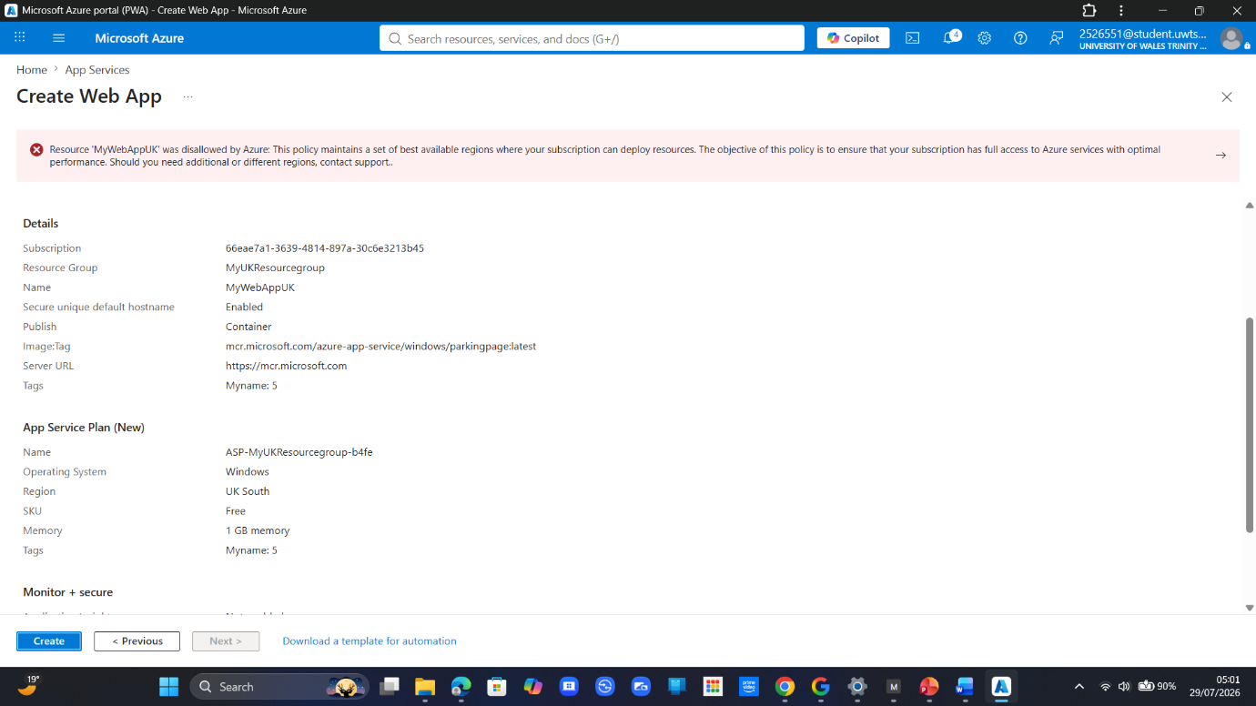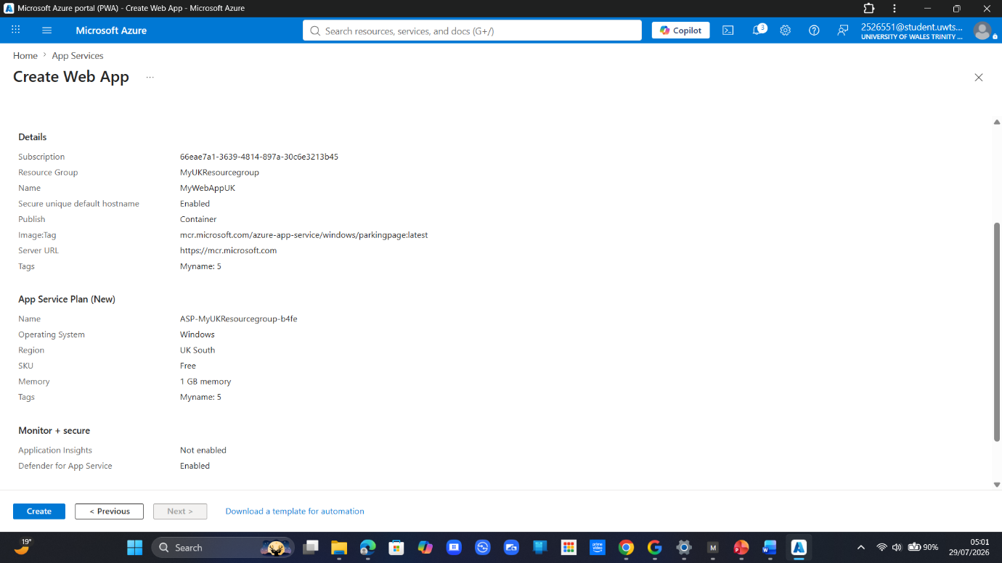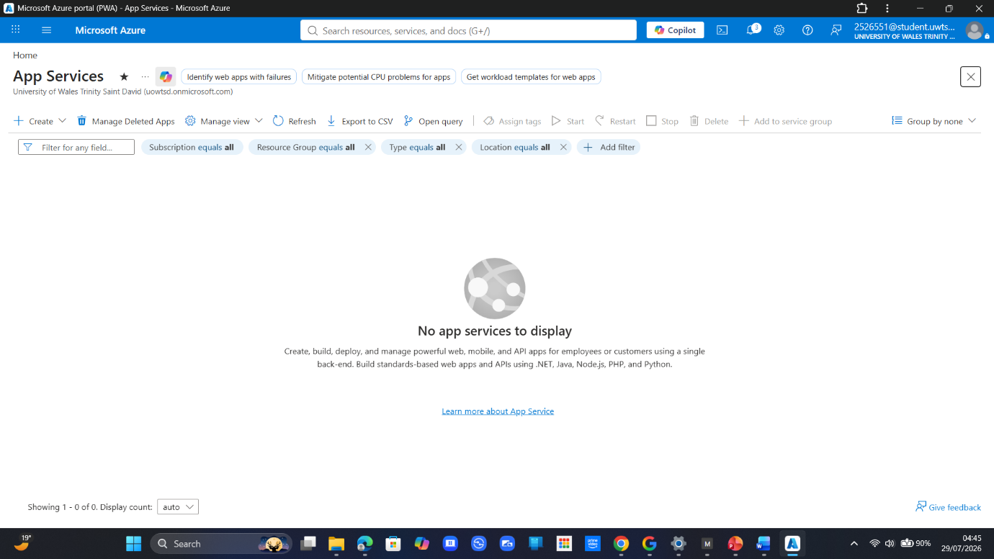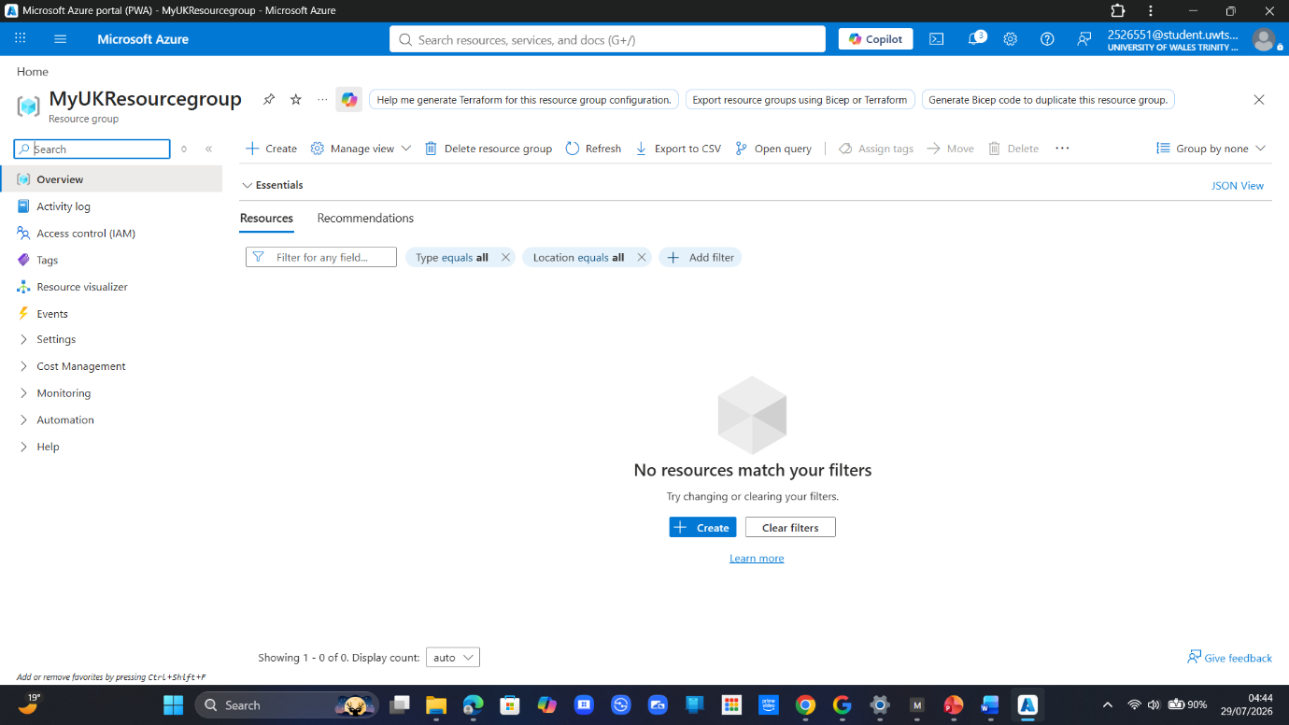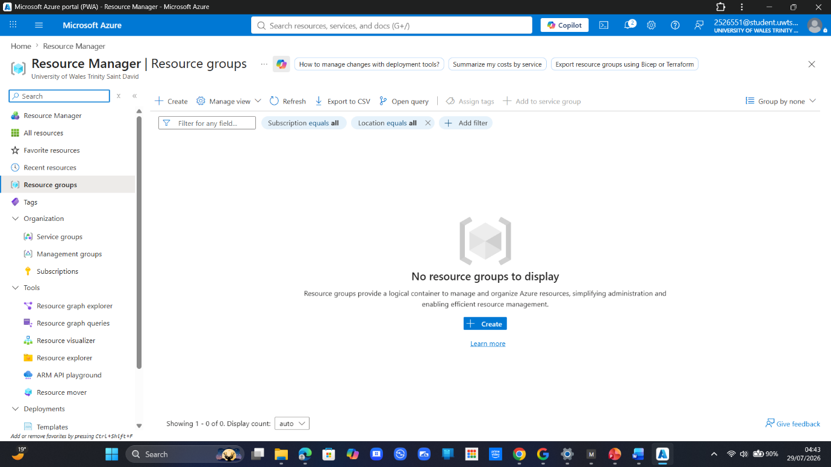

Part D — Answers & Key Concepts
1. Cost Verification (Step 14)
- Credit Balance Status: Checking Cost Management + Billing confirms that your credit balance remains unchanged. Because the Free F1 tier falls under the Always Free tier model (subject to daily quotas like 60 minutes of daily compute time), zero funds were drawn down from your $100 student allowance.
2. Side-by-Side Costing Models Overview
Model | How It Works | Session Example | Real-World Use Case
Always Free Tier | Fixed monthly resource limits provided at no cost; never billed if usage remains within specified boundaries. | App Service Free F1 Plan (Part C) | Hosting low-traffic staging environments, micro-services, or development web apps.
Free Credit | A pre-allocated financial balance used against billable services; expires once exhausted or after a set time limit. | $100 Azure for Students Credit (Part A) | Prototyping, proof-of-concept testing, and hands-on training with paid cloud services.
Pay-As-You-Go | On-demand billing per second/hour/GB consumed. No upfront costs, but no automatic spending cap unless configured. | VM + Storage Account estimate in Pricing Calculator (Part B) | Production workloads with unpredictable, bursting, or fluctuating traffic demands.
Reserved / Committed | Significant discount (up to 72%) applied in exchange for a 1- or 3-year commitment to continuous usage. | Not used today (CapEx-style financial commitment within an OpEx model) | Enterprise workloads running 24/7/365 with predictable baseline compute requirements.
3. Core Financial Principles Summary
- OpEx Optimization: Modern cloud architecture relies on picking the right pricing model for each workload component. Combining Always Free tiers for lightweight components with Pay-As-You-Go for elastic spikes—and Reserved Instances for steady-state workloads—ensures maximum cost efficiency.
- Governance & Safeguards: Budgets and spending limits act as administrative guardrails. Combining budget alerts with proper resource group tagging ensures enterprise teams maintain full visibility over cloud expenditure before costs scale.

1. Deleting Resources & Verification (Steps 14–16)
- Single-Step Deletion via Resource Groups: Deleting rg--cloudlab cascadingly removes every asset contained within it—including the App Service and its associated App Service Plan. This eliminates orphan resources (like standalone disks or unused IP addresses) that frequently generate silent charges.
- Final Balance Check: Confirming in Cost Management + Billing that your credit remains untouched verifies both the zero-cost nature of the Free F1 tier and the complete termination of the deployment.
2. The Critical Importance of Cloud Hygiene
Concept | Why It Matters | Consequence of Neglect
Forgotten Resources ("Zombie Infrastructure") | Virtual machines, unattached storage volumes, or idle public IPs continue billing per hour/GB even if no traffic hits them. | Unexpected cloud bills running into hundreds or thousands of dollars/pounds overnight.
Resource Group Scope | Grouping assets logically allows single-command deletion for temporary projects, labs, or testing pipelines. | Loose resources scattered across subscriptions that are hard to trace and audit.
Cost Control Triad (Parts B & E) | Combining Budgets/Alerts + Deallocation/Deletion + Pricing Calculator Forecasts forms full operational control over OpEx expenditure. | Overspending, exhausted credits, or breached organizational IT budgets.
The Golden Rule of Cloud Management: Deploy in Resource Groups, set budget alerts before building, and tear down environments the moment they are no longer actively serving a purpose.
Part E — Answers & Key Concepts
1. Execution & Verification (Steps 14–16)
- Cascading Teardown: By targeting the rg--cloudlab Resource Group for deletion, Azure automatically purges all child dependencies—including the App Service instance and the App Service Plan runtime environment—in a single atomic operation. This prevents orphaned assets (such as unattached storage or persistent public IPs) from lingering in your subscription.
- Final Balance Status: Rechecking Cost Management + Billing validates that your $100 credit remains 100% intact. This confirms both the zero-cost nature of the F1 Free tier and the total removal of all provisioned services.
2. Operational Discipline: The Danger of Zombie Infrastructure
In commercial cloud environments operating on OpEx (Operating Expenditure), unmonitored compute and storage draw down funds continuously per second, whether active or idle.
[ Unmonitored Deployment]
│
▼
┌──────────────────────────────────────┐
│ Zombie Resources (Idle VMs/Disks) │
└──────────────────┬───────────────────┘
│ Billed continuously (per hour/GB)
▼
┌──────────────────────────────────────┐
│ Unexpected OpEx Budget Breach │
└──────────────────────────────────────┘
- Why Clean-Up Habits Matter: If an unconfigured Pay-As-You-Go virtual machine is left running unattended for a month, it continues to accrue charges for compute allocation, attached disk storage, and static IP addresses.
- The Governance Triad: Professional cloud engineering balances three critical disciplines:
  - Forecasting via the Pricing Calculator (Part B)
  - Proactive Guardrails via Budgets & Email Alerts (Part B)
  - Strict Resource Lifecycle Management via Resource Group Teardowns (Part E)
Screenshots of Progress
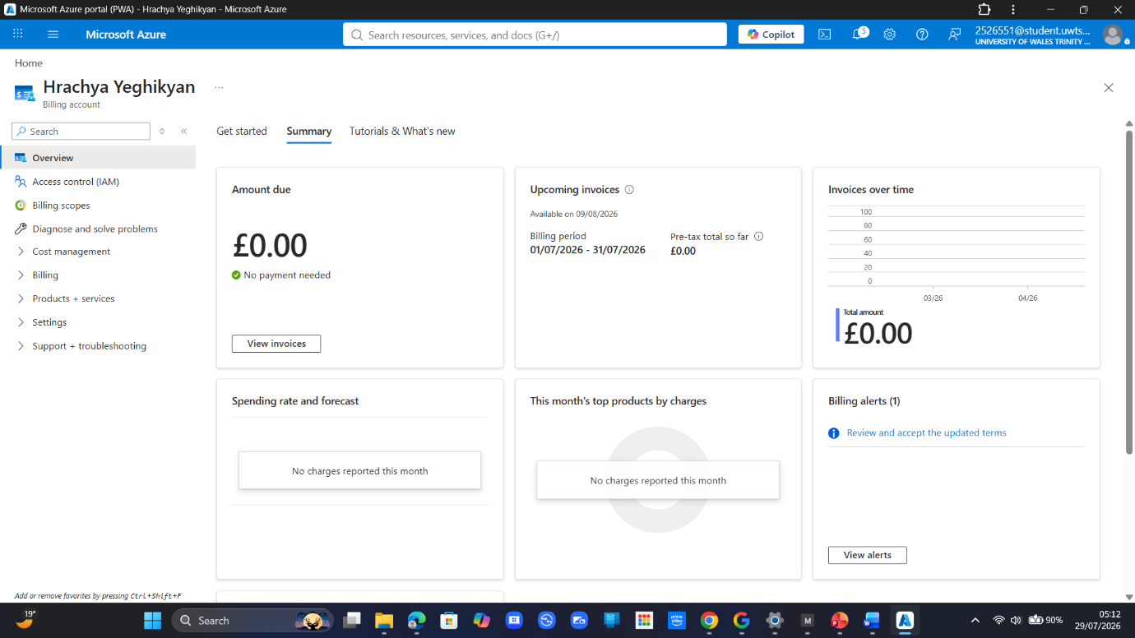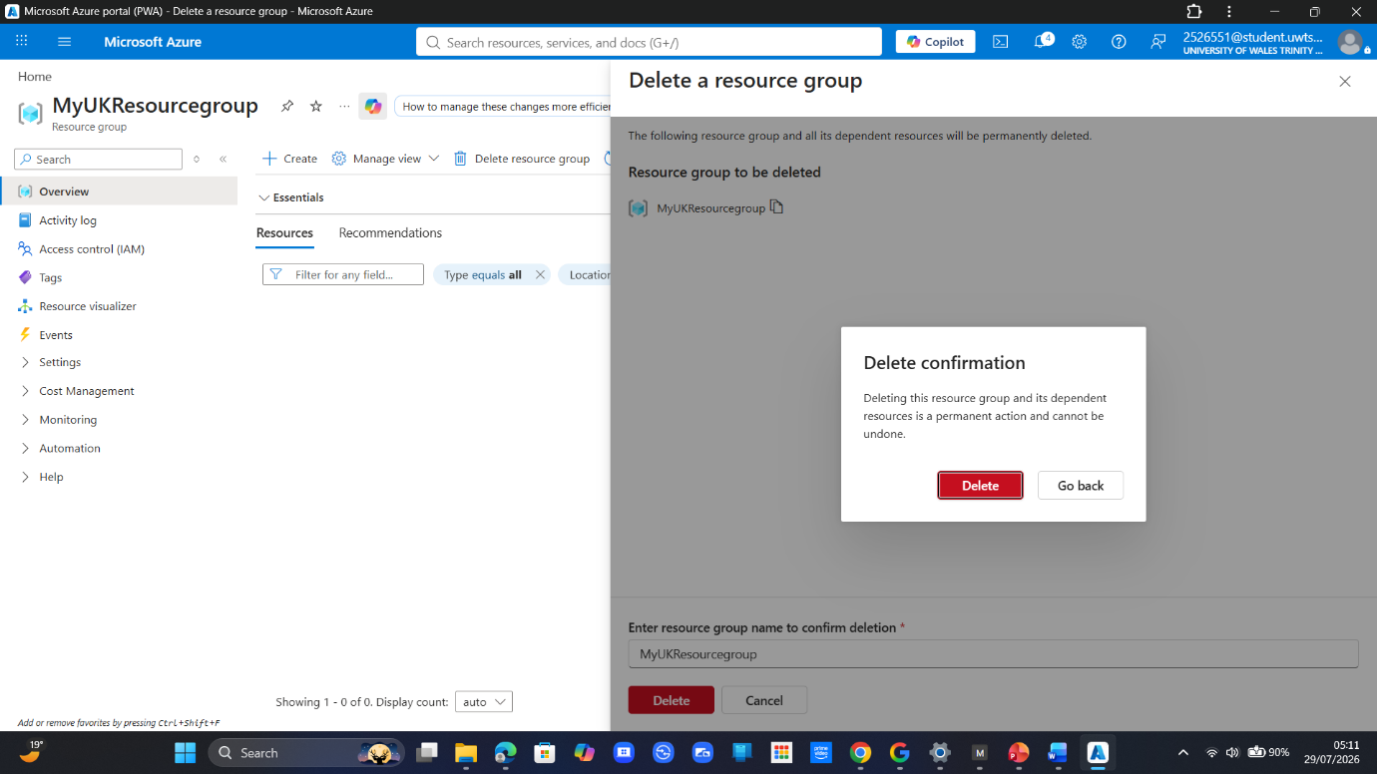
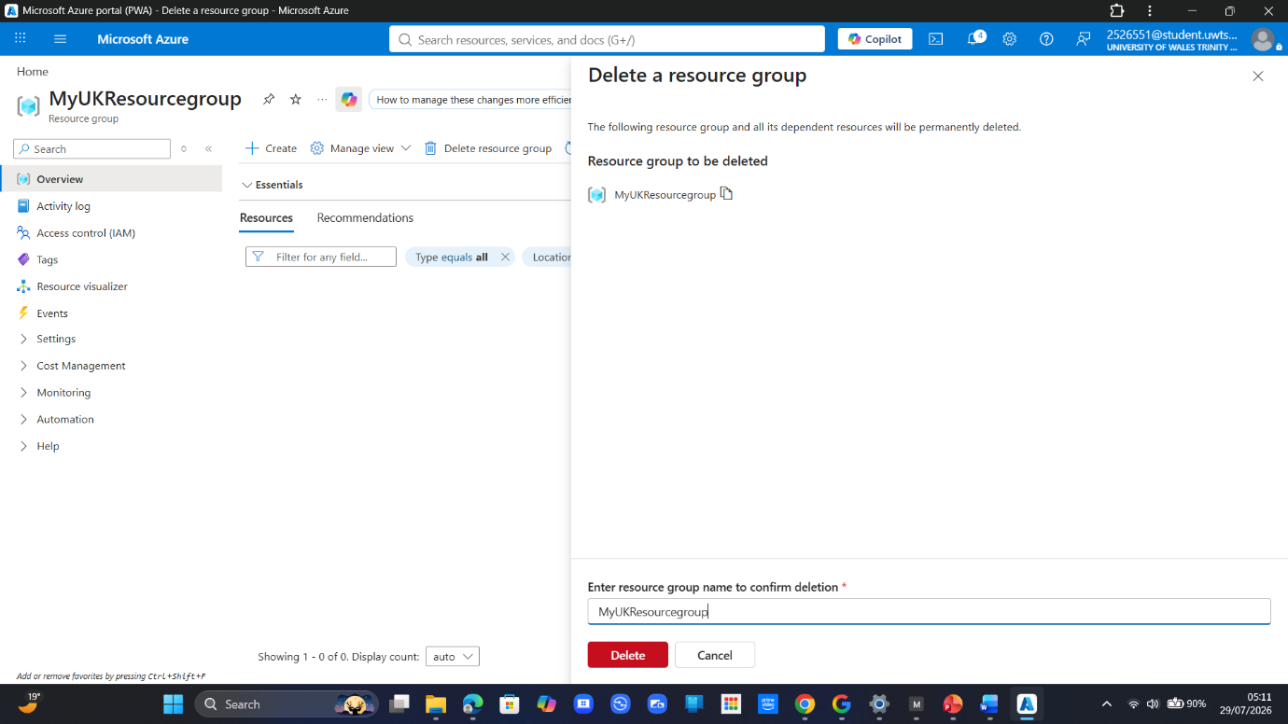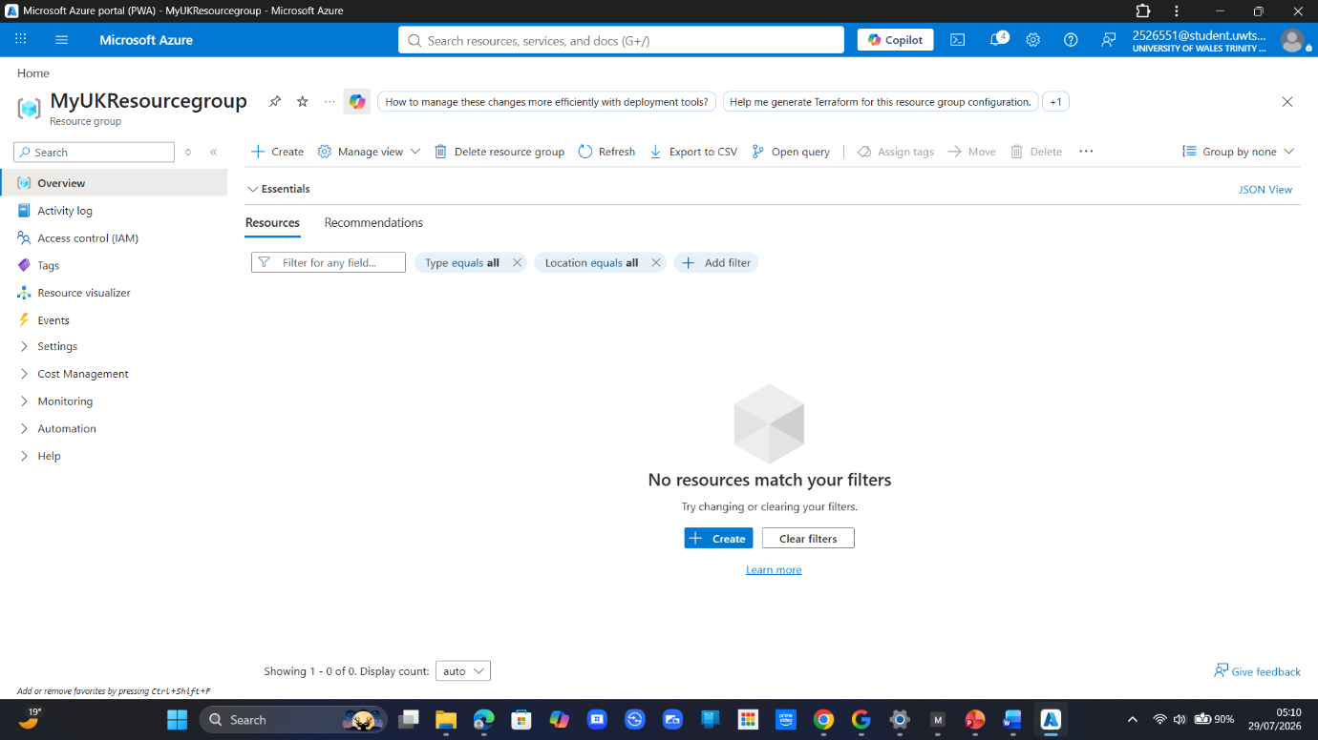

Reflection Answers
1. Classification of Activity Components (IaaS, PaaS, SaaS)
- PaaS (Platform as a Service) — The Web App Deployment (Part C):
  - Justification: You configured the runtime stack (Node.js/Python) and deployed the app, while Azure fully abstracted, managed, and patched the underlying host OS, web server, and physical hardware.
- IaaS (Infrastructure as a Service) — The VM Cost Estimation (Part B):
  - Justification: Evaluating a Virtual Machine in the Pricing Calculator represented IaaS. Had it been deployed, you would have had full administrative access to manage the operating system, network interfaces, storage disks, and security patching.
- SaaS (Software as a Service) — The Azure Portal & Microsoft 365 Authentication (Part A):
  - Justification: The Azure Portal itself and the personal/institutional Microsoft account logins are fully managed web applications. You simply consume the software interface without controlling its codebase, updates, or backend infrastructure.
2. Strategic Rationale for Student Credits
Microsoft provides student-specific credits primarily for long-term ecosystem adoption and skill pipeline development:
- Developer Mindshare: Introducing cloud practitioners to Azure during their academic training builds familiarity, making them far more likely to recommend or deploy Azure in commercial environments upon entering the workforce.
- Gated Risk Profile: Restricting the offer to verified academic status (. ac.uk / .edu) reduces financial exposure to abuse, fraud, or crypto-mining operations that frequently target unverified free tier promotions.
3. Early Billing Problem Detection in Cost Management
If the App Service had run on a paid tier, you would check three key metrics to catch costs early:
- Actual vs. Forecasted Burn Rate: Reviewing the Cost Analysis dashboard to track daily spending trends against expected monthly forecasts.
- Budget Threshold Trigger Status: Checking if usage has breached the 80% email alert boundary set up in the Budgets blade.
- Cost Breakdown by Resource / Meter: Inspecting the specific billing meters (e.g., compute hours, outbound data egress, associated App Service Plan instance size) to identify exactly which resource or feature is driving up expenditure.
4. Pay-As-You-Go vs. On-Premises (CapEx vs. OpEx)
- Advantage (Agility & Zero Upfront Cost): Eliminates capital expenditure (CapEx). You can instantly provision high-performance resources on demand without ordering, racking, or financing physical hardware—paying strictly for what you consume.
- Risk (Financial Volatility & Runaway Costs): Lacks built-in spend ceilings by default. Misconfigurations, forgotten "zombie" resources, or sudden traffic spikes can lead to unexpected, unbounded operating expenses (OpEx) if spending alerts or governance guardrails are not strictly implemented.
References
https://docs.google.com/spreadsheets/d/1eRmzyQqYevie0g63bdodgquhGPxmYv3eaAmOS0N31vM/edit?gid=166282880#gid=166282880 – (1)
https://docs.google.com/spreadsheets/d/1WLf0W-bb0-yxlFNlw_qkntGsLg4MoPi6MRagVOCVDc8/edit?gid=870621810#gid=870621810 – (2)
https://docs.google.com/spreadsheets/d/19d5Cx_wnNABo_nlCZNG_GhIRjmy6H_MJ07XcmGjWZqI/edit?gid=815783875#gid=815783875 – (3)

