

Name: Ruth Bannor
Student ID: 2432011
Module Code: LCHS4003
Module Name: Introduction to Health and Social Care
Lecturer: Debrah Odeh
Assignment Title: Portfolio – Two Tasks

Table of Contents
Task 1: dentistry services poster 1
Task 2: NHS Origins 2
References 4

Task 1: dentistry services poster

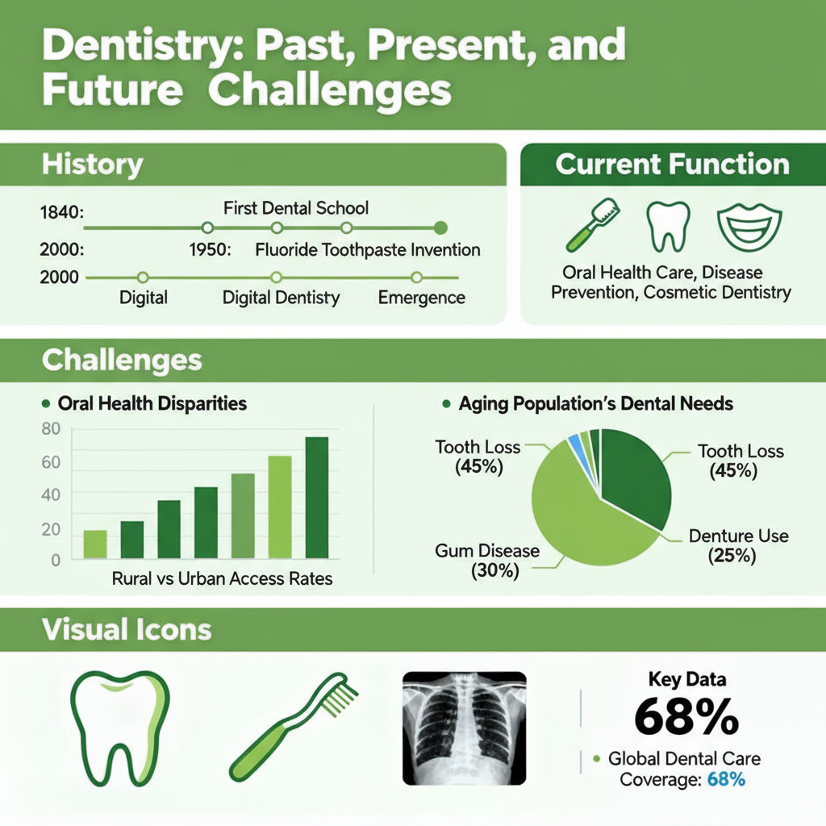
Figure 1

Task 2: NHS Origins
Many individuals in Britain were either unable to pay for treatment or only received limited help when they were ill since, prior to 1948, health care was supplied by a combination of private contributions, local governments, and charities. Leaders were prompted to think about a national solution when the strain of the interwar depression and the experience of two world wars exposed glaring and unjust disparities in quality and access. To remove financial barriers and unify clinics and hospitals, the government established a single tax-funded service after 1945. On 5 July 1948, Health Minister Aneurin Bevan launched the National Health Service, making care-free at the point of use and available to everyone, which quickly became a defining part of the modern welfare state and a symbol of social solidarity. “The NHS was established in 1948 to provide comprehensive, universal, and free healthcare at the point of delivery, driven by a vision to eliminate health inequalities (The King’s Fund, 2023).”

The 1942 Beveridge Report, which outlined a strategy for post-war societal reconstruction centred on social security and equity, increased public and political support for a universal health care. According to the research, health services should be provided when people need them, not just when they can afford them. “It also claimed that Britain should address the five main issues of want, disease, ignorance, squalor, and idleness (The National Archives,2021).” These concepts strengthened public confidence in a government-run system and made a compelling moral case for universal coverage. After the 1945 election, the Labour government moved quickly to turn this vision into law, aiming to protect the health of every citizen through a comprehensive and publicly funded service (The National Archives, 2021).

Bevan's plan was difficult to adopt since lengthy talks were required before the law was agreed upon, and some physicians and other groups were concerned about losing their income or independence. Three straightforward tenets served as the foundation for the NHS when it was established, and they remain relevant today: treat people based on clinical need rather than personal wealth, serve everyone, and be free at the point of use. The new system integrated general practice, maternity services, dentistry, and optical care under a single national framework from the outset, together with hospital and ambulance services. A coherent framework that aimed to deliver prompt, secure, and uniform care throughout the nation took the place of the previous patchwork of systems. “The fundamental principles of universal access and need-based treatment have not changed despite attempts to increase quality and efficiency through reforms and reorganisations over time (Klein, 2013)."
NHS England handles national planning, funding, and performance, while the Department of Health and Social Care sets policy and oversees responsibility. In order to connect primary care (GPs, dentists, pharmacists, and opticians), secondary care (specialised hospital services), and critical mental health and community services, services are arranged throughout local systems. Quality and value are supported by independent organisations: national guidelines assist physicians in adhering to evidence-based standards, and the Care Quality Commission inspects and rates providers. To improve service efficiency and care coordination, the system is also investing on digital technologies like remote consultations and electronic records. The NHS is under a lot of strain right now because to an ageing population, more chronic illnesses, limited funding, a lack of employees, and the long-term consequences of COVID-19. The main goal is to keep care universal, safe, timely, and fair while adapting structures and using data to improve access and outcomes.

References
Klein, R. (2013) The new politics of the NHS, 7th edn, Abingdon: CRC Press/Routledge.
NHS England (2024) Our plan to recover and reform NHS dentistry, Long read, 6 February, link: https://www.england.nhs.uk/long-read/our-plan-to-recover-and-reform-nhs-dentistry/.
The King’s Fund (2023) Reflecting on 75 years of the NHS. link: https://www.kingsfund.org.uk/insight-and-analysis/projects/reflecting-75-years-nhs
The National Archives, (2021) Beveridge Report: the ‘five giants’, Education resources: Attlee’s Britain, link: https://www.nationalarchives.gov.uk/education/resources/attlees-britain/beveridge-report/.
The National Archives (2025) The foundation of the NHS. link: https://www.nationalarchives.gov.uk/explore-the-collection/stories/the-foundation-of-the-nhs/
World Health Organization (2022) Global oral health status report: towards universal health coverage for oral health 2030, Geneva: WHO, link: https://www.who.int/publications/i/item/9789240061484.

