
Digital business (bmsp 6002)
Tutor: Dr Roisin Mullins


Katarzyna white
1905801

Content
- Executive Summary………………………………………………………………...2
- Introduction…………………………………………………………………………2
  - Airbnb Landscape………………………………………………………………2
    - Sharing Economy and Collaborative Consumption………………...…..2
    - Airbnb Business Model…………………………………………………3
    - Airbnb Financial Position……………………………………………….3
    - Airbnb Business Strategy……………………………………………….4
    - Airbnb PEST Analysis………………………………………………….4
- Airbnb Business Model Canvas…………………………………………………….5
- Strategic Formulation Framework SFF……………………………………………..6
- Grand strategy Matrix GSM……………………………………………………...…7
- Tools/Software………………………………………………………………………8
- Conclusion…………………………………………………………………………..9
- References……………………………………………………………………….....11

- Executive Summary
The purpose of this report is to critically examine Airbnb as an example of sharing economy. Moreover, this report also examined Airbnb's business model, business strategy, and financial landscape. Also, a business model canvas was made to obtain a clear picture of how Airbnb creates, delivers and captures value. In addition, a strategic formulation framework SFF was discussed in detail, and a grand strategy matrix was applied to Airbnb. Based on the analysis conveyed, Airbnb was placed in Quadrant 1 as their competitive advantage is strong and their market is rapidly growing. This analysis was followed by recommendations on how to stay in that quadrant. Lastly, the ERP, SCM and CRM software were discussed and explained how Airbnb could use those tools to support their business activities.

- Introduction

  - Airbnb Landscape

2.1.1 Sharing Economy and Collaborative Consumption
According to Schlagwein et al. (2020), the sharing economy can be described as "an IT-facilitated peer-to-peer model for commercial or non-commercial sharing of underutilised goods and service capacity through an intermediary without a transfer of ownership." Munoz & Cohen (2017) proposed seven characteristics of sharing economy, and they are as follow:
- platform dependence
- underutilised resources
- peer to peer interactions
- collaborative governance
- mission-driven
- alternative funding
- technology dependence
Another term closely associated with the sharing economy is collaborative consumption. The definition chosen for this report was proposed by Benoit et al. (2017), and it states that collaborative consumption is an exchange between three parties the platform provider, seller and buyer. They further maintain that there is no transfer of ownership involved but only a short time usage of underutilised resources.
Concerning Airbnb, and based on the definitions discussed in this report, it can be assumed that Airbnb loosely falls into a sharing economy model as it does not meet all of the seven characteristics stated above. Only two features are fully satisfied the platform dependence and technology dependence. Airbnb relies on the online platform and is entirely dependent on technology. In regards to collaborative consumption, Airbnb completely fits within this model. Airbnb supports the triadic exchange involving guests, hosts and the facilitator. The facilitator (Airbnb) allows hosts (sellers) to list their properties on the platform, which can be rented by guests (buyers).

2.1.2 Airbnb Business Model
According to Osterwalder and Pigneur (2010), a business model reflects the reasons behind how a company creates, delivers and captures value.
Airbnb adopts several business models. According to businessmodelnavigator.com, Airbnb business models include affiliation, cross-selling, digitisation, leverage customer data, customer loyalty, peer-to-peer and two-sided market (Businessmodelnavigator, 2021). Business model diversification allows Airbnb to take full advantage of the resources they already have and create more value.

2.1.3 Airbnb Financial Position
Throughout the year, 2021 Airbnb was in a recovery stage from the initial Covid 19 restrictions, which had a significant adverse effect on the business finances and the travel industry. In Q3 2021, Airbnb experienced the highest ever revenue of $2.2 billion. In comparison, the Q3 2020 revenue of almost $1.3 billion was 70 % lower than Q3 in 2021. The solid financial position of Airbnb is accredited to the summer travel peak and relaxations of the Covid-19 travel restrictions (Airbnb, 2021).
On December 9th 2020, Airbnb IPO was estimated at $68; however, on December 10^{th,} Airbnb shares started trading at $146 per share, more than double the estimated IPO.
As of December 31st 2021, Airbnb stock price was 166.49. The highest Airbnb stock closing price was $219.94, and the lowest was $129.71 (Macrotrends, 2022).
Airbnb decided to go public during the pandemic and stated that its main reason was to generate funding for future growth (Securities and Exchange Commission, 2020).

2.1.4 Airbnb Business Strategy
According to Porter (1998), a strategy is a competitive advantage and distinction from competitors. In other words, the strategy makes businesses stand out from their competitors and provides goods and services to customers at a lower price and better quality than rivals ones.
It is believed that Airbnb strategy is a digital disruption strategy, which refers to digital innovation processes that change the way existing procedures are performed and disrupts current markets (Skeg et al., 2018). Airbnb fully capitalised on the sharing economy, and its unique online platform-based business altered and interrupted the travel industry. Via the Airbnb platform, many people were able to list their unused accommodations, which created an increase in room availability, especially in cities, resulting in more competitive prices for customers.

2.1.5 PEST analysis
Political Factors
Airbnb is faced with many legal and regulatory frameworks in many different countries. The discrepancies between local housing laws and regulations and the Airbnb business model causes many hosts to exploit loopholes in an under-regulated sharing economy.
Economical Factors
Airbnb is the undeniable leader within the sharing economy concept. The business took full advantage of the peer-to-peer digital platform. However, as mentioned earlier, the sharing economy lacks clear regulations crucial to accommodating new innovative business models due to its relatively short existence.
Another factor influencing Airbnb is the growing competitor base. Airbnb business model is relatively easy to copy; therefore, many businesses take the opportunity to establish themselves within peer-to-peer accommodation networks such as Tripping.com or FlipKey.
Social Factors
Initially, the pandemic caused many disruptions and loss of revenue for Airbnb; however, since the lift of travel restrictions, people were looking for affordable holiday accommodation more than ever. High demand in Airbnb offerings was a positive factor for the business that caused the highest-ever revenue.
The Airbnb business model allowed many people to generate income and created entrepreneurial opportunities.
Technological Factors
Technology is what drives Airbnb's success. Airbnb utilises ERP, CRM and SCM software to aid its e-commerce processes. Airbnb provides the best and hassle-free experience for sellers and buyers with its innovative business model.

- Airbnb Business Model Canvas
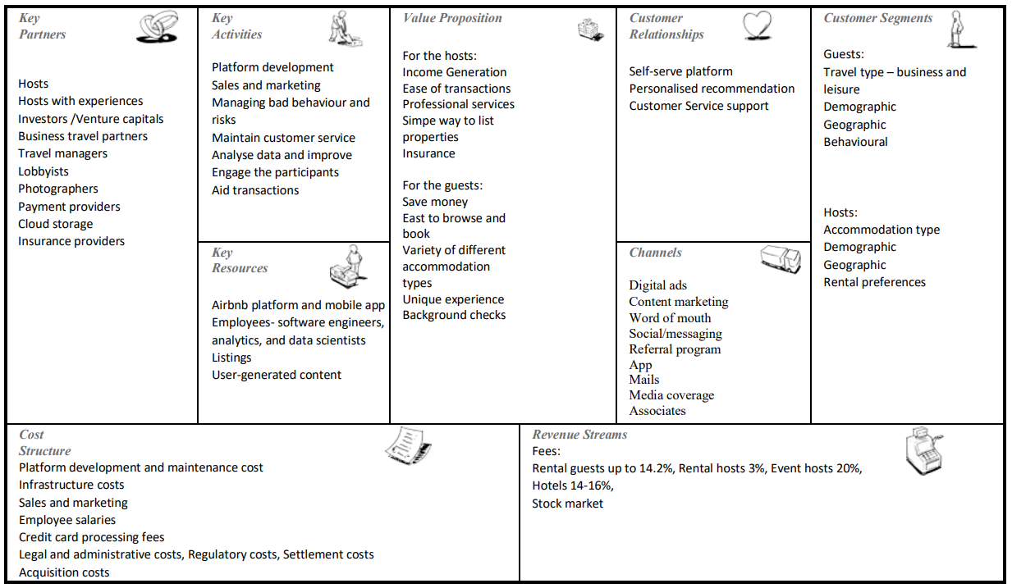

For the purpose of this report above Airbnb business model canvas was adapted from the Innovation Tactics website (Innovationtactics, 2020).
The business model canvas (BMC) is a strategic management tool created by Osterwalder et al. (2010) to describe, visualise, change, and create new innovative business models. BMC consists of nine building blocks: customer segment (CS), value proposition (VP), channels (CH), customer relationship (CR), revenue streams (RS), key resources (KR), key partnership (KP) and cost structure (CS). Each of the building blocks must be completed/filled to represent the foundation of the business model. The business model canvas should be updated whenever significant changes occur within the business (Fritscher & Pigneur, 2014).

- SFF – Strategic Formulation Framework

Strategy Formulation Framework SFF was designed by Fred David (2007) to aid managers in decision-making. There are three stages.
- The Input Stage
This stage encapsulates the essential information that will help to create strategies. This stage uses the EFE Matrix, an IFE Matrix, and a CPM.
- The matching Stage
Within this stage, five different techniques are used to formulate strategies. The methods are: "the SWOT Matrix, the SPACE Matrix, the BCG Matrix, the IE Matrix, and the Grand Strategy Matrix" (David, 2014). The information from the input stage is used to complete the methods mentioned earlier.
- The Decision Stage
The final stage of SFF involves one technique called Quantitative Strategic Planning Matrix (QSMP). This technique uses information from the input stage to objectively evaluate strategies identified in stage two. QSPM can compare strategies at the corporate, decision-making, and functional levels. Moreover, the rating and attractiveness score system is used to determine which strategies should be prioritised.

Prioritising strategies without quantitative input can be very subjective as it is left to managerial discretion. The SFF is based on objective information, allowing managers to gain a more unbiased perspective on proposed strategies.
The drawback to using SFF is time consumption. The SFF is laborious, which can be off-putting for many. In addition, it requires a high level of expertise from managers, and the effectiveness of the QSPM is only as good as the information inputted in previous stages.

- Grand Strategy Matrix GSM


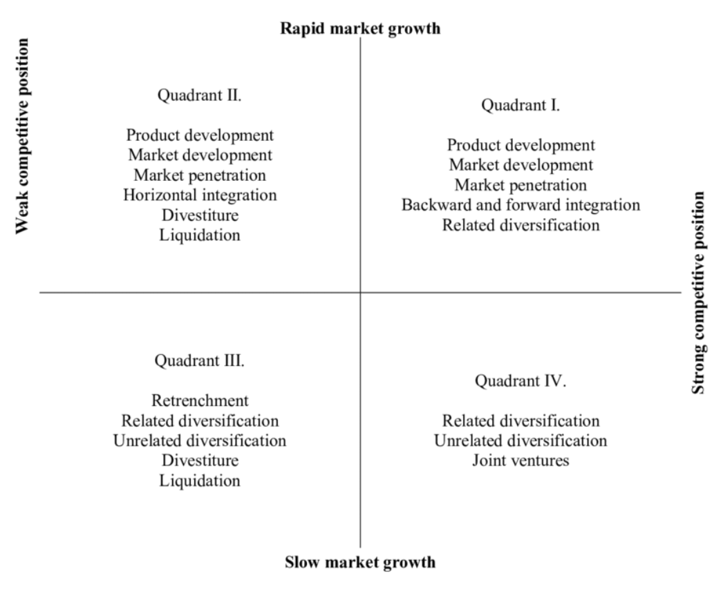
This Photo by Unknown Author is licensed under CC BY-NC-ND

For this report, GSM will be applied to Airbnb, followed by an analysis and recommendation. As mentioned earlier, the GSM is used in stage two, the matching stage. The GSM consists of two coordinates, the market growth rate and competitive position and four quadrants where suitable strategies are listed from the most attractive to least (Torlak & Sanal, 2007).
It was decided that Airbnb can be placed in Quadrant 1 as their competitive position is strong and the industry, they operate in experiences rapid market growth. Airbnb market share accelerated from 2010 and in 2019 was estimated at 20% within the rental holiday industry (Clifford, 2020). Airbnb has a solid competitive position and is currently a market leader within the home-sharing market with global listings (Lock, 2021).

The strategies associated with Quadrant 1 are:
- Product development
- Market development
- Market penetration
- Backward, forward or horizontal integration
- Related diversification

It is advised that Airbnb continue expanding its markets and improving its products range, which they frequently do. For example, they have introduced Airbnb gift cards and the Airbnb Plus programme for hosts.
Airbnb has participated in horizontal integration. They acquired many platform businesses similar to theirs, e.g., Accoleo and CrashPadder (Techcrunch, 2011 and 2012).
Due to excessive financial resources, Airbnb had decided to diversify and, in 2019, announced its new project called Backyard, which suggest there are moving into the architecture and construction industry. The Backyard initiative focuses on designing and building spaces with Airbnb principles in mind (Gibson, 2018).

Recommendation for Airbnb to stay in Quadrant 1:
- A membership programme for guests – from conducted research, it has been noticed that Airbnb does not offer a membership option for its guests. Depending on which level guests are at, an appropriate membership reward would follow. Similarly, to airlines who provide air miles for their customers, Airbnb could provide bronze, silver or gold membership options based on the accumulated number of stays or the accumulated duration time.
- All in one place – accommodations, car rentals and best deals on flights all available on the Airbnb website. Airbnb could create a partnership with Turo carsharing business to keep in the sharing economy theme. Turo’s business model is almost identical to Airbnb, where users can rent a car from a local owner (Turo, 2022).

- Tools/Software
Enterprise Resource Planning - ERP
ERP is a software and system that allows businesses to plan, manage and integrate all processes within that business. The ERP includes tools for "financial and cost accounting, sales and distribution, materials management, human resource, production planning and computer integrated manufacturing, supply chain, and customer information"(Shehab et al., 2014). In other words, ERP can obtain, store and process the data accumulated throughout the business activities.
Supply Chain Management - SCM
Schonsleben (2000) states that SCM refers to managing materials and information from suppliers to customers. Moreover, he suggests that the primary purpose of SCM is to minimise costs, improve quality, maximise profits and customer service. Some of the benefits of using SCM includes shipping optimisation, better collaboration and keeping up with the demands.
Customer Relationship Management - CRM
CRM is a software system designed to collect and store all customer information across all channels. The advantages of using CRM include higher efficiency, better analytics and customer retention (Sirk, 2022).

ERP can be described as the foundation of the whole system, with SCM on one side and CRM on the other. ERP captures transactions in real-time, stores them, and updates SCM and CRM systems to improve and streamline business processes.
Airbnb uses Amazon Web Services AWS as their cloud computing platform. The AWS package includes ERP, SCM and CRM software systems; therefore, it can be assumed that Airbnb is benefitting from all three systems. According to Agrawal (2020), when Airbnb invested in AWS, they have saved a lot of time and effort associated with the infrastructure.
Regarding Airbnb, SCM captures information about their suppliers, the hosts. Moreover, the SCM links with the ERP where the booking system is hosted. CRM connects Airbnb with its customers and hosts. CRM allows Airbnb to capture information from completed enquiries, reviews, bookings and financial transactions, then send it to ERP and redistribute it to relevant departments.

- Conclusion
Through the analysis of Airbnb, it can be concluded that the company has established itself well within the sharing economy, and it is a market leader in peer-to-peer rental accommodation. Airbnb grows and overcomes the challenging times during the Covid-19 pandemic, finishing 2021 with the highest revenues ever. With many restrictions and businesses suffering during the pandemic, especially within the travel industry, Airbnb decided to enter the stock market, surprising for many. However, the company did exceptionally well, and their debut on the stock market was a triumph and boosted their brand image even more. Airbnb's business strategy is digital disruption. Their innovative business model changed the hospitality industry and altered customers' way of booking short term accommodation.
The strategy formulation framework can be beneficial to Airbnb when creating and choosing the next strategy, as it is based on quantitative data, therefore allowing managers to make unbiased decisions. Airbnb has been placed in Quadrant 1of the Grand Strategy Matrix due to its strong competitive position and rapidly growing industry. To stay in Quadrant 1, Airbnb should continue developing its markets and products and diversify. Two specific recommendations were suggested the membership programme for guests and all in one platform, including accommodation, car rentals and best deals on airline tickets all on the Airbnb platform. A considerable part of Airbnb success can be attributed to their software management systems. Airbnb used Amazon Web Services that provide Airbnb with all the tools necessary to carry out various processes within the business. The software discussed in this report is Enterprise resource planning, supply chain management and customer relationship management system. Investment in those management systems has proven very beneficial for Airbnb as it helped streamline processes and increased the number of users visiting the platform.

References

- Airbnb, (2021). Available at: https://news.airbnb.com/airbnb-second-quarter-2021-financial-results/
- Benoit, S., Baker, T. L., Bolton, R. N., Gruber, T., & Kandampully, J. (2017). A triadic framework for collaborative consumption (CC): Motives, activities and resources & capabilities of actors. Journal of Business Research, 79(May), 219–227.
- Clifford, R. (2020). Competitors For Airbnb: Who’s Stealing Market Share From The Industry Giant? Available at: https://hospitable.com/competitors-for-airbnb/
- David, F. R., (2007), Strategic Management Concepts and Cases, (11th ed.), Prentice Hall, New York.
- David, F. R., Ali, A. J., & Al-Aali, A. Y. (2009). Strategic management: Concepts and cases.
- Fritscher, B., & Pigneur, Y. (2014, July). Visualising business model evolution with the business model canvas: Concept and tool. In 2014 IEEE 16th Conference on Business Informatics (Vol. 1, pp. 151-158). IEEE.
- Gibson, E. (2018). Airbnb's Backyard initiative to roll out house designs in 2019. Available at: https://www.dezeen.com/2018/12/04/airbnb-backyard-initiative-samara-housing-prototype/
- Innovationtactics, (2020). Airbnb Business Model Canvas. Available at: https://innovationtactics.com/business-model-canvas-airbnb/
- Lock, S. (2021). Airbnb – statistics & facts. Available at: https://www.statista.com/topics/2273/airbnb/#dossierKeyfigures
- Macrotrends, (2022). Airbnb - Stock Price History | ABNB Available at: https://www.macrotrends.net/stocks/charts/ABNB/airbnb/stock-price-history
- Munoz, P. & Cohen, B. (2017) Mapping out the sharing economy: A configurational approach to sharing business modelling, Technological Forecasting and Social Change, DOI: 10.1016/j.techfore.2017.03.035.
- Osterwalder, A; Pigneur, Y; Clark, T(2010). Business Model Generation: A Handbook For Visionaries, Game Changers, and Challengers. Strategyzer series. Hoboken, NJ: John Wiley & Sons. ISBN 9780470876411. OCLC 648031756. With contributions from 470 practitioners from 45 countries.
- Porter, M. E. (1998). Competitive strategy : techniques for analysing industries and competitors : with a new introduction (1st Free Press ed.). Free Press.
- Schlagwein, D., Schoder, D., & Spindeldreher, K. (2020). Consolidated, systemic conceptualisation, and definition of the “sharing economy”. Journal of the Association for Information Science and Technology, 71(7), 817-838.
- Schonsleben, P. (2000). Integral Logistics Management. St. Lucie Press and APICS, Alexandria, VA.
- Securities and Exchange Commission, (2020). Available at: https://www.sec.gov/Archives/edgar/data/1559720/000119312520294801/d81668ds1.htm
- Shehab, Sharp, M. Supramaniam, L., & Spedding, T. (2004). Enterprise resource planning: An integrative review. Business Process Management Journal, 10(4), 359–386. https://doi.org/10.1108/14637150410548056
- Skog, D A., Wimelius, H., Sandberg, J. (2018) Digital Disruption Business & Information Systems Engineering, 60(5): 431-437 https://doi.org/10.1007/s12599-018-0550-4
- Tayler,C. (2012). Techcrunch. Airbnb Acquires UK-based Crashpadder As Part Of International Growth Push. Available at: https://techcrunch.com/2012/03/20/airbnb-acquires-uk-based-crashpadder-as-part-of-international-growth-push/
- Techcrunch, (2011). Airbnb buys German clone Accoleo, opens first European office in Hamburg. Available at: https://techcrunch.com/2011/06/01/airbnb-buys-german-clone-accoleo-opens-first-european-office-in-hamburg/?guccounter=1&guce_referrer=aHR0cHM6Ly93d3cuZ29vZ2xlLmNvbS8&guce_referrer_sig=AQAAANxIJ3QScuLs5B2MoezSJniAhWgbcBPAU5ZLOkf9nxNfCVBx9XHT8hIOGB_rY0PWzbVtPTf51c9sy3WjPSDEKpvk25SzRtTdbBTkQg8fk1j6WU2wrwIuWCeU3ost3C7-JLbGoPxryU0JkviZ6YYfeRH_7WrWnPw28gvUe2Tbm6Rd
- Torlak, N. G. & Şanal, M. (2007). David’s Strategy Formulation Framework in Action: The Example of Turkish Airlines on Domestic Air Transportation . İstanbul Ticaret Üniversitesi Fen Bilimleri Dergisi , 6 (12) , 81-114 . Retrieved from https://dergipark.org.tr/en/pub/ticaretfbd/issue/21352/229056
- Turo, (2022). Available at: https://turo.com/gb/en

