Name:__Tristan Budenis_______________________________

Student Number: __2428021______________________
__________________________________________________________

WORKSHEET 4 – TESTING

- Original code:
- import random

- print("Welcome to Treasure Island!")
- print("Multiple treasure chests are hidden on the island (locations 1–50).")

- treasure_locations = [random.randint(1, 50) for _ in range(5)]

- while True:
- user_input = input("\nWhere would you like to search? (Enter one or more numbers 1–50, separated by spaces): ")
- guesses = user_input.strip().split()
- found_treasure = False

- for guess_str in guesses:
- try:
- guess = int(guess_str)
- if guess < 1 or guess > 50:
- print(f"Invalid range for guess '{guess}'. Please enter numbers between 1 and 50.")
- continue

- distances = [abs(guess - loc) for loc in treasure_locations]
- min_distance = min(distances)

- if min_distance == 0:
- print(f"Treasure found at location {guess}! You have uncovered 1000 gold coins.")
- found_treasure = True
- break
- elif min_distance <= 2:
- print(f"Location {guess}: Scorching! You're extremely close.")
- elif min_distance <= 4:
- print(f"Location {guess}: Very hot. The detector is reacting strongly.")
- elif min_distance <= 7:
- print(f"Location {guess}: Hot. You're close.")
- elif min_distance <= 12:
- print(f"Location {guess}: Warm. You're getting nearer.")
- elif min_distance <= 18:
- print(f"Location {guess}: Cool. Perhaps try a different area.")
- elif min_distance <= 25:
- print(f"Location {guess}: Cold. You're quite far from any treasure.")
- else:
- print(f"Location {guess}: Freezing. No signs of treasure nearby.")

- except ValueError:
- print(f"Invalid input '{guess_str}'. Please enter whole numbers only.")

- if found_treasure:
- break

Code Testing

First, create a test rig, so that you can see the generated numbers before testing the programme - so that you can see what you’re doing!

For each test below, run your code and enter the values provided. Provide a screenshot of what happened when the programme ran. Did the programme behave correctly or did it do something unexpected? Fill in a box for each test below. You should present 11 separate boxes, 1 for each test. (Note: the first box is provided as a template)

Test the following:

- Guess is an exact match on the first number in the set
- Guess is an exact match on the last number in the set
- User enters their guess as -4
- User enters their guess as 55
- Within 2 of a number (below)
- Within 2 of a number (above)
- Within 5 of a number (below)
- Within 5 of a number (above)
- Within 2 of two numbers
- Within 2 or 5 of three numbers (you may need to run your program a few times to generate a suitable number set, or you can hard code the values into the test rig)
- What happens if a duplicate number is generated within the random number set?

Test:
- Guess is an exact match on first number in the set

Screenshot(s) of output:
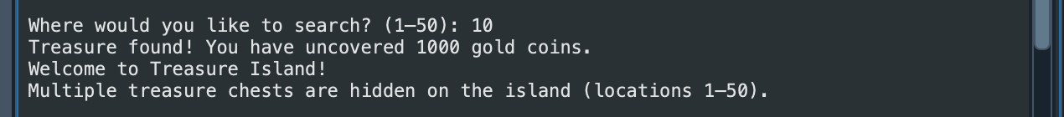
yes

Test:
- Guess is an exact match on the last number in the set

Screenshot(s) of output:
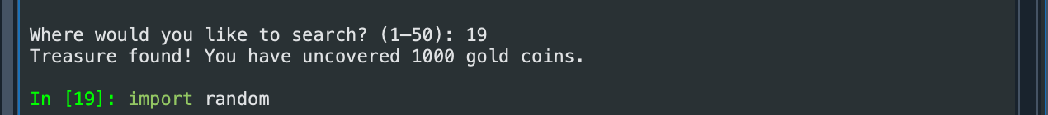
yes

Test:
- -4

Screenshot(s) of output:
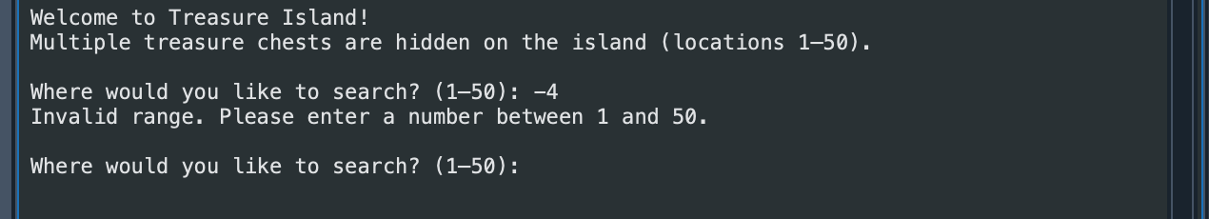
yes

Test:
- 55

Screenshot(s) of output:
yes

Test:
Within 2

Screenshot(s) of output:
yes

Test:
- Within 5

Screenshot(s) of output:
yes

Test:
- Within 2 of two numbers

Screenshot(s) of output:
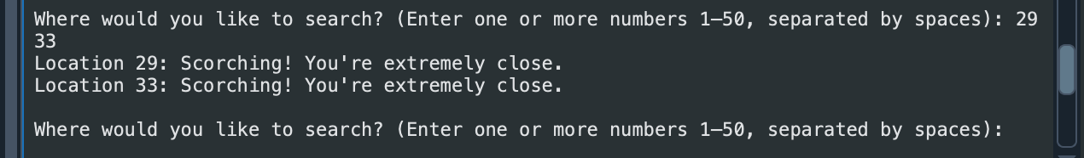
yes

Test:
- Within 2 or 5 of three numbers

Screenshot(s) of output:
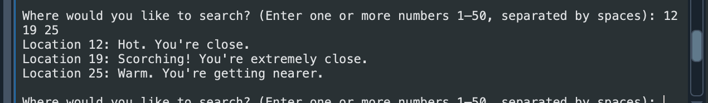
yes

Test:
- Duplicate

Screenshot(s) of output:
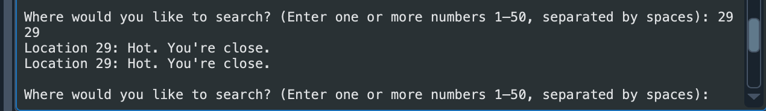
no

- Consider the results of the above tests and revisit your original code in order to address the tests that failed. (Note: you may not be able to solve all of the problems that were originally encountered, but solve as many as you can.)

Paste your full revised code here :
I am unsure how to avoid the duplicate entry. Here is my final code

import random

print("Welcome to Treasure Island!")
print("Multiple treasure chests are hidden on the island (locations 1–50).")

treasure_locations = [random.randint(1, 50) for _ in range(5)]

while True:
user_input = input("\nWhere would you like to search? (Enter one or more numbers 1–50, separated by spaces): ")
guesses = user_input.strip().split()
found_treasure = False

for guess_str in guesses:
try:
guess = int(guess_str)
if guess < 1 or guess > 50:
print(f"Invalid range for guess '{guess}'. Please enter numbers between 1 and 50.")
continue

distances = [abs(guess - loc) for loc in treasure_locations]
min_distance = min(distances)

if min_distance == 0:
print(f"Treasure found at location {guess}! You have uncovered 1000 gold coins.")
found_treasure = True
break
elif min_distance <= 2:
print(f"Location {guess}: Scorching! You're extremely close.")
elif min_distance <= 4:
print(f"Location {guess}: Very hot. The detector is reacting strongly.")
elif min_distance <= 7:
print(f"Location {guess}: Hot. You're close.")
elif min_distance <= 12:
print(f"Location {guess}: Warm. You're getting nearer.")
elif min_distance <= 18:
print(f"Location {guess}: Cool. Perhaps try a different area.")
elif min_distance <= 25:
print(f"Location {guess}: Cold. You're quite far from any treasure.")
else:
print(f"Location {guess}: Freezing. No signs of treasure nearby.")

except ValueError:
print(f"Invalid input '{guess_str}'. Please enter whole numbers only.")

if found_treasure:
break

