We Build Better People
(Griffiths, 2022)

Sarah Chislett 1810559 University of Wales Trinity St David

Date - 03rd December 2023

Resourcing and Talent Management Video

I Sarah Chislett confirm that the work enclosed is my own
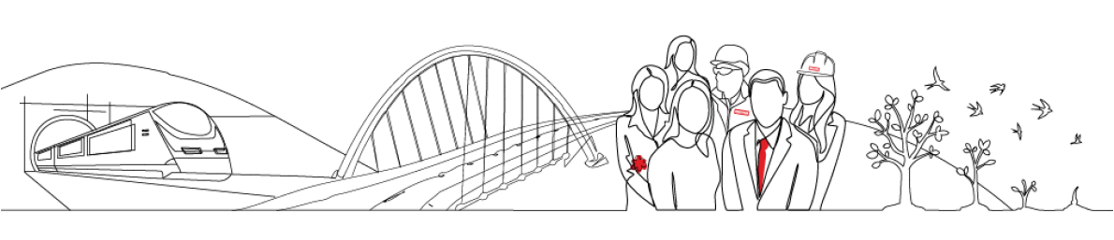

Link to Video

https://youtu.be/l5v1wYzsmxk

Bibliography

Ali, L (2022) Equality, Diversity and Inclusion in the workplace. Available at: https:// www.cipd.org/uk/knowledge/factsheets/diversity-factsheet/ (Accessed 18th November 2023).

Alun Griffiths Contractors (2022) We build better. Available at: https://griffiths.co.uk (Accessed: 25th October 2023).

Bottorff, C. (2022) The four principles of change management. Available at: https://www.forbes.com/advisor/business/principles-of-change-management/ (Accessed: 12th October 2023).

CIPD (2019) Flexible working. Available at: https://www.cipd.org/uk/about/news/flexible-working/ (Accessed: 28th October 2023).

CIPD. (2022) Resourcing and talent planning report 2022. London: Chartered Institute of Personnel and Development

Indeed (2023) How to become and employer of choice. Available at: https:// uk.indeed.com/career-advice/career-development/employer-of-choice (Accessed 18th November 2023).

Peters, R (2023) Employer Brand. Available at: https://www.cipd.org/uk/knowledge/factsheets/recruitment-brand-factsheet/ (Accessed: 18th November 2023).

