Developing workplace critical thinking (BMSK5001)
  Developing workplace critical thinking  SUBMISSION DATE 2nd AUGUST 2019 4000 WORDS | SYED MOKSUDUL ISLAM  STUDENT NUMBER 1709371

Student name: Syed Moksudul Islam
Student number: 1709371
Lecturer: Ernest Ovia
4000 words

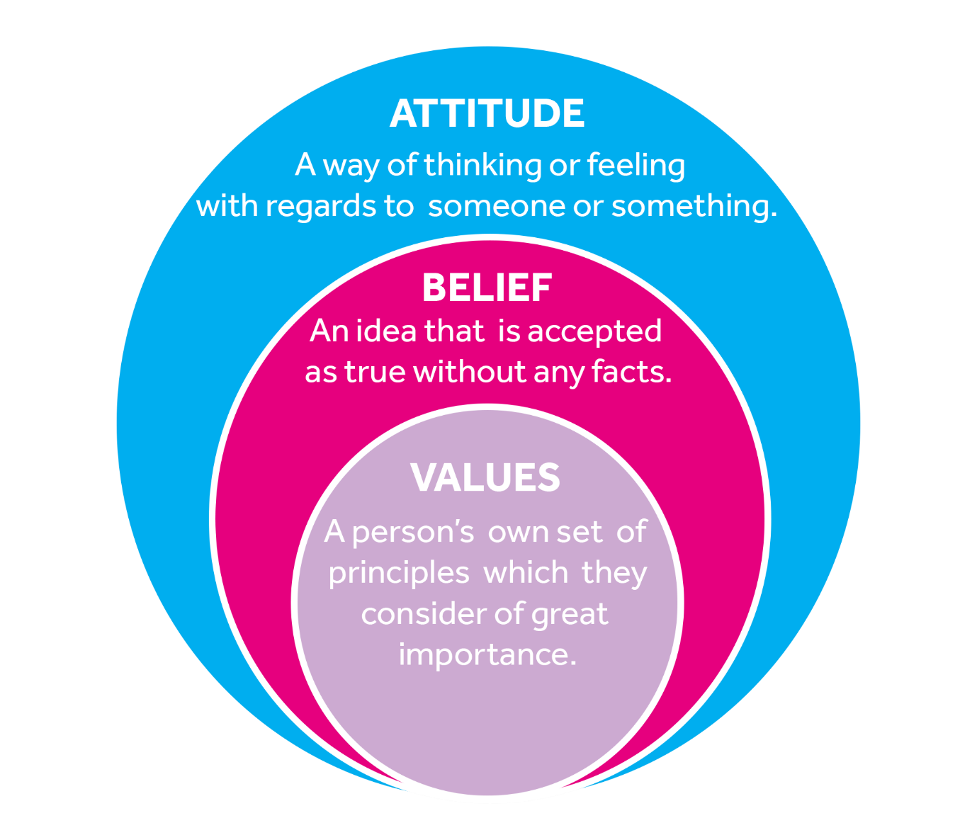

(FutureLearn,2019).

Contents
Contents 2
Introduction: 3
Task 1. 4
Definition of beliefs: 4
Definition of values: 5
Personal beliefs and their impact in the workplace: 6
Personal value and beliefs impact in the workplace behaviour: 7
Attitudes and behaviour in the workplace: 8
Importance/impact of organisational culture: 10
Task 2. 10
Taylor’s scientific management and motivation theory: 10
Other views-Maslow’s hierarchy of needs: 12
Other views- Herzberg 2-factor theory: 12
How relevant is Taylorism in the modern world? 13
Beliefs, values and attitudes and its effectiveness: 13
Conclusion: 14
Reference page: 15

Beliefs, values and attitudes in the NHS

Introduction:
This report assesses various management theories/tools, how individuals hold beliefs, values and attitudes, and how it influences action, behaviour in each individual in workplaces and personal life. The report will also delve in organisational behaviour and its beliefs, values and attitudes; and how critical thinking plays a role in shaping businesses and employees way of thinking in the modern world (Kline, 2002). The study will also thoroughly scrutinise strong organisational culture and how culture is used to manage, develop, progress and govern employees.
National Health Service, also known as the (NHS) to most people is a publicly funded health care service in the UK. It is one the largest health care system in the world, largely funded through government and managed by the Department of Health and Social Care. To access NHS services, the requirements are to be a legal citizen or resident in the UK. There are many vital treatment and services that are free for non-UK and visitors, for example, infectious, sickness and other emergency treatment which are all free for everyone (Brain, 2019).
The Health Care Service was originally established by the Labour Government, Health Minister Nya Bevan’s dream came into being 1948, allowing anyone to legally access the service who is fully registered with health care system in ownership of an NHS number. This was made available to those who are legally residing in the UK irrespectively of their nationality. The NHS has other available non-emergency services like dental care, eye test, prescriptions, long term care, depending on income some these are free or the charges lower to venerable families. NHS provides the majority of the care in the UK; these range from primary care, long term care, inpatient care, dentistry and ophthalmology (Campbell, 2016).
What is critical thinking:
Critical thinking is an advanced form of cognitive thinking; this concept has been evolving during the past 2,500 years (The foundation for critical thinking, 2019). Cottrell (2017) said, the term critical thinking merely means to critical think in an intellectual disciplined to develop clearer analytical thinking, to produce arguments in a systematical approach and interpret effectively and be observant of what one sees and hears.

Task 1.

Definition of beliefs:
According to the dictionary of Merriam Webster (2019) definition of belief is when a person or individual places a trust or confidence, this could be due to habit or it can be a strong political belief in democracy. It can also be a person's religious view, an opinion considered to be factual or this can be on phenomenon or facts, these can be applied as organisational beliefs to any corporations.
Organisational beliefs:
National Health Service (NHS) has 7 beliefs; these set of principles is vital for the care services image. Managers and leaders are the change representatives, and they are given the duty for the implementation of the NHS beliefs and the organisational. The views, beliefs and attitudes are, therefore, principal to the practical and successful implementation of the reform of the NHS culture and image (Merali, 2003).
7 beliefs and principles that guide the NHS:
- NHS delivers a complete service, accessible to all.
- NHS services accessible to all, based solely on clinical necessity and not the ability to pay.
- NHS aims to the highest standards of quality and expertise.
- NHS ensures the all-action and everything it does it taken with patients in mind.
- NHS works to excel above and beyond.
- NHS is responsible for providing the most exceptional value for taxpayers’ money.
- NHS is answerable to the public, communities and patients that it serves (Essex Partnership University NHS Foundation Trust, 2019).
Organisational beliefs are set principles a corporation follows; these beliefs are aimed at individuals and employees to respect the corporation’s belief (Schrodt,2002). Every individual carries his or her personal beliefs, this can occasionally clash in the workplace environment. Having organisational beliefs avoids a common clash, eliminating differences by creating workplace beliefs, where all employees abide and respect one another. These organisational beliefs give companies image and create a culture where different race, religion, gender and, ethics and belief work under the same belief system respectfully; this is a motivation tool that helps employees vision the NHS is wanted to be seen in the private and public spectrum.

NHS beliefs in action
Positive impact on behaviour | Negative impact on behaviour
- Motivates workers to produce good quality of work. | - NHS is not always able to deliver its promise/beliefs as stated.
- Eliminates differences in the workplace  . | - Organisational beliefs and personal beliefs may clash due to differences.
- Gives focus clarity on patient’s rights. | - NHS may ignore religious beliefs to maintain their own belief.
- Everyone works towards a universal NHS approach and goals. | - Some employees may refuse to give up their beliefs.
Figure 1
(Figure 1) Represents how NHS beliefs are applied and how it functions in a working environment. The main objective is to motivate the employees and minimise the differences between staffs and patients.

Definition of values:
According to Collins Dictionary (2019) Value is something an individual gives importance to or something that is useful. Values can mean a person who holds a moral principle and believes he is important values held by a corporation is also known as organisational values.
There are six values in the NHS Constitution, and by living these values an organisation can ensure the best possible care for patients. Patients, public and staff have aided develop of this expression of values that encourage desire in the NHS and that must underpin all it does. Individual bodies will develop and build upon these values, tailoring them to their local needs. The NHS values provide common ground for collaboration to achieve shared aspirations, at all levels of the NHS (GOV.UK, 2019).
NHS 6 core values are also known as the NHS Constitution; these values were created on the bases to ensure excellent care for patients. The values are designed to inspire local care system to deliver services with passion leading to improved care, well-being for patients.
- Working together for patients.
- Respect and dignity.
- Commitment to quality of care.
- Compassion.
- Improving lives.
- Everyone counts (NHS Health Education England, 2019).
These core values/ethics of a company every one must abide regardless of the situation, the constitution is designed to motivate employees in the workplace and to stimulate their best actions and behaviour. Gorenak and Kosir (2012) stressed the importance of values of a company that guide staff behaviour, everyday operational and strategic decision. These core values will establish integrity, moral character, and demonstrate the organisational culture and separate it from the competitors. Values will decrease the threat of bad behaviour and improve and strengthen the moral value of work, and these values play an integral role in constructing a positive culture at an organisation.
Benefits of organisational core values:
- Reduce prejudice and bad behaviour.
- Creates a strong organisational culture.
- Gives guidance and a set of rules to follow.
- Creates diversity and equality for everyone.
- Increases productivity.
Negatives of organisational core values:
- LGBT, gender equality, gay rights- for example, not everyone is quick to accept organisational values because it goes against their values.
- Ideological differences – for example, not everyone believes that men and women are equal.
- Resistance to change - Many, not willing to change due to their religious and cultural beliefs.

Personal beliefs and their impact in the workplace:
Individual beliefs are somewhat one holds to be true; this could be based on scientific facts or something he or she has heard from parents, teachers, colleagues, friends or personal experience. These beliefs are not the same as organisational beliefs, rather personal individual beliefs. Individual beliefs may also include, religious, social, economic, political views, freedom of speech, equal rights, freedom of expression, Jewish right to exist, animals and human rights. It is important to remember that an individual's belief is essential and it will grow and mature into a value, and these beliefs can shape a person way of thinking, behaviour towards others and even have negative and positive impacts workplace and personal lives.
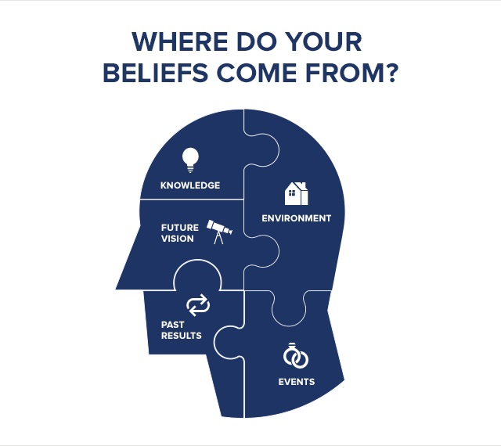
An individual who holds religious views may be truthful and respectful, and as an employee can make a difference in the workplace; managers are continuously seeking employees with honest integrity in the workplace. Workplace scenario, Mr Ahmed and Mr Anderson work in the same hospital ward, the manager notices Mr Ahmed is always truthful due to his religious belief, regardless of what happens in work; Anderson is always trying to hide the truth or make excuses. The manager does not like his behaviour and appoints Mr Ahmed as the team leader. It is essential to remember that beliefs cannot be seen, but behaviour can be seen, and with behaviour, an individual will be judged or measured. However, a religious person is very reluctant to follow specific rules if it contradicts its belief; for example, he may not want to work with female colleagues or take orders from younger workers in a high position, management does not expect someone to change their beliefs, but this only happens on a small scale.
Image sourced from: https://www.tonyrobbins.com/mind-meaning/do-your-beliefs-limit-you/

Personal value and beliefs impact in the workplace behaviour:
Values are significant fundamental of beliefs that lead or inspire attitudes or actions, these describe the personal talents, or in the manner, one would like to be treated, these are seen through our behaviour and action.
Values versus Beliefs
Values can be a set of ethics/principles or one's standard of behaviour, one’s perception of what is essential in life. | Beliefs refer to the accepting something exists or are true, particularly one without evidence.
- Values can affect actions/behaviour and character. | - Beliefs can affect one's moral standard and values.
- Examples of values; integrity, equality, justice, respect and empathy. | - Examples of beliefs; lying is a sin, God created the world, the earth is round.
- Values are related to day to day activity. | - Beliefs are usually related to religion.
Figure 2 sourced from: https://pediaa.com/difference-between-values-and-beliefs/
Values and beliefs both play a vital role in behaviours and attitudes, and both are very much alike. The critical differences, as illustrated in (figure 2), values are driven by ethics, principles, moral standards which displays one's behaviour. Beliefs are driven by religious convictions or something one accepts to be true, and these beliefs can also impact and influence values, attitude and behaviour. Owoyemi and Ekwoaba, (2014) said, the aim of company values is to bring about a positive impact/transformation in an organisation, bringing like-minded people together in line with organisational shared values. These fruitful change will encourage commitment and loyalty to company work, for example, Google believes individuals do not need to wear a suit to impress the company buses, Google prefers contributing to the company and abiding by its core beliefs and values uplifts its image (Saffold, 1988).

Milton J. Rosenberg and Carl I. Hovland designed the following the Three-Component Model of Attitude (1960):
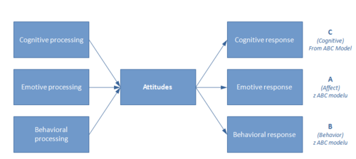
Figure 3. sourced from: https://managementmania.com/en/attitude

Attitudes and behaviour in the workplace:
Definitions of attitude can differ, according to Collins Dictionary (2019), attitude is something an individual thinks or feels; this is often shown in an individual’s behaviour. There are three main components that create attitudes (emotions-behaviours-thoughts). These are also known as the ABC model (affective-behavioural-cognitive) as illustrated in the above diagram. Attitude is a combination of values and beliefs which develop over a specific time in every individual. Individual attitude is displayed through behaviours; these behaviours can be negative or positive. Having assumptions on a person behaviour are not always accurate. For example, if an individual turns up to a job interview in jeans and t-shirt, the interviewer may think that the job applicant is not interested or has no respect; the other perspective is the applicant may believe that his skill and knowledge is enough to get him the job and not his dress sense. Some occasions employees can change or fake their own behaviour suiting individual needs when necessary or wanting something from the management, the final stage of attitude is behaviour, and most people will be judged by their behaviours. However, managers need to be aware of this before making any judgments. It’s a true fact that positive behaviour can lead to a job promotion, more customer satisfaction, respect from peers and more productivity. Under the specific condition, behaviour can be a crucial indicator of an employee, whether the employee is happy in his job position or going through some personal dilemma (Martin and Siehl, 1983).
The diagram outlines the bases of our beliefs, value and attitudes, and how it impacts our behaviour, it also shows how each one is connected.
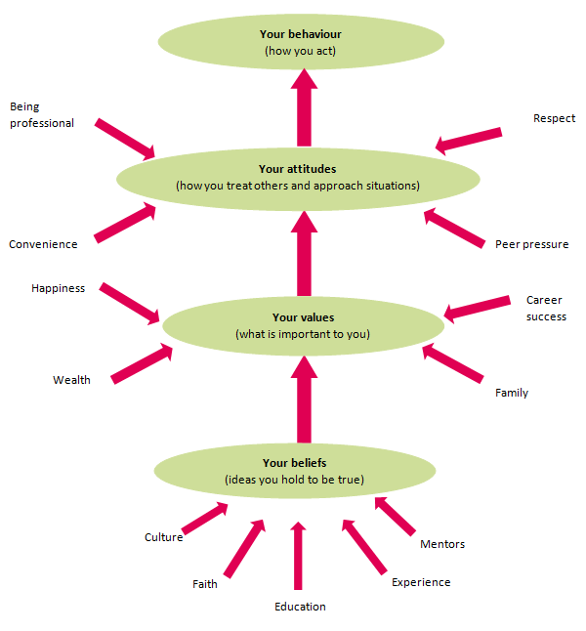
Figure 4. Image sourced from: https://www.iaa.govt.nz/for-advisers/adviser-tools/ethics-toolkit/personal-beliefs-values-attitudes-and-behaviour/

Importance/impact of organisational culture:
According to Sun (2009), organisational culture is a manifestation of characters of an organisation, values and beliefs are the core of the culture and are shared by all personnel in an organisation. Hofstede (1997 wrote, culture can encourage people behaviour and think, for that reason, it is vital that organisation comprehend what is culture. Others like Grieves (2000) said the corporation should adopt the growth of human values. Deal and Kennedy (1982) supported organisational growth should be implemented with organisational culture to create a productive working environment. These direct employees and members making positive impacts on revenues, performance and image; these create a positive working condition for employees, Organisation's main goal is to create an environment that inspires their employees to connect, plan and make responsible choices. These are organisations, guidelines and code of conduct that all employees are expected to follow.

Task 2.

Taylor’s scientific management and motivation theory:
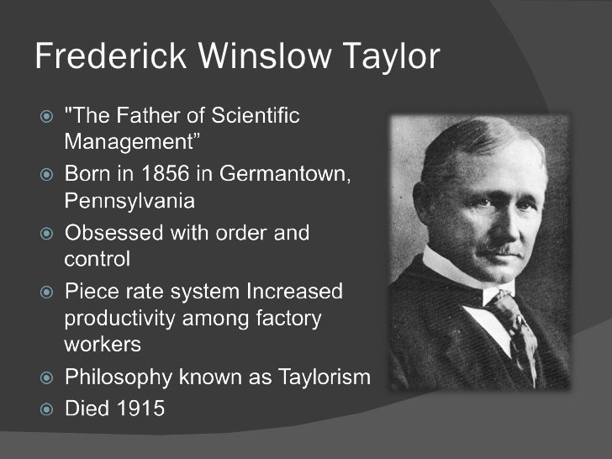
Frederick Winslow Taylor, an engineer who bought us the first motivation theory in the 1900s, it was the earliest scientific theory on workplace motivation, Taylor’s goal and desire were to find the most efficient way of performing a task. The theory is based on a very autocratic leadership, where a manager or a leader tells its employees and these instructions are carried out without questions. Taylor’s scientific motivational model was very time based and did not consider human needs, it is merely driven by the motivation of money and wealth; he believes that individual/employees were all driven by money. (Tools Hero, 2019). The example of this style can be found in the modern business-like Amazon, Primark and McDonald’s. McDonald's took his business further across the globe, by creating a system that is very similar and uses the same approach, and employees will follow the identical technique serving, cleaning, packaging, uniform and ingredients, in the same manner, this allows more output, yield and efficiency. Henry Ford used this identical model, paying piece rate, which led to mass production in car manufacturing. Amazon became a global phenomenon pushing profitability through efficiency, using technologies like wrist bands tracking the worker's performance all three based on Taylor’s theory (Yeginsu, 2018); however, there are minimum workers’ rights, low wages very little democracy more driven towards the autocratic style of leadership.
Taylor’s scientific management theory.
Science, not rules of thumb | Scientifically train employees. | Ensure the most efficient ways of working are used. | Divide work between managers and workers. | Pay based on results.

Figure 5.
Above diagrammed shows the scientific principle approach to management, Taylor’s approach was first identifying the most efficient approach to the job. Secondly, train each employee based on what is learned from the first theory. The third approach was, select the most efficient worker and used and monitor the worker for effectiveness. Forth approach was to divide the work between managers for the process of development and pay based on how much staff produce. Having examined Taylor’s theory against the different business model likes of Amazon, McDonald's it becomes transparent that it functions mainly to save time, money and create a greater output. Taylors’ theory is outdated; it came about in the industrial revolution where manufacturing was abundant, driven by profit; NHS is a service and not a manufacturing business, nor does it pay based on piece work. Its model lacks workers’ rights and democracy, whereas NHS is a publicly funded run by the government; it shows much empathy towards its staff and stakeholders. However, most of the modern companies have adopted this theory by adding additional features like pension, holiday pays, sick pay and maternity pay, e.g., for that reason it is possible to use it in the NHS.
Benefits of Taylorism:
- Saves time-Taylor’s method utilises the most scientific efficient/organised methods of production.
- High output- Taylor’s rate of pay based performance, this led to higher output in certain environment’s like manufacturing.
- Lowers expense reducing labour cost.
- Increases profit by finding the most scientific solution to productivity.
- Motivates workers to work higher efficiency because of Taylor’s stopwatch method.
Negatives of Taylorism:
- Dehumanises employees by treating them like robots.
- No democracy, because employees have very little method or input in the methods used.
- Negative image of Taylorism due to connection communism style of work.
- Does not consider the importance of workers beliefs or values.

Other views-Maslow’s hierarchy of needs:
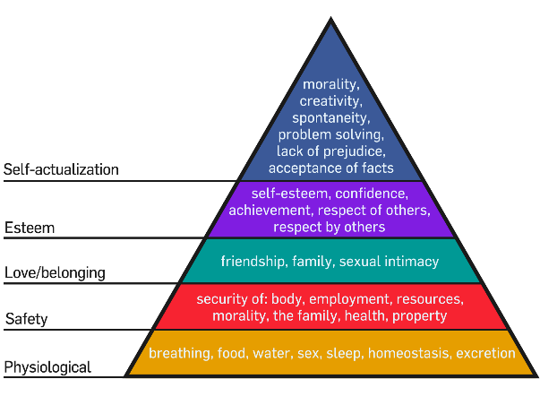
Abraham Maslow’s theory is based on individual needs and not driven by money, and he believed employees had other needs and satisfaction. Though money is the primary driver, there are other needs like job security, good working conditions, a great job title, recognition for one's hard work and opportunity for promotion. Organisations need to recognise that workers as assets and should invest through creating different incentives.
Figure 6. sourced from: https://medium.com/@MarshaChan/applying-some-psychology-to-social-media-9deb505f678

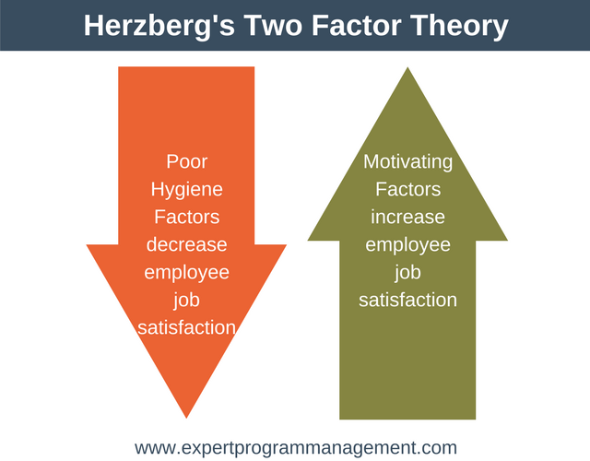
Other views- Herzberg 2-factor theory:
Professor Fredrick Herzberg also believed an employee is not always driven by money; he to believed there are other reasons like non-financial rewards. He believed that if the hygiene factors were not met, workers would be demotivated.

Figure 7. sourced from: https://expertprogrammanagement.com/2018/04/herzbergs-two-factor-theory/
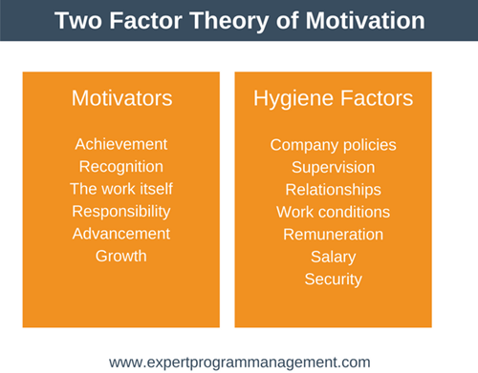
It is categorically important that the hygiene factors and motivators are met, the absence of these factors may cause negative behaviour towards the job. He believed workers motivation came from no- financial rewards, as illustrated in figure 6. Both Maslow and Herzberg theory mirrored each other and their approach toward job enrichment and satisfaction were very similar, and it was very people-focused.
Figure 8. sourced from: https://expertprogrammanagement.com/2018/04/herzbergs-two-factor-theory/

How relevant is Taylorism in the modern world?
Taylor showed us how to mass-produce consumer goods efficiently as possible minimising costs, saving time, producing more profit, and his idea came about in the early industrial revolution where work was abundant and countries were growing fast to meet consumer demands. What many critiques overlooked about Taylor's theory, it is still implemented even today; with likes of McDonald's, Burger King, Amazon and Primark and many others (Derksen, 2014). Many argued it is an outdated method, and it is no longer practical, and that is further from the truth. Taylor’s method has evolved with the current period and on employee’s demand; it has implemented most legal requirement like sick pay, pension and safety etc (Caldari, 2007). It is also one of the favourite methods used in India, Bangladesh, Pakistan and other African countries; these nations are developing countries and mass produce goods for the western corporations at a very low cost, though others have questioned the ethics behind these models (Picavet, 2009). Taylorism has not died just merely evolved into the new world global capitalism serving western consumers, still serving industries as it did in early 1900. Furthermore, while Herzberg and Maslow’s theory is good for the first world countries, Taylor's theory is excellent for developing countries.

Beliefs, values and attitudes and its effectiveness:
A great many people do not comprehend the effectiveness of beliefs, values and attitudes function in a workplace or how it shapes an individual’s thoughts, behaviours. There is no doubt, some of the most successful companies have core values and beliefs (Leibson, 2018). For example, Apple, Microsoft, NHS and many more, these companies have reaped the rewards of having a workplace constitution. A large corporation likes to cement itself in the public spectrum, giving a positive image of itself. These core values are aimed at the public, employees, team leaders and managers.
The influence of belief, values and behaviour can be underestimated, for example, the great Mahatma Gandhi and Nelson Mandela believed in freedom and equality, their positive behaviour viewed by the public led to the rebellion and of liberty of their country. Same in business and corporation take this approach of influencing their employees with the creation of universal organisational culture, bringing like-minded people together from different culture thus illuminating differences and bias. It is fair to say that every individual comes with pre-existing preconceptions, thoughts and beliefs, to alter this behaviour organisational constitution plays a major role in aligning with organisational beliefs and culture. Organisational culture is a way of managing their human resources effectively.
The most important lesson learnt here is, organisational intentions are to influence their human resource, by creating a climate of culture, this can only be applied by the managers and leaders; only they can physically and proactively implement the organisational constitution, combining with Taylor’s management tools as mentioned above.

Conclusion:
From birth, we are all hard-wired to think and behave in a particular way. People come to organisations with pre-existing beliefs and values, which can be influenced by their own personal experience. Everyone is entitled to their own beliefs and no one has the right to ask them to change this because its different from someone else. However, the organisation have responsibilities and need to manage the human resource. Using corporate beliefs, constitutions and management tools, an organisation can give guidance to their employees and some rules to follow. These are designed to bring every individual inline with organisational culture and beliefs.

Reference page:

- Brain, J. (2019). The birth of the NHS - Historic UK. [online] Available at: https://www.historic-uk.com/HistoryUK/HistoryofBritain/Birth-of-the-NHS/ [Accessed 24 Jun. 2019]
- Caldari, K. (2007). Alfred Marshall's critical analysis of scientific management. The European Journal of the History of Economic Thought, 14(1), pp.55-78.
- Campbell, D. (2016). Nye Bevan's dream: a history of the NHS. [online] the Guardian. Available at: https://www.theguardian.com/society/2016/jan/18/nye-bevan-history-of-nhs-national-health-service [Accessed 16 Jun. 2019].
- Collins Dictionary. (2019). Attitude definition and meaning | Collins English Dictionary. [online] Available at: https://www.collinsdictionary.com/dictionary/english/attitude [Accessed 21 Jul. 2019].
- Collins Dictionary. (2019). Value definition and meaning | Collin’s English Dictionary. [online] Available at: https://www.collinsdictionary.com/dictionary/english/value [Accessed 17 Jul. 2019].
- Cottrell, S. (2017). Critical thinking skills. 3rd ed. London: Palgrave/Macmillan Education.
- Deal, T.E. & Kennedy, A.A. (1982). Corporate cultures. The rites and rituals of corporate life. Addison-Wesley, Reading, MA.
- Derksen, M. (2014). Turning Men into Machines? Scientific Management, Industrial Psychology, and the “Human Factor”. Journal of the History of the Behavioral Sciences, 50(2), pp.148-165.
- Essex Partnership University NHS Foundation Trust. (2019). 7 Key Principles | EPUT. [online] Available at: https://eput.nhs.uk/about-us/nhs-constitution/7-key-principles/ [Accessed 16 Jul. 2019].
- Future Learn. (2019). Values, beliefs and attitudes. [image] Available at: https://www.futurelearn.com/courses/supporting-learning-secondary/1/steps/483490 [Accessed 1 Jul. 2019].
- Gorenak, M. and Kosir, S. (2012). The importance of organizational values for organization. [online] ResearchGate. Available at: https://www.researchgate.net/publication/239807972_The_Importance_of_Organizational_Values_for_Organization [Accessed 31 Jul. 2019].
- GOV.UK. (2019). The NHS Constitution for England. [online] Available at: https://www.gov.uk/government/publications/the-nhs-constitution-for-england/the-nhs-constitution-for-england [Accessed 20 Jul. 2019].
- Grieves, J. (2000). Introduction: the origins of organizational development. Journal of management development, 19(5), pp.345-447.
- Hofstede, G. (1997). Culture and organisations: Software of the mind: Intercultural cooperation and its importance for survival. McGraw-Hill.
- Kline, N. (2002). How do personal values influence health care?. Journal of Pediatric Oncology Nursing, 19(4), p.113.
- Leibson, H. (2018). The Power of purpose-driven. [online] Forbes. Available at: https://www.forbes.com/sites/hayleyleibson/2018/01/25/the-power-of-purpose-driven/#351421bd5dca [Accessed 31 Jul. 2019].
- Martin, J. and Siehl, C. (1983). Organizational culture and counterculture: An uneasy symbiosis. Organizational Dynamics, 12(2), pp.52-64.
- Merali, F., 2003. NHS managers' views of their culture and their public image: The implications for NHS reforms. The international journal of public sector management, 16(7), pp. 549-563.
- Merriam Webster. (2019). Definition of belief. [online] Available at: https://www.merriam-webster.com/dictionary/belief [Accessed 14 Jul. 2019].
- NHS Health Education England. (2019). The NHS constitutional values hub. [online] Available at: https://www.hee.nhs.uk/about/our-values/nhs-constitutional-values-hub-0 [Accessed 17 Jul. 2019].
- Owoyemi, O. and Ekwoaba, J. (2014). Organisational culture: A tool for management for management control, motivate and performance enhancement. American journal of business and management, 3(3).
- Picavet, E. (2009). Opportunities and pitfalls for ethical analysis in operations research and the management sciences. Omega, 37(6), pp.1121-1131.
- Saffold, G. (1988). Culture traits, strength, and organizational performance: Moving beyond “strong” culture. Academy of management review, 13(4), pp.546-558.
- Schrodt, P. (2002). The relationship between organizational identification and organizational culture: Employee perceptions of culture and identification in a retail sales organization. Communication studies, 53(2), pp.189-202.
- Sun, S. (2009). Organizational culture and its themes. International journal of business and management, 3(12), p.137.
- The foundation for critical thinking. (2019). Defining critical thinking. [online] Available at: http://www.criticalthinking.org/pages/defining-critical-thinking/766 [Accessed 13 Jul. 2019].
- Tools Hero. (2019). Frederick Taylor, founder of scientific management | Tools Hero. [online] Available at: https://www.toolshero.com/toolsheroes/frederick-taylor/ [Accessed 25 Jun. 2019].
- Yeginsu, C. (2018). If workers slack off, the wristband will know. (And Amazon has a patent for it.). [online] The New York Times. Available at: https://www.nytimes.com/2018/02/01/technology/amazon-wristband-tracking-privacy.html [Accessed 29 Jul. 2019].

