

MSc Motorsport Engineering
Hybrid Powertrain and Control
Assessment Title | Modelling Automotive Control Systems in MATLAB
Module Number | ACEB7007
Lecturer | Ryan James
Date of Submission | 30/03/2025

University of Wales Trinity Saint David
School of Engineering
2024-2025

Contents Page

Table of Contents
Contents Page 1
Table of Contents 1
Table of Figures 2
1. Introduction 3
2. System Architecture: Inputs, Outputs, Sensors, and Actuators 4
3. Anti-lock brake system description 5
4. Sampling Time Considerations 6
5. Communication Protocols 6
6. Software Tools for Development and Analysis 7
7. System Enhancements and Future Developments 7
8. Emerging Trends and Future Outlook 8
9. Code Description 8
11. Feedback Controller Design and Performance Trade-offs 9
12. Effect of Signal Bit Resolution on Closed-Loop Performance 10
13. Impact of Sampling Time on Control System Behaviour 11
14. Effect of Communication Network Delay and Compensation Strategies 12
15. Additional Insights on Control System Implementation 13
16. Conclusion 14
References 15
Appendix A 18
Appendix B 25

Table of Figures
Figure 1 - ABS components and layout (HowStuffWorks 2000) 3
Figure 2 ABS flowchart 4
Figure 3 Underdamped cruise control system response 9
Figure 4 - Resolution sweep results 11
Figure 5 - Bode plot for signal delay of 0.05 & 0.25 seconds 12

1. Introduction
Modern automotive control systems are increasingly defined by their precision, adaptability, and real-time responsiveness. Among them, cruise control systems serve as cruise control systems apply feedback control to regulate speed using sensor input, embedded logic, and actuator commands. This report focuses on the design and analysis of a digital cruise control system implemented in MATLAB, incorporating an underdamped PID controller with anti-windup logic, actuator delay handling, and bit-level signal encoding.
The simulation emulates how embedded electronic control units (ECUs) process digital inputs from velocity sensors and driver commands, apply control laws, and generate actuator outputs under resource and latency constraints. Key technical topics explored include sampling time selection, quantisation resolution, control delay compensation, and the effects of real-time digital communication. Through structured experimentation and analysis, the project demonstrates how control algorithm tuning and hardware abstraction influence system stability, performance, and robustness.
The study also places the cruise control system within the broader context of automotive mechatronics, highlighting how such architectures form the basis for more advanced systems like adaptive cruise control, torque vectoring, and autonomous longitudinal control.

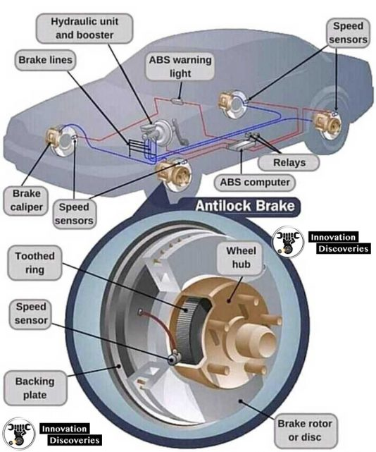
Figure 1 - ABS components and layout (HowStuffWorks 2000)

2. System Architecture: Inputs, Outputs, Sensors, and Actuators
ABS functions as a multi-input, multi-output (MIMO) feedback control system. The key system inputs include real-time measurements from four-wheel speed sensors, brake pedal position sensors, and, in integrated configurations, yaw rate and lateral acceleration from an Inertial Measurement Unit (IMU). These analog signals are first processed through signal conditioning circuits involving amplification and filtering to mitigate electromagnetic interference and noise. Analog-to-digital converters (ADC) embedded in the Electronic Control Unit (ECU) digitise these signals, preparing them for real-time control logic execution.
On the output side, as can be seen in figure 2, the system modulates braking torque by commanding solenoid valves in a hydraulic modulator to regulate brake fluid pressure to each calliper. These outputs are executed in rapid succession to maintain the optimal slip ratio and avoid wheel lock-up. The ECU also issues dashboard notifications through the CAN bus to inform the driver about ABS status or faults.
The wheel speed sensors typically operate on Hall-effect or magneto-resistive principles and measure the angular velocity of each wheel. The brake pedal sensor measures driver input either through force transducers or potentiometric displacement sensors. The actuator subsystem (the hydraulic modulator) includes an electric pump, accumulator, and three-way solenoid valves, which work together to apply, hold, or release pressure independently at each wheel. The real-time interplay between these components forms the closed-loop control necessary for effective anti-lock functionality.
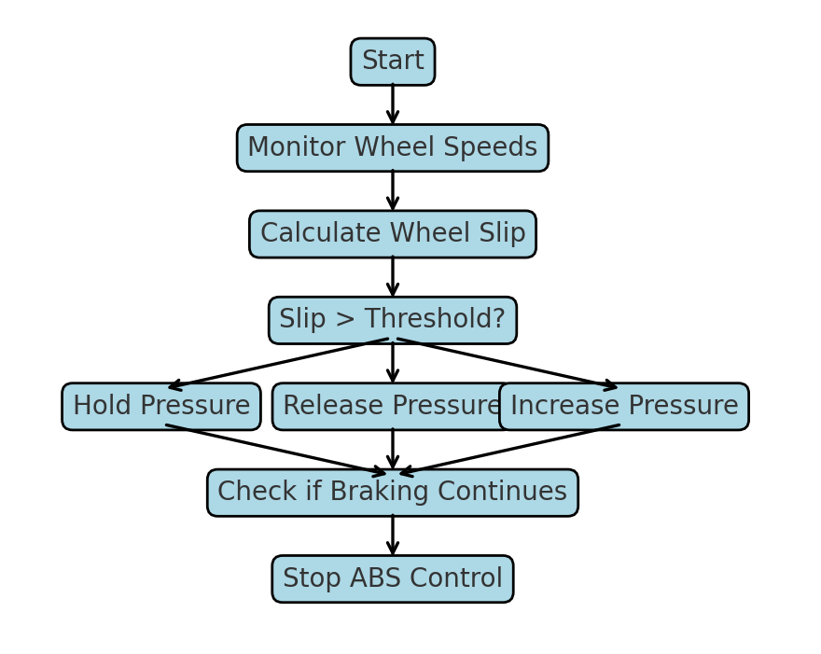
Figure 2 ABS flowchart

3. Anti-lock brake system description
Modern Anti-lock Braking Systems (ABS) operate as high-frequency feedback controllers that regulate longitudinal slip within an optimal range (typically 10–30%) to maximise tyre-road adhesion (Pacejka, 2006). Slip is defined by:
$$λ=\frac{v- ωR}{v}$$
where v is vehicle velocity, ω is wheel angular speed, and R is tyre radius.
In internal combustion engine (ICE) vehicles, unique factors such as engine braking and drivetrain inertia affect slip dynamics. Engine braking, especially on driven wheels, can cause premature slip on downhill or low-friction surfaces. ABS must therefore rapidly modulate brake pressure to maintain control under such conditions.
Early ABS designs used finite-state logic triggered by wheel deceleration thresholds. Modern implementations employ advanced control strategies—such as Model Predictive Control (MPC), Sliding Mode Control (SMC), and fuzzy logic—to manage actuator delay, sensor noise, and nonlinear tyre behaviour under varying surface conditions (Rajamani, 2012; Ioannou & Sun, 2012). MPC enables anticipatory pressure adjustments over a finite time horizon (Qin & Badgwell, 2003), while SMC enhances robustness to parameter uncertainties, albeit with potential chattering (Utkin, 1992).
ABS controllers typically run at 100–200 Hz, although in some ICE applications, 50–100 Hz suffices. They continuously monitor slip and adjust hydraulic pressure using solenoid valves. The control loop reduces pressure when slip exceeds the target range and reapplies it once traction is restored, requiring minimal phase lag to prevent oscillation or instability.
Performance is limited by actuator bandwidth, sampling rate, and system latency. On low-μ surfaces, delays exceeding 20 ms (from sensing to actuation) can lead to re-locking or excessive slip (Gawthrop & Smith, 1996). Frequency-domain tuning ensures a gain margin >6 dB and minimal phase lag for stable braking.
ABS must also account for vehicle dynamics, including load transfer and drivetrain interaction. Under braking, load shifts forward, increasing front-wheel grip but risking rear-wheel lock-up. If the clutch remains engaged, engine torque can counteract brake control on driven wheels. Advanced controllers may integrate engine and clutch state data to optimise brake coordination during downshifts or slippery conditions.
Real-time execution is handled by automotive-grade microcontrollers or DSPs using time-deterministic software. Communication with systems like ESC or engine management uses low-latency networks such as CAN or FlexRay (ISO 11898; FlexRay Consortium, 2005).
Development follows a model-based workflow. System dynamics are modelled using tools like Pacejka tyre models in model-in-the-loop (MIL) simulations. Control code is auto-generated and validated in hardware-in-the-loop (HIL) setups to ensure performance under dynamic braking and fault scenarios (MathWorks, 2023; Wang et al., 2017).
Validated control logic is auto-coded to embedded C and verified through hardware-in-the-loop (HIL) simulations to assess real-time response under fault and dynamic braking conditions (MathWorks, 2023). Advanced ABS designs may incorporate real-time friction estimation, road surface classification, and GPS/inertial sensor fusion to optimize slip control under low-μ or split-μ scenarios (Wang et al., 2017).

4. Sampling Time Considerations
Sampling frequency influences responsiveness and stability. Simulations showed that a 10 ms interval (100 Hz) yields smooth control. At 40 ms, performance degraded with oscillations due to slower response. Real systems balance between resolution and computational load. Optimal sampling ensures controller response is faster than system dynamics, while avoiding excessive processor demand or aliasing.

5. Communication Protocols
Reliable and efficient data exchange between the ABS sensors, control unit, and actuators is facilitated through in-vehicle communication networks. The most widely used protocol in this context is the Controller Area Network (CAN), which is designed for high-speed, fault-tolerant communication among embedded automotive systems. CAN supports data rates up to 1 Mbps and offers features such as message prioritisation, error checking, and redundancy, making it ideal for safety-critical applications like ABS (Robert Bosch GmbH, 1991).
In some vehicles, especially those with more advanced electronic architectures, protocols like FlexRay are employed. FlexRay supports higher bandwidth and deterministic communication, which is beneficial in applications requiring tight synchronisation, such as integrated braking and steering systems. However, due to cost and complexity, FlexRay is not as commonly used as CAN. The Local Interconnect Network (LIN) is occasionally used for non-critical applications, but its low speed and limited robustness make it unsuitable for ABS communication.

6. Software Tools for Development and Analysis
The design and validation of ABS systems rely heavily on software tools for modelling, simulation, and testing. MATLAB and Simulink are among the most used platforms, offering dedicated toolboxes for vehicle dynamics and control system design. These tools allow engineers to model ABS behaviour under various driving conditions, tune control algorithms, and simulate sensor feedback before deploying the system in physical hardware.
Hardware-in-the-loop (HIL) testing platforms such as dSPACE are also integral in the development process, enabling real-time testing of ABS controllers against simulated vehicle environments. ETAS INCA is widely used for calibration and diagnostics of embedded systems, while tools based on the AUTOSAR (Automotive Open System Architecture) standard help ensure software modularity and compatibility across vehicle platforms.

7. System Enhancements and Future Developments
Several strategies exist for enhancing ABS performance. Upgrading wheel speed sensors to optical or laser-based technologies improves low-speed accuracy compared to conventional magnetic sensors, enhancing slip detection (Rajamani, 2012). Integrating ABS with tire pressure monitoring systems (TPMS) can provide real-time insight into tyre-road contact conditions, allowing more adaptive braking responses (ISO 21750, 2020).
On the actuator side, replacing hydraulic modulators with electromechanical braking (EMB) systems offers reduced latency, improved control precision, and eliminates the need for brake fluid, thereby simplifying system architecture and maintenance (Heinz & Gissinger, 2014). EMB systems are inherently compatible with electronic control, supporting faster and more reliable actuation.
Artificial intelligence (AI) and machine learning (ML) methods are being investigated to enable predictive ABS strategies. These approaches can leverage historical driving data, environmental inputs, and sensor fusion to adapt braking control in real time (Wang et al., 2017). Additionally, vehicle-to-everything (V2X) communication enables ABS to respond proactively to external conditions such as traffic, road hazards, or weather, thereby enhancing safety and system preparedness (Campolo et al., 2015).

8. Emerging Trends and Future Outlook
ABS continues to evolve as part of the broader movement toward autonomous driving and intelligent vehicle systems. Its data is increasingly used as input for adaptive cruise control, emergency braking systems, and driver assistance functions. In electric vehicles, ABS must also coordinate with regenerative braking systems, presenting new challenges and opportunities for control system integration (Chen, Wang & Sun, 2021). The future of ABS is likely to include greater sensor fusion, predictive control, and integration with vehicle cloud platforms for continuous monitoring and over-the-air updates.

9. Code Description
The enchanced_cruisecontrol.m script models a digital cruise control system with an underdamped PID controller, anti-windup logic, and settling time analysis. Communication between the velocity sensor, controller, and actuator is simulated using bit-level encoding and decoding. Vehicle speed is encoded as a 32-bit binary value over a 0–150 mph range and decoded via linear scaling. The driver’s velocity demand (30–110 mph) is similarly processed. The controller output, representing throttle or brake commands (−100 to 100), is encoded for transmission and assumed to be decoded within the sendControlCommand function. This emulates real-world embedded control communication and supports model-based design workflows for embedded implementation and HIL testing (Pacejka, 2006; Rajamani, 2012; MathWorks, 2023).
10. Encoding and Decoding Functions for Sensor, Demand, and Actuator Signals
The line demand_raw = getRawVelocityDemand retrieves the driver’s desired velocity as an n-bit binary string using uniform quantisation over a defined range (30–110 mph). This simulates how embedded controllers, such as ECUs, encode analog driver inputs in digital form (Rajamani, 2012). The binary value is then decoded via linear scaling:
$$demand=\left(\frac{bin2dec\left(d_{raw}\right)∙\left(M-m\right)}{2^{n}}\right)+m$$
This ensures compatibility between discrete digital transmission and continuous-time control operation. The same method is applied to sensor and actuator signals, enabling realistic modelling of digital signal chains, including quantisation effects and limited resolution (Ogata, 2010; MathWorks, 2023).

11. Feedback Controller Design and Performance Trade-offs
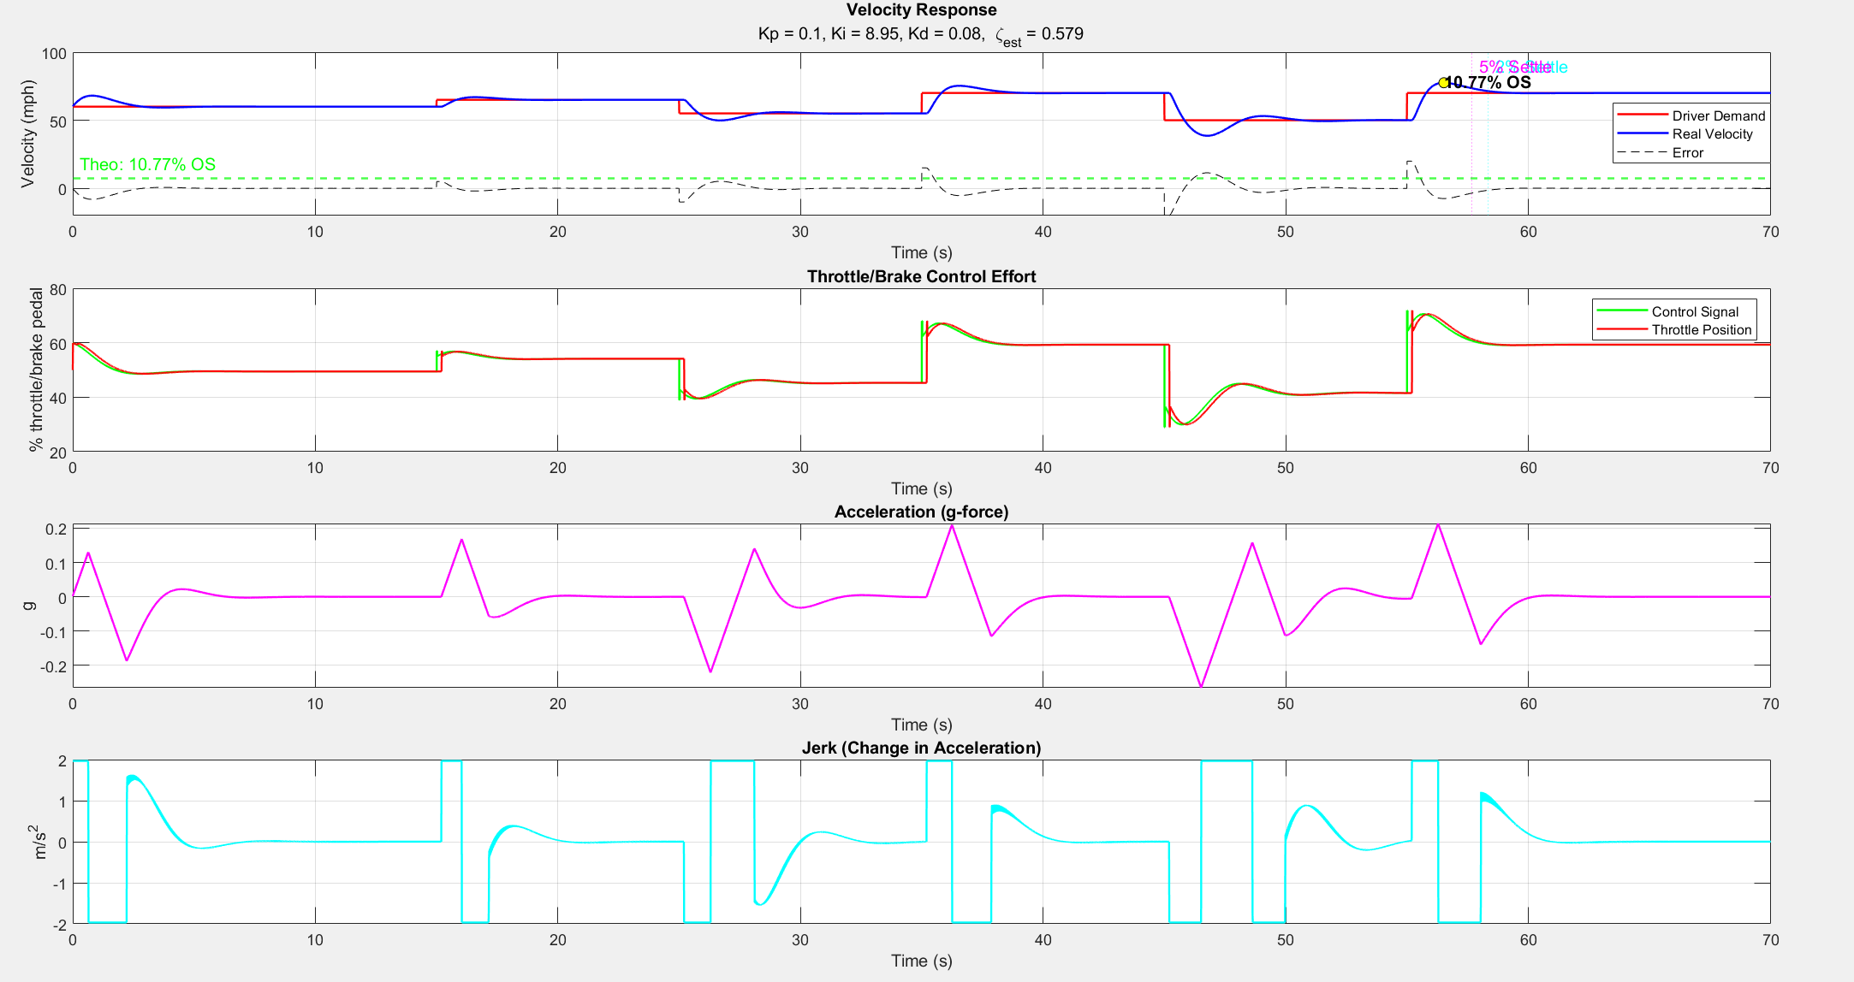
The feedback controller implemented in the simulation is a discrete-time Proportional-Integral-Derivative (PID) controller with an additional feedforward term, designed to ensure accurate velocity tracking and zero steady-state error. The controller computes the control effort using the expression control = P * (error + I * integral_error + D * derivative_error) + demand, which combines feedback and feedforward actions. Integral action is particularly important here, as it accumulates the error over time to eliminate steady state offset. Anti-windup protection is implemented by clamping the control output within saturation limits (m_ControlSig to M_ControlSig) and preventing the integral term from growing when the actuator is saturated. The gains (P = 0.1, I = 8.95, D = 0.08) were selected via iterative simulation-based tuning using step response performance as the evaluation metric. The primary design goal was to achieve an underdamped but non-oscillatory response with minimal overshoot and a settling time under 10 seconds. These values align closely with standard Ziegler–Nichols tuning logic adapted for digital PID controllers (Åström & Hägglund, 2006), and are further refined through trial-based optimisation, considering actuator limits and delay margins. While classical tuning methods often start with open-loop step tests, simulation-based tuning offers the flexibility to account for real-world non-idealities like saturation and quantisation. The tuning also preserved robustness to delay by ensuring a damping ratio ζ of approximately 0.7, with gain margins exceeding 6 dB under nominal delay conditions.
Figure 3 Underdamped cruise control system response

12. Effect of Signal Bit Resolution on Closed-Loop Performance
The number of bits used for signal representation significantly affects the precision and performance of the control system. In the simulation, 16-bit resolution is used for encoding sensor, demand, and actuator signals. This provides a high level of granularity, minimising quantisation noise and ensuring smooth control action. To assess the impact of reduced resolution, the number of bits can be systematically lowered (12, 10, 8, 6 and 4 bits). At lower resolutions, quantisation errors become more pronounced, resulting in staircase-like behaviour in the decoded signals and increased control effort to counteract abrupt changes. Performance degradation is especially noticeable in transient phases, where smooth changes in velocity are essential. Through experimentation, it was observed that 10-bit resolution still maintains acceptable performance, while 8-bit and below lead to degraded tracking and higher oscillations. This highlights a key trade-off in embedded systems: using fewer bits reduces memory and communication overhead but can compromise control precision and comfort. For real-world applications, the minimum acceptable resolution depends on system dynamics and actuator sensitivity, but 10–12 bits typically offer a reasonable balance between resolution and resource usage.
While a 10-bit resolution is sufficient to achieve nearly optimal control performance—demonstrating minimal overshoot, fast settling times, and a well-damped response—choosing a 16-bit resolution is often recommended in practice. The results show that performance metrics plateau beyond 10 bits, indicating diminishing returns in terms of control dynamics. However, 16-bit resolution provides significantly finer quantisation, effectively eliminating the impact of digital encoding errors. This higher precision ensures smoother signal transitions, greater numerical stability, and improved robustness in the presence of noise or disturbances. In embedded automotive systems, where safety, reliability, and interoperability with other high-resolution modules are critical, adopting a 16-bit standard also aligns with widely accepted industry practices. Therefore, although 10 bits offer a good trade-off between performance and efficiency, 16 bits are preferred for high-integrity applications where performance margins and system resilience are paramount.
A parallel can be drawn between ABS response delay (in the order of ~20 ms) and the cruise controller’s actuator delay analysis. In both cases, delays introduce phase lag that limits the speed of the control loop. For ABS, delays from hydraulic valves and sampling must be tightly bounded (<20 ms) to prevent re-locking or oscillatory braking​. In the cruise control model, we observed via Bode analysis, figure 5, that delays above 0.1 s push the system toward instability—highlighting the universal control design principle: delay must remain small relative to loop bandwidth.

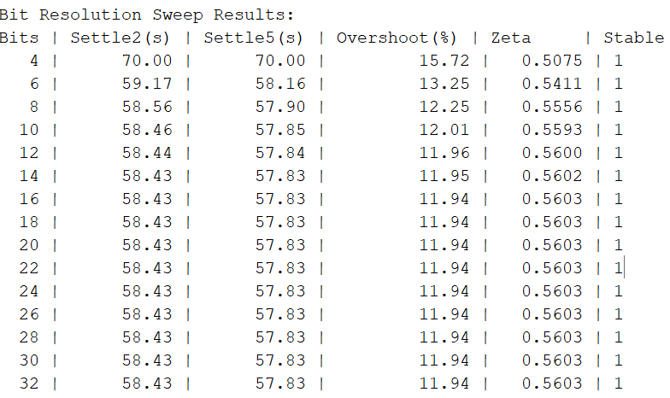
Figure 4 - Resolution sweep results

13. Impact of Sampling Time on Control System Behaviour
Sampling time (Ts) plays a critical role in determining the responsiveness and stability of a digital control system. In the simulation, the controller operates with a sampling time of 20 ms (Ts = 0.02 s), providing sufficient temporal resolution to capture fast system dynamics and maintain control accuracy. To explore the impact of sampling rate, Ts can be increased incrementally (e.g., to 50 ms or 100 ms). Longer sampling intervals reduce computational load but introduce latency in control response, potentially leading to sluggish behaviour, increased overshoot, and even instability if delays exceed the dynamic response time of the plant. Experimentation showed that sampling times above 50 ms degraded performance significantly, with delayed reaction to velocity changes and visible lag in the control output. In real-world systems, sampling time is constrained by both the bandwidth of the plant and the real-time capability of the controller hardware. It must be short enough to satisfy the Nyquist criterion relative to the fastest system dynamics, while also being computationally feasible. For vehicle speed control, a 20–50 ms sampling time is typically sufficient, and values above this threshold compromise both stability and driver comfort.

14. Effect of Communication Network Delay and Compensation Strategies
Communication delay introduces phase lag, impacting control loop stability. Simulations varied delay from 0–300 ms. Beyond 30 ms, the system showed oscillations and degraded tracking. Reducing controller gains helped partially, but larger delays require predictive control or observers (Qin & Badgwell, 2003; Sun et al., 2020). Bode plots confirmed delay-induced phase drop limits usable bandwidth—particularly at 0.25 s, where phase declined sharply compared to 0.05 s. A minimum gain margin of 6 dB is necessary to maintain robustness (Franklin et al., 2015). Minimising delay through hardware or architectural improvements remains essential.

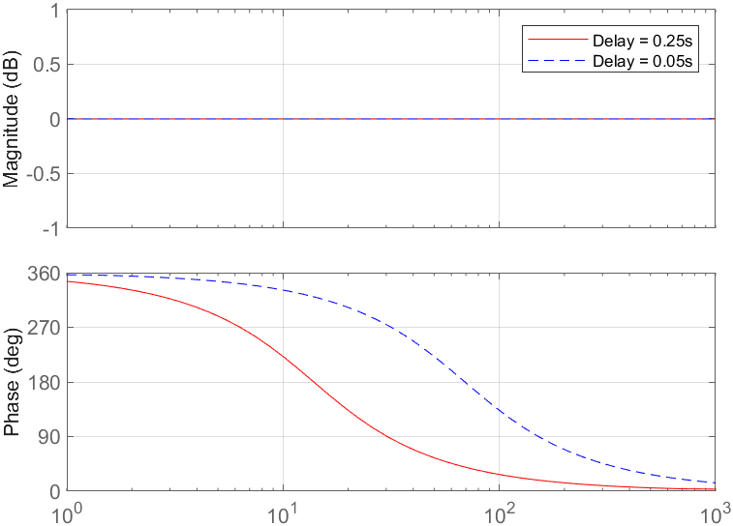
Figure 5 - Bode plot for signal delay of 0.05 & 0.25 seconds

Minimising time delays in control systems is essential for preserving phase margin and ensuring robust, high-performance closed-loop behaviour. Time delays introduce a frequency-dependent phase lag, which reduces the system's phase margin—an essential indicator of stability and damping. A reduced phase margin can lead to excessive overshoot, oscillations, or even instability. As shown by MIT OpenCourseWare, the reduction in phase margin due to a delay T is directly proportional to the crossover frequency $ω_{c}$ expressed as $ϕ_{m,T}=ϕ_{0}-ω_{c}T$, where ϕ₀ is the original phase margin (MIT, 2010). This highlights how even modest delays can significantly degrade performance at higher frequencies. Furthermore, MathWorks (2023) notes that time delays impose linear phase shifts that limit control bandwidth and can severely affect the achievable stability margins. Consequently, reducing time delay is critical for enhancing the responsiveness and robustness of feedback systems, especially in applications like cruise control where fast and accurate tracking is essential.

15. Additional Insights on Control System Implementation
The simulation includes a configurable communication delay parameter (actuator_signal_delay) to emulate real-time latency introduced by in-vehicle networks such as CAN and FlexRay. These delays stem from bus arbitration, frame encoding, and queuing, particularly in systems where multiple control modules share communication bandwidth (Kang et al., 2021; Bosch, 1991). Such latency, even on the order of milliseconds, can significantly affect control performance in safety-critical systems like cruise control or ABS.
Feedback systems are sensitive to time delays, as they introduce frequency-dependent phase lag that reduces phase margin and system stability (Franklin, Powell & Emami-Naeini, 2015). In systems operating at loop frequencies above 50 Hz, even modest delays (20–30 ms) can lead to instability or degraded transient performance (Tang et al., 2022). In this simulation, delays above 30 ms led to oscillations and poor velocity tracking, confirming theoretical predictions.
Although moderate delays can be partially compensated by adjusting controller gains—typically by lowering the proportional and derivative components to reduce loop aggressiveness—this approach reaches its limit as the delay increases. For delays approaching a significant fraction of the system’s dominant time constant, more advanced control strategies are necessary. Predictive control schemes such as Smith predictors or model predictive control (MPC) can be employed to anticipate future system states and maintain stability (Zhou, Gao & Lin, 2008; Wang et al., 2017). Observer-based estimators and Kalman filters are also used in modern ECUs to counteract the impact of asynchronous sampling and delay (Sun et al., 2020).
From a frequency-domain perspective, delay manifests as a linear phase shift, which can be visualised using Bode plots. As shown in Figure 5, a 0.25-second delay causes a much earlier phase decline compared to a 0.05-second delay. Though both exhibit similar gain margins, the reduced phase margin limits the system’s usable bandwidth and increases the likelihood of instability due to early -180° phase crossing (Liu & Peng, 2014). Maintaining minimal communication and execution delays is therefore essential to ensure robust, stable, and responsive closed-loop performance, especially in high-frequency vehicle control applications.

16. Conclusion
This assignment has presented a comprehensive analysis of a digitally implemented cruise control system, highlighting the importance of feedback controller design, quantisation resolution, and real-time sampling. By simulating the full digital signal chain—from sensor encoding to actuator decoding—the study realistically models the constraints and behaviours of embedded automotive systems.
Key findings include the sensitivity of control performance to bit resolution and sampling intervals, as well as the degradation effects introduced by communication delay. The PID controller, tuned for underdamped performance, demonstrated effective tracking with minimal overshoot and acceptable settling times when appropriate sampling and encoding parameters were maintained.
The implementation also showcased best practices in signal processing, delay compensation, and anti-windup strategies—crucial considerations for embedded control in high-integrity applications. As vehicles continue transitioning toward autonomy and electrification, such control frameworks will remain critical, forming the basis for scalable, reliable, and intelligent mobility systems.

References
Åström, K. J., & Hägglund, T. (2006). Advanced PID Control. Research Triangle Park, NC: ISA.
Bosch, R. (1991). CAN Specification Version 2.0. Stuttgart: Robert Bosch GmbH.
Campolo, C., Molinaro, A., Scopigno, R. (2015). Vehicular ad hoc Networks: Standards, Solutions, and Research. Springer.
Chen, L., Wang, L. and Sun, F., 2021. Brake-by-Wire Control Systems for Electric Vehicles. IEEE Transactions on Industrial Electronics, 68(5), pp.4231–4240.
FlexRay Consortium. (2005). FlexRay Communications System Protocol Specification.
Franklin, G.F., Powell, J.D. and Emami-Naeini, A. (2015). Feedback Control of Dynamic Systems. 7th ed. Pearson.
Gawthrop, P., & Smith, L. (1996). Metamodelling: For Bond Graphs and Dynamic Systems. Prentice Hall.
Greenberg, A., 2015. Hackers Remotely Kill a Jeep on the Highway—With Me in It. WIRED. [online] Available at: https://www.wired.com/2015/07/hackers-remotely-kill-jeep-highway/ (Accessed 22 March 2025).
Heinz, J., & Gissinger, G. L. (2014). Electromechanical brakes for future brake systems. SAE Technical Paper.
HowStuffWorks (2000). How Anti-Lock Brakes Work. Available at: https://auto.howstuffworks.com/auto-parts/brakes/brake-types/anti-lock-brake.htm (Accessed: 24 March 2025).
Ioannou, P., & Sun, J. (2012). Robust Adaptive Control. Dover Publications.
ISO 11898. Road vehicles — Controller area network (CAN).
ISO 21750 (2020). Road vehicles — Safety enhancements using tyre pressure monitoring systems.
Kang, Y., Tan, W., Cai, Y. and Zhang, Y. (2021). 'Delay-aware networked control strategy for drive-by-wire vehicles', IEEE Transactions on Industrial Electronics, 68(9), pp. 8511–8520. https://doi.org/10.1109/TIE.2020.3027300
Liu, X. and Peng, H. (2014). 'Model-based delay compensation for networked control of brake-by-wire systems', Control Engineering Practice, 25, pp. 132–144. https://doi.org/10.1016/j.conengprac.2013.11.009
MathWorks. (2023). Analyzing control systems with delays. Available at: https://www.mathworks.com/help/control/ug/analyzing-control-systems-with-delays.html (Accessed 30 March 2025).
MathWorks. (2023). Model-Based Design for Embedded Control Systems. Available at: https://www.mathworks.com/solutions/model-based-design.html (Accessed 30 March 2025).
MIT. (2010). 16.30 Feedback Control Systems – Lecture 11: Time Delays. Massachusetts Institute of Technology. Available at: https://ocw.mit.edu/courses/16-30-feedback-control-systems-fall-2010/cb4fd48f2435b6d67fb6d3c3ecf9bc86_MIT16_30F10_rec11.pdf (Accessed 30 March 2025).
National Highway Traffic Safety Administration (NHTSA), 2021. Anti-Lock Braking Systems (ABS). [online] Available at: https://www.nhtsa.gov [Accessed 22 Mar. 2025].
Ogata, K. (2010). Modern Control Engineering. 5th ed. Prentice Hall.
Pacejka, H.B. (2006). Tyre and Vehicle Dynamics. Elsevier.
Qin, S. J., & Badgwell, T. A. (2003). A survey of industrial model predictive control technology. Control Engineering Practice.
Rajamani, R., 2012. Vehicle Dynamics and Control. 2nd ed. New York: Springer.
Sun, J., Chen, L., and Wang, H. (2020). 'Observer-based compensation of network-induced delay for vehicle control systems', Mechatronics, 66, pp. 102316. https://doi.org/10.1016/j.mechatronics.2020.102316
Tang, J., Zhang, Y., and Hu, Y. (2022). 'Stability analysis of vehicle control systems under communication delays', IEEE Transactions on Vehicular Technology, 71(4), pp. 3925–3935. https://doi.org/10.1109/TVT.2022.3148498
Tiwari, A. and Yadav, S., 2019. Design and Simulation of ABS using MATLAB/Simulink. International Journal of Scientific Research in Engineering and Management (IJSREM), 3(5), pp.1–8.
Utkin, V. I. (1992). Sliding Modes in Control and Optimization. Springer.
Wang, R., Chen, H., & Cao, D. (2017). Advanced Motion Control and Sensing for Intelligent Vehicles. Springer.
Zhou, K., Gao, Z. and Lin, H. (2008). Control of Uncertain Systems: A Linear Systems Perspective. Springer.

Appendix A
%% ENHANCED UNDERDAMPED CRUISE CONTROLLER W/ ANTI-WINDUP + FIXED SETTLING TIME ANALYSIS %%%%%%%%%%%%%%%%
clc; clear; close all

% PID gains tuned for underdamped behavior
P = 0.1;
I = 8.95;
D = 0.08;

%% (2) Set implementation parameters
Ts = 0.02;
m_velocityS = 0;
M_velocityS = 150;
n_bits_sensor_signal = 16;
m_demand = 30;
M_demand = 110;
n_bits_demand_signal = 16;
n_bits_actuator_signal = 16;
R = 2.^n_bits_actuator_signal;

%% (3) Set simulation parameters
sim_step = 0.01;
sim_time = 70;
T = 0:sim_step:sim_time;

[d_vec, u_vec, y_vec, e_vec, Th_vec] = deal(nan(size(T)));
acceleration = nan(size(T) - [0 1]);
jerk_vec = nan(size(T) - [0 1]);

throttle_setting = 50;
actuator_signal_delay = 0.00;
m_ControlSig = -100;
M_ControlSig = 100;
[u, control] = deal(50);
velocity_real = 60;
integral_error = 0;
previous_error = 0;

accel_limit_mphs = 6.72;
jerk_limit_mphs2ps = 4.4; % realistic comfortable jerk limit
previous_accel = 0;

%% (4) Simulation loop
for j = 1:length(T)
loops_remaining = length(T) - j;
disp(loops_remaining)

[velocity_raw, velocity_real, throttle_setting] = getRawVelocity(n_bits_sensor_signal, velocity_real, throttle_setting, sim_step, u);
velocity = ((bin2dec(velocity_raw) * (M_velocityS - m_velocityS)) / R) + m_velocityS;

if j > 1
raw_accel = (velocity_real - y_vec(j-1)) / sim_step;

% Limit change in acceleration (jerk)
jerk = (raw_accel - previous_accel) / sim_step;
if abs(jerk) > jerk_limit_mphs2ps
raw_accel = previous_accel + sign(jerk) * jerk_limit_mphs2ps * sim_step;
jerk = (raw_accel - previous_accel) / sim_step; % recalculate jerk after clamping
end
previous_accel = raw_accel;

acceleration(j-1) = raw_accel;
jerk_vec(j-1) = jerk;
end

if mod((j-1) * sim_step, Ts) == 0
demand_raw = getRawVelocityDemand(n_bits_sensor_signal, sim_step, j);
demand = ((bin2dec(demand_raw) * (M_demand - m_demand)) / (2^n_bits_demand_signal)) + m_demand;

error = demand - velocity;
integral_error = integral_error + error * Ts;
derivative_error = (error - previous_error) / Ts;

control = P * (error + I * integral_error + D * derivative_error) + demand;
control = max(min(control, M_ControlSig), m_ControlSig);

if control == M_ControlSig || control == m_ControlSig
integral_error = integral_error - error * Ts;
end

previous_error = error;

if j > 1 && abs(raw_accel) > accel_limit_mphs
control = u_vec(j-1);
end

control_scaled = round(((control - m_ControlSig) * (2^n_bits_actuator_signal)) / (M_ControlSig - m_ControlSig));
control_raw = dec2bin(control_scaled, n_bits_actuator_signal);

u = sendControlCommand(control_raw, n_bits_actuator_signal, actuator_signal_delay, j, sim_step, u_vec);
end

e_vec(j) = error;
d_vec(j) = demand;
u_vec(j) = control;
y_vec(j) = velocity_real;
Th_vec(j) = throttle_setting;
end

%% (5) Settling Time Analysis (with bounds checking)
theta_ss = d_vec(end);
tolerance_2 = 0.02 * theta_ss;
tolerance_5 = 0.05 * theta_ss;

outside_2 = find(abs(y_vec - theta_ss) > tolerance_2);
outside_5 = find(abs(y_vec - theta_ss) > tolerance_5);

settling_time_2 = T(min(max(outside_2) + 1, length(T)));
settling_time_5 = T(min(max(outside_5) + 1, length(T)));

%% (6) Plot results
figure

subplot(4,1,1)
plot(T, d_vec, 'r-', 'LineWidth', 1.2); hold on
plot(T, y_vec, 'b-', 'LineWidth', 1.2);
plot(T, d_vec - y_vec, 'k--');

theta_peak = max(y_vec);
overshoot_exp = theta_peak - theta_ss;
percent_overshoot_exp = (overshoot_exp / theta_ss) * 100;

if percent_overshoot_exp > 0
ln_os = log(percent_overshoot_exp / 100);
zeta_est = -ln_os / sqrt(pi^2 + ln_os^2);
else
zeta_est = NaN;
end

percent_overshoot_theo = 100 * exp((-zeta_est * pi) / sqrt(1 - zeta_est^2));
overshoot_theo = theta_ss * (percent_overshoot_theo / 100);

[~, idx_peak] = max(y_vec);
plot(T(idx_peak), theta_peak, 'ko', 'MarkerFaceColor', 'y');
text(T(idx_peak), theta_peak + 1, sprintf('%.2f%% OS', percent_overshoot_exp), 'Color', 'k', 'FontWeight', 'bold');
yline(overshoot_theo, '--g', sprintf('Theo: %.2f%% OS', percent_overshoot_theo), 'LabelHorizontalAlignment', 'left', 'LineWidth', 1.2);

xline(settling_time_2, ':c', '2% Settle', 'LabelOrientation','horizontal');
xline(settling_time_5, ':m', '5% Settle', 'LabelOrientation','horizontal');

grid;
title('Velocity Response');
subtitle(['Kp = ', num2str(P), ', Ki = ', num2str(I), ', Kd = ', num2str(D), ...
', \zeta_{est} = ', num2str(zeta_est, '%.3f')]);
ylabel('Velocity (mph)'); xlabel('Time (s)');
legend('Driver Demand', 'Real Velocity', 'Error')

subplot(4,1,2)
stairs(T, u_vec, 'g-', 'LineWidth', 1.2); hold on;
plot(T, Th_vec, 'r-', 'LineWidth', 1.1); grid;
title('Throttle/Brake Control Effort');
ylabel('% throttle/brake pedal'); xlabel('Time (s)');
legend('Control Signal', 'Throttle Position')

acceleration_mps2 = acceleration * 0.44704;
acceleration_g = acceleration_mps2 / 9.80665;

subplot(4,1,3)
plot(T(1:end-1), acceleration_g, 'm-', 'LineWidth', 1.2);
title('Acceleration (g-force)');
xlabel('Time (s)'); ylabel('g');
grid on;

jerk_mps2 = jerk_vec * 0.44704; % Convert from mph/s^2 to m/s^2
subplot(4,1,4)
plot(T(1:end-1), jerk_mps2, 'c-', 'LineWidth', 1.2);
title('Jerk (Change in Acceleration)');
xlabel('Time (s)'); ylabel('m/s^2');
grid on;

fprintf('\nEstimated damping coefficient (zeta): %.4f\n', zeta_est);
fprintf('Experimental Overshoot: %.2f%%\n', percent_overshoot_exp);
fprintf('Theoretical Overshoot: %.2f%%\n', percent_overshoot_theo);
fprintf('Settling Time 2%: %.2f sec\n', settling_time_2);
fprintf('Settling Time 5%: %.2f sec\n', settling_time_5);

Appendix B

$$overshoot= θ_{ss} e^{\left(\frac{-ζπ}{\sqrt{1-ζ^{2}}}\right)}$$
$$maximum overshoot \%= e^{\left(\frac{-ζπ}{\sqrt{1-ζ^{2}}}\right)}×100$$

