ENTERPRISE AND ENTREPRENEURSHIP LCLM 4006

Student Name:Raluca Ioana Serban
Student Id:2213917
Programme:Certificate in Higher Education
Module Code:4006
Module Leader:Daminabo Pokubo
Assignment Title:Individual Written Business Plan

Table of Contents
Introduction 3
Business Overview 3
Legal format of the company 3
Management of the company 4
Target market and the marketing strategies 4
Target market 4
Marketing Strategy 5
Industry and Competitors analysis. 7
Funding and Financial Analysis 7
Conclusion 8
References 10

Introduction
An entrepreneur is a person who takes the initiative to start a company and manage it at their own financial risk. The purpose of this work is to draft a business plan that takes into account everything that has to be thought about before a company is launched (Santellano, 2021). The report will focus on the strategic tactics and approaches that contributed to the successful company strategy.

Business Overview
The bakery sector welcomes newcomer Moon Light. The first Moon Light bakery was just opened in London. It's undeniable that the popularity of pastries has skyrocketed in recent years, and that a company like Moon Light stands to gain financially as demand for pastries continues to rise in the marketplace (Morris, 2018). Moon Light is in a category of its own thanks to its in-house pastry bakery. The company's early success may be attributed to the variety of flavors and tastes it offered. Moon Light also sells a variety of other items on the market, which vary with the seasons. These are some of the most popular items on the market today:


Legal format of the company
Since there is no other entity involved in the ownership of Moon Light, it may be classified as a single proprietorship. In the business world, startups are often defined as limited liability companies (LLCs). The ability to respond rapidly to changes in the business environment is a major perk of operating as a lone proprietor. The absence of governmental interference in sole proprietorships also facilitates their expansion. A company's capacity to expand into new markets may be aided by its minimal liability and by less government regulation. Due of the lower overhead associated with starting a single proprietorship, Moon Light may legally operate in this country.

Management of the company
In the setting of Moon Light, the following describes the senior management staff, along with their relevant qualifications and degrees:
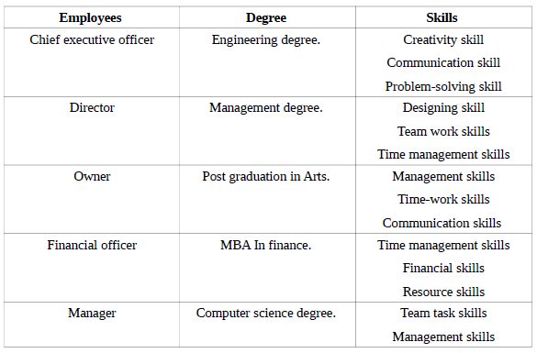

Target market and the marketing strategies

Target market
Moon Light' ability to stand apart from the competition is a potential selling point. Moon Light stands out from the competition because to the novelty of its pastry beans in retail bakeries; the fact that the company also operates its own farms further increases this advantage.
Moon Light has decided to concentrate on the younger market since, according to their research, young people are particularly interested in pastry drinks.

Marketing Strategy
A company's ability to increase sales and productivity may be charted out in detail with the help of a well-thought-out strategic marketing strategy. To be successful, a company must first comprehend and then put into action its own unique strategic marketing strategy. The new Moon Light company has to implement a winning advertising strategy to ensure its continued success.
Executive Summary
New to the pastry scene is Moon Light, which offers doorstep delivery of a variety of pastries in a wide range of flavours. In order to ensure the firm's steady growth, it must first prepare a comprehensive strategy. The plan lays out the specifics of how you'll achieve your marketing goals and reach your target demographic. You'll also receive an in-depth look at your competitive landscape and your marketing approach.
Marketing objectives
In order to expand successfully, we need to raise the total revenue of baked goods and drinks sold online.
The goal is to increase the company's net profit by 40 percent via the use of Omni channels to persuade customers.
To learn whether or not the hoped-for results may be attained by the designated deadline.
Assessing the impact of internet advertising on revenue and output.
Improve the degree of customer satisfaction with the company's products and services by meeting or exceeding their expectations.
Situational analysis
When doing a swot analysis of the internal setting of a new start-up firm, it is crucial for the company to consider the marketplace as well as the company's surroundings as a whole (Fadhil and et al., 2018).
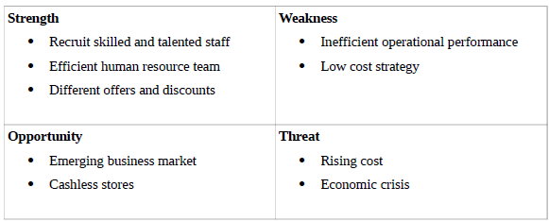
Marketing Strategy
To get an edge in the marketplace, businesses develop marketing strategies with the long-term objective of satisfying the wants and requirements of their target audience. The Moon Light company plans to adopt a marketing mix approach to boost sales and overall efficiency. To better meet the needs of its target market, the Moon Light startup will distribute its pastry goods in a wide range of flavours and varieties. The term "price" refers to the monetary consideration that a buyer must provide in return for a seller's goods or services. The company's dedication to keeping prices low has allowed them to win over and keep as many customers as possible. Location: Cunningham and coworkers (2018) note that new businesses are more likely to succeed if they provide their wares both online and off. It is planned to have a physical storefront from which users may also access various internet services. The Moon Light will be promoting themselves via online channels.
Tactics and Implementation
In order to succeed, a new company has to use methods and approaches that have been proven effective in promoting similar companies in the past. Each company must engage in marketing since it is crucial to their success. When trying to market a product or service, it's crucial for a business to have a firm grasp of its value proposition and areas of uniqueness. These areas serve to define the product's characteristics and include client requirements that must be met efficiently in order to achieve profitability.

Industry and Competitors analysis.
A business's potential for success may be traced back to the specific actions outlined in an operational strategy. It's a strategy for figuring out where a company is making money and where it's losing money so that it can make the necessary adjustments to get off the ground (Maye, Kirwan, and Brunori, 2019). In its early stages, the Moon Light startup will use digital channels to advertise its wares and provide its services both online and in physical locations. The company will be based in London, UK, and its first order of business will be to determine what kinds of physical infrastructure it would require in order to function effectively and achieve its goals. On January 15th, 2023, the company will officially launch after months of planning, gathering funding, and setting up the necessary infrastructure. Before kicking out a new venture, it's crucial to do a thorough assessment of all necessary components, including design approval and major project milestones. However, before a corporation can begin operating legally, it must first complete a number of necessary legal procedures and paperwork. The Moon Light company is a sole proprietorship, meaning that its one and only owner makes all business decisions and keeps all of the company's earnings or losses. In order to ensure the safety of their clients, pastry shops must adhere to regulations concerning health trade licences, eating house licencing, insurances, and even emergency security certificates. When opening a pastry and beverage establishment, it is crucial to take into account all of the relevant regulations, standards, and certifications.

Funding and Financial Analysis
For any enterprise to get off the ground, its founder will need access to funding mechanisms that will allow them to invest in necessary infrastructure like computers and office space (Di Marino and Lapintie, 2018). Moon Light is a new bakery that wants to provide customers a variety of pastries, so they need to figure out how much money they'll need to get started. While preparing to establish a firm, it's crucial to think through a contingency plan that anticipates and accounts for potential financial risks. There is an initial investment of $800,000. However, stressing the need of a sales projection and proforma financials.
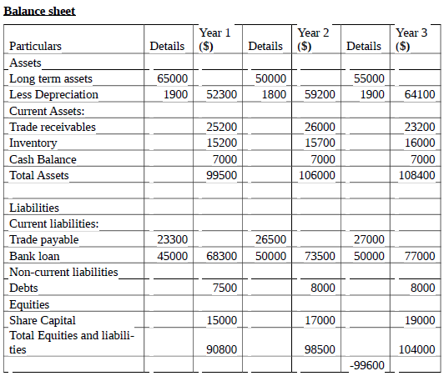
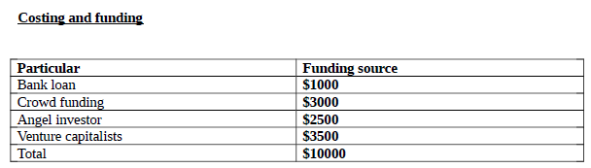

Conclusion
The purpose of this business plan is to lay out all of the major steps that need to be taken before launching a firm. The Moon Light Pastry Shop is a fictional new bakery in this business plan. What makes this company stand out is its promise to satisfy customers' growing need for a variety of pastry flavours (Yun and Kim, 2019). Some companies provide flavoured pastries, but they charge high prices, whereas Moon Light plans to sell theirs at more reasonable rates in order to attract more customers and expand their business. The marketing strategy, strategic goals, marketing strategies, operational plans, market research, and financial projections are all part of the company plan. Therefore, it is crucial to create and organise a business strategy before launching a company for the best chance of success.

References
Chawla, K. (2018). BUSINESS PLANNING ESSENTIALS: PREPARING A BUSINESS PLAN. Journal of Advances in Business Management, 1(3), pp.93–99. doi:https://doi.org/10.14260/jadbm/2015/12.
Cunningham, B., and et.al, 2018. Accounting: information for business decisions. Cengage AU.
Di Marino, M. and Lapintie, K., 2018. Exploring multi-local working: challenges and opportunities for contemporary cities. International Planning Studies.
Fadhil, R. and et.al, 2018. Development strategy for a quality management system of gayo pastry agro-industry using soft systems methodology. Periodica Polytechnica Social and Management Sciences, 26(2), pp.168-178.
Ghandour, A. (2021). Identifying Dimensions of Business Continuity Plan from Common Expressions among Business Continuity Professionals. International Journal of Business Administration, 5(3). doi:https://doi.org/10.5430/ijba.v5n3p136.
Kadam, Dr.M.S. (2017). Disaster Recovery Plan (DRP) and Business Continuity Plan (BCP) for Financial Cooperatives in New Market Economy. SSRN Electronic Journal . doi:https://doi.org/10.2139/ssrn.2920431.
Maye, D., Kirwan, J. and Brunori, G., 2019. Ethics and responsibilisation in agri-food governance: the single-use plastics debate and strategies to introduce reusable pastry cups in UK retail chains. Agriculture and human values, 36(2), pp.301-312.
Morris, J., 2018. Why espresso? Explaining changes in European pastry preferences from a production of culture perspective. European Review of History: Revue européenne d'histoire,20(5), pp.881-901.
Perera, R., 2017.The PESTLE analysis. Nerdynaut.
Sandy, W. (2019). Link Your Business Plan to a Performance Plan. Journal of Business Strategy, 11(6), pp.4–8.
Santellano, K., 2021. Compounded inequality: how the US Paycheck Protection Program is failing Los Angeles Latino small businesses. Ethnic and Racial Studies, 44(5), pp.794- 805.
Tucker, C.M., 2017.Pastry culture: Local experiences, global connections. Routledge.
Tusin, J. (2020). Book Review: Writing and Presenting a Business Plan. Business Communication Quarterly, 69(2), pp.226–229. doi:https://doi.org/10.1177/1080569906287907.
Yun, S. and Kim, T., 2019. What do pastry shop entrepreneurs need to do to raise proenvironmental customer behavioral intentions?. Sustainability, 11(9), p.2666.

