The Magna Carta
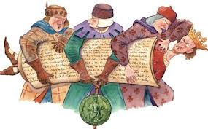

This may look like a plain piece of parchment but it is one of the most famous documents in the world. The Magna Carta has inspired people across the centuries from Thomas Jefferson to Ghandi but why was the charter originally created and what does it actually say? let’s take you it back to medieval England it was the year 1215 and the ruler is King John. Many people believe that King John was one of the worst Kings in history; he imprisoned his former wife starved, his opponents to death, he allegedly killed his own nephew and got under the skin of the Irish chiefs. King John had imposed heavy taxes on his barons in order to pay for his foreign wars and if they refused to pay the King would punish them in an extreme way or seize their property by force.

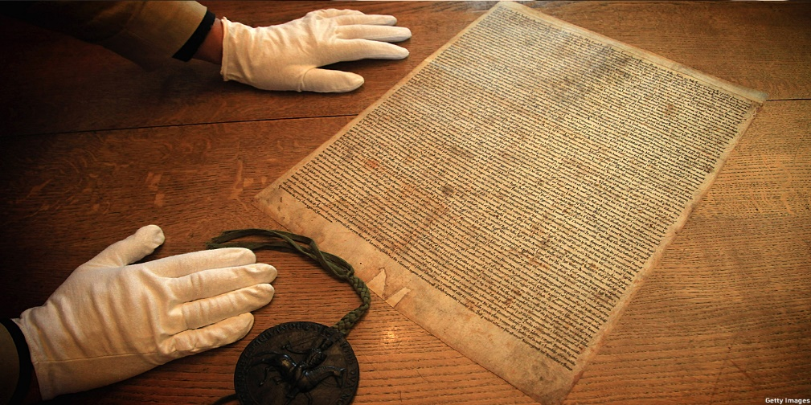

“The Barons demanded that King John obey the law. When King John refused to obey the law, the Barons would then go on to capture London and the king was then forced to negotiate. The two sides then met at a little place in England called Runnymede in the year 1215. When the two sides eventually came to an amicable conclusion the result of the negotiations was written down on parchment by King John’s clerks into the document as we know today as the Magna Carta. Even though most of the charters clauses dealt with mediaeval rights and customs Magna Carta has become a powerful symbol of liberty and justice around the world”. Harrison (2014)

“Although the Magna Carta was designed to create a truce between King John and his rebellious Barons, England was plummeted into civil war after the Pope Innocent the third declared that the charter was invalid. When King John died in 1216 of dysentery 9-year-old Henry the third took to the throne, to keep the peace. the magna carta was issued several times during the thirteenth century 1217, 1225 and 1297 until finally it was made part of English law. The magna carta has lived on for 800 years and is echoed around the world in the fundamental cornerstone of legal systems”. Harrison (2014)

The Magna Carta, or as it is translated the great charter of King John, was signed on the 15th of June 1215 in Runnymede, England by the King but was put forward by a few unruly restless Barons as a practical political solution to make everyone, including the King, to be subject to law. This document was the first important high status legal deed of English law and politics just like Rome’s law of the Twelve Tables. Comparable to Rome’s Twelve Tables the Magna Carta was created to protect the rights of individuals and place limitations upon the crown; it was demanded by the people who had complained about the asymmetrical and capricious savagery of the king of England, King John. This then became the foundation of English freedom and democracy. In 1628 in the reign of Charles the first parliament put across a law which was called the Petition of Rights but was subsequently changed to the Bill of Rights in 1689 hence the 1215 charter was the constitutional starting point of the English people. Rt. Hon. Viscount Bryce (1917)

Nearly a third of the great charter was rewritten within ten years of it being signed and, in this time, nearly every clause in this document had been dismantled, but regardless of this the Magna Carta still remains the foundation of the British and colonial constitution. The reason for the change in the charter and clauses was because most of the injustices put forward by the people were to do with King John and his barbaric decree. But some more of the most famous clauses still are in effect to this day; the 39 clauses state that all “free men of the realm” shall have the right to a fair trial and justice. Most of the core foundations of law today use the principles of the Magna Carta; this is mirrored in, for example, the 1791 Bill of Rights, the 1948 Declaration of Human Rights and the 1950 European Convention of Human Rights. Shaw (2005)

From the charter of sixty-three clauses that were written only three of these clauses still remain to this day in British law. The most acclaimed of these clauses In the Magna Carta is the right to justice and fair trial, which translated from the Latin reads
“no free man shall be seized or imprisoned or stripped of his rights or possessions, or outlawed or exiled or deprived of his standing, in any other way, or will we proceed with force against him, or send others to do so, except by the lawful judgement of his equals or by the law of the land. To no one will we sell, to no one deny or delay right or justice”. (Davies, G.R.C. 1963)

In the medieval times not, every man was a freeman of the realm, most of the unfree people of England were peasants and could only pursue justice under their lords. Rt. Hon. Viscount Bryce (1917) Clause 39 of the charter gave the common man freedom and justice, but this clause would be contested for centuries to come. In the year 1302, a royal Justice allowed ‘trial by his peers’ for a simple knight. Then in the year 1354, an historic statute that no man ‘of what state or condition so ever shall be put out of his land or tenement or be put to death without being brought to answer by due process of law.’ Many reckoned that the concept of freeman now applied to all the king’s male subjects but the words ‘due process of law’ would long be debated. In the 1360s, peasants of a manor of Christ Church cited the Great Charter in a petition to their Prior.

In 150 years the sonorous pledge of the Liberties of Runnymede ‘to all the freeman of our kingdom…’ had seeped down to the grass roots. In the words of Max Webber the German born sociologist and political economist, the very idea of natural law derives in part ‘from the idea indigenous to England that every member of the community has certain natural rights. This idea of birth right arose essentially under the influence of the popular conception that certain rights confirmed in the Magna Carta as the special rights of the barons where the habitual Liberties of all Englishmen as such.’ Hindley (1990)

As the legal system today has the basic fundamental foundations of the Magna Carta’s three kept Clauses, as Max Webber had put that the special rights of barons and the Liberties of Englishmen as such suggests that this thrust upon English document like every other English document is not only just there to secure the rights of the English and their ideologies but also it seems to only apply to, as he states, he English. The English law should not apply to other countries such as Wales which is a country with its own people with its own ideologies, language, and culture. In the process of time, the facts embodied in (the Charter) and the circumstances giving rise to them, where buried or misunderstood but the underlying idea of the sovereignty of the law, long existent in feudal custom, was raised by the Charter into a doctrine of the national state. Winston Churchill

In 1215, King John was, therefore, placed beneath the law, but the Magna Carta of 1215 was very far from giving equal treatment to all the King’s subjects. Socially it was a divided and diverse document, often reflecting the interests of a baronial elite a few hundred strong in a population of several millions. Having asserted that taxation required the common consent of the kingdom, the assembly giving that consent was to be attended primarily by Earls, Barons, Bishops and Abbots. There was no place for London and other towns, although the Londoners thought that there should be. There was no place for knights elected by and representing the counties, although the charter elsewhere assigned important roles to elected knights. In other words, there was no equivalent house of commons.

At least, in the chapter on taxation, the good and the great of the realm could be seen as protecting the rest of the king’s subjects from arbitrary exactions. But the king’s subjects were far from sharing equally in the charters benefits. Indeed, the unfree villeins, who made up perhaps half the population, did not formally share in those benefits at all. The liberties in the charter were granted not to “all the men” of the kingdom, but to “all the freemen”. It was likewise only freemen who were protected from arbitrary imprisonment and dispossession by chapter 39. As far as the magna carta was concerned, both king and lords remained perfectly free to dispossesses their unfree tenants at will. The threat of doing so was a vital weapon for control of the peasant workforce. Chapter 40s “to no one will we deny delay or sell right or justice” seemed more inclusive.

“But this was less helpful to the unfree as it seemed. It was the law itself that laid down the villeins had no access to the king’s courts in any manner concerning their land and services. These where entirely for the lord to determine. As one law book put It, “a villain when he wakes up in the morning, does not know what services he must perform for his lord by night”. The one chapter in the charter which specifically protected the unfree was less than it seemed. Under chapter 20, fines imposed on villeins were to match the offence and be assessed by local men. During the negotiations at Runnymede this chapter was redrafted to make it clear that the fines in question where those imposed by the king. In other words, they did not apply to all to fines imposed by lords”. Carpenter (2005)

The Magna Carta also echoed the bias among men and women, and specifically the way women played a very restricted part in public affairs. In the charter there are names of thirty-four men. Only three women are mentioned in the charter: King Johns Queen, and the Royal sisters of King Alexander II of Scotland. No other women were named. It is correct that “man” could be understood at the time of the charter to mean simply “human being”. The “no freeman” of chapter 39 thus protected free women. Indeed, the chapter owed something to the way John had destroyed Matilda de Briouze. But the chapter also established the inequalities between the sexes. If a free woman secured judgement of her peers (that is social equals), under its terms those peers would have been exclusively male, for women were not allowed to sit on juries. Chapter 39 also omitted women altogether when it spoke of outlawry, for women where not outlawed they were “waived”, which meant left as a “waif”. This had the same effect. A waived woman could be killed on sight just like an outlawed man. But the distinction showed how accountable women were to men. There was no oath of allegiance taken by women to the king because in theory women were consistently under the protection of a man – father, husband or lord they were, therefore, never “in law” and so could not be “outlawed”, thus they were “waived” as a substitute. Carpenter (2005)

It can be concluded that this English document not only gives us the legal foundations and rights that we have today whether that be where it was created in the England, 800 years ago but also the core foundations and principles that other countries like Australia and America also use to this day due to emigration. It also shows how over time the document has been changed when passed though the hands of the elite and how laws only applied to everyone except the church but also if you were a peasant, which made up nearly threequarters of the population you where unfree and where subject under the jurisdiction of their lord’s court and had no access and protection of the royal courts. Women were also under the protection of either their husbands or fathers but if you were a widow then you would be under the protection of the king, but as Susanna Ansley from London’s king’s college indicates that even though the Magna Carta has irrefutable betterment there was still noticeable escape clauses the King or a relative would use to exploit widows so they would still find themselves under an overlord. The document shows how the poor and women suffer under this rule which does not seem so different 800 years later in today’s day and age. Even this legal document protects the rights of men and or men with power and high status, it still even in today’s legal structure needs to catch up with the ideals and problems that women and the poor face. Men created it so men need to readdress the document to balance out fundamental issues of inequality.

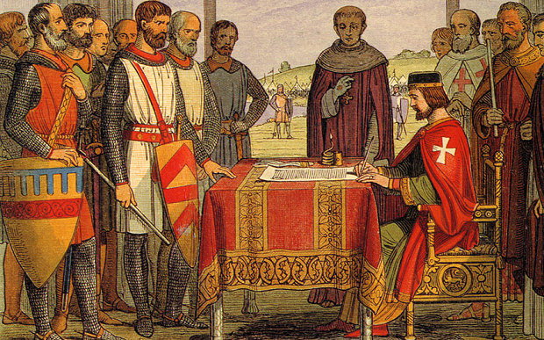

References:

Carpenter, D. (2005) new translation the magna carta: the guardian
Available at:
https://www.theguardian.com/books/2015/jan/02/magna-carta-800th-anniversary-relevance-david-carpenter

Hindley, G. (1990) The Book of Magna Carta, Law Legend and Talisman. P.182
Davies, G.R.C. (1963) Magna Carta London: British Museum) pp.22-33.

Shaw, M. (2005) Early America and Magna Carta) The British Library
Available at:
https://www.bl.uk/magna-carta/articles/modern-america-and-magna-carta

Rt. Hon. Viscount Bryce (1917) Magna Carta Commemoration Essays: The Royal Historical Society) pp.01 -09.

Harrison, J. (2014) Magna Carta an Introduction: British library
Available at:
https://www.bl.uk/magna-carta/articles/magna-carta-an-introduction

Susanna Ansley from London’s king’s college

Harriett Obrien (2005) The Independent: The Magna Carta, where to visit the Four Surviving Origins:
Available at:
https://www.independent.co.uk/travel/news-and-advice/magna-carta-where-to-visit-the-four-surviving-originals-10002631.html

