Managing Enterprise in the 21st Century
Student name: Mohammed Shuhan Miah
Student Id No: 1707398
Teacher: Molly Jack

Contents
Executive summary 3
Introduction 4
Business description 5
Market analysis 6
Financing and funding 9
Application of a range of employment skills 10
Conclusion 11
References 12

Executive summary
The UK is a residence for increasing “fast food” businesses. Businessmen of this manufactures are a liability, they are doing virtuous day by day. The key idea of this business is to launch a multilevel “fast food” restaurant on the popular side of South West Wales. Nonetheless the “fast food” businesses are communal and trendy in the UK. This category of “fast food” idea is rare and will be very supportive for every kind of customers. In this restaurant, not only people just can buy food and eat in the restaurant but they correspondingly can arrange other events such as birthday, engagement parties, bridal showers or even baby showers, as well as that they can arrange small business meetings. Original backing of this business will be done by particular funding and by granting a small amount of loan from the local bank

Introduction
Managing an enterprise in the 21st century, especially in a young age, is a tough challenge for every individual. Entrepreneurship is a much more challenging and freedom based occupation than any other occupation in the world. Entrepreneurs can think of the way they want, they can do anything as the way they want to be done. In addition to that, entrepreneurship also provides all kinds of support to an individual regarding the real knowledge about the enterprise, information regarding be self-employment and information and knowledge regarding the relevant skills that are needed to be a self-employed. In this report, a new type of business plan will be designed and the business idea will be thoroughly evaluated and examined. In addition to that application of a different range of employment, skills will be applied to the business idea.

Business description
The UK is the region where people have the record of consuming highest “fast-food” in their daily lives. This has been possible for only having the expanded culture within the UK. People of UK are having to have a busy daily schedule all day long. On the other hand, having diverse cultural perception, people would love to share each other’s cultural principles by sharing the foods. Due to this reason, the UK has the global success in the fast-food business. A recent study says, the fast-food industry in the UK has been grown up by 25.6% and reached to a value of $15.2 billion. This “fast-food” business of UK has been apprehended by some main players such as McDonalds, Burger King, Greggs, KFC, Pizza Hut, Domino's Pizza, Fish and Chips, Indian and Chinese Takeaways and many other street food restaurants. The “fast-food” business in the UK is getting very popular due to the number of customers that they keep getting every day, their income is a lot higher than usual. This would help to improve their business by bringing up more ideas to attract customers of all ages and cultures.
This “fast-food” restaurant is not going to assist to the customers in a traditional manner rather it will follow a changed manner from other “fast-food” business in the UK industry. In an outmoded “fast-food” restaurant, people give order and wait for their foods to be served. Some people finish their food by sitting inside of the restaurant and some other want the restaurant to make the order in a parcel. There is such a little place to sit inside of this restaurant and having a meeting whether it is a formal one or not.

Market analysis

PESTEL is a valuable tool+ used for the market and environmental analysis, this then supports strategic decision making (Narayanan and Fahey, 2001).” As a company looks to leverage its capabilities and expand, it is imperative that is considers PSETEL analysis to accompany the SWOT analysis
PESTEL analysis of the fast-food industry of UK
- Political: By launching a rule, the government of UK has tried to ensure the health safety of the customers. That is why, this industry is also the safest industry for a start-up business. The government or the authority of UK had set new rules regarding the genetically modified labelling in the fast-food industry since 2004.
- Economic: The cost of overview of a new business in this sector of UK is very much lower than the other sectors. A start-up business can be happening with the help of several franchises. The most striking fact of this market it is the fastest increasing market from many sectors in the UK. A recent study says, the fast-food industry in the UK has been grown up by 25.6% and reached to a value of $15.2 billion.
- Social: This trade is a society approachable industry and pays a close attention to the society in every aspect.
- Technological: Technology has a huge role in the success of this industry in the UK. Contestants are using any types of modern knowledges in their business action which is helping them to provide better and improved services to the customers.
- Environmental: Many “fast-food” outlets such as KFC, subways, peri peri and others are now preserving the regulation of animal rights for doing the virtuous duty to the environment.

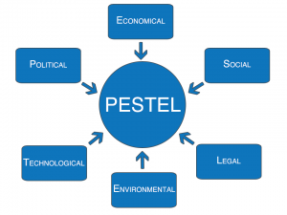
Figure: PESTEL analysis
Legal: This business of UK is also afraid with the health and safety guidelines that have been set by the proper authority of UK. To ensure the health and safety issues of general public, the competitors of this business industry needs to follow the regulations of FSA (Food Standard Agency) properly.
Besides PESTEL analysis, the “fast-food” industry of UK has been investigated through the helping of Porter’s five influences analysis. A brief explanation is given below:
- Buyer power: Although everybody doesn’t like “fast-food” like the homemade food, the competitors in the UK “fast-food” industry are influence a vast range of exclusive items that are attracting customers. This awareness is weakening the power of the buyers and making strong the brand loyalty.
- Supplier power: This industry has around 4600 leading suppliers who are energetically working in this market. The power of supplier is cumulative within the market because the restaurants have to depend on them because of the raw ingredients of foods.

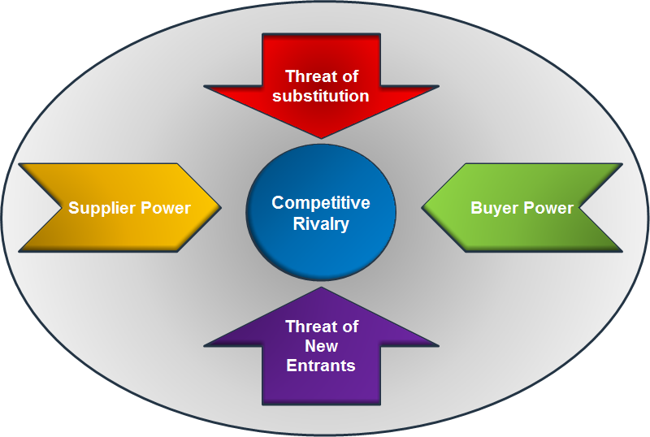
Figure: Porter’s five factors analysis
- The threat of new entrants: It is threatening to earn profit quickly in this market by competing the established competitors in the market. Besides, the new entrants must comply with the rules and guidelines of proper expert which will be a limitation for the business.
- The threat of substitution: The main additional foodstuffs of the “fast-food” are the frozen foods, ready-to-eat-meals and so on. But, “fast-food” is inexpensive and quicker than these alternatives.
- Competitive rivalry: This business is a place of huge competition; many traditional and new start-up entrants are doing business and they are having huge rivalry among themselves.
So, from the above analysis, it can be said that starting a new business in this subdivision will be a stimulating matter and also a money-making one due to its rapid popularity.

Financing and funding
The total budget for introduction the business will be around £45000. A short-term situation of allocating the budget is shown below:
Particulars | Amount
License and registration cost | £2000
Rent of the premises | £13000
Decoration | £20000
Raw materials | £10000

The funding of the business will recover from three sources. A brief explanation is given below:
- Personal source: Personal funding is a great source for a start-up business. This initial stage, 40% of the total fund will be collected from personal savings, relatives and other personal sources.
- Angel investing: Angel investing is that kind of investment into a business by another firm. The firm will help the start-up business by providing several advice and also provide a report to the bank as a security.
- Loans from the bank: Many banks in the UK provide a loan to start-up business against a little amount of collateral. 60% of the total fund will be collected through the loan.

Application of a range of employment skills
There are certain employment skills that need to have an entrepreneur. These skills will help the individuals conquer anything within the business industry. A brief explanation regarding various employment skills is given below:
- Communication skills: Communication skill helps an individual to understand the mindset and the demands of another party. In the “fast-food” business, the management of the business needs to understand the demands of the customers and needs to provide according to the demands of the customers.
- Technical skills: Technical skill shows the improvement of the practical information of certain individuals. For the “fast-food” business, it is important to know about all the technical characteristics of the business and how the market is reacting to any technical changes.
- Team working skills: Team working skill is another important skill for any employee or any team leader or for any certain individuals who work within a team. Through team working a short-term analysis and all the workable solutions to the problems can be found in an easy manner. The success rate of working within a team is much higher than working alone for any project. In the business like “fast-food”, people need to work within a team so that any challenges can be faced.
- Organizing and prioritizing: all the works should be done in an organized manner so that the works don’t mix up with each other. After organizing the work, the works must be done by giving proper priority.
- Flexibility: Flexibility helps a person to adopt things quickly within an adverse environment. A flexible person is always up to take any encounters and achieve the task without any disappointment. “Fast-food” business must be done in a stretchy manner so that it can conform with any situation or challenges that might hinder the operation of the business.
These are most appreciated service assistances that a person or an employee must have to make them adapt to any situation or any condition.

Conclusion
Managing an enterprise in the 21st century is a tough job especially when an individual wants to start his or her business in such a market where already many established organizations are doing business successfully. To survive in this business industry, the organization or the business idea of the organization must be unique than other business organizations and must be very customer friendly. The government or the proper authority needs to be more helpful to these start-up businesses.

References
Austin, D. (2012). Human services management. New York: Columbia University Press.
Eiteman, D., Stonehill, A. and Moffett, M. (2013). Multinational business finance. Boston [Mass.]: Pearson.
Hall, K. and Schulz, C. (2011). Hospitality. New York: Ferguson Pub.
Hanaysha, J. (2016). Testing the effects of food quality, price fairness, and physical environment on customer satisfaction in fast food restaurant industry. Journal of Asian Business Strategy, 6(2), pp.31-40.
Hisrich, R., Peters, M. and Shepherd, D. (2017). Entrepreneurship. New York, NY: McGraw-Hill Education.
McDonough, T. (2017). Closing the Skills Gap: Key Learnings for Employers and Job Seekers. Employment Relations Today, 43(4), pp.49-54.
Pieroni, L. and Salmasi, L. (2014). Fast-food consumption and body weight. Evidence from the UK. Food Policy, 46, pp.94-105.
Scott, S. (2013). Labour, Migration and the Spatial Fix: Evidence from the UK Food Industry. Antipode, pp.1-20.
Stein, S. (2017). American Fast Food Industry Making Millions for the Medical Industry. Nutrition & Food Science International Journal, 2(2).
Tulgan, B. (2016). Bridging the Soft-Skills Gap. Employment Relations Today, 42(4), pp.25-33.

